Metacognitive uncertainty in Correct and Error trials across inter-stimulus-intervals
Jesper Fischer Ehmsen¹, Siebe Everaets^{xx}, Arthur S. Courtin¹, Kelly Hoogervorst¹, Micah G. Allen^{1,2,*}, Francesca Fardo^{1,3,*}
Table of Contents

¹Center of Functionally Integrative Neuroscience (CFIN), Department of Clinical Medicine, Aarhus University
²Cambridge Psychiatry, University of Cambridge, United Kingdom
³Danish Pain Research Center, Department of Clinical Medicine, Aarhus University
*Equal contributions
Corresponding author: Jesper Fischer Ehmsen (jesperfischer@cfin.au.dk)

This pre-registration consists of 3 parts; 1. considerations of models and empirical data of perceptual decision making tasks with confidence ratings 2. Outlining two computational models 3. Design, methods, hypotheses and sample size considerations of the current study.
These three parts are covered in 3 separate documents, with this document including them all.

Part 1: Perceptual Decision-Making with Confidence
Metacognition, the ability to reflect on one’s own cognitive processes, is commonly studied through confidence ratings in decision-making tasks. In this document we highlight empirical findings and experimental considerations when investigating perceptual decision making with confidence ratings.
We believe that there are three main aspects of confidence ratings and their relationship to choices.
- Confidence ratings reflect a noisy, subjective probability of being correct or self-consistency, that incorporates response biases rather than purely objective performance (Caziot and Mamassian 2021; Sánchez-Fuenzalida et al. 2025; Mihali et al. 2023; Navajas et al. 2017).
- Confidence judgments under perform relative to first-order accuracy, (i.e. 90% Accuracy might produce 80% confidence) (Shekhar and Rahnev 2021).
- Metacognition and error-monitoring are functionally related systems. Being confident about an error is a form of error-monitoring (Yeung and Summerfield 2012; Stephen M. Fleming and Daw 2017; Öztel and Balcı 2024).

Models of perceptual decision making and metacognition
Computational models of metacognition typically fall into two categories: static models based on Signal Detection Theory (SDT) and dynamic models based on evidence accumulation (EA).
Static models describe choice and confidence as originating from a static process of acquiring a fixed evidence per trial. This evidence is then used independently or in conjunction with additional information to produce the confidence ratings.
Dynamic models additionally account for response times by assuming that evidence is accumulated over a time period and when a decision boundary is reached (enough evidence for a choice has been collected) a choice is made. Confidence is then thought to be generated by additional evidence accumulation in the post-decisional time window.
Both of these approaches can be understood as (approximately) optimal solutions to partially observable Markov decision processes under different assumptions. In most perceptual decision making tasks these two types of models are not mutually exclusive and can be seen as extensions of one another. I.e. the dynamic models being extensions of the static models.

Patterns of Confidence ratings
Metacognitive models regardless of originating from EA or SDT need to be able to capture several empirical patterns observed in the literature of both binary choices and confidence ratings.
- Performance increases with stimulus strength: Stronger stimuli yield higher accuracy
- Confidence curves shifts in tandem with binary choice curves: As the psychometric function, governing the choice probability, moves from unbiased (threshold at 0) so does the confidence curves. Meaning that the lowest confidence ratings for correct trials are at the stimulus value of the threshold (Caziot and Mamassian 2021; Sánchez-Fuenzalida et al. 2025; Mihali et al. 2023).
- Confidence increases with stimulus strength: Stronger stimuli yield higher Confidence ratings (conditional on accuracy, see below) (Hangya et al. 2016; Sanders et al. 2016)
- Confidence varies with accuracy: The relationship between confidence and stimulus strength depends on response correctness, with correct trials showing higher confidence than incorrect. (Hangya et al. 2016; Sanders et al. 2016)
  - “Folded-X” pattern: Confidence sometimes increases with stimulus strength for correct responses but decreases (or plateaus) for errors, considered a signature of metacognition (Hangya et al. 2016; Sanders et al. 2016)
  - “Double-increase” pattern: Confidence increases with stimulus strength for both correct and incorrect responses
Recent work suggests these two differing patterns of confidence, arise from different experimental manipulations (Xue et al. 2026; Fung et al. 2025):
- Folded-X: Emerges when manipulating decision-relevant stimulus properties (e.g., coherence in RDM)
- Double-increase: Occurs when manipulating auxiliary difficulty markers (e.g., stimulus visibility).
These recent studies investigating 4a and 4b show these patterns on a confidence scale that ranges from guessing to certain. This highly limits how much the incorrect side of the confidence curve can express, as we will argue for in the next section. Furthermore, if subjects are not able express that they made an error, one might argue that this cannot be error-monitoring, even if confidence ratings for incorrect trials decrease as a function of stimulus intensity increasing.
These patterns of confidence can therefore be viewed in light of error-monitoring, but only when a particular confidence scale is used, where subjects are able to express they made a mistake. Furthermore, as expressed below, confidence ratings need to be administered after the binary choice and not simultaneous with the choice in order for subjects to make a mistake and then be aware of it. If subjects choose and rate simultaneously a folded X-pattern would mean that the subject deliberately answers incorrectly.
To summarize, only a full confidence scale ranging from incorrect to correct and a sequential design of choice followed by confidence rating give subjects the ability to demonstrate error-monitoring which would lead to a full folded-X pattern. This full folded-X pattern would have confidence ratings for incorrect trials go below the middle of the scale which expresses “guessing”. Only in such a case could the folded-X reflect functioning error-monitoring (confidence decreases for errors), while the double-increase pattern would suggest limited or no error-monitoring.
below we describe in more detail how experimental designs and measurement scale can influence the type of data and the interactions one might observe.

Confidence scales, stimulus granularity, and measurement considerations
Here we outline several methodological considerations, and argue that some of these will inevitably determine the types of empirical data one can observe.
Confidence measurement: Confidence is collected either discretely or continuously. One of the most prominent models of metacognition (M-ratio) require discrete data, leading many experiments collecting or discretization of continuous confidence (Maniscalco and Lau 2012; Stephen M. Fleming 2017: hierarchical Bayesian estimation of metacognitive efficiency from confidence ratings).
Stimulus strength: Main stimulus axis that determine the difficulty of a trial. can be discrete or continuous.
Confidence scale construction: The particular anchors of a confidence scale.
- Half-scale confidence. A “half-scale” of confidence ranges from “guessing” to “confident”, this prevents expressing certainty about errors: agents cannot indicate they are sure they made a mistake. This generally produces “half-folded-X” patterns (flatish incorrect branch) rather than a true folded-X.
- Full-scale confidence. A “full scale” of confidence ranges from “confidently incorrect” to “confidently correct” enabling subjects to express error-monitoring and can therefore produce a complete folded-X patterns.
- Simultaneous choice–confidence. When choice and confidence are produced together. With such an experimental paradigm a double-increase pattern should be expected, as otherwise an agent would have to deliberately choose the wrong answer.
These patterns of confidence and how the confidence scale is conceptualized in the experiment, mainly change how the incorrect trials are distributed across stimulus strength, this is due to the allowed expressiveness of error-monitoring with only a full confidence scale allowing for expressing error-monitoring.
A key question is therefore why agents make such errors in the first place and especially how these errors are accompanied by a “knowing” of error.
Considering the above points we believe that a task including continuous stimulus and confidence ratings is the most parsimonious and statistically powered way to investigate meta cognition using confidence ratings, and most importantly a confidence scale that allows subjects to report that they made an error (i.e. a full scale) is paramount.

Error-monitoring
Computational models of meta cognition differ in how they explain error-monitoring. One of the main obstacles for these models is why would a rational agent make a mistake that they subsequently aware of.
One of the main ways this question has been addressed, from both modeling perspectives, is to assume that the information that is accessible for the binary choice that is evaluated by the confidence rating is not identical, as if this was the case error-monitoring would be impossible (Stephen M. Fleming and Daw 2017).
Because of this Stephen M. Fleming and Daw (2017) formalized the second order rater. In this framework evidence for the action and evidence for the confidence judgement is draw from a multivariate normal with correlation $ρ$ governing information sharing. If $ρ$ = 1, the confidence judgement is based on the same information as the action (and no error-monitoring is possible), however if $ρ$ = 0 the confidence judgement is based on completely independent information.
A similar idea to the independent information accessible to the rater has been proposed in the dynamic models of perceptual decision making. In these models evidence for the inital choice arise from a noisy accumulation process until an evidence bound is hit and a choice is made. It is then further assumed that evidence keeps accumulating after the choice, in a post decision evidence accumulation window, which then gives rise to a confidence rating (Pleskac and Busemeyer 2010).
This framework of post-decisional evidence accumulation (PDEA) of confidence ratings is one of the leading theoretical accounts of the generative process underlying both choice and confidence ratings that can explain error-monitoring (Desender et al. 2021). Below we provide a non-comprehensive review of studies investigating PDEA. Here we challenge the idea that additional independent information is used or necessary for the computation of confidence to explain the confidence patterns described above and error-monitoring. We end by arguing that the rater just needs access to the action provided by the actor in order to explain the empirical patterns.

Post Decisional Evidence Accumulation
There has been several approaches at determining how post decisional evidence accumulation (PDEA) works. Generally it has been shown that PDEA increase meta cognitive efficiency and have particular electro-phyisological signatures (Desender et al. 2021).
Temporal dynamics of Post Decisional Evidence Accumulation PDEA unfolds within a remarkably short temporal window. Intracranial recordings in epilepsy patients performing mouse-tracking tasks reveal that post-decisional confidence processing occurs within approximately 300 - 500 ms, with the pre-supplementary motor area associated with confidence and changes of mind (Goueytes et al. 2025; Resulaj et al. 2009). Neural recordings in rhesus monkeys has further demonstrated that anatomical regions implicated in choice formation are also the regions associated with confidence generation (Kiani and Shadlen 2009). This brief time course and overlapping neural circuitry suggests that PDEA, rather than reflecting slow deliberative processes, operates as a relatively automatic extension of the initial decision dynamics.
Task demands
PDEA appears to be conditional on task demands and resource constraints. Under speed stress instructions (responses below 500 ms), confidence response times increase relative to choice times, and subjects show enhanced error-monitoring particularly for easy trials (Baranski and Petrusic 1998).
In contrast, under accuracy stress, when subjects have sufficient time for choice formation, choices are generally produced much slower and confidence judgments are made after a constant time, independent of difficulty and choice response time. Consistent with this pattern, subjects take significantly longer to respond when they know a confidence judgment is required compared to choice-only trials, suggesting that when not time-pressed, evidence accumulation for choice and confidence may occur pre-decisionally (Petrusic and Baranski 2003; Baranski and Petrusic 2001).
Stimulus independence and accumulation dynamics
Another way to investigate PDEA is to provide additional exposure to the stimulus after having comited to a choice, Stephen M. Fleming et al. (2018) showed that 300 ms of additional stimulus viewing after choice can increase confidence efficiency, with the strongest effect seen for a decrease in confidence ratings for incorrect trials.
Yu et al. (2015) found that manipulating inter-stimulus intervals between choice and confidence produced changes in confidence ratings, regardless of whether the stimulus was continuously on or not in the inter-stimulus interval. Here again it was found that confidence decreased and particularly for errors in easy trials. This has been interpreted as internal evidence may be sufficient for post-decisional updating and additional exposure to the stimulus is not necessary.
In most of the highlighted studies a random dot motion stimulus is used as the perceptual decision making task. In such a task it has been shown that the performance of subjects asymptote with exposure times of only 300–600 ms, showing no improvement with longer presentations (Tsetsos et al. 2015). Crucially, this pattern holds even when stimulus-response mappings are manipulated, indicating that optimal decisions require only brief stimulus exposure.
Taken together, these findings suggest that when time permits, most confidence-relevant processing may occur pre-decisionally, with the most convincing evidence for PDEA being when subjects are time constrained in the primary decision. In such cases PDEA seem to increase meta cognitive efficiency by mainly decreasing confidence ratings for incorrect choices.
An Alternative Account: Motor Control and Choice Variability
While the PDEA framework offers a mechanistically parsimonious explanation, using the same accumulation process for both choice and confidence, we propose a more general account that does not require additional independent information. The short temporal window of PDEA (~300-500 ms) coincides with timescales consistent with motor control processes, suggesting that what is characterized as PDEA may instead reflect motor awareness. This account can be further argued for given that Under speed stress conditions subjects produce more errors, and these errors partly arise from reduced coordination between the central nervous system and effectors due to the time constraints. Motor control theory, particularly comparator models involving efference copy mechanisms, provides a framework for understanding these errors and how agents can quickly correct them. When an agent initiates an action, an efference copy is generated and after commitment of the action compared against the expected sensory consequences via a forward model. Any mismatch between predicted and actual motor output signal an error, and the magnitude of this prediction error is an indication of the degree of confidence in the choice. Subjects can therefore become aware that their executed action differs from their intended choice, enabling confidence ratings below guessing, without requiring PDEA about the stimulus itself.
From the above formulation we propose that error-monitoring can arise from choice variability, i.e. stochasticity in the mapping from evidence to choice. While most perceptual decision-making models assume deterministic choices given the acquired evidence, a stochastic choice process allows agents to produce errors that they can subsequently be aware of. Ordinarily, evidence variability and choice variability would be indistinguishable from binary responses alone. However, as will be shown below multivariate modeling of choices and confidence ratings allows for distinguishing these noise sources.
In the following section we derive one particular model incorporating choice variability, which can produce the empirical patterns of confidence and choices described above. We show that this model can be expressed as a specific instantiation of Fleming and Daw’s second-order framework (Stephen M. Fleming and Daw 2017), but critically, without requiring independent information but still allowing for error-monitoring. The rater need only access the actor’s chosen action, not additional post-decisional evidence.

Part 2: Current Model
In this section we first describe the general structure of ideas of static models of perceptual decision making and confidence judgements. Next we describe, derive and simulate from proposed model, demonstrating that it can produce important patterns highlighted in the Design considerations.

Static models of metacognition
In SDT, an actor makes a binary choice on each trial i, $a_{i}∈\{−1,+1\}$ based on some internal evidence $e_{i}$. The action reflects the actor inference on the true state of the stimulus $D_{i}∈\{−1,+1\}$.
In SDT, evidence is drawn from a normal distribution, as perception is a noisy process, with a mean in the direction of the true state scaled by the strength of the signal $X_{i}$.
$$e_{i}∼N\left(X_{i}D_{i},σ_{e}\right)$$
To produce an action the actor compares the internal evidence to criterion $c$:
$$a_{i}=\left\{\begin{matrix}+1 & \text{if }e_{i}>c \\ −1 & \text{if }e_{i}≤c\end{matrix}\right.$$
This criterion is usually thought to be static within an experimental setting for each agent.

Confidence Ratings
Having made a binary choice, the agent is asked to give a confidence judgement in their choice. A particularly prominent way describe this is to assume that the agent computes the probability that the action, that they produced, was correct. Stephen M. Fleming and Daw (2017) proposed a framework that using the above assumption could also account for error-monitoring.
In their formulation confidence judgement are based on draws from a multivariate normal, which contains the evidence used for the action $e_{i}$ and partially independent information only accessible to the rater $r_{i}$, these quantities are assumed to be correlated with $ρ$ governing information sharing. I.e. if $ρ$ = 1, the confidence judgement is based on the same information as the action, however if $ρ$ = 0 the confidence judgement is based on completely independent information.
$$\left[\begin{matrix}e_{i} \\ r_{i}\end{matrix}\right]∼N\left(\left[\begin{matrix}X_{i}D_{i} \\ X_{i}D_{i}\end{matrix}\right],\left[\begin{matrix}σ_{e}^{2} & ρ⋅σ_{e}⋅σ_{m} \\ ρ⋅σ_{e}⋅σ_{m} & σ_{m}^{2}\end{matrix}\right]\right)$$
The rater is then thought to use this information to calculate the subjective probability of being correct, to make a confidence judgement. One of the main arguments for such model and other models with independent information was to explain error-monitoring i.e. agents’ ability to know that they produced an error and give low (even below guessing) confidence ratings.

Evidence copy (Choice Variability) model of metacogntion (EA/CV - Meta)

Choices
Below we argue that independent information is not necessary to explain error-monitoring, if it is instead assumed that agents have variability in their choices, given the evidence. The difference from the above account is that instead of a deterministic decision policy (which is usually assumed in SDT), agents have a noisy decision process that can produce errors even though the evidence is in favor of the correct choice. By extending the standard SDT framework with the introduction of a stochastic choice policy it is possible for agents to display error monitoring. One way to implement this is to assume that the criterion varies from trial-by-trial: $c_{i}∼N\left(0,σ_{c}\right)$. This yielding:
$$a_{i}=\left\{\begin{matrix}+1 & \text{if }e_{i}>c_{i} \\ −1 & \text{if }e_{i}≤c_{i}\end{matrix}\right.$$
Due to the fact that both $e_{i}$ and $c_{i}$ are normally distributed, it is possible to marginalize their difference which gives the probability of the action:
$$P\left(a=1∣D_{i},X_{i}\right)=Φ\left(\frac{D_{i}⋅X_{i}}{\sqrt{σ_{e}^{2}+σ_{c}^{2}}}\right)$$
Before moving on to the confidence ratings we also assume that the evidence distribution might be biased for each subject. This assumption will help explain the fact that the psychometric function of the choices generally shift the other behavioral variables such as confidence ratings (see (Caziot and Mamassian 2021; Sánchez-Fuenzalida et al. 2025; Mihali et al. 2023; Navajas et al. 2017))
This leads to:
$$e_{i}∼N\left(X_{i}D_{i}−β,σ_{e}\right)$$
And when marginalized
$$P\left(a=1∣D_{i},X_{i}\right)=Φ\left(\frac{D_{i}⋅X_{i}−β}{\sqrt{σ_{e}^{2}+σ_{c}^{2}}}\right)$$
From choices alone, only the sum $σ_{e}^{2}+σ_{c}^{2}$ can be identified, as both noise sources equivalently flatten the psychometric function. However, by including confidence ratings these can be disentangled.

Confidence ratings
For confidence ratings, we assume that the agent computes the probability that the given choice was correct.
$$\text{confidence}=P\left(\text{correct}∣r,a\right)=P\left(D=a∣r\right)$$
Here we assume that the rater has access to a noisy readout of the evidence: $r_{i}∼N\left(e_{i},σ_{m}\right)$, where $σ_{m}$ is meta cognitive noise.
This can be shown to yield: (See the full derivation in Derivations).
$$P\left(D=1∣r_{i},X_{i}\right)=g\left(\frac{2⋅r_{i}⋅X_{i}}{σ_{e}^{2}+σ_{m}^{2}}\right)$$
Assuming a uniform prior on D, i.e. $P\left(D_{i}=1\right)=P\left(D_{i}=−1\right)=0.5$
Which gives the following equation for the trial by trial confidence ratings.
$$P\left(\text{correct}∣r_{i},a,X_{i}\right)=\left\{\begin{matrix}g\left(\frac{2⋅r_{i}⋅X_{i}}{σ_{e}^{2}+σ_{m}^{2}}\right) & \text{if }a=1 \\ 1−g\left(\frac{2⋅r_{i}⋅X_{i}}{σ_{e}^{2}+σ_{m}^{2}}\right) & \text{if }a=−1\end{matrix}\right.$$
Here the function $g\left(.\right)$ is the inverse logit function i.e. $g\left(x\right)=\frac{1}{1+exp\left(−x\right)}$.
From confidence alone, only the sum $σ_{e}^{2}+σ_{m}^{2}$ can be identified. However, combining choices and confidence allows estimating all three parameters: $σ_{e}$, $σ_{c}$, and $σ_{m}$.
As can be seen from equation (2), to compute the probability of being correct the rater needs access to the stimulus intensity, $X_{i}$. Even though that it is assumed in some models (Stephen M. Fleming et al. 2018), we believe that the rater cannot have access to the objective stimulus intensity. We will get back to this and a final formulation without this term later. Interested readers are refereed to (Rausch and Zehetleitner 2019), were simulations are conducted with differing generative processes for the stimulus intensity.
Below we showcase a plate notation schematic of the above proposed model, demonstrating a visualization of the noise parameters.
## # A tibble: 1 × 7
## format width height colorspace matte filesize density
## <chr> <int> <int> <chr> <lgl> <int> <chr>
## 1 PNG 1200 839 sRGB TRUE 0 600x600
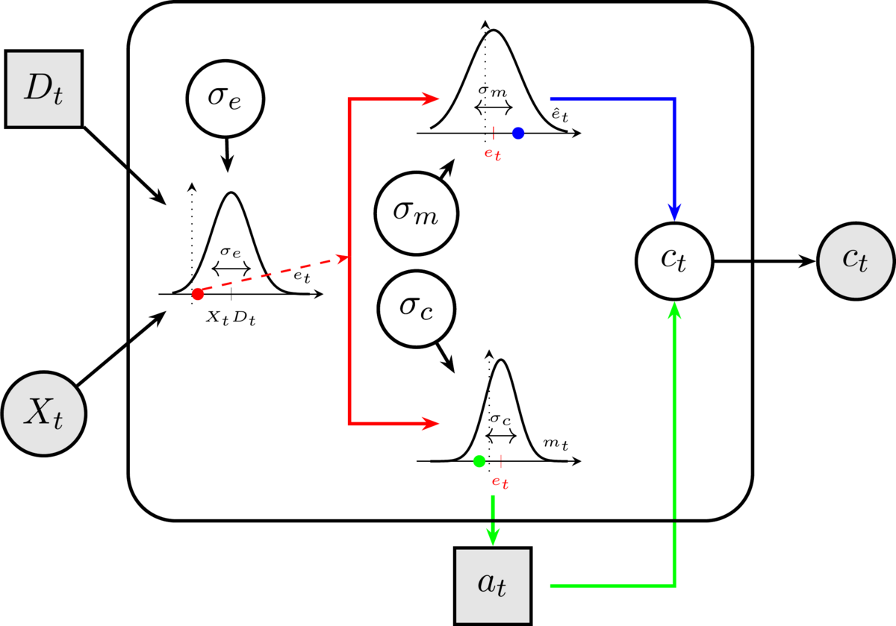
Plate notation of the EC-Meta model
Figure 1; An agent is presented with a stimulus that has a direction $D_{i}$ (the true state of the world) and an intensity $X_{i}$. This creates an internal evidence representation $e_{i}$ (red point), due to noise in the sensory encoding ($σ_{e}$). This internal evidence representation is then sent to the pre-motor and motor cortex where an efferent signal is produced together with an efference copy (red split path). Due to additional noise($σ_{c}$) in the processing and transmission of the signal to limb generating the action, it is possible that the action generated is in the opposite side of what the evidence entailed (green point). The efference copy might also be subjected to additional noise ($σ_{m}$), which is then used together with the action to produce a prediction error in the comparator $C_{t}$. This prediction error is then used to give a confidence ratings $C_{t}$.
Next we demonstrate simulations from this model to provide an intuition for the meaning of the parameters and their interactions.

Simulations
Below we demonstrate that the model reproduces key behavioral patterns of choice and confidence ratings under different parameter combinations. Foreshadowing the results, our simulations show that the ratio $\frac{σ_{e}}{σ_{c}}$ determines the main confidence patterns of folded-X or double increase which relate to error-monitoring.
- A low ratio (high $σ_{c}$ low $σ_{e}$) produces folded-X (strong error-monitoring), while a high ratio (low $σ_{c}$ high $σ_{e}$) produces double-increase (weak or no error-monitoring).
- The metacognitive noise $σ_{m}$ flattens the confidence curves regardless of accuracy.
Note: For all simulations below we assume that the bias in evidence encoding $β$ is 0. We will get back to this, which relates to the assumption of subjects have access to the objective stimulus intensity.
First, we might look at the distribution of internal evidence to the objective signed stimulus (i.e. the product of the stimulus intensity and the true state) across the choice parameters.
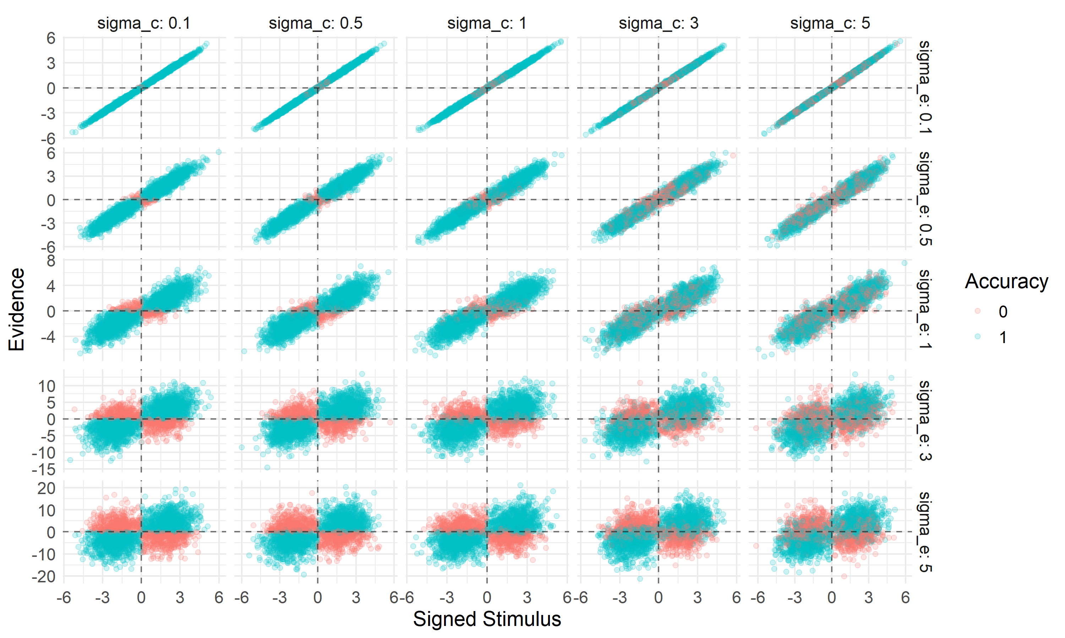
From the above plot we see that $σ_{e}$ scales the the range of evidence observed, moving down the rows the y-axis greatly changes its range. When $σ_{c}$ is low (left column) choices are consistent (when the the evidence is positive and the signed stimulus is positive (i.e. D = 1), a correct response is given). When $σ_{c}$ increases this relationship essentially becomes more noisy, such that correct and incorrect choices are less distinguishable across the evidence = 0 line.
Another way to display this is by plotting the actions instead of the accuracy:
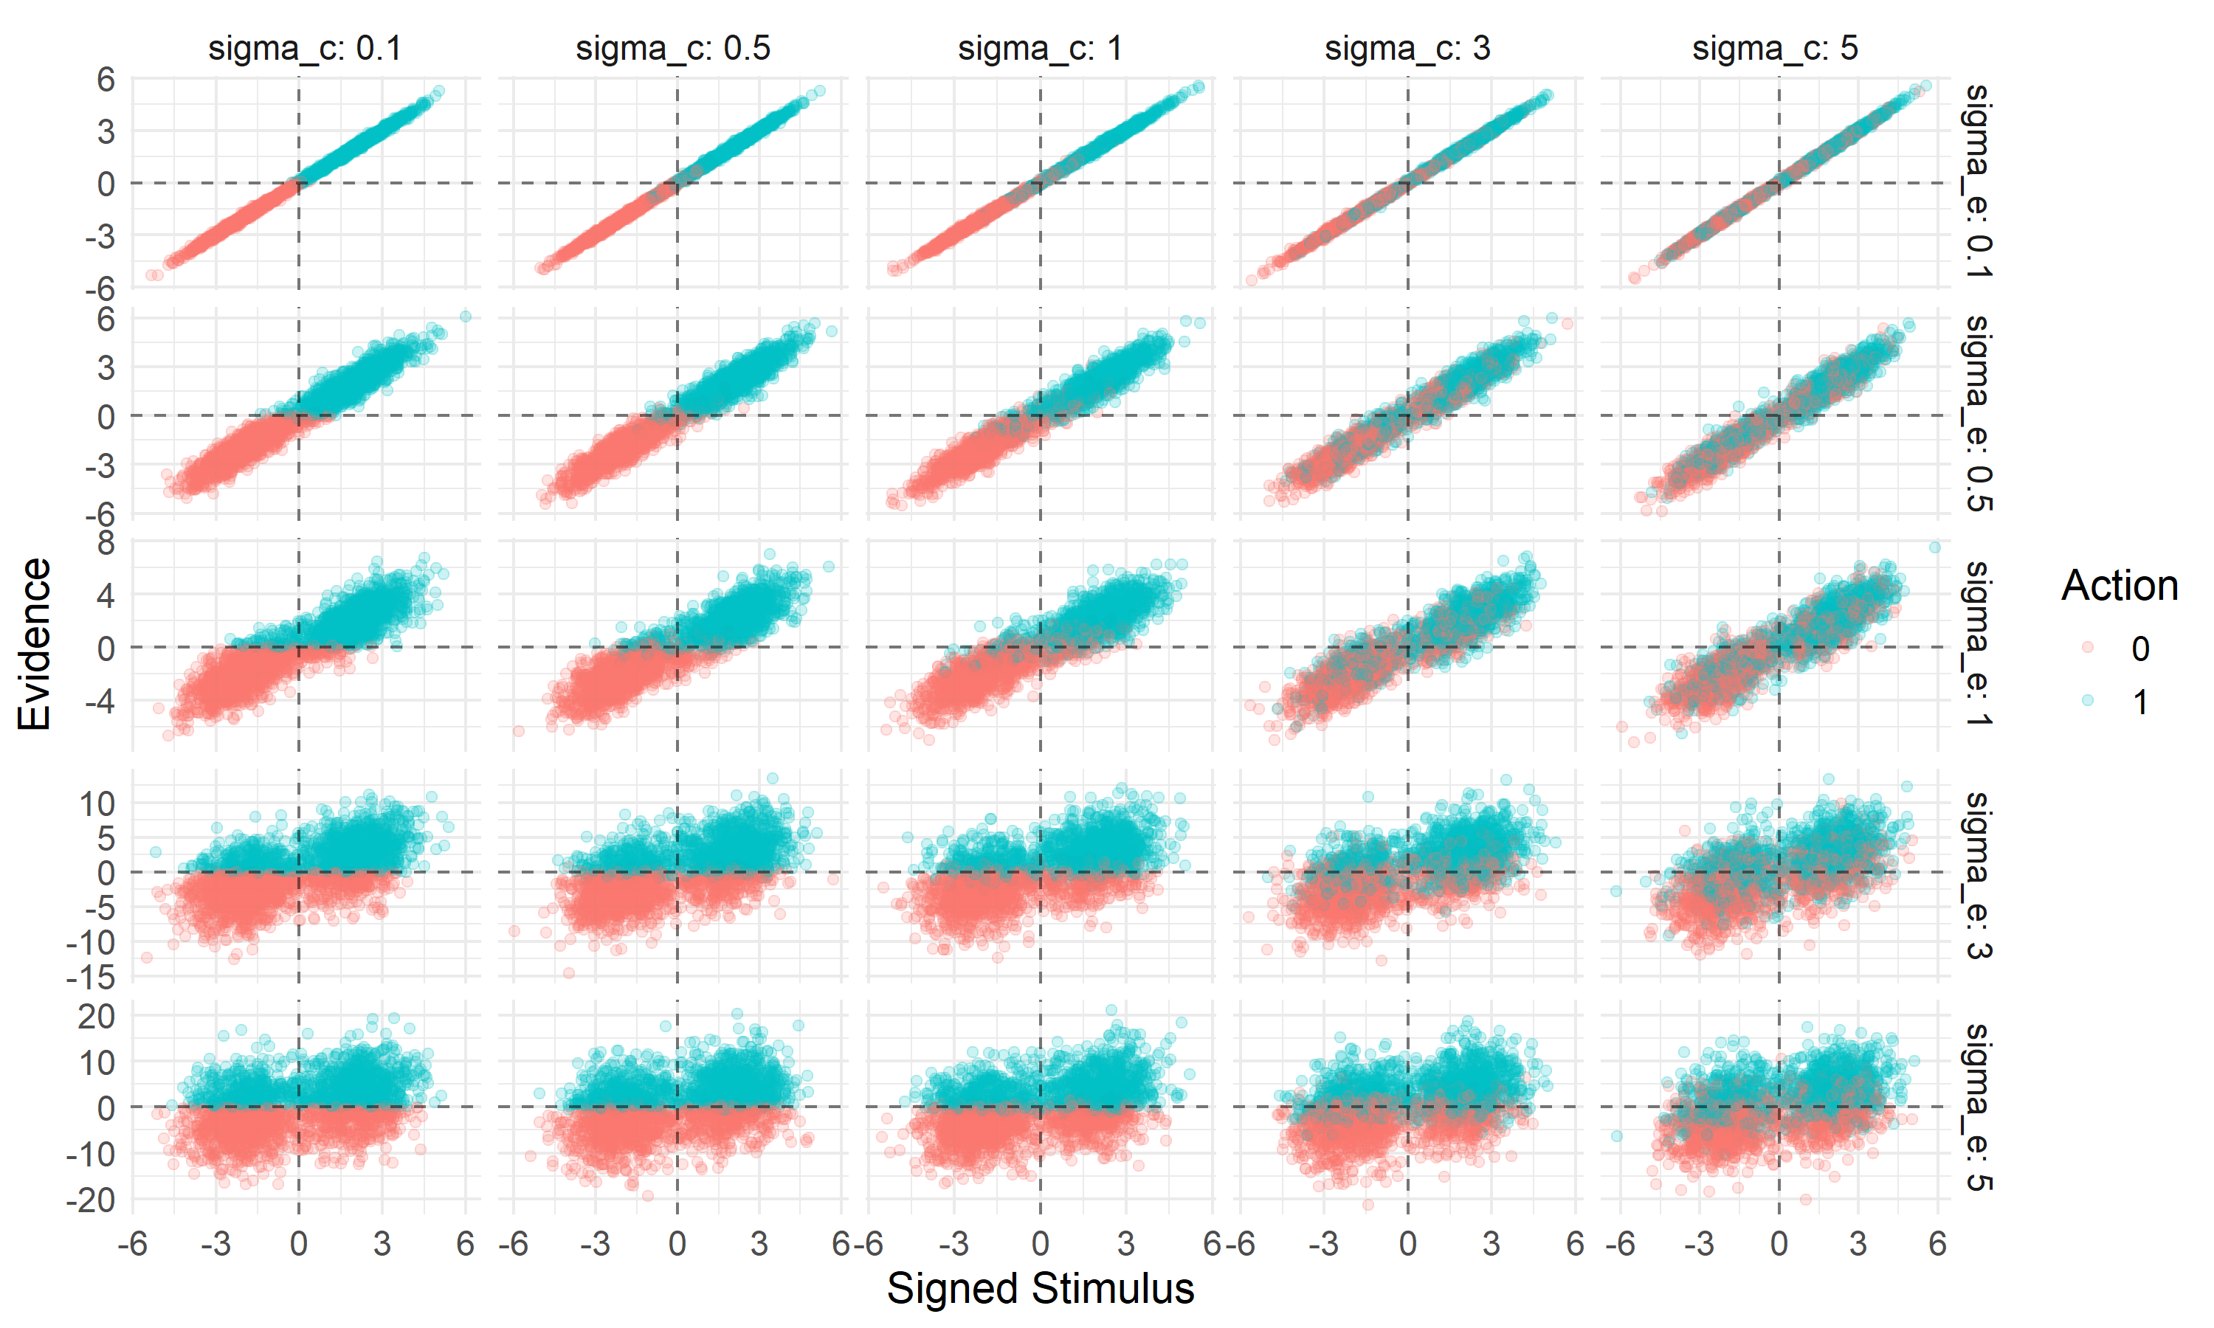 Next we look at the confidence ratings as a function of the three different sigmas.
First we fix $σ_{c}=1$ and then we look at how $σ_{e}$ & $σ_{m}$ change confidence ratings as a function of the signed stimulus strength:
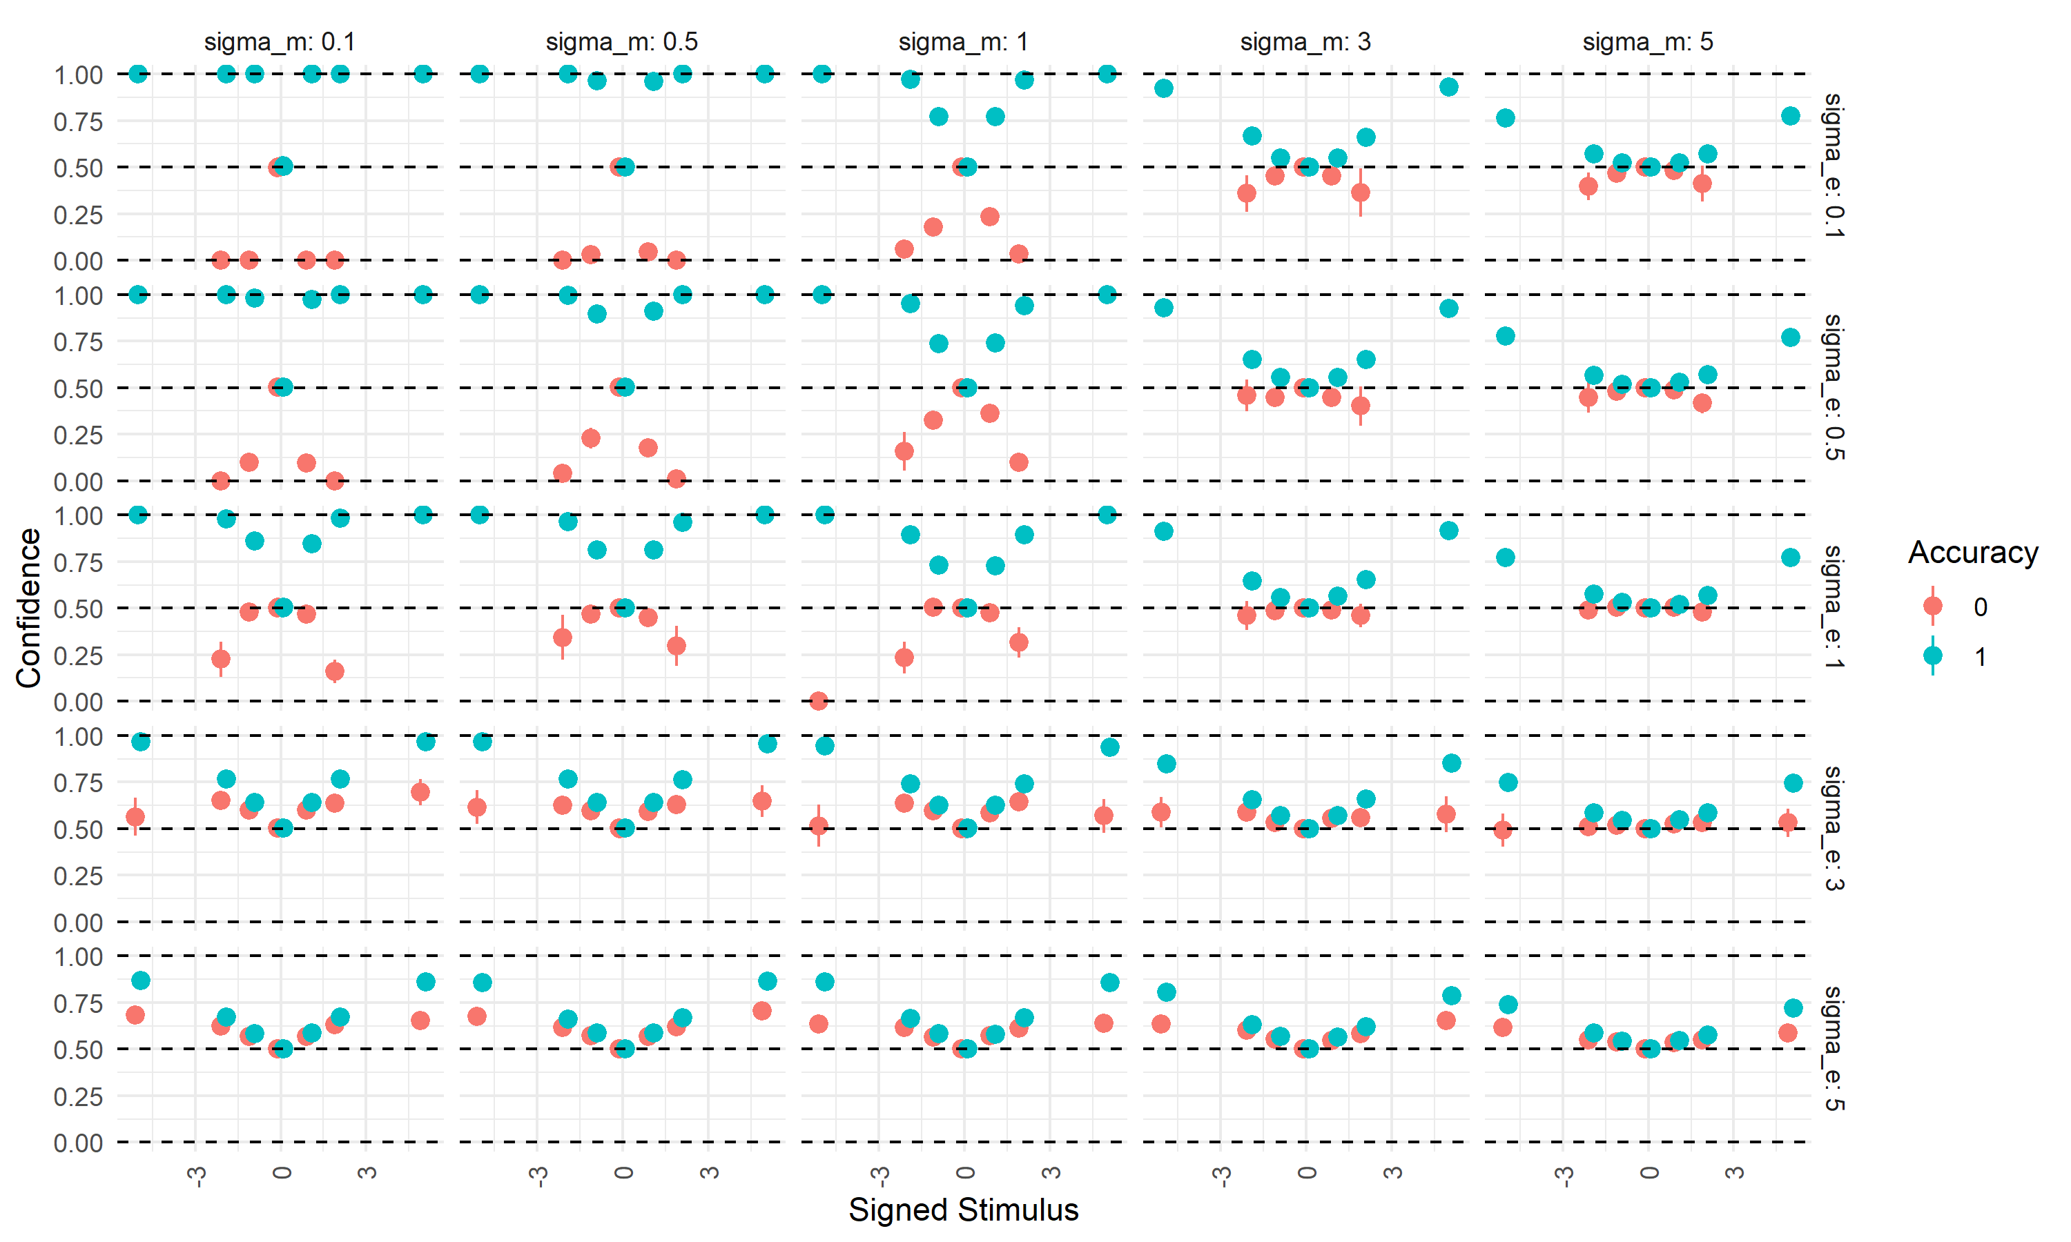
From the above plot we see that when we plot confidence on the Signed Stimulus scale we end up with a double increase pattern when $σ_{e}$ is high. Furthermore, when $σ_{e}$ is low we see a folded X pattern. Lastly, when meta uncertainty ($σ_{m}$) increase both confidence curves becomes increasingly flat (i.e. closer to a flat line at 0.5) regardless of their correctness.
Next we fix $σ_{e}=1$ and then we look at $σ_{c}$ & $σ_{m}$:
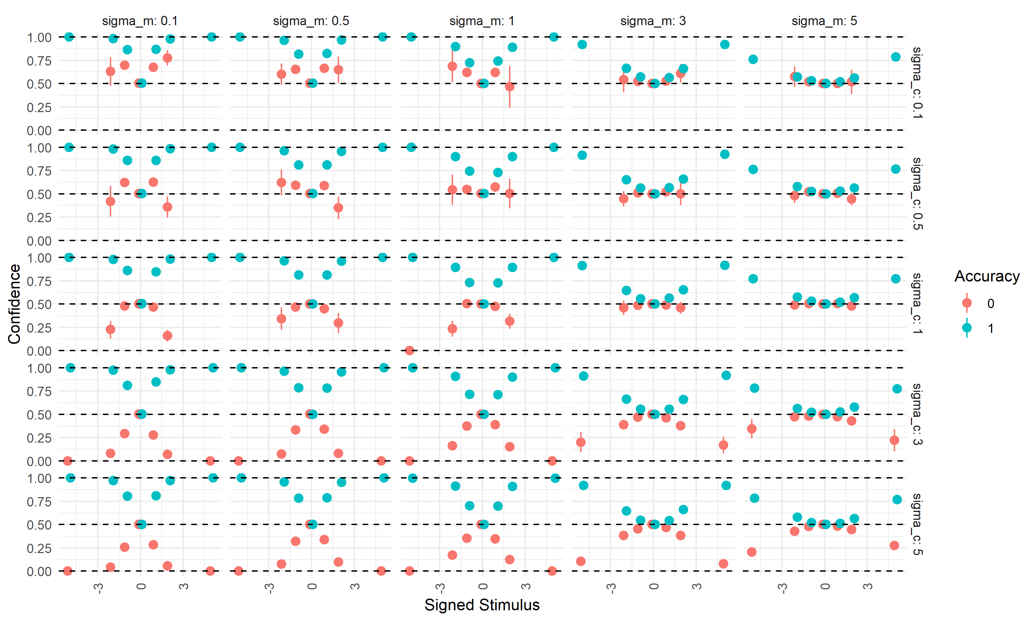
Here we observe a similar patterns as before with $σ_{c}=1$. Here we have that a high $σ_{c}$ reflects a folded X, whereas lower values (especially below 1) make a double increase.
lastly we might plot $σ_{m}=1$
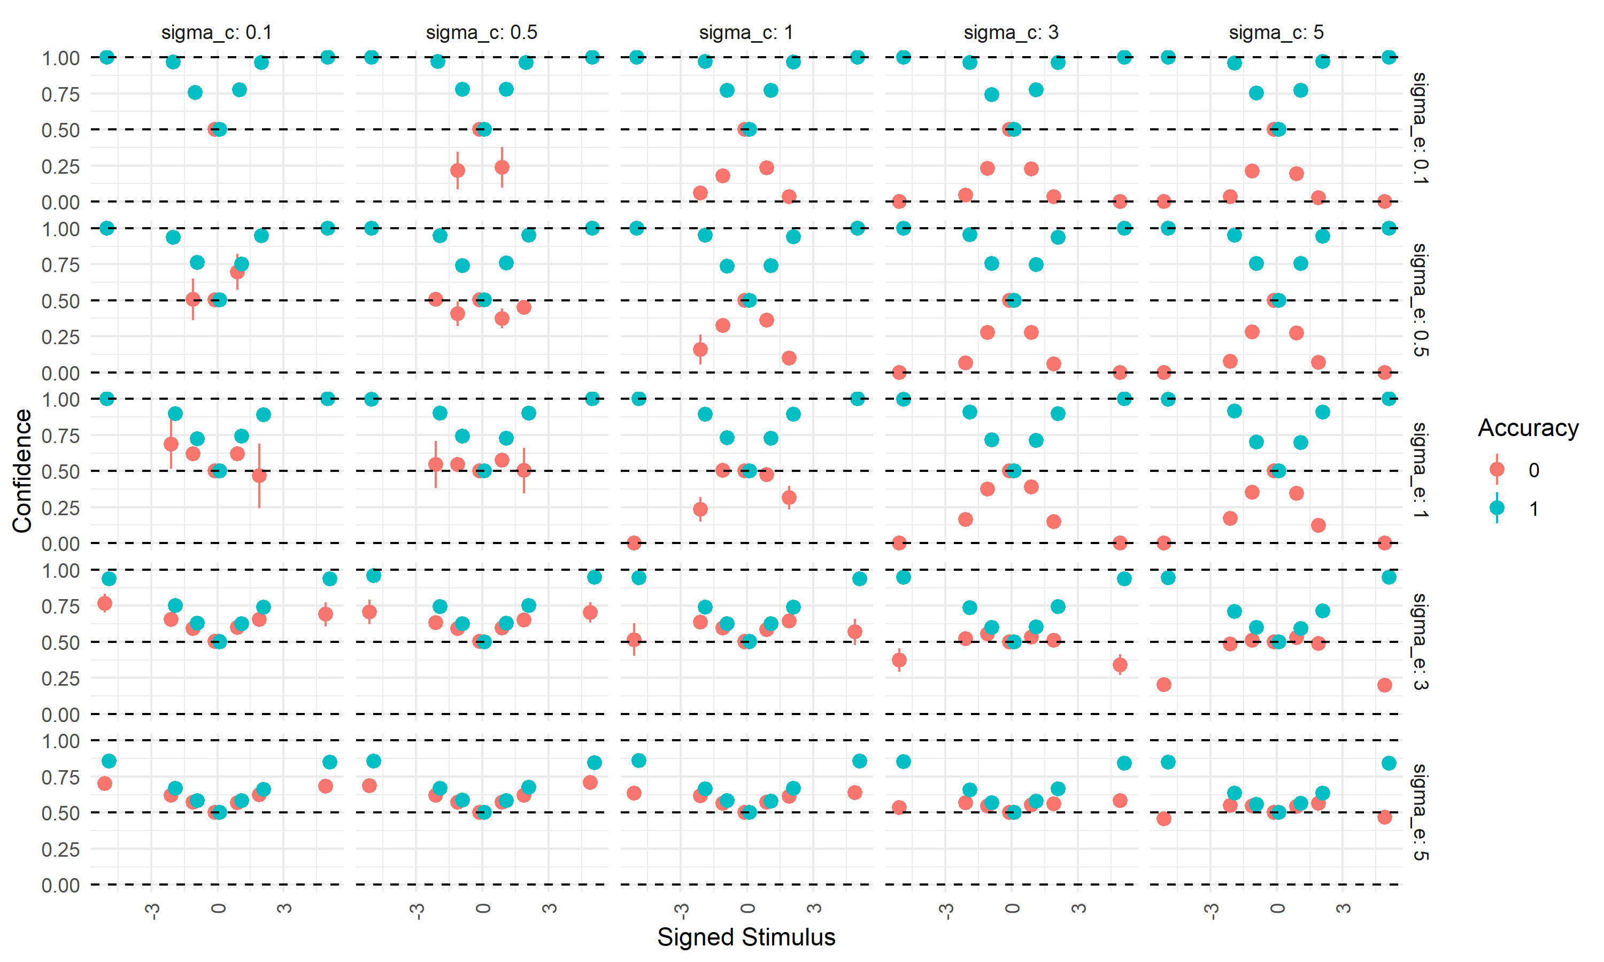 Here we see that when $σ_{e}=σ_{c}$ (the diagonal), there is a mix between a folded X and a double increase pattern, with incorrect trials being close to 0.5 and independent of stimulus strength. Correct trials increase in confidence across all parameter combinations with stimulus strength. Looking at the upper triangle, where $σ_{c}>σ_{e}$ we see folded-X patterns, whereas in the lower triangle ($σ_{c}<σ_{e}$) we see the opposite pattern, double increase patterns.
These simulations show that from the current model’s perspective, the double increase and Folded-X pattern arise due to different ratios of uncertainty in the encoding and choice. When choice variability is high compared to stimulus encoding, a folded X pattern arises whereas choice variability is low compared to stimulus encoding a double increase pattern arises. Meta uncertainty ($σ_{m}$) is agnostic to the accuracy of the rater and when it increases it makes the confidence curves more flat regardless of correctness.

Fitting
We want to fit this model using full Bayesian inference with Stan’s NUTS sampler, treating the latent trial-by-trial evidence as parameters estimated jointly with the subject-by-subject noise parameters. Investigating our pilot data we saw that on a single-subject-level this model was possible to fit with sufficiently good sampler diagnostics. However, trying to fit this model in a hierarchical framework (i.e. drawing subject level parameters from group level parameters), we ran into sampling issues. As the current project is going to use a sequential sampling paradigm, a robust and efficient model is necessary. We therefore build a heuristic model that approximates the model shown above, without the need for estimation of trial-by-trial evidence.

The Heuristic model
While the above model is powerful, its computational complexity (especially in hierarchical settings) motivate a simpler heuristic approximation. The key challenge is that confidence requires trial-specific evidence $r_{i}$, which cannot be marginalized analytically, because the random variable is inside the inverse logit function.
The inverse logit function and the cumulative normal distribution are in practice close to being indistinguishable up to a constant i.e. $g\left(.\right)∼Φ\left(\frac{1}{1.7}\right)$, see plot below:
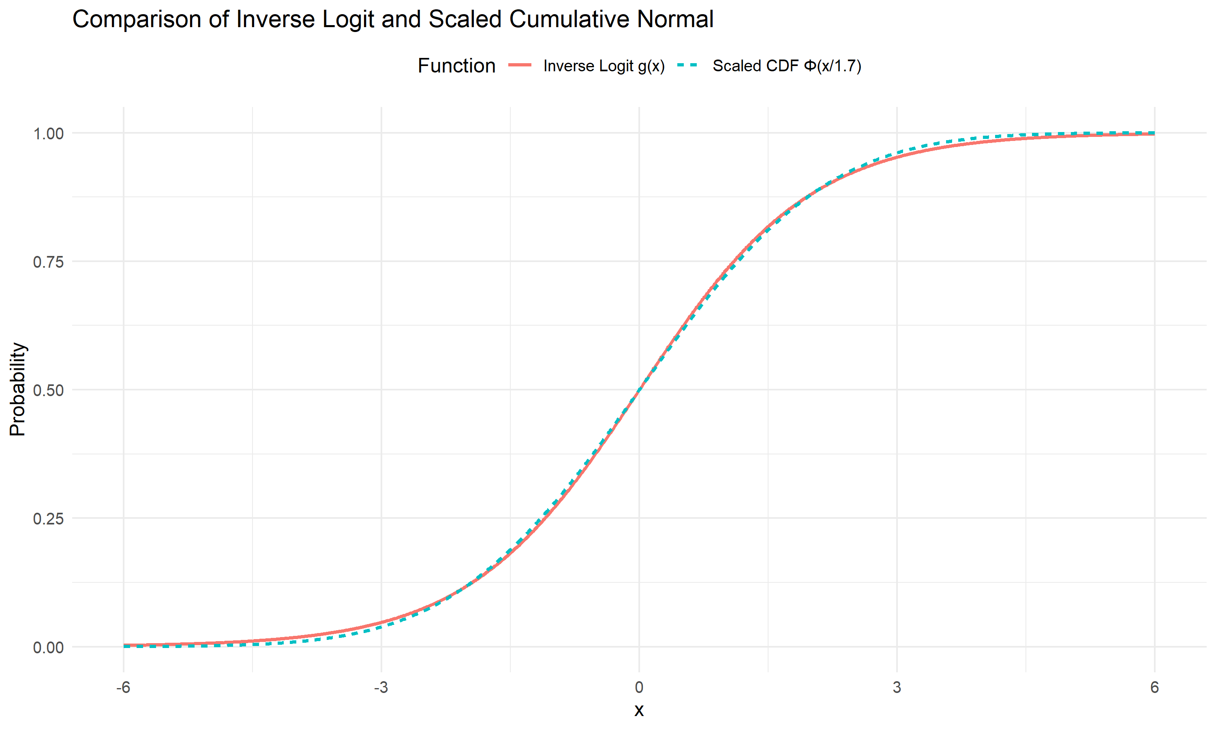
Using this approximation it is possible to marginalize out the trial-by-trial evidence and hereby getting a computationally less expensive model (and an equation for the expectation of confidence) that uses the same parameters.
With this approximation we go from equation (2) to the following:
$$P\left(\text{correct}∣r_{i},a,X_{i}\right)=\left\{\begin{matrix}Φ\left(\frac{C⋅r_{i}⋅X_{i}}{σ_{e}^{2}+σ_{m}^{2}}\right) & \text{if }a=1 \\ 1−Φ\left(\frac{C⋅r_{i}⋅X_{i}}{σ_{e}^{2}+σ_{m}^{2}}\right) & \text{if }a=−1\end{matrix}\right.$$
with $C=\frac{2}{1.7}$.
Focusing on the instance where the choice was one.
$$Φ\left(\frac{C⋅r_{i}⋅X_{i}}{σ_{e}^{2}+σ_{m}^{2}}\right)$$
We want to marginalize over $r_{i}$, meaning that we want to calculate the expectation of above equation, across $r_{i}$.
This is can be done using the general formula for the expectation of a random continuous variable.
$$E\left(X\right)=\int_{−∞}^{∞}{x} p\left(x\right)dx$$
Substituting the variables, with the following $b=\frac{CX_{i}}{σ_{e}^{2}+σ_{m}^{2}}$
$$\int_{−∞}^{∞}{Φ}\left(b⋅r_{i}\right) p\left(r_{i}\right)dr_{i}$$
with $r_{i}∼N\left(μ,σ\right)$
This integral can be shown to have the solution:
$$Φ\left(\frac{μ⋅b}{\sqrt{1+σ^{2}⋅b^{2}}}\right)$$
Given that we have $r_{i}∼N\left(X_{i}D_{i}−β,\sqrt{σ_{m}^{2}+σ_{e}^{2}}\right)$, we get:
$$Φ\left(\frac{E\left(r_{i}\right)⋅b}{\sqrt{1+\left(σ_{e}^{2}+σ_{m}^{2}\right)⋅b^{2}}}\right)$$
Here we write the expectation of $r_{i}$, instead of the mean of the $r_{i}$ distribution ($X_{i}D_{i}−β$), as this will be conditional on the choice (remember we are looking at $a_{i}=1$).
Writing it all out and simplify, we get:
$$Φ\left(\frac{E\left(r_{i}\right)⋅CX_{i}}{σ_{e}^{2}+σ_{m}^{2}}⋅\frac{1}{\sqrt{1+\frac{C^{2}X_{i}^{2}}{σ_{e}^{2}+σ_{m}^{2}}}}\right)$$
This equation thus gives us the probability of being correct, when the choice is 1. Given that the rater knows the choice, we need to get the expectation of meta cognitive evidence ($r_{i}$) conditional on the choice.
Equation (3), therefore now becomes:
$$P\left(\text{correct}∣a,X_{i}\right)=\left\{\begin{matrix}Φ\left(\frac{E\left(r_{i}∣a=1\right)⋅CX_{i}}{σ_{e}^{2}+σ_{m}^{2}}⋅\frac{1}{\sqrt{1+\frac{C^{2}X_{i}^{2}}{σ_{e}^{2}+σ_{m}^{2}}}}\right) & \text{if }a=1 \\ 1−Φ\left(\frac{E\left(r_{i}∣a=−1\right)⋅CX_{i}}{σ_{e}^{2}+σ_{m}^{2}}⋅\frac{1}{\sqrt{1+\frac{C^{2}X_{i}^{2}}{σ_{e}^{2}+σ_{m}^{2}}}}\right) & \text{if }a=−1\end{matrix}\right.$$
The last step is now to calculate the two expectations of $r_{i}$ given the choice i.e. $E\left(r_{i}∣a_{i}=1\right)$ and $E\left(r_{i}∣a_{i}=−1\right)$

Calculating conditional expectations
To calculate these expectations, we need to account for the fact that the choice $a_{i}$ depends on the relationship between the evidence $e_{i}$ and the criterion $c_{i}$, and given that $r_{i}$ is a noisy readout of $e_{i}$ there is a dependency structure.
We have the following relationships:
- Evidence: $e_{i}∼N\left(X_{i}D_{i}−β,σ_{e}\right)$
- Criterion: $c_{i}∼N\left(0,σ_{c}\right)$
- Metacognitive evidence: $r_{i}=e_{i}+ϵ_{m}$ where $ϵ_{m}∼N\left(0,σ_{m}\right)$
- Choice: $a_{i}=1$ if $e_{i}>c_{i}$, otherwise $a_{i}=−1$
we can treat the difference distribution $e_{i}−c_{i}$ as a joint bivariate normal distribution with $r_{i}$ and calculate the expectation of $r_{i}$ given that the $e_{i}−c_{i}$ random variable is above 0 (or equivalently that the choice was 1).
The difference $e_{i}−c_{i}$ follows a Gaussian distribution, as both random variables are Gaussian.
$$\left(e_{i}−c_{i}\right)∼N\left(X_{i}D_{i}−β,\sqrt{σ_{e}^{2}+σ_{c}^{2}}\right)$$
The joint bivariate normal distribution becomes:
$$\left[\begin{matrix}e_{i}−c_{i} \\ r_{i}\end{matrix}\right]∼N\left(\left[\begin{matrix}X_{i}D_{i}−β \\ X_{i}D_{i}−β\end{matrix}\right],\left[\begin{matrix}σ_{e}^{2}+σ_{c}^{2} & σ_{e}^{2} \\ σ_{e}^{2} & σ_{e}^{2}+σ_{m}^{2}\end{matrix}\right]\right)$$
Intuitively this bivariate normal distribution can be argued for by realizing that both distributions of $e_{i}−c_{i}$ and $r_{i}$ share $e_{i}$, with the same mean but are otherwise independent.
The key mathematical insight is that the covariance between $e_{i}−c_{i}$ and $r_{i}$ is $σ_{e}^{2}$ and not zero.
Writing the full covariance and expanding it using this we get:
$$\text{Cov}\left(e_{i}−c_{i},r_{i}\right)=\text{Cov}\left(e_{i}−c_{i},e_{i}+ϵ_{m}\right)$$
$$\text{Cov}\left(e_{i}−c_{i},r_{i}\right)=\text{Cov}\left(e_{i},e_{i}\right)+\text{Cov}\left(e_{i},ϵ_{m}\right)−\text{Cov}\left(c_{i},e_{i}\right)−\text{Cov}\left(c_{i},ϵ_{m}\right)=\text{Cov}\left(e_{i},e_{i}\right)=\text{Var}\left(e\right)=σ_{e}^{2}$$
As $e_{i}$ and $ϵ_{m}$ and also $c_{i}$ are independent, these covariances are 0:
$$\text{Cov}\left(e_{i}−c_{i},r_{i}\right)=\text{Cov}\left(e_{i},e_{i}\right)=\text{Var}\left(e\right)=σ_{e}^{2}$$
This shared variance structure means that $e_{i}−c_{i}$ and $r_{i}$ are correlated with correlation coefficient.
$$ρ=\frac{σ_{e}^{2}}{\sqrt{\left(σ_{e}^{2}+σ_{c}^{2}\right)}⋅\sqrt{\left(σ_{e}^{2}+σ_{m}^{2}\right)}}$$

Truncated normal distributions
To proceed, we need a general result from probability theory. Suppose we have two jointly normal random variables:
$$\left(\begin{matrix}Z \\ Y\end{matrix}\right)∼N\left(\left(\begin{matrix}μ_{Z} \\ μ_{Y}\end{matrix}\right),\left(\begin{matrix}σ_{Z}^{2} & ρσ_{Y}σ_{Z} \\ ρσ_{Y}σ_{Z} & σ_{Y}^{2}\end{matrix}\right)\right)$$
It can be shown that the expectation of Y given Z>0 is:
$$E\left(Y∣Z>0\right)=μ_{Y}+ρ⋅σ_{Y}\frac{ϕ\left(z_{z}\right)}{Φ\left(z_{z}\right)}$$
With $z_{Z}=\frac{μ_{Z}}{σ_{Z}}$
For a full derivation see; Derivation.
Now replacing Y with $r_{i}$ and Z with $e_{i}−c_{i}$ we get:
$$E\left(r_{i}∣\left(e_{i}−c_{i}\right)>0\right)=\left(X_{i}D_{i}−β\right)+ρ⋅\sqrt{σ_{e}^{2}+σ_{m}^{2}}⋅\frac{ϕ\left(z_{z}\right)}{Φ\left(z_{z}\right)}$$
With $z_{z}=\frac{X_{i}D_{i}−β}{\sqrt{σ_{e}^{2}+σ_{c}^{2}}}$
It can then easily be shown using the same steps that when the action is -1 i.e. $\left(e_{i}−c_{i}\right)<0$ this becomes:
$$E\left(r_{i}∣\left(e_{i}−c_{i}\right)>0\right)=\left(X_{i}D_{i}−β\right)−ρ⋅\sqrt{σ_{e}^{2}+σ_{m}^{2}}⋅\frac{ϕ\left(−z_{z}\right)}{Φ\left(−z_{z}\right)}$$
we might define $λ\left(x\right)=\frac{ϕ\left(x\right)}{Φ\left(x\right)}$, which is the inverse Mills ratio giving us:
$$E\left(r_{i}∣a=1\right)=\left(X_{i}D_{i}−β\right)+ρ⋅\sqrt{σ_{e}^{2}+σ_{m}^{2}}⋅λ\left(\frac{X_{i}D_{i}−β}{\sqrt{σ_{e}^{2}+σ_{c}^{2}}}\right)$$
For $a=−1$ (when $e_{i}−c_{i}≤0$):
$$E\left(r_{i}∣a=−1\right)=\left(X_{i}D_{i}−β\right)−ρ⋅\sqrt{σ_{e}^{2}+σ_{m}^{2}}⋅λ\left(−\frac{X_{i}D_{i}−β}{\sqrt{σ_{e}^{2}+σ_{c}^{2}}}\right)$$
Note that $λ\left(−x\right)=\frac{ϕ\left(x\right)}{1−Φ\left(x\right)}$ by properties of the normal distribution.

Final confidence model
Substituting these conditional expectations back into our marginalized confidence equation (4).
$$P\left(\text{correct}∣a=1,X_{i},D_{i}\right)=Φ\left(\frac{\left[\left(X_{i}D_{i}−β\right)+ρ⋅\sqrt{σ_{e}^{2}+σ_{m}^{2}}⋅λ\left(\frac{X_{i}D_{i}−β}{\sqrt{σ_{e}^{2}+σ_{c}^{2}}}\right)\right]⋅CX_{i}}{σ_{e}^{2}+σ_{m}^{2}}⋅\frac{1}{\sqrt{1+\frac{C^{2}X_{i}^{2}}{σ_{e}^{2}+σ_{m}^{2}}}}\right)$$
Simplifying.
$$P\left(correct∣a=1,X_{i},D_{i}\right)=Φ\left(\left[\frac{\left(CX_{i}^{2}D_{i}−CβX_{i}\right)}{σ_{e}^{2}+σ_{m}^{2}}+ρ⋅\frac{λ\left(\frac{X_{i}D_{i}−β}{\sqrt{σ_{e}^{2}+σ_{c}^{2}}}\right)CX_{i}}{\sqrt{σ_{e}^{2}+σ_{m}^{2}}}\right]⋅\frac{1}{\sqrt{1+\frac{C^{2}X_{i}^{2}}{σ_{e}^{2}+σ_{m}^{2}}}}\right)$$
which for a = -1 becomes.
$$P\left(correct∣a=−1,X_{i},D_{i}\right)=Φ\left(\left[\frac{\left(CX_{i}^{2}D_{i}−CβX_{i}\right)}{σ_{e}^{2}+σ_{m}^{2}}−ρ⋅\frac{λ\left(−\frac{X_{i}D_{i}−β}{\sqrt{σ_{e}^{2}+σ_{c}^{2}}}\right)CX_{i}}{\sqrt{σ_{e}^{2}+σ_{m}^{2}}}\right]⋅\frac{1}{\sqrt{1+\frac{C^{2}X_{i}^{2}}{σ_{e}^{2}+σ_{m}^{2}}}}\right)$$
(6a) and (6b) gives us a fully marginalized model for confidence ratings that depends only on the parameters $Θ_{1}=\left(β,σ_{e},σ_{c},σ_{m}\right)$ and the observed data (choices $a_{i}$, stimuli $X_{i}$ and true states $D_{i}$), without requiring trial-by-trial estimation of latent evidence variables $e_{i}$ and $r_{i}$.
Before interpreting on the parts of the terms we need to revert back to one of the key assumptions of this model as was outline just after introducing equation (2). When the subject calculates the subjective probability of being correct it is assumed that the subject has access to the stimulus intensity. Below we show which of the stimulus intensities this is related to (the two $X_{i}$ terms that we highlight):
$$P\left(\text{correct}∣a=1,X_{i},D_{i}\right)=Φ\left(\frac{\left[\left(X_{i}D_{i}−β\right)+ρ⋅\sqrt{σ_{e}^{2}+σ_{m}^{2}}⋅λ\left(\frac{X_{i}D_{i}−β}{\sqrt{σ_{e}^{2}+σ_{c}^{2}}}\right)\right]⋅CX_{i}}{σ_{e}^{2}+σ_{m}^{2}}⋅\frac{1}{\sqrt{1+\frac{C^{2}X_{i}^{2}}{σ_{e}^{2}+σ_{m}^{2}}}}\right)$$
Interestingly these two stimulus intensities (shown in bold), especially the first one (which is not from the marginalization) serves to make sure that at intensity 0 the predicted confidence will always be 0.5. So not only is it a strong assumption that the agent has access to the objective stimulus strength, this assumption does not even hold given the empirical observation that the lowest confidence rating shifts with the psychometric function which we highlighted in the Models and Data Markdown. From the formalization that confidence ratings reflect a noisy, subjective probability of being correct, incorporating response biases, the above formulation falters as there is an objective anchor at $X_{i}=0$.
Due to these consideration, supported by some empirical validation on our pilot data below, we believe that this particular stimulus intensity, coming from an unjustified assumption, needs to be accessed.
One interesting idea of how to deal with this, is to assume that the agent has a noisy readout of the stimulus strength, $\hat{X}∼p\left(\hat{x}|θ,c\right)$. The problem with such formulation is defining the probability distribution of the internal stimulus intensity. This probability distribution needs to be positively bound as $\hat{X}>0$, which introduces an abitrary choice, but more importantly makes is non trivial to marginalize the trial-by-trial readout. Another approach would be to replace this stimulus intensity value with a constant, which could vary across subjects. Such parameterization would serve as a placeholder for idosyncratic differences in how subjects might use the stimulus intensity above and beyond what they should have access to.
Instead of opting for these options, we chose to assume that the agents do not have access to this stimulus intensity and therefore fix it to 1. This approach in its simplicity circumvents some of the troublesome computational aspects, as well as obeying to what the agents is assumed to have access to. This also importantly this makes it possible for the model to accommodate the empirical observation that the confidence curve follows the psychometric function of the binary choices.
This means that the final equations become
$$P\left(\text{correct}∣a=1,X_{i},D_{i}\right)=Φ\left(\left[\frac{\left(CX_{i}D_{i}−Cβ\right)}{σ_{e}^{2}+σ_{m}^{2}}+ρ⋅\frac{λ\left(\frac{X_{i}D_{i}−β}{\sqrt{σ_{e}^{2}+σ_{c}^{2}}}\right)C}{\sqrt{σ_{e}^{2}+σ_{m}^{2}}}\right]⋅\frac{1}{\sqrt{1+\frac{C^{2}}{σ_{e}^{2}+σ_{m}^{2}}}}\right)$$
which for the other choice becomes:
$$P\left(\text{correct}∣a=−1,X_{i},D_{i}\right)=Φ\left(\left[\frac{\left(CX_{i}D_{i}−Cβ\right)}{σ_{e}^{2}+σ_{m}^{2}}−ρ⋅\frac{λ\left(−\frac{X_{i}D_{i}−β}{\sqrt{σ_{e}^{2}+σ_{c}^{2}}}\right)C}{\sqrt{σ_{e}^{2}+σ_{m}^{2}}}\right]⋅\frac{1}{\sqrt{1+\frac{C^{2}}{σ_{e}^{2}+σ_{m}^{2}}}}\right)$$
with:
$$\begin{matrix}λ\left(x\right) & =\frac{ϕ\left(x\right)}{Φ\left(x\right)} \\ C & =\frac{2}{1.7}\end{matrix}$$
In the above formula it is noteworthy that the terms inside the cumulative normal distribution function have clear interpretations.
Firstly the common factor, is a correction factor for marginalization. thus we define:
$$K_{i}=\frac{1}{\sqrt{1+\frac{C^{2}}{σ_{e}^{2}+σ_{m}^{2}}}}$$
The two other terms can be thought to have more cognitive interpretations. Looking back at equation 3 we had (now with $X_{i}=1$)
$$P\left(\text{correct}∣r_{i},a,X_{i}\right)=\left\{\begin{matrix}Φ\left(\frac{C⋅r_{i}}{σ_{e}^{2}+σ_{m}^{2}}\right) & \text{if }a=1 \\ 1−Φ\left(\frac{C⋅r_{i}}{σ_{e}^{2}+σ_{m}^{2}}\right) & \text{if }a=−1\end{matrix}\right.$$
One can observe that the first term from equation (7a / 7b) is just the expectation of the argument to the cumulative normal distribution function in equation (3). This argument, from the derivation is the log-likelihood ratio, can be interpreted as the average strength of evidence in favor of the true state. We might call this is I;
$$I_{i}=E\left(\frac{C⋅r_{i}}{σ_{e}^{2}+σ_{m}^{2}}\right)=\frac{\left(CX_{i}D_{i}−Cβ\right)}{σ_{e}^{2}+σ_{m}^{2}}$$
The latter term in equation (7a / 7b) adjusts this average evidence strength, because of the information contained by the action selected:
$$S_{i}=−ρ⋅\frac{λ\left(−\frac{X_{i}D_{i}−β}{\sqrt{σ_{e}^{2}+σ_{c}^{2}}}\right)C}{\sqrt{σ_{e}^{2}+σ_{m}^{2}}}$$
This term serves the purpose of changing the mean expectation of the confidence to incorporate the information of the action. The addition of actions into the confidence computation have been proposed in the second order rater model from Fleming and Daw, where they also re-analyzed data to show this pattern empirically (Stephen M. Fleming and Daw 2017). To summarize, confidence computation can in this model be thought of as a weighting of the expected normalized evidence with a correction factor for having committed to a choice. Below we introduce a couple of additional parameters in order to encompass idiosyncrasies in the task and participants, as well as probabilistic relate the above formulation to the observed confidence ratings.

Additional parameters
We introduce 5 additional parameters. $Θ_{2}=\left(κ_{c},λ,μ_{β}\right)$.
- $λ$ is the lapse rate on the binary choices this is a stimulus independent factor that shifts the asympote of the psychometric function away from certainty i.e. the asymptotic becomes $λ$ and $1−λ$.
- $μ_{β}$ is a meta cognitive bias parameter, serving as an independent vertical shift of confidence ratings.
- $κ_{c}$ is the precision of the ordered beta likelihood.
- Lastly $c_{0},c_{1}$ reflects the two cutpoints for the ordered beta likelihood. These two parameters help generalize the beta-distribution to outcomes that contain 0 and 1 ratings.
See (Kubinec 2023) for the ordered beta likelihood.
The complete set of parameters for the model are:
$$\begin{matrix}Θ_{s} & =\left[\begin{matrix}β_{s} \\ σ_{e_{s}} \\ σ_{c_{s}} \\ σ_{m_{s}} \\ μ_{β_{s}} \\ κ_{c_{s}} \\ λ_{s}\end{matrix}\right]∼N\left(μ_{Θ},Σ_{Θ}\right) \\ \text{where } & β_{s}∈\left[−1,1\right],σ_{e_{s}}>0,σ_{c_{s}}>0,σ_{m_{s}}>0, \\ & μ_{β_{s}}∈R,κ_{c_{s}}>0,λ_{s}∈\left[0,0.5\right] \\ & \left(c_{1_{s}},c_{0_{s}}\right)∼δ\left(\left[1,10,1\right]\right)\end{matrix}$$
In the above formulation that $N$ is a multivariate normal distribution with mean and covariance. Further all constraints on the parameters as written were accomplished by transformation, all positively constrained parameters were exponentiated, parameters with an upper and lower bound were transformed with the inverse logit function and multiplied appropriately. The constraint of the cut-points were applied by the prior of a Dirichlet distribution ($δ\left(\right)$). Note, the cutpoints are sampled on a subject-by-subject basis.
The full model becomes.
$$\begin{matrix}P\left(a=1\right) & =Φ\left(\frac{D_{i}⋅X_{i}−β_{s}}{\sqrt{σ_{e_{s}}^{2}+σ_{c_{s}}^{2}}}\right) \\ μ_{c_{i}} & =\left\{\begin{matrix}Φ\left(\left(I_{i}−S_{i}\right)⋅C_{i}\right) & \text{if }a_{i}=1 \\ 1−Φ\left(\left(I_{i}+S_{i}\right)⋅C_{i}\right) & \text{if }a_{i}=−1\end{matrix}\right. \\ a_{i} & ∼bernoulli\left(p\left(a_{i}=1\right)\right) \\ Conf_{i} & ∼ordβ\left(μ_{c_{i}},κ_{c_{s}},c_{0_{s}},c_{1_{s}}\right)\end{matrix}$$
with
$$I_{i}=\frac{\left(CX_{i}D_{i}−Cβ\right)}{σ_{e_{s}}^{2}+σ_{m_{s}}^{2}}, S_{i}=−ρ_{s}⋅\frac{λ\left(−\frac{X_{i}D_{i}−β_{s}}{\sqrt{σ_{e_{s}}^{2}+σ_{c_{s}}^{2}}}\right)C}{\sqrt{σ_{e_{s}}^{2}+σ_{m_{s}}^{2}}}, K_{i}=\frac{1}{\sqrt{1+\frac{C^{2}}{σ_{e_{s}}^{2}+σ_{m_{s}}^{2}}}}$$
Next we show verification of the above formulated marginalized heuristic model, by simulating data from from equation (2) (with $X_{i}=1$) averaging across the signed stimulus axis and displaying for the same parameter estimates (i.e. $Θ_{1}$) of the marginalized heuristic model.
The In the first validation step we simulate from different combinations of noise parameters (facets).
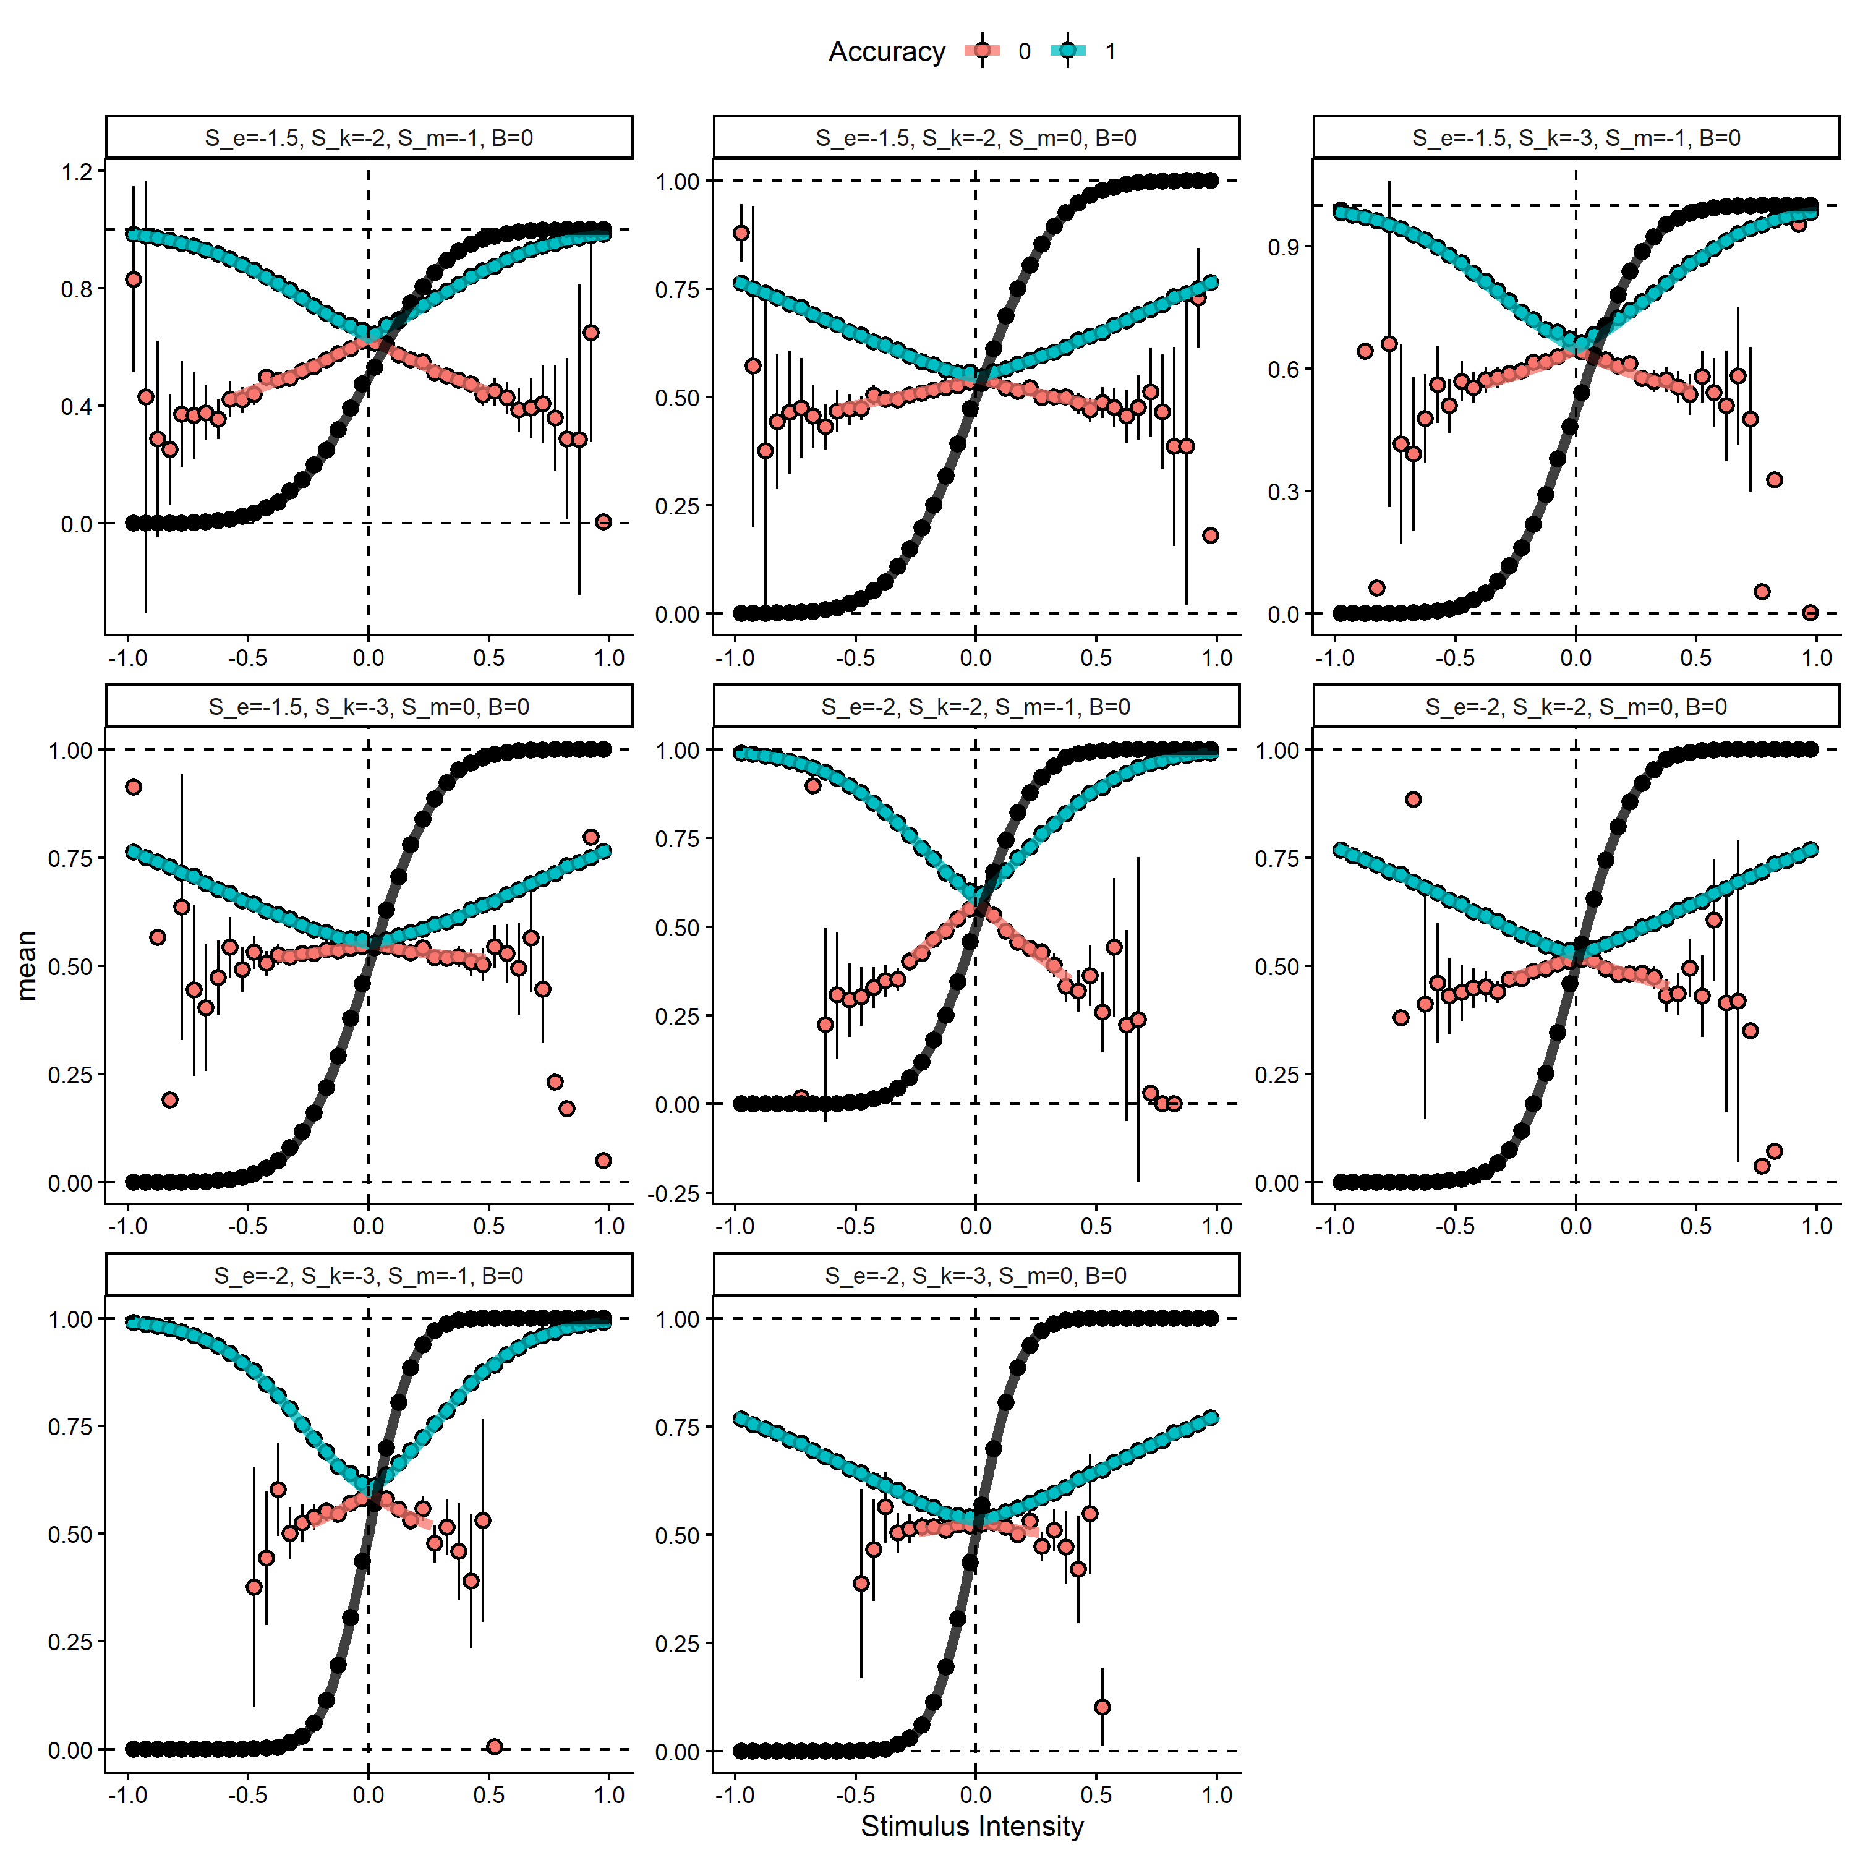
In the above plot we see the results from averring 5^{5} simulated trials from equation (2), for each bin of the signed stimulus intensity scale (dots are mean and approximate 95 Interval). The thick solid lines represents the marginalized heuristic model predictions.
Next we simulate using fixed noise parameters and change the bias $β$. Note, that now we are displaying the action and not the accuracy of the choice.
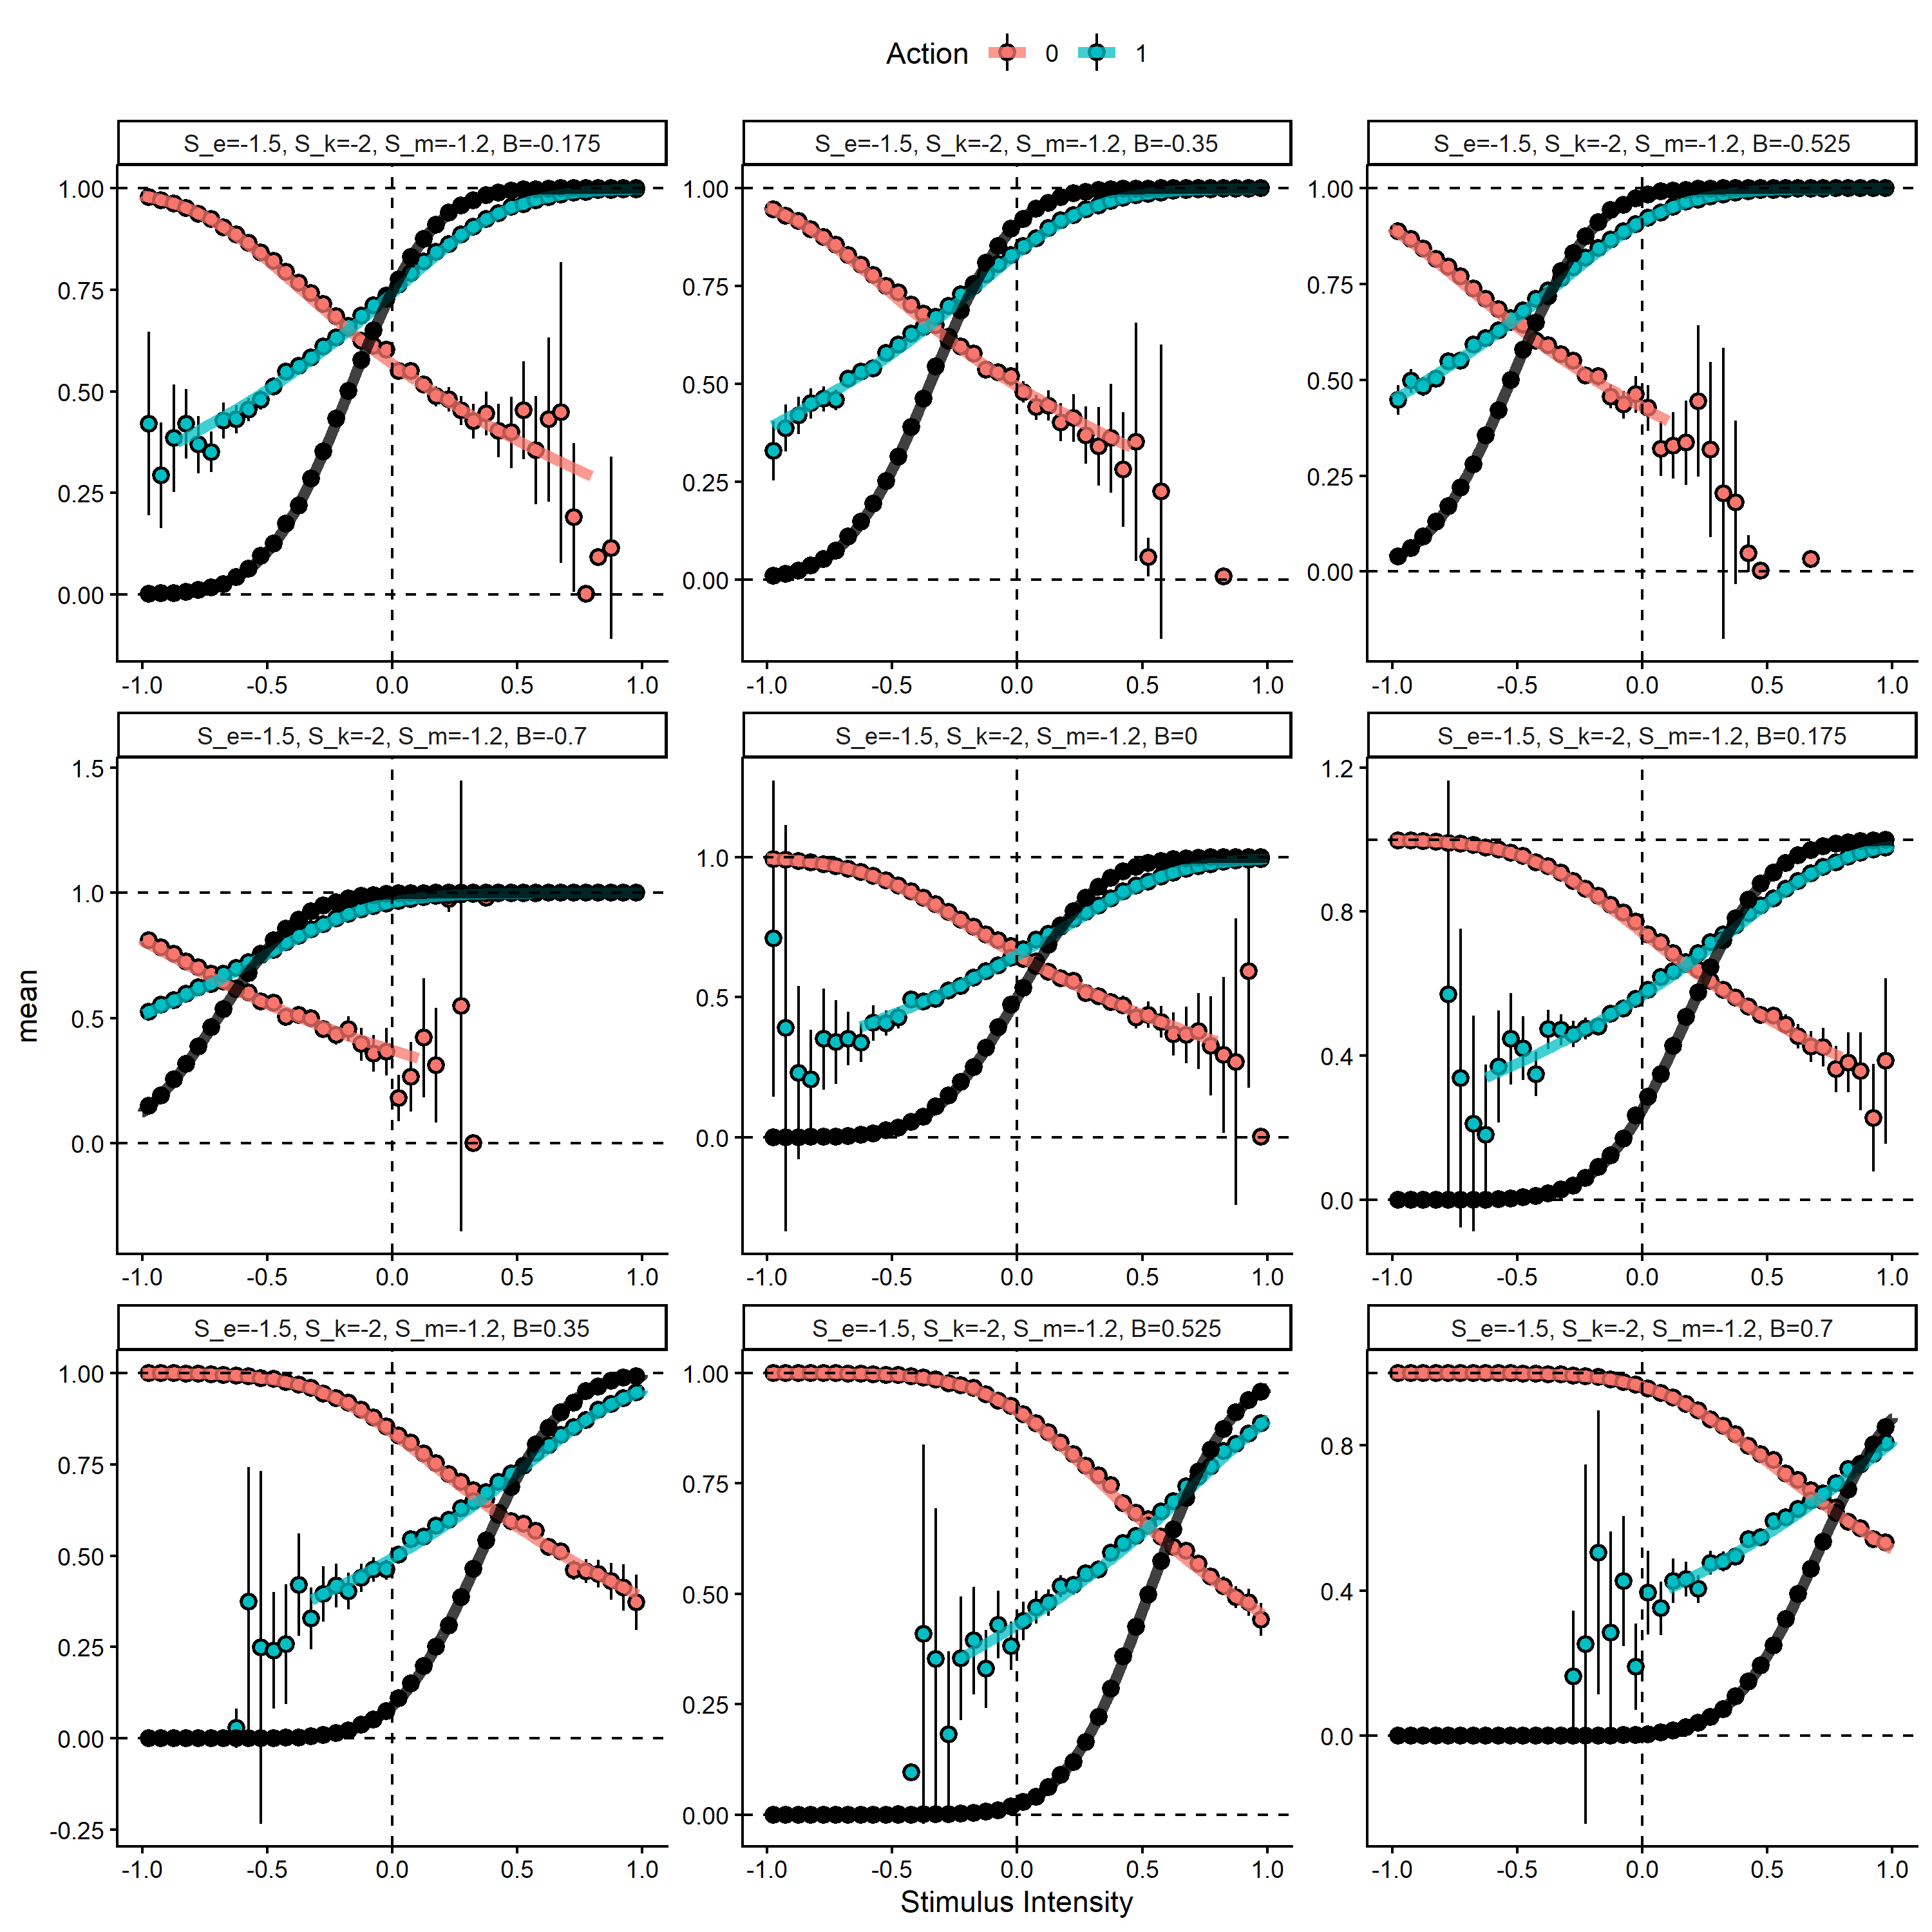
In the above plot we see the results from averring 5^{5} simulated trials from equation (2), for each bin of the signed stimulus intensity scale (dots are mean and approximate 95 Interval). The thick solid lines represents the marginalized heuristic model predictions.
Next, we demonstrate parameter recovery simulating from equation (2) (with $X_{i}=1$) and fitting with the heuristic model derived above.
Lastly, we fit this model to our pilot data hierarchically and compare to the single subject estimated from equation (2).

Model comparison
As a sanity check on the assumption of $X_{i}=1$, we fitted both hierarchical models to our pilot data and computed approximate leave one out cross-validation, to test if the assumption could be justified. This comparison showed that the two models were essentially indistinguishable with the difference in expected log probability density being -1.58 $±$ 9.9, where generally it is thought that a difference below -4 and or more than two standard errors can be considered as evidence for one model over the other (REF), thus atleast for our pilot data for predictive performance there seems to be no difference. Digging further into the distinction between these two models we below plot all pairwise parameters together with the identity line.
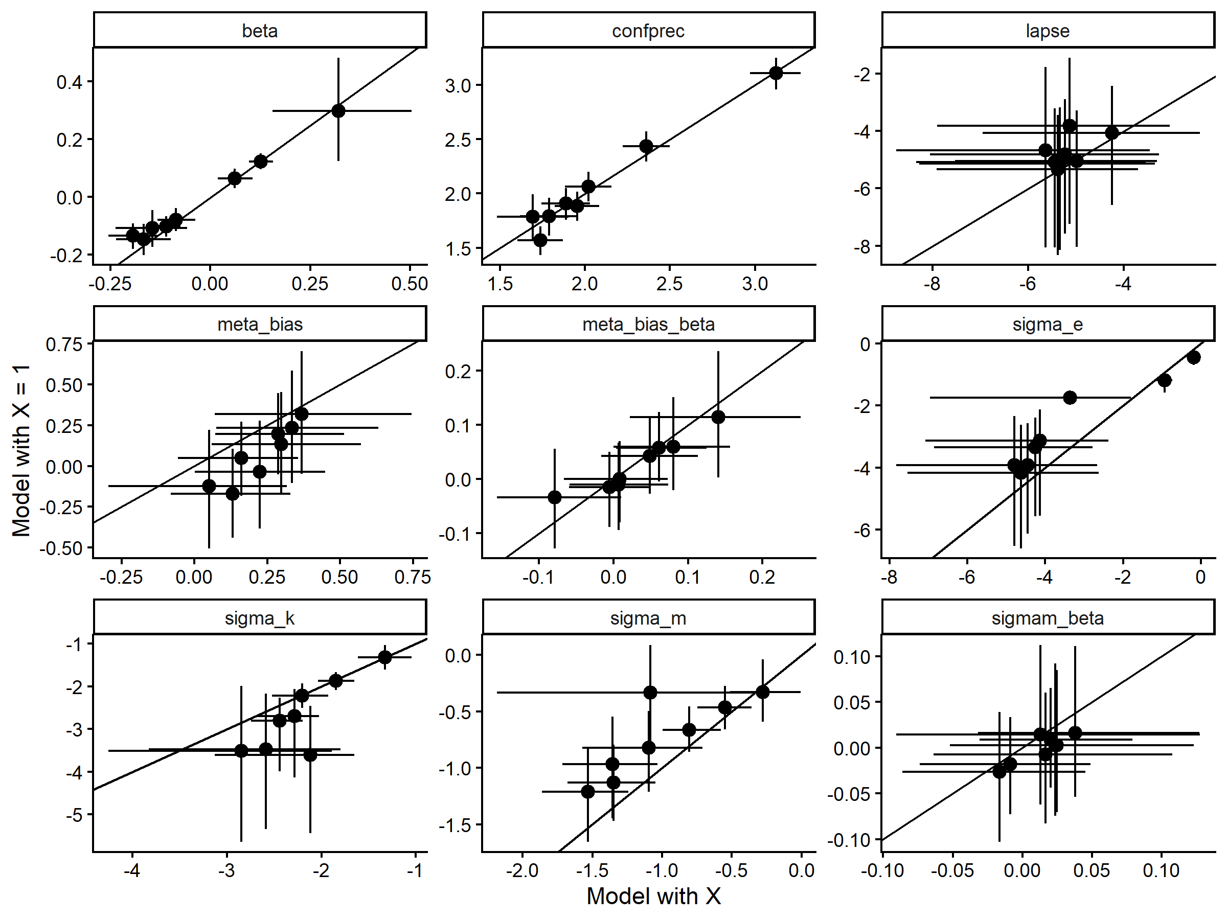
Generally the two models align well in their subject level parameter estimates, further justifying this simplification which makes theoretical sense.
Next we show predictive checks of the Hierarchical Heurestic model for our pilot participants.
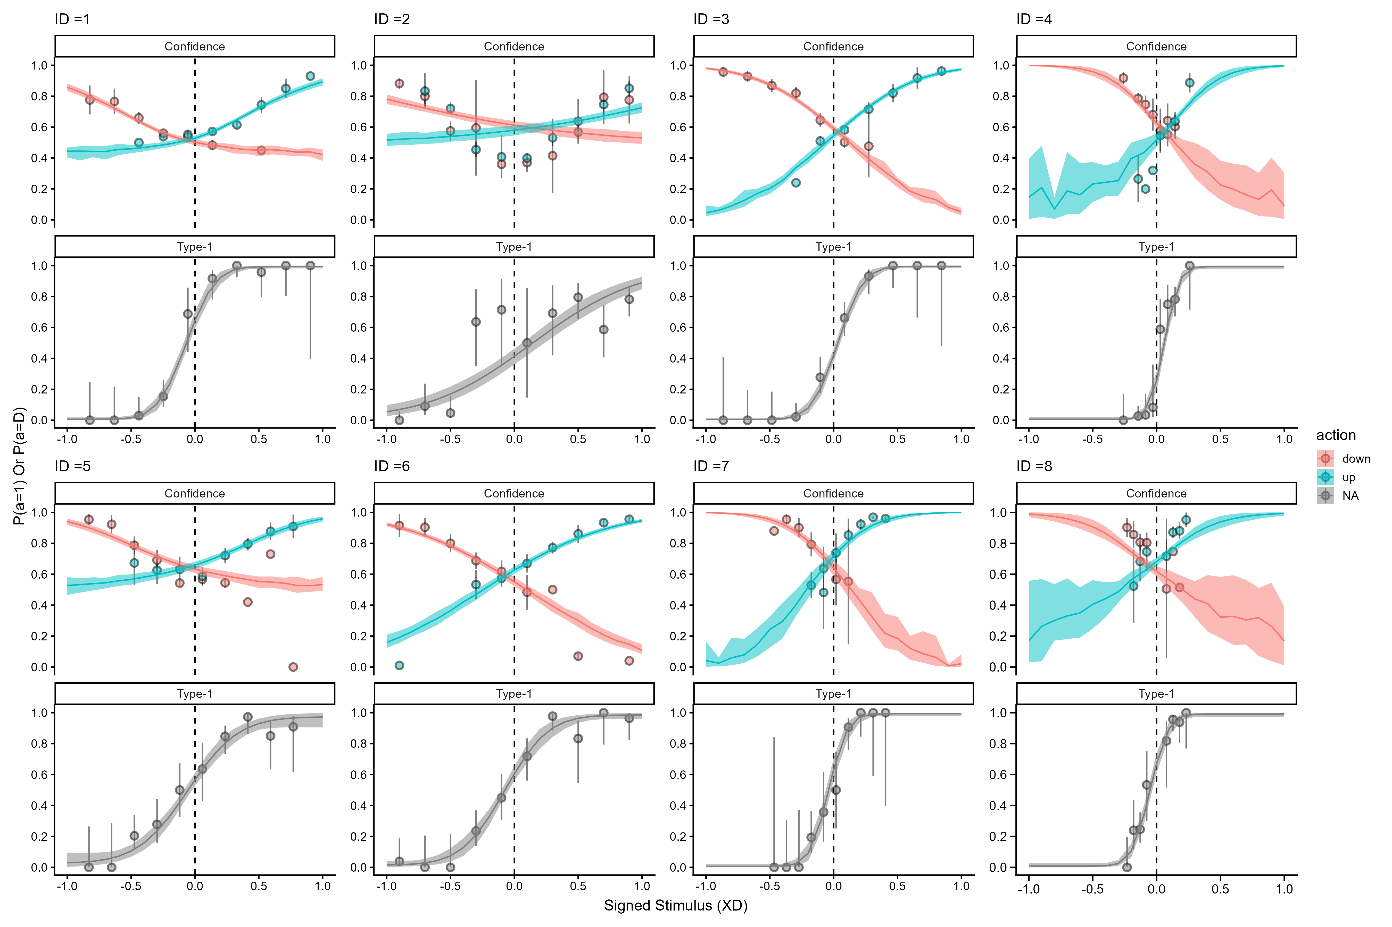

Hierarchical parameter recovery
To further robustness check our implementation of the model as well as the planned sequential sampling, we simulated new subjects from the posterior distribution of the hierarchical model. We did this by extracting a draw from the posterior and then simulating 25 subjects from this draw. We then fitted the model to increasing steps (i.e. 5,7,9, 12,15,20,25) of subjects, to demonstrate that the sequential sampling approach would be feasible. This also allowed us to do parameter recovery on the hierarchical model without additional computational resources. Below we showcase that the model can to an adequate degree recover its parameters on a subject and group level for parameters of interest.
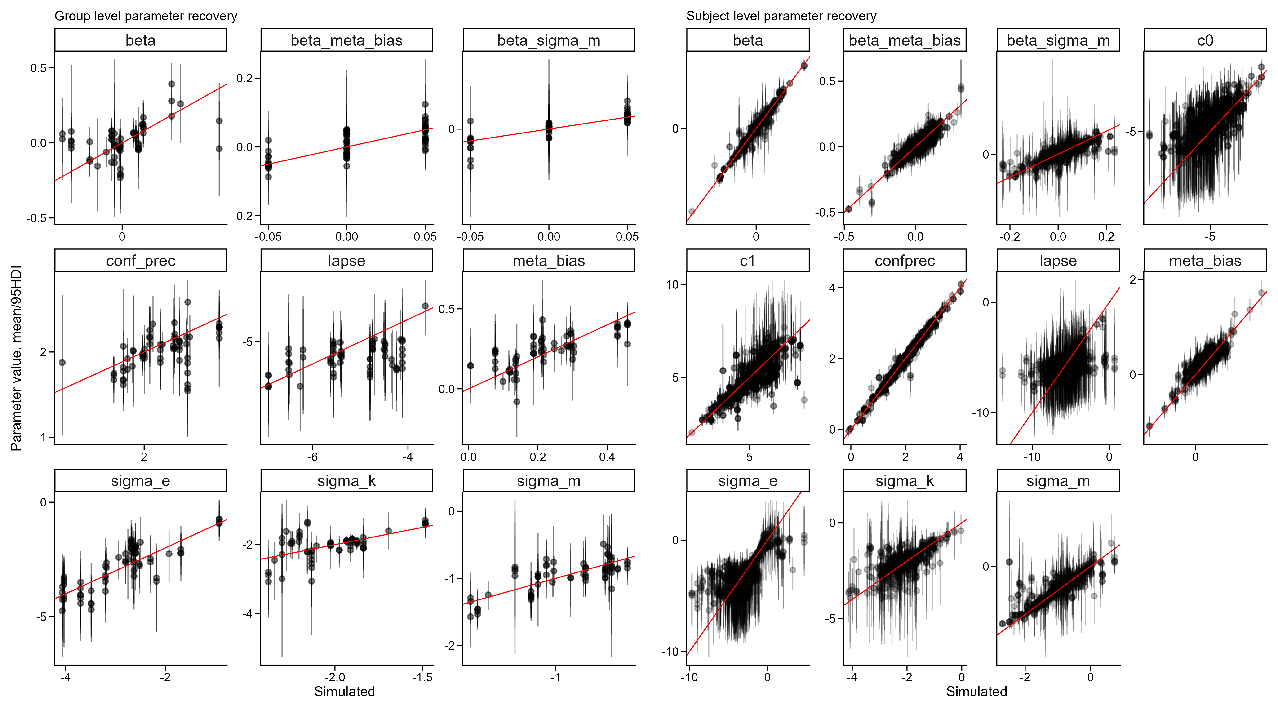

Part 3: Design, Methods, and Hypotheses

Experimental study
The current study examines motion discrimination and meta-cognition in a Random Dot Motion (RDM) task. Specifically, we are interested in the question of whether post-decisional timing influences meta-cognitive uncertainty. We conceptualize this as whether confidence ratings follow the probability of being correct more closely when subjects are forced to wait longer before giving their confidence ratings, compared to when they can respond directly.
Dynamic models of meta-cognition assume that evidence is accumulated until a response boundary is reached and a binary decision is initialized. After the binary choice is given, additional evidence is assumed to be accumulated (i.e. post-decisionally) in order to give a confidence rating to the binary choice. If this post-decisional evidence accumulation is informative about the correctness of the choice, one would expect that increasing waiting time should increase the quality of the confidence ratings (i.e. confidence ratings would be closer to the objective probability that the choice was correct). However, if evidence used for the confidence rating is already computed around the time of the decision (i.e. pre-decisional) one would expect there to be no-difference or even expect the opposite effect. The reverse effect would indicate a situation where there exists some leakage of the information (perhaps due to memory constraints). In this study we manipulate the post decisional time window to examine its effects on the quality of the confidence ratings.
Previous studies investigating post decisional evidence accumulation have generally found that if post-decisional evidence accumulation exists it is easiest to detect in speed binary decision making tasks for easy trials, where increased post-decisional timing can decrease confidence ratings for incorrect choices. In this first study we set out to test the opposite case, a non-speeded perceptual decision making task with a range of trials from very easy to very hard (individually calibrated). As the evidence is not clear and we do not nessecarily expect to find a significant difference in how post-decisional timing changes meta-cognitive uncertainty, we set out to test this in a Bayesian framework using sequential sampling. This not only let us provide evidence for the NULL-hypothesis (post-decisional time does not change the quality of the confidence ratings), but also allows us to collect as many participants as strictly needed to provide sufficient evidence.

Hypotheses
- Hypothesis 1: Increasing the post-decisional time window will lead to no improvement or deterioration in the relationship between confidence and accuracy.
  - Test specification:
This hypothesis is tested by allowing the $σ_{m}$ parameter to vary by the trial-by-trial post-decisional time window. As this is the main parameter of interest, we will sequentially test whether this parameter has reached a a Bayesfator of either 30 or 1/30, which is our termination criteria.
- Hypothesis 2: Increasing the post-decisional time window will lead to no difference in confidence bias.
  - Test specification:
This hypothesis is tested by allowing the $μ_{β}$ parameter to vary by the post-decisional time window. The primary test evaluates whether the group-level parameter differs from 0 (i.e. does the 95 Highest density interval include 0), here we also aim to report the bayesfactor to determine the strength of the evidence compared to the NULL (i.e. there is no difference). This test will be conducted when the data collection has been terminated.

Priors and Sequential Sampling.
To limit the number of subjects needed to get sufficient evidence for our inference we will conduct a sequential sampling paradigm. Here we choose to terminate recruitment when the above explained Bayesfactor reaches either 30 or 1/30, or we have collected 50 subjects. We will start examining the Bayesfactors in increments of 5 subjects when we have reached 15 total subjects. This is mainly due to stability of the model estimation, as well as expecting to test around 5 subjects per day.

Priors
As our sequential sampling approach uses bayesfactors for the termination of data collection, the prior distribution of this parameter is highly influential. To maximize transparency we visualize the curves that we allow given the prior below.
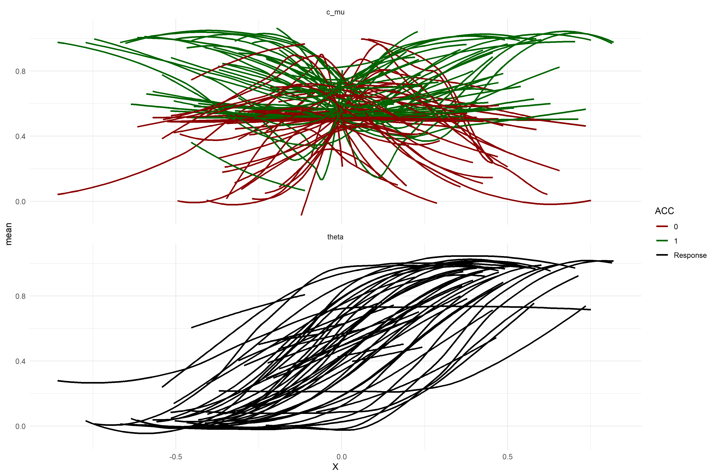
The plot above shows the prior predictive checks of the group level parameters (i.e. these curves represent group level curves). As can be seen the curves generally span everything. Now in order to test whether our sequential sampling approach works we simulate data from draws of the posterior distribution of our pilot data, we then investigate how the bayesfactors of both hypotheses outlined above evolve over time. Instead of drawing the parameters of interest we fix these to either -0.05, 0 or 0.05 to test that we can detect effects of this magnitude in both direction, but also terminate sampling if there is no effect. Below we display the size of these effects (simulated data from the mean of the group means).
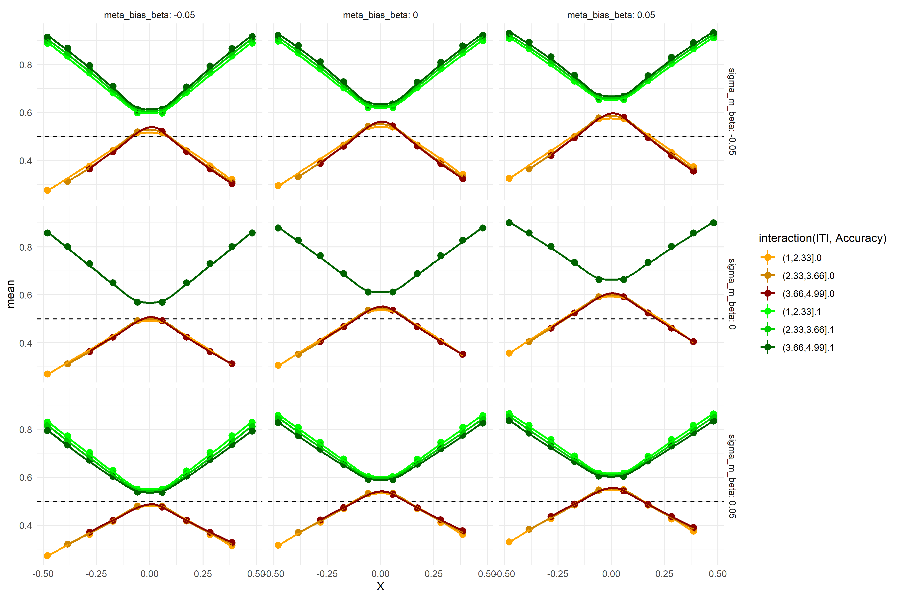

Sequential sampling
As mentioned above we simulated subjects from draws of the posterior that was informed by our pilot data. We then fitted the model to increasing steps (i.e. 5,7,9, 12,15,20,25) of subjects, to demonstrate that the sequential sampling approach would be feasible. below we showcase 5 such trajectories of Bayes factors across the number of subjects used, together with another panel showing how the posterior distribution of the parameter of interest changes with increasing subjects.
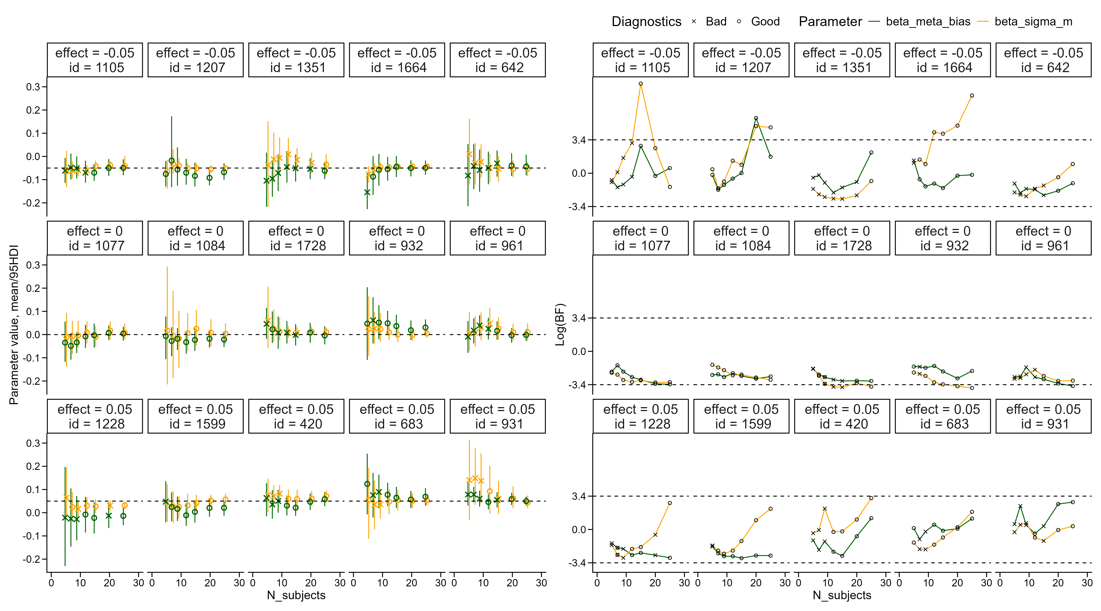 In the above plot we show the development of the effect of the inter-stimulus-interval on both meta cognitive bias (green) and meta cognitive uncertainty (orange). Circles display a fitted model without divergences above 400 effective sample size for both the bulk and the tails and rhat values below 1.03. Left side displays the updating of the posterior distribution of each parameter for increasing subjects. The right side displays the development of the Bayes-factors for the same draw of the posterior fitted to our pilot data.
As can be seen from the simulated sequential sampling we might run into a problem of getting bad diagnostics from the sampler even with this marginalized heuristic model. Here we firstly define our initial sampler parameters, then what we deem sufficiently good sampler diagnostics and lastly contingency plans if we do not get convergence.

Initial Sampler Configuration
The model is initially estimated using the following sampler settings:
- Number of chains: 4
- Number of iterations per chain: 1000
- Warmup iterations: 1000
- Target acceptance rate (adapt_delta): 0.95
- Maximum tree depth (max_treedepth): 12
These values represent our baseline configuration for model estimation.

Convergence Criteria
Sampler convergence and reliability will be assessed using the following diagnostics:
- $\hat{R}$ values below 1.03 for all group level parameters
- Effective sample size (ESS) above 400 for all group level parameters
- Zero divergent transitions after warmup
- No saturation of the maximum tree depth
- well-mixing trace-plots
If these criteria are met, the sampling procedure will be considered satisfactory.

Contingency Procedures
If the above convergence criteria are not met, we will apply the following steps depending on the convergence failure:
- Increase the number of iterations.
- Increase the target acceptance rate (adapt_delta).
- Increase the maximum tree depth (max_treedepth).
- Reconsider model parameterization (i.e. centered vs non-centered parameterization).
- Estimate the lapse-rate parameter non-hierarchically
These steps are intended to improve sampler stability and ensure reliable posterior estimation.
Interested readers are referred to the directory used to perform the Sequential Sampling. Here the full Stan model and the scripts for checking diagnostics and model fit are present.

Participants
Eligible participants will be 18–40 years old, have normal or corrected‑to‑normal vision, and be proficient in English. Individuals with neurological or psychiatric diagnoses or those taking medication that may affect cognitive performance are also not eligible to participate. Subjects will be recruited through COBE Lab its participant pool to insure fast and effective recruitment and will be rewarded with 110DKK.

Design
This study consists of a single lab visit where participants perform a computer experiment on a COMPUTERSPEC(XXX) run using Psychopy (Peirce et al. 2019). The experiment uses a random dot motion (RDM) decision‑making task. On each trial, participants view a random dot kinematogram in which a majority of dots move either upward or downward. While the dots are displayed, participants indicate whether the overall motion is ‘up’ or ‘down’ by pressing a corresponding key. They have 2 seconds to respond, trials without a response within this window are classified as no‑response trials. After indicating their response, participants view a post‑decisional fixation cross. The duration of this interval is the main experimental manipulation and is randomly drawn from a uniform distribution ranging from the maximum response time of 2 seconds to 5 seconds ($PostD_{i}∼\text{U}\left(2,5\right)$). After the interval, participants provide a metacognitive evaluation of their decision. They are asked, ‘How confident were you in your decision?’ and respond using a scale ranging from ‘certainly wrong’ to ‘certainly right.’ Participants navigate the scale using the arrow keys and confirm their response with a key press. If no response is made within 3 seconds, the trial is classified as a no‑response trial. Before the start of each new trial, an inter‑trial interval is presented consisting of a fixation cross. The duration of this interval is drawn from a log‑normal distribution with a mean of 1 seconds and a standard deviation of 0.1 ($ITI_{i}∼\text{Lognormal}\left(1,0.1\right)$).
In total, participants will complete 288 trials, spread over 8 blocks of 36 trials. Before the main experiment begins, participants receive instructions on how to perform the decision task. They then complete six easy, non‑speeded practice trials without confidence ratings, followed by 120 more difficult practice trials. Afterward, participants receive additional instructions about the confidence scale and complete 10 easy, non‑speeded practice trials that include confidence ratings, after which the main experiment begins. The key variables of interest are response choice, accuracy, response times, confidence ratings, and the response times associated with those confidence ratings.
To ensure that task difficulty is calibrated at the individual level, the 120 harder practice trials are used as part of a staircase procedure. In a random dot kinematogram, task difficulty is determined by several stimulus properties, which can be broadly grouped into two categories: stimulus parameters and stimulus noisiness. To ensure that difficulty is optimally calibrated for each participant, we use the first 40 of the harder practice trials to staircase the dotlife parameter in the Dotstimclass in psychopy. This is a stimulus parameter that determines how many frames a dot lives before disappearing. Once an appropriate dot‑life value is identified, we start staircasing coherence. Coherence controls the stimulus signal-to-noise ratio and is the most commonly manipulated difficulty parameter in the literature. It ranges from 0 to 1 and determines the proportion of signal to noise dots, with higher values indicating a greater percentage of signal dots.
The remaining 80 trials are used to estimate the slope and threshold of the participant’s psychometric function on coherence. Both staircases are implemented in PsychoPy using the QUEST+ Bayesian adaptive procedure, which selects each stimulus to minimize posterior entropy over the psychometric parameters (Watson, 2017; implementation: https://www.psychopy.org/api/data.html#psychopy.data.QuestPlusHandler). Using the estimated psychometric function, we determine the coherence levels for the main experiment based on a set of predefined target accuracies ($ACC=\left[0.51,0.6,0.7,0.8,0.99\right]$). The corresponding coherence values are then sampled in a quasi‑normal fashion: the extreme accuracy levels (0.51 and 0.99) appear once per direction, the intermediate levels appear twice, and the 0.70 level appears three times. In each block of the main experiment, trials are presented in a pseudo‑randomized sequence of upward and downward motion such that no more than three consecutive trials share the same direction. This reduces the risk of implicit directional bias. All of this ensures that participants use the full confidence scale and that difficulty is balanced across upward and downward motion directions.

Exclusion criteria
Because the task is a two‑alternative forced‑choice decision, chance performance is 50%. For each participant, we will compute overall accuracy across all main‑task trials and will exclude all participants with an accuracy lower than 60%. For our trial count, accuracy below this threshold is not reliably above chance under a binomial model of guessing. Furthermore, given the stimulus calibration procedure, an optimal observer is expected to achieve approximately 71% accuracy.
Taken together, an accuracy below 60% is inconsistent with meaningful participation in the task. We will also exclude participants who have a no‑response rate greater than 30% (combining decision and confidence responses), as a high proportion of missed responses also indicates insufficient engagement with the task.

Physiological measures
As an additional stream of data we also collect physiological measures from each of our subjects. Specifically, we will be collecting eyetracking (and pupil size) using an Eyelink 1000, furthermore we will collect electrocardiogram (ECG) and respiration measures using Biopac Systems. To ensure calibration of the eyetracker the experimental script re calibrates after each experimental block, which also allows for frequent breaks for the participant.

References
Baranski, J. V., and W. M. Petrusic. 1998. “Probing the Locus of Confidence Judgments: Experiments on the Time to Determine Confidence.” Journal of Experimental Psychology. Human Perception and Performance 24 (3): 929–45. https://doi.org/10.1037//0096-1523.24.3.929.
Baranski, J. V., and W. M. Petrusic. 2001. “Testing Architectures of the Decision-Confidence Relation.” Canadian Journal of Experimental Psychology = Revue Canadienne De Psychologie Experimentale 55 (3): 195–206. https://doi.org/10.1037/h0087366.
Caziot, Baptiste, and Pascal Mamassian. 2021. “Perceptual Confidence Judgments Reflect Self-Consistency.” Journal of Vision 21 (12): 8. https://doi.org/10.1167/jov.21.12.8.
Desender, Kobe, K. Richard Ridderinkhof, and Peter R. Murphy. 2021. “Understanding Neural Signals of Post-Decisional Performance Monitoring: An Integrative Review.” eLife 10 (August): e67556. https://doi.org/10.7554/eLife.67556.
Fleming, Stephen M. 2017. “HMeta-d: Hierarchical Bayesian Estimation of Metacognitive Efficiency from Confidence Ratings.” Neuroscience of Consciousness 2017 (1): nix007. https://doi.org/10.1093/nc/nix007.
Fleming, Stephen M., and Nathaniel D. Daw. 2017. “Self-Evaluation of Decision-Making: A General Bayesian Framework for Metacognitive Computation.” Psychological Review 124 (1): 91–114. https://doi.org/10.1037/rev0000045.
Fleming, Stephen M., Elisabeth J. van der Putten, and Nathaniel D. Daw. 2018. “Neural Mediators of Changes of Mind about Perceptual Decisions.” Nature Neuroscience 21 (4): 617–24. https://doi.org/10.1038/s41593-018-0104-6.
Fung, Herrick, Medha Shekhar, Kai Xue, Manuel Rausch, and Dobromir Rahnev. 2025. “Similarities and Differences in the Effects of Different Stimulus Manipulations on Accuracy and Confidence.” Consciousness and Cognition 136 (November): 103942. https://doi.org/10.1016/j.concog.2025.103942.
Goueytes, Dorian, François Stockart, Alexis Robin, et al. 2025. “Evidence Accumulation in the Pre-Supplementary Motor Area and Insula Drives Confidence and Changes of Mind.” Nature Communications 16 (1): 6998. https://doi.org/10.1038/s41467-025-61744-8.
Hangya, Balázs, Joshua I. Sanders, and Adam Kepecs. 2016. “A Mathematical Framework for Statistical Decision Confidence.” Neural Computation 28 (9): 1840–58. https://doi.org/10.1162/NECO_a_00864.
Kiani, Roozbeh, and Michael N. Shadlen. 2009. “Representation of Confidence Associated with a Decision by Neurons in the Parietal Cortex.” Science 324 (5928): 759–64. https://doi.org/10.1126/science.1169405.
Kubinec, Robert. 2023. “Ordered Beta Regression: A Parsimonious, Well-Fitting Model for Continuous Data with Lower and Upper Bounds.” Political Analysis 31 (4): 519–36. https://doi.org/10.1017/pan.2022.20.
Maniscalco, Brian, and Hakwan Lau. 2012. “A Signal Detection Theoretic Approach for Estimating Metacognitive Sensitivity from Confidence Ratings.” Consciousness and Cognition, Beyond the Comparator Model, vol. 21 (1): 422–30. https://doi.org/10.1016/j.concog.2011.09.021.
Mihali, Andra, Marianne Broeker, Florian D. M. Ragalmuto, and Guillermo Horga. 2023. “Introspective Inference Counteracts Perceptual Distortion.” Nature Communications 14 (1): 7826. https://doi.org/10.1038/s41467-023-42813-2.
Navajas, Joaquin, Chandni Hindocha, Hebah Foda, Mehdi Keramati, Peter E. Latham, and Bahador Bahrami. 2017. “The Idiosyncratic Nature of Confidence.” Nature Human Behaviour 1 (11): 810–18. https://doi.org/10.1038/s41562-017-0215-1.
Öztel, Tutku, and Fuat Balcı. 2024. “Metric Error Monitoring as a Component of Metacognitive Processing.” European Journal of Neuroscience 59 (5): 807–21. https://doi.org/10.1111/ejn.16182.
Peirce, Jonathan, Jeremy R. Gray, Sol Simpson, et al. 2019. “PsychoPy2: Experiments in Behavior Made Easy.” Behavior Research Methods 51 (1): 195–203. https://doi.org/10.3758/s13428-018-01193-y.
Petrusic, William M., and Joseph V. Baranski. 2003. “Judging Confidence Influences Decision Processing in Comparative Judgments.” Psychonomic Bulletin & Review 10 (1): 177–83. https://doi.org/10.3758/BF03196482.
Pleskac, Timothy J., and Jerome R. Busemeyer. 2010. “Two-Stage Dynamic Signal Detection: A Theory of Choice, Decision Time, and Confidence.” Psychological Review (US) 117 (3): 864–901. https://doi.org/10.1037/a0019737.
Rausch, Manuel, and Michael Zehetleitner. 2019. “The Folded X-pattern Is Not Necessarily a Statistical Signature of Decision Confidence.” PLOS Computational Biology 15 (10): e1007456. https://doi.org/10.1371/journal.pcbi.1007456.
Resulaj, Arbora, Roozbeh Kiani, Daniel M. Wolpert, and Michael N. Shadlen. 2009. “Changes of Mind in Decision-Making.” Nature 461 (7261): 263–66. https://doi.org/10.1038/nature08275.
Sánchez-Fuenzalida, Nicolás, Simon van Gaal, Stephen M. Fleming, Julia M. Haaf, and Johannes J. Fahrenfort. 2025. “Confidence Reports During Perceptual Decision Making Dissociate from Changes in Subjective Experience.” Communications Psychology 3 (1): 81. https://doi.org/10.1038/s44271-025-00257-y.
Sanders, Joshua I., Balázs Hangya, and Adam Kepecs. 2016. “Signatures of a Statistical Computation in the Human Sense of Confidence.” Neuron 90 (3): 499–506. https://doi.org/10.1016/j.neuron.2016.03.025.
Shekhar, Medha, and Dobromir Rahnev. 2021. “Sources of Metacognitive Inefficiency.” Trends in Cognitive Sciences 25 (1): 12–23. https://doi.org/10.1016/j.tics.2020.10.007.
Tsetsos, Konstantinos, Thomas Pfeffer, Pia Jentgens, and Tobias H. Donner. 2015. “Action Planning and the Timescale of Evidence Accumulation.” PLOS ONE 10 (6): e0129473. https://doi.org/10.1371/journal.pone.0129473.
Xue, Kai, Herrick Fung, and Dobromir Rahnev. 2026. “Stimulus Reliability but Not Boundary Distance Manipulations Violate the Folded-X Pattern of Confidence.” Cognition 272 (July): 106490. https://doi.org/10.1016/j.cognition.2026.106490.
Yeung, Nick, and Christopher Summerfield. 2012. “Metacognition in Human Decision-Making: Confidence and Error Monitoring.” Philosophical Transactions of the Royal Society B: Biological Sciences 367 (1594): 1310–21. https://doi.org/10.1098/rstb.2011.0416.
Yu, Shuli, Timothy J. Pleskac, and Matthew D. Zeigenfuse. 2015. “Dynamics of Postdecisional Processing of Confidence.” Journal of Experimental Psychology. General 144 (2): 489–510. https://doi.org/10.1037/xge0000062.

