Jessica Owens
DSC650 Big data
Week 7

Objective 1. Kafka Fundamentals
Kafka is an open-source distributed messaging system. It is used to build real-time data pipelines and streaming apps, capable of handling trillions of events daily. Kafka sits between systems that produce data and systems that consume data, making sure information flows reliably, at scale, and in near real time.
Kafka has a producer which publishes messages into Kafka. The producers send records to a broker under a specified topic. The consumer receives messages from the brokers for that specific topic. A Kafka topic organizes messages logically because it’s a named feed of data. When many topics exist, they are distributed to different partitions and distributed across multiple brokers.
Kafka can have multiple producers sending messages to the brokers for the same topic. Having more brokers and producers allows Kafka to scale and improve its fault tolerance. When Kafka has several brokers that are working together, it’s called a cluster. This allows for distributed deployment. This provides parallel processing and scalability. The zookeeper coordinates the clusters, stores the metadata, and monitors the broker’s health.

Objective 2. Topic Creation and Verification
2.1. Navigate to the Kafka directory and start the Docker container. Open two terminal sessions in each.

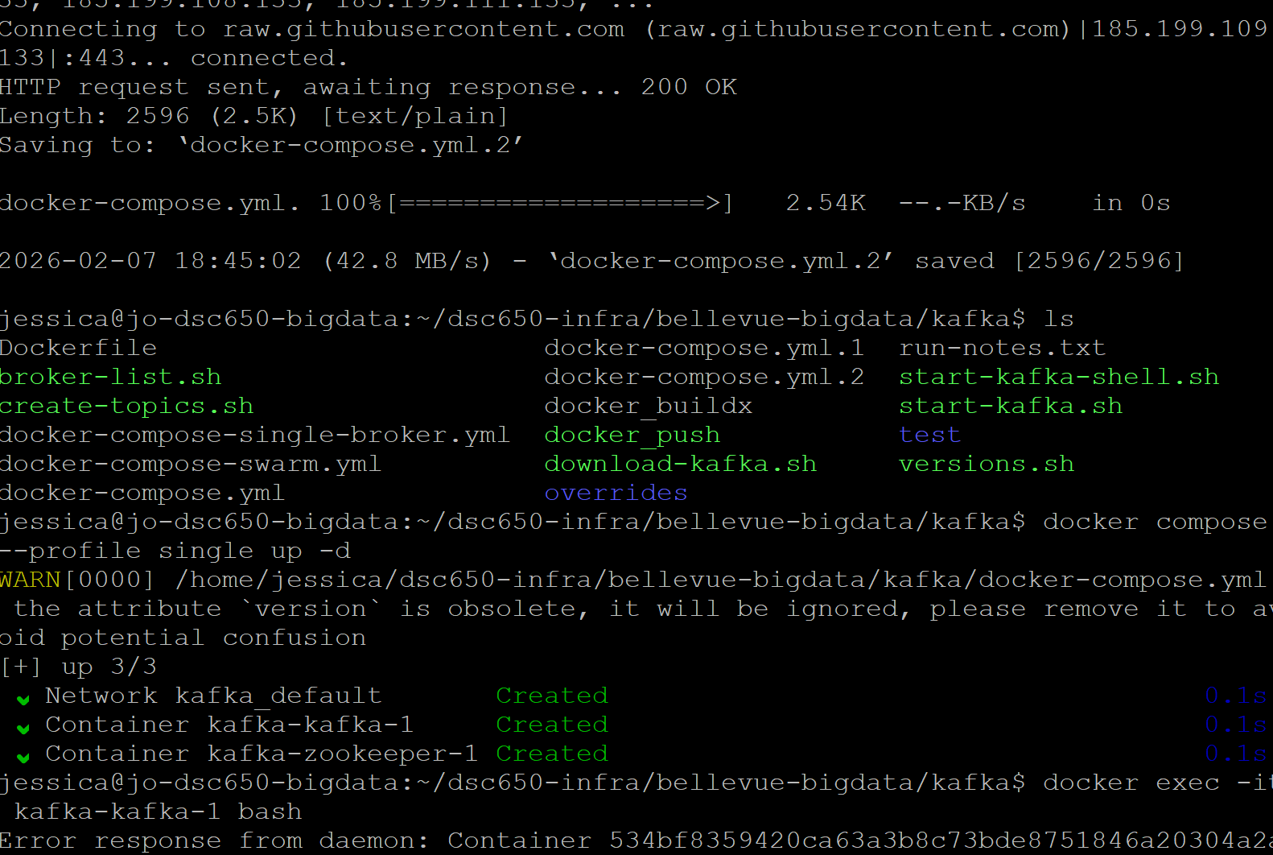

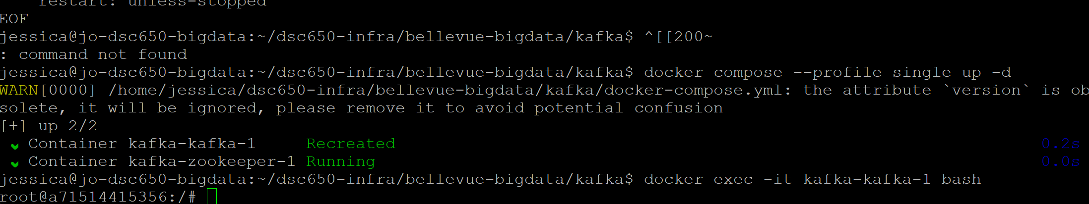
2.2. Create a Kafka topic named ‘my-topic’ and verify it’s creation. Doing this creates a topic that in Kafka, acts like a message channel where producers send data and consumers retrieve it.
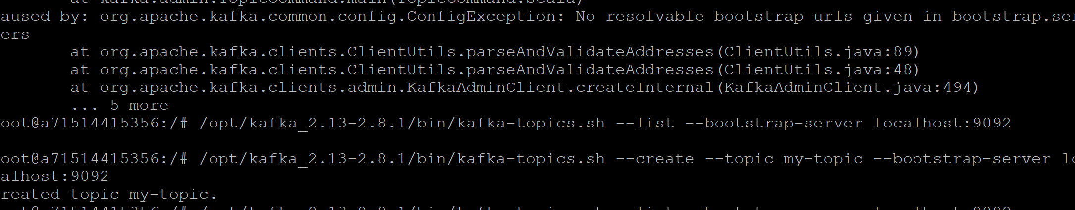

2.3. Verify that ‘my-topic’ has been created by using the list command.
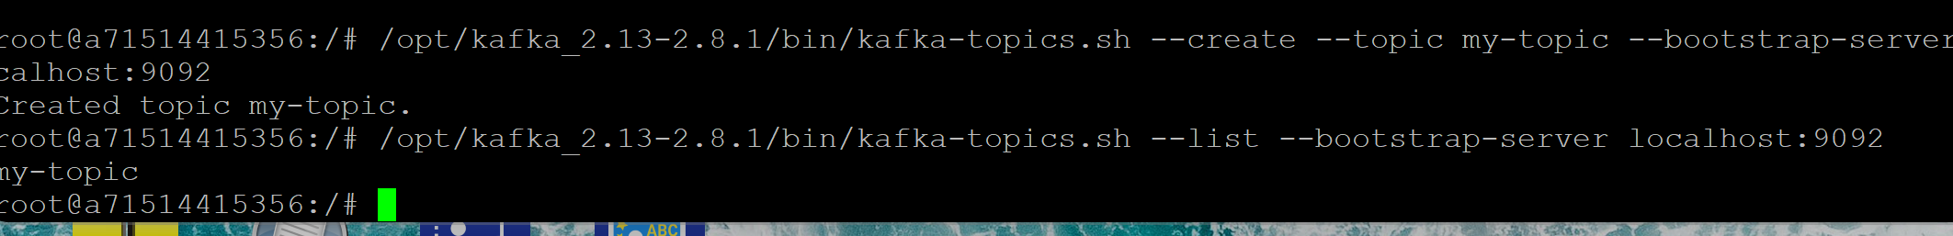

Objective 3. Producing and Consuming Messages
3.1. Started a Kafka consumer to allow the producer to send messages so the consumer will retrieve the messages.
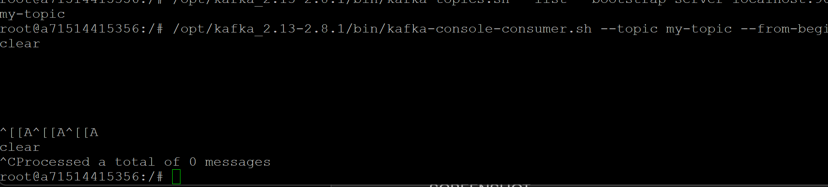
3.2. Started the Kafka producer to send messages to the consumer.

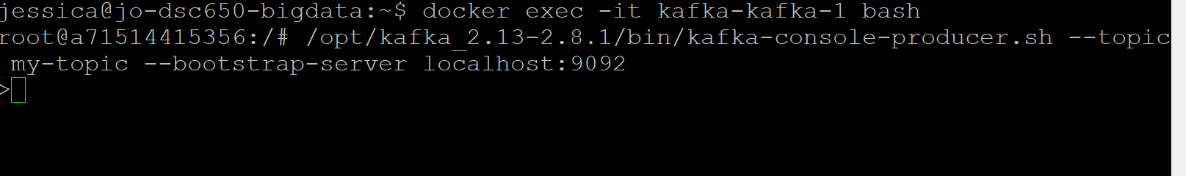
Typed some text into producer and received the output in the consumer.
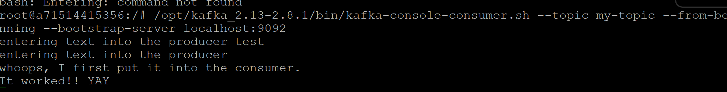
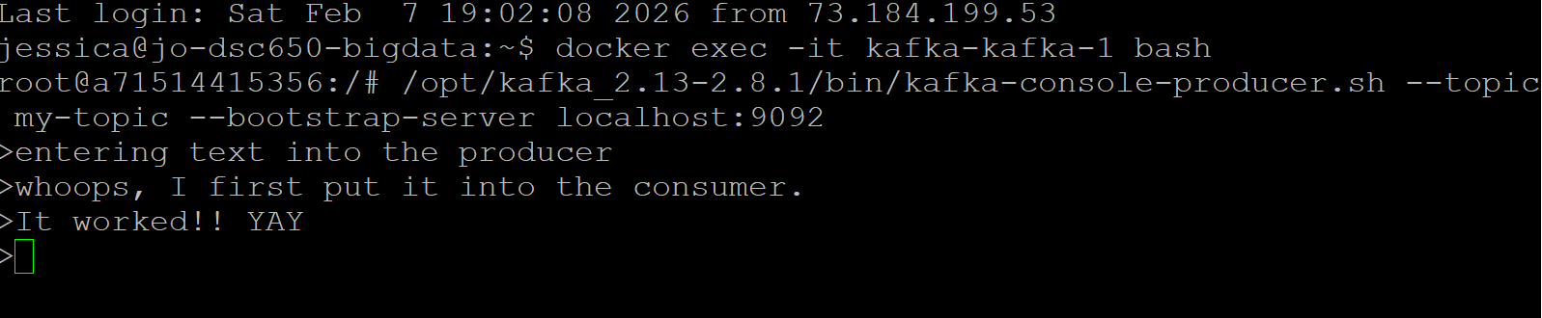

Objective 4. Kafka Performance Tests (Single Broker)
4.1. Perform producer and consumer performance tests on ‘my-topic’ to measure Kafka’s throughput.
Producer performance test output.
The producer sent about 1000 messages. Its average latency is .7 milliseconds, and it’s got a consistent throughput with having 5002 records sent with 1000.2 records per second.
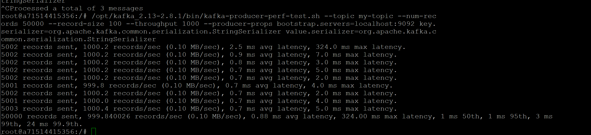
Consumer performance test output.
The consumer read about 50,000 messages. The processing speed was 9.k messages per second.

The consumer and producer performance test provides information on Kafkas throughput, latency and overall health. In this example, the health of Kafka is great. It’s latency is minimal, the throughput is consistent with sending 1000.2 records per second. By increasing the consumer parallelism, it would increase it’s throughput.
Objective 5. Expanding Kafka and Partitioned/Replicated Topics
5.1. Scale Kafka to 3 instances and test out it performs with partitioned and replicated topics. Create a new topic that’s scaled to 3 instances.
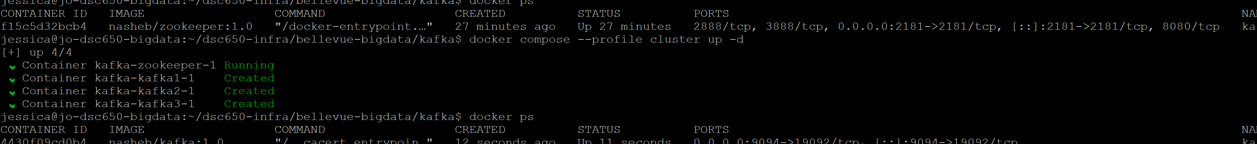
Create a new topic that’s scaled to 3 instances.
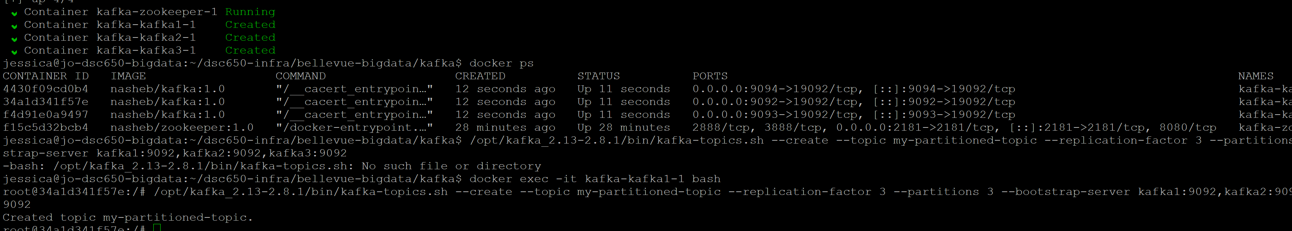
5.2 Perform producer and consumer performance tests on ‘new-topic’ to measure Kafka’s throughput.
Producer performance test output.
The producer sent about 50,000 messages. Its average latency is 1.24 milliseconds, and it’s got a consistent throughput with 50,000 records sent with 1000 records per second.
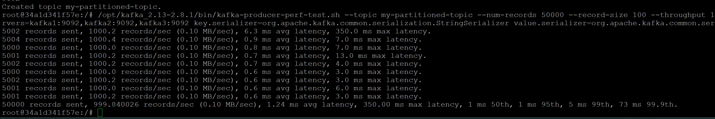
Consumer performance test output.
The consumer read about 56,180 messages per second. A 5.7x improvement after scaling.

5.3.
Between the single-broker test and the scaled test, we can see that the throughput is consistent on both the single-broker test and the scaled test. The latency of the scaled test is less than it was on the single-broker test, meaning that the distribution of data provided a faster processing speed rather than only using the single broker to relay the data. After increasing consumer parallelism, throughput improved from ~9.8k msg/sec to ~56k msg/sec (~5.7× improvement). The broker fetch capacity is still slightly higher which indicates that the consumer application remains the primary processing bottleneck. However, even with scaling, performance can still plateau when the underlying shared storage system cannot deliver enough input/output operations per second.

