Jessica Owens
Week 9
DSC 650 Big Data

Objective 1 - Conceptual Foundations

NiFi is an informational dataflow process. It was built to help tackle dataflow challenges such as system failures, data accessibility, and the ability to keep pace with system evolution. NiFi is the tool that connects all the data together in a visual way. The core concepts of NiFi is the FlowFile, FlowFile Prcessor, Connection, Flow Controller, and Process Group.
A FlowFile represents each object moving through the system and contains the raw and meta data. The connection is a queue that holds data pending processing and will allow various processes to interact at different rates. The FlowFile Processor performs the work of extract, transform and load in real time. The Flow Controller maintains the details of how the processes connect and manages the exchange of FlowFiles between processors. A Process Group is a set of processes and their connections.
NiFi provides an easy way to design, monitor, and scale pipelines that reliably use data from point A to point B even if the data is in much different formats. NiFi allows for visual creation and management of data pipelines using it’s user interface platform. The point of data ingestion, transformation, and output is easily identified and tracked.
Solr and NiFi work seamlessly together. While NiFi ingests and transforms the data into something readable in for Solr, and Solr indexes the data for efficient searching. Both NiFi and Solr provide real-time updates with continuous stream updates and are scalable to handle large volumes of data and queries.

Objective 2 - Environment Initialization
Started NiFI in the environment, then opened the user interface. Because the user interface of NiFi opened and I was able to see the My First NiFi Flow, I know that the UI is working.
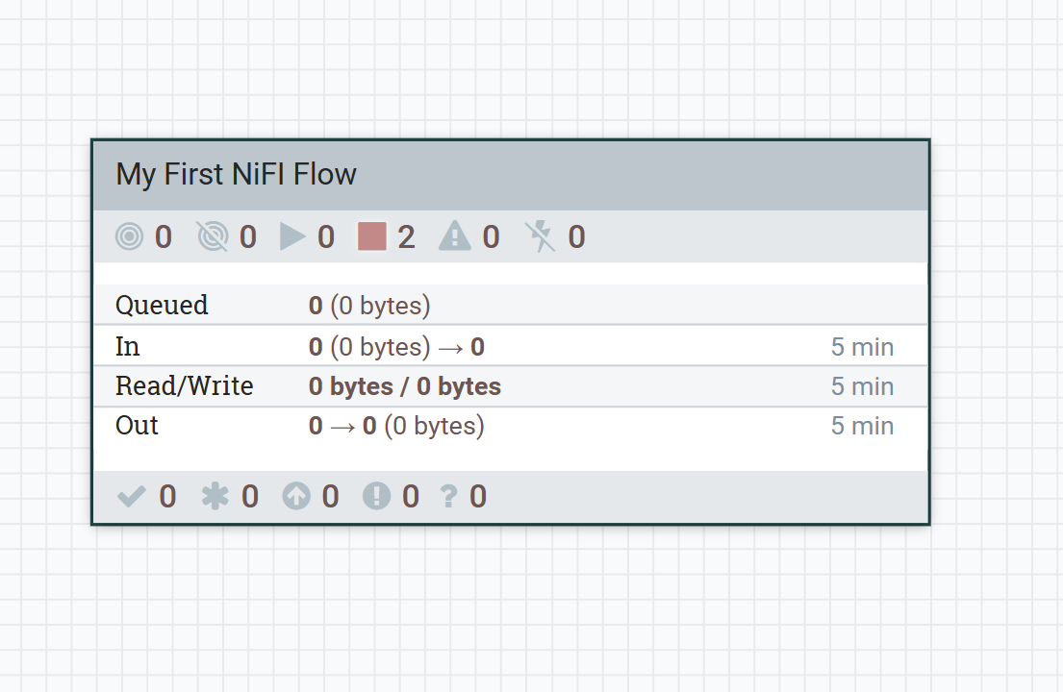
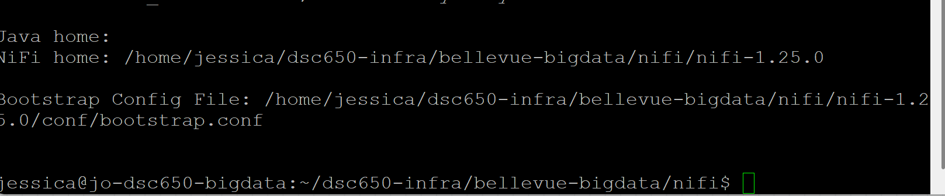

Objective 3 - Creating a Processor Group and Context (10 points)
1. Creating a Processor Group
I created a processor group and configured the processor to run every 5 seconds and configured the filesize. This is where I will enter my processes to be performed on the data.

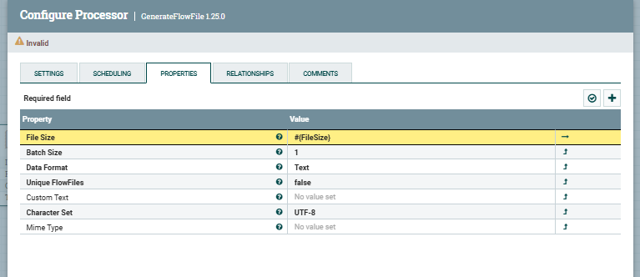

Objective 4 - Designing a Simple Flow
1. Designing a Simple Flow
Created a simple flow in the processor. Added parameters to run every 5 seconds and file size. This defines how often the process flows and what size of data it’s capturing. I then configured the log attribute processor to log payload to true and build the relationship between the generate flow, it will log the data and stop the flow.
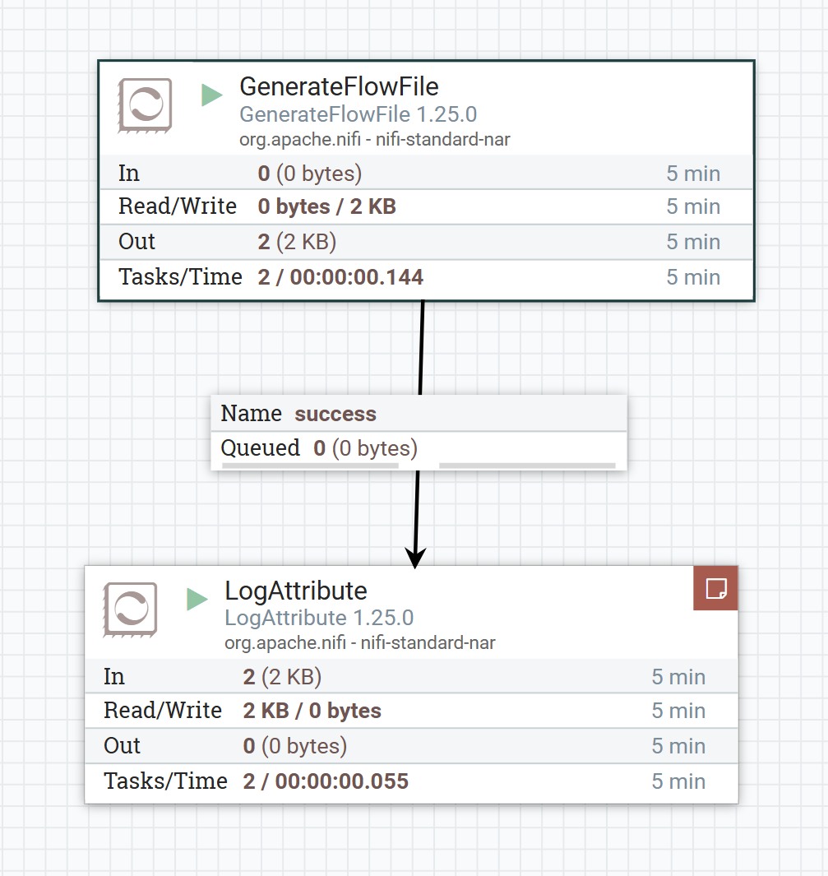

Objective 5 - Setting Up Solr Collection
1. Setting Up Solr Collection
Started Solr and created Solr a collection called syslog. This is the integration between NiFi and Solr. Now, I’ll be able to see the data uploaded into the UI for Solr.

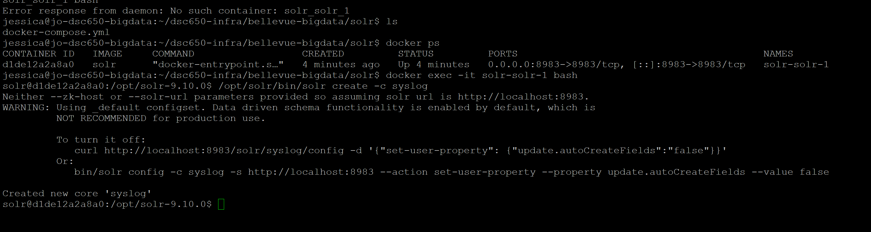

Objective 6 - NiFi Advanced Flow with Solr Integration
  - NiFi Advanced Flow with Solr
Opened up Solr, uploaded the JSON process file into NiFi, fixed the errors by starting AvroSchemaRegistry. The AvroSchemaRegistry allows me to define a scheme on my data such as data formatting. Then started the controller services for reading and writing data.
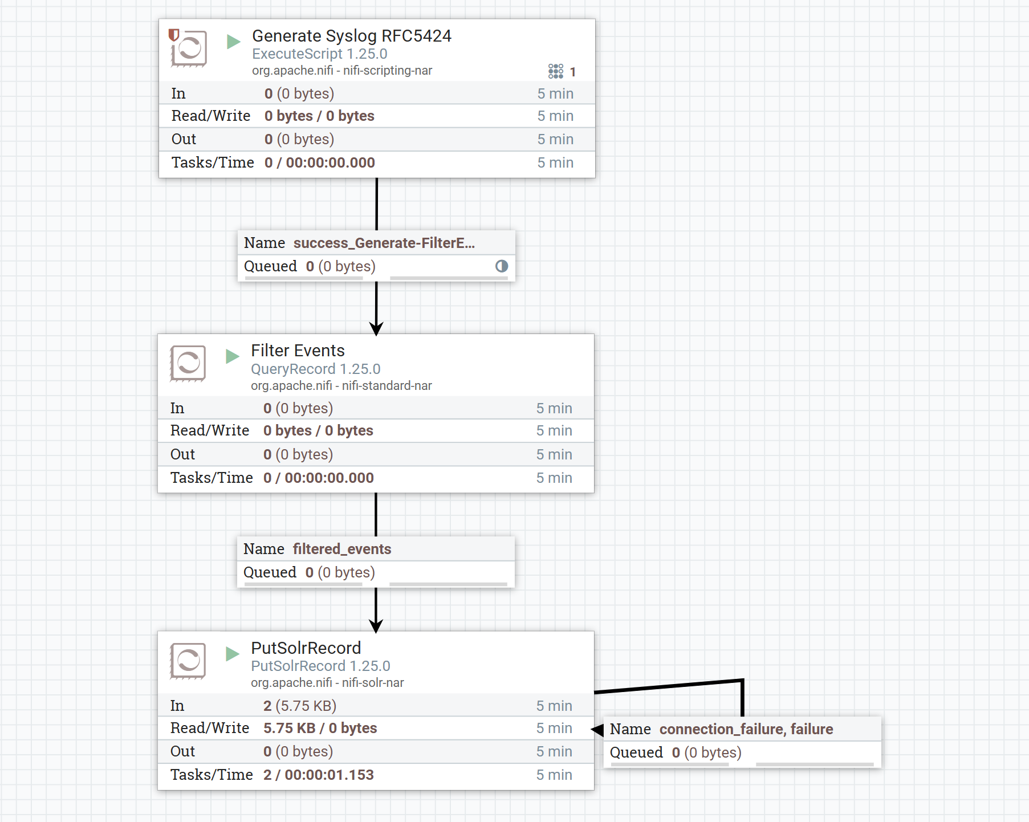

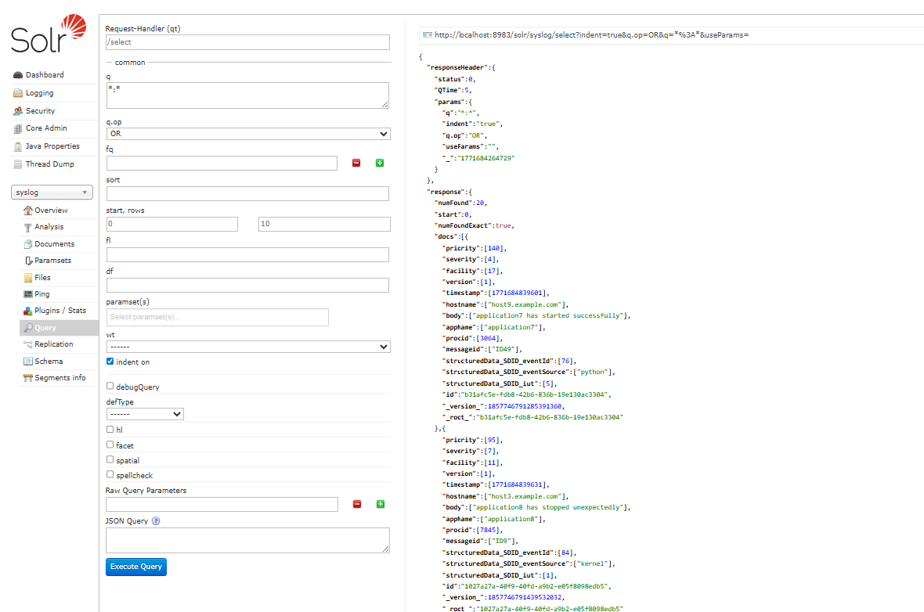
Objective 7 – Querying Solr Data
Querying Solr Data. I queried the data to see all appName equal to application3. Solr indexed the data correctly, so the query was successful.

