Jessica Owens
Airport Complaint_mapping_visualization

Objective: In a customer experience role, it’s their job to understand where most complaints come from and why. In this role, one would want to see where they compare within their industry. For this analysis, the industry is travel and it’s up to the airport to provide the customer with the best experience possible. In a customer experience role, it’s their job to understand where most complaints come from and why. In this role, one would want to see where they compare within their industry. For this analysis, the industry is travel and it’s up to the airport to provide the customer with the best experience possible.

Data: After pulling all four of the datasets, I started by preparing the data, cleaned the columns, renamed columns for readability, and removed several columns to minimize redundancy and confusion. I grouped the datasets by category, airport ID and year_month. I then merged them individually using the “iata” from the “airport, iata-icao”, category, year_month, subcategory. The final dataset, df, contains the airport ID, location, latitude, longitude, complaint count by airport, complaint by category and complaint by subcategory.

Methods:
To visualize how airports in the US compare with customer complaints, I created a proportional circle map because I’m looking for bubble size in relation to a numeric value such as count. This map identifies which locations have higher and lower numbers of customer complaints, if the complaints number is higher, the bubble size is larger.
To visualize what airports, have the most complaints, I chose to create a heatmap. The original heatmap was extremely busy and not readable so I filtered the visual to show the top 10 airports along with the top 10 categories of complaints. Now it’s easy to see that John F. Kennedy International Airport has the highest number of complaints in the category, Mishandling of passenger property with Los Angeles International Airport at a close second. This visual is clear for understanding with a red, orange, and yellow gradient, dark red having the most complaints over the years.
If I were in the customer experience department for John F. Kennedy, I’d be curious to know more about what the most recent year of data shows for the JFK airport. To do this, I created a pareto chart, this allows me to easily see the top contributors of complains for JFK and the year 2023. Doing this, I found that for JFK, the top contributor was not the mishandling of passenger property but the top contributor was Expedited Passenger Screening Program.
This data was sourced from a credible source. The data was merged and verified to have not been altered in any way besides for analysis purposes. The audience is the customer experience representative to see where they should put some focus into for a better customer experience. In a customer experience role, they are to identify what customer complaints impact the customer experience. For this analysis, I’m digging in as a customer experience outlook for the JFK airport.

A proportional circle map is created to visually compare JFK with other airports. This allows me to see that JFK seems to be one of the airports with the highest number of customer complaints.
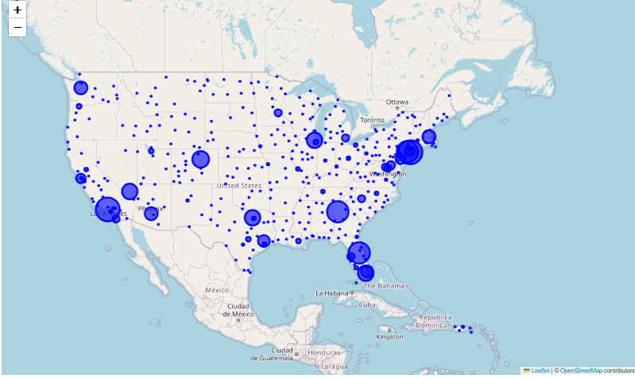
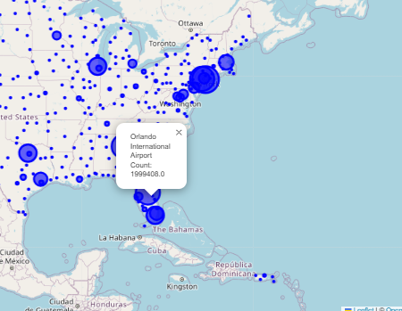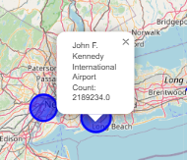

To visualize what airports have the most complaints, I chose to create a heatmap. The original heatmap was extremely busy and not readable so I filtered the visual to show the top 10 airports along with the top 10 categories of complaints. Now it’s easy to see that John F. Kennedy International Airport has the highest number of complaints in the category, Mishandling of passenger property with Los Angeles International Airport at a close second. This visual is clear for understanding with a red, orange, and yellow gradient, dark red having the most complaints.
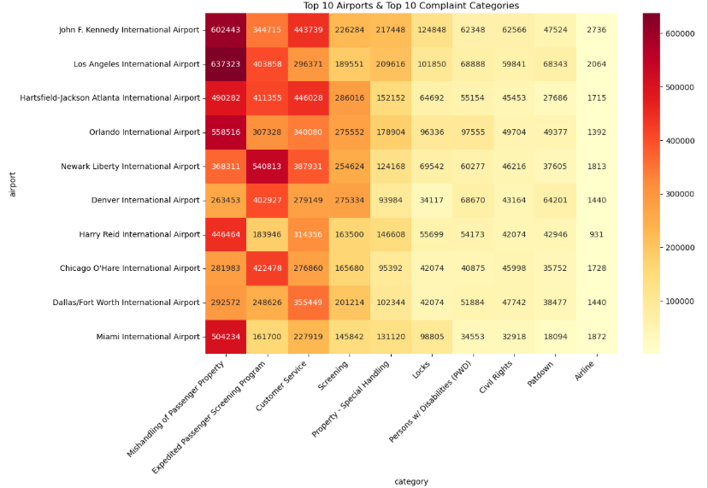

Now that I see how the years look, I’d like to see what made up the complaints for 2023. To visualize this, I created a Pareto chart to visualize what categories are the top contributors to complaints for JFK and the year 2023. From this visual, I can see that “Expedited Passenger Screening Program” makes up for over 80% of the complains. This is interesting because in the heatmap, it could have been assumed that "Mishandling of Passenger Property” was the highest complaint contributor. While this is true when looking at all years, by narrowing it down to 2023, I can see that “Expedited Passenger Screening Program” and “Customer Service” are the complaints that I should look at for JFK.
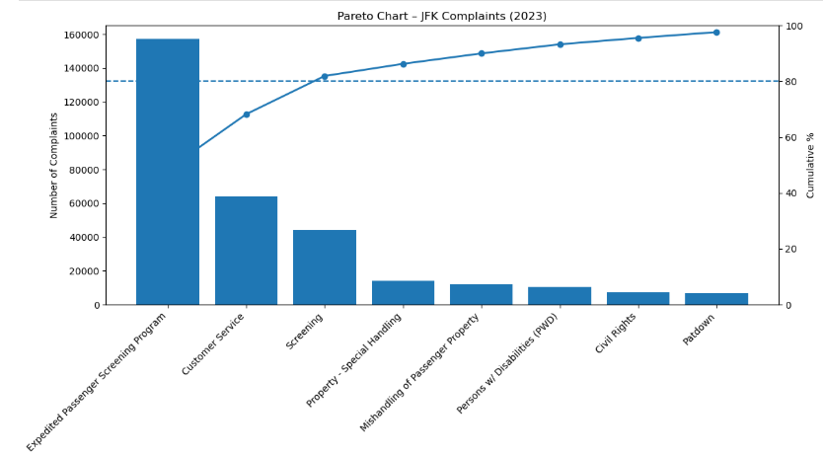

Since I’m trying to look at the data to help the customer experience, I’m going to drill down the top complaint category, Expedited Passenger Screening Program, my first question is “When did these complaints occur?” For this, I created a simple bar graph. It’s easy to see that the mishandling of passenger property had a significant increase from 2021 – 2022, and after verifying, the data was not fully captured for 2024.
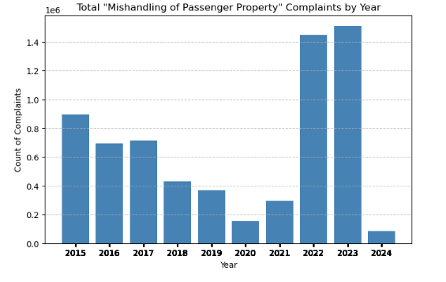

Next, I think it’s important to see if the top two categories had subcategories. To do this, I’ve created a sunburst chart to visualize the categories, “Expedited Passenger Screening Program” and “Customer Service” by subcategory types. This visual shows that each of these categories only have one subcategory so it won’t be necessary to break them down by subcategories. It also shows that “Expedited Passenger Screening Program” accounts for 71% of the top two complaint contributors. 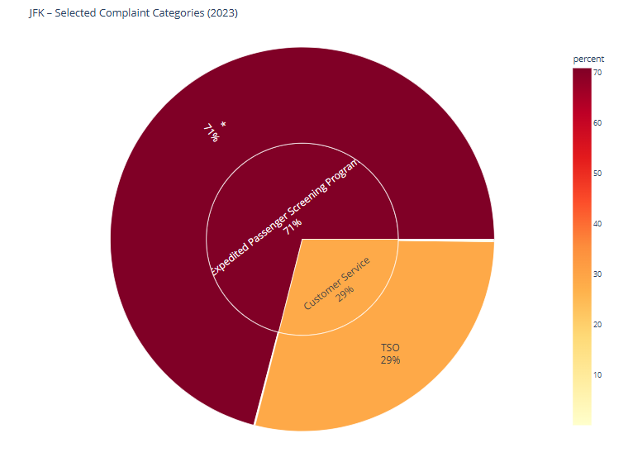

Finally, I wondered if the Expedited Passenger Screening Program trended upwards over the years, specifically for JFK. For this, I created a box plot showing only the “Expedited Passenger Screening Program” and plotted each year.
