NoteKeeper
Phase-1 Project Proposal
Collaborative Note-Taking and Workspace System

Field | Detail
Author | Jessica Irakoze
GitHub | https://github.com/Jess-xca/Notekeeper_JSF
Video | [Add Google Vid link after recording]
Technology | JSF, Hibernate, PostgreSQL, Maven, Jakarta Validation

1. Abstract
NoteKeeper is a web application for organizing notes in workspaces, labeling them with tags, and sharing them securely. The full system will include accounts, pages, sharing, notifications, and administration.
Phase-1 documents the project and delivers a working JSF + Hibernate prototype with full CRUD on two entities: Tag and Workspace. The prototype uses three validation types and three CSS types, as required.
2. Problem Statement
Notes are often scattered across paper, phone apps, documents, and chat. That leads to:
- Poor findability — no consistent structure, tags, or workspaces
- Weak collaboration — sharing a whole file often gives too much or too little access
- Risk of loss — no clear ownership or backup process
- Weak security — little role control and no strong authentication
- No central administration for users and content
NoteKeeper solves this by keeping notes in workspaces, organizing them with tags, and controlling access through accounts and roles.
3. Scope
3.1 Full project (planned)
- Authentication (login, registration, password reset, Google login, 2FA)
- Users, roles, and profiles
- Workspaces and members
- Pages, tags, attachments
- Sharing, invitations, and notifications
- Admin management
3.2 Phase-1 (implemented)
- This proposal document
- Initial class model for all entities
- JSF + Hibernate CRUD for Tag and Workspace
- Three validation types and three CSS types
- Public GitHub repository
- 5–10 minute Google Vid (screen + camera)
3.3 Out of scope for Phase-1
- Full login screens in JSF
- Page editor, attachments, and sharing in JSF
- Production deployment
Note: In Phase-1, workspace owner is stored as a name field. In the full system, a workspace belongs to a User.
4. AS-IS Model
Today, capturing and sharing notes is fragmented.
Area | Current practice
Capture | Whatever tool is nearest (paper, phone, Docs, chat)
Organization | Folders or none; tags rarely consistent
Search | Manual scrolling or memory
Sharing | Send a copy or share an entire file
Security | Device lock or basic account password
Collaboration | Conflicting copies; unclear ownership
Administration | No central view of users or content

Flow: Idea → choose random tool → store locally or send a file → hard to find later → time lost reconstructing information.
5. TO-BE Model
NoteKeeper provides one web system for capture, organization, and controlled sharing.
Area | Future practice
Capture | Pages inside a workspace
Organization | Workspaces, tags, favorites, archive
Search | Search with filters
Sharing | Role-based page and workspace access
Security | Authentication, hashed passwords, 2FA
Collaboration | One shared record instead of file copies
Administration | Admin screens for users and content

Phase-1 slice: Dashboard → Tag CRUD / Workspace CRUD / Search → PostgreSQL (Hibernate) → JSF, Bean, and custom validation.
6. Business Requirements
6.1 Full system (selected)
ID | Requirement
BR-01 | Users can register, log in, reset passwords, and enable 2FA
BR-02 | Users can create and manage workspaces
BR-03 | Users can create, edit, favorite, archive, and delete pages
BR-04 | Users can create tags and assign them to pages
BR-05 | Workspace owners can invite members and assign roles
BR-06 | Page owners can share pages with view or edit permission
BR-07 | Attachments can be linked to pages
BR-08 | Users receive notifications for shares and invitations
BR-09 | Admins can manage users, pages, and workspaces
BR-10 | Invalid data is rejected by validation before save

6.2 Phase-1 (implemented)
ID | Requirement | Status
P1-01 | CRUD for tags | Done
P1-02 | CRUD for workspaces | Done
P1-03 | Validate tag name and color | Done
P1-04 | Validate workspace name, owner, and description | Done
P1-05 | Persist data with Hibernate (hibernate.cfg.xml) | Done
P1-06 | Dashboard with live counts | Done
P1-07 | Search across tags and workspaces | Done
P1-08 | One default workspace (prefer Personal) | Done

7. Software Qualities
Quality | Application
Functionality | CRUD for Tag and Workspace; full domain planned
Usability | Clear forms, messages, and confirm-before-delete
Reliability | Transactions with rollback; validation before persist
Security | Full system: auth, hashing, 2FA, roles; Phase-1: input validation
Maintainability | Layers: model, DAO, bean, validator, view
Portability | Maven WAR on Tomcat 10; PostgreSQL
Integrity | Unique names, required fields, reserved workspace names
Reusability | Shared CSS, DAOs, and validators
Testability | DAO and validators separated from the view
Adaptability | Same domain aligns with the Spring Boot backend

8. Initial Class Diagram (Entities)
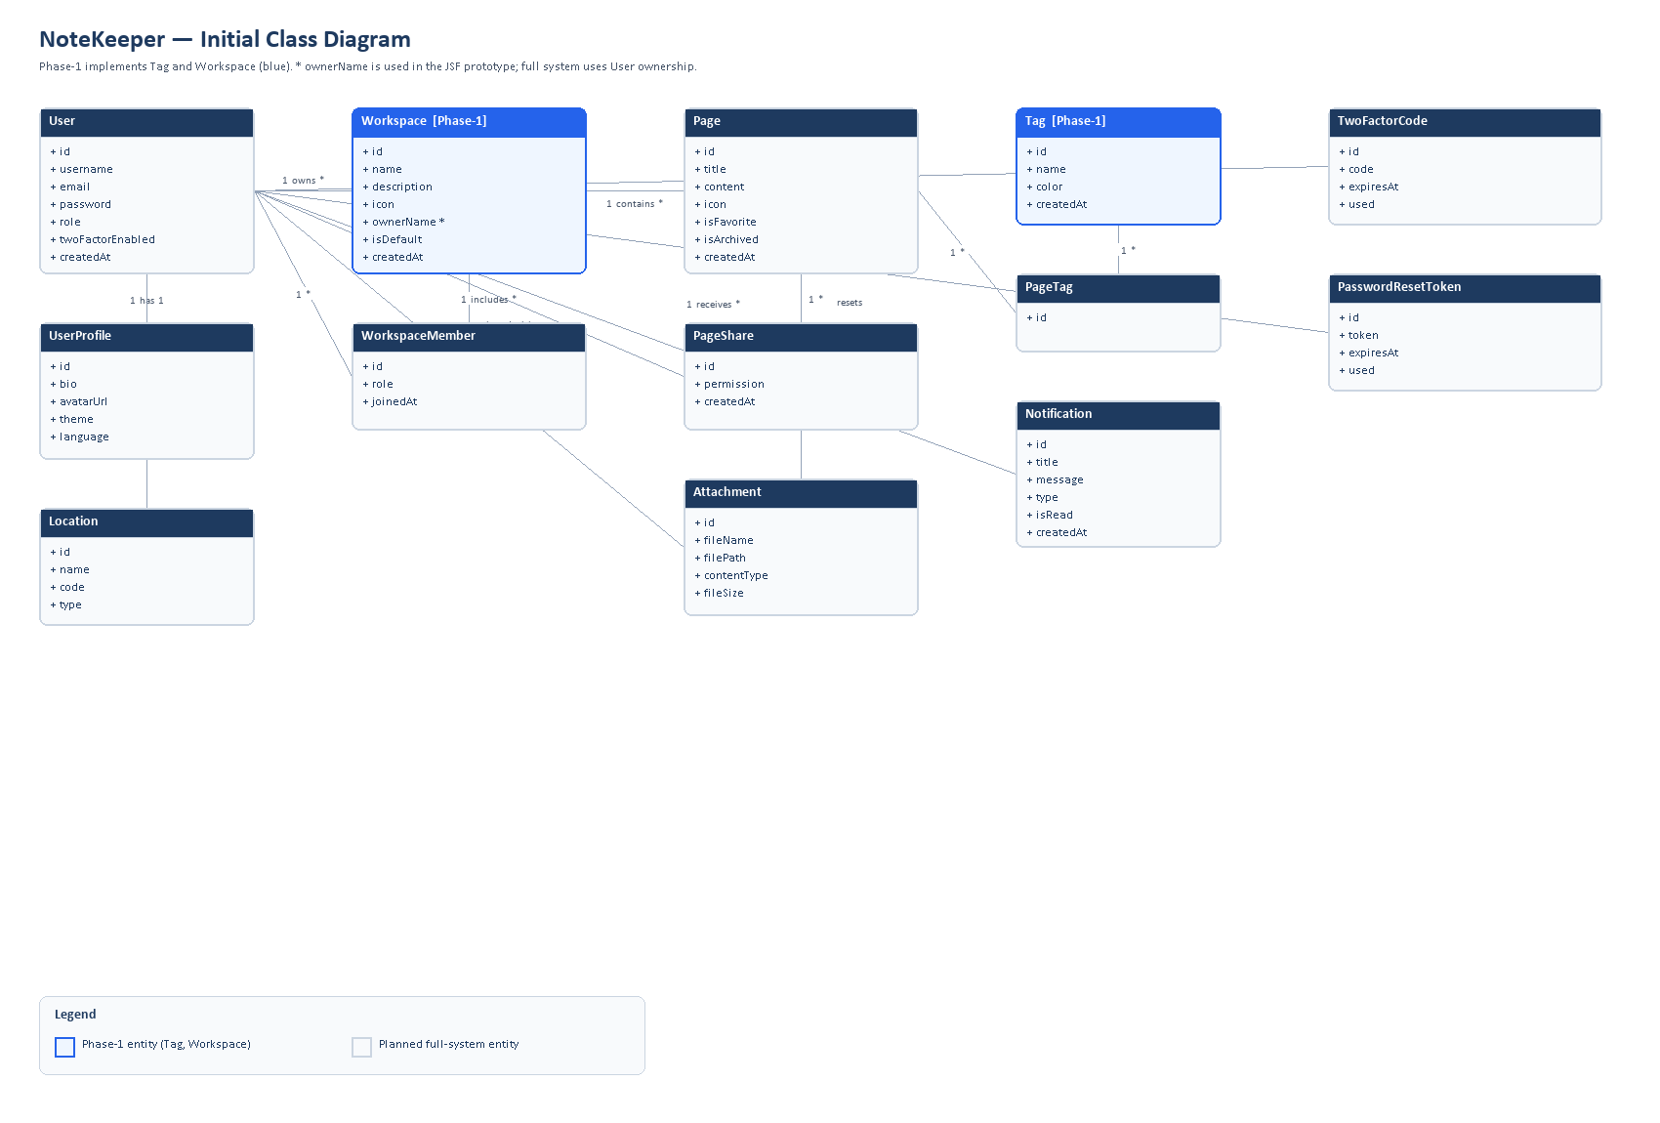
Figure 1. Initial class diagram for NoteKeeper. Phase-1 entities (Tag, Workspace) are highlighted.
Main entities: User, UserProfile, Location, Workspace, WorkspaceMember, Page, Tag, PageTag, PageShare, Attachment, Notification, TwoFactorCode, PasswordResetToken.
Key relationships:
- User owns Workspaces and authors Pages
- Workspace contains Pages and WorkspaceMembers
- Page links to Tags (via PageTag), Shares, and Attachments
- User receives Notifications and uses 2FA / password-reset tokens
8.1 Phase-1 entities (implemented)
Tag: id, name, color, createdAt
Workspace: id, name, description, icon, ownerName, isDefault, createdAt
In the full system, Workspace.owner is a User reference instead of ownerName.
9. Phase-1 Implementation
9.1 Selected entities
Entity | Reason
Tag | Clear rules for uniqueness and color format
Workspace | Core product concept; required fields and custom name rules

9.2 CRUD
Operation | Tag | Workspace
Create | New tag form | New workspace form
Read | Tags table | Workspaces table
Update | Edit then save | Edit then save
Delete | Confirm then delete | Confirm then delete

9.3 Three validation types
Type | Examples
JSF built-in | required, f:validateLength, f:validateRegex
Bean Validation | @NotBlank, @Size, @Pattern on entities
Custom | UniqueTagNameValidator, HexColorValidator, WorkspaceNameValidator

9.4 Three CSS types
Type | Location
External | resources/css/app.css
Internal | style blocks in tags.xhtml and workspaces.xhtml
Inline | Color swatches and selected headings

9.5 Default workspace
Only one default workspace is shown. A workspace named Personal is preferred.
9.6 How to run
Requirements: JDK 17, Maven, PostgreSQL (notekeeper_db). Set the password in hibernate.cfg.xml.
Command: mvn clean package cargo:run
Dashboard: http://localhost:8081/notekeeper-jsf/
Tags: http://localhost:8081/notekeeper-jsf/tags.xhtml
Workspaces: http://localhost:8081/notekeeper-jsf/workspaces.xhtml
10. Public GitHub Link
https://github.com/Jess-xca/Notekeeper_JSF
The repository should remain public for assessment.
11. Video (Google Vid)
Item | Detail
Duration | 5–10 minutes
Format | Screen + camera
Tool | Google Vid
Link | [Paste link here]

Suggested outline:
- Introduce yourself and the problem (about 1 minute)
- Walk through this proposal (about 2 minutes)
- Demo Tag and Workspace CRUD, validation, CSS, and search (about 5 minutes)
- Show GitHub and close (about 1–2 minutes)
12. Conclusion
Phase-1 defines NoteKeeper and proves the approach with a JSF and Hibernate CRUD prototype for Tag and Workspace. Later phases will add authentication, pages, sharing, and administration to complete the product.

