Morphometric properties of shallow water kelp, *Ecklonia maxima*, along thermal and wave exposure gradients

Jesse Smith

November 2018

Supervisor: Prof. AJ Smit

Co-supervisor: Ross Coppin

A mini-thesis submitted in partial fulfillment of the requirement for the degree BSc. (Hons.) in the Department of Biodiversity and Conservation Biology.

**Contents**

Plagiarism Declaration . . . . . . . . . . . . . . . . . . . . . . . . . . . . . . . . . . . . . 3

Abstract . . . . . . . . . . . . . . . . . . . . . . . . . . . . . . . . . . . . . . . . . . . . 4

Introduction . . . . . . . . . . . . . . . . . . . . . . . . . . . . . . . . . . . . . . . . . . . . 5

Methods . . . . . . . . . . . . . . . . . . . . . . . . . . . . . . . . . . . . . . . . . . . . 8

Study Area . . . . . . . . . . . . . . . . . . . . . . . . . . . . . . . . . . . . . . . . 8

Morphometric data collection . . . . . . . . . . . . . . . . . . . . . . . . . . . . . . . 8

Temperature data . . . . . . . . . . . . . . . . . . . . . . . . . . . . . . . . . 8

Wave Parameters . . . . . . . . . . . . . . . . . . . . . . . . . . . . . . . . . 10

Statistical Methods . . . . . . . . . . . . . . . . . . . . . . . . . . . . . . . . . . . . 10

Results . . . . . . . . . . . . . . . . . . . . . . . . . . . . . . . . . . . . . . . . . . . . . 11

RDA . . . . . . . . . . . . . . . . . . . . . . . . . . . . . . . . . . . . . . . . . . . . 17

Discussion . . . . . . . . . . . . . . . . . . . . . . . . . . . . . . . . . . . . . . . . . . . 17

Conclusions . . . . . . . . . . . . . . . . . . . . . . . . . . . . . . . . . . . . . . . . . . 20

Acknowledgements . . . . . . . . . . . . . . . . . . . . . . . . . . . . . . . . . . . . . . . 21

References . . . . . . . . . . . . . . . . . . . . . . . . . . . . . . . . . . . . . . . . . . . 21

|  |  |
| --- | --- |
|  | University of the Western Cape  *Private Bag X17 Bellville 7535 South Africa*  *Telephone: [021] 959-2255/959 2762*  *Fax: 021]959 1268/2266* |

##### FACULTY OF NATURAL SCIENCE

**PLAGIARISM DECLARATION TO BE INCLUDED IN ALL ASSIGNMENTS, THESIS PROPOSALS ETC, BE IT FOR MARKS OR NOT:**

I, **Jesse L. Smith**, having the student number **3869982**, do hereby declare that the following assignment entitled **“Morphometric properties of shallow water kelp, *Ecklonia maxima*, along thermal and wave exposure gradients”** is my own work and that all the sources I have quoted have been indicated and acknowledged by means of complete references.

Signed this day 19 November 2018 at the University of the Western Cape.

Signature: ………………………………………

# Morphometric properties of shallow water kelp, *Ecklonia maxima*, along thermal and wave exposure gradients

**Jesse L. Smith**

Department of Biodiversity and Conservation Biology, University of the Western Cape,

Private Bag X17, Bellville 7535, South Africa

# Abstract

*Ecklonia maxima* a large brown kelp, order Laminariales, occurs in areas of warm to cold temperate waters in the sub- and intertidal rocky substrate, and its biogeographical range extends from north of Lüderitz, Namibia to west of Cape Agulhas in South Africa. This large geographic distribution is characterized by various thermal and wave energy regimes. Temperature is said to drive the geographical distribution and wave exposure is the most identified cause of morphological variation in kelp. Sites were selected along the geographic distribution of *E. maxima* under varying temperature and wave exposure regimes. Morphometric measurements of thirteen *E. maxima* sporophytes were collected in 1m deep shallow water at 16 sites in False Bay and along the south west coast. The parameters of temperature and wave exposure were investigated to identify which parameters best explain the morphological variation in the different kelp communities. The results of the RDA showed no temperature parameters to be influential in the morphology of shallow water *E. maxima*. The wave exposure parameters with the most influence were the parameters around the mean of annual wave direction, annual wave height, and annual wave period. Annual maximum wind direction and April’s mean and maximum wave direction were also important factors. Kelps collected from False Bay sites showed to have longer stipe lengths to withstand extreme wave exposure, whereas, kelps along the west coast have adapted morphologies that increase their surface area for maximum nutrient uptake.

*Keywords*: Temperature regimes, Wave exposure, *Ecklonia maxima*, Morphology, Distribution

|  |
| --- |
|  |

|  |
| --- |
| Introduction |

Kelps often congregate in populations known as kelp forests and are found in temperate and polar coastal regions and are amongst the most productive ecosystems in the world (Mann1973,Fredriksen2003,RysgaardandNielsen2006,Merzouk2011, Bolton2010, Lüning1990, Kain1979, SteneckandJohnson2013), especially in areas of frequent upwelling (Druehl1981). The rich biodiversity of kelp forests allows for a number of food webs and trophic levels to exist. Kelps form the basis of some of these food webs, and are important primary producers, as they supply herbivores, detritivores and microbes with vital nutrients. These underwater forests also provide shelter, food and are nursery grounds for various marine species (Anderson1997, Steneck2002, Merzouk2011). Kelp is considered as an ecosystem engineer, and is important in ecosystem functioning, providing ecosystem services that include purifying and removing waste produced by organisms living within the forests.

Many environmental factors influence kelp bed communities, where temperature drives the geographical distribution of marine organisms (Lüning1990, Bolton2010, Rothman2015). This biogeographical range is largely determined by the kelp species tolerance of high summer maxima and low winter minima temperatures (Lüning, 1984,vandenHoekandLüning1988, vandenHoeketal., 1990, AdeyandSteneck2001) However, for kelp beds, many other factors determine their distribution, these include: wave action, grazing (McQuaidandBranch1984,KalvasandKautsky1993, Wernberg and Goldberg2008, Bekkbyetal., 2009), nutrient concentrations, photoperiod (Lüning1980, Lüning1990), tides, topography of substrata (Fowler-WalkerandConnell2007, Bekkbyetal., 2009) and depth, among other ecological factors. Depth is a proxy for light attenuation (Lüning1990, Bekkbyetal., 2009) making it (depth) a major regulatory factor in the vertical distribution of kelp.

South Africa is bordered by two large intricate currents, the warm tropical Agulhas current on the east coast (Bealetal., 2011, Rouaultetal., 2010,Schumann1988, DeClercketal., 2005), and the northward flowing cold nutrient rich Benguela on the west coast (AndrewsandHutchings1980, Shannon1985, ShannonandPillar1986), thus interaction of these two currents have profound effects on marine life (Partridgeetal.,2004, Schmitz1995, Shillingtonetal., 2006, Walker1990). South Africa is unique in that the interaction of these currents occurs over a relatively short spatial scale at the south western coast, between Cape Point and Cape Agulhas. This interaction results in a large temperature gradient along the shore (Smitetal., 2013, Smitetal., 2017). These large temperature gradients have shown to diminish kelp distribution (Bolton2010). The west coast proves to be an ideal location for the growth of kelp, due to the intense upwelling conditions experienced in summer (Fieldetal., 1980, Fieldetal., 1981). The upwelling of deep cold water brings with it nutrients which allow life to proliferate. However, it comes at a cost; upwelling results in a more turbid environment, drastically reducing light levels (Anderson1982). Light and nutrients are both limiting factors for the optimal growth of kelp, and studies by Lüning and Neushul (1978), and Lüning (1980), showed that due to insufficient light and nutrients, growth and reproduction rates were reduced in Laminarian species.

*Ecklonia maxima* (Osbeck) Papenfuss is a species of large brown kelp from the order Laminariales; it is characterized by a long hollow stipe, a spear-shaped primary blade, and secondary blades that grow bilaterally. It is the more dominant species of the four kelp species (*Ecklonia maxima*, *Laminaria pallida* (Grev.) J. Agardh, *Macrocystis pyrifera* (Linnaeus) C. Agardh and *Ecklonia radiata* (Linnaeus) C. Agardh), found along the coast of Southern Africa. The former three species form dense beds in the cold nutrient rich waters of the Benguela Marine Province and the Benguela-Agulhas Transition Zone (Bolton2012), while *E. radiata* inhabits the warmer east coast of South Africa. *Ecklonia maxima* forms a floating canopy up to depths of 19m and *L. pallida* forms the sub-canopy at depths generally greater than that of the former species. *E. maxima* occurs in areas of warm to cold temperate waters in the sub- and intertidal rocky substrate (StenekandJohnson2013, Rothman2015), and its biogeographical range extends from north of Lüderitz, Namibia to west of Cape Agulhas in South Africa (Bolton1985,Probyn1985, Bolton1987, Bolton2012). Previously described as a cold-water species by Griffiths and Mead (2011);*E. maxima* has since been reclassified as a warm temperate water species since it is found in False Bay, in the Benguela-Agulhas Transition zone, where monthly mean temperatures in summer exceed 18 °C (Bolton2012). False Bay’s high summer temperatures are a result of solar heating of entrained water (Andersonetal., 1997) by the strong south easterly wind, affectionately named the Cape Doctor, blowing the warm Agulhas current into the bay. The same south easterly wind moves up over Table Mountain and blows the surface water offshore, allowing cold, nutrient rich water to be upwelled to the surface, promoting primary productivity (Boyeretal., 2000,Skogen1999).

Many studies have stated that wave exposure is the most identified cause of morphological variation in kelp (GerardandMann1979, Cousens1982 CheshireandHallam1988,MolloyandBolton1996, Ralphetal., 1998, Hurd2000, Blanchetteetal., 2002, RobersonandCoyer2004), while Koehl (1986), Wheeler (1988), Hurd (2000) and Wernberg and Thomsen (2005) demonstrated that wave exposure affects many of the morphological characteristics in kelp. Because wave climates can statistically and physically be described by a suite of wave parameters, it is probable that each wave metric would interaction different morphological variables would respond differently to each parameter. Generally, kelp growing in exposed areas is tougher, sturdier, and more strongly attached than those in sheltered areas (WernbergandThomsen2005). Frond characteristics of kelp in exposed areas are narrow, thick, flat and smooth, whereas those in sheltered areas have blades that are wide and thin with ruffled margins (WernbergandThomsen2005).

Wernberg and Thomsen (2005) observed that *Ecklonia radiata* responded to intense wave exposure by having small narrow blades (Gerard1987) with minimal spinosity to reduce drag, as well as larger holdfasts (SjøtunandFredriksen1995), thicker stipes (CheshireandHallam1988, KlingerandDeWreede1988) and thicker lamina (CheshireandHallam1988, MolloyandBolton1996,Kawamata2001) for increased strength. Morphological adaptations are beneficial for mortality (FriedlandandDenny1995, Blanchetteetal., 2002, WernbergandThomsen2005) but are consequential in that it reduces rates of photosynthesis, productivity and growth (GerardandMann1979,JackelmanandBolton1990, Blanchetteetal, 2002, WernbergandThomsen2005). Kelp needs to be flexible, to resist hydrostatic bending forces (Nortonetal., 1982). It was suggested that kelp flexibility in the stipes might be related to wave exposure, especially in shallow water, implying that the kelp strategy for survival in high water motion environments is flexibility rather than strength and resistance (Rothman2015).

Since the temperature and wave climate that affect kelp distribution and morphology are subject to climatic change, it is not unreasonable to surmise that this changing climate might have consequences for the ecology of kelp beds. The Agulhas current system has warmed significantly (1.5°C in 20 years) and a decrease in sea surface temperature (up to 0.5°C per decade) has been observed along the East Coast, near Port Alfred and in Algoa Bay (Port Elizabeth) Rouaultetal., 2010, Rouaultetal., 2011). Bolton (2012) suggested that there is a high probability that kelp abundance increased (1986-2007) along the west coast of South Africa, where water temperatures are getting cooler. In addition, the altered wind and rainfall patterns change the intensity of the Benguela upwelling system (Rouaultetal., 2010).

Kelp are an important indicator of change as they are extremely responsive to environmental conditions and are very exposed to human activities such as harvesting, pollution, recreational fishing and sedimentation, which impact on the coastal zone (Krumhansletal., 2016). Increased sea surface temperatures could result in a loss of abundance and alter the range of this keystone species (Merzouk2011), resulting in changes in the community structure of marine organisms living within the kelp beds.

The distribution of kelps range across vast hydrodynamic environments and therefore they present an array of morphological variation (JohnsonandKoehl1994, Roberson andCoyer2004, WernbergandVanderklift2010). It is therefore to be determined how environmental factors such as temperature and wave exposure influence or affect the morphology of shallow water *E. maxima*. This will be accomplished by understanding how the various aspects of kelp morphology and environmental parameters differ at various sites along the Cape Peninsula. The parameters of temperature and wave exposure will also be investigated to identify which parameters can best explain the morphological variation in the different kelp communities. Based on previous studies it is hypothesized that populations with similar temperature and wave exposure regimes will have similar morphologies and that populations in False Bay, would have morphologies adapted to high wave action and thus be stronger and flexible; whereas populations along the West coast would have developed morphologies to maximize nutrient uptake.

# Methods

## Study Area

Sites were selected according to the geographic distribution of *E. maxima*, under varying levels of wave exposure and temperature regimes along the south west coast of South Africa. This region experiences. The chosen sites are along the West Coast and False Bay regions, from St. James in False Bay to Yzerfontein on the West Coast.

## Morphometric data collection

Sampling took place between March and October 2018 during low tide. The 13largest *Ecklonia maxima* individuals were collected by snorkel in an area where the kelp bed was ~1m deep and in shallow water (along the shoreline). Juvenile kelp (juvenile sporophytes, plants in their first year) of about 30cm in length were collected. After collection, various morphological and biomass measurements were recorded.

## Temperature data

The monthly shallow water temperature data was obtained from the South African Coastal Temperature Network (SACTN) web interface (<https://robert-schlegel.shinyapps.io/SACTN/>).The temperature dataset was a compilation of contributions made by several sources, using in situ data and digital underwater temperature recorders (UTRs). The thermal parameters used were minimum temperature (oC), maximum temperature (oC) and mean temperature (oC).

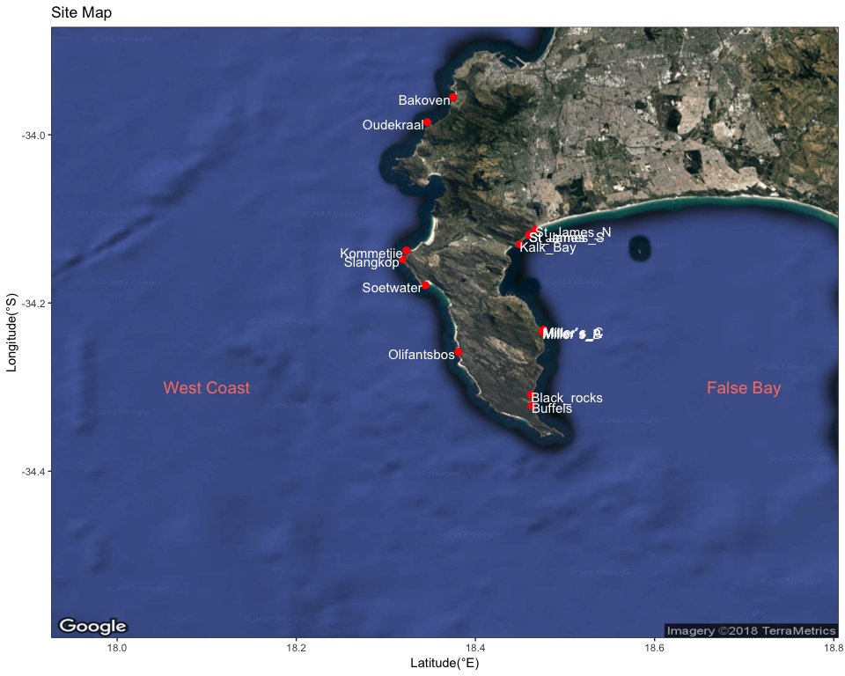

**Figure 1.**A site map showing the locations at which the morphometric measurements of Ecklonia maxima were collected for this study.

**Table 1.**A list of morphological measurements, unit and procedures of *Ecklonia maxima* that were collected.

|  |  |  |
| --- | --- | --- |
| **Morphological measurement** | **Unit** | **Description** |
| Primary blade length | cm | From where the stipe widens and flattens into frond at distal end of primary blade |
| Primary blade width | cm | At maximum width |
| Frond length | cm | Longest frond |
| Stipe length | cm | From directly above the holdfast to where stipe widens and flattens into frond. |
| Stipe circumference | cm | At widest point (around pneumatocyst) |
| Number of tufts | N/A | Number of points at which secondary blades branches off primary blade |
| Epiphyte length | cm | Length of stipe from base covered in epiphytes |
| Frond mass | kg | Total mass of fronds from base of primary blade |
| Stipe mass | kg | Total mass of stipe (see stipe length) |

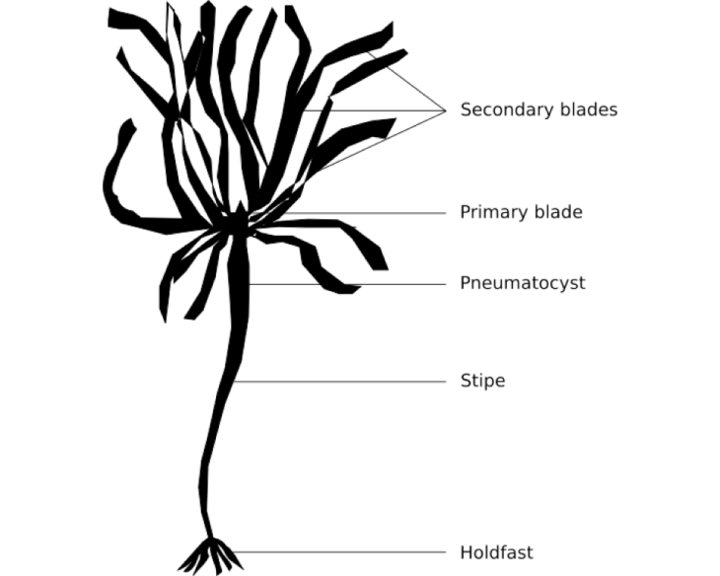

**Figure 2.**An annotated diagram of an Ecklonia maxima sporophyte. This consists of the holdfast, stipe, primary and secondary blades and the pneumatocyst.

## Wave Parameters

All wave data, taken at three-hour resolutions, were obtained from the South African Weather Service (SAWS). The wind and wave parameters measured were; wave height (*hs*, m), wave period (*tp*, s-1), wave direction (*dir*, o), wind direction (*dirw*, o) and wind speed (*spw*, km.h-1). Short-crested waves, generated by wind into the coastal environment (Booijetal., 1997) were modeled from the data using the Simulating Waves in the Nearshore (SWAN) model (Booijetal., 1997). SWAN enables the removal of wave parameters from particular gridded locations in the nearshore. For this study, a 200m alongshore resolution was used, at both the 7 and 15m isobaths.

## Statistical Methods

The Shapiro-Wilk test for normality was performed. The morphometric data were then standardized to a mean of 0 and a standard deviation of 1 in order to easily compare variables measured on different scales.

A descriptive summary of the temperature and wave data was also conducted, including statistics such as minimum, maximum, mean, and standard deviation. This was used to determine the monthly and annual climatologies of the sites sampled. These climatologies were used in the redundancy analysis (RDA) to identify the parameters of temperature and wave exposure which are the most influential in kelp morphology. RDAs help to summarize the variation in response variables (morphometric measurements), that is explained by explanatory variables (temperature and wave exposure parameters). This is achieved by performing multiple linear regressions between the response and explanatory variables. All statistical analyses were conducted using R 3.5.1 (R Core Team 2018).

# Results

Frond length showed no specific pattern in geographic location among the sites (Figure 3). Both west coast and False Bay sites had variable frond lengths. Kalk Bay and Soetwater both had significantly shorter frond lengths than the other sites displayed. Olifantsbos, St. James North, Yzerfontein and Oudekraal showed the largest variability in frond lengths when comparing the descriptive statistical boxplots. Frond mass however, displayed large variability at Oudekraal, St. James and Yzerfontein and Kommetjie, with the former three sites having lager masses than that of Kommetjie. All other sites had relatively low variability and lighter frond mass. Sites located fairly close together such as Miller’s Point (including Miller’s PointA, Miller’s PointB and Miller’s PointC), St. James North and St. JamesSouth, and Black Rocks and Buffels Bay, showed no significant difference in frond mass compared to each other. Stipe length displayed the most variability among sites, irrespective of the proximity of their locations. False Bay sites generally have longer stipes than sites along the west coast. Stipe mass is fairly similar across all sites. Stipe circumference is rather similar for all sites except Bakoven on the west coast and Kalk Bay in False Bay.The primary blades of *E. maxima* have high variability in their lengths, with longer primary blades found along the west coast, especially at Olifantsbos, Oudekraal and Slangkop.

Both deep and shallow adult kelp show morphological variation between St. James North and St. James South for all variables, however the differences are not significant. However, all morphological variables of shallow kelp collected at Kalk Bay is significantly larger than that of adult kelp collected at 1m (Figure 4). Juvenile kelp at all sites is significantly different in primary width, stipe circumference, stipe length, stipe mass and total length.

The general pattern observed from Figure 5, shows that kelp collected at 7m deep is larger for all variables than those collected at 1m deep. Kommetjie and Soetwater display significantly different values between depths for all variables. Buffels Bay specimens are only significant in stipe length, stipe mass, frond mass and number of tufts. Oudekraal differs significantly only in stipe length and stipe mass.

Adult *E. maxima* growing at depths of 7m at Miller’s Point, differs only from 1m adults in frond length, stipe length, stipe mass, total length and number of tufts, with all these variables being larger than that of kelp collected at 1m. Miller’s Point_A, Miller’s Point_B and Miller’s Point_C show no significant differences in any of the morphological variables (Figure 6).

Kelp found at 7m depth have a larger variability, but are not really significantly different from adult kelp in shallower water, except for stipe length, stipe mass, total length and number of tufts. Adult kelp collected in 1m deep water is more similar in morphology to juvenile kelp collected at the shoreline (Figure 7).

In figure 8, the annual temperature climatologies show a clear seasonal variation, and a large range between the maximum (red) and minimum (blue) temperatures, at sites located in the north-west region of False Bay, namely Kalk Bay, St. James, St. James_N and St. James_S. Moving south along Cape Point, seasonality and temperature range becomes rather dampened. West coast sites have fairly constant temperatures throughout the year.

For the annual wind and wave climatologies, wave height (left), peaks around September/October - December at sites located in False Bay (Figure 9). West coast sites experience the largest maximum (red) wave heights, especially during winter months. Wave direction (right), is invariable for all parameters, at all sites, except during winter, where there is a slight change in direction. Wave period (left) is somewhat consistent at all sites, however, the minimum (blue) wave period (m/s) is higher and more variable for sites Kommetjie, Olifantsbos, Slangkop, Soetwater and Yzerfontein along the West coast (Figure 10), Wind direction (right) is consistent in all parameters for all sites, with the mean (green) wind direction changing course in winter. Maximum wind speed (Figure 11, red), increases significantly during winter, and decreases again during summer months, for sites in the False Bay region. All parameters of wind speed remain steady along west coast locations.

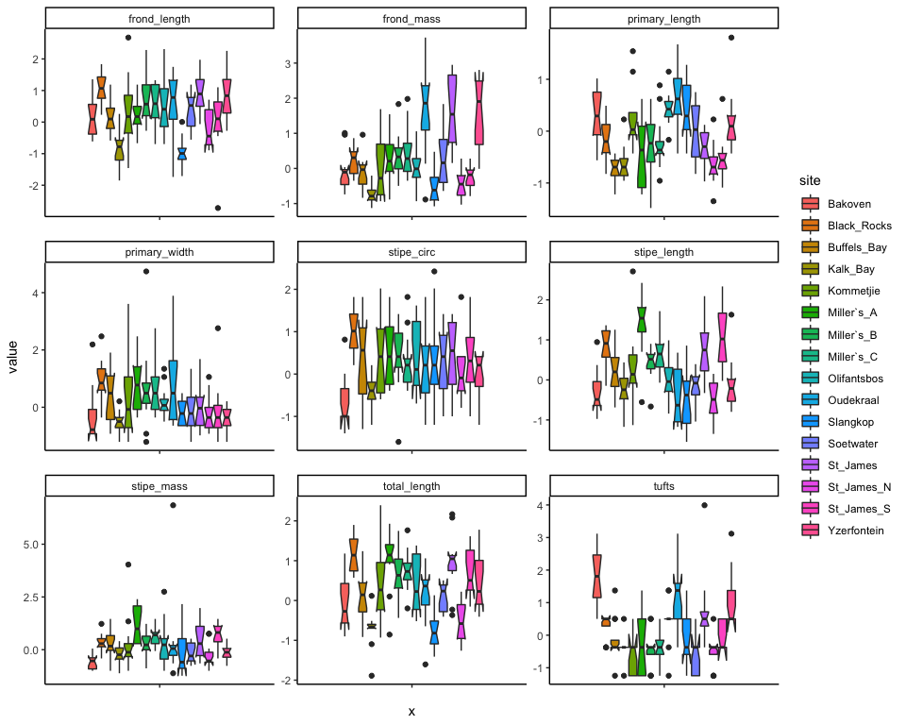

**Figure 3:** Box-and-whisker plots displaying the distribution of morphological measurements of E. maxima collected at 1m depth, based on the five number summary: minimum, first quartile, median, third quartile, and maximum.

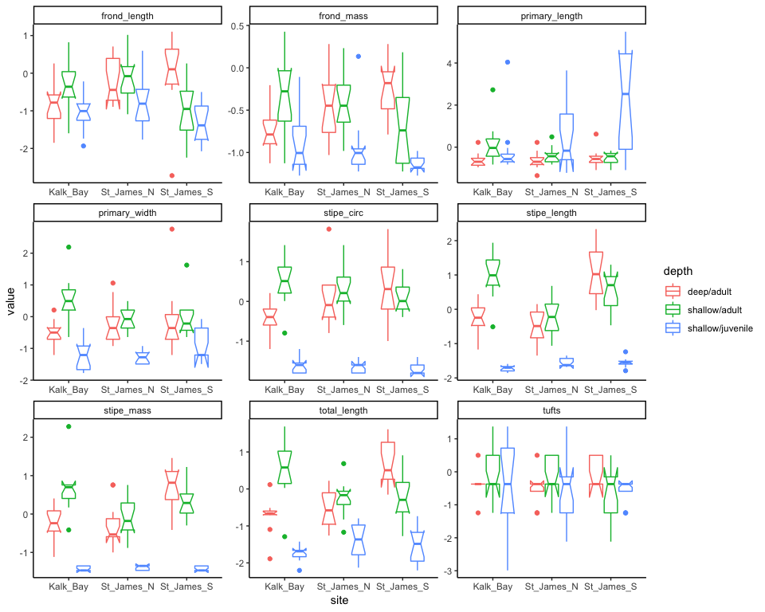

**Figure 4:** A comparison of the morphology of E. maxima collected from three sites, at three different depths. (deep/adult collected at 1m depth, shallow/adult and shallow/juvenile collected at the shoreline).

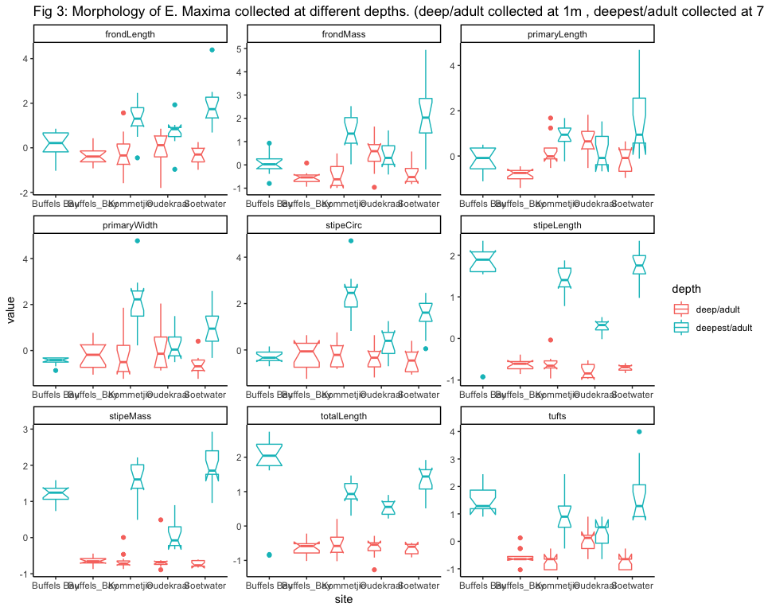

**Figure 5:** Morphometric measurements of E. maxima collected at different depths. (deep/adult collected at 1m depth, deepest/adult collected at 7m depth)

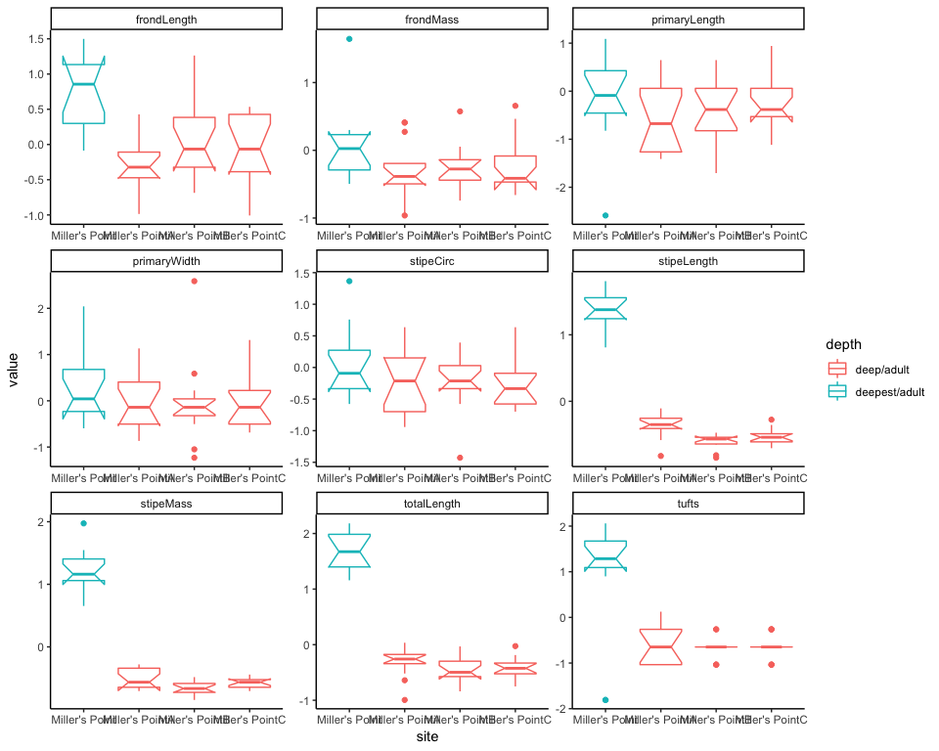

**Figure 6:** Morphological variables of E. maxima collected at Miller’s Point at 1m and 7m depths (deep/adult collected at 1m, deepest/adult collected at 7m).

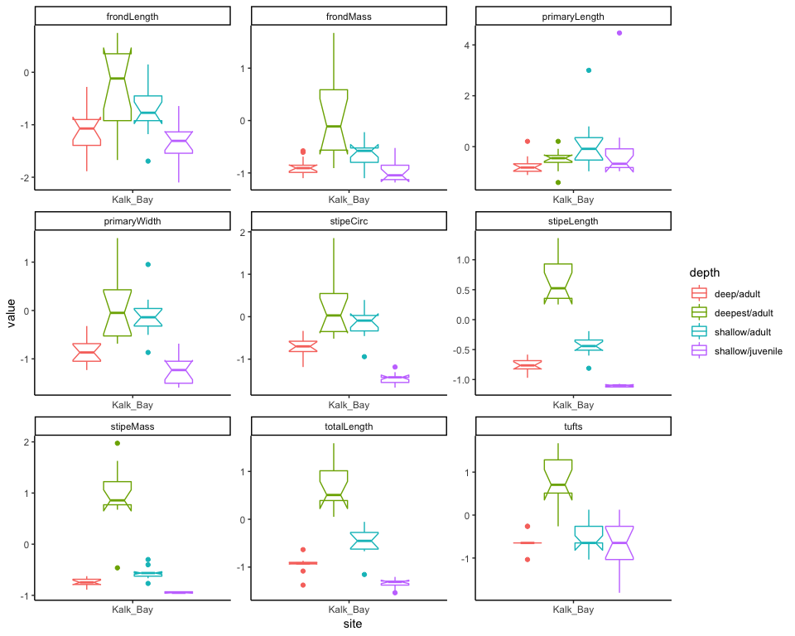

**Figure 7:** Morphology of E. maxima collected at Kalk Bay at different depths (deep/adult collected at 1m, deepest/adult collected at 7m, shallow/adult and shallow/juvenile collected along the shoreline)

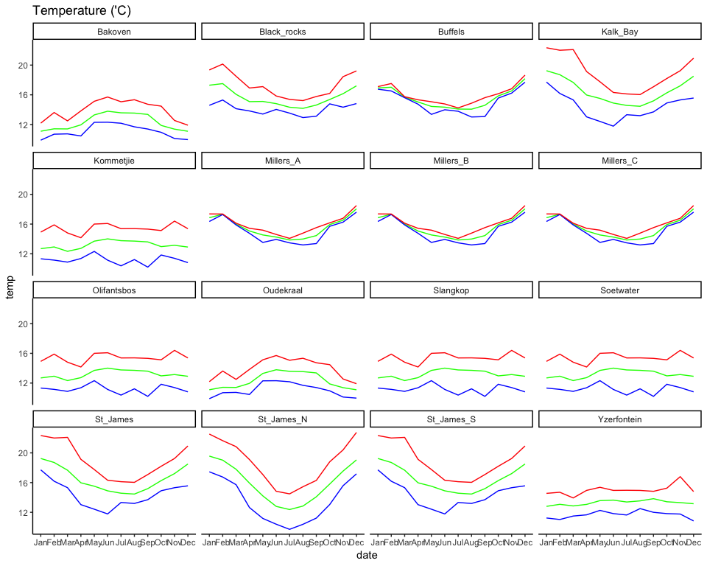

**Figure 8:** The annual temperature climatologies for the site locations at which the morphometric measurements of E.maxima were collected. Temperature parameters mean (green), max (red) and min (blue) are depicted. Climatologies were determined using historical data dating back to 1972 until 2017, although historical data ranges differ for each site.

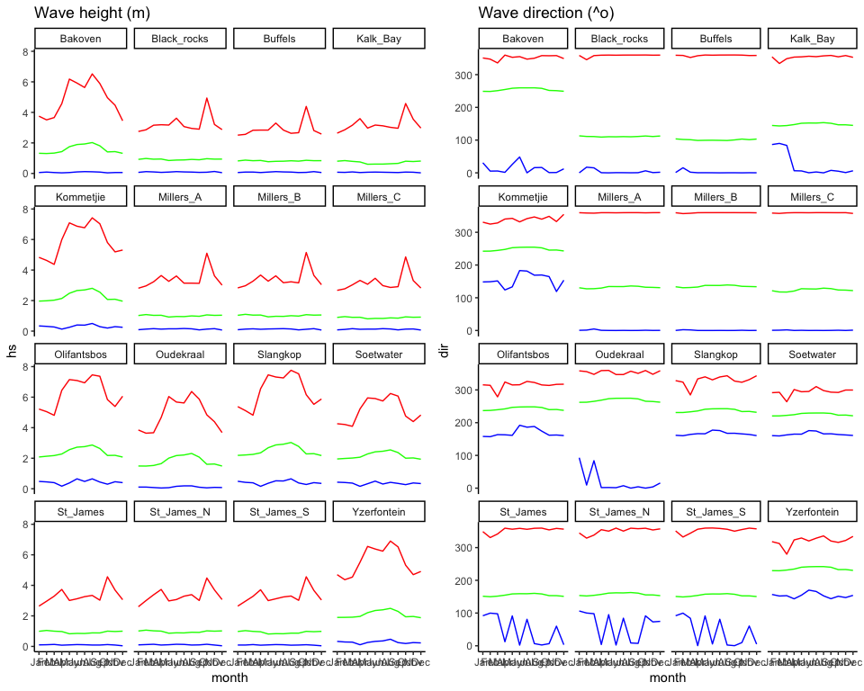

**Figure 9:**The annual wave climatologies for the site locations were the morphometric measurements of E. maxima were collected.The mean (green), maximum (red) and minimum (blue) values for each parameter is depicted in the graphs above.

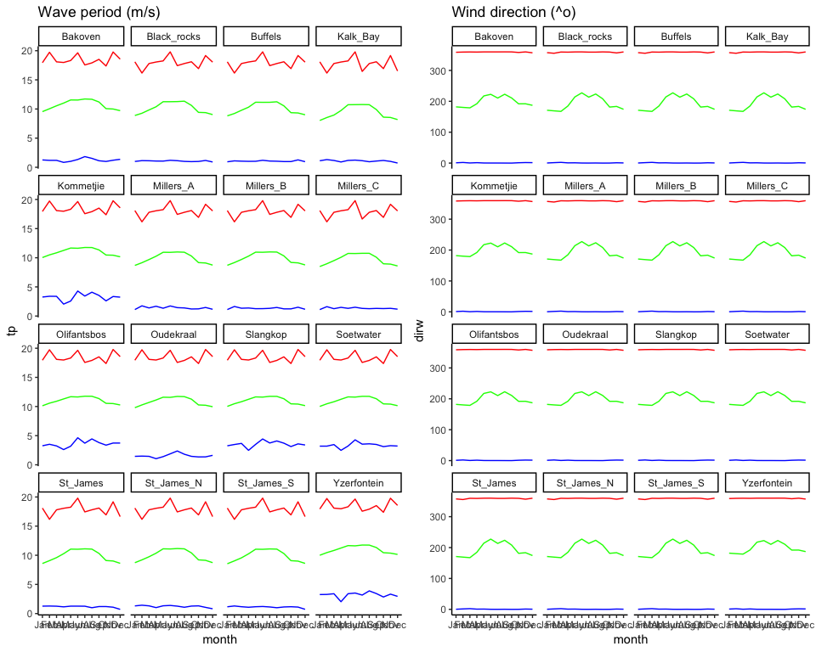

**Figure 10:** The annual wind and wave climatologies for the site locations were the morphometric measurements of E. maxima were collected. The mean (green), maximum (red) and minimum (blue) values for each parameter is depicted in the graphs above.

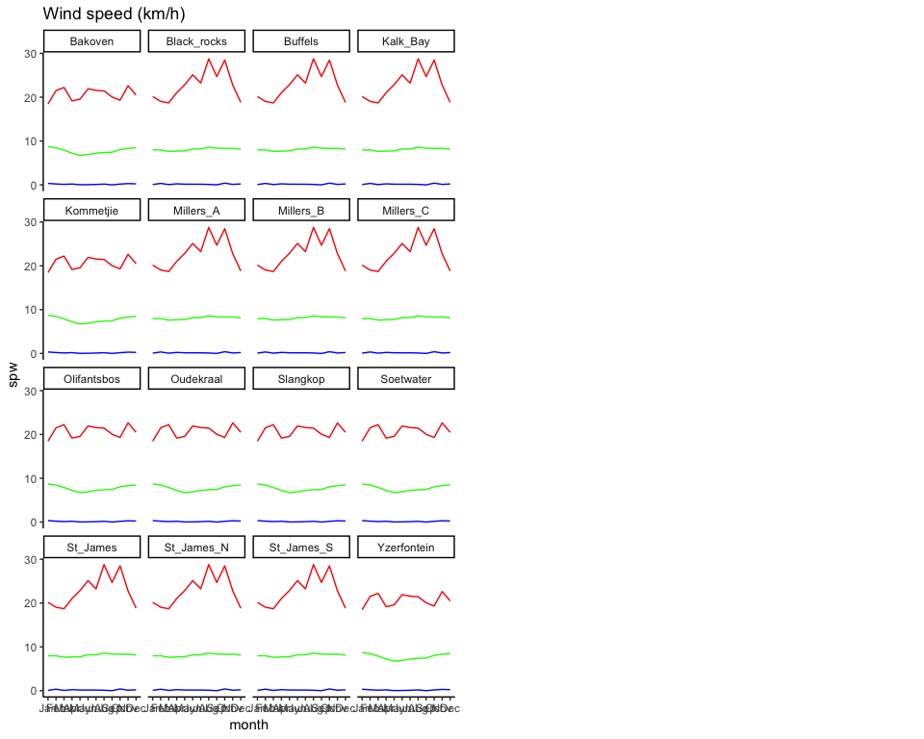

**Figure 11:** The annual wind climatology for the site locations were the morphometric measurements of *E. maxima* were collected. The mean (green), maximum (red) and minimum (blue) values for wind speed is depicted in the graph above.

## RDA

The results of the RDA showed that the mean, minimum, maximum and standard deviation of the annual wave direction, the mean, minimum, maximum and standard deviation of the annual wave period, the annual maximum wind direction, the mean, minimum, maximum and standard deviation of the annual wave period and the mean and maximum wave direction in April are the most influential environmental factors affecting *E. maxima* morphology, with an *R*2 value of 0.999. The adjusted *R*2 value yielded inconclusive results (NA). Only the first two canonical axes were used in the RDA; RDA1 and RDA2, explaining 57.7% and 30.3% of the variation respectively, and 88% cumulatively. The biplot scores for constraining variables, showed that annual wave standard deviation (*Annual_dir_sd*), annual wave period standard deviation (*Annual_tp_sd*), maximum annual wave direction (*Annual_dir_max*) and the maximum wave direction in April (*Apr_dir_max*) were heavily loaded along the RDA1 axis, and negatively influence stipe length. Whereas the other influential factors mentioned above, were more heavily loaded along the second RDA axis (RDA2), positively influencing primary length.

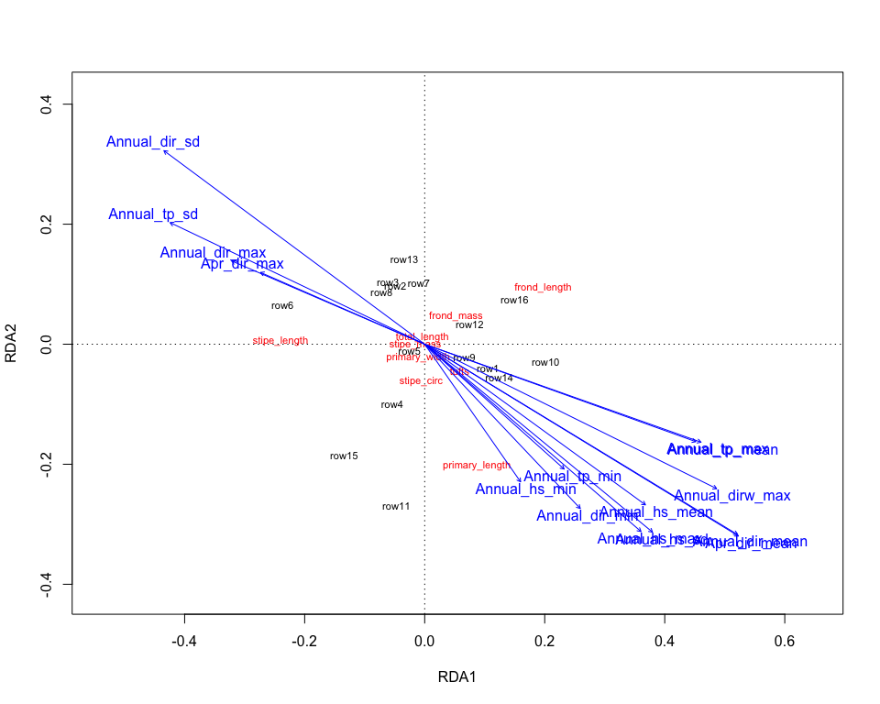

**Figure 12:** An RDA biplot for the morphometric measurements *of E. maxima,* constrained by thermal and wave exposure parameters (environmental variables). The first two canonical axes, RDA1 and RDA2, represent the bulk of the inertia. The environmental (explanatory) variables are depicted by blue vectors extending from the origin. The morphological measurements represent the response variables, and are shown in red. The black points represent the sites, at which morphological measurements were collected.

# Discussion

In this study, we aimed to determine how, or rather which aspects of temperature and wave parameters influence the morphology of *E. maxima* in shallow water. Sporophytes of *E. maxima* were collected in the central parts of its geographical range, at sites with variable temperature and wave exposure regimes. Previous studies have shown that temperature is a driver of the geographic distribution of most marine organisms, including kelp (Bolton 2010). However, there is a strong consensus among biologists, that wave action is responsible for the morphological variation found within kelps (GerardandMann1979, MolloyandBolton1996, Hurd2000, WernbergandThomsen2005). Our results show that wave parameters are the most influential aspects of morphological variation within *E. maxima*, especially parameters around the mean of annual wave direction, annual wave height, and annual wave period. Annual maximum wind direction and the mean and maximum wave direction in April were also important in influencing the morphology of *E.maxima* in shallow water.

Although temperature is the determining factor of the distribution of kelp (Bolton2010), temperature parameters had no influence whatsoever on the morphology of *E. maxima*. Temperature shows more variation at sites in False Bay, especially during summer when temperatures can reach highs of 24oC. Maximum temperatures during summer (Figure 8) coincides with the peak of the upwelling season (Velimirovetal., 1997) bringing nutrients to the surface. South easterly winds are stronger during summer months (Figure 9, right), blowing the warm Agulhas current waters into the bay. This occurrence has a strong effect on the intensity of wave action and wave height within False Bay. West coast sites experience fairly constant temperatures throughout the year. The unique topography of Cape point shelters the west coast sites from this strong prevailing wind during summer. Minimum temperatures were recorded between the winter months of June and September, when the first south-easterly wind of the season occurs, blowing the coastal waters offshore (Velimirovetal., 1997).Unseasonal upwelling occurs during this time, when the south-easter blows for short periods of time (Velimirovetal., 1997).

After thorough analysis between kelps in exposed and sheltered sites, Fowler-Walker, Wernberg and Connell (2006) determined that morphological variation is a plastic trait, which kelps have developed in response to their local environment. When comparing morphological variables among sites, it is evident that there are clear patterns distinguishing False Bay sites, to those along the West Coast. Primary blade length and stipe length are two variables where these patterns are clearly visible (Figure 3). Sites in the False Bay region generally have shorter primary blades and, longer stipe lengths. This could be in response to environmental conditions, as False Bay is more exposed to the prevailing south easterly winds, resulting in more extreme wave action. Increased stipe lengths are thought to be a morphological response to light limitation due to crowding in kelp beds (Hymansonetal., 1990, Holbrooketal., 1991,SjøtunandFredriksen1995). Longer stipe lengths, also allow kelp to be more flexible and adopt a “go with the flow” style of living, reducing the effects of wind-driven water motion (GaylordandDenny1997). It is however less beneficial in shallower waters and areas experiencing large wave heights (GaylordandDenny1997).

Blade morphology is highly variable in kelp species, as they adapt to local wave regimes (WernbergandVanderklift2010, RobersonandCoyer2004, WernbergandThomsen2005). Morphologies include long, flat blades in high wave action areas (Koehletal., 2008), which decrease drag (Denny1988) to prevent breakage (JohnsonandKoehl1994, Blanchetteetal., 2002) and lower rates of dislodgement (Hurd2000).

Kelps in sheltered localities, along the West Coast show similar trends to studies done by Gerard and Mann (1979), Wheeler (1980) and Fowler-Walker, Wernberg and Connell (2006), where kelp sporophytes have adapted by increasing the surface area of their secondary fronds, characterized by wide, rough blades in shallow, low wave action areas (Koehl et al., 2008, Levy 2014), which increase turbulence around the blade, decreasing the boundary layer in order to increase nutrient uptake (Wheeler 1980, Roberson and Coyer 2004, Levy 2014) and receive optimal light for photosynthesis.

Differences in growth rates and morphology are related to the position of the kelp within the canopy, as well as seasonal variations, because kelps grow faster in summer than in winter (Stewartetal., 2009). This is reiterated by the peak of upwelling supplying nutrients to the kelp, and wave action removing waste products from the surface of the kelp, promoting growth (Westlake1967). Adult sporophytes collected in shallow water are significantly larger than adult kelps collected in 1m deep water (Figure 4). This is a result of the dampening effect kelp canopies have on current velocities and waves along the shore (KoehlandAlberte1988, DudgeonandJohnson1992, Jackson1997, Koehl2000, Gaylordetal., 2007).

When comparing sporophytes collected in water as deep as 7m (Figures 5 and 6), it is important to note that these kelps are usually below the surface of the water. Thus, they are not in the direct path of intense wave action, and the risk of dislodgement and/or breakage, is far less than for that of kelps at 1m depth. Kelps in deeper water invest more of their energy into stipe length, stipe mass and frond lengths, in order to compromise for the lack of light penetration, evident at Buffels Bay and Miller’s Point which are exposed to semi exposed sites. Kelps collected at the West coast sites of Kommetjie and Soetwater (Figure 5), are more invested in morphologies that increases surface area to maximize nutrient uptake.

Numerous studies have shown that wave exposure is the most commonly identified cause of morphological variation in kelps (GerardandMann1979, Cousens1982, CheshireandHallam1988, MolloyandBolton1996, Blanchetteetal., 2002, RobersonandCoyer2004, Hurd2000, WernbergandThomsen2005). Wave exposure comprises many parameters including, height, direction, speed, period and wind speed and wind direction. So, it is assumed that morphology responds differently to each parameter within the hydrodynamic environment (WernbergandThomsen2005). Although, it needs to be considered that site-specific factors such as depth, (MolloyandBolton1996), grazing (KalvasandKautsky1993) and nutrient levels (Blanchette et al., 2002) also somewhat influence kelp morphology. Deeper kelps are however less affected by wave action than those occurring in shallower areas (Velimirovetal.,1997). The RDA showed annual maximum wave height is one of the most influential parameters on *E. maxima* morphology. West coast sites tend to have larger waves, especially in winter. This has allowed *E. maxima* to adapt to these harsh conditions by developing larger primary blades that can withstand intense wave action. Stipe circumference is also larger at these sites in order for kelp to remain buoyant and more flexible. Another possible reason for the larger morphologies in this location is to maximize the uptake of nutrients which comes with the intense upwelling. Therefore, fronds become longer, the primary blades become wider and the thalli in general are sturdier.

Frond mass was explained by the standard deviation of the annual wave direction. This is another technique of *E. maxima* to become sturdier and prevent dislodgement or breakage. When wave direction changes from the south easterly, to a more northerly direction, the sites along the west coast feels the full effects. The Cape Point headland shelters False Bay in the same way that the west coast sites are sheltered from the summer south easterly.

Kelps are an important indicator of change as they are extremely responsive to environmental conditions, thus with the looming threat of climate change and resulting increase of sea surface temperatures, it is predicted that geographic distribution will be shifted and fairly reduced (Mulleretal., 2009, Merzouk2011). Kelps have an impact on community structure (Stenecketal., 2002), so the impacts of global warming and climate change will have a cascading effect throughout temperate marine ecosystems (Wernbergetal., 2010). Consequences include possible loss of fragmentation of kelp habitats, causing a loss in biodiversity within kelp beds and its surrounds (Wernbergetal., 2010).

# Conclusions

The results of the RDA showed no temperature parameters to be influential in the morphology of shallow water *E. maxima*. The wave exposure parameters with the most influence were the parameters around the mean of annual wave direction, annual wave height, and annual wave period. Annual maximum wind direction and April’s mean and maximum wave direction were also important factors. Although it is important to note that a number of biological factors also play a role in kelp morphology. Kelp are keystone species that are extremely responsive to environmental change, and therefore global warming and climate change will have cascading effects on the community structure around and within kelp forests.

Limitations of this study include a poor representation of *Ecklonia maxima*’s geographic distribution. More sites needed to be sampled, up to and including its eastern and western boundaries, De Hoop and St Helena Bay respectively. For depth comparison analysis, more sites needed to be compared at the four different depths mentioned in this study, in order to achieve significant results. Future studies should include morphological measurements of secondary blade width and measurements surrounding holdfast structure, and traits representing flexibility and strength.

Wave direction, wave height and wave period are the most important wave exposure parameters in the morphological variation of *Ecklonia maxima* around the south west coast of South Africa.

# Acknowledgements

Firstly, I would like to thank my supervisor, Prof. AJ Smit, for guiding me through this year, and for sharing his extensive knowledge of kelp and love for R with me. To Ross Coppin, my co-supervisor, I am beyond grateful for all the pointers and words of encouragement when things got too much. A big thank you to Team Kelp, for sacrificing their valuable time to help me with sampling, obtaining the temperature and wave data as well as the R analyses, it is greatly appreciated. A special thank you to Carlin Landsberg and Amieroh Abrahams, you ladies have made this BSc (Honours) journey so much more bearable and a lot of fun, especially when we were seeing geom_flames(). Thank you to my family and friends, for their unfailing love and support, and words of encouragement. Thank you to the Department of Biodiversity and Conservation Biology at the University of the Western Cape; especially the BSc (Honours) class of 2018, it has been a privilege being surrounded by such enthusiastic biologists. Finally, I would like to thank the NRF for providing me with funding to complete this project.

# References

Adey, W.H., Steneck, R.S., 2001.Thermogeography over time creates biogeographic regions: a temperature/space/time-integrated model and an abundance-weighted test for benthic marine algae. *Journal of Phycology* 37, 677-698.

Anderson, R.J., Carrick, P., Levitt, G.J., Share, A., 1997. Holdfasts of adult kelp *Ecklonia maxima* provide refuges from grazing for recruitment of juvenile kelps. *Marine Ecology Progress* Series 159, 265-273.

Andrews, W., Hutchings, L., 1980. Upwelling in the Southern Benguela Current. *Progress in Oceanography* 9, 1-81.

Beal, L.M., De Ruijter, W.P.M., Biastoch, A., Zahn, R. 2011. On the role of the Agulhas system in ocean circulation and climate. *Nature* 472, 429-36.

Blanchette, C.A., Miner, B.G., Gaines, S.D., 2002. Geographic variability in form, size and survival of *Egregia menziesii* around Point Conception, California. *Marine Ecology Progress Series*. 239, 69-82.

Bolton, J.J., Levitt, G., 1985. Light and temperature requirements for growth and reproduction in gametophytes *of Ecklonia maxima* (Alariaceae: Laminariales). *Marine Biology* 87, 131-135.

Bolton, J.,Anderson, R., 1987. Temperature tolerances of two southern African *Ecklonia* species (Alariaceae: Laminariales) and of hybrids between them. *Marine Biology* 96,293-297.

Booij, N., Holthuijsen, L., Ris, R., 2001.The “SWAN” wave model for shallow water. *Coastal Engineering Proceedings, 1(25).*

Bekkby, T., Rinde, T.,Erikstad, L., Bakkestuen, V., 2009. Spatial Predictive Distribution Modelling of the Kelp Species *Laminaria Hyperborea*. *ICES Journal of Marine Science* 66(10), 2106-2115. https://doi.org/10.1093/icesjms/fsp195.

Bolton, J.J., 2010. The biogeography of kelps (Laminariales, Phaeophyceae): A global analysis with new insights from recent advances in molecular phylogenetics. *Helogoland Marine Research* 64,263-279.

Bolton, J., Anderson, R., Smit, A. & Rothman, M. 2012. South African kelp moving eastwards: The discovery *of Ecklonia maxima* (Osbeck) Papenfussat De Hoop Nature Reserve on the south coast of South Africa*.* *African Journal of Marine Science* 34, 147-151.

Boyer, D., J. Cole, and C. Bartholomae, 2000: Southwestern Africa: Northern Benguela Current region. *Marine Polution Bulletin*41, 123-140.

Cheshire, A.C., Hallam, N.D., 1988. Morphology of the southern Bull-Kelp (*Durvillaeapotatorum*, Durvilleales, Phaeophyta) from King Island (Bass Strait Australia). *Botanica Marina* 31, 139-148.

Cousens, R., 1982. The effect of exposure to wave action on the morphology and pigmentation *of Ascophyllum nodosum* (L.) Le Jolis in South-Eastern Canada. *Botanica Marina* 25, 191-195.

De Clerck, O., Bolton, J., Anderson, R., Coppejans, E., Bolton, J., Anderson, R., 2005b. Guide to the Seaweeds of KwaZulu-Natal, *Scripta Botanica Belgica*, 294

Denny, M.W., (1988). Biology and the Mechanics of the Wave-swept Environment. Princeton, NJ: Princeton University Press. Retrieved from http://www.jstor.org/stable/j.ctt7ztnb7

Dudgeon, S.R., Johnson, A.S., 1992. Thick vs. thin: thallus morphology and tissue mechanics influence differential drag and dislodgement of two co-dominant seaweeds. *Journal of Experimental Marine Biology and Ecology*165, 23-43.

Field, J.G., Griffiths, C.L., Griffiths, R.J., Jarman, N., Zoutendyk, P., Velimirov, B., Bowes, A,. 1980. Variation in structure and biomass of kelp communities along the South-west Cape coast. *Transactions of the Royal Society of South Africa* 44, 145-203.

Fredriksen, S., 2003. Food web studies in a Norwegian kelp forest based on stable isotope (delta C-13 and delta N-15) analysis. *Marine Ecology Progress Series* 260, 71-81.

Friedland, M.T., Denny, M.W., 1995. Surviving hydrodynamic forces in a wave-swept environment: Consequences of morphology in the feather boa kelp, *Egregia menziesii* (Turner). *Journal of Experimental Marine Biology and Ecology* 190, 109-33.

Gerard, V.A., Mann, K.H., 1979. Growth and production of *Laminaria longicruris* (Phaeophyta) populations exposed to different intensities of water movement. *Journal of Phycology* 15, 33-41.

Gerard, V.A., 1987. Hydrodynamic streamlining of *Laminaria saccharina* Lamour in response to mechanical stress. *Journal of Experimental Marine Biology and Ecology* 107, 237-244.

Gaylord, B., & Denny, M., 1987. Flow and flexibility. *Journal of Experimental Biology*, *200*, 3141-3164.

Gaylord, B., Rosman, J.H., Reed, D.C., Koseff, J.R., Fram, J., MacIntyre, S., Arkema, K., McDonald, C., Brzezinski, M.A., Largier, J.L., Monismith, S.G., Rainmondi, P.T., Mardian, B., 2007.Spatial patterns of flow and their modification within and around a giant kelp forest. Limnology and Oceanography 52, 1838-1852.

Griffiths, C., Mead, A., Zietsman, L., 2011. Human activities as drivers of change on South African rocky shores. Observations on Environmental Change in South Africa*, Sun Media, Stellenbosch, South Africa* 242-246.

Holbrook, N.M., Denny, M.W., Koehl, M.A.R., 1991. Intertidal trees consequences of aggregation on the mechanical and photosynthetic properties of sea palms *Postelsia palmaeformis* Ruprecht. *Journal of Experimental Marine Biology and Ecology* 146, 39-68.

Hymanson, Z.P., Reed, D.C., Foster, M.S., Carter, J.W., 1990. The validity of using morphological characteristics as predictors of age in the kelp *Pterygophora californica* Laminariales Phaeophyta. *Marine Ecology Progress Series* 59, 295-304.

Hurd, C.L., 2000. Water motion, marine macroalgal physiology, and production. *Journal of Phycology*. 36, 453-472.

Jackelman, J.J., Bolton, J.J., 1990. Form variation and productivity of an intertidal foliose *Gigartina*species (Rhodophyta) in relation to wave exposure. *Hydrobiologia* 204, 57-64.

Jackson, G.A., 1997. Currents in the high drag environments of a coastal kelp standoff California. *Continental Shelf Research* 17, 1913-1928.

Johnson, A., Koehl, M.A.R., 1994. Maintenance of dynamic strain similarity and environmental stress factor in different flow habitats: thallus allometry and material properties of a giant kelp. *Experimental Marine Biology* 195, 381-410.

Kain, J. 1979. A view of the genus *Laminaria*. *Oceanography and Marine Biology, an Annual Review* 17, 101-161.

Kalvas, A., Kautsky, L., 1993. Geographical variation in *Fucus vesiculosus* morphology in the Baltic and North Seas. *European Journal of Phycology* 28, 85-91.

Kawamata, S., 2001. Adaptive mechanical tolerance and dislodgement velocity of the kelp laminaria japonica in wave-induced water motion. *Marine Ecology Progress Series* 211, 89-104.

Klinger, T., De Wreede, R.E., 1988. Stipe rings, age and size in populations of *Laminaria setchellii* Silva (Laminariales, Phaeophyta) in British Columbia, Canada. *Phycologia* 27, 234-240.

Koehl, M., 1986. Seaweeds in moving water: Form and mechanical function. In Givnish, T. J. [Eds.] On the Economy of Plant Form and Function. *Cambridge University Press, Cambridge* 603-34.

Koehl, M.A.R., Alberte, S., 1988. Flow, flapping and photosynthesis of *Nereocystis luetkeana*: A functional comparison of undulate and flat blade morphologies. *Marine Biology* 99, 435-444.

Krumhansl, K., Scheibling, R., 2012. Production and fate of kelp detritus. - *Marine Ecology Progress Series* 467, 281-302.

Levy, S., 2014. How reliable is morphological species delimination in kelp? A study of two closely related South African *Ecklonia* specie*s.* (Honours). University of Cape Town.

Lüning, K., Neushul, M., 1978. Light and temperature demands for growth and reproduction of Laminarian gametophytes in southern and central California. *Marine Biology* 45, 297-309.

Lüning, K., 1984. Temperature tolerance and biogeography of seaweeds—the marine algal flora of Helgoland (North Sea) as an example. *Helogoland Marine Research* 38, 305-317.

Lüning, K., 1990. Seaweeds, Their Environment, Biogeography and Ecophysiology. *Wiley, New York*, 527.

Mann, K., 1973. Seaweeds: their productivity and strategy for growth. *Science* 182, 975-981.

McQuaid, C.D., Branch, G.M., 1984. Influence of sea temperature, substratum and wave exposure on rocky intertidal communities: an analysis of faunal and floral biomass. *Marine Ecology Progress Series.* 19, 145-151.

Merzouk, A., Johnson, L., 2011. Kelp distribution in the northwest Atlantic Ocean under a changing climate. *Journal of Experimental Marine Biology and Ecology* 400(1-2), 90-98.

Molloy, F., Bolton, J., 1996. The effects of wave exposure and depth on the morphology of inshore populations of the Namibian kelp, *Laminaria schinzii Foslie. Botanica Marina* 39,525-32.

Papenfuss, G. F., 1942. Studies of South African Phaeophyceae: *Ecklonia maxima, Laminaria pallida, and Macrocystis pyrifera. American Journal of Botany* 29, 15-24.

Partridge, T.C., Scott, L., Schneider, R.R., 2004. Between Agulhas and Benguela: responses of southern African climates of the Late Pleistocene to current fluxes, orbital precession and the extent of the circum-Antarctic vortex. In Battarbee, R. W. [Ed] Past Climate Variability through Europe and Africa, *Springer, Netherlands* 45-68.

Probyn, T., McQuaid, C.D., 1985. *In-situ* measurements of nitrogenous nutrient uptake by kelp (*Ecklonia maxima*) and phytoplankton in a nitrate-rich upwelling environment. *Marine Biology* 88, 149-154.

R Core Team (2018). R: A language and environment for statistical computing. R Foundation for Statistical Computing, Vienna, Austria. URL https://www.R-project.org/.

Ralph, P.J., Morrison, D.A., Addison, A., 1998. A quantitative study of the patterns of morphological variation within *Hormosirabanksii* (Turner) Decaisne (Fucales: Phaeophyta) in south-eastern Australia. *Journal of Experimental Marine Biology and Ecology* 225, 285-300.

Roberson, L.M., Coyer, J A., 2004. Variation in blade morphology of the kelp *Eisenia arborea*: Incipient speciation due to local water motion? *Marine Ecology Progress Series* 282, 115-28.

Rothman, M D., Mattio, L., Wernberg, T., Anderson, R.J., Uwai, S., Mohring, M.B., Bolton, J.J., 2015. A molecular investigation of the *genus Ecklonia* (Phaeophyceae, Laminariales) with special focus on the Southern Hemisphere. *Journal of Phycology* 51(2), 236-46.

Rouault, M.J., Mouche, A., Collard, F., Johannessen, J.A., Chapron, B., 2010. Mapping the Agulhas Current from space: An assessment of ASAR surface current velocities. *Journal of Geophysical Research* 115(C10), 1-14.

Rouault, M.J., Penven, P., 2011, New perspectives on Natal Pulses from satellite observations*. Journal of Geophysical Research*116, C07013.

Rysgaard, S., Nielsen, T.G., 2006. Carbon cycling in a high-arctic marine ecosystem—Young Sound, NE Greenland. *Progress in Oceanography* 71, 426-445.

Schmitz, W.J., 1995. On the interbasin-scale thermohaline circulation. *Reviews of Geophysics* 33(2), 151-73.

Schumann, E.H., 1988. Physical oceanography off Natal. In Schumann, E. H. [Ed] Coastal Ocean Studies off Natal, South Africa, *Springer, Heidelberg* 101-130.

Shannon, L., 1985. The Benguela ecosystem. I: Evolution of the Benguela physical features and processes. *Oceanography and Marine Biology* 23, 105-182.

Shannon, L., Pillar, S.C., 1986. The Benguela ecosystem Part 3. Plankton. *Oceanography and Marine Biology, Annual Review* 24, 65-170.

Shillington, F.A., Reason, C J.C., Duncombe Rae C.M., Florenchie, P., Penven, P., 2006. Large scale physical variability of the Benguela Current large marine ecosystem (BCLME). In Shannon, V., Hempel, G., Malanotte-Rizzoli, P., Moloney, C., & Woods, J. [Eds] Large Marine Ecosystems. *Elsevier, Netherlands*, 14, 49-70.

Sjøtun, K., Fredriksen, S., 1995. Growth allocation in Laminaria hyperborea (Laminariales, Phaeophyceae) in relation to age and wave exposure. *Marine Ecology Progress Series* 126, 213-222.

Skogen M.D., 1999. A biophysical model applied to the Benguela upwelling system, *South African Journal of Marine Science*21(1) 235-249.

Smit, A.J., Roberts, M., Anderson, R.J., Dufois, F., Dudley, S.F., Bornman, T.G., Olbers, J., Bolton, J.J., 2013. A coastal seawater temperature dataset for biogeographical studies: Large biases between in situ and remotely-sensed data sets around the coast of South Africa*. Public Library of Science* 8,e81944.

Smit, A.J., Bolton, J.J., Anderson, R.J., 2017. Seaweeds in Two Oceans: Beta-Diversity. *Frontiers in Marine Science*. 4, 1-15.

Steneck, R.S., Johnson, C.R., 2013. Kelp forests: Dynamic patterns, processes, and feedbacks. In Bertness, M. D., Bruno, J. F., Silliman, B. R. &Stachowicz, J. J. [Eds.] *Marine Community Ecology and Conservation*. Sinauer Associates, Inc., Sunderland, USA. 315-336.

van den Hoek, C., Lüning, K., 1988. Biogeography of marine benthic algae—preface. *Helogoland Marine Research* 42, 131-132.

van den Hoek, C., Breeman, A.M., Stam, W.T., 1990. The geographic distribution of seaweed species in relation to temperature—present and past. In: Beukema, J.J., Wolff, W.J., Brouns, J.J.W. (Eds.), Expected Effects of Climatic Change on Marine Coastal Ecosystems*. Developments in Hydrobiology, Springer, Dordrecht 57*

Velimirov, B., Field, J.G., Griffiths, C.L., Zoutendyk, P., 1977. The ecology of kelp bed communities in the Benguela upwelling system. *Helgoländer Wiss. Meeresunters* 30, 495-518.

Walker, N.D., 1990. Links between South African summer rainfall and temperature variability of the Agulhas and Benguela Current systems. *Journal of Geophysical Research* 95(C3), 3297-3319.

Wernberg, T., Thomsen, M.S., 2005. The effect of wave exposure on the morphology of *Ecklonia radiata*. *Aquatic Botany* 83, 61-70.

Wernberg, T., Goldberg, N., 2008. Short-term temporal dynamics of algal species in a subtidal kelp bed in relation to changes in environmental conditions and canopy biomass. *Estuarine, Coastal and Shelf Science* 76, 265-72.

Wernberg, T., Vanderklift, M.A., 2010. Contribution of temporal and spatial components to morphological variation in the kelp *Ecklonia* (Laminariales)*. Journal of Phycology* 46, 153-161.

Westlake, D.F., 1967. Some effects of low-velocity currents on the metabolism of aquatic macrophytes. *Journal of Experimental Botany* 18, 187-205.

Wheeler, W.N., 1980. Effect of boundary layer transport on the fixation of carbon by the giant kelp *Macrocystis pyrifera*. *Marine Biology* 56, 103-110.

Wheeler, W.N., 1988. Algal productivity and hydrodynamics—a synthesis. *Progress in Phycology Research* 6, 23-58.