Title: Dart

Short Description: An endless runner game.

Full Description: This game is focused on a blue blob with legs named Dart. They run along the platforms and gradually gain speed as they reach certain milestones. This endless runner game is fun and has cute sound effects when jumping along with a groovy looping sound in the background. There is main menu with a play and quit button, also instruction for the user to turn their phone to landscape mode in order to properly play the game. In the game there is the score counters and a when the player dies it has a death screen which allows the player to restart or go back to the main menu. The goal of the game is to get the newest high score and strive to beat it over and over again.

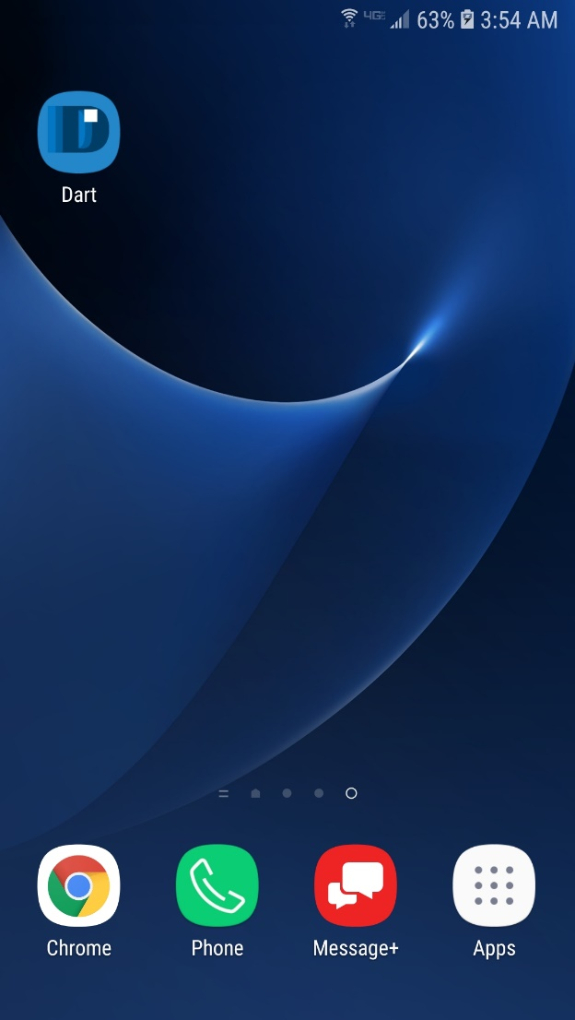

Icon:



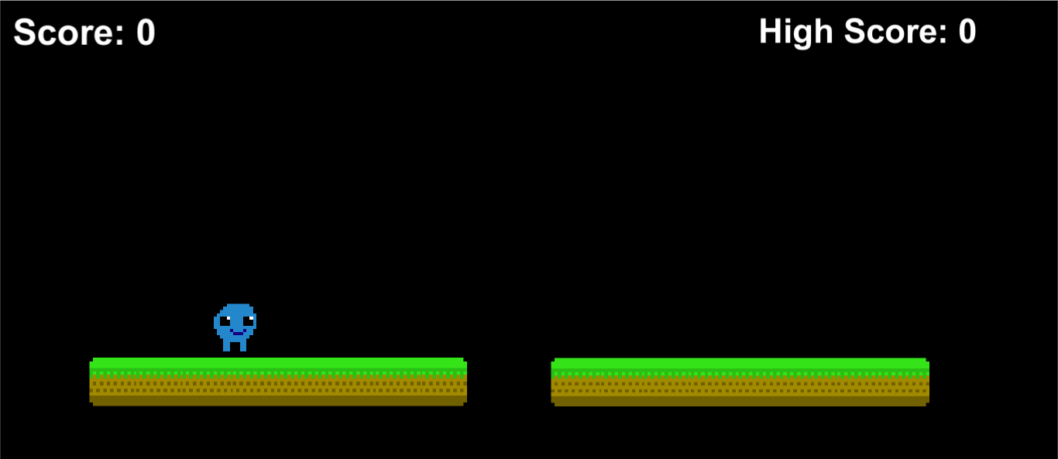Screenshots: 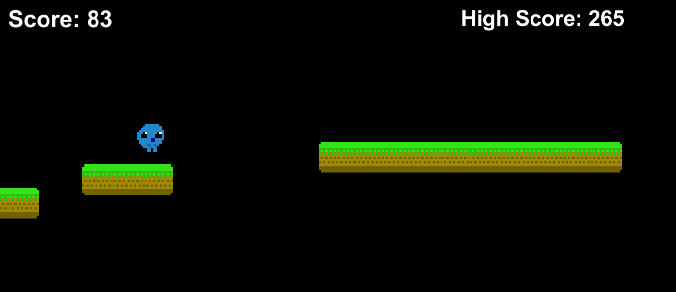

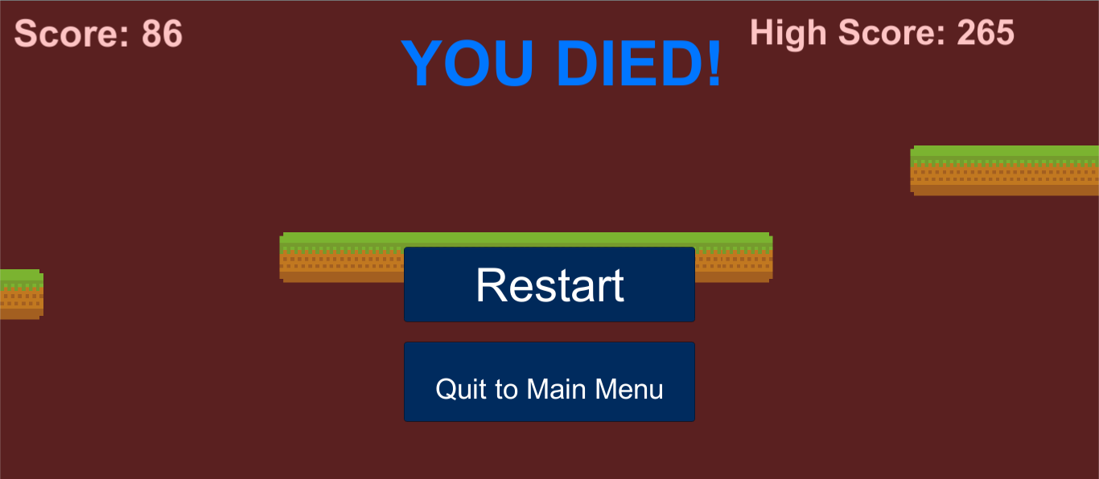

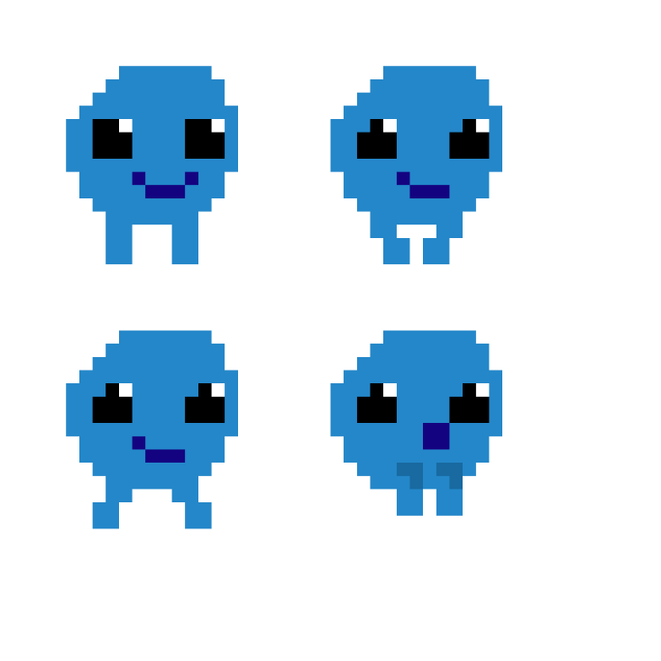Assets Used:

