**Introduction to programming – Unit Conversion**

**Getting started**

* Double-click on the file *UnitConversion.R*
* Make sure your working directory is set to UnitConversion

**Main exercise**

So far, we have been working with measurements obtained from pictures, using units from a graph. This tells us very little about the real world if we don’t have a way to convert these measurements to physical units such as centimeters or meters. Fortunately, we took a picture of a sheet of paper with the same camera settings as we used to capture our waves. We know how wide the sheet is, so all we need is to calculate how graphing units relate to centimeters, using the sheet!

* Modify the reference_file <- "reference.png" line at the top of the script to match the reference picture for your data collection. In our case, we only have one reference image, but in the future, you might have multiple days of data collection with their own reference images.
* In the R console, type source("UnitConversion.R").
* Modify the values for scale_xstart, scale_xend, and scale_y until the red ruler just covers the sheet we taped on the tank. Try not to include the laminated edge, just the paper. Record the values below:  
    
  scale_xstart: ____________ scale_xend: ____________
* **Calculate the length of the scale bar in graphing units.** Write down your calculations not to forget.  
  Length of scale bar (graphing units): ____________________________________________________
* **Calculate the conversion factor.** The piece of paper is 28 cm or 0.28 m. Calculate how many graphing units are in one cm (graphing unit/cm) and how many cm are in one graphing unit (cm/graphing unit). Understanding this may take time, but it will be very useful at school, in science and even for recipes!  
    
    
  graphing units per cm: ____________________________________________________  
    
    
    
  cm per graphing unit: ____________________________________________________
* Go back to **Activity 9** and recopy your wave’s characteristics, including its speed. Using your conversion factor, convert these measurements to physical units. Use the space under table 1 for calculations.  
    
  **Table 1:** Wave characteristics

|  |  |  |  |
| --- | --- | --- | --- |
|  | **In graphing units** | **In centimeters** | **In meters** |
| **Wave #** |  |  |  |
| **Amplitude (A)** | [graphing units] | [cm] | [m] |
| **Wavelength (L)** | [graphing units] | [cm] | [m] |
| **Water depth (D)** | [graphing units] | [cm] | [m] |
| **Speed** | [graphing units/second] | [cm/s] | [m] |

**Advanced activities – if your group is done early**

* **See if you can use RStudio to convert units faster.** In RStudio, open a new script by clicking the icon in the top left corner and selecting R Script.

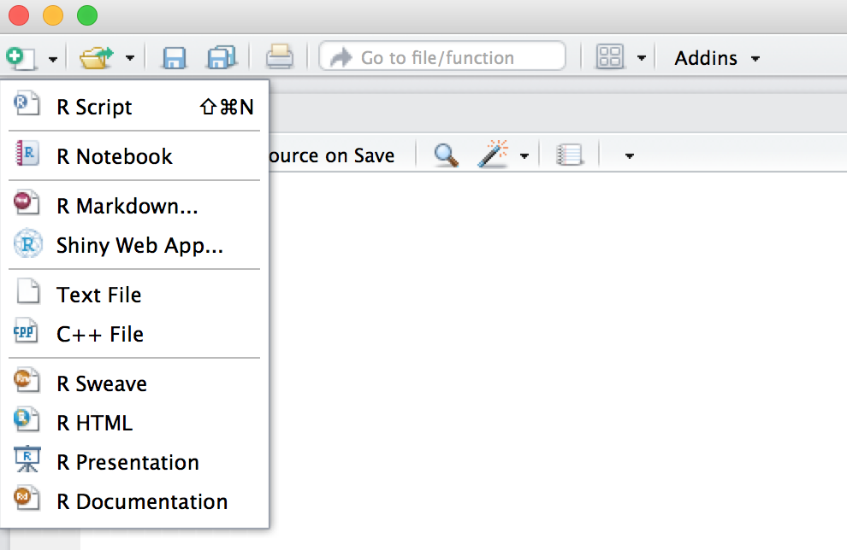

* In this script, assign your wavelength value, in graphing units, to the variable **Lgu** by typing   
  Lgu <- ###. Change the ### to your value. Click the run button to make sure the line works, or copy-paste it in the console. Now, if you type Lgu in the console and press enter, its value should appear.
* Go back to the script and assign the paper width value, in graphing units, to the variable **Pagu** by typing Pagu <- ###. Change the ### to your value. Click the run button to make sure the line works, or copy-paste it in the console.
* Since you know that the paper width in real life is 28 cm, assign the paper width value, in cm, to the variable **Pacm** by typing Pacm <- 28. Click the run button to make sure the line works, or copy-paste it in the console.
* Your conversion factor, from graphing units to cm is now simply **Pacm/Pagu** (cm per graphing units). Assign this ratio to a new variable, **convf**, by typing convf <- Pacm/Pagu. Click the run button to make sure the line works, or copy-paste it in the console.
* Calculate the wavelength, in cm, by using the conversion factor: Lcm <- convf * Lgu. Click the run button to make sure the line works, or copy-paste it in the console.
* Do you see how the units cancel as your instructor taught you? Draw how the units cancel below. If you type Lcm in the console, you should now have the wavelength in cm, provided you did all the calculations right.
* Repeat with the other measurements if you have time.