Critical Thinking Assignment Module 5: Option 1

Jessica Ham

CSC505 – Principles of Software Development

Colorado State University – Global Campus

Steven Evans

October 11, 2020

Critical Thinking Assignment Module 5: Option 1

The requirements this week are to design a fully functional pothole reporting system for a city or area. This system would be quite complex when you consider the types of updates a citizen and an employee both need to be able to initiate. The use case diagram would look as follows:

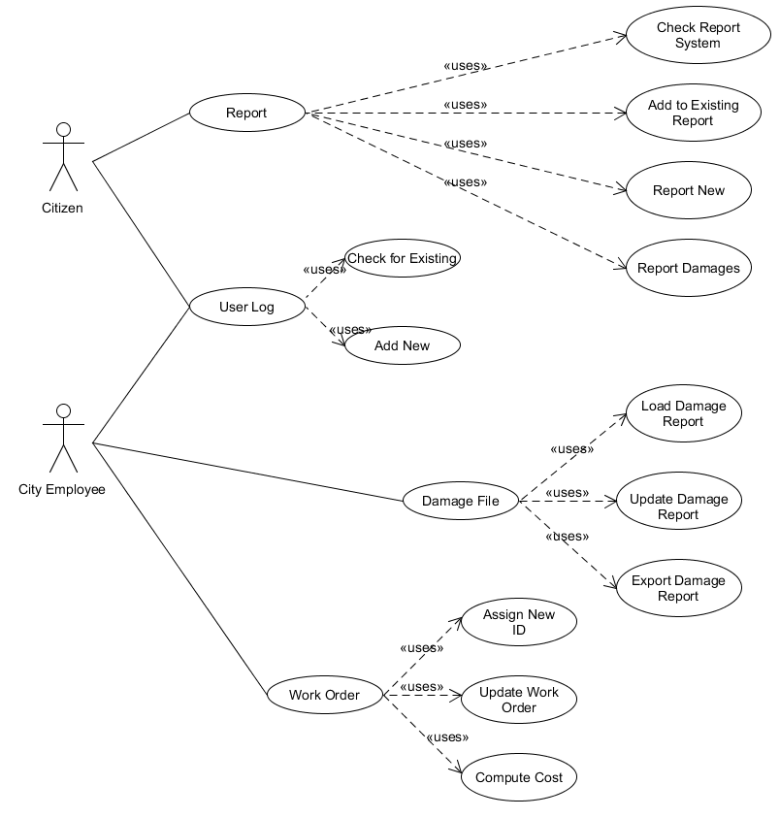

Figure 1 Use Case Diagram

The screenshots that follow will show the operation of the program, from a citizen and then from an employee perspective. These screenshots are not comprehensive and access to the full program is included in the submission.

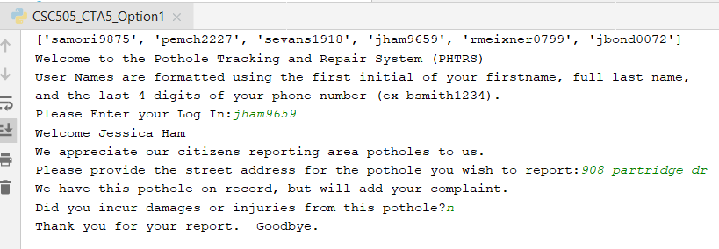

Figure Citizen Reports an existing hole w no damage

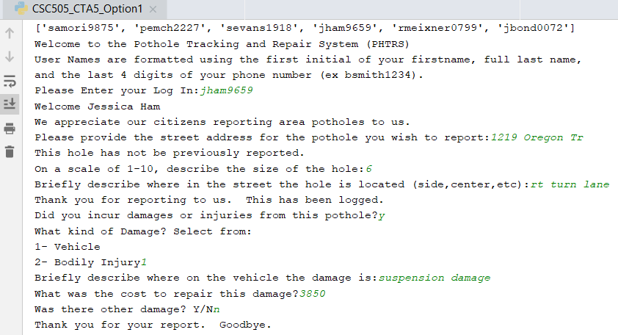

Figure Citizen Reports a new hole w damages

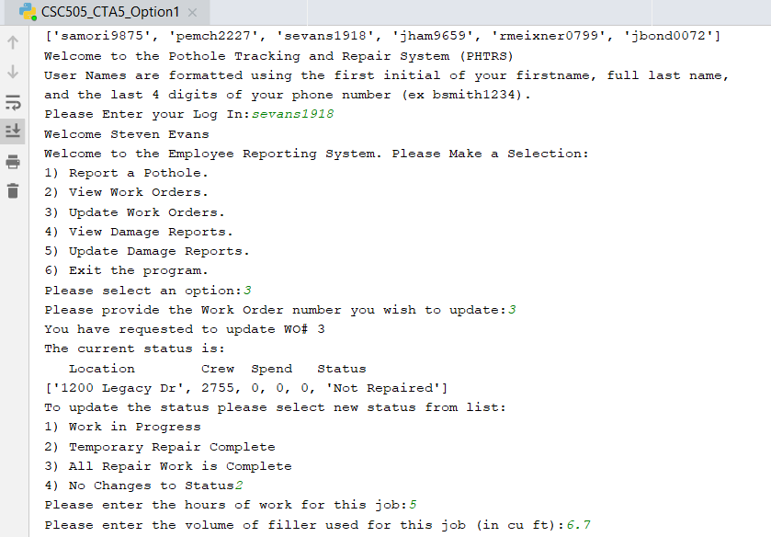

Figure Employee updating Work Order

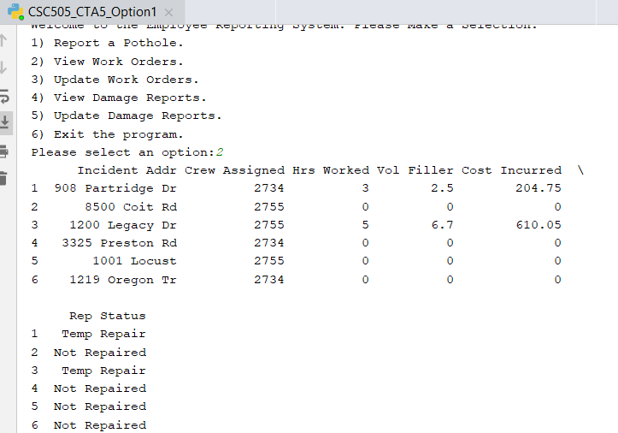

Figure Employee reviews Work Orders after update

The build out of this program is also feeding this data out to databases in the background to ensure all changes are stored. Damages can be paid and that status updated. If I were to complete this for a company, more time would be spent building out the districts and priority which were requested on the system as requirements and on error control as there are still a number of places a user could throw an error with the wrong data type. Additionally, the Work Orders were to include information about what equipment was assigned. I used that for calculating costs, but have equipment as a factor of crews for now. A subsequent version of the program would also build out the addition of crew details to the Work Order print out.

As this assignment continues into next week with a different diagram, some of these flaws can be programmed out at that time, just as they would be after a test and conversation with the future users.

References

JetBrains, 2017. *Pycharm*. [online] JetBrains. Retrieved on 10/2/2020 from:

<https://www.jetbrains.com/pycharm/>.

UMLet (n.d.). Use Case. Retrieved on 10/2/2020 from: <http://www.umlet.com>.