Critical Thinking Assignment Module 6: Option 1

Jessica Ham

CSC505 – Principles of Software Development

Colorado State University – Global Campus

Steven Evans

October 18, 2020

Critical Thinking Assignment Module 6: Option 1

The requirements this week are to update last week’s design of a fully functional pothole reporting system for a city or area. This update should be focused on the program design versus use case. I believe an Object Oriented Architecture best suits this program as there are activities that can be performed depending on the access level of the user. This means there is an application that the user logs in to and it delves into a service layer where classes PHReporter and Employee call actions depending on the user and the request. Finally, all services result in an update to the database directly.

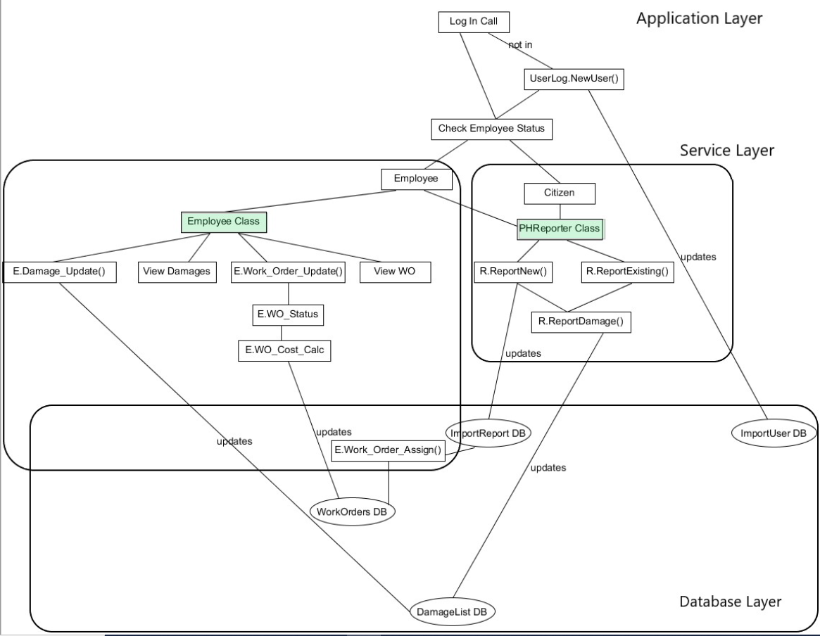

Figure OO Design Architecture

There are a variety of ways these classes may interact with themselves and reuse functions. For example, in the PHReporter class, whether a new or existing pothole is being reported, both allow a report to damages and an update of the Pothole Import Database and the Damage Database. The employee log in actually accesses both classes, reusing the PHReporter class for when an employee is reporting a pothole and damages for themselves. Future expansion of this could allow the employee to report on behalf of citizens if needed without the need to dramatically alter the code for the existing class. A final example of the interactions in this object oriented design is where the Work Order Update function passes through, or uses two other functions to prep data to be rewritten to the database. First the employee can choose to update the status of the work order as a whole, and then, if any repairs have been done, they have the opportunity to add cost information to the repair. These edits feed into the Cost Update function which recalculates the total cost of the repair based on the newest information. For simplicity sake, this program assumes that repair costs will be entered once, and that the data entered is the cumulative hours and materials for the entire repair, though a future expansion on this project could be a sum effect where only the most recent hours and materials are added and increase the already existing info.

The screenshots that follow will show the operation of the program, from a citizen and then from an employee perspective. These screenshots are not comprehensive and access to the full program is included in the submission.

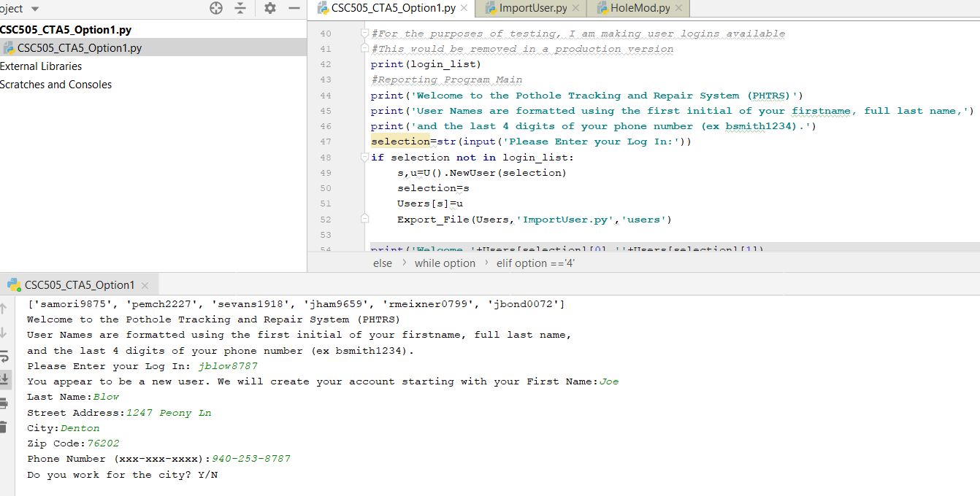

Figure 2 New User Login

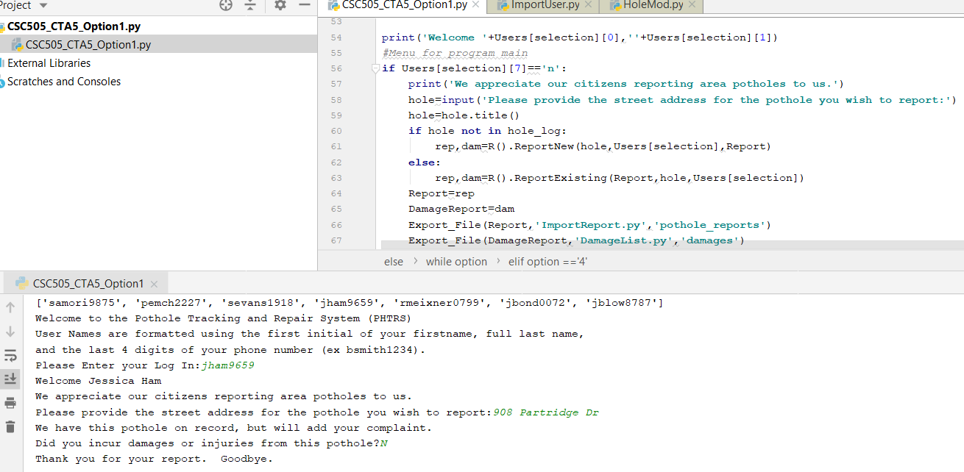

Figure 3 Citizen Reports an existing hole w no damages

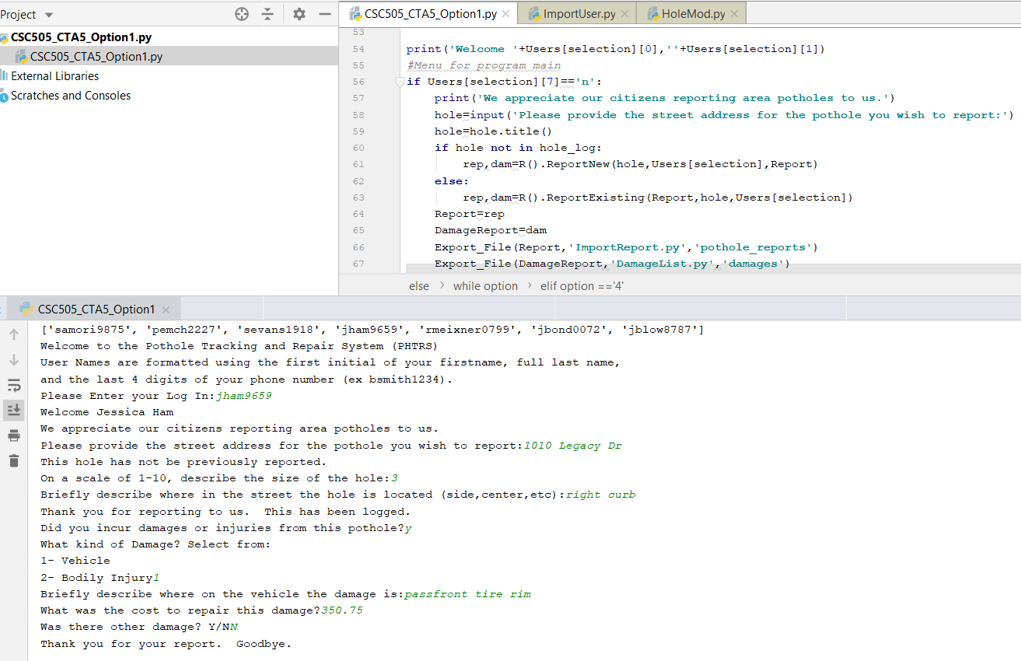

Figure 4 Citizen Reports new hole w damages

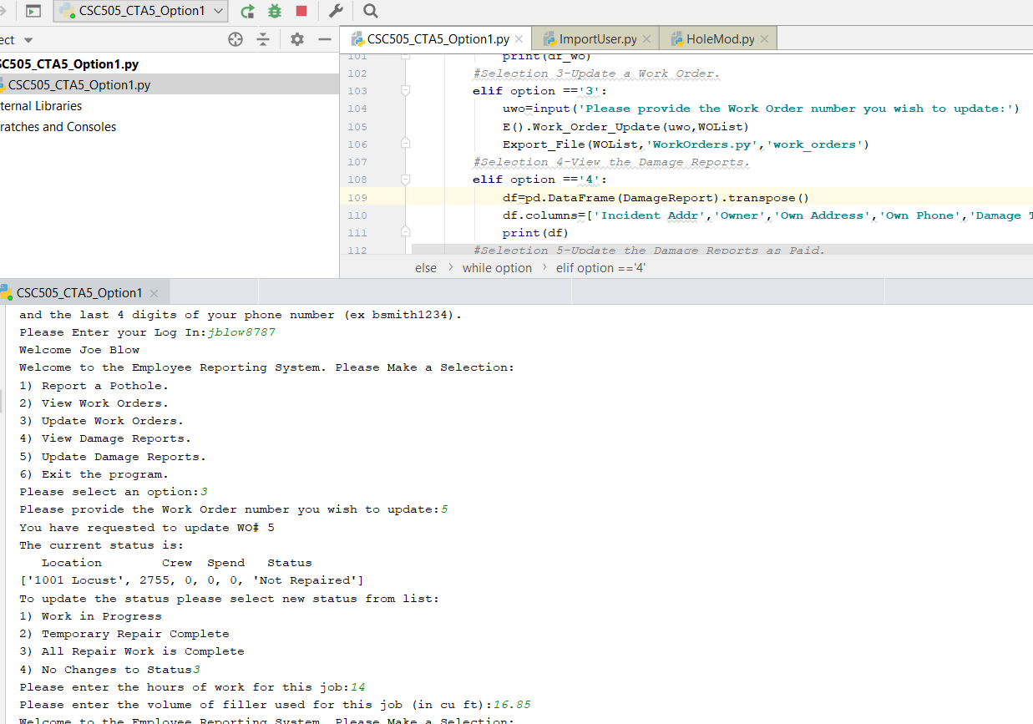

Figure 5 Employee Updates a Work Order

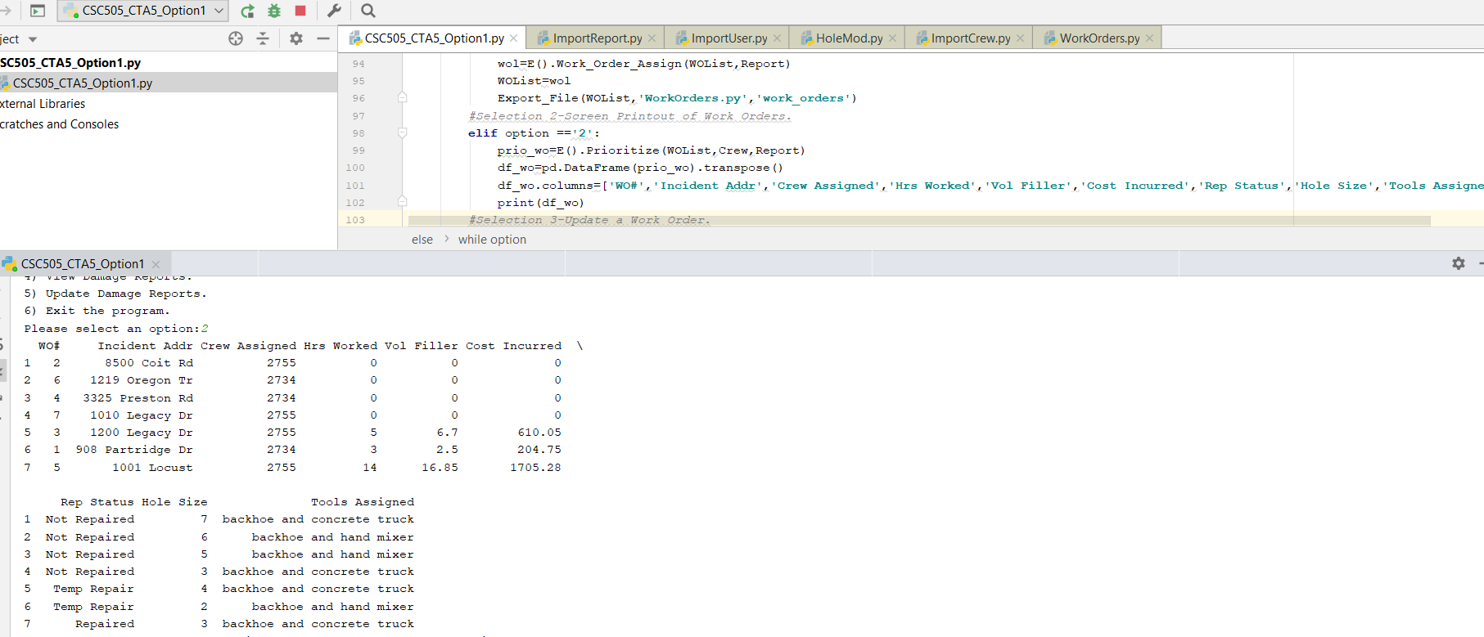

Figure Employee Reviews Work Orders after updates

The build out of this program is also feeding this data out to databases in the background to ensure all changes are stored. Damages can be paid and that status updated. If I were to complete this for a company, more time would be spent building out the districts, which would require another table which classified addresses into districts. By referencing this, it would be possible to quickly assign a district, rather than expecting the user to know the district they were in and report it accurately.

Compared to last week’s program, I have tweaked a couple additions that were requested in the original requirements. Equipment details have been added to the Work Order print out, and I have added the priority when the work order prints out. Work Orders are prioritized first by state of repair then by size of the hole.