

**FULLSTACK ALTERNATIVE EXAM - 2 HOURS**

|  |  |  |
| --- | --- | --- |
| **SECTION TYPE** | **TOTAL MARKS AVAILABLE** | **NOTES** |
| **Redux (pseudocode code/ reasoning explanation)** | 15 | Multiple questions, all comprising 15 total |
| **Algorithms 1 (Coding)** | 20 | 1 question only |
| **Algorithms 2 (Coding)** | 25 | 1 question only |
| **60 marks available total** | | |

*Questions begin on the next page*

|  |  |
| --- | --- |
| **Redux** | **15 total** |

This question involves using built-in React Hook for a simple attendance app.

*Here are notes to help: -*

* *useState() : This allows you to have states variables in functional components. It helps to set and retrieve the state.*
* *A reducer: This is a function that returns some state data, triggered by an action type.*
* *An action: This is dispatched by components and is represented as one object that contains type property and sometimes payload property. It tells the reducer how to change the state. Here is an example of the shape of an action -> { type: 'GREETINGS', payload: ‘Hello’}*
* *Dispatch: this helps update the state by sending the type of action to the reducer function for it to perform its job. To invoke a dispatch function, you need to pass action as an argument to the dispatch function, e.g. dispatch ({type: "SOMETHING", payload: “SOMETHING” })}*

*\*\* Remember: Submit pseudocode or simply describe the solution.*

**Part 1 (8 marks):**

This section involves handling state locally.

*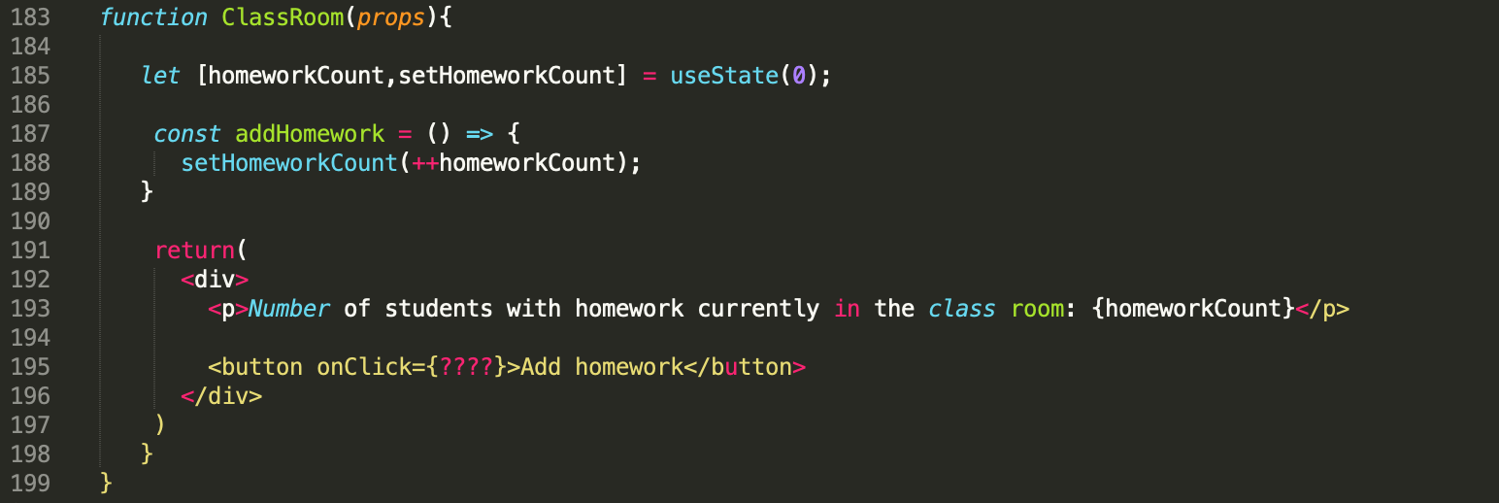Figure 1*

*In the code above the useState hook is used to set the state of a variable inside the component.*

1. Read the code and understand what is happening. How do you ensure the “addHomework” function is triggered when the button is clicked?

You set the function to run when the button is clicked using the onClick event. In the above code you would replace the ‘????’ with addHomework.

1. When a user clicks on the “Add student” button update the state (homeworkCount) to include the total amount of homeworks of only the students who are present. Using the data provided below:

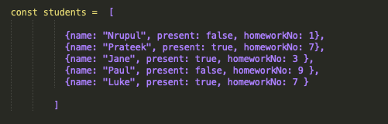

*Figure 2*

1. Update the “addHomework” function and write a *pseudocode (or provide a description)*  of how your function would look.

I would add the students variable into the ClassRoom function so they are defined. I would then add an additional function within ClassRoom to filter the students on whether they were present once the button is clicked. To do this I would use the filter function to return only the students within the array that were present. I would then use the reduce function to subtract the total number of students with the calculated number of students that were present. I would then update the state: setHomeworkCount(myCalculatedNumber).

1. How will you update the state with the result of your function on button click?

By setting the setHomeworkCount value to my calculated value as demonstrated above, it will update the state. This means when the button is clicked it triggers a re-render and the value is updated.

**Part 2 (7 marks):**

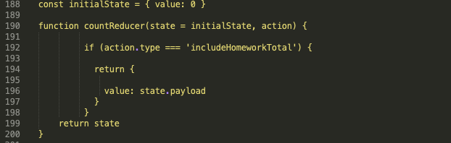

*Figure 3 (Reducer)*

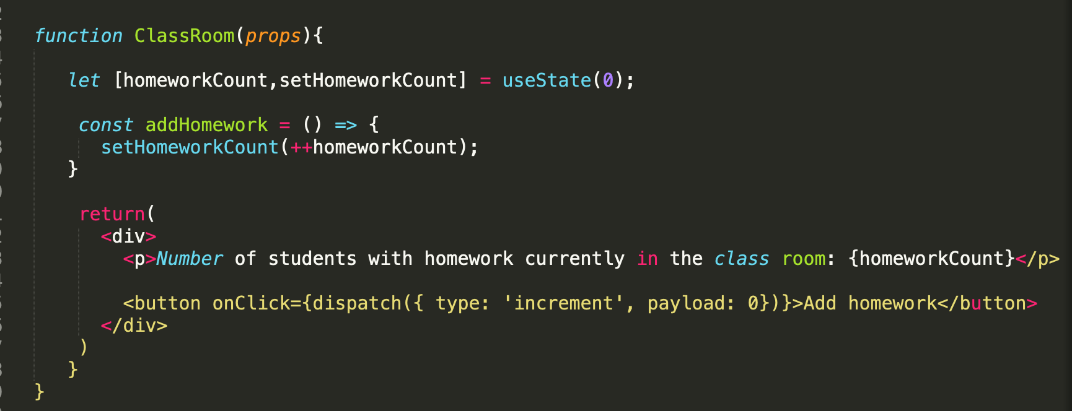

*Figure 4*

As you can see in the *ClassRoom* function the button onclick has been changed , the state is now being updated with the dispatch function on button click. Our *countReducer* uses the payload that is passed from the dispatch function and sets our state object to the payload.

1. At the moment on the classroom function our payload is set to 0. How do we ensure that our payload contains the result returned from the newly updated *addHomework* function? (The result should depend on your answer from part 1.2). What changes need to be made to our current code? *[Remember we want to dispatch this action when the user clicks on the button]*

Within the function that is calculating the number of students present we would need to dispatch and action with the type ‘includeHomeworkTotal’:

Dispatch({ type: ‘includeHomeworkTotal’, payload: totalHomework });

With this dispatch added, our function dispatches an action with the calculated number of students present, and the reducer updates the state.

1. According to the current countReducer function code, when I click on the “Add Homework” button, the state value would always be 17. Why is this happening? What changes can be made to our reducer code to ensure that the state value increases according to the latest payload.

This is because the value is being assigned as state.payload. By changing this to action.payload it means that when the action happens, in this case calculating the number of students present, the payload from this action is used to update the state.

|  |  |
| --- | --- |
| **Algorithms 1 (Coding)** | **20 (1 question)** |

Write an algorithm that returns true if the given string is a pangram. Otherwise, return false. Only lowercase alphabets are to be taken into consideration ( e.g. *AbC === abc*)

*Note: A pangram is a sentence containing every letter in the English Alphabet.*

If the input string contains only numbers value then return an error with the correct error message.

For example, some sample input and outputs would be:

|  |  |  |  |
| --- | --- | --- | --- |
|  | **String** | **Result** | **Explanation** |
| **Sample Input 1** | the quick brown fox jumps over the lazy dog | True | Contains all the characters from ‘a’ to ‘z’] |
| **Sample Input 2** | when zombies arrive, quickly fax Judge Pat | True | Contains all the characters from ‘a’ to ‘z’] |
| **Sample Input 3** | we will not allow you to bring your pet armadillo along. | False | Does not contains all the characters from ‘a’ to ‘z’] |
| **Sample Input 4** | 12356 | It must be a string | Only strings should be passed in. |

The time complexity is 0(N). This is because the time it takes to check if the input is a string and to create the array is constant and therefore has a big 0 notation of 0(1). Iterating through the input depends on the length of the string and therefore for has a big 0 notation of 0(N) where N is the length of the string. Adding these results together provides the final notation 0(1 + N) -> 0(N).

The space complexity is 0(1). This is because all the variables stored use constant space and therefore can be simplified to 0(1) regardless of the length of the array etc.

*In your answer, please discuss your solution - what is its Big O Time & Space complexity? Why have you chosen this approach? Could there be a more efficient way (and if so, how)?*

*If you are short on time, you can also submit pseudocode or simply describe what solution you’d write in code (just describe what you have in your mind) - this cannot attain full marks, but it is still a perfectly acceptable answer and can get partial marks.*

*In essence, just submit what you have even if you don’t know the answer!*

|  |  |
| --- | --- |
| **Algorithms 2 (Coding)** | **25 (1 question)** |

Write a function that takes in two integers. Your function should return the integer that is first to become an odd integer by a smaller number of divisions by 4. If both numbers become an odd integer at the same time after the same number of operations then return 0.

|  |  |  |  |
| --- | --- | --- | --- |
|  | **Input** | **Output** | **Why?** |
| **Sample Input 1** | 20, 16 | 20 | Step 1: 20/4 = 5, 16/4 = 4  *20 is the first number to be converted to an odd integer.* |
| **Sample Input 2** | 36, 60 | 0 | Step 1: 36/4 = 9, 60/4 = 15  *Both numbers are converted to an odd integer at the same time.* |
| **Sample Input 3** | 32, 48 | 48 | Step 1: 32/4 = 8, 48/4 = 12  Step 2: 8/4 = 2, 12/4 = 3  *48 is first converted to an odd integer.* |

*If you are short on time, you can also submit pseudocode or simply describe what solution you’d write in code (just describe what you have in your mind) - this cannot attain full marks, but it is still a perfectly acceptable answer and can get partial marks.*

*In essence, just submit what you have even if you don’t know the answer!*

