Student Name : Jessica McCabe

Project Repo URL : <https://github.com/JessMcCabe/advisorySpeedSubmission>

|  |  |  |  |  |
| --- | --- | --- | --- | --- |
| Grade Band | Combined Knowledge | Networking Technologies | IoT Solution | Communication |
| Base | Computer Systems and Programming both used |  |  |  |
| Good | Programming in Javascript, Logic used to determine Road Type, Appropriate Speed range, calculate speed. Calls to an API using HTTP Get Request.  Computer Systems – running the program on Raspberry Pi, connecting to Blynk and APIs, using putty to connect to RPi, use of FTP to transfer the program files to RPi, use Computer systems knowledge to detect the RPi on the network to determine the IP address to connect to. Set up the RPi to connect to the mobile hotspot created on the phone so the Pi was mobile. | Wifi used to connect Rpi to Phone (Blynk App) and to web (API calls) and to WIA (IOT Platform). | IOT Solution suited to the Motor industry/Insurance Industry. Could be developed further and used for Learner/Novice drivers as a safety enhancement. Could also be applied to the Motor Insurance Industry as a way of helping reduce costs based on recording of safe driving in adverse conditions. Ideally implemented with more reliable/suited technology such as getting actual speed directly from the car’s system etc. | Git Repository, documentation and video. |
| Excellent |  |  |  |  |
| Outstanding |  |  |  |  |

____________________________________________________________________________________________________________________

Additional Comments:

Google API was originally going to be used, but the information returned was not suitable, the road type was not returned, and speed limits could not be returned either (I signed up to a billed version but still had no access to the speed limits API). I had tried the roads API and geocoding API but was not getting useful info.

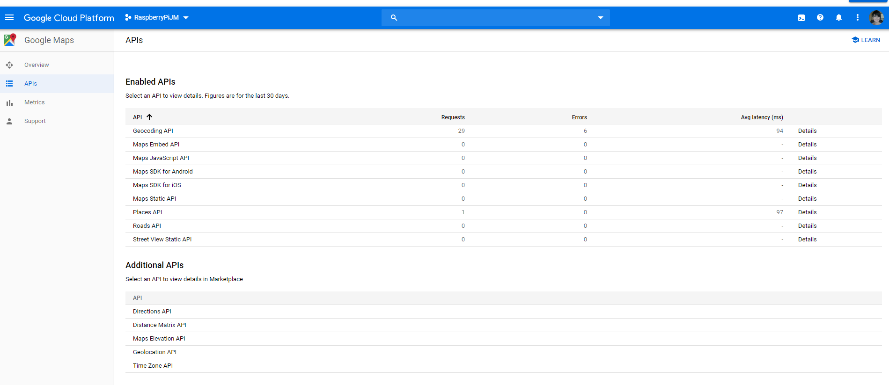

The Geocode API JSON object returned can be found in GeoCodeAPIGoogle.txt file. The nearest Roads JSON object returned can be found in the NearestRodesAPIGoogle.txt

I found another geo API that would return more suited data which was OpenCage (<https://opencagedata.com/>) , while this provided the actual road name (example R407), if the road was not able to be identified it just did not have the road data in the JSON object returned which meant that accessing data.results[0].components.road when it didn’t exist, resulted in an unidentified type.

GPS co-ordinates were sourced from BLYNK, I found this to also be somewhat unreliable, the GPS co-ordinates were often off by a small bit , this then interfered with trying to identify the road you are on and also impacted the speed calculation as speed is an approximate calculation based on the time and distance between the 2 sets of GPS coordinates. BLYNK also has a speed parameter in the GPS Stream, however, this was way off.

Weather data was not actually implemented but would have been retrieved from the Met API. The API would be called via <http://metwdb-openaccess.ichec.ie/metno-wdb2ts/locationforecast?lat=54.7210798611;long=-8.7237392806;from=2019-12-22T12:00:00Z;to=2019-12-22T12:00:00Z;> The parameters retrieved from BLYNK would be sent in the request along with the currentDate and hour. The Met API returns an XML object. It does not however return any weather warnings so adverse conditions would have to be set in logic and determined.

Information sent to WIA is location and speed and colour. This was only recorded in WIA but further usage of this data would be reports based on the speed being recorded in each colour to determine how often advisory and non-advisory speed was used. This could then determine patterns of good/dangers driving.

Initial testing was done locally to see if the approximate speed matched the actual speed of the vehicle and it was within the actual speed , give or take. This was done on local/regional roads under speeds of 80km. There seems to be a major issue though when I tested this on the Motorway, speeds were showing well above actual speed of the vehicle, likely related to the ability of BLYNK to capture the GPS co-ordinates accurately at higher speeds.

Ideally, speed should be sourced from the vehicles data for accuracy, and location should be sourced from a reliable GPS system. The senseHAT was not an effective way of displaying the speed and in the future this should be displayed on a small digital or LCD display.

