**Name:** Micheal Alberts

**Age**: 55

**Gender**: Male

**Occupation**: Accountant

**Religion**: Scientology

**Goals**: Gift Cards for family

**Site Access**: Micheal accesses the internet mainly through his desktop computer at work

**Pains**: Micheal despises having to navigate through multiple web pages full of “fluff” before finding what he is looking for. He wants to log on and off as fast as possible.

Bio: Micheal is a Chartered Professional Accountant for a busy oil company. A whiz with numbers, he has worked at this company for the past 22 years and is considering retirement soon.

Scenario #1: Micheal is going to his niece’s birthday party this weekend and he knows that she is a fan of eyelash extensions, regularly getting them done. He accesses our website from the computer in his office and is looking to purchase a gift card for his niece. Having no knowledge of eyelash extension himself, he is interested in finding out what the different services cost and the dollar amount he should load on the card.

Scenario #2: Having purchased a gift card for his niece’s birthday last year, he decides to use our site again for his wife’s birthday. He is familiar with the site and his niece was pleased with the treatment she received; therefore, he is interested in making a bigger purchase, an option that would allow his wife to get her eyelashes done for a full year without having to pay.

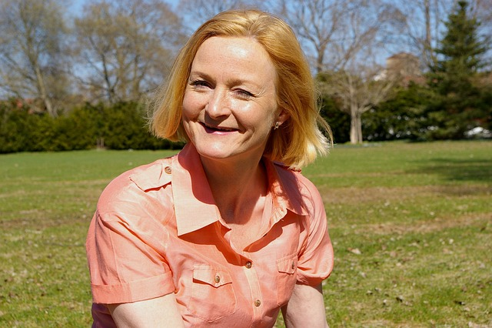**Name:** Michelle Allard

**Age**: 54

**Gender**: Female

**Occupation**: Daycare Worker

**Religion**: Protestant

**Site Access**: Michelle accesses the internet mainly with her iPhone 13 that her husband purchased for her; however, she does use his desktop from time to time as well.

Bio: Michelle is a daycare worker, and she enjoys the challenge of being a role model for the children and cares for them deeply. She has worked in numerous positions at various school boards throughout her career as care giver but prefers working with younger children.

**Goals**: Due to Michelles hectic schedule, she is looking for site that will allow her to book in advance online without having to call in all the time

**Pains**: Michelle’s major concern is the durability of false lashes. Being a day care worker, she is constantly holding children and playing games with them throughout the day. This level of daily physical activity makes keeping her eyelashes looking nice become very difficult.

Scenario #1: Michelle hears about our website through a friend and decides to take a look. She has her usual eyelash technician that she goes to normally; however, because of her friends’ rave reviews about us she logs on to see how we differ from her usual lady. She would consider changing the place she gets her eyelashes done if we can provide some sort of guarantee of our work. She has had issues with eyelash extensions not lasting long.

Scenario #2: Due to Michelle’s hectic schedule, she logs onto our site looking to book an appointment online.

**Name:** Yvonne Walters

**Age**: 25

**Gender**: Female

**Occupation**: Social Worker

**Religion**: Non-Religious

**Site Access**: Yvonne accesses the internet from her phone. She doesn’t own a desktop but does use her iPad occasionally when she is at home and relaxing on the couch.

**Goals**: Yvonne is looking for an extremely accessible website. She believes all interactions should happen in person and

**Pains**: Christina’s pet peeve is

**Bio**: Yvonne graduated from high school and decided to take a break year and backpack through Eastern Europe while staying in hostiles and meeting new people. Once she got back, she completed a Social Work Diploma from her local community college. She is a very friendly and bubbly woman; she can strike up a conversation with anyone.

**Scenario #1**: Yvonne comes to our site looking for an eyelash technician which is friendly and not egotistical like many of the woman she has met in the beauty industry. She is looking for personal experience just as much as she is looking to get eyelash extensions. She comes to the site to spend time and read our philosophy

**Scenario #2**: Yvonne went back to Eastern Europe to see the friends she had met. The week she is to return to Canada, she logs onto our site to book an appointment for when she gets back. The internet connection in her hostile is extremely slow and choppy at the best of times and frequently fails to properly load websites. She requires a website that can function without the use of hi-res graphics

Scenario #3: As Yvonne is always engaging with people and experiences life outside herself, she is often forgetful about dates, addresses, and other details. One day while she’s driving home, she decides to call and see if she can get for some extensions; she logs onto the site and requires an intuitive way of getting the directions to the shop without having to dive into small print

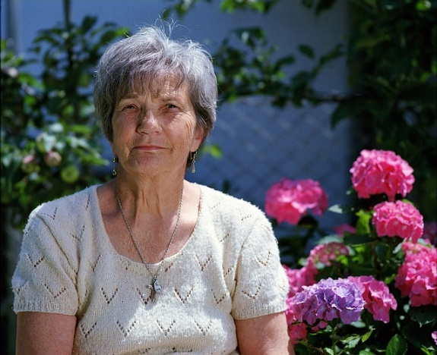**Name:** Gabby Richardson

**Age**: 72

**Gender**: Female

**Occupation**: Retired

**Religion**: LDS

**Site Access**: Gabby accesses the internet strictly from her Compaq Presario desktop she keeps in the spare room. She does not own a mobile phone, choosing to stick to what she knows best, her trusty rotary phone attached to the wall.

**Bio**: Gabby is a retiree and has worked in the hospitality industry for most of her life. She is widowed for 3 years and spends most of her time at the local legion playing cards with other seniors in her area. Gabby is very family oriented and when she is not playing cribbage with her friends she enjoys having her grandkids over for sleepovers. Being a retiree, she is fugal and always looking for things on sale.

**Goals**: Gabby’s

**Pains**: Gabby’s eyesight is not what it used to be, and she has difficulties reading small print.

**Scenario #1**: Gabby accesses our website from her inter Celeron and is looking to purchase gift certificates for her daughter’s birthday. From speaking with her daughter about her eyelash extensions, Gabby is familiar with the going rate of eyelash extensions as well as the different variants.

**Scenario #2**: Gabby will be attending her daughters wedding next week and has decided that she would surprise her daughter and get the false lashes that she loves so much. With this being her first time getting her lashes done, she is nervous that her eyes will become irritated and that it will affect her eyesight

**Name:** Alex Bischon

**Age**: 32

**Gender**: Female

**Occupation**: Esthetician

**Religion**: Catholic

**Site Access**: Alex uses her phone for most of her online viewing. Most of the sites she spends time on come from social media links.

**Bio**: Alexandra has been working as an Esthetician since she completed the course 5 years ago. She enjoys everything beauty and is continuously researching all the latest procedures and products.

**Goals**: Alexandra is looking for the best product on the market.

**Pains**: She has been getting eyelashes done for most of her adult life and is turned off by shotty, unprofessional eyelash technicians that do not take pride in their work.

**Scenario** **#1**: Alexandra comes across our site, on her phone, while she is looking for eyelash studios in her area. Being in the beauty industry herself, she appreciates websites that display the technicians’ qualifications and work that the technician has completed. She searches through our site to see if our qualifications are up to her standards.

**Scenario #2**: Alexandra comes back to our site after being pleased with her last experience. This time she is looking at the possibility of exchanging services; she is willing to provide facials to the technician for the application of eyelashes. She comes to the site with the premise of contacting the technician and seeing if they are willing to do this.

**Name:** Christina Childs

**Age**: 14

**Gender**: Female

**Occupation**: Student

**Religion**: Non-religious

**Site Access**: Chirstina accesses the internet solely through her phone.

**Bio**: Christina is a very outgoing young girl in grade 9. She will be entering high school next year and is always looking for ways to make herself seem older and more mature. Being a grade 9 student, Christina is easily influenced by her peers and is beginning to be more self conscious as she gets older.

**Goals**: Impress her friends

**Pains**: Chistina is color blind and has troubles reading certain font colors sometimes

Scenario #1: Christina is wanting to get false eyelash extensions for the start of her sophomore year of high school. This will be the first time she will be getting eyelash extensions, and she has been saving up her allowance for the past month to do it. She is very nervous about how she will look with eyelash extensions and will not have enough money to get them redone if she doesn’t like them.

Scenario #2: Christina enjoyed having her lashes done so much that it has inspired her to investigate becoming an eyelash technician herself. She logs onto our site looking for information on how she would be able to get qualified and start doing lashes while she is in high school.

Pic #1: https://pixabay.com/photos/portrait-man-businessman-5519817/

Pic #2: https://pixabay.com/photos/woman-middle-aged-mischievous-happy-797394/

Pic #3: https://pixabay.com/photos/girl-model-portrait-smile-smiling-1867092/

Pic #4: https://pixabay.com/photos/granny-woman-senior-elder-elderly-1280445/

Pic #5: <https://pixabay.com/photos/woman-portrait-model-knitwear-2150881/>

Pic #6: https://pixabay.com/photos/girl-teenage-girl-eyes-beauty-7172289/

wwws