INTEROFFICE MEMORANDUM
To: IT Director
From: Team 07
Date: March 07, 2026
Subject: Role of AI in Cyber Defense
Summary: This memo discusses how AI technology can be useful in providing Cyber Defense capabilities to an organization.

Artificial Intelligence, almost synonymous with machine learning, has revolutionized the Cybersecurity industry. From AI enable next-generation firewalls for intrusion detection and prevention systems, to smart filtering and blocking of phishing emails, as McKinsey & Company puts it, “AI is the greatest threat-and defense-in Cybersecurity today. For the sake of our organization, it’s been our greatest asset.
Over the past two days, while combating active incidents, our security team has been able to both thwart attacks and troubleshoot critical business services leveraging free AI platforms. This has substantially decrease our time-to-resolve incidents, and troubleshooting critical service failures.
For example, troubleshooting our database conflict with SIEM monitoring tools:
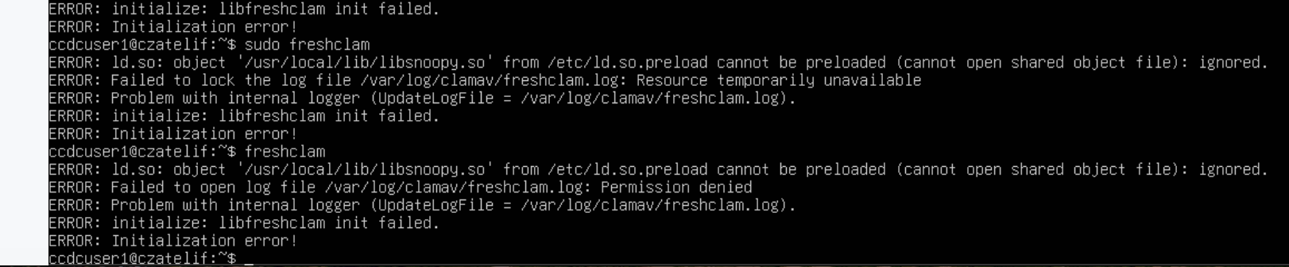
Figure 1: Snoopyctl Conflicting with ClamAV Scans + MySQL Loading

AI has also been incredibly impact for our security engineers when it comes to the creation of custom tooling, monitoring, and further security control development. For example, we leveraged AI to create scripts to monitor disk usage on our Linux devices, or the automated integrity checking and restoration of our ecommerce website:
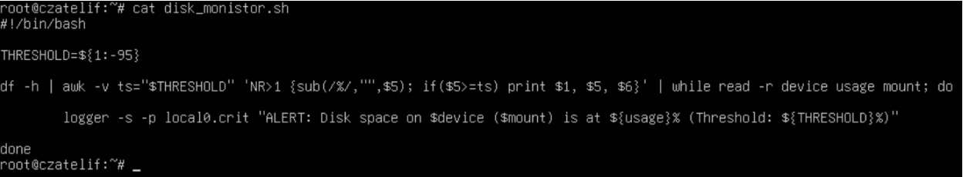
Figure 2: Disk Monitoring Tool Created via Free AI Tool (ChatGPT)
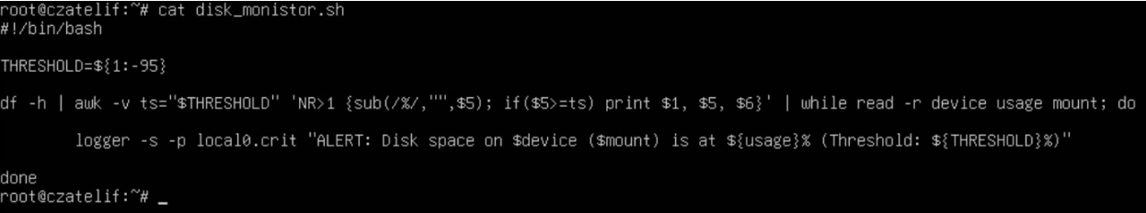
Figure 3: Disk Monitoring Tool Created via Free AI Tool (Gemini)

By levering AI for this service level troubleshooting, we were able to determine the root cause of the service downtime and remediate almost immediately.
Moving forward, we believe that integrating AI agents, services, and systems will be how we differentiate our security posture from other organizations. One goal that our team has moving forward is the creation of a threat hunting, incident response AI enabled agent to continuously monitor our networks, identify indicators of compromise, and further protect our environment.
We are firm believers that integrating AI into our Cybersecurity applications, tooling, services, and workflows, in a responsible and practical fashion, will allow us to be at the forefront of technology, adding security layers throughout our organization, and optimizing for overall availability for our customers by establishing advanced security controls.

If there are any concerns, questions, or clarifications, please do not hesitate to reach out.

With Regards,
Team 07

Sources:
https://www.mckinsey.com/about-us/new-at-mckinsey-blog/ai-is-the-greatest-threat-and-defense-in-cybersecurity-today

