Multi-agent Decision Making

COMP 4418 – Assignment 2

**Question1**

1. **Prove or disprove that the preference profile is single-peaked with respect to some order of alternatives.**

The preference profile is single-peaked with the order of

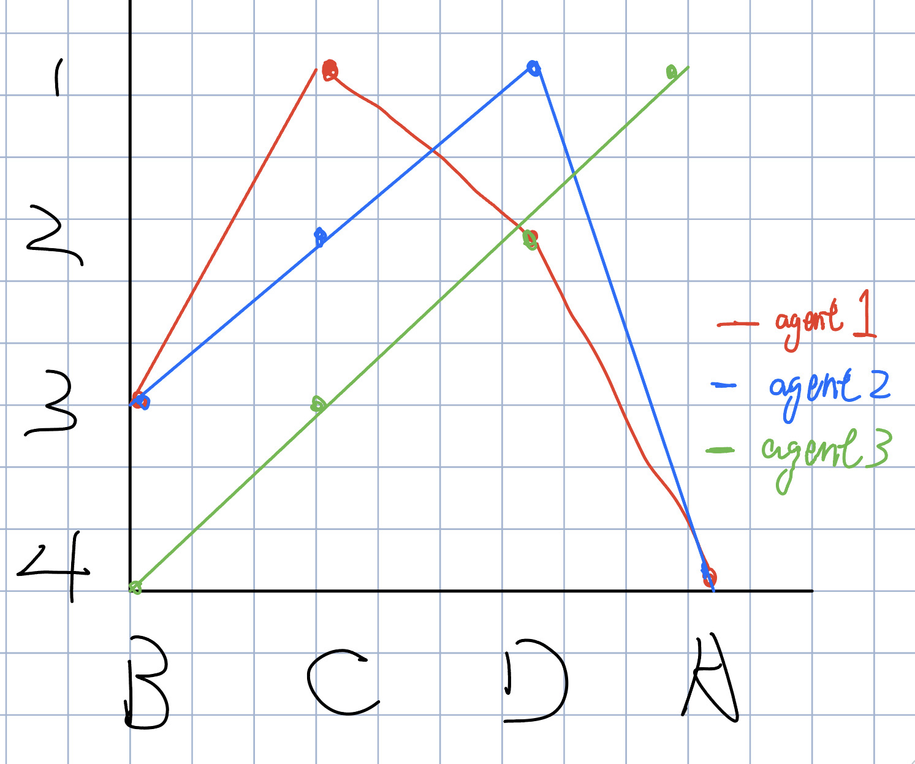

Each agent has a "best outcome" in the set, for voter 1, for voter 2, for voter 3.

For each agent, outcomes that are further from his or her best outcome are preferred less.

According to the definition, the preference profile is single-peaked

1. **Prove or disprove that a Condorcet winner exists for the preference profile.**

There are three voters, the number of majority of voters is 2. Condorcet winner should be pairwise preferred by a majority of voters over every other alternative.

For alternative , : 1 vote; : 1 vote; : 1 vote. So, alternative is not Condorcet winner.

For alternative , : 2 votes; : 0 vote; : 0 vote. So, alternative is not Condorcet winner.

For alternative , : 3 votes; : 2 votes; : 1 vote. So, alternative is not Condorcet winner.

For alternative , : 3 votes; : 2 votes; : 2 votes. So, alternative is Condorcet winner.

Hence, a Condorcet winner exists for the preference profile

1. **Compute the pairwise majority graph for the preference profile.**

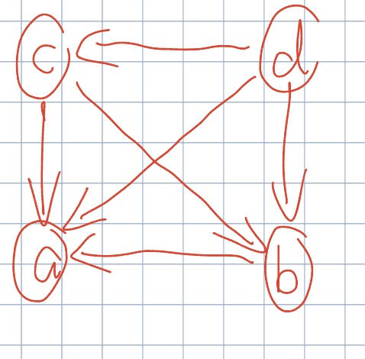

1. **Compute the Top Cycle set for the preference profile.**

Top cycle set:

**Question 2**

1. **The allocation that maximizes utilitarian welfare is Pareto optimal.**

Assume the allocation is Pareto optimal.

Then there exists another allocation that changing an agent’s allocation makes total welfare increase but reduces the utility of the other agents.

In this case, it may maximize utilitarian welfare, but it is not pareto optimal anymore.

Hence, the allocation that maximizes utilitarian welfare is not Pareto optimal. The statement is wrong.

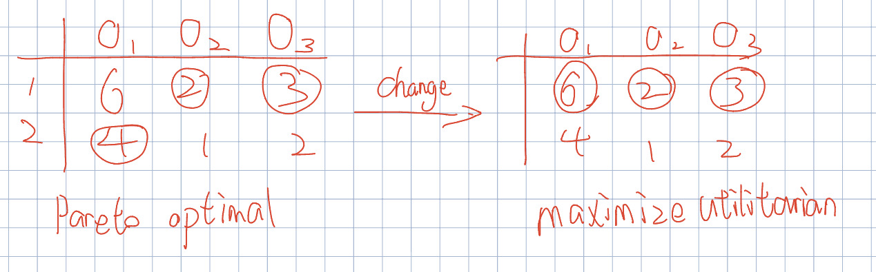

before changing: utilitarian welfare (9), pareto optimal (5,4)

after changing: utilitarian welfare (11), pareto optimal (11,0)

1. **If an allocation is Pareto optimal, it is envy-free.**

Assume the allocation is envy-free.

Then there exists another allocation that make Pareto optimal, but it is not envy-free.

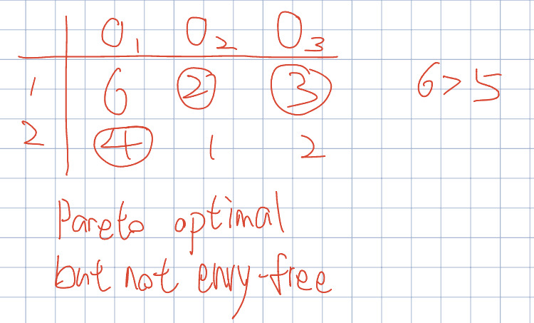

Hence, the statement is wrong.

1. **If , envy-freeness and proportionality are equivalent.**

Assume the allocation is envy-freeness, then for agent and .

It is same as the definition of proportionality.

Assume the allocation is Pareto optimal,

Hence, the statement is true.

1. **The sequential allocation algorithm, in which agents arrive in order (1, 2, 3, …, n) and are given a most preferred unallocated item, is strategyproof.**

Because sequential allocation algorithm let every agent to select the most preferred item in the current stage. So, individual preference will not affect other’s choice. In other word, there exist no preference profile such that

.

The statement is true.

**Question 3**

1. **Find the outcome matching of the student proposing deferred acceptance algorithm, showing working out. Prove or disprove that the resultant matching is Pareto optimal for the students.**
   1. 1 applies to ; 2 applies to ; 3 and 4 apply to ; 5 applies to
   2. rejects 3 in favour of 4:
   3. 3 applies to
   4. rejects 2 in favour of 3:
   5. 2 applies to
   6. rejects 4 in favour of 2:
   7. 4 applies to
   8. rejects 4
   9. 4 applies to
   10. gets accepted:

Only consider students’ preference, it is not Pareto optimal.

There exists an allocation, such that for all and for some .

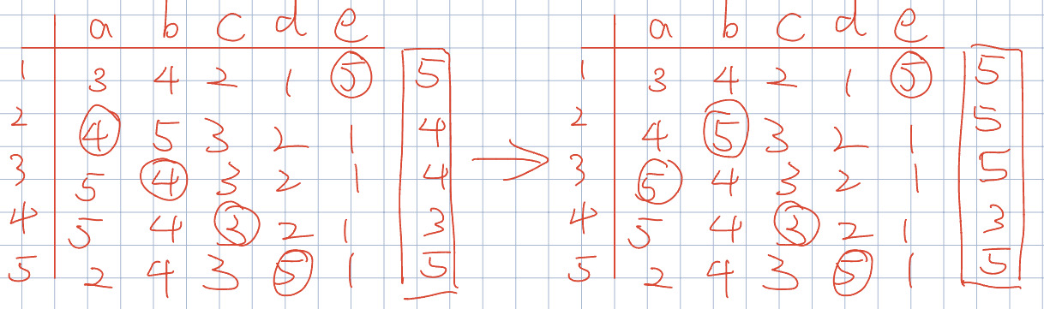

1. **Suppose that initially, student 1 is allocated to school a, student 2 is allocated to school b, student 3 is allocated to school c, student 4 is allocated to school d, and student 5 is allocated to school e. Apply the Top Trading Cycles (TTC) Algorithm with respect to the students’ preferences here and find the output, showing working out. Note that we ignore the schools’ priorities here.**

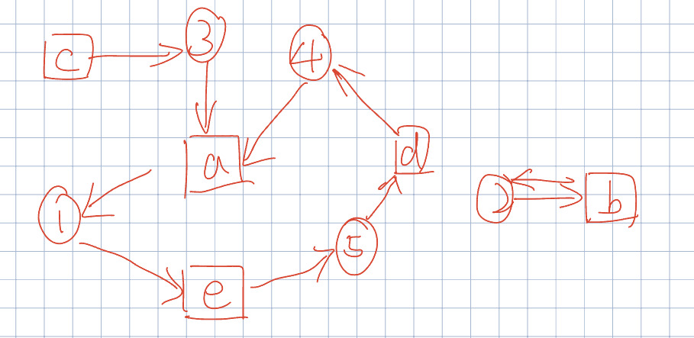

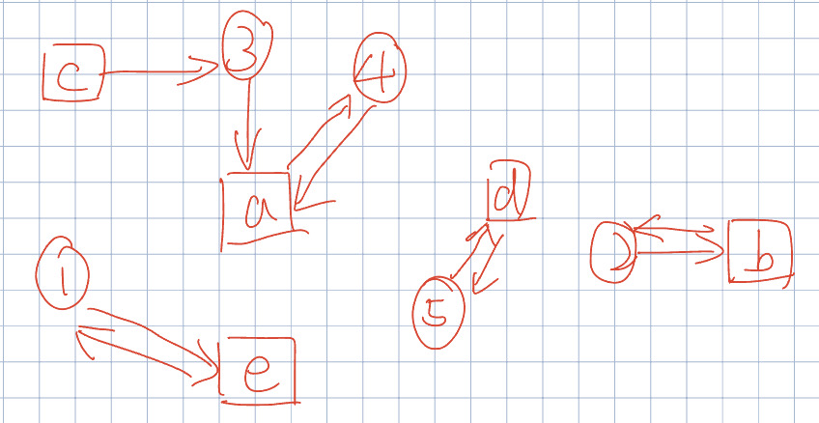

1. **Give three reasons, with examples if necessary, why the deferred acceptance algorithm is preferred for school choice over the TTC algorithm.**
2. TTC algorithm ignore the schools’ priorities, it only considers students’ preference for better outcome.
3. Deferred acceptance algorithm gives schools the right to reject students.
4. The below example shows the difference:

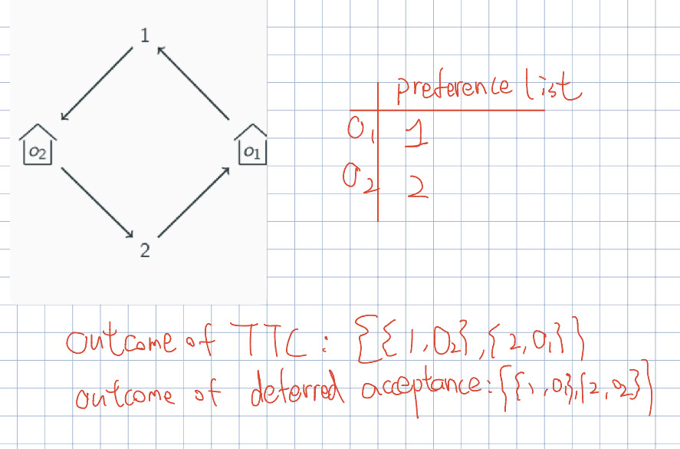

1. **Give a reason, using an example if necessary, why TTC may be preferred for this school choice setting over the deferred acceptance algorithm.**

TTC is strategyproof, so the school will not get withheld information

**Question 4**

1. **We can define the rank/3 predicate, where indicates voter ranks outcome as its th most preferred outcome in his/her vote. Write down the ASP encoding for the preference profile in Question 1.**
2. **Write an ASP program condorcet.lp that takes in a preference profile as input, and outputs the Condorcet winner in the predicate condorcetWinner/1. If there is no Condorcet winner, there should be no instance of this predicate/the predicate should be empty.**
3. **Write an ASP program condorcetborda.lp that takes in a preference profile as input, and outputs the Condorcet winner if one exists, or the Borda winner if no Condorcet winner exists. If no Condorcet winner exists and there are multiple alternatives with a tied winning Borda score, the program should output the alternative that comes first in alphabetical order.**
4. **Consider the voting rule from the previous subquestion that selects the Condorcet winner if one exists, or the Borda winner if no Condorcet winner exists, breaking ties by alphabetical order. Write an ASP program cbmanipulation.lp that takes in a preference profile as input, and returns a different preference ordering that a voter can report to achieve a better outcome under the aforementioned voting rule. The program should additionally return the misreporting voter’s original (truthful) preference ordering. If no such misreport exists for any voter, the program should return UNSATISFIABLE.**