Assignment-3

z5320711

## Advice on the company to decide about the location of the ATMs

The proposal needs to be formulated based on what the company pursues, because I believe that both rating and revenue are things that companies need to pay attention to. But as shown in the following figure, rating and revenue are not completely same (the closer the value is to 1, the higher the correlation), so I will make two assumptions.

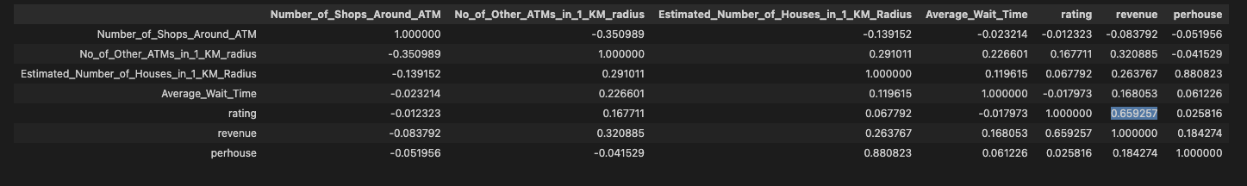

* If the company focuses more on revenue

When considering the location of an ATM, the company should not consider about each variable one by one, because some variables have combination relative, like the number of other ATMs within a 1 km radius and the estimated number of houses within a 1 km radius. As shown in the following figure, the p-value of estimated number of houses in 1 km radius is relevantly high, which means the value of it has nothing to do with the revenue. But the p-value of perhouse (= no of other ATMs in 1 km radius / estimated number of house) is not that high. So, considering combination variable is much important that consider only one variable.

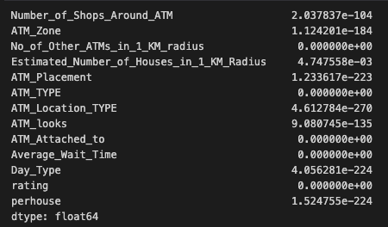

About the placement and type, I think the mean revenue can better illustrate the problem. Semi urban and facing road looks more likely to have more revenue.

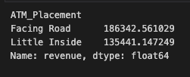

When consider the ATM_Location_TYPE, Passbook looks more likely to have more revenue.

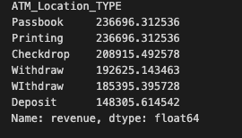

* If the company focuses more on rating

Two of the most significant factors that customers are highly concerned about are the average wait time and day type. The value of ATM zone is the effect that costumers not care about. Because there is still a certain relationship between rating and revenue, banks also need to pay attention to wait time and day type in addition to the location selection.

