Jesse Lucas

P274063

Activity 1

12/08/2020

# Assessment Title: Activity 1

## Student Name: Jesse Lucas

## Student ID: P274063

## Date: 31/07/2020

Contents

Assessment Title: Activity 1 1

Student Name: Jesse Lucas 1

Student ID: P274063 1

Date: 31/07/2020 1

Test Table 2

Debugging 3

Coding Standards 8

Design Specifications 9

Class Diagram 10

# Test Table

|  |  |  |
| --- | --- | --- |
| First song | All working order with a try catch | Refer to screenshot in screenshot folder |
| Next Song | All working order with a try catch | Refer to screenshot in screenshot folder |
| Previous song | All working order with a try catch | Refer to screenshot in screenshot folder |
| Add song | All working order with a try catch | Refer to screenshot in screenshot folder |
| Stop song | All working order with a try catch | Refer to screenshot in screenshot folder |
| Display | Correctly displays the song title  Without all the other rubbish | Refer to screenshot in screenshot folder |

# Debugging

Add Button

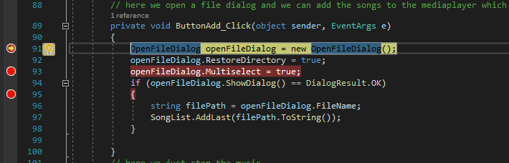

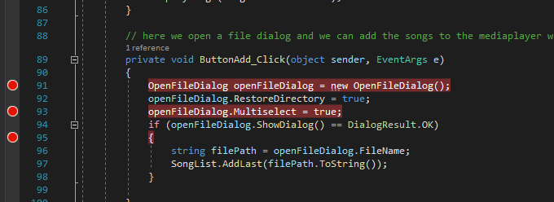

Play Button

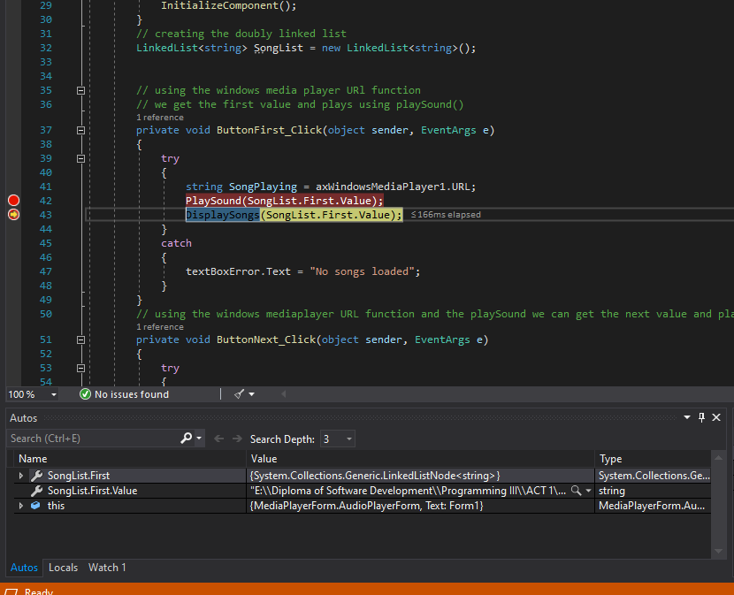

Next Song

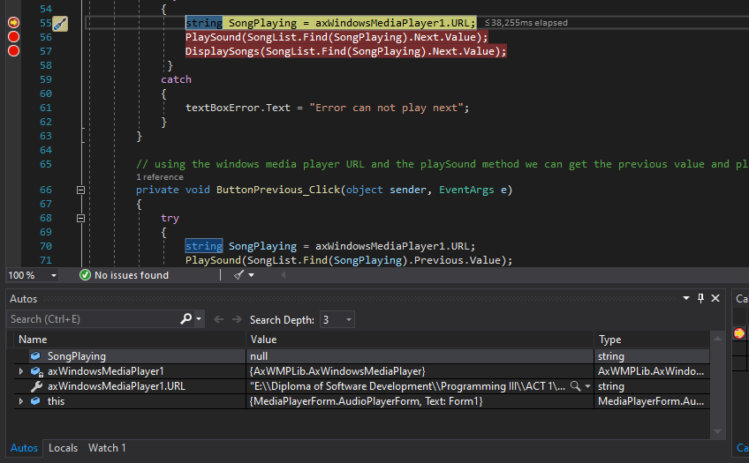

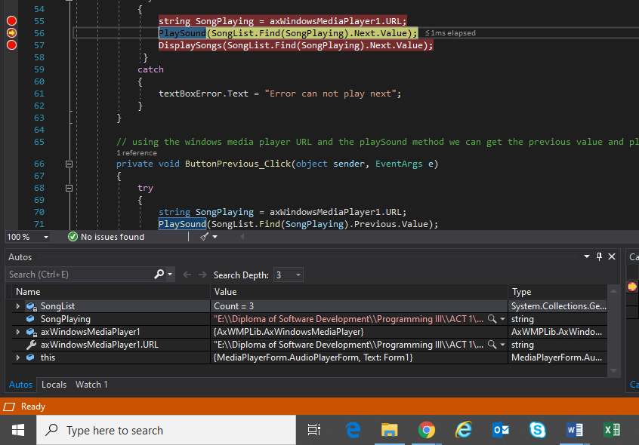

Previous song

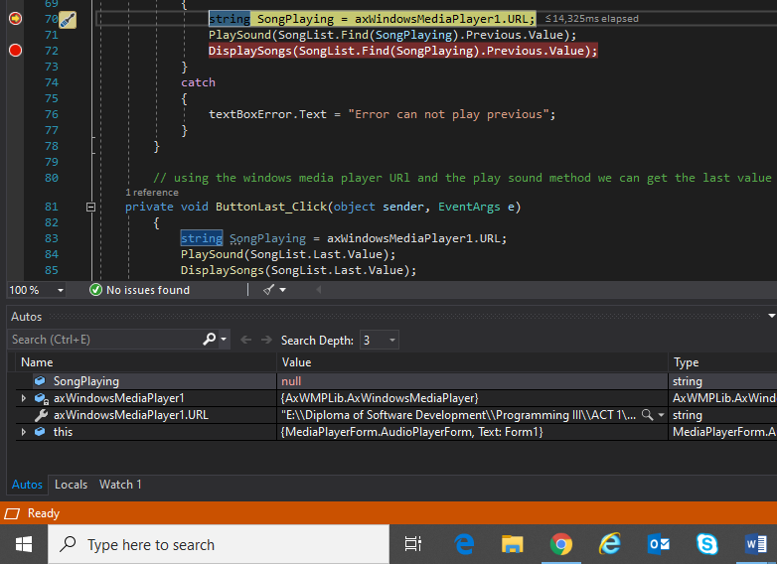 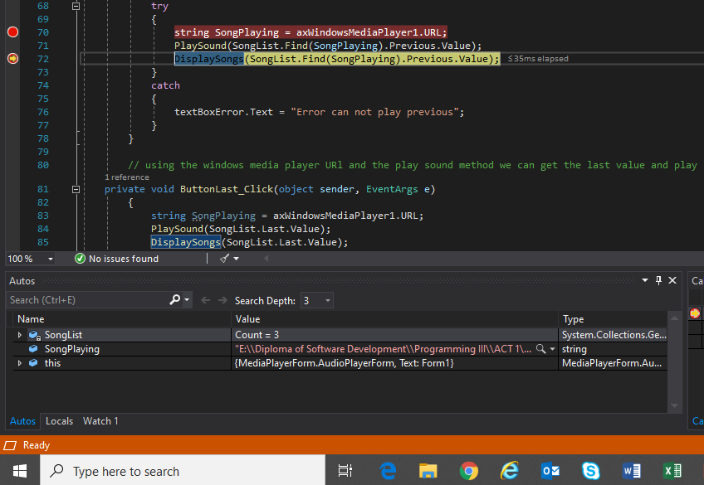

Last

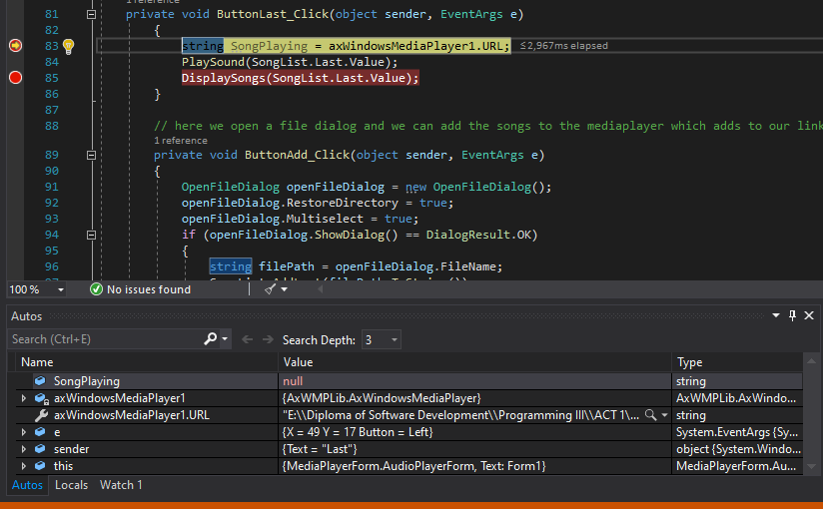

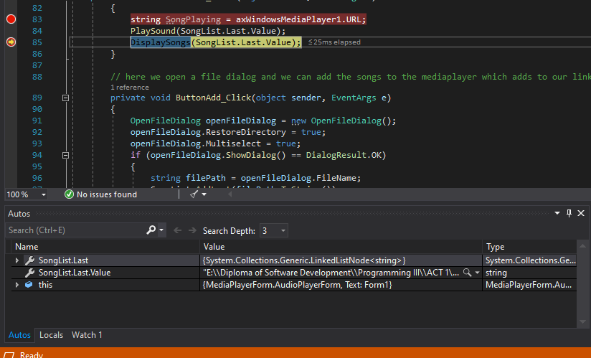

# Coding Standards

private void ButtonFirst_Click(object sender, EventArgs e)

LinkedList<string> SongList = new LinkedList<string>();

private void ButtonNext_Click(object sender, EventArgs e)

private void ButtonLast_Click(object sender, EventArgs e)

private void ButtonAdd_Click(object sender, EventArgs e)

private void ButtonStop_Click(object sender, EventArgs e)

public void PlaySound(string playsong)

public void DisplaySongs(string title)

string songPlaying = axWindowsMediaPlayer1.URL;

# Design Specifications

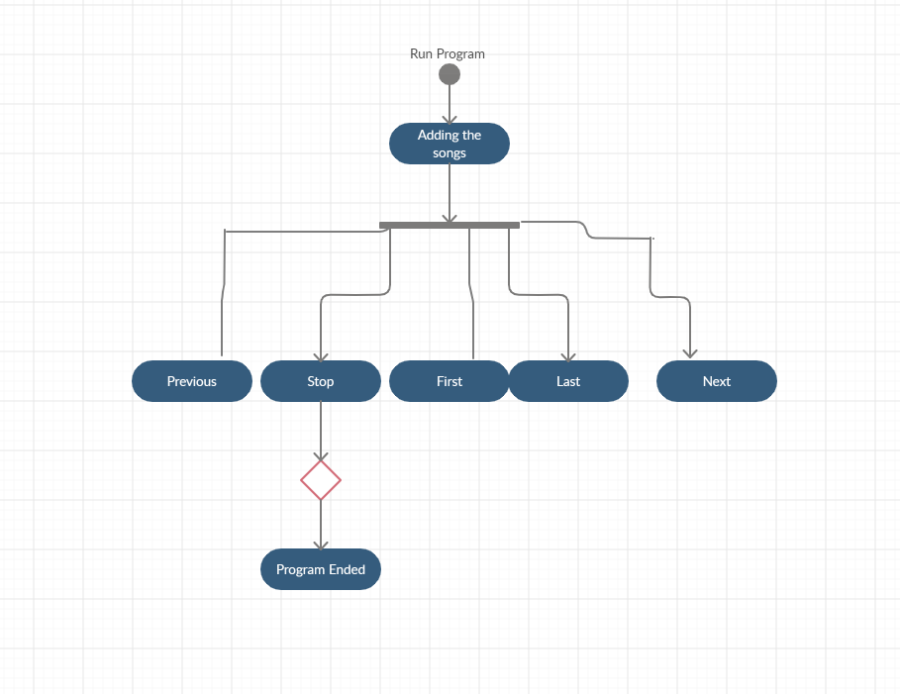

# Class Diagram

