Sprint One Report

Team C

Nathan Merrit  
Jesse Lucas  
Calum Smith

Contents

Source Control 3

Project Management 4

Trello 4

Project Libre 5

Adaptive vs Responsive 6

Analysis Report 8

CITE Business Rules 8

CITE Managed Services Quality Assurance 9

Acme Entertainment Pty Ltd Development Requirements 9

The Development Requirements for ACME Entertainment are that XAMPP version needs to be version 7.1.1 to be able to run the database, you will need Windows 10 as the OS, the latest version of Chrome for checking the code through localhost and checking it on different resolutions, Project Libre for making the Gantt chart and Microsoft Word for documentation. 9

XAMPP – To run XAMPP there are no minimum requirements so if Windows 10 can run so can XAMPP. 9

Windows 10 – The minimum requirements for Windows 10 is 1gb RAM, 16gb HDD, DirectX 9 or later, and a display of 800x600. 9

Chrome – To run Chrome you will need Windows 7 or later (preferably Windows 10) and an Intel Pentium 4 processor. 9

Project Libre – To run Project Libre you will need Windows 8 or later, 4GB HDD and a 32bit processor. 9

Test Plan 10

Introduction 10

Scope 10

Quality Objective 10

Roles and Responsibilities 10

Test Methodology 10

Overview 10

Test Levels 11

Bug Triage 11

Suspension Criteria and Resumption Requirements 11

Test Completeness 11

Test Deliverables 11

Resource & Environment Needs 12

Testing Tools 12

Test Environment 12

Testing 13

Bug Triage 13

Testing Levels 13

Functions 14

Home Page Case 1 14

Show Movies Case 2 15

Search Case 3 16

Bar Chart Case 4 7

Responsiveness 8

Responsiveness Case 5 8

4” 800 x 480 9

4.3” 800 x 400 10

4.3” 1280 x 720 11

10.6” 1920 x 1080 12

10.6” 2560 x 1440 13

Terms/Acronyms 14

Bibliography 15

# Source Control

GitHub Changes

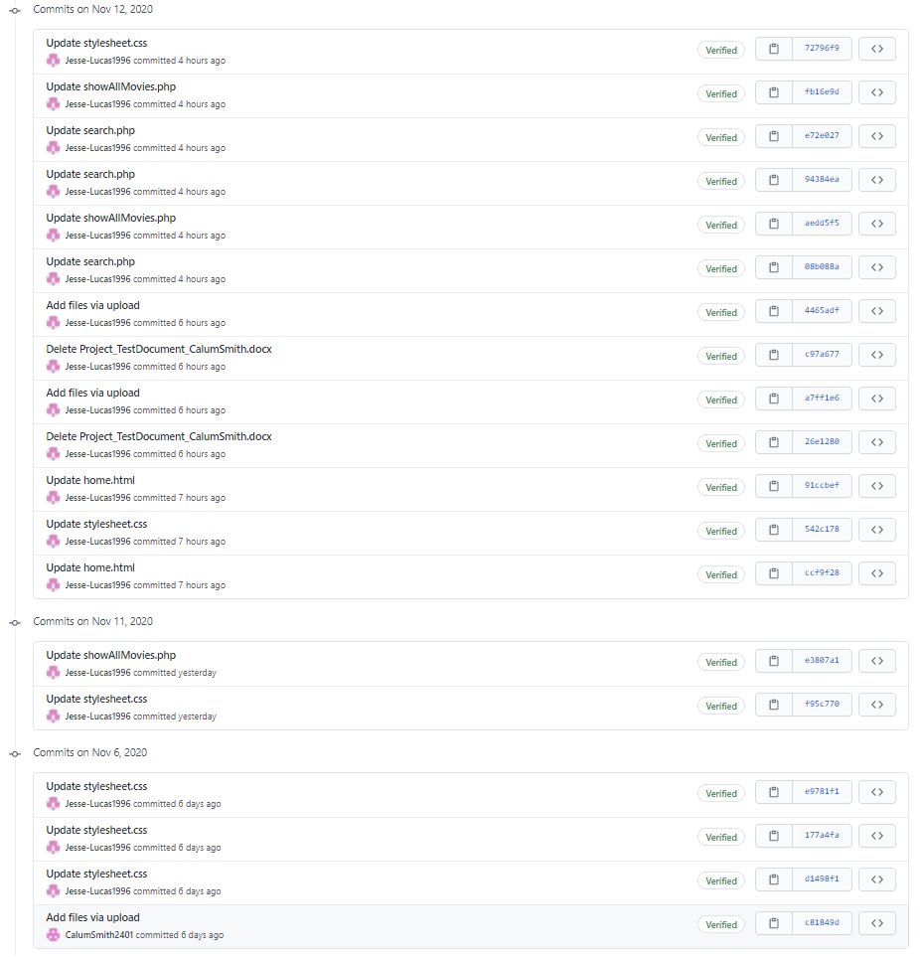

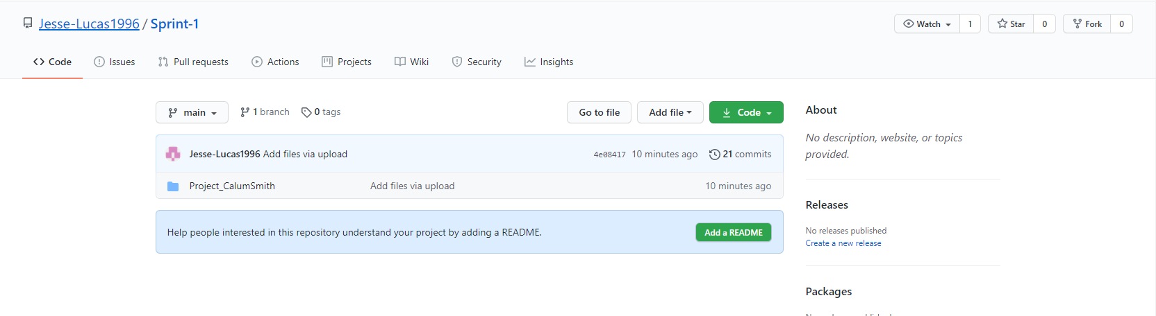

# Project Management

## Trello

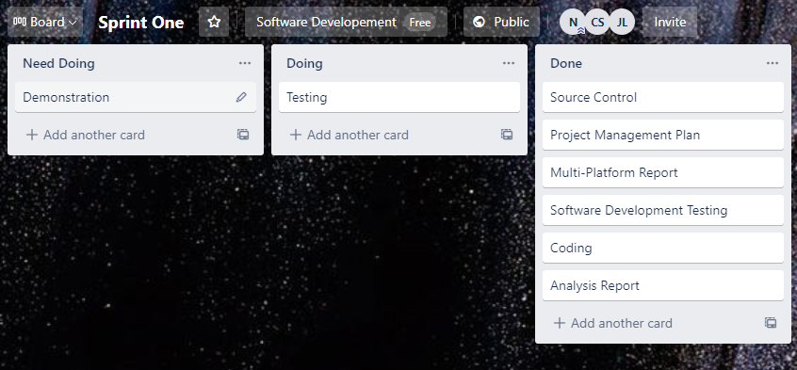

We used Trello to keep everyone updated with the tasks and what needed doing, what was being done and what has been completed. This was the Trello on the 12/11/2020, when most of the testing was being done before the final demonstration.

## Project Libre

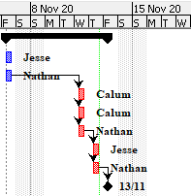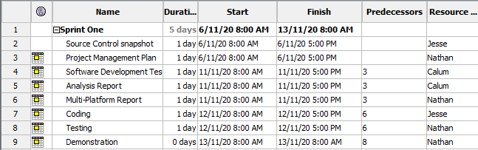**Gantt Chart**

**Resources**

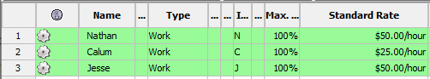

# Adaptive vs Responsive

**Adaptive**

Adaptive design is a user interface that is adapted to different screen sizes. It consists of multiple fixed layouts where the size most closely associated with the user’s device is rendered whether that is a phone, tablet, computer, or something in between.

When using an adaptive design, the web page will adapt to the different screen sizes. Designers apply it in GUIs, such as webpages, which must function on devices of different sizes. Adaptive design typically uses multiple fixed layout sizes when the system detects the browser size, it selects the layout most appropriate for the screen.

Adaptive design is like responsive design, which also adapts to different screen sizes. However, the difference between adaptive and responsive design is that the content follows a fixed layout size in adaptive design, while it moves dynamically in responsive design. In other words, adaptive design uses a few fixed layouts, and then selects the best layout for the current screen size. On the other hand, responsive design uses a single layout, which resizes according to the screen size. In adaptive design, developing six designs for the six most common screen widths 320, 480, 760, 960, 1200, and 1600 pixels is standard practice for designers.

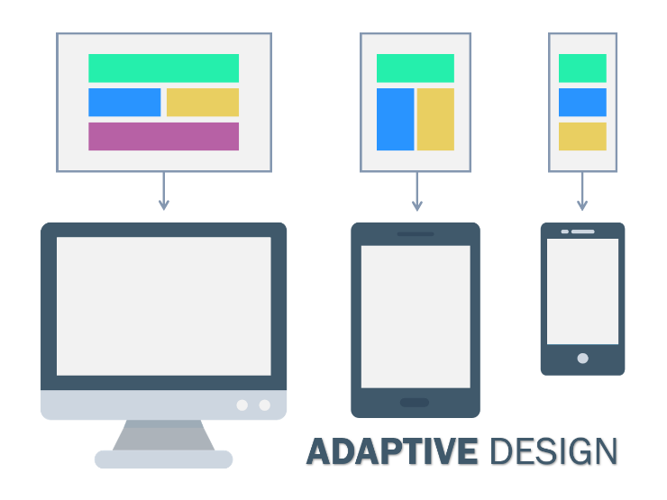The advantage of adaptive design is that it allows the designer to tailor-make solutions, so the GUI appears optimally on different screen sizes.

The disadvantage is that adaptive design is expensive, because, in effect, it requires the designer to create up to six individual GUIs or, the equivalent of six versions of a single webpage so as to have the best one ready to latch with the screen specifications a user needs. Another disadvantage is that adaptive design might also leave users who don’t have a standard-sized screen without an optimal solution. Nevertheless, as it remains one of the options in presenting output that might otherwise be unsuited to another approach, no designer should dismiss its value.

Figure 1 (adaptive vs responsive design, n.d.)

**Responsive**

Responsive web design describes a web design approach that allows websites and pages to render (or display) on all devices and screen sizes by automatically adapting to the screen, whether it’s a desktop, laptop, tablet, or smartphone.

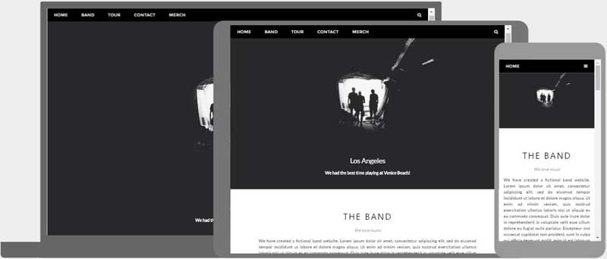

*Figure 2* (HTML Responsive, n.d.)

Responsive web design works through Cascading Style Sheets, using various settings to serve different style properties depending on the screen size, orientation, resolution, colour capability, and other characteristics of the user’s device. Responsive design is straightforward. Because it is fluid, it means that users can access your online world and enjoy as much of it on their handheld device as they would on a massive monitor.

**Responsive vs adaptive**

Responsive design is easier and takes less work to implement. It affords less control over your design on each screen size, but it is by far the preferred method for creating new sites at this moment. Whereas an adaptive design will theoretically ensure the best user experience according to whichever device the user is using to interface. Unlike responsive design, where a screen flows from desktop design into a smaller device’s, adaptive design offers tailor-made solutions. As the name suggests, they adapt to the user’s situational needs and capabilities. However with an adaptive design it is a bigger work load, it requires the designer to create up to six individual GUIs or, the equivalent of six versions of a single webpage so as to have the best one ready to latch with the screen specifications a user needs.

**Reason for Choosing Responsive**

Upon discussion with the team, 66% of them have used responsive web design, also on further inspection of adaptive, using google we found not much information or tutorials on adaptive. This led us to choose responsive, also the fact that the website doesn’t contain much but a few tables and a chart.

# Analysis Report

## CITE Business Rules

A Business Rule defines specific instructions or constraints on how certain actions should be performed when at work. Business rules represent policies, procedures and constraints which regard to how the business runs. The Business Rules for Software Development include:

Clients – The Client’s always come first and if we produce good products to our client’s the success will follow.

Accountability – We are not afraid to make decisions and are not afraid to be held accountable for those decisions.

People and reputation – We will always work in an ethical way and always follow the guidelines which are provided no matter whom we are working with.

Professionalism and quality – We are always working to the best of our ability to achieve the best outcome for every project.

Innovation, creativity – We always work as hard as possible to find the best solution to any of our client’s problems.

Teamwork – Working by yourself is always a good thing, but if you work well as a team it will always produce a better result for the client’s.

Size – We are not a big firm but we want to be big enough to tackle the largest projects which any of our client’s ask us to do.

Anticipation – We are always trying to predict the changes in the market so that we can give the latest services, tools and technologies to our client’s

Growth – We are used to a highly competitive environment but we will always be fair to our competitors.

Integrity – We expect our employees to have high ethical standards no matter what they do.

## CITE Managed Services Quality Assurance

We have established processes that evaluate project performance and aim to assure that quality standards are being followed and that the deliverables comply with customer requirements. The Quality management system includes:

Quality Planning – CITE Managed Services constructed a quality plan which outlines the set of standards, regulations, procedures, guidelines and tools during the production of each project which we create.

Quality Assurance – We created processes which calculate project performance and make sure that the quality standards are always being followed so that the client has no issues when it comes to the final product.

Quality Control – We aim to measure performance trends in the code so that when we deliver the product it is of high quality when we commune with the client

## Acme Entertainment Pty Ltd Development Requirements

## The Development Requirements for ACME Entertainment are that XAMPP version needs to be version 7.1.1 to be able to run the database, you will need Windows 10 as the OS, the latest version of Chrome for checking the code through localhost and checking it on different resolutions, Project Libre for making the Gantt chart and Microsoft Word for documentation.

## XAMPP – To run XAMPP there are no minimum requirements so if Windows 10 can run so can XAMPP.

## Windows 10 – The minimum requirements for Windows 10 is 1gb RAM, 16gb HDD, DirectX 9 or later, and a display of 800x600.

## Chrome – To run Chrome you will need Windows 7 or later (preferably Windows 10) and an Intel Pentium 4 processor.

## Project Libre – To run Project Libre you will need Windows 8 or later, 4GB HDD and a 32bit processor.

Microsoft Word – To run Microsoft Word 2016 you will need to be running Windows 7 or later, 3GB HDD and have a 64bit processor.

# Test Plan

## Introduction

### Scope

The features of the project are a Search which allows the user to search through the database and display it in a table to show the name, genre, year etc. The other features are that it has the option to Display the entire database and has the feature to display the top 10 most searched for movies in the database in a chart.

The functional requirements are the search, display all function and the most searched for graph which are all going to be tested in the document. The non-functional requirements are how the software works, the search works by searching by the title, genre, rating and year which then displays everything which matches the search. The display all function works by getting the database and displaying it in a table and the chart works by getting the frequency column which goes up by 1 every time something is searched.

### Quality Objective

The application needs to meet certain guidelines before we start testing which are:

* Meeting functional requirements
* Ensure it meets client’s expectations
* Follows the scope

### Roles and Responsibilities

**Nathan** – Nathan’s role is the Scrum Master, so he oversees what tasks people do and presents all the information by the end of the week.

**Jesse** – Jesse’s role is the programmer, so he is responsible for the coding and having no bugs or glitches so when the Scrum Master presents there are no issues

**Calum** – Calum’s role is the Documenter, so he is responsible for the documentation being well presented, concise and easy to read for the Scrum Master when he presents the information.

## Test Methodology

### Overview

The testing methodology which my team chose was Agile. The reason we chose Agile as our software methodology is:

* Improved Quality
* Focus on users
* Early and Predictable delivery
* Allows for change
* Predictable cost and schedule

### Test Levels

The type of testing that my team will be using is Unit Testing. Unit testing makes sure that each part of the code delivers the required output. Unit testing provides documentation for the code because each unit of the code is tested before ongoing with the next unit.

The reason we chose Unit testing because:

* Good quality of the code
* Finds bugs early
* Simplifies the debugging process
* Provides documentation

### Bug Triage

The bug triage is the process of going through a list of bugs to find bugs which need assistance, escalation, or follow-up. All bugs are different and require a different way of handling each one.

### Suspension Criteria and Resumption Requirements

Suspension criteria define the criteria to be used to suspend all or part of the testing procedure while Resumption criteria determine when testing can resume after it has been suspended. The reason behind Suspension Criteria are a few things like:

* lacking the availability of external dependent components during execution
* when a defect is detected which may restrict the [testing process](https://professionalqa.com/test-process) to proceed further

Resumption Requirements means the requirements which is needed for the program to be resumed. There will need to be various tests to make sure the program is satisfactory.

### Test Completeness

To determine whether our testing is complete we would have to have tested the entire code and make sure we fixed all bugs which we found while testing. We will also need to run the code and see if everything works properly and nothing is crashing when for example, we press a button or open something up.

## Test Deliverables

In Agile Testing methodology, the test plan is updated after every release. A Test plan in Agile includes:

1. Test Scope
2. New functionalities to be tested
3. Types of testing/levels of testing
4. Performance & load testing
5. Consideration of infrastructure
6. Risks plan
7. Planning of resources
8. Deliverables & Milestones

## Resource & Environment Needs

### Testing Tools

List of tools to test the product are:

* Visual Studio code debug
* JSON Formatter

### Test Environment

The minimum hardware requirements that you will need to test our product is:

* OS – You will need Windows 10 or Mac OS X
* Documentation – The documentation will all be created in Microsoft Word 2016
* Graphic Card – The minimum Graphics card which will be needed is GeForce 1050
* Processor – The minimum processor will be an i5

# Testing

## Bug Triage

Bugs we are looking for:

* Unresponsiveness
* Function not working such as buttons
* SQL queries not executing correctly

### Testing Levels

Using Junit testing, we made sure to make sure each part of the code delivers the required output. Doing this will ensure:

* Good quality of the code
* Finds bugs early
* Simplifies the debugging process
* Provides documentation

|  |  |  |
| --- | --- | --- |
| **Case** | **Expected** | **Comment** |
| Case 1 Home Page Display | To display all buttons | As expected, find case further down. |
| Case 2 Show Movies Display | Displays all 2298 movies in a table | As expected, find case further down. |
| Case 3 Searching Through Movie Database | All search criteria work, and you can search multiple subjects. | As expected, find case further down. |
| Case 4 Bar Chart | Shows a bar chart with the top 10 searched movies. | As expected, find case further down. |
| Case 5 Responsiveness | Makes it respond to different sized screens, such as mobile or an iPad. | As expected, find case further down. |

## Functions

### Home Page Case 1

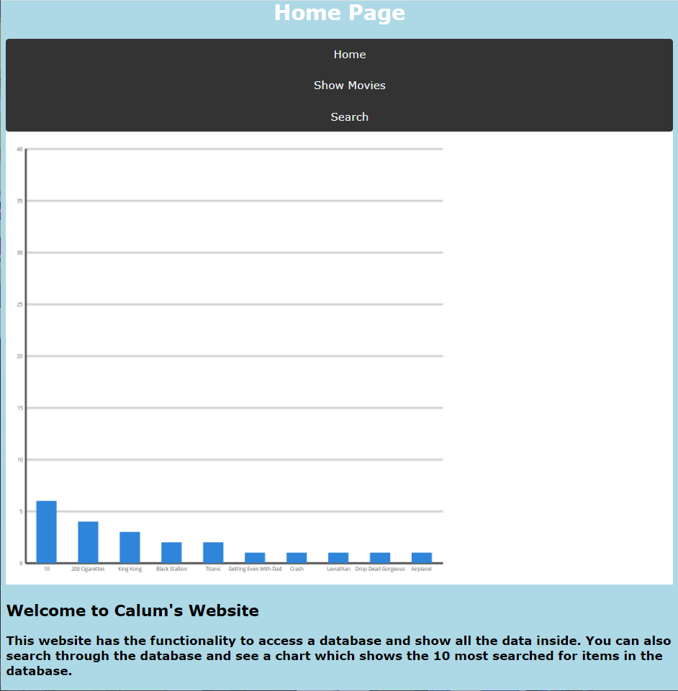

**Home Page Functions**

* **Home button**
* **Show movies button**
* **Search button**
* **Bar graph of top 10 searched movies**
* **Introduction to the website**

### Show Movies Case 2

The SQL query to display the movies.

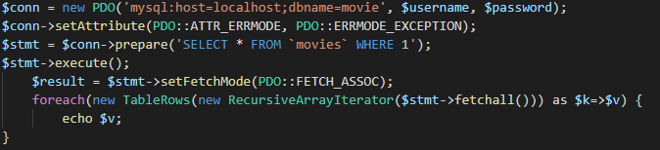

This code is how the table is displayed

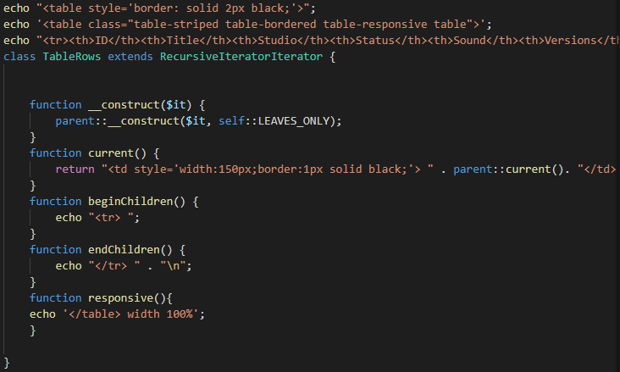

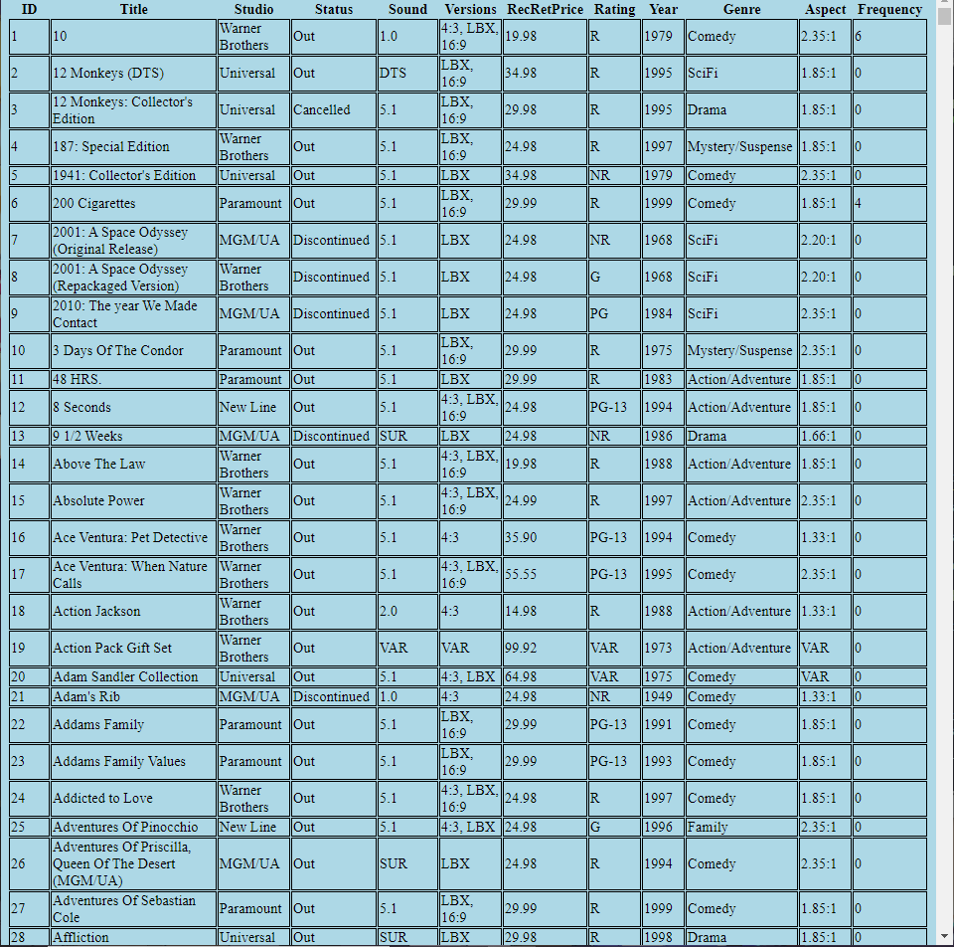

Holds all 2298 movies and there data



**Information Shown On The Table**

* ID
* Title
* Studio
* Status
* Sound
* Versions
* Recommended Retail Price
* Rating
* Year
* Genre
* Aspect
* Frequency Searched

### Search Case 3

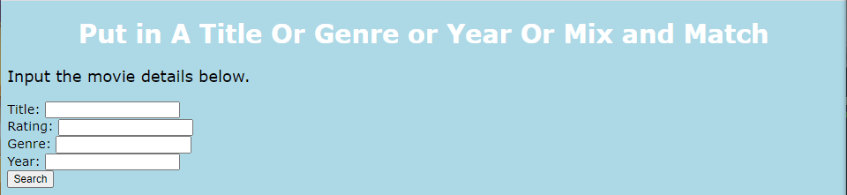

**Functions**

* Search by title
* Search by rating
* Search by genre
* Search by year
* Search by multiple entries

**Search by Title**

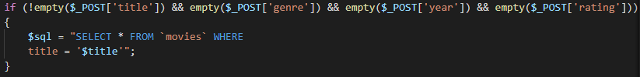

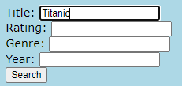Shows only the titles with Titanic



**Search by Rating**

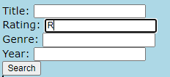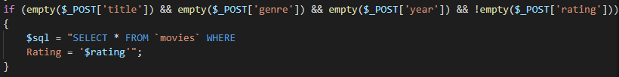Shows only movies with the rating R

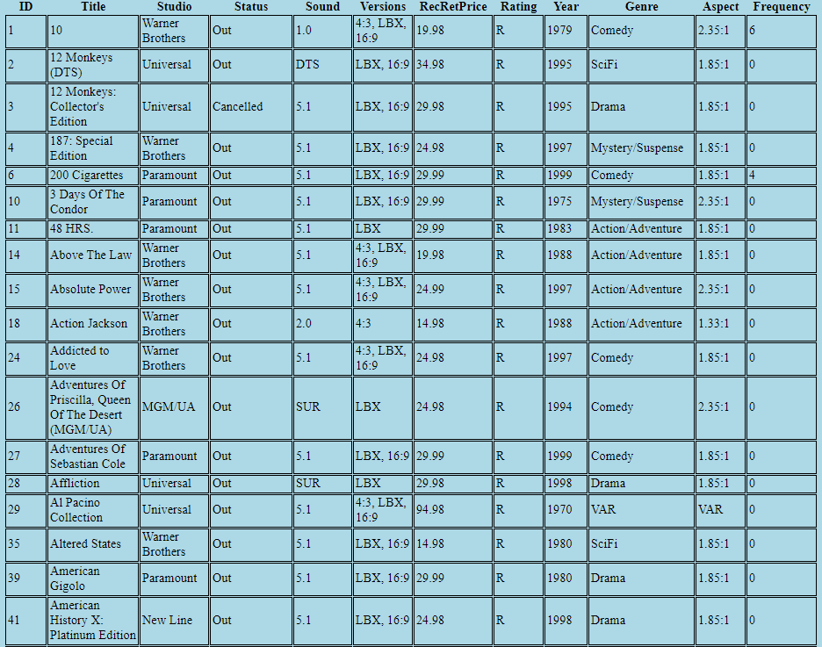

**Search by Genre**

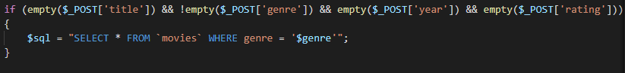

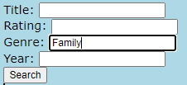Shows all movies with the Family genre

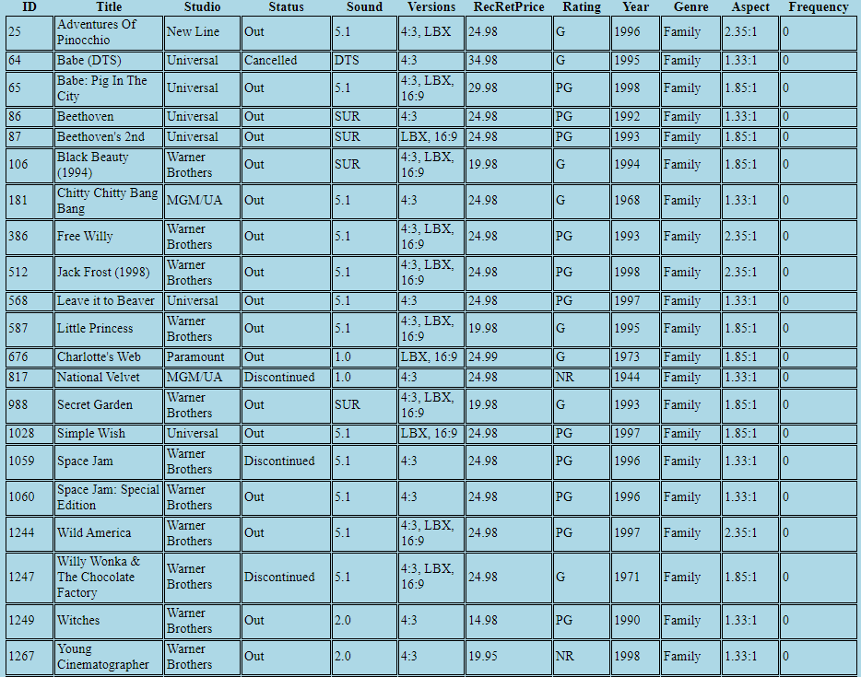

**Search by Year**

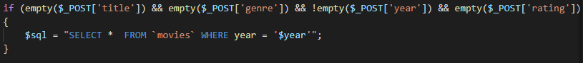

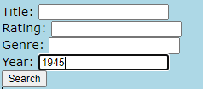Shows all movies from 1945

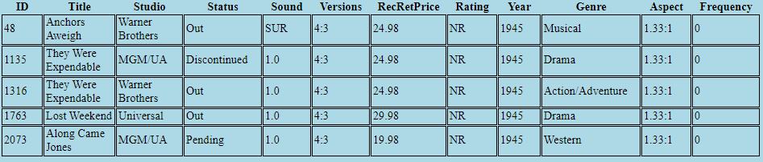

**Searching by Rating and Genre**



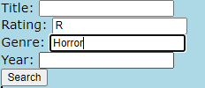Shows all movies rated R and in the genre of horror.

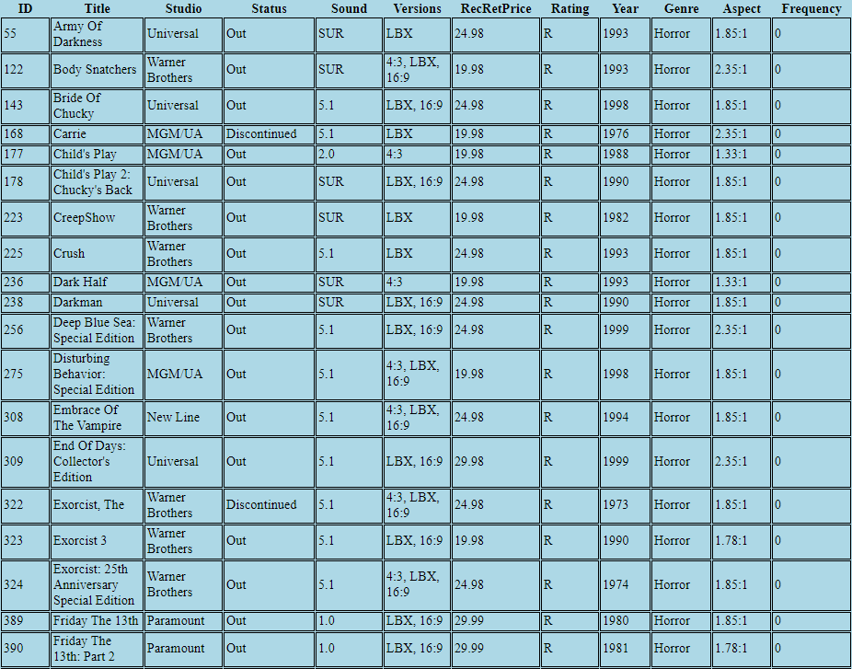

**Searching by Rating and Year**

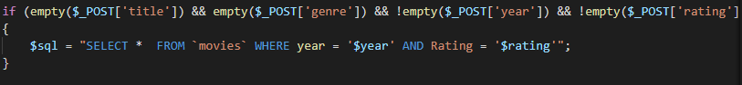

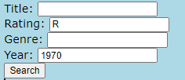Shows all movies rated R from 1970

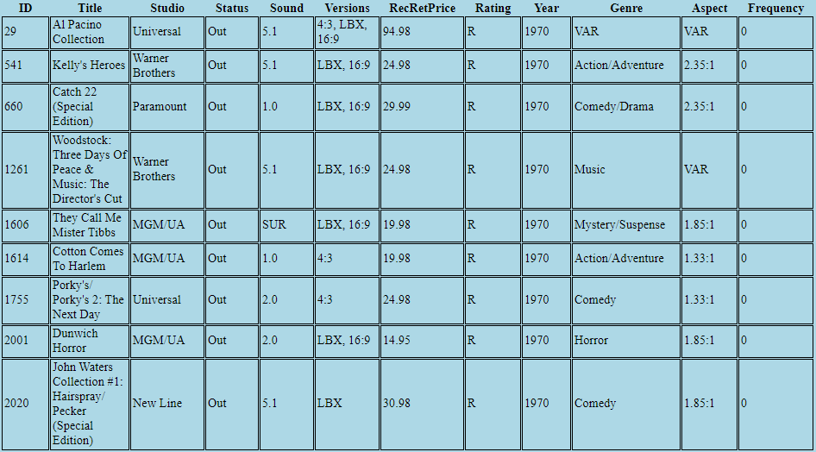 **Searching by Genre and Year**

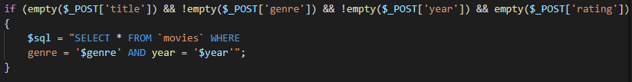

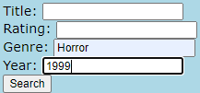Shows all movies in the genre horror from 1999

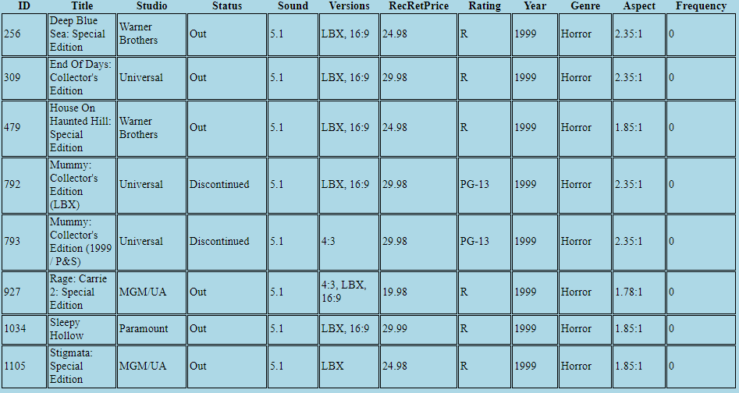

**Searching by Genre, Rating and Year**

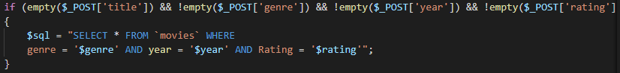

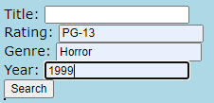Shows all movies rated pg-13 with the genre horror from 1999.

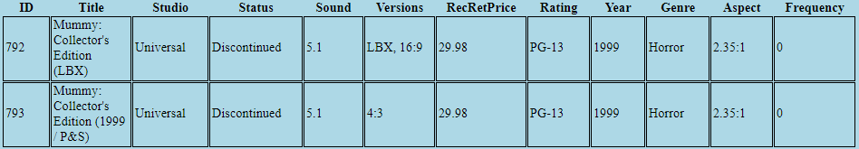

### Bar Chart Case 4

Shows the top 10 most searched movies

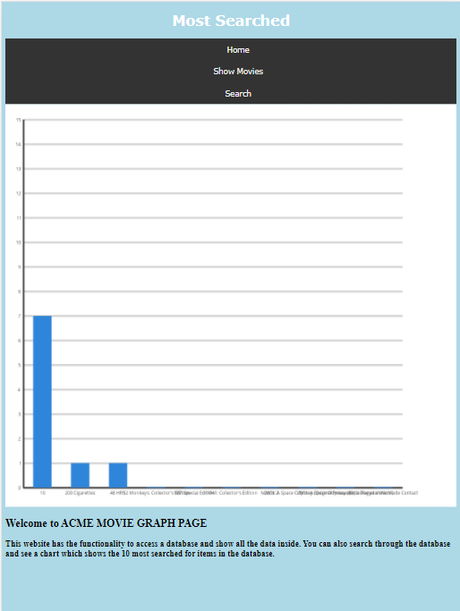

## Responsiveness

### Responsiveness Case 5

**Making the table responsive**

Echoing the responsive table function



Calling the responsive function and defining that the width should be 100%.

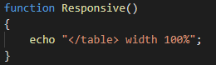

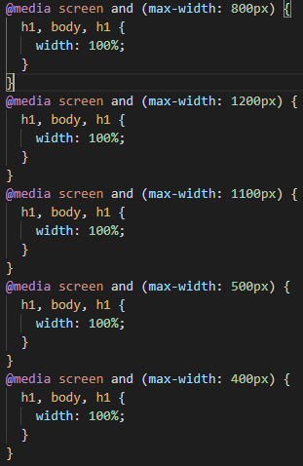**Making the html responsive**

Making the HTML responsive we made it so whenever the page was at a certain width of pixels it would make the width of the page to fit the current sized screen.

### 4” 800 x 480

**Home Show Movies**

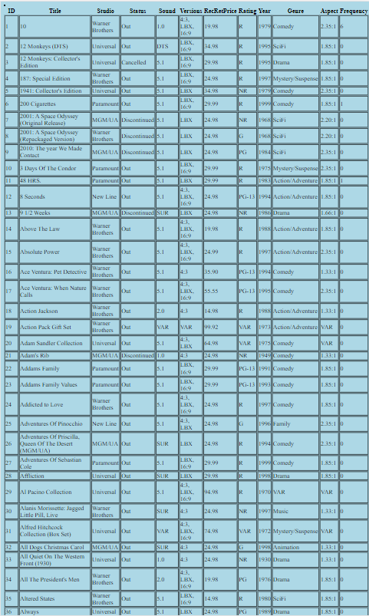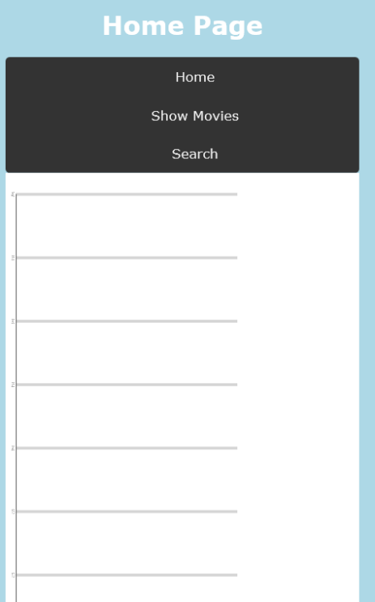

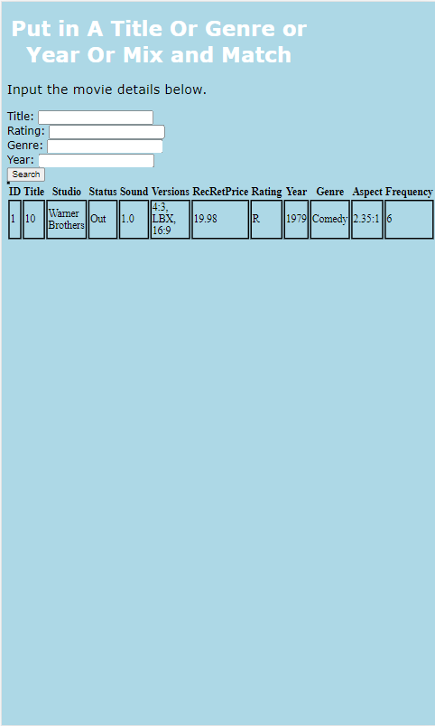**Search**

### 4.3” 800 x 400

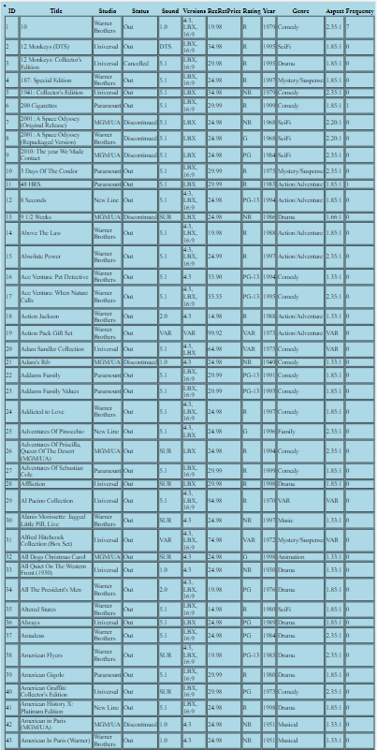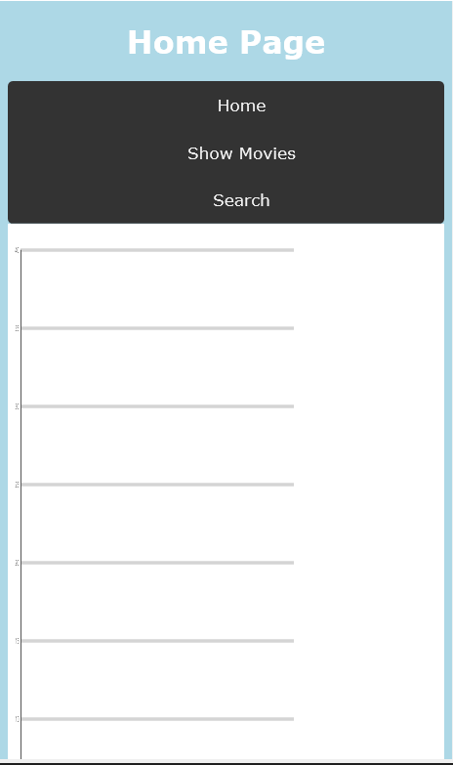**Home Show Movies**

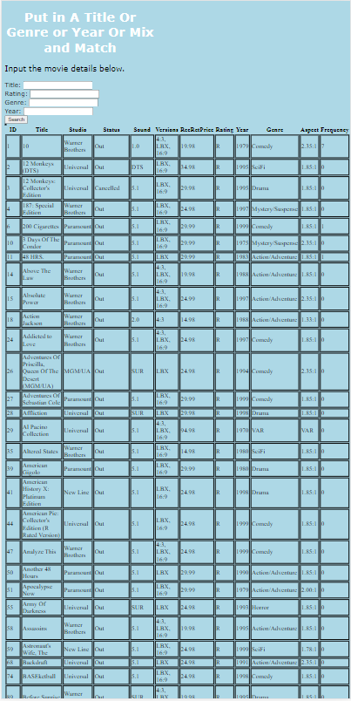**Search**

### 4.3” 1280 x 720

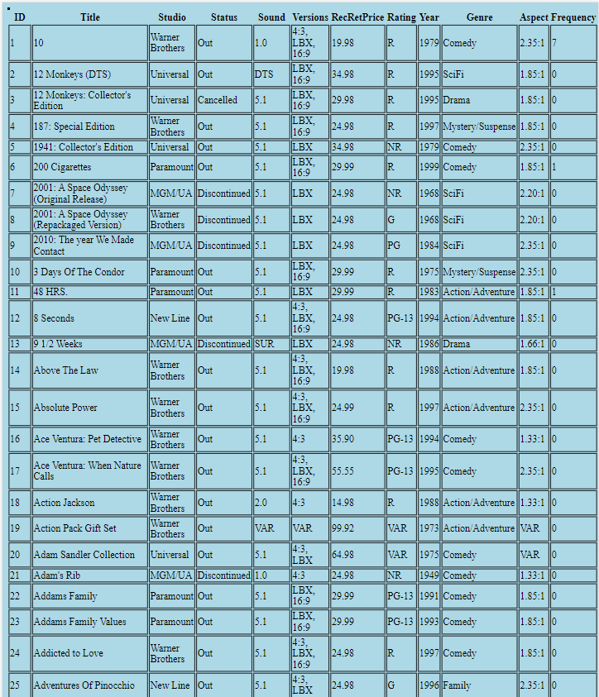**Home Show Movies**

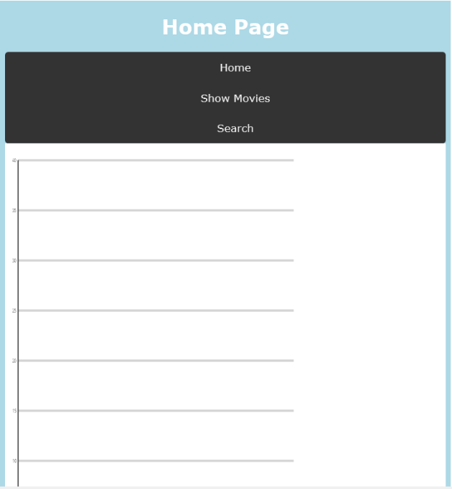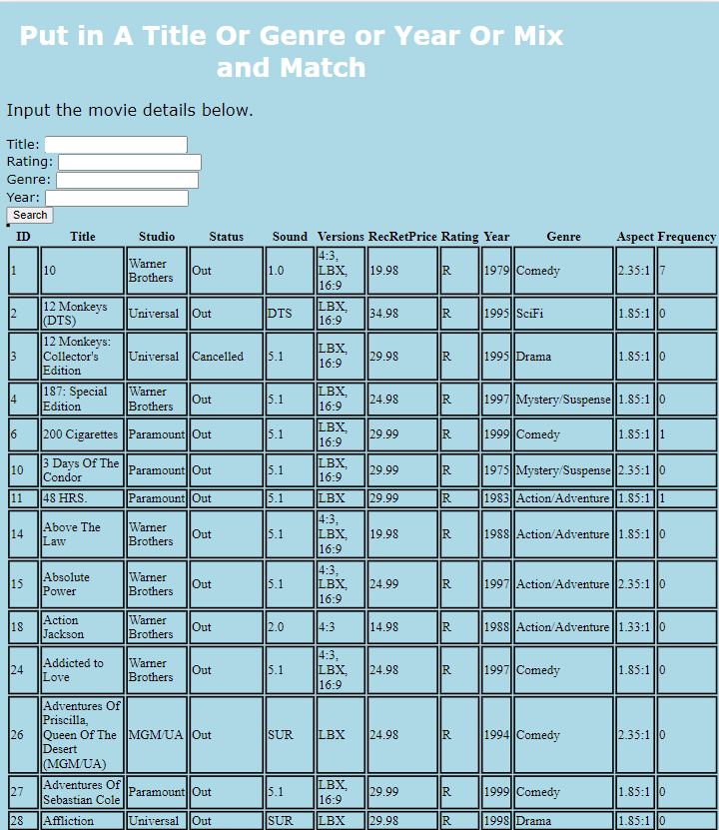

**Search**

### 10.6” 1920 x 1080

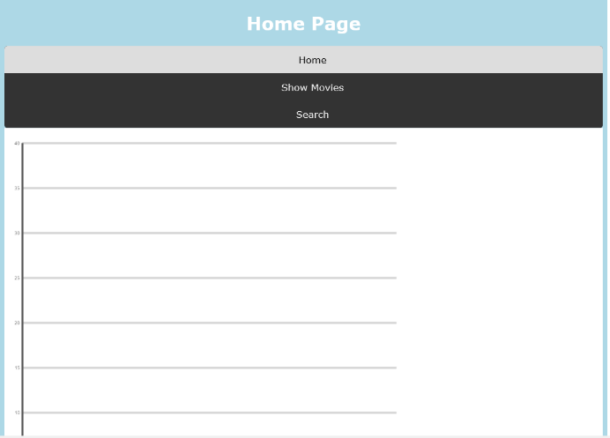**Home Show Movies**

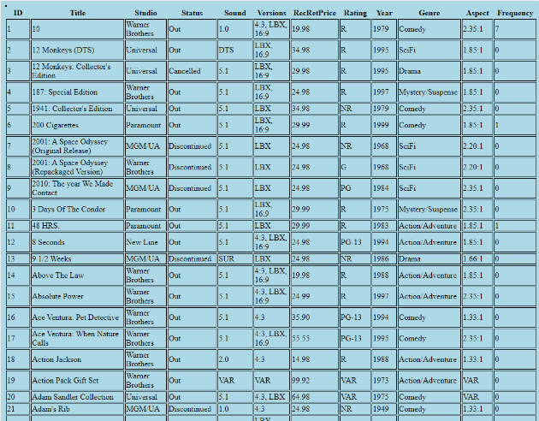

**Search**

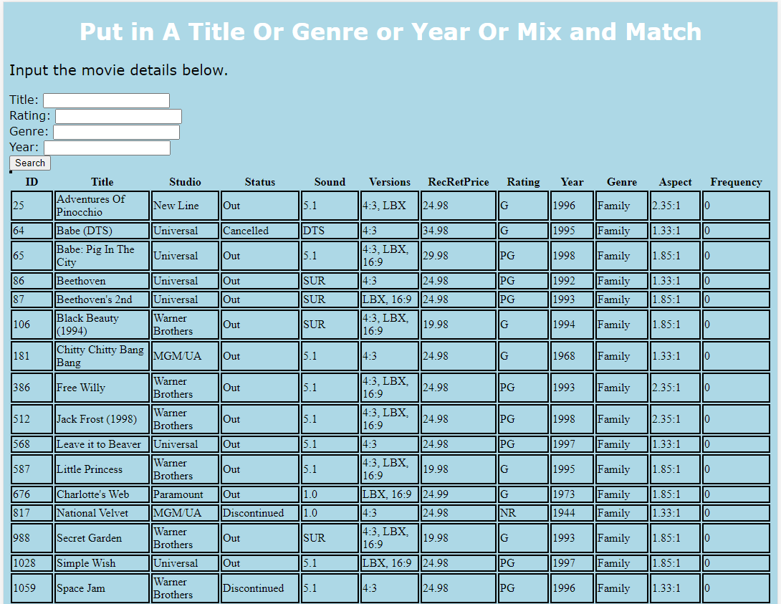

### 10.6” 2560 x 1440

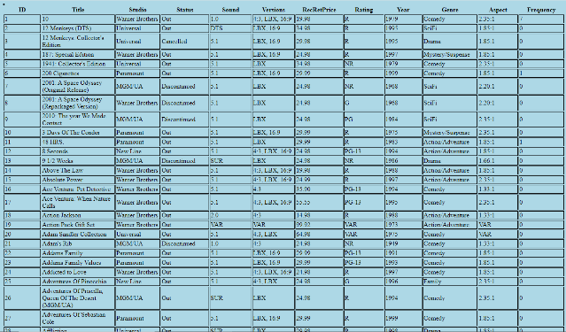**Home Show Movies**

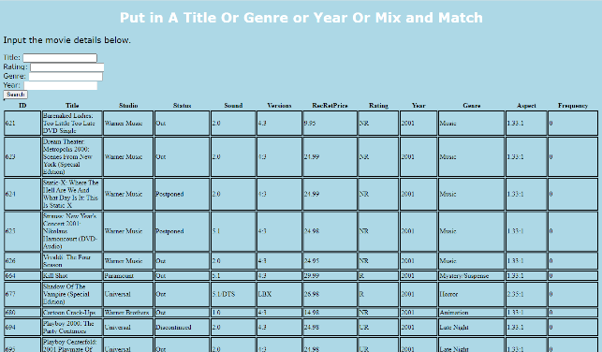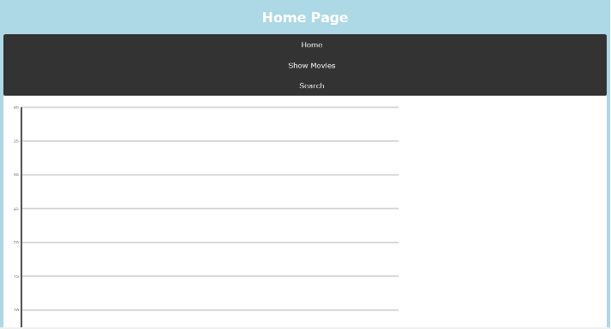 **Search**

# Terms/Acronyms

| **TERM/ACRONYM** | **DEFINITION** |
| --- | --- |
| API | Application Program Interface |
| AUT | Application Under Test |
| OS | Operating System |
| Mac | Macintosh |

# Bibliography

*adaptive vs responsive design*. (n.d.). Retrieved from Web Flow: https://webflow.com/blog/adaptive-vs-responsive-design

*HTML Responsive*. (n.d.). Retrieved from w3schools: https://www.w3schools.com/html/html_responsive.asp