9/18/2020

Calum Smith

South Metro TAFE

Project Test Document

Contents

Test your code against the PEAR code standard with an appropriate static analysis tool, e.g. PHP_CodeSniffer 2

Demonstrate software risk analysis and provide a simple report. ▪ Identify potential software risks or problems, e.g. Possible invalid user inputs that cause unexpected behaviour? Is requirements incomplete? Security issues? 4

Test and validate with sample inputs with screenshots. Test the logic of the contents of the application. Validate the consistency between the code and the software design. Include testing in various browsers, e.g. Chrome and Firefox. 4

Chrome 4

Search 4

Show all Movies 10

Chart 10

Firefox 11

Search 11

Show all Movies 17

Chart 17

# Test your code against the PEAR code standard with an appropriate static analysis tool, e.g. PHP_CodeSniffer

Before

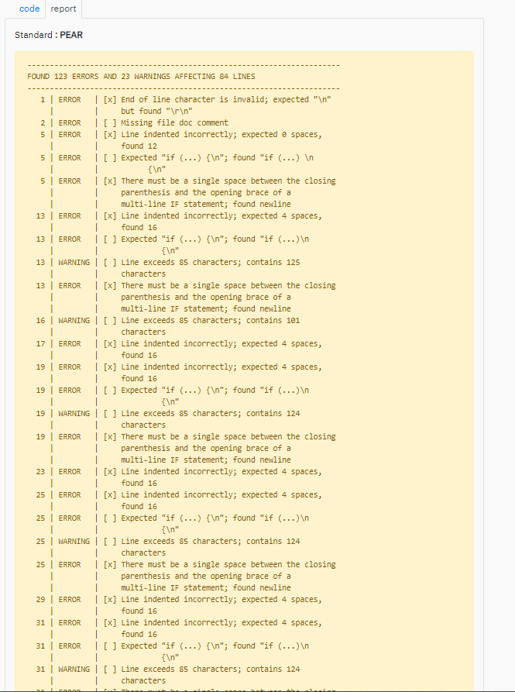

After using Beautifier

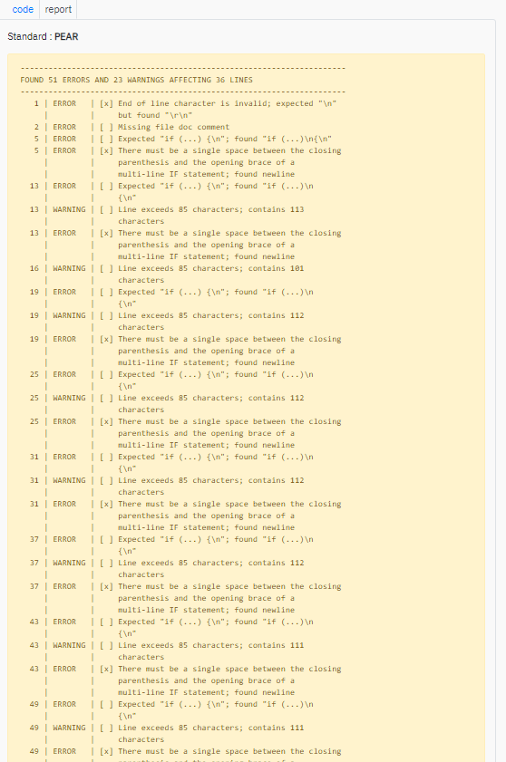

# Demonstrate software risk analysis and provide a simple report. ▪ Identify potential software risks or problems, e.g. Possible invalid user inputs that cause unexpected behaviour? Is requirements incomplete? Security issues?

Some risks could be that when someone tries to open up the chart on the website it may come up with an error because of the way that I had to implement the chart into the code.

The way I dealt with security issues was by using PDO which I more secure alternative to something like mysqli which has security issues. I also used POST instead of GET because GET passes parameter via a URL which means it is stored in server logs and browser histories. This makes it very easy to alter the data which is being submitted to the server.

# Test and validate with sample inputs with screenshots. Test the logic of the contents of the application. Validate the consistency between the code and the software design. Include testing in various browsers, e.g. Chrome and Firefox.

## Chrome

### Search

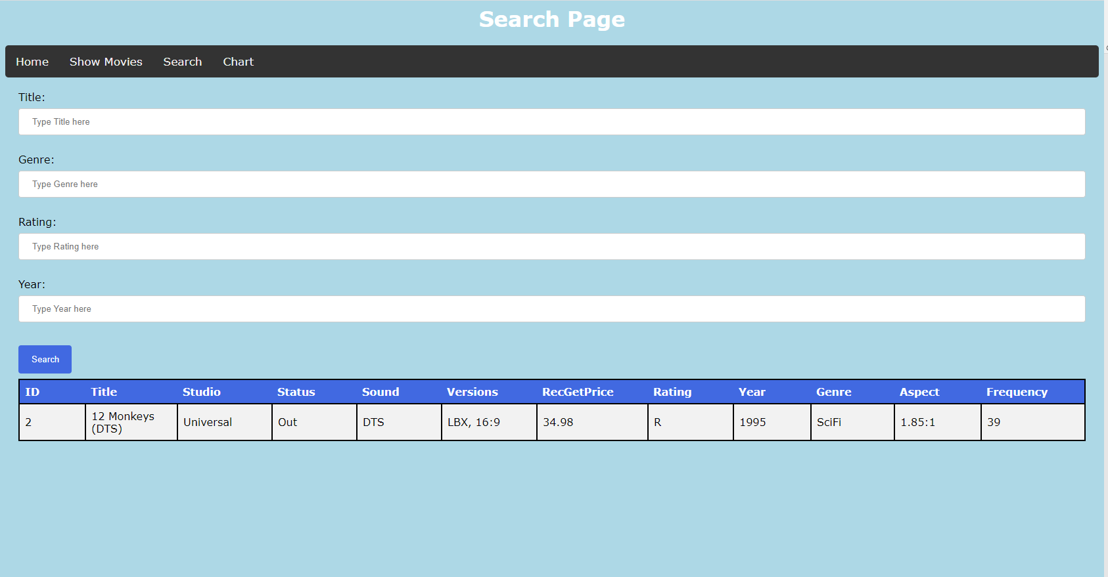Searching by Title

Searching by Genre

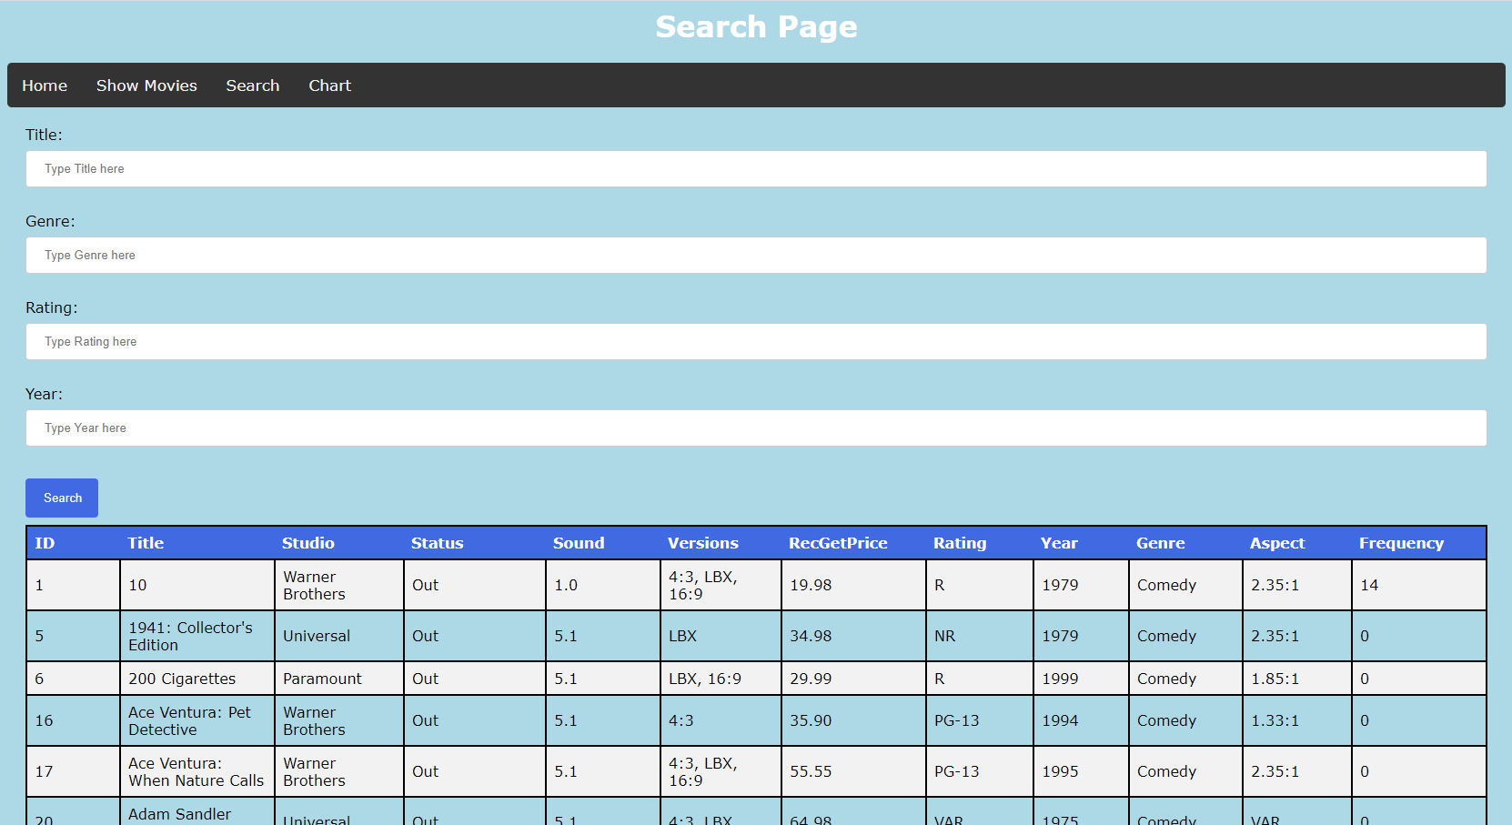

Searching by Rating

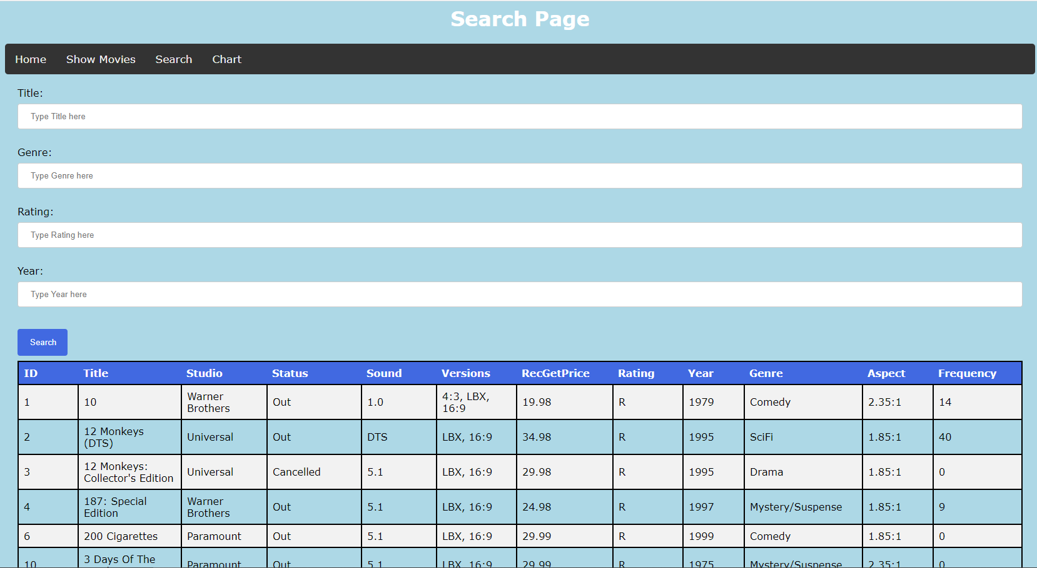

Searching by Year

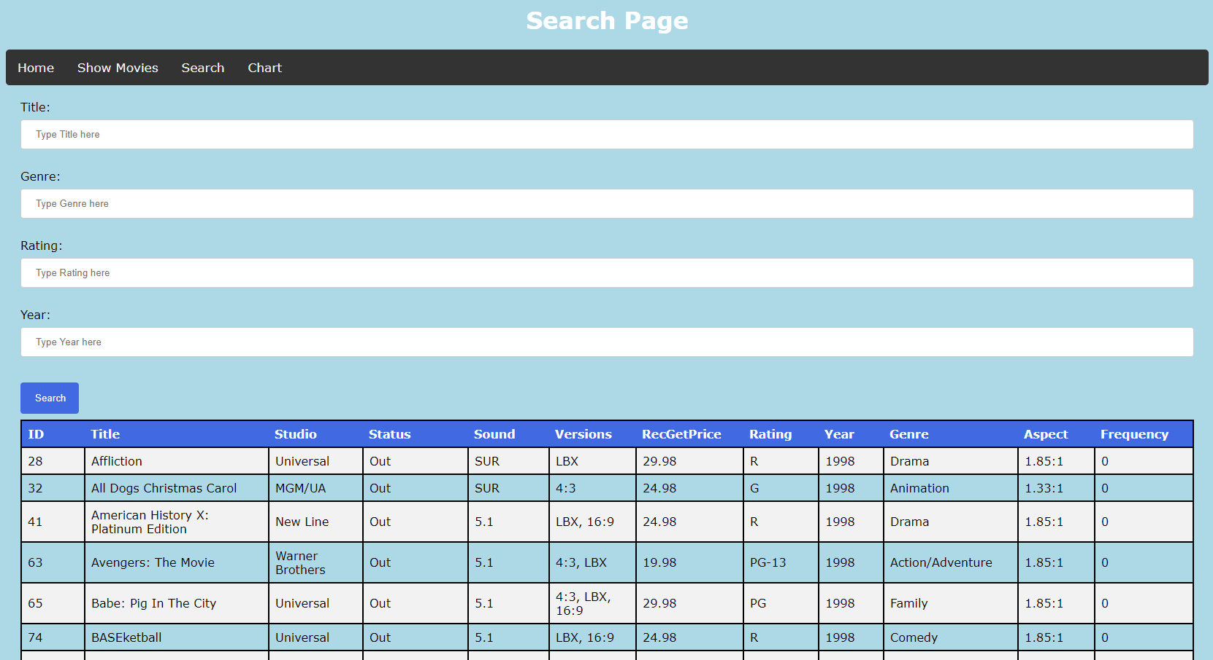

Searching by Title, Genre, Rating and Year

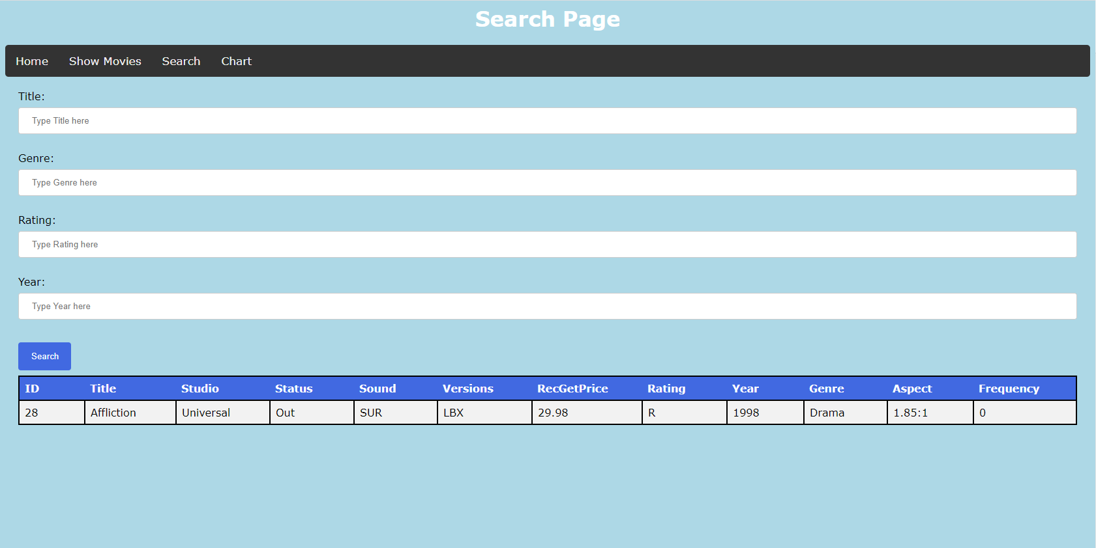

Searching by Title and Genre

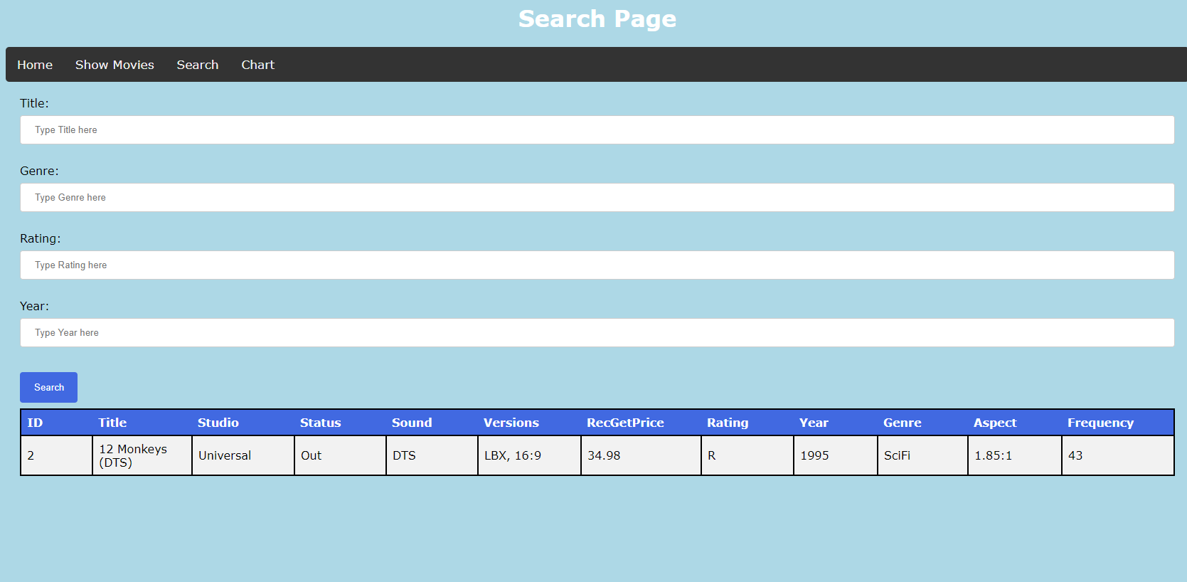

Searching by Title and Rating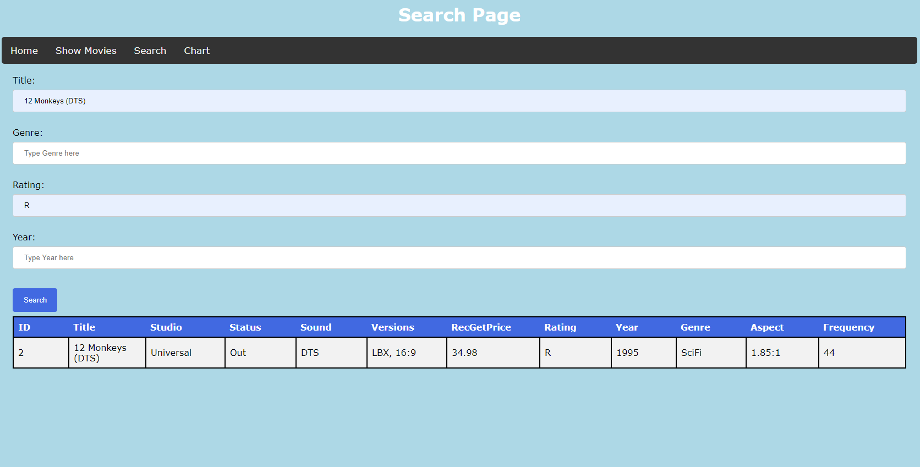

Searching by Title and Year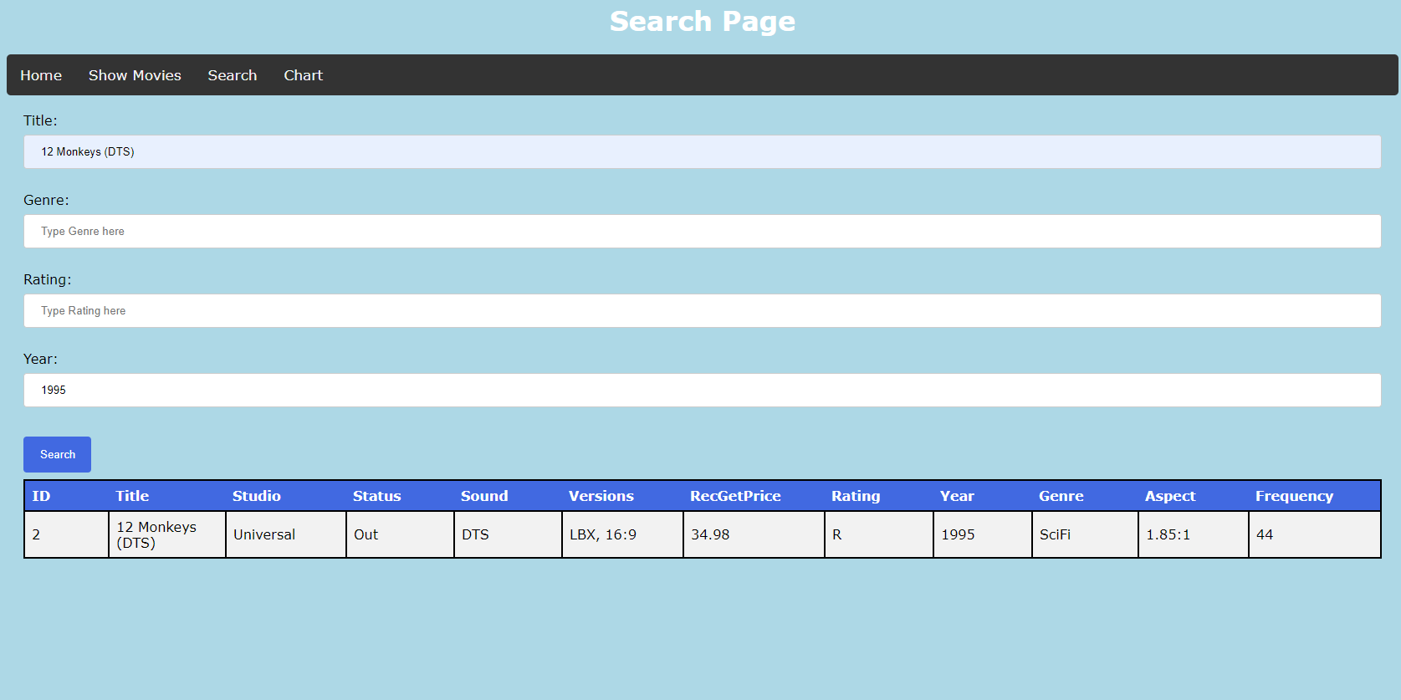

Searching by Genre and Rating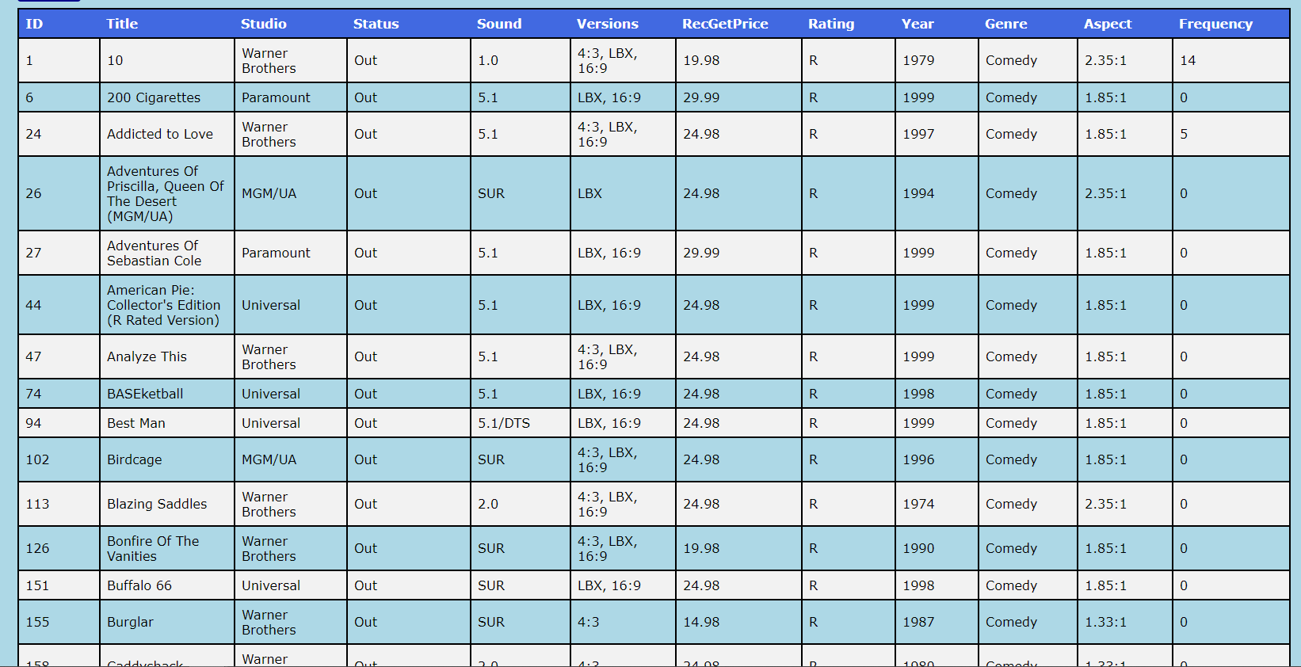

Searching by Genre and Year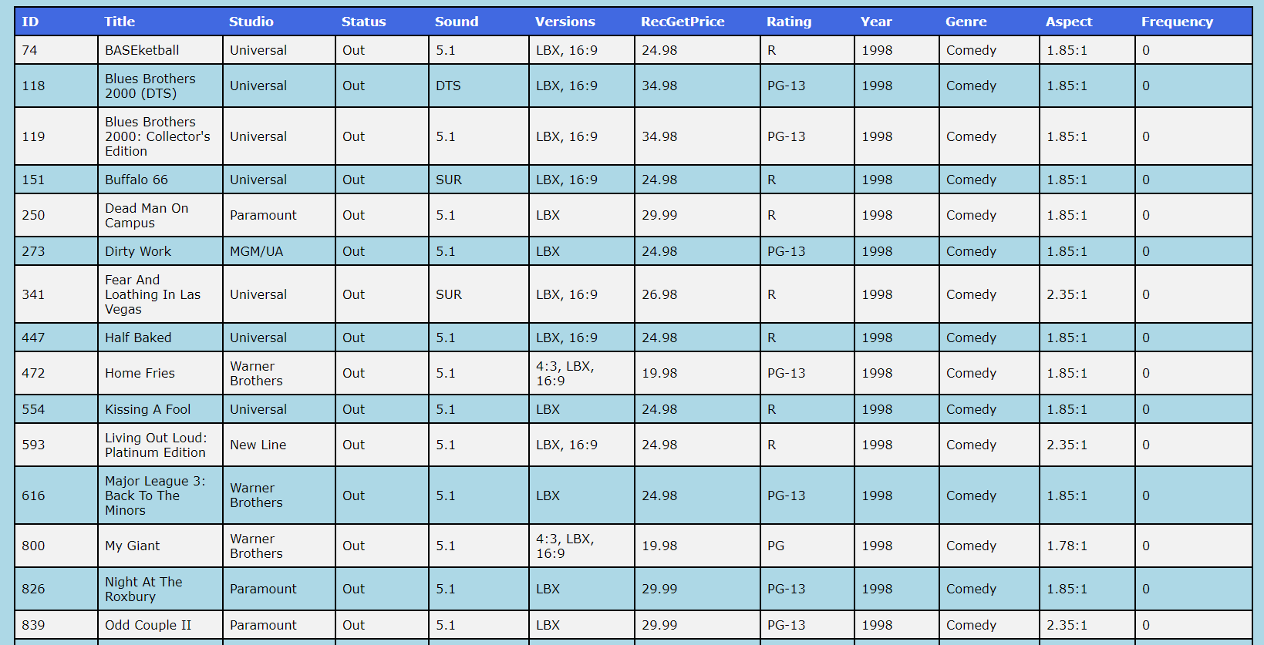

Searching by Rating and Year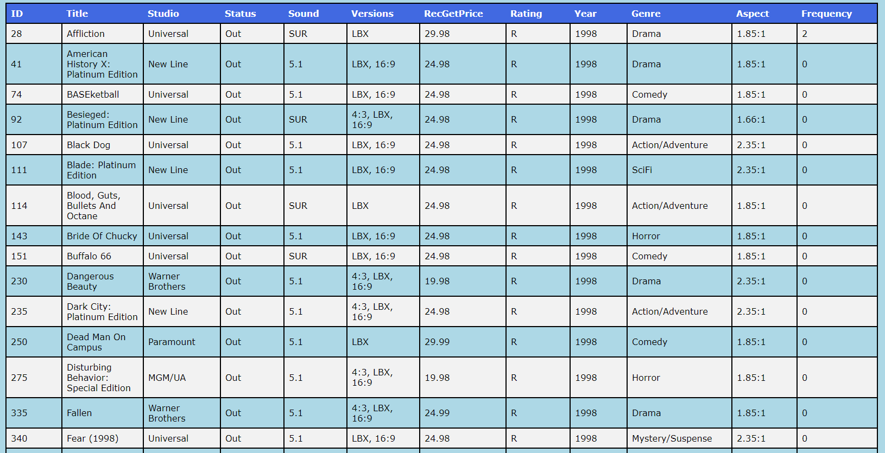

### Show all Movies



Chart

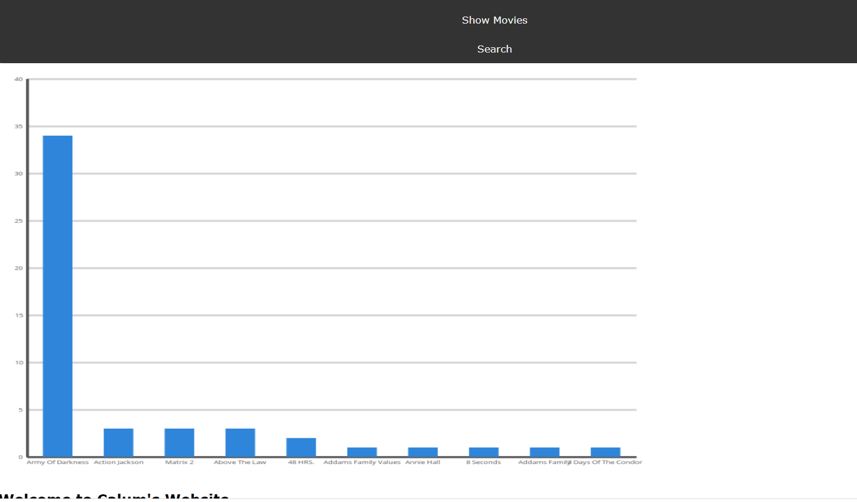

## Firefox

### Search

Searching by Title

Searching by Genre



Searching by Rating



Searching by Year



Searching by Title, Genre, Rating and Year



Searching by Title and Genre



Searching by Title and Rating

Searching by Title and Year

Searching by Genre and Rating

Searching by Genre and Year

Searching by Rating and Year

### Show all Movies



Chart

