Jesse Victors
February 1, 2014
Buddhabrot
For this project, I rendered the anti-buddhabrot using MPI. I tested the rendering speed on 1, 2, 4, 8, 12, 16, 20, 25, and 30 cores on the Sawtooth supercomputer at USU. I observed a linear speedup for each iteration, demonstrating that my rendering technique is embarrassingly parallel.
The Buddhabrot fractal is closely related to the Mandelbrot. However, the Buddhabrot differs from the Mandelbrot in that the intermediate complex points are traced rather than the initial point being plotted, as is the case in the Mandelbrot. In other words, each complex point is repeatedly run through an equation which transforms the point, and after the iterations are complete and the point has escaped to infinity, the intermediate transformed points are plotted on an image. Given enough points, this forms a complex pattern knows as the Buddhabrot. In my case, I rendered the anti-Buddhabrot, which plots the point only if the given point has not escaped, or in other words if it is inside the traditional Mandelbrot. I found this image to be much more interesting than the regular Buddhabrot.

In my application, each instance first created a two-dimensional array of the size of my desired image. It then repeatedly used the Mersenne pseudorandom number generator to pick two complex points, each in the range of [-2, 2]. It then ran this point through the iterative equation up to 50 thousand times. If the point did not escape to infinity, it would plot the intermediate points on the 2D array. It would repeat this process until approximately five minutes elapsed. At this point, instances 1 and above would send their image to instance 0, which would combine all images with its image, and print the result to a file.
I ran the following tests on the Sawtooth supercomputer:
Nodes Requested | Processes Per Node | Total Instances | Iterations in 5 mins
1 | 1 | 1 | 32.5 billion
1 | 2 | 2 | 65 billion
1 | 4 | 4 | 70 billion
2 | 4 | 8 | 230 billion
4 | 3 | 12 | 362.5 billion
4 | 4 | 16 | 490 billion
5 | 4 | 20 | 670 billion
5 | 5 | 25 | 795 billion
5 | 6 | 30 | 980 billion

Alternatively, this same data as a graph:
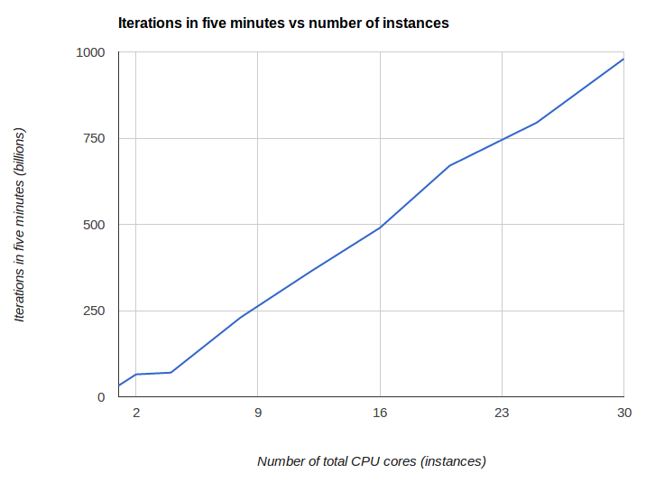
Although is an unexpectedly low value for four cores, generally speaking the speedup appears very linear. One would expect that at 64 or 128 cores that approximately 2,090 billion and 4181.3 billion iterations could be achieved, respectively.

