Jesse Brand

IS 5315-03 HW1

1. **Web Address: 206.189.168.233/index.html**

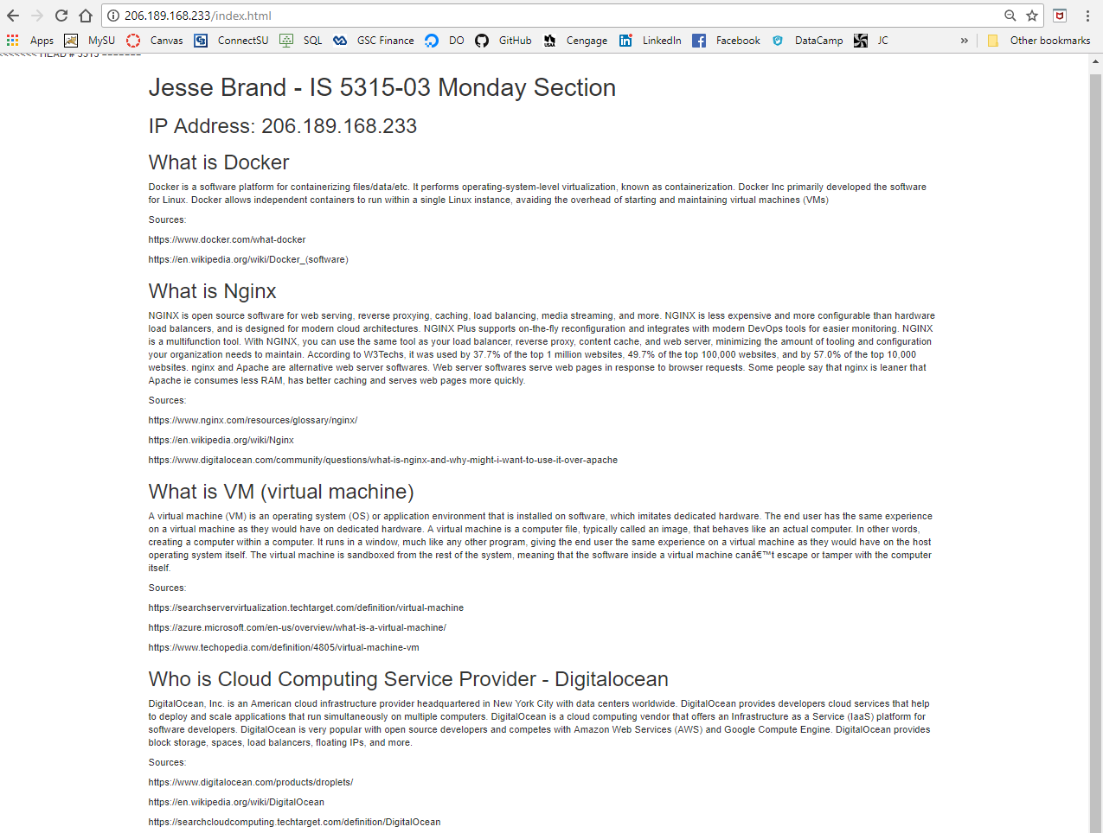

1. **Source Code:**

<html>

<head>

<link href="https://maxcdn.bootstrapcdn.com/bootstrap/3.3.5/css/bootstrap.min.css" rel="stylesheet" integrity="sha256-$">

<title>Docker nginx Tutorial</title>

</head>

<body>

<div class="container">

<h1>Jesse Brand - IS 5315-03 Monday Section</h1>

<h2> IP Address: 206.189.168.233</h2>

<h2>What is Docker</h2>

<p>Docker is a software platform for containerizing files/data/etc. It performs operating-system-level virtualization, known as containerization. Docker Inc primarily developed the software for Linux. Docker allows independent containers to run within a single Linux instance, avaiding the overhead of starting and maintaining virtual machines (VMs) </p>

<p> Sources: </p>

<p> https://www.docker.com/what-docker </p>

<p> https://en.wikipedia.org/wiki/Docker_(software)</p>

<h2>What is Nginx</h2>

<p>NGINX is open source software for web serving, reverse proxying, caching, load balancing, media streaming, and more. NGINX is less expensive and more configurable than hardware load balancers, and is designed for modern cloud architectures. NGINX Plus supports on-the-fly reconfiguration and integrates with modern DevOps tools for easier monitoring. NGINX is a multifunction tool. With NGINX, you can use the same tool as your load balancer, reverse proxy, content cache, and web server, minimizing the amount of tooling and configuration your organization needs to maintain. According to W3Techs, it was used by 37.7% of the top 1 million websites, 49.7% of the top 100,000 websites, and by 57.0% of the top 10,000 websites. nginx and Apache are alternative web server softwares. Web server softwares serve web pages in response to browser requests. Some people say that nginx is leaner that Apache ie consumes less RAM, has better caching and serves web pages more quickly.

</p>

<p> Sources: </p>

<p> https://www.nginx.com/resources/glossary/nginx/ </p>

<p> https://en.wikipedia.org/wiki/Nginx </p>

<p> https://www.digitalocean.com/community/questions/what-is-nginx-and-why-might-i-want-to-use-it-over-apache </p>

<h2>What is VM (virtual machine)</h2>

<p>A virtual machine (VM) is an operating system (OS) or application environment that is installed on software, which imitates dedicated hardware. The end user has the same experience on a virtual machine as they would have on dedicated hardware. A virtual machine is a computer file, typically called an image, that behaves like an actual computer. In other words, creating a computer within a computer. It runs in a window, much like any other program, giving the end user the same experience on a virtual machine as they would have on the host operating system itself. The virtual machine is sandboxed from the rest of the system, meaning that the software inside a virtual machine can’t escape or tamper with the computer itself. </p>

<p> Sources: </p>

<p> https://searchservervirtualization.techtarget.com/definition/virtual-machine </p>

<p> https://azure.microsoft.com/en-us/overview/what-is-a-virtual-machine/ </p>

<p> https://www.techopedia.com/definition/4805/virtual-machine-vm </p>

<h2>Who is Cloud Computing Service Provider - Digitalocean</h2>

<p>DigitalOcean, Inc. is an American cloud infrastructure provider headquartered in New York City with data centers worldwide. DigitalOcean provides developers cloud services that help to deploy and scale applications that run simultaneously on multiple computers. DigitalOcean is a cloud computing vendor that offers an Infrastructure as a Service (IaaS) platform for software developers. DigitalOcean is very popular with open source developers and competes with Amazon Web Services (AWS) and Google Compute Engine. DigitalOcean provides block storage, spaces, load balancers, floating IPs, and more. </p>

<p> Sources: </p>

<p> https://www.digitalocean.com/products/droplets/ </p>

<p> https://en.wikipedia.org/wiki/DigitalOcean </p>

<p> https://searchcloudcomputing.techtarget.com/definition/DigitalOcean </p>

</div>

</body>

</html>