**Supplementary 1**

**How to create a virtual machine (virtual host)**

Install the belows apps on your computer:

All Computers:

<https://www.sublimetext.com/3>

Mac:

<https://git-scm.com/download/mac>

Windows:

<http://www.chiark.greenend.org.uk/~sgtatham/putty/latest.html>)

<https://gitforwindows.org/>

Creating a Virtual Machine - DigitalOcean:

* In your account page (web login page)
* Create a droplet
* Choose an image - Ubuntu 16
* Choose a size - Minimum Plan (around $5/month)
* Choose a data center region - Bay area
* How many droplets - 1
* Choose a host name - 5315Tu
* Check your email from Digitalocean for a Password (the droplet just created)

Using Terminal (Mac) or PuTTy (Windows):

On Mac OS X:

Start Terminal (Utility | Terminal)

ssh root@xxx.xx.xx.xxx

It means id@IPaddress

Once you set up a sudo id, you may use:

ssh [james@xxx.xx.xx.xxxx](mailto:james@xxx.xx.xx.xxxx)

On Windows:

Download and start PuTTY. (<http://www.chiark.greenend.org.uk/~sgtatham/putty/latest.html>)

Save your session.

Click the Open button.

* PuTTy – Paste: right mouse click

* PuTTy – Copy: any current block

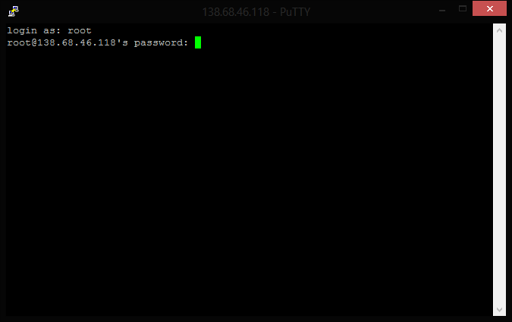

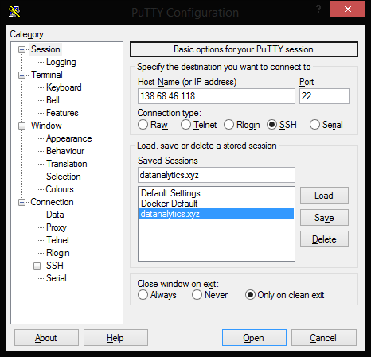

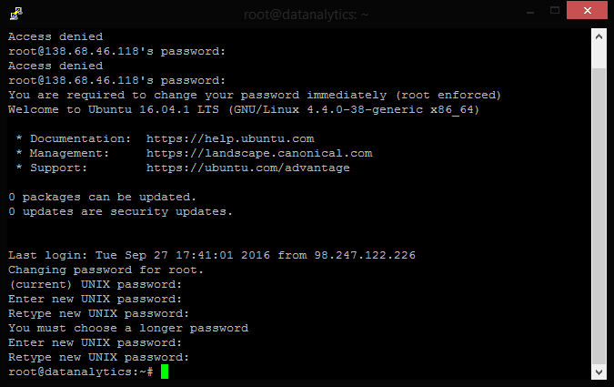

Initial Setup with your VM:

**Initial Server Setting – Ubuntu 16**

Source: <https://www.digitalocean.com/community/tutorials/initial-server-setup-with-ubuntu-16-04>

**Do Step 1, 2, 3.**

Step One — Root Login

ssh root@SERVER_IP_ADDRESS

You will need to **enter the password** from email **twice**.

Step Two — Create a New User – you can use any name below

adduser sammy

You will need to enter the password from email again when it asks the existing password. Password should at least 6 characters.

Step Three — Root Privileges

usermod -aG sudo sammy

Now your user can run commands with superuser privileges! - sudo

Step Four - Switch User

su sammy

**Docker & Docker Compose**

<https://www.digitalocean.com/community/tutorials/how-to-configure-a-continuous-integration-testing-environment-with-docker-and-docker-compose-on-ubuntu-14-04>

**Do Step 1, 2.**

Step 1 — Install Docker

wget -qO- https://get.docker.com/ | sh

In order to make it easier to work with Docker, add your user to the docker group with the following command:

docker --version

sudo usermod -aG docker $(whoami)

**(ctrl + d)Log out and then log in to your server** to activate the docker group for your user.

ssh sammy@SERVER_IP_ADDRESS

Step 2 — Install Docker Compose

sudo apt-get update

sudo apt-get -y install python-pip

sudo pip install docker-compose

docker-compose --version

(Optional) DNS Setup:

You may not need MX records. Below example is using gmail. You also need to point digitalocean DNS Servers.

**Domain Registry**: An example of namecheap.com for setting up nameservers

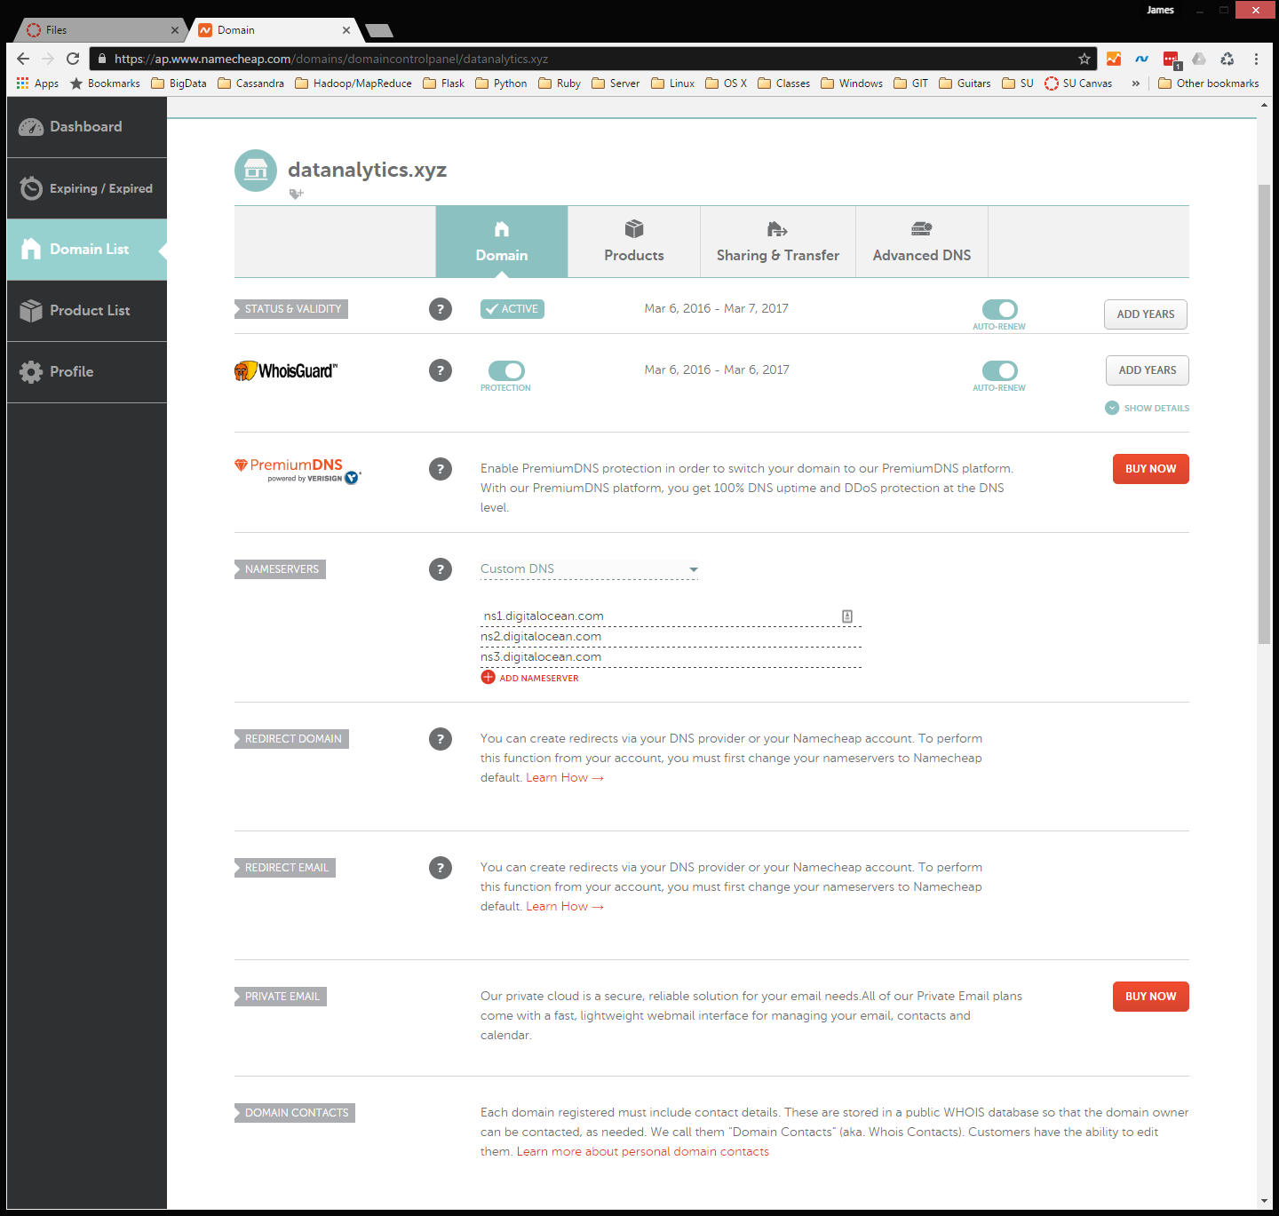

**Virtual Maching**: An example of digitalocean.com for setting up networking

