**Supplementary 2**

**Version Control System - GIT**

GIT Basics:

<http://rogerdudler.github.io/git-guide/>

GIT Reference:

<https://www.atlassian.com/git/tutorials>

<https://guides.github.com/>

Server - SSH Registration:

**PuTTy** or **ssh** to your instance

**sudo apt-get update**

**sudo apt-get install git**

**git config --global user.name** "Your Name"

**git config --global user.email** "youremail@domain.com" (email used in GitHub account)

**ssh-keygen -t rsa** (hit Enter key three times to use default without passphrase)

**cat ~/.ssh/id_rsa.pub** (for PuTTy, you can just make a block – then it will be copied to your clipboard)

Copy the value shown in your terminal.

1. On your **web browser**, go to GitHub site and log into your account - github.com
2. Go to ‘Settings’ (click the small arrow on the top right by your user logo)
3. Choose ‘SSH section’
4. Click ‘New SSH Key’ button/link
5. Add a title of your own use, such as ‘My Laptop Name’
6. Paste your public key from your terminal to ‘Key’ textbox
7. Complete the process by clicking ‘Add SSH key’ at the bottom

**Creating a new Repository**

1. Click the top left logo to go to your main repository page
2. Click ‘New repository’ button on the top right corner
3. Repository name: 5315

**sudo chown sammy:sammy -R ~/** (you should use your id instead of james)

**mkdir -p ~/web**

**cd ~/web**

# Below: copy (or use) the similar code from GitHub web site you just created above

**echo "# 5315" >> README.md**

**git init**

**git add README.md**

**git commit -m "first commit"**

**git remote add origin git@github.com:JesseAngelBrand/5315.git**

**git push -u origin master**

# Above: copy (or use) the similar code from GitHub web site you just created above

**docker run --name nginx -p 80:80 -d -v ~/web:/usr/share/nginx/html nginx**

**docker ps**

Local - SSH Registration:

1. OS X: in your **new terminal**, Windows: in your **git bash** window (you must install git to your local computer)

git config --global user.name "Your Name"

git config --global user.email "youremail@domain.com"

ssh-keygen -t rsa

cat ~/.ssh/id_rsa.pub

# Add another ssh key to github.com (Server Steps 1 – 7)

mkdir -p ~/web

cd ~/web

git clone git@github.com:JesseAngelBrand/5315.git (**copy from YOUR GitHub web site**)

https://github.com/JesseAngelBrand/5315.git

git push origin master --force

https://github.com/JesseAngelBrand/5315.git

git remote set-url --push origin https://github.com/JesseAngelBrand/5315.git

git remote set-url --pull origin https://github.com/JesseAngelBrand/5315.git

HW Setup:

1. In your **local computer**



cd ~/web/5315

explorer . **(Windows only)**

open . **(Mac only)**

# Copy and paste all hw1 file (index.html) in your file manager

1. In your **local computer**: terminal or git bash

cd ~/web/5315

git add .

git commit -m "hw files"

git push origin master

1. In your **server**

cd ~/web

git pull origin master

1. Test your sites on a Web Browser's address bar:

yourIP/index.html

http://i.stack.imgur.com/YC4H0.png

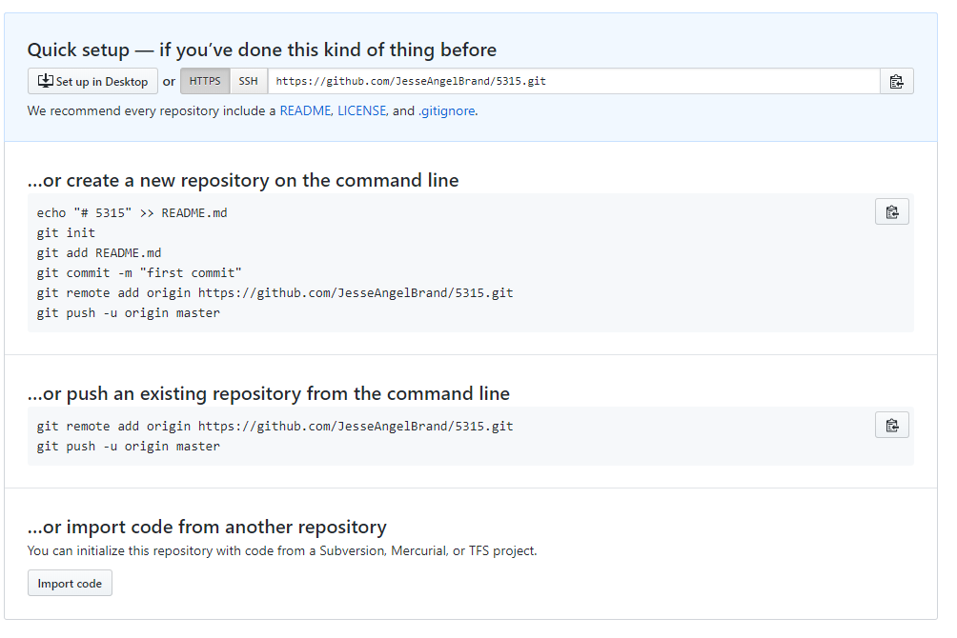

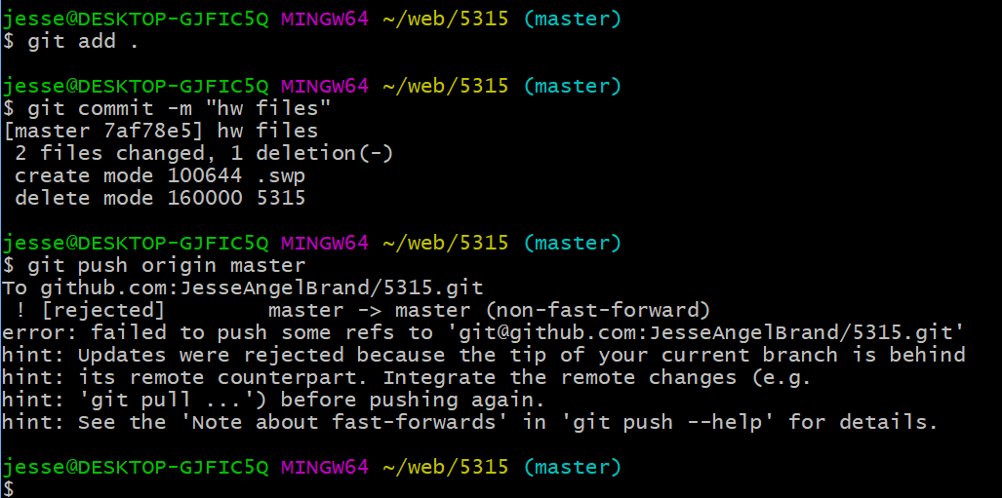

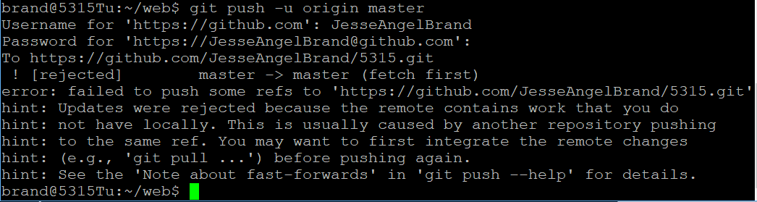

**References:**

<https://www.digitalocean.com/community/tutorials/how-to-install-git-on-ubuntu-16-04>

<https://github.com/boersmamarcel/challengesplatform/wiki/SSH-keys-digital-ocean-server>

<https://www.digitalocean.com/community/tutorials/how-to-use-ssh-keys-with-digitalocean-droplets>

<https://help.github.com/articles/adding-a-new-ssh-key-to-your-github-account/>

Ubuntu Docker Nginx

<https://www.digitalocean.com/community/tutorials/how-to-run-nginx-in-a-docker-container-on-ubuntu-14-04>

<https://www.digitalocean.com/community/tutorials/initial-server-setup-with-ubuntu-16-04>

<https://www.digitalocean.com/community/tutorials/how-to-configure-a-continuous-integration-testing-environment-with-docker-and-docker-compose-on-ubuntu-14-04>

Linux commands:

<https://www-uxsup.csx.cam.ac.uk/pub/doc/suse/suse9.0/userguide-9.0/ch24s04.html>

<http://www.thegeekstuff.com/2010/11/50-linux-commands/?utm_source=feedburner>

<http://www.codingbyte.com/30-most-frequently-used-linux-commands-with-examples/>