**DESIGN AND IMPLEMENTATION OF A WEB-BASED RADIO AUDIENCE MEASUREMENT SYSTEM**

**BY**

**AYEGBA JESSE-JOSEPH, ANIBE**

**A PROJECT REPORT SUBMITTED TO THE DEPARTMENT OF ELECTRICAL & INFORMATION ENGINEERING, IN PARTIAL FULFILMENT OF THE REQUIREMENTS FOR THE AWARD OF THE BACHELOR OF ENGINEERING DEGREE IN ELECTRICAL AND ELECTRONICS ENGINEERING**

**SUPERVISOR: ENGR. OMORUYI OSEMWEGIE**

**AUGUST 2021**

1. DECLARATION
2. I hereby declare that I carried out the work reported in this project in the Department of Electrical and Information Engineering, Covenant University, under the supervision of Engr. Omoruyi Osemwegie. I also solemnly declare that to the best of my knowledge, no part of this report has been submitted here or elsewhere in a previous application for the award of a degree. All sources of knowledge used have been duly acknowledged.

…………………………………….

AYEGBA JESSE-JOSEPH ANIBE

16CK020793

1. CERTIFICATION

This is to certify that the project titled "Design and Implementation of a Web-based Radio Audience Measurement System” by AYEGBA JESSE-JOSEPH, ANIBE, meets the requirements and regulations governing the award of the Bachelor of Engineering (Electrical and Electronics Engineering) degree of Covenant University and is approved for its contribution to knowledge and literary presentation.

|  |  |
| --- | --- |
| **Supervisor:** | Name: Engr. Omoruyi Osemwegie  Sign: ___________________ Date: ________________ |
| **Head of Department :** | Name: Prof. Emmanuel. A. Adetiba  Sign: ___________________ Date: ________________ |
| **Internal Examiner:** | Name: _______________________________________  Sign: ___________________ Date: ________________ |

1. ACKNOWLEGEMENTS

My sincere appreciation goes to God Almighty for enabling me to complete this project. I would also like to express my deepest gratitude to the members of my family for their unending support.

I would like to express my appreciation to my project supervisor, Engr. Omoruyi Osemwegie, for providing me with the necessary guidance needed to complete this project.

1. ABSTRACT

With the rapid increase in the technology of the world today, there is really no limit to the possibilities that can be accomplished. Audience measurement technologies have evolved over the years from the use of diaries and meters to the use of more modern and sophisticated technologies. The increase in the population of the world has contributed to the diversity of the information content that is broadcast in different parts of the world. The demand for easier and more accurate ways to determine the type of content that people are interested in listening to is increasing on an exponential scale as advertisers are constantly in search of audience data.

This project puts forward a highly scalable approach for carrying out audience measurement. It uses three channels for tracking purposes to see how well it can make predictions using machine learning technologies. It focuses on how a remote audience can be measured with the use of both mobile and web-based applications.

1. TABLE OF CONTENT

CHAPTER 1 1

1.1 Background of study 1

1.1.1 Brief history of audience measurement 1

1.1.2 Audience measurement in digital signage 2

1.2 Significance of the project 3

1.3 Problem statement 3

1.4 Aim and objectives 4

1.5 Methodology 4

1.6 Scope of study 4

1.7 Limitation of study 5

1.8 Project organization 5

CHAPTER 2 6

2.1 Introduction 6

2.2 Definition of key terms 6

2.3 History and evolution of audience measurement 7

2.3.1 Birth (1950): phone surveys 7

2.3.2 Infancy stage (1953) - diaries and meters 7

2.3.3 Childhood stage (1986) - VCRs and Cable tv and 8

2.3.4 Adolescent stage (2000–2010) - the internet and social media 9

2.4 Review of related works 9

2.4.1 Review on an architecture for real time television audience measurement 9

2.4.2 Review on audience measurement technologies for user centric media 11

2.4.3 Review on investigation of spectral centroid magnitude and frequency that is used for speaker recognition 12

2.4.4 Review on estimating audiences: sampling in television and radio audience research 14

2.5 Summary 16

CHAPTER 3 17

3.1 Introduction 17

3.2 Application design 17

3.2.1 Figma 17

3.3 Client-side technologies 17

3.3.1 Javascript 18

3.3.2 Hyper text mark-up language (html) 19

3.3.3 Cascading style sheet(css) 19

3.3.4 React js 20

3.4 Server-side technologies 22

3.4.1 Firebase 22

3.5 Machine learning technologies 26

3.5.1 Teachable machine 26

3.5.2 Tensorflow js 27

3.6 Project requirements 27

3.6.1 User interfaces 27

3.6.2 Software interfaces 28

3.7 Implementation 29

3.7.1 Use case diagrams 30

3.7.2 Class diagram 32

3.8 Summary 33

CHAPTER 4 34

4.1 Introduction 34

4.2 Scope 34

4.3 Mobile interfaces 35

4.4 Web interfaces 38

4.4.1 Deployment testing 40

4.4.2 Usability testing 41

4.4.3 User interface testing 41

4.5 Summary 41

CHAPTER 5 42

5.1 Introduction 42

5.2 Summary 42

5.3 Recommendations 42

5.4 Achievements 42

5.5 Conclusion 43

**LIST OF TABLES**

Table 3. 1 Different technologies used for the application development 30

**LIST OF FIGURES**

Figure 1. 1: The general digital signage architecture with audience measurement 15

Figure 3. 1: Firebase console 35

Figure 3. 2: Firebase Build Suite 35

Figure 3. 3: Firebase Engage Suite 36

Figure 3. 4: Illustration of firebase requests 37

Figure 3. 5: Flowchart for cloud firestore 38

Figure 3. 6: Firebase Authentication 42

Figure 3. 7: Mobile app use case diagram 43

Figure 3. 8: Web app use case diagram for administrators 44

Figure 3. 9: Class Diagram 45

Figure 4. 1: Mobile registration screen 47

Figure 4. 2: Registration success prompt 47

Figure 4. 3: Mobile login screen 48

Figure 4. 4: Mobile record screen 48

Figure 4. 5: Microphone permission prompt 49

Figure 4. 6: Recording in progress 49

Figure 4. 7: Audio upload prompt 49

Figure 4. 8: Administrators Login page 50

Figure 4. 9: Administrators dashboard 50

Figure 4. 10: Users page showing registered users 51

Figure 4. 11: A user’s profile page showing the user’s uploads 51

Figure 4. 12: Audio analysis 52

**ABBREVIATIONS**

HTML – Hyper Text Mark-Up Language

CSS – Cascading Style Sheets

JS – JavaScript

SEO – Search Engine Optimization

MFCC – Mel-scale Filter bank Cepstrum Coefficients

DOM – Document Object Model

SQL – Structured Query Language

NoSQL – No Structured Query Language

UI – User Interface

OS – Operating system

SDK – Software Development Kit

SDG – Sustainable development goals

API – Application programming interface

LPCC – Linear Prediction Cepstrum Coefficient

UML – Unified Modelling Language

ML – Machine Learning

CDN – Content Delivery Network

NPM – Node Package Manager

VCR – Videocassette recorder

# 

**INTRODUCTION**

## Background of study

The traditional definition of audience measurement is the estimation of the number of people watching a certain TV show or channel, or the number of listeners who are tuned to a particular radio program or channel. Audience measurement takes into account, the behaviour of the audience as well as its demographics [1]. Direct and indirect measurement methods are used, and the results of a carefully selected sample are usually extrapolated to give estimates for the entire population. Audience research is an important aspect of television and radio production broadcasting as well as newer forms of media material. Internet, IPTV, mobile phones, and personal computers are all examples of delivery methods. Audience measurement can be used for everything from self-promotion to fine-tuning a service [2].

Content consumption measurement is one of the solutions that audience measurement technologies aim to bring about. One of the most common approaches used by service providers or broadcasters to get important data for improving service offerings or setting advertising rates is to evaluate content consumption. Its uses are much broader than that. Without accurate audience data, many firms may be reluctant to join in the new delivery platforms.

### Brief history of audience measurement

First launched in the late 1940's soon after the start of commercial broadcasting, the audience measurements allowed radio broadcasting business to flourish through networks which offered advertisers, who paid for the estimated number of ears listening on commercials, a way to quantify the financial value of radio audiences. The early methods of measurement had many drawbacks, as reliable large-scale data acquisition was expensive. However, criteria for measurement remained essentially unaltered for years until the expansion of digitally available data in devices like cable boxes, on-demand video boxes, mobile phone and online apps, browser clicks, site queries and social media activity. Radio listeners increasingly leave their digital footprints, which may be used to collect significant data for individual users and businesses in virtually every part of their everyday lives. Data is now more substantial, real-time, and less expensive to get, allowing for precise and fine grained radio audience monitoring [1].

### Audience measurement in digital signage

The digital signage technology displays advertising and valuable information on terminals with electronic displays and can collect data using a wide variety of sensors such as cameras. In comparison to standard DID (Digital Information Device) services, which only supply one-way content, digital signage services can offer more advanced features like user interactivity and audience measurement. It is feasible to give appropriate material to users and boost advertisement effects by measuring audience behavior. Digital signage services are becoming more popular these days for a variety of reasons allowing for increased contact and intelligence services especially now that digital signage devices are being put in a variety of locations including public spaces [3]. Bus stops, hallways, and shopping malls are examples of public spaces. Static signs are losing their impact, but digital signage, on the other hand, are designed to capture consumers' attention and convey messages that are tailored to improve their experience. It is useful for obtaining audience and environmental data to aid the kind of content to present to then. This project presents a web-based approach for gathering these data, using machine learning to accurately predict and identify different sound data.

Figure 1. : The general digital signage architecture with audience measurement [3]

## Significance of the project

With the rapid increase in the population of the world today, there is a progressive increase in the demand for good and quality information content. Advancements in technology are gradually bringing about a change in what people engage in as well as their interests. It is clear, that what people listened to some 40 years ago on radio stations is not what they are interested in listening to these days. Thus, the need for some way to accurately determine what people are really interested in listening to. This project tries to measure the listening patterns of radio audiences and predict what people are interested in listening to.

The data gathered over the course of this project's execution will benefit the following categories of people:

1. **Advertisers**: Data gathered from this project could be used by advertisers to target a specific audience to advertise their content to.
2. **Researchers**: Researchers are constantly looking for ways to improve the spread of good and reliable information. The data gotten from this project could be of tremendous help to achieve this goal.
3. **Students**: The project provides more information for further works and research on the subject area.
4. **Data analysts**: Data analysts need data sets to analyze, to predict future problems as well as solutions. Data gathered from this project could aid them.

The implementation of this project will also be inline with the sustainable development goal(SDG) 9. Which is to “build resilient infrastructure, promote inclusive and sustainable industrialization and foster innovation”.

## Problem statement

With the rapid technological advancements that the world is experiencing, a shift from the traditional way of doing things to a more efficient way is required. Currently, radio audience measurement is done in a way that requires full human input by recalling their listening patterns which is prone to some inaccuracies. It has been noted that humans are inherently fallible, and errors are highly inevitable. Therefore, there are high possibilities of errors gotten from data taken from human inputs to lead to errors in the calculation of radio audience listenership.

## Aim and objectives

This project aims to design and build a web-based audience measurement system that will be used in the estimation of the number of people who are tuned to, and actively listening to radio stations. The implementation of the application was done as a modern system that would reduce all forms of human error and, also make the data gotten from the system reliable.

The objectives of this project are to:

1. To design a mobile and web application using figma.
2. To build out the mobile application using JavaScript with a library called React native.
3. To build out the web application application using CSS and JavaScript with a library called ReactJS.
4. To use a cloud storage platform like firebase to store the audio recordings of participants.
5. To use machine learning to accurately predict the nature of the recordings that participants have uploaded.
6. To determine the effectiveness of the system by comparing the results to a predetermined set of results.

## Methodology

Two client-side applications were built a web application for administrators and a mobile application for participants. The mobile application sends audio data to a server-side service called firebase. The server-side service handles things like user authentication to allow participants sign up and login. The mobile and web application were built using JavaScript with frameworks like React native and ReactJS respectively. A JavaScript library called ml5 js handles machine learning on the administrators’ dashboard, to predict the kinds of recordings that participants have sent to the server. These results are then analyzed and used to estimate the listening audience.

## Scope of study

This project concentrates on the creation of a modern audience measurement system. The scope of the study cuts across mobile application development, web application development and machine learning.

## Limitation of study

Currently, the acquisition of radio audience data, particulary the recordings from different radio stations is not so easy to come by. This study depends on the acquisition of such data as well as processing the data.

## Project organization

**Chapter 1**: It comprises the project summary, background information, the aim and objectives of this project, the project's significance, and a short methodological explanation.

**Chapter 2**: It reviews literature and analyzes prior work on the subject of the project. It includes theory and other concepts needed for a good understanding of the project.

**Chapter 3**: Contains software design and block diagrams as well as project approach and implementation.

**Chapter 4**: This chapter details the project's implementation and testing. It gives a detailed functional system design and shows the project being tested. This chapter will also evaluate the project's results.

**Chapter 5**: This is the final chapter of the project report with findings and suggestions. It also illustrates the project's results.

# 

**LITERATURE REVIEW**

## Introduction

With the growth of data, the question of what to quantify in terms of radio listeners and their habits has become increasingly crucial. Multiple radios are frequently used at the same time. This necessitates cross-platform measuring. Furthermore, the fact that radio users are adjusting their listening habits at an increasing rate suggests that more effective radio audience measurement techniques need to be employed.

This chapter covers a proper description of concepts in this work, it delves into radio audience measurement systems, its history, evolution and the use of audience measurement systems in various nations and economic settings. Finally, a review of previous research and projects relating to the concept of radio audience research, web-based and machine learning systems is considered. The information garnered from this review will be very vital to the situation of this project.

## Definition of key terms

Some key terms related to this project, audience research and radio audience measurement are described below.

1. **Audience:** An audience is a group of individuals who are watching, witnessing or listening to something, such as a television program, a live speaker, or radio program, or it can refer to people who have similar tastes in entertainment.
2. **Audience measurement:** Audience measurement refers to the number of people in a group, usually in terms of radio listeners and television viewers, but also in terms of newspaper and magazine readers and, increasingly, website traffic. Audience measurement is sometimes applied to practices that assist broadcasters and advertisers in determining who is listening rather than how many people are listening. The resulting relative statistics are referred to as audience share in some parts of the world, while market share is used in other locations. Audience research is another term for this broader meaning.
3. **Sampling:** sampling refers to the process of selecting a group of people to represent an entire population.
4. **Radio:** A Radio is a device that makes use of electromagnetic radiation to transmit electrical signals across long distances without the use of cables, such as in sound transmission, television, and radar. The number of oscillations of electromagnetic radiation per second is referred to as MHz in the context of radio.
5. **Machine Learning:** Machine Learning is a branch of artificial intelligence that deals with computer systems' capacity to solve problems on their own by detecting patterns in databases, enabling computers make successful predictions using past experiences [4]. To put it another way, Machine Learning allows IT systems to discover patterns using current algorithms and data sets and build appropriate solution concepts. As a result, artificial knowledge is developed based on experience in Machine Learning.

## History and evolution of audience measurement

### Birth (1950): phone surveys

Systems have been in place to measure what people are listening to since the debut of commercial radio broadcasting in 1947[5]. These rating methods relied heavily on public telephone calls and used procedures established for evaluating radio audiences. By establishing a survey approach that inquired just about the stations respondents were listening to at the time they received the call, as well as demographic data about the listeners[6], Clark Hooper's methodology overcame the biases and complexities inherent in prior survey techniques that required respondents to recall what they had heard. Numerous industry-standard statistics, like as audience share, have been created as a result of these phone coincidentals. Nielsen purchased Hooper's firm in 1950 and created the Nielsen Radio Index to track national radio listeners [5].

### Infancy stage (1953) - diaries and meters

Nielsen largely used metering devices to monitor audiences, which is a technique for tracking radio listeners that was created by Nielsen. These audimeters were used to measure what was being listened to on radio. This system reduced reliance on frequently faulty and untrustworthy sources of information. expensive phone surveys [7], but the system merely gathered data about what was on the radio, not who was listening. To close this gap, Nielsen began collecting more precise data. thanks to a subgroup of the individuals in the sample who Nielsen Diaries maintained track on listening patterns. The data is demographic. As a result, the data collected by the audimeter was supplemented. Nielsen released their rendition of an American in 1971. Data from a Research Bureau meter could be obtained via phone lines, reducing the time it took to prepare data for the market. During the day, this instantaneous audimeter saved data and guaranteed that it was delivered overnight [8]. This newfound quickness ratings and reporting from Nielsen, made Nielsen ratings become increasingly vital, as demographic data of listeners influenced advertising decisions [9]. This method remained mostly unaltered until 1986, when the peoplemeter was developed and used for the first time. This new listenership measurement approach enabled the collection of individual data from numerous household members; individual users recorded their listening habits as well as demographic information on this gadget. This paradigm change in data collecting resulted in the creation of a huge, easily accessible database with far more detailed information on who viewed what than was previously available. Businesses may now more precisely focus their advertising messages.

### Childhood stage (1986) - VCRs and Cable tv and

With the rise of cable television, the types of data collected for audience measurement and how they were used changed even more.

In the 1940s, cable television was introduced to provide television broadcasts to rural areas. Operators collected signals from regions with good reception and transmitted them to subscribers through coaxial cable. Cable systems could handle more stations, and beginning in the 1970s, networks tailored exclusively for cable distribution were formed, with increasingly diverse programming [10]. In 2011, there were around 5300 systems in operation in the United States, with around 60 million members. The ability of the peoplemeter technology to assess tiny, demographically targeted audiences allowed programming content and show development to be tailored to specific populations. At the same time, cable's ad-supported networks could gather the granular information needed to entice niche product advertisers to put advertising specifically targeted at specific demographic groupings. The development of cable networks increased the importance of TV ratings and increased the value of user data for advertisers. They could now

stop catering to the lowest common denominator and focus on the groups most likely to be interested in their products.

In the 1980s, the widespread use of VCRs brought in yet another shift in television viewing habits. Individuals may now record and view television programs at a later time, a practice termed time shifting. Time shifting dramatically impacted how data is acquired and used in programming and advertising decisions with the advent of digital television recorders.

### Adolescent stage (2000–2010) - the internet and social media

The Internet revolutionized how people listened to radio and incorporated it into other aspects of their lives in the early 2000s. As customers spent more time online, businesses recognized that clicks, searches, geolocation, tweets, sales, and demographics could all be tracked reasonably easily on a wide scale in real time. The public's entry into the new Internet environment heralded the dawn of a new data era[11]. This may be used to determine the effect of radio streaming and advertising on listeners' attention, their "thoughts" while listening, and their purchases. This is possible in a variety of ways. comScore has evolved since its establishment in 1999 to measure demographics, clicks, and purchases across a number of platforms (e.g., both home and mobile Internet). Google Trends allows for the tracking of keyword searches over time and by geographic location. Despite the fact that customers are more inclined to seek out brands online after hearing them promoted on radio, the first online measurement systems were unable to account for radio listenership owing to data inaccessibility[12]. This is not the case anymore. Since the inception of a chat room for discussing the program "The Prisoner in 199512”, a plethora of social radio platforms have sprouted up, with use rates rising. According to Viacom and Mass Media executives, consumers are now more engaged with radio programming since it promotes two-way communication.

## Review of related works

### Review on an architecture for real time television audience measurement

This article advanced the argument that, at the moment, audience measurement for television broadcasts is only accessible after a significant amount of time has elapsed, such as a daily report[13]. This research describes a method for real-time television viewership measurement. Real-time measurement may give vital data to channel owners and advertisers that can help them expand their businesses [13].

[13] This study demonstrated how to record television viewing with the use of devices that identify a channel's logo and communicate viewership data to a server through the internet. The server collects and analyses viewership data, which is then shown in real time on a web-based dashboard. Additionally, it provides online reporting of viewership trends on an hourly and location-based basis, as well as TRP (Television Rating Points) data. In-memory databases, reporting and graphing libraries, and a J2EE-based application server form the server infrastructure.

This study established that a television channel's or program's popularity is quantified in terms of Television Rating Points (TRP). TRP is a numeric value between 1 and 100, with one rating point equaling 1% of the population of a targeted television audience. Typically, TRPs are determined from a target population through statistical sampling techniques[13].

Television broadcasters, media companies, advertising agencies, and advertisers all value TRP ratings. It has a significant impact on ad spending and television show scheduling. Each year, media firms and organizations buy and sell air time that is worth billions of dollars.

Current automated TRP measurement methods rely on the placement of “People Meters” in the houses of the population that has been sampled. The People meters are connected devices that track viewing patterns and provide reports to a backend system on a regular basis. The following are the current methodologies employed by "People Meters."

1. **Matching of Audio** — The gadget captures the audio material of a television show, compresses it, and delivers it to a backend server in this case. The audio samples are compared to the server-stored program audio data, and viewing statistics are generated. This technique is challenging to implement and requires large expenditures in backend systems.
2. **Measurement of frequency** — This is a technique that is utilized with analog transmission systems. Here, the People Meter detects the tuned TV channel's frequency and transmits the data to the server. The server connects the collected frequency with channels and programs, which enables the server to follow viewers' activity. While this is the most frequently used technique in the country, it is also the most prone to mistakes and inaccuracies due to the fact that local cable service providers are not controlled or supervised for transmission frequency.
3. **Watermarking** — At the broadcaster's end, watermarks are applied to the program feed, which the People Meter recognizes. The watermark and timestamp that are detected are then communicated to the backend by the people Meters. This technique has the disadvantage of necessitating the watermarking of each aired program and the active participation of all associated broadcasters.
4. **Visual recognition** — In this situation, the People Meters examines the displayed screen for visual patterns and images in order to determine the program being viewed. This approach is used in the suggested system.

Software like Trumedia [14], aids advertisement makers in offering personalized commercials by analyzing the current audience utilizing technology like as video analytics on the faces of the audience captured by a camera. The audience data is sent to a dedicated server, which facilitates the presentation of current audience reports. Through TruMedia's interaction with Cisco Digital Media Player, real-time information about the audience may be used to select the next message to play, enabling targeted advertising. Quividi [15, 16] and CognoVision is another participant in this business.

### Review on audience measurement technologies for user centric media

When compared to traditional media, how can you tell the difference between what the consumption is, and what the generation of content is? In a world that is full of new media. In a world where the user of a content could also be a creator/distributor. How appealing is it to the end users? Which business models that are both new and viable may be found in this context, and what is the market and technology's potential evolution? Perhaps it will never be possible to adequately answer these questions, but coming up with new, efficient and robust reference models for audience measurement in a new media world [17], and how they adapt to user-centric media through the use of combined metrics, are some of the most reassuring ways of achieving these goals. This paper outlines a possible system proposal that is based off of the afore mentioned reference model that can be applied in the new media world, which is then applied to user-centric media to provide answers to some of the questions stated above [17].

[2] Suggested that obtaining reliable numbers of media consumption through the use of testbeds or panels of homes or individuals is a critical procedure in the media industry, particularly in user-centric media. This is utilized to validate the different affects and interests of service offerings, contemporary technology developments, and even to forecast new and feasible business models. Many businesses may be unwilling to engage in new platforms in the absence of reliable consumption statistics, therefore impeding the development of new media and service technologies [17]. While not all audience measurement characteristics applicable to traditional media can be directly applied to user-centric media, where users are permitted to distribute and consume both audio and visual content, the situation becomes even more complicated when consumption or creation occurs in user communities, where individual and collective consumption are equally valued. This study presented a comprehensive method for collecting the aforementioned data via both traditional and user-centric media channels. The following are the components of the system:

1. To begin, a model for convergent media consumption will be presented across a variety of terminals and networks, including broadcasting to mobile and portable devices and broadband IPTV distribution.
2. Second, the model's adaptation to user-centric media and not individual, but collective consumption is discussed.
3. Then, to integrate the results, a set of metrics is formalized.

To address user usage, many measures have been established to address possible program recommendations to users [18]. However, when users are linked in communities, one of the primary issues is the adaption of metrics for measuring audience interest and impact.

### Review on investigation of spectral centroid magnitude and frequency that is used for speaker recognition

MFCC, LPCC, and Perceptual Linear Prediction (PLP) are three of the most often utilized spectral envelope descriptors in speaker recognition. Due to its widespread use, the MFCC has evolved into a de facto standard feature for speaker recognition. Other than the average subband energy, alternative features such as frequency modulation (FM) and subband spectral centroid characteristics have been proposed for transmitting information [19]. This paper describes the method of defining subband energy as a two-dimensional characteristic composed of Spectral Centroid Magnitude (SCM) and Spectral Centroid Frequency (SCF). Empirical tests using SCF, SCM, and their fusion on the NIST 2001 and 2006 datasets demonstrate that the combination of SCM and SCF is somewhat more accurate than standard MFCCs and that both combine effectively with MFCCs. Additionally, we demonstrate that frame-averaged FM features are essentially centroid features and offer a SCF implementation that improves speaker identification performance for both subband spectral centroid and FM feature speakers[19].

[19] Suggested that speaker recognition relies on the separation of speaker dependent properties from speech signals, and because of anatomical and behavioral differences between participants, the speaker's vocal tract configuration has been found to be very speaker-dependent [20]. Mel-frequency cepstral coefficients are the most successful vocal tract-related acoustic characteristic (MFCC). However, information on the distribution of energy across the band is not efficiently captured during the MFCC extraction procedure. MFCC conveys the average energy of the subband as a single dimension for a subband speech stream (the overlapped triangular filters capture some information from neighbouring bands, but this can be considered an inter-band rather than an intra-band information). In this study, we look at how to turn this one-dimensional data into two-dimensional data that includes both the average energy and additional information on the energy distribution inside each subband. Phase or frequency related properties may be complimentary to MFCCs, according to research published in [21], [22]. The computational cost of applying frequency modulation (FM) extraction in actual applications is one issue [23]. The efficiency of frame-averaged FM components extracted using the second order all pole approach [21] on speaker recognition, as well as their complimentary nature to magnitude-based information, has recently been established [22]. When these frame-averaged FM components are compared to the deviation of the subband spectral centroid [24] from the subband's center frequency, as illustrated in Figure 1, it is clear that both the subband spectral centroid and the frame-averaged FM components provide identical information. Estimating the subband spectral centroid, on the other hand, is more efficient than estimating frameaveraged FM components. [24] shown that the formant-related information is carried by the spectral centroid frequency. It was also suggested that, while formant locations are resistant to additive noise, formant frequencies should not be employed as features directly due to the difficulty in estimating them accurately. Other features that convey formant related information, such as spectral centroid frequency, can be used to solve this problem, as shown in [24]. The use of subband spectral centroid in recent literature has demonstrated some success in noisy voice identification [. Spectral centroid frequency was previously employed in [24] for speech recognition. In contrast to FM features, spectral centroid frequency has recently been employed to enhance cepstral based features for speaker recognition [25]. The minor advantages over MFCC in speech recognition applications appear to be an oddity, given the similarity with frame-averged FM.This paper studied the efficiency of combining Spectral Centroid Frequency (SCF) and Spectral Centroid Magnitude (SCM) characteristics for speaker recognition, and showed how subband spectral centroid can be enhanced. SCM, like MFCC, conveys magnitude-related information, but SCF carries the SCM's frequency bias. The NIST2001 and NIST2006 speaker recognition datasets will be used to test these functionalities.

### Review on estimating audiences: sampling in television and radio audience research

This paper put forward the argument that cultural consumption is problematic. It explained various angles to back up its argument and resolved that, certain responses from producers, regulators and observers are contingent on quantitative and qualitative consumption measurements. The data's trustworthiness varies greatly, not least because consumption is undetectable to those who would measure it in some locations, forcing them to come up with estimates that are based on assumptions about methodology and sample practices. Meanwhile, at auditoriums, turnstiles can correctly measure footfall through the doors, and the sale or return of certain sorts of publications drastically inspire inspires greater confidence levels in circulation figures, broadcasters play to intangible audiences who cannot be measured or witnessed en masse [26].

The propriety of sampling methodologies used to gather audience research data for the broadcasting industry, advertisers and programmers who require precise "knowledge" about their viewers, is discussed in this article. It is based on breaking down of Cultural Trends into contexts which looked at the argument over rival approaches for measuring consumption using either innovative technology gadgets or more traditional human recall. For individuals who utilize sampling techniques in the cultural sector, as well as those who would evaluate their results, the paper presents critical considerations [26].

This paper put forward the factors that affect audiences in the cultural sector. The following are some of the factors this paper put forward:

1. This size of the audience.
2. The demography of the audience.
3. The degrees of appreciation of the audience.
4. The nature of any involvement with presentation by the audience.
5. The possibility of members of the audience returning form more on future occasions.

Numerous public and commercial ventures rely on the availability of trustworthy qualitative and quantitative data for consumption, but the degree to which audiences can be measured accurately varies significantly depending on the nature of the work presented and the context in which the work is consumed [26]. When audience size has a monetary value, precision in measurement is crucial for a range of stakeholders, including investors, producers, performers, exhibitors, and marketers. While distinct people can be physically counted with acceptable accuracy, the advent of consuming implies consumption, that is, audiences visiting and exiting premises, even if the staff or technology required to do so automatically may be prohibitively expensive for some firms. The box office receipts of feature films are used to build comparative league tables, the contents of which can make or break an actor's or director's reputation. The numerous feature films that have grossed over $1 billion at the box office supply data for comparison league tables, the contents of which can make or break an actor's or director's reputation. Cinemas are able to pay distributors depending on the sales of various tickets, and the numerous feature films at the box office give data for comparative league tables, the contents of which can make or destroy an actor's or director's reputation[26]. Similarly, newspaper and magazine sales may be meticulously monitored, with returns eliminated from total sales figures and real purchases distinguished from promotional copies given to hotels and airlines. Even website visits could be physically counted, and data on the nature of these 'visitors' could be analyzed and disseminated quickly. One disadvantage is that, hit and footfall counts can't always tell the difference between repeat and first-time visitors, thus regular visitors may bias the findings since their characteristics outweigh those of the others.

This paper is divided into the following parts, with each part addressing some form of sampling:

1. Various sampling principles.
2. Using sampling in practice.
3. Right and Wrong uses of estimates from different sample data.
4. Carrying out sampling in crisis.
5. Selecting samples.

.

## Summary

In this chapter, a brief overview of audience research, audience measurement and audience related subjects have been discussed to provide a more rounded understanding of the processes involved in carrying out an audience measurement process. Furthermore, previous studies related to different audience monitoring technologies have been reviewed. From the studies reviewed above, it could be inferred that more efficient and less complicated methods need to be employed in carrying out audience measurement. Also, earlier methods used for carrying out audience monitoring were prone to human errors. The general opinion is that the best solutions audience measurement is to rely on more competent computers, thereby reducing human errors and limitations.

# 

**SYSTEM ANALYSIS AND DESIGN**

## Introduction

This chapter addresses the process involved in the development of a web-based radio audience measurement system. The various technologies used in the implementation of this project are discussed. UML diagrams are used where appropriate.

## Application design

### Figma

The process of taking this project from an idea stage into a pictorial form was done using figma.

Figma is a vector graphics editor and prototype tool that is mainly web-based, with offline capabilities provided via macOS and Windows desktop apps. The accompanying Figma Mirror applications for Android and iOS enable real-time viewing of Figma prototypes on mobile devices. Figma's feature set is geared at usage in UI and UX design, with an emphasis on real-time collaboration.

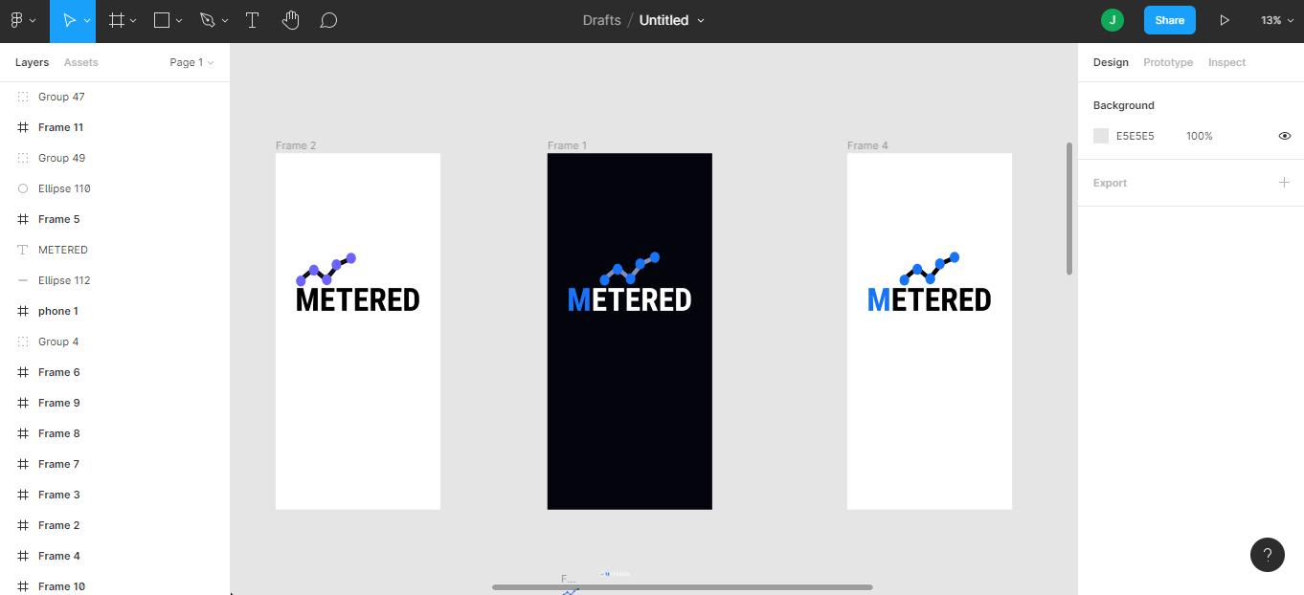

## Client-side technologies

The table below shows the various technologies that were used in the implementation of the front-end of the web application and mobile application.

Table 3. Different technologies used for the application development

|  |  |
| --- | --- |
| **Technology** | **Place used** |
| JavaScript | Web and Mobile Application |
| HTML | Web Application |
| CSS | Web Application |
| ReactJS | Web Application |
| React Native | Mobile Application |

### Javascript

JavaScript is a high-level programming language that allows programmers implement complex features on a web page. It allows programmers manipulate the DOM when any JavaScript event is fired. Anytime a webpage executes a function as a user interacts with it, JavaScript is probably involved.

The following are some advantages of JavaScript:

1. According to Stack Overflow, JavaScript is the most used programming language on the planet, which makes it an excellent option for programmers. JavaScript enables the creation of excellent front-end and back-end software via the use of several JavaScript-based frameworks such as jQuery, Node.JS, and others.
2. JavaScript is ubiquitous; it is pre-installed on every contemporary web browser, and therefore no specific environment configuration is needed to learn JavaScript. For instance, Chrome, Mozilla Firefox, and Safari all have JavaScript.
3. JavaScript enables the development of truly standard, scalable, and responsive online applications. It enables the creation of rich web apps with high-quality user interfaces and experiences.
4. JavaScript is currently used in the creation of mobile applications, desktop applications, and games. This has increased the number of apps available for the JavaScript language.
5. JavaScript has a sizable support community, with people from all around the globe continuously working to enhance the language's capabilities.
6. JavaScript is a framework-rich language with a large number of pre-developed frameworks and libraries that may be utilized directly in software development to significantly decrease development time.

The following are some features of JavaScript:

1. JavaScript is a scripting language that is object-oriented.
2. It provides users with more control over the browser.
3. It controls date and time, it does this by detecting the user's browser and OS.
4. It is very light in weight.
5. JavaScript is a scripting language that is interpreter-based.
6. JavaScript has a case-sensitive syntax.
7. JavaScript includes predefined objects that can be used at any point with a JavaScript file.
8. In JavaScript, each statement must be ended with a semicolon (;).
9. The grammar of the majority of JavaScript control statements is identical to the syntax of control statements in the C language.
10. The ability to define new functions inside scripts is a critical feature of JavaScript. In JavaScript, the function keyword is used to declare a function.

### Hyper text mark-up language (html)

Hyper Text Markup Language commonly known as HTML, is a language used for standard marking up of documents to be displayed on a website browser. It serves as a formatting system for presenting information gotten from the internet. Each unit used for the retrieval is know as a Web page. Web pages usually contain hypertext links that allow related pages to be fetched. Thereby, providing html to describe the structure of Web pages, HTML, allows software engineers to publish and videos while provide the ability to access online data and information via hypertext links. HTML elements are usually put in tags.

### Cascading style sheet(css)

Cascading style sheet commonly known as CSS, is a style sheet language used for describing the presentation of a document written in HTM or any other markup language. It allocates the style of a HTML manuscript and determines how HTML elements will be presented. CSS contains both rules and properties by which a software engineer must follow in order to achieve the desired result. It can either be put directly into a HTML document or through another file with a .css extension.

### React js

React is a free and open-source JavaScript front-end library for developing graphical user interfaces or UI components. It is maintained by Facebook with the assistance of a community of independent developers and businesses. React may be used to build single-page applications as well as mobile applications. Due to ReactJS' component-based architecture, it is an extremely effective choice for developing fast and scalable front-end solutions for both web and mobile applications. It is well-known for its ability to create highly dynamic and responsive user interfaces. The following are some features of ReactJS:

1. **Document Object Model (DOM):** The virtual DOM in ReactJS is a critical component for fast and flexible application development. The virtual memory-based replication of a web page is possible using React's memory reconciliation method. As a result, a virtual DOM is a carbon copy of a genuine DOM. Each time the web application is updated, the virtual DOM re-renders the entire user interface. Only the components that have changed are updated in a virtual DOM representation, not the entire collection of components. As a result, ReactJS significantly accelerates and reduces the cost of developing mobile applications.
2. **JSX (JavaScript XML):** JSX (JavaScript XML) is a JavaScript XML abbreviation. It's a markup language comparable to HTML that's used to define the appearance of a program's graphical user interface (GUI). One of ReactJS' most powerful features is JSX. It essentially converts React component syntax into HTML, which is subsequently injected into the web page. This simplifies and automates the development of ReactJS's building blocks for developers, giving a clear path to success.
3. **Data binding with a one-way street:** One of the most compelling reasons to use ReactJS in a project is its one-way data flow. ReactJS is a framework for data flow in one direction. That is, developers are prevented from directly modifying any component. They must make changes to the components using the callback function. This is referred to as one-way data binding. ReactJS manages data flow from a single point using Flux, a JavaScript application architecture. With a unidirectional data flow, ReactJS developers can exert greater control over their online or mobile application, increasing the program's flexibility and efficiency.
4. **Declarative, intuitive user interfaces:** As previously said, ReactJS is the finest framework for creating dynamic and engaging user interfaces for mobile and web applications. As data changes, ReactJS renders and updates just the required components. For each application state, it offers a simple view. This feature enhances readability and simplifies debugging.
5. **Component-based architecture:** ReactJS is a framework for building component-based applications. In other words, the user interface (UI) of a React-based mobile or online application is composed of numerous components. Each component is subject to its own set of restrictions. Rather of using templates, the logic is written in JavaScript. This lets developers using ReactJS to move data between components without modifying the DOM. Components are essential for ReactJS applications to communicate and appear.

The following are some benefits of using ReactJS:

1. **Effectiveness and speed:** React is used for its efficiency and quickness. ReactJS enables developers to use both client-side and server-side components of their applications.Simply stated, various engineers or teams may confidently create separate components. Any modifications will have no effect on the application's overall logic. Additionally, it allows developers to create clean, modular code and componentize their programs. This enables code reuse and speeds up development.
2. **Flexibility:** ReactJS is diametrically opposed to other big monolithic frameworks. Its code is versatile and simple to maintain due to its modular nature. This increases the scalability of the applications and results in significant time and cost savings for the business.
3. **Performance:** The primary goal of ReactJS development services is to provide a high-performance application. Some of ReactJS's key capabilities, including as a virtual DOM and server-side rendering, enable the rapid development of large-scale and sophisticated applications.
4. **Not difficult to master:** Deploying ReactJS will be very straightforward and fast for a developer who is already acquainted with JavaScript. Indeed, an experienced JavaScript developer may pick up ReactJS programming in a matter of days or even hours.
5. **Development of mobile applications using ReactJS:** React Native, a framework for developing mobile apps, is one of the main advantages of utilizing ReactJS for online development. Due to the framework's ReactJS foundation, JavaScript developers may simply transition to React Native and build native-looking mobile applications. Additionally, portions of a React online application may be reused in a React Native mobile application. This demonstrates why you should use ReactJS while developing websites.
6. **SEO:** A website's visibility in the online market is highly dependent on Search Engine Optimization (SEO). Backend rendering substantially lowers the load time of ReactJS websites, which makes them more search engine optimized. Additionally, the advantages of high performance and speed boost the overall performance and SEO functioning.
7. **Toolset abundant:** ReactJS comes with a robust ecosystem that includes technologies like Flux and Redux. Additionally, the backend utilizes Nodejs. The Node.js development trends for 2020 are focused on boosting your application's performance. Additionally, Facebook has included developer tools for ReactJS and Chrome. These tools enable developers to find child and parent components, as well as to visually inspect component hierarchies.
8. **Support from the community:** One of the reasons you should choose ReactJS for your next project is because of its huge ecosystem. ReactJS has been supported by Facebook since its debut.Apart from that, the library is constantly updated by over 1,000 volunteer contributors. Additionally, a variety of specialists provide free articles and videos to the ReactJS community, which strengthens it. React is a dependable and up-to-date technology due to the community's and corporate's strong backing.

## Server-side technologies

### Firebase

Firebase is a mobile application development platform birthed by Google that supports in build, develop, and advance application. Firebase offers one of the layers of cloud computing, which is Backend-as-a-service. The firebase console is displayed in the figure below.

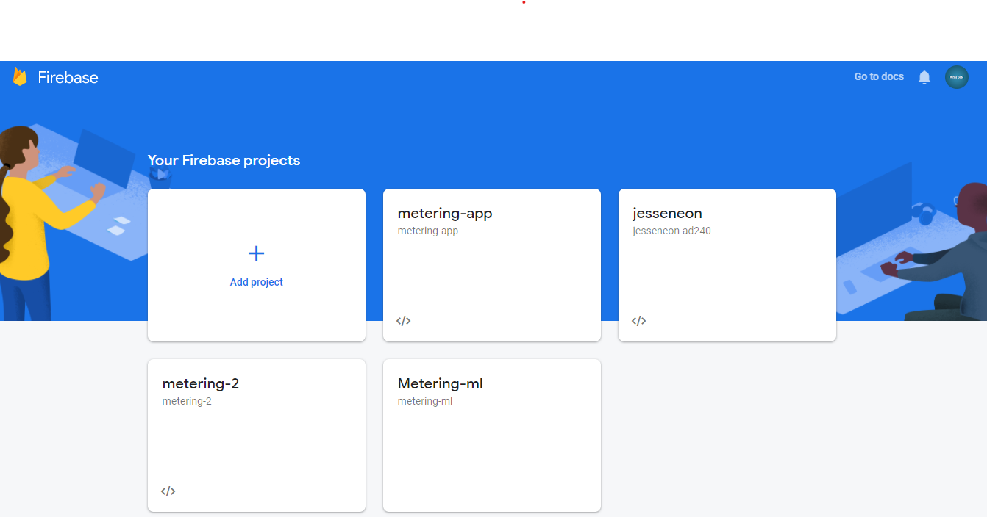

Figure 3. : Firebase console

Firebase is a real-time database, file storage, provides user authentication services, and it can be used to host services for static files and data, the figures below show a complete firebase suite.

Figure 3. : Firebase Build Suite

Figure 3. : Firebase Engage Suite

Traditionally, most databases require making HTTP calls to get and synchronize data to gadgets, and they only give data only when queried for it. An app associated with firebase is not interfacing through normal HTTP, but instead, it is interfacing through a WebSocket. WebSockets offer a persistent connection between a client and server that the two players can use to exchange data whenever in real-time. The client sets up a WebSocket connection through a procedure known as the WebSocket handshake. WebSocket API presents an advanced technology that makes it feasible for a two-way interaction between the client's program and a server. With this API, the app can converse with a server and get event-driven responses without surveying the server for an answer. WebSockets is faster than HTTP. The apps do not need to make individual WebSocket calls since one attachment connection is the length. The entirety of the data syncs automatically through that single WebSocket relying upon the quality of the network available.

The Figure below shows a graphical explanation.

Figure 3. : Illustration of firebase requests

Because the Firebase Realtime Database SDK saves data to disk, one of the benefits of a Firebase application is that it stays responsive even while it is offline. The client device gets any updates it missed once connection is restored, bringing it up to date with the current database server state.

For the implementation of this project, Firebase would be used for the following:

1. **Authentication:** This is controls operations like user sign-up and user sign-in.
2. **Data Storage:** With the use of firebase’s cloud fire store service, changes within the database of the system can be rendered on the frontend in real-time. Cloud firestore is a NoSQL database.
3. **Media File Storage:** This uses firebase’s storage to store audio files sent from the mobile application.

Figure 3. : Flowchart for cloud firestore

## Machine learning technologies

### Teachable machine

Teachable machine is a machine learning solution that allows you train machine learning models in the browser in real-time. It is current divided into:

1. Image Classification
2. Sound Classification
3. Pose Classification

Teachable machine is becoming very popular as it is being adopted by developers around the world. It has the following advantages which make it desirable:

1. Its several models meet user specific needs.
2. It requires little to no experience coding.
3. It has a vast ecosystem of developers.
4. It is cross-platform.
5. It does not have issues with memory management.
6. It is open-source and beginner-friendly.

### Tensorflow js

TensorFlow JS is a JavaScript library that enables people use JavaScript to create machine learning models. It is built on TensorFlow (a python library) and is light weight, easy to use and fast. Currently, it can be accessed either using a content delivery network (CDN) or using node package manager (NPM). The CDN approach works well with vanilla JavaScript while the NPM approach works well with applications that are built in a node JS environment.

## Project requirements

Here, the details about the functional and quality requirements of the system are stated. It contains an explanation of how the system works. It also gives a description of the users, software, and a description of the UIs contained in the application.

### User interfaces

A new user of the mobile application would see a login page upon opening the application. If the user is not registered, the user would be required to do so from the register page.

During the user registration process, the permission of a user is automatically assigned to him. The following data fields will be required from each user:

1. First Name
2. Last Name
3. Gender
4. Age
5. Email
6. Password

If a user fails to provide any of the required details, the user would be prevented from proceeding to other parts of the application.

When a user has completed the sign-up process, he is automatically redirected to the to record page. Upon getting to the record page, the application asks the user to grant it permission to make use of the user’s microphone. If the permission is not granted, the application prompts the user and automatically closes. However, if permission is granted, the application now allows the user to record his listening sessions and send the recording to the secure database.

The recordings a sent to a web application which is made for only administrators. The administrators would have access to all the users’ profiles as well as their individual recordings.

Every administrator is required to periodically go through users’ profiles and analyze their recorded samples. To carry out this analysis, an administrator is required to be actively signed-in on the web application. After this, the administrator opens a user’s recording and clicks the analyze button. This activates the machine learning feature running on the server, so that a prediction on the nature of recording can be made. After a prediction is made, the system comes up with one three results:

1. WazobiaFM
2. CityFM
3. RaypowerFM

An administrator is required to save the analysis session by clicking a save button. The system immediately updates the database in real-time and marks the recording as “analyzed”. During this process, the system simultaneously updates the analytics charts on the administrators’ dashboard to reflect the analysis that has been carried out by an administrator.

### Software interfaces

The mobile and web application communicate with the same database to send and receive data from users. The web application also uses technologies to ensure that all updates on the server are updated on the client on real time.

## Implementation

The proposed system will consist of nine screens, out of which three are for the users’ mobile application and six are for the administrators. The following are the description of each screen:

1. **The login screen for users:** This is the screen where registered users request for permission and are granted permission into the system. A firebase package called firebase auth is responsible for this authentication process. The login screen text form input takes in two inputs, namely the email address and the password of the user.
2. **The sign-up screen for users:** The sign up is a screen with a sign-up form. The aim of the sign-up pages is to gather data about the user that would be needed in assigning a permission to the user. The data is stored in cloud firestore database with the help of firebase auth as shown in the figure below.
3. **Splash screen for users:** The splash screen is the first screen that users see. It mainly gives information about the application.
4. **The landing page for admins and visitors:** This is the first page of the web application. It contains information about the entire application (both web and mobile). It also contains links for administrators to sign in and use the system.
5. **The Login page for admins:** This is very similar to the login page for users only that it runs on the web and allows only administrators to login.
6. **The Dashboard for admins:** This is the first page presented to administrators that have successfully logged in. It contains visual analytics like graphs and charts that give a real time overview of what is happening in the system.
7. **The users page for admins:** This page displays allow the users that have signed up ato the platform.
8. **The audio recordings page for admins:** This page contains the raw audio files that have been sent by the users.
9. **The user profile page:** This page contains specifics about a user. It contains things like a user’s name, email etc. It also contains all the recordings that a user has sent as well as the format of the recordings.

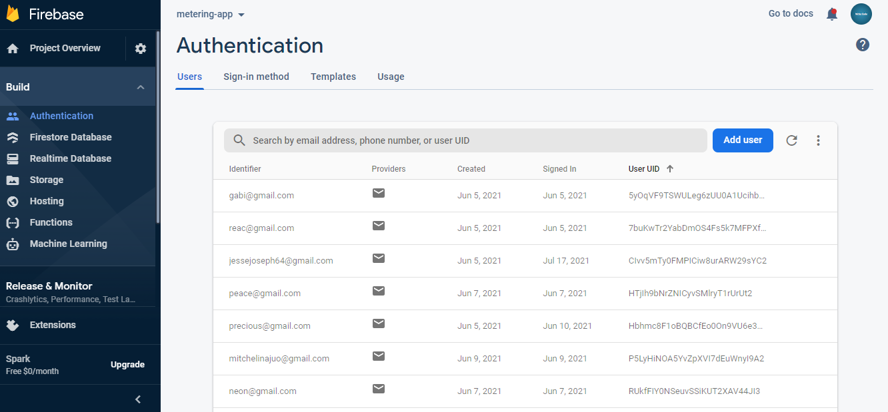

Figure 3. : Firebase Authentication

### Use case diagrams

Use case diagrams are employed to collect the requirements of a system, including internal and external impacts, generally design requirements. The use case diagrams below show the number of screens and the level of access available to both users and administrators.

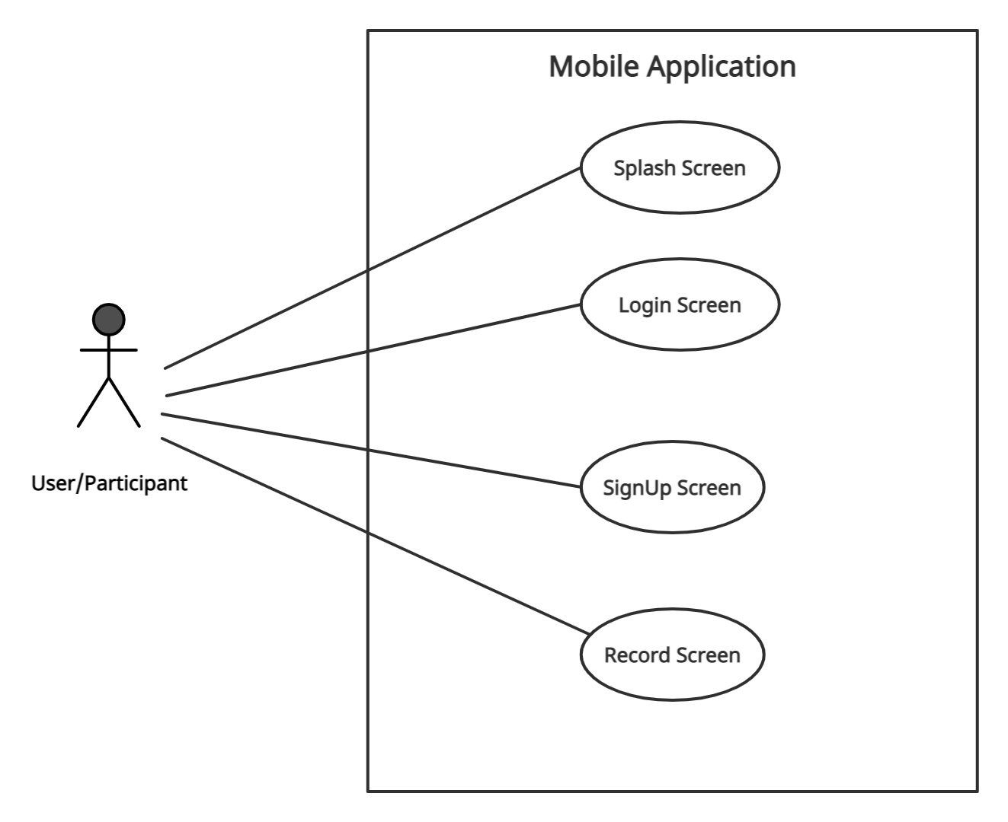

Figure 3. : Mobile app use case diagram

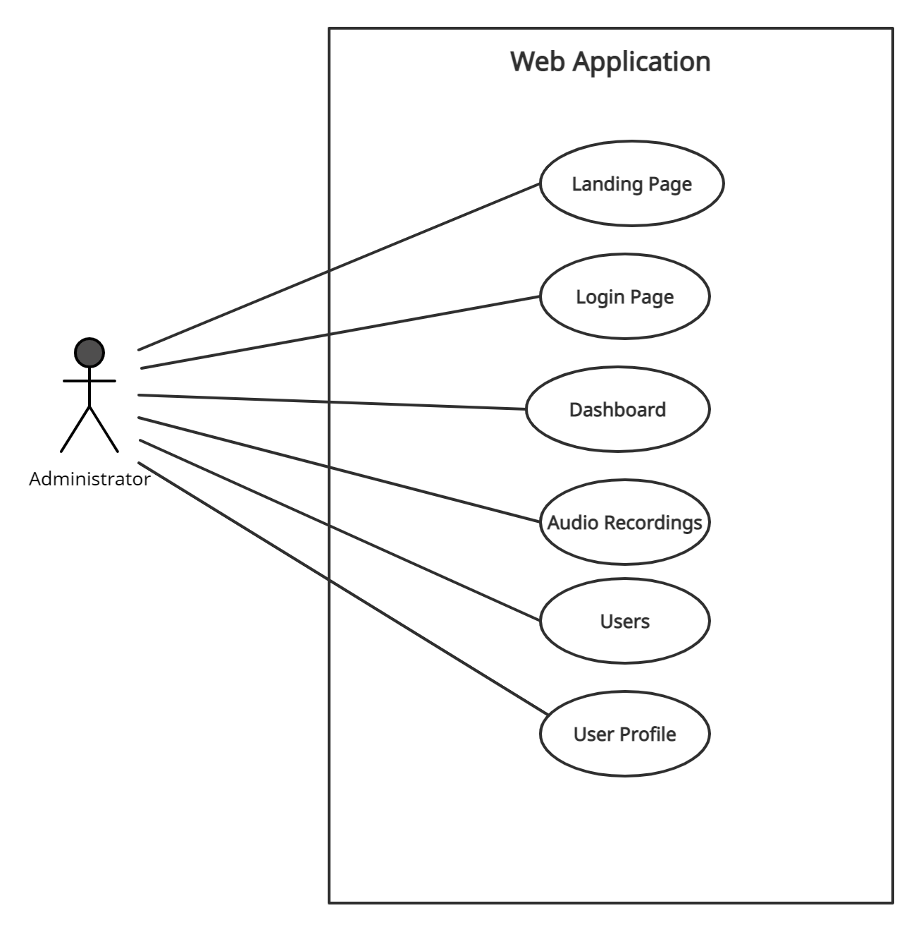

Figure 3. : Web app use case diagram for administrators

### Class diagram

A class diagram is a static diagram as it depicts an application's static perspective. A class diagram is used to construct executable code for an application as well as to describe and record various parts of the system. Class diagrams illustrate the attributes and methods contained within a class, as well as the relationships between classes within a project.

Figure 3. : Class Diagram

## Summary

The various technologies used in the implementation of this project from its design stage to its development stage were discussed in this chapter. This chapter also described the procedure involved in the development of this project.

# 

**IMPLEMENTATION AND TESTING**

## Introduction

This chapter sheds some light on the work that was done in the development process of this project. It describes the implementation of every component in the system. It also highlights the performance of the system as a whole and how its components work together to achieve this performance. Finally, this chapter shows the results of the work that was carried out at various points in the project.

## Scope

At the time of writing this report, the name I have chosen for the application is “Metered” for the sake of reference. Metered would provide a way to measure a radio audience by leveraging a mobile and web application. The mobile application is expected to be used by radio listeners while the web application is expected to be used by administrators. All system information is maintained in a NoSQL database called cloud firestore.

On opening the mobile application for the first time, a user is expected to sign up by providing some of his data.

The mobile application has some of the following functionality:

1. Obtaining permission from users to access their microphones.
2. Recording radio listenership.
3. Making post requests to the database.

While the web application has some of the following functionality:

1. Real-time audio upload tracking.
2. Audio file analysis with machine learning.
3. Visualizing radio listenership with charts and graphs.

## Mobile interfaces

The UI of the mobile application, their functionalities and their level of accessibility are discussed.

|  |  |
| --- | --- |
| A screenshot of a computer  Description automatically generated with medium confidence  Figure 4. : Mobile registration screen | Graphical user interface, application  Description automatically generated  Figure 4. : Registration success prompt |

Figure 4.1 above is the register screen, it contains a form that a new user is required to fill. After the completion of this form, the user’s details are stored in cloud firestore and the user is redirected to the record screen where he can start recording his listening pattern.

On the other hand, a previously existing user will be taken to the login screen where he’ll be required to sign in. The below shows the sign in process.

|  |  |
| --- | --- |
| A picture containing text, monitor, black, electronics  Description automatically generated  Figure 4. : Mobile login screen | A screenshot of a computer  Description automatically generated with medium confidence  Figure 4. : Mobile record screen |

After an existing user has successfully signed in, he’ll be taken to the record screen where he is required to start recording what he is listening to. Before the recording process starts the application asks for the user’s permission to use the device’s microphone. Once the permission is granted, the recording process starts. After the recording process is completed, it starts uploading the recording to firebase. If all goes well, the user is prompted that is audio recording has been successfully uploaded to the servers. The next set of figures illustrate the recording process in the mobile application.

|  |  |
| --- | --- |
| Figure 4. : Microphone permission prompt | A screen shot of a computer  Description automatically generated with low confidence  Figure 4. : Recording in progress |

Figure 4. : Audio upload prompt

## Web interfaces

The UI of the web application, their functionalities and their level of accessibility are discussed.

|  |
| --- |
|  |
| Figure 4. : Administrators Login page |
|  |
|  |
| Figure 4. : Administrators dashboard |

Figure 4.8 above shows the login page for administrators. When an admin successfully logs in, he is redirected to the admin dashboard where he can monitor what is going on in the system in real-time. An administrator could navigate to the users page where he can see all the people that have signed-up using the mobile application. Here, he’ll have the ability to see every user’s profile to analyze the uploads that they have made. The figures below show the users’ page and the profile page of a specific user.

|  |
| --- |
|  |
| Figure 4. : Users page showing registered users |
|  |
| Figure 4. : A user’s profile page showing the user’s uploads |

When a user’s profile is accessed by an administrator, he sees all of the recordings a user has sent. To analyze these recordings, an administrator clicks on the analyze button which brings an analysis modal into display. In this modal, an administrator has the ability to analyze a recording multiple times to get more accurate results. When an analysis is completed, the system predicts the channel that a user has sent using machine learning. Then the administrator saves the result to the database. As seen in Figure 14.11 above, all analyzed recordings have a green tick beside them, while all recordings that are yet to be analyzed have a yellow icon beside them. When a recording is successfully analyzed and saved to the database, the charts on the dashboard are updated in real-time on all client applications. So, any other administrator that is using the system simultaneously, will get the update. The figure below shows the analysis modal.

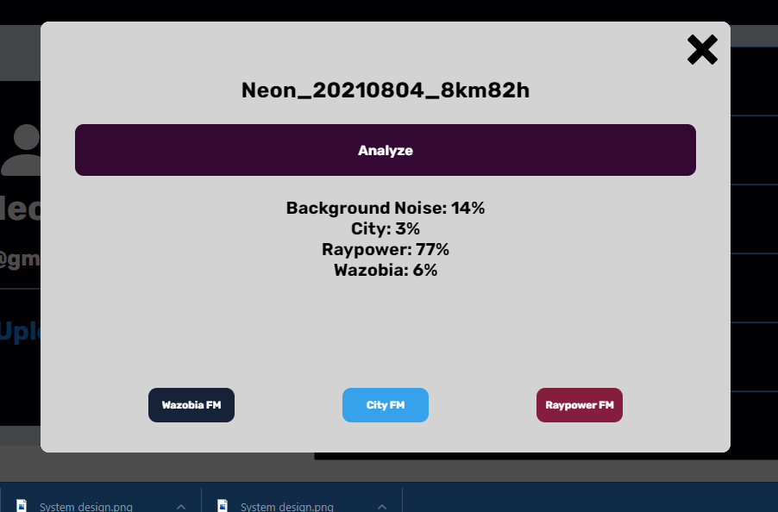

Figure 4. : Audio analysis

### Deployment testing

Prior to deployment, many checks were performed to guarantee that the system would perform properly in production. Among these tests were unit testing, user interface testing, and functionality testing. While the program was being developed, it was tested locally on a variety of browsers, including Microsoft Edge, Google Chrome, and Mozilla Firefox, to ensure that it functioned properly on all major browsers.

### Usability testing

Usability testing was conducted to guarantee that the web application is intuitive and simple to use. The response was gathered by inviting users to visit the link and provide feedback on the platform. The outcomes of this testing revealed users' perceptions of their interactions with the online application.

### User interface testing

The user interface is a critical component of the majority of systems. It is critical since it dictates how users interact with the system; hence, a user interface test was conducted. Fifteen respondents were requested to participate in the survey in order to evaluate the web application's user interface and make suggestions for future changes.

## Summary

The purpose of the chapter was to present the software implementation process of a free and open source audience measurement software. The chapter also discusses the different stacks of the screen and their level of accessibility.

# 

**CONCLUSION AND RECOMMENDATION**

## Introduction

This is the concluding chapter; the summary, recommendation, and achievements of the project are discussed.

## Summary

In this report, the use of a web-based application to carry out radio audience measurement is proposed. So, a mobile application and a web application were developed for the acquisition and analysis of audio data respectively. Various tests were carried out on the system to ascertain its reliability and performance in the real world. The data gathered by the system is stored in a secure cloud based no SQL database for further analysis. The system uses machine learning to analyse these data and make predictions. These predictions are now used in the estimation a radio audience. Results from the system confirm that the proposed radio audience measurement system can be a promising solution for web-based radio audience measurement.

## Recommendations

“The biggest room in the world is the room for improvement” – Helmut Schmidt

In every system there is always room for improvement. To improve this system, I’ll recommend the following:

1. Since the main function of this systems lies in its ability to make accurate audio predictions, I’ll suggest that radio data be made readily available and open-source to ease the creation of machine learning models.
2. A chatbot feature could be added to the administrators’ dashboard to help them easily navigate the system and enable them ask questions about what is going on in the system in real-time.

## Achievements

The aim of this project was to build an audience measurement system. This project achieved this aim by using its objectives as guidelines. Thus, it can be said that the desired goal of this project which is to build a web-based radio audience measurement system as specified in chapter 1 of this report was achieved.

Another important achievement this project made is the setup of a database that could be used in the acquisition of radio audience data for further studies.

## Conclusion

This project has provided a software-based solution to the problem of radio audience measurement. The project would grant people the ability to know what other people are listening to around the country in real time. This information would help advertisers and service providers plan on what content to create as well as what innovation to make on already existing content.

The implementation of this project will be useful in both small and large-scale applications. Certain challenges faced by carrying out manual computations would be greatly reduced if the methods employed in this project are applied. This project will also help in the conservation of time and resources.

**REFERENCES**

[1] S. Hill, “TV audience measurement with big data,” *Big Data*, vol. 2, no. 2, pp. 76–86, 2014, doi: 10.1089/big.2014.0012.

[2] F. Álvarez *et al.*, “Audience Measurement Modeling for Convergent Broadcasting and IPTV Networks,” *IEEE Trans. Broadcast.*, vol. 55, no. 2, pp. 502–515, 2009, doi: 10.1109/TBC.2008.2012040.

[3] W. Hyun, M. Y. Huh, S. H. Kim, and S. G. Kang, “Study on design and implementation of audience measurement functionalities for digital signage service using Kinect camera,” *Int. Conf. Adv. Commun. Technol. ICACT*, vol. 3, no. 5, pp. 597–600, 2014, doi: 10.1109/ICACT.2014.6779030.

[4] J. Allmer, “miRNomics: MicroRNA Biology and Computational Analysis,” vol. 1107, p. 333, 2014, doi: 10.1007/978-1-62703-748-8.

[5] L. L. James Webster, Patricia Phalen, *Ratings Analysis Audience Measurement and Analytics*, 4th ed. 2013.

[6] P. M. Napoli, “Ratings and Audience Measurement,” *Handb. Media Audiences*, pp. 286–301, 2011, doi: 10.1002/9781444340525.ch14.

[7] Karen Buzzard, Electronic Media Ratings: Turning Audiences Into Dollars and Sense. .

[8] “Nielsen.” http://sites.nielsen.com/90years/ (accessed Jul. 07, 2021).

[9] E. Barnouw, “Review of The Evolution of American Television.,” *Contemp. Psychol. A J. Rev.*, vol. 36, no. 3, pp. 264–264, 1991, doi: 10.1037/029580.

[10] “Cable Television | Federal Communications Commission.” https://www.fcc.gov/media/engineering/cable-television.

[11] J. Liaukonyte, T. Teixeira, and K. C. Wilbur, “Television advertising and online shopping,” *Mark. Sci.*, vol. 34, no. 3, pp. 311–330, 2015, doi: 10.1287/mksc.2014.0899.

[12] K. Chorianopoulos and G. Lekakos, “Introduction to social TV: Enhancing the shared experience with interactive TV,” *Int. J. Hum. Comput. Interact.*, vol. 24, no. 2, pp. 113–120, 2008, doi: 10.1080/10447310701821574.

[13] D. Mukherjee, T. Chattopadhyay, S. Bhattacharya, A. Ghose, and P. Misra, “An architecture for real time television audience measurement,” *Isc. 2011 - 2011 IEEE Symp. Comput. Informatics*, pp. 611–616, 2011, doi: 10.1109/ISCI.2011.5958986.

[14] Trumedia, “Trumedia.” http://http//trumedia.co.il/.

[15] Quividi, “Quividi.” https://quividi.com/.

[16] Cognovision, “Cognovision.” http://www.cognovision.com/.

[17] F. Álvarez, D. Alliez, C. A. Martín, J. M. Menéndez, and G. Cisneros, “Audience measurement technologies for user centric media,” *Proc. Int. Symp. Consum. Electron. ISCE*, no. 1, pp. 1–4, 2008, doi: 10.1109/ISCE.2008.4559460.

[18] D. Ziou, “A Graphical Model for Context-Aware Visual Content Recommendation,” no. April, 2015, doi: 10.1109/TMM.2007.911226.

[19] J. M. K. Kua, T. Thiruvaran, M. Nosratighods, E. Ambikairajah, and J. Epps, “Investigation of spectral centroid magnitude and frequency for speaker recognition,” *Odyssey 2010 Speak. Lang. Recognit. Work.*, no. August 2014, pp. 34–39, 2010.

[20] D. Hosseinzadeh and S. Krishnan, “On the Use of Complementary Spectral Features,” no. December 2007, 2014, doi: 10.1155/2008/258184.

[21] T. Thiruvaran, E. Ambikairajah, and J. Epps, “Extraction of FM components from speech signals using all-pole model,” 2008.

[22] M. Nosratighods, T. Thiruvaran, J. Epps, E. Ambikairajah, B. Ma, and H. Li, “Evaluation of a fused FM and Cepstral-based speaker recognition system on the NIST 2008 SRE,” *ICASSP, IEEE Int. Conf. Acoust. Speech Signal Process. - Proc.*, no. April, pp. 4233–4236, 2009, doi: 10.1109/ICASSP.2009.4960563.

[23] T. Thiruvaran, M. Nosratighods, E. Ambikairajah, and J. Epps, “Computationally efficient frame-averaged FM feature extraction for speaker recognition,” *Electron. Lett.*, vol. 45, no. 6, pp. 335–337, 2009, doi: 10.1049/el.2009.0170.

[24] K. K. Paliwal, “Spectral subband centroid features for speech recognition,” *ICASSP, IEEE Int. Conf. Acoust. Speech Signal Process. - Proc.*, vol. 2, pp. 617–620, 1998, doi: 10.1109/ICASSP.1998.675340.

[25] N. P. H. Thian, C. Sanderson, and S. Bengio, “Spectral subband centroids as complementary features for speaker authentication,” *Lect. Notes Comput. Sci. (including Subser. Lect. Notes Artif. Intell. Lect. Notes Bioinformatics)*, vol. 3072, pp. 631–639, 2004, doi: 10.1007/978-3-540-25948-0_86.

[26] G. Starkey, “Estimating audiences: Sampling in television and radio audience research,” *Int. J. Phytoremediation*, vol. 21, no. 1, pp. 3–25, 2004, doi: 10.1080/0954896042000216428.

**APPENDIX**

MOBILE APPLICATION SOURCE CODE: [**https://github.com/JesseAyegba/metering**](https://github.com/JesseAyegba/metering)

WEB APPLICATION SOURCE CODE: [**https://github.com/JesseAyegba/metering-web**](https://github.com/JesseAyegba/metering-web)

DEPLOYED WORKING APPLICATION: [**https://metering-app.web.app**](https://metering-app.web.app)