The alphabets AB shown on the software:

<Describe what has happened and the reason of an error of the serial communication (check eagleCom’s screen.>

The speed of popping is faster than before. Also, A is popping up once combining with multiple B and repeated. It should have the same effect as previous which is repeating “ABAB”. It may due to data corruption because of the pervious character has not been sent and the new character already launch.

< Describe the setting and procedures of the subroutine ‘IERG3810_clock_tree_init()’>

It clears first 16 bits and conf of clock output on CFGR, setting PLL off, Clock detector OFF, HSE oscillator ON.

Check for internal 8 MHz RC oscillator ready, HCLK divided by 2, PLL input clock x 9, HSE clock divided by 2, Two wait states, if 48 MHz < SYSCLK ≤ 72 MHz. PLL ON, check PLL clock ready flag, PLL selected as system clock.

While loop until the PLL used as system clock, set the temp = System clock switch status and keep last two bits.

<The signal path>

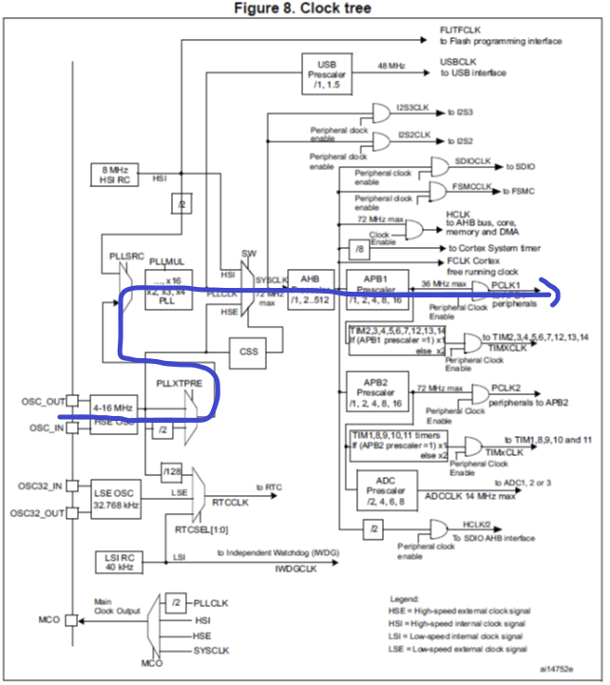

< Describe the setting and procedures of the subroutine ‘IERG3810_USART2_init()’>



Baud is calculated by the above formula. It further divided into integer and fraction and let them as mantissa and fraction. GPIOA and USART2 are enabled. Setting USART2 as alternative functions with PA2 and PA3. Set the mantissa of USARTDIV and Transmitter enable.

<Try to understand the function of USART_print().>

The function takes the port number of USART and the target printed char. Then it iterates the string char by char. It sends to the specify port number then wait for data is transferred to the shift register. It continues to send the next char in the string until the last char is send.