

Software Requirement Document

For

Time and attendance management system

Version 1.0 Approved.
SEN 301. Section 2. Group 9.
Dated: 31st December 2025.

Section 2 Group 9 Members.

S/N | Name | ID | ROLES
1. | KASSA Goodluck Jesse | 20232286 | Project Manager, Developer,  Product Tester, System Designer  And Deployment Lead
2. | ADEJUMO Treasure Ileri-Iyanu | 20232377 | Requirement Analyst,  System Designer,  Product and QA Tester
3. | SHEHU Muhammad Al-Amin | 20232246 | Requirement Analyst and  System Designer
4. | SHUAIBU Faruk | 20232244 | Technical Writer
5. | BEN-CHIOMA Jimmy Chukwuma Chibueze | 20232245 | Technical Writer
6. | YUSUF Hassan Shuaibu | 20232260 | Technical Writer
7. | MAI MELEH Kashim Sugun | 20232275 | Technical Writer
8. | TAIWO Faysal Oluwademilade | 20232524 | Developer, Product Tester  And Technical Writer
9. | GARBA Haruna Halifa | 20232391 | Technical Writer
10. | BASHIR Muhammad Sani | 20232291 | Technical Writer

Table of Contents
1. Introduction 1
1.1 PURPOSE 1
1.2 Document Conventions 2
1.3 Intended Audience and Reading Suggestions 3
1.4 Product Scope 5
1.5 References 10
2. Overall Description 10
2.1 Product Perspective 10
2.2 Product Functions 15
2.3 User Classes and Characteristics 17
2.4 Operating Environment 20
2.6 User Documentation 26
2.7 Assumptions and Dependencies 28
3 External Interface Requirements 30
3.1 User Interfaces 30
3.2 Hardware Interfaces 34
3.3 Software Interfaces 36
3.4 Communications Interfaces 38
4 System Features 39
5 Other Nonfunctional Requirements 52
5.1 Performance Requirements 52
5.2 Safety Requirements 55
5.3 Security Requirements 57
5.4 Software Quality Attributes 58
5.5 Business Rules 60
6 Requirement Traceability Matrix (RTM) 62
7 Other Requirements 63

Revision History
Name | Date | Reason For Changes | Version

Introduction

PURPOSE
The Time and Attendance Management System (TAMS) version 1 for Nile University of Nigeria aims to; provide a real-time update via the student portal on their attendance, develop an automated solution that enhances accountability, streamlines attendance tracking, optimizes time management for staff and student, schedules classes and exams, provides detailed reporting for academic and administrative purpose and enhance efficiency. It ensures timely and accurate data collection, integrates with the university systems, and supports analytics for decision-making. By automating these processes, the system aims to reduce manual errors, improve record accuracy, and ensure compliance with university policies and academic regulations

SCOPE
The scope of the Time and Attendance Management System for Nile University of Nigeria (NUN) includes the following:
1. Real-Time Updates in Student Portal:
- Instant Notifications: Students receive immediate updates on their attendance status, including any changes or alerts.
- Live Attendance Tracking: Faculty can monitor attendance in real-time, allowing for quick identification of absentees.
- User -Friendly Interface: The student portal is designed for easy navigation, ensuring students can access their attendance records effortlessly.

2. Efficient Attendance Taking:
- Automated Attendance Recording: Use of technology (e.g., QR codes, biometric systems) to streamline the attendance process, reducing manual errors.
- Quick Check-In/Check-Out: Students can mark their attendance swiftly, minimizing disruption during class.
- Integration with Class Schedules: Attendance is automatically linked to the class timetable, ensuring accurate records.

3. Transparency of Student Attendance:
- Accessible Attendance Records: Students can view their attendance history at any time, promoting accountability.
- Regular Reports: Periodic summaries of attendance are generated for students and faculty, highlighting trends and patterns.
- Feedback Mechanism: Students can provide feedback on attendance policies, fostering a collaborative environment.

4. To Reduce Unserious Students:
- Engagement Metrics: Track participation levels to identify students who may be disengaged or frequently absent.
- Incentives for Good Attendance: Implement rewards or recognition for students with high attendance rates to encourage commitment.
- Intervention Strategies: Develop support systems for students who struggle with attendance, such as counseling or academic assistance.

5. Keep Track of Student Participation:
- Participation Logging: Record not just attendance but also active participation in class discussions and activities.
- Analytics Dashboard: Provide faculty with tools to analyze participation data, helping to identify students who may need additional support.
- Integration with Grading: Link participation metrics to overall academic performance, emphasizing the importance of engagement.

6. To Ensure Proper Schedule of Lectures:
- Centralized Scheduling System: Implement a unified platform where all lecture schedules are created, managed, and accessed by both faculty and students, reducing confusion and conflicts.
- Conflict Detection: Automatically identify and flag scheduling conflicts (e.g., overlapping classes or double-booked rooms) to ensure that all lectures are scheduled without issues.
- Dynamic Scheduling: Allow for adjustments to be made in real-time, accommodating changes such as instructor availability, room assignments, or special events.
- Student Preferences: Incorporate student input into the scheduling process, allowing them to indicate preferred times or days for classes, which can enhance attendance and engagement.

Document Conventions
Document Conventions for the Time and Attendance Management System
This section outlines the conventions used throughout the Software Requirements Specification (SRS) document to ensure clarity, consistency, and ease of use. By adhering to standardized formatting, labeling, and organization, the document facilitates readability and ensures accurate communication among all stakeholders.

1. Formatting Conventions:
- Font Type: We have chosen a standard, readable font which is Times New Roman, typically in size 12 for body text.
- Headings: We will use a hierarchical heading structure (e.g., Heading 1 for main sections, heading 2 for subsections) to organize content clearly. Headings will be bolded for emphasis.
- Bold: Used to highlight key terms, headings, and important requirements.
- Italics: Used for emphasis and to denote document titles or references.
- Mono spaced Font: Used for code snippets, system messages, and commands.
2. Requirements Labeling:
All system requirements are distinctly identified using the pattern REQ [Number] (e.g., REQ001, REQ002) for reference and traceability.
3. Numbering and Bullets:
- Numbered Lists: Used to outline steps in processes or to organize ordered information.
- Bullet Lists: Used to present unordered information or key points.

4. Date and Time Format:
- Date: Follows the YYYYMMDD format (e.g., 20241224).
- Time: Follows the 24hour format (e.g., 14:30 for 2:30 PM).

5. Units of Measurement:
- Time: Measured in hours and minutes.
- Attendance: Recorded as Present (P) or Absent (A).

6. Section Organization:
Sections and subsections are hierarchically numbered (e.g., 1, 1.1, 1.2) for clear structure and logical flow.

7. Glossary:
Technical terms, abbreviations, and acronyms are explained in the glossary to ensure a consistent understanding of specialized language.

8. Figures, Tables, and Diagrams:
- Diagrams: We will use diagrams or tables where appropriate to illustrate complex processes or relationships between requirements, such as the flow of attendance data.

Intended Audience and Reading Suggestions

Intended Audience

1. Developers
Developers will use this document to understand the functional and non-functional requirements, system design constraints, and technical specifications necessary for building the software. They are advised to focus on the detailed requirements (Sections 3 and 4) and system architecture.

2. Project Managers
Project managers will use the document to plan, allocate resources, and monitor the progress of the software's development. They should begin with the purpose (Section 1) and scope (Section 2) to understand the goals and boundaries of the project, then review the functional requirements and priorities.

3. Marketing Staff
Marketing teams can leverage the document to understand the value propositions and key benefits of the software. They should focus on the system overview and benefits (Sections 1.1 and 2.1), as well as use cases that demonstrate the software's relevance to end-users.

4. End Users
End users, such as employees, students, and administrators, can refer to this document to gain insight into the software's functionality and usability. They are encouraged to review the use case scenarios (Section 2.3) and the functional requirements that directly impact their interactions with the system.

5. Testers
Quality assurance testers will utilize the document to create test cases and verify that the system meets the defined requirements. They should pay particular attention to the detailed functional requirements (Section 3), nonfunctional requirements (Section 4), and acceptance criteria.

6. Documentation Writers
Technical writers responsible for user manuals and guides will use the document to understand the system's features and workflows. They should focus on the functional requirements and use case scenarios (Section 2.3), which will provide the necessary information to craft comprehensive user documentation.

Document Structure and Suggested Reading Order

This document is structured to facilitate ease of understanding for all stakeholders.

1. Introduction (Section 1):
Provides an overview of the purpose, scope, and audience of the document. All readers should begin here to gain context about the software.

2. Overall Description (Section 2):
Describes the system's goals, benefits, and key use cases. This section is particularly useful for project managers, marketing staff, and end users.

3. Specific Requirements (Section 3):
Details the functional and nonfunctional requirements of the software. Developers, testers, and documentation writers should prioritize this section.

4. System Models (Section 4):
Includes diagrams, flowcharts, and architectural overviews to illustrate how the system components interact. This section is vital for developers and technical architects.

5. Appendices (Section 5)
Contains reference materials, definitions, and supplementary information. Readers seeking clarification or additional context should refer to this section.

For most readers, it is recommended to follow this sequence: Introduction → Overall Description → Specific Requirements → System Models. Additional sections can be reviewed as needed based on roles and responsibilities.

Product Scope

Brief description of the Time and Attendance System

As the 21st century becomes digital, most advanced learning institutions have an integrated Time and Attendance Management system that tracks the activities of all its users. Managing an institution or any organization is like managing a big mass and keeping track of this big mass is very important for any organization. The Time and Attendance Management system is an online system capable of recording and tracking attendance to classes, work and all school visitations, its purpose is to efficiently manage and track all users.
Therefore, attendance is the top priority to keep track of the large volume of mass. But keeping attendance on track is a hectic process especially if it is done by the paper traditional method that is currently being used in Nile university of Nigeria. But those hectic days have ended because the Attendance Management System we have come up with, will solve this issue.
This system seamlessly maintains leave management, overtime verification, tracks working-hours, class attendance, Exam attendance, school visitation (by all stakeholders including Guests) etcetera, it does this by using biometrics and a hotspot verification mechanism (class attendance). By using this system, parents can focus on their child's learning progress in school thus lowering the stress on the University by managing attendance more efficiently and accurately.
The primary purpose of the Time and Attendance Management System is to revolutionize operational efficiency by automating attendance tracking and recording while delivering real-time, actionable insights into the productivity and engagement of both employees and students. By eliminating manual inefficiencies and streamlining workflows, the system supports the university’s mission to achieve operational excellence. It ensures equitable compensation for employees by precisely tracking work hours, overtime, and attendance, while automating intricate processes such as payroll integration, faculty reward systems, scheduling, and compliance management.
For employees, the system not only guarantees fairness in wage calculation but also optimizes resource allocation and workload distribution, contributing to higher staff satisfaction and overall productivity. Meanwhile, the system significantly enhances student accountability and academic performance by providing accurate records of attendance, participation, and engagement in learning activities. This data empowers educators and administrators with the ability to monitor trends, proactively address absenteeism, and maintain equitable access to institutional resources.
The software’s intuitive interface and robust functionalities offer powerful tools for tracking and managing attendance across diverse stakeholder groups. By fostering transparency and accountability, the system strengthens trust between stakeholders while ensuring strict adherence to institutional and regulatory policies. Its analytical capabilities further enable data driven decision-making, supporting the continuous improvement of resource allocation, employee management, and student engagement strategies.
With its dual focus approach, the Time and Attendance Management System creates a seamless, efficient, and scalable solution that evolves alongside the organization’s needs. By reducing administrative burdens, enhancing decision-making processes, and ensuring equity and accountability, the system lays the foundation for a sustainable, high performing academic and operational environment that benefits all stakeholders.

Benefits of a Time and Attendance Management System
- Enhanced Accuracy:
Reduces time lost to manual errors commonly encountered when recording attendance or preparing payroll, ensuring precise and reliable data.

- Improved Efficiency:
Automates time-consuming tasks such as monitoring attendance, approving or rejecting leave requests, and maintaining records.

- Regulatory Compliance:
Ensures adherence to labor laws by accurately recording working hours, breaks, and overtime, reducing the risk of violations.

- Cost Savings:
Minimizes overpayments caused by time theft, inaccurate calculations, or manual processing errors, thereby reducing payroll costs.

- Flexible Functionality:
Provides support for remote work and hybrid arrangements through features like mobile clock in and geolocation tracking.

- Accurate Work Hour Tracking:
Enables precise tracking of employee work hours, improving accountability and transparency across the organization.

- Payroll Automation and Integration:
Streamlines payroll operations by automating calculations and allowing integration with other HR and financial software systems.

- Data Driven Decision Making:
Enhances resource planning and operational efficiency by analyzing real-time data on attendance, availability, and productivity.

- Improved Corporate Image:
Builds trust with stakeholders by maintaining honest and transparent records of employee time spent on organizational activities.

- Organizational Time Optimization:
Increases overall productivity by minimizing time wasted on manual tracking and redundant processes.

- Reduced Bureaucracy:
Simplifies the process of tracking work hours, reducing administrative burdens and associated costs.

- Lower Risk Levels:
Decreases risks for both organizations and employees by maintaining clear, compliant, and secure records of attendance and work hours.

- Scalable and Flexible Solution:
Adapts to evolving business needs, providing a solution that can grow with the organization as its workforce and operational demands expand

Objectives
- Precision in Time Tracking:
Implement advanced tools to ensure precise logging of employee work hours, including overtime and breaks, through biometric systems, mobile apps, or cloud-based platforms.

- Streamlined Payroll Processes:
Automate payroll operations by integrating with existing HR and accounting systems, reducing errors and manual intervention in wage calculation.

- Data Driven Resource Allocation:
Utilize detailed analytics to optimize staffing, reduce downtime, and allocate resources efficiently across various departments.

- Improved Employee Experience:
Foster transparency and trust by providing employees with real-time access to their attendance records, leave balances, and work schedules.

Goals
- Boost Organizational Productivity:
Optimize employee performance and operational workflows by eliminating bottlenecks in time tracking and attendance management.

- Minimize Administrative Overhead:
Reduce the workload and costs associated with manual timekeeping and error correction by automating routine tasks.

- Promote Accountability and Transparency:
Build a culture of trust by offering accurate, transparent time records and fostering accountability among employees.

- Deliver a Scalable Solution:
Provide a robust platform that can adapt to evolving business requirements, supporting workforce expansion and new operational models without compromising efficiency.

Relation to corporate Goals and Business Strategies

The Time and Attendance Management Software directly aligns with corporate goals and business strategies by improving efficiency, ensuring compliance, and fostering accountability among staff and students. Here’s how it relates:

- Enhancing Operational Efficiency:
By automating repetitive tasks such as attendance tracking, payroll processing, and resource scheduling, the software reduces administrative overhead and allows organizations to allocate resources strategically. This supports the corporate goal of maximizing productivity while minimizing waste.

- Driving Data Driven Decision Making:
Real-time insights provided by the software enable management to identify trends, optimize staffing, and improve resource allocation. These capabilities align with business strategies focused on leveraging analytics for informed decision making and continuous improvement.

- Ensuring Compliance and Risk Mitigation:
By accurately tracking work hours, overtime, and attendance, the software ensures compliance with labor laws and institutional policies, reducing the risk of legal disputes or financial penalties. This supports corporate goals of maintaining ethical standards and regulatory adherence.

- Promoting Accountability and Transparency:
The system fosters a culture of trust by providing clear, accessible records for both staff and students. Transparency in time tracking and attendance management builds credibility and aligns with business strategies focused on improving organizational culture and stakeholder trust.

- Supporting Flexibility and Scalability:
As organizations grow, the software scales to meet increased demands, integrating seamlessly with existing systems to support evolving business needs. This aligns with corporate goals of adaptability and long-term sustainability.

6. Enhancing Employee and Student Engagement:
For employees, the software simplifies timekeeping and payroll processes, boosting satisfaction and morale. For students, it reinforces accountability and supports academic success. Aligning with strategies that prioritize stakeholder wellbeing, the software contributes to a positive institutional reputation.

By addressing key operational challenges and aligning with broader organizational objectives, the Time and Attendance Management Software becomes a strategic tool that drives efficiency, compliance, and engagement across the institution.

References

- IEEE Software Engineering Standards:
- Title: IEEE Standard for Software Requirements Specifications
- Author: IEEE Computer Society
- Version Number: IEEE Std 830-1998
- Date: 1998
- Source/Location: IEEE Xplore Digital Library

- Interview 1:
- Name of the interviewee: Abdulsalam Nur (Lecturer)
- Organization: Nile University of Nigeria
- Date of the interview: 13/12/2024
- Location or format: in person

- Interview 2:
- Name of the interviewee: Obi Tabugbo (Security and safety Manager)
- Organization: Nile University of Nigeria
- Date of the interview: 17/12/2024
- Location or format: in person

- Interview 3:
- Name of the interviewee: Ologun Abraham (Administrative Assistant)
- Organization: Nile University of Nigeria
- Date of the interview: 17/12/2024
- Location or format: in person

- Interview 4:
- Name of the interviewee: Rogbitan Seun (Creative Lead (Media and Graphics))
- Organization: Nile University of Nigeria
- Date of the interview: 16/12/2024
- Location or format: in person

Overall Description

Product Perspective
The Time and Attendance Management System (TAMS) for Nile University of Nigeria is a new, self-contained product which replaces conventional manual and card-based systems with attendance management at Nile University of Nigeria. It tackles the concerns of data loss, inaccuracies, and inefficiency that arise due to outdated methods.

TAMS is an electronically automated system that employs a blend of biometric devices, mobile applications, and a hotspot verification process in capturing attendance in real time. The system works effortlessly with the existing student portal in the university to provide live updates with total transparency and accountability for all its users.

Context and Origin
Nile University of Nigeria has experienced a steady increase in enrollment and a diversification of its academic programs, which has made the need for an efficient attendance management system more pressing. The existing methods, which may include paper-based attendance sheets or basic electronic spreadsheets, are not only cumbersome but also hinder the university's ability to maintain accurate records. These traditional methods can lead to discrepancies in attendance data, making it difficult for faculty and administration to monitor student engagement and compliance with academic policies.
The TAMS is designed to replace these outdated systems with a modern, automated solution that enhances the accuracy and efficiency of attendance tracking. By implementing this system, the university aims to provide a user-friendly interface for both students and staff, enabling them to easily check in and out, view their attendance records, and generate reports. The system will also facilitate real-time data collection and analysis, allowing for timely interventions when attendance issues arise.

Relationship to Larger System
The Time and Attendance Management System is not an isolated product; rather, it is a critical component of Nile University’s broader administrative ecosystem. The integration of TAMS with other existing systems is essential for creating a cohesive and efficient operational framework.

- Student Information System (SIS):
The TAMS will interface with the SIS to access essential student data, including enrollment status, course schedules, and demographic information. This integration ensures that attendance records are accurately linked to the correct classes and students, allowing for seamless tracking of attendance across different courses. By pulling data from the SIS, the TAMS can automatically update attendance records based on class rosters, reducing the administrative burden on faculty and ensuring that attendance data is always current.

- Learning Management System (LMS):
As online and hybrid learning environments become more prevalent, the TAMS will also connect with the LMS to monitor student engagement in virtual classes. This integration will allow the university to track attendance not only in physical classrooms but also in online sessions, providing a comprehensive view of student participation. By analyzing attendance data from both the LMS and TAMS, the university can identify patterns of engagement and intervene when students are at risk of falling behind.

- Human Resource Management System (HRMS):
For staff attendance management, the TAMS will interface with the HRMS to track employee attendance and integrate this data with payroll systems. This connection will ensure that attendance records are accurately reflected in payroll calculations, thereby enhancing the efficiency of human resource operations. By automating attendance tracking for staff, the university can reduce administrative overhead and improve compliance with labor regulations.

Interfaces
The TAMS will feature several key interfaces that facilitate interaction with users and other systems:

- User Interface (UI):
The TAMS will provide both a mobile app and web-based user interface designed for ease of use by both students and staff. The UI will allow users to check in and out of classes or work, view their attendance history, and generate reports for personal or administrative use. The design will prioritize user experience, ensuring that navigation is intuitive and that users can quickly access the information they need.

- Database Interface:
A secure and robust database will serve as the backbone of the TAMS, storing all attendance data, user profiles, and system logs. The database interface will ensure that data is organized, easily retrievable, and protected against unauthorized access. Regular backups and data integrity checks will be implemented to safeguard against data loss and ensure the reliability of the system.

- API Interfaces:
The TAMS will utilize restful APIs to facilitate data exchange with the SIS, LMS, and HRMS. These APIs will enable real-time synchronization of attendance data across systems, ensuring that all relevant parties have access to the most current information. For example, when a student checks in for a class, the TAMS will immediately update the SIS and LMS, reflecting the student's attendance status in all connected systems. This integration will not only enhance data accuracy but also streamline administrative processes, allowing for more efficient reporting and analysis.

- Reporting Interface:
The TAMS will include a reporting interface that allows administrators and faculty to generate customized reports on attendance trends, patterns, and anomalies. This feature will enable the university to analyze attendance data over time, identify areas for improvement, and make informed decisions regarding student engagement strategies and resource allocation.

System Components
Some of the major components of TAMS include:

- User Interface (UI):
- Admin Dashboard: Administrators can manage users, set configurations, and run reports.
- Employee/Student Portal: It allows users to look at attendance records and be informed.

- Attendance Capture Mechanism:
- Biometric Devices: Attendance is captured through fingerprint or facial recognition, which are secure and accurate.
- Mobile App: It has an integrated functionality of checking in and out while verifying users against hot-spots (hosted by the lecturers) for attendance tracking based on proximity.
- Database: It includes storage for user details, attendance, and schedules thus ensuring data consistency and integrity.
- Back-End Server: The back-end server handles attendance data by following specific rules set by the organization. It processes this data to calculate things like work hours, absences, or late arrivals.

How the Biometric Devices and Mobile App Work Together:
•Primary Capture Mechanism: Biometric devices are used in central locations, like entry points or offices, for strict attendance tracking.
•Secondary Capture Mechanism: The mobile app with hotspot verification allows for attendance tracking in classrooms or temporary setups.

Systems Connections
The system interfaces with:
• Biometric Scanners and Mobile Apps: For collecting attendance information in real time.
• University Student Portal: For updating attendance records and their accessibility to other relevant stakeholders.

Integration with Existing Systems:
TAMS is a standalone system, but it is designed to work with existing university tools, like the scheduling platform, Student Portal or Human Resources systems. This means it can adapt to future needs if more functionality is required.

System Architecture Diagram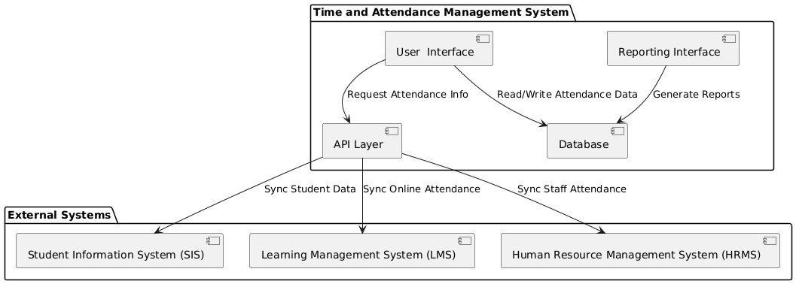
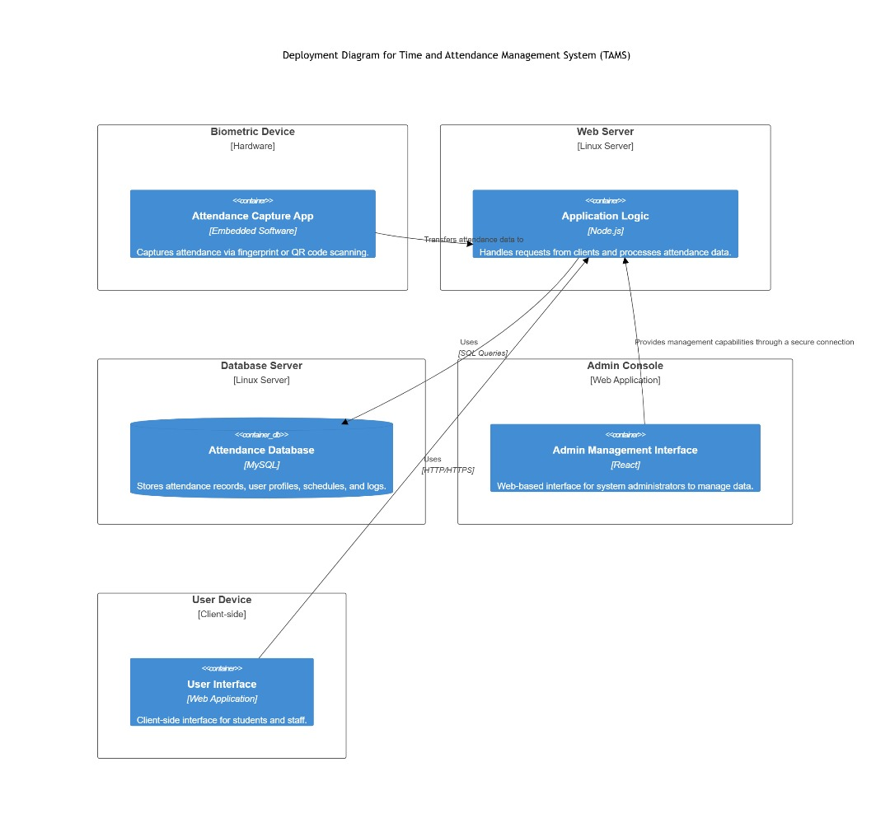
DEPLOYMENT DIAGRAM

Product Functions
The Time Attendance Management System (TAMS) is a new, web-based software application designed to automate attendance tracking for educational institutions. TAMS replaces the existing manual attendance tracking system, providing a more efficient and accurate method for recording and managing student attendance. Below is a detailed summary of the major functions that the product must perform or enable users to perform.

Major Functions
• User Authentication and Authorization:
The system will implement a secure user authentication mechanism that allows users, including students and staff, to log in using unique credentials. This function ensures that only authorized individuals can access the system, protecting sensitive attendance data. Role-based access control will be established, allowing different functionalities based on user roles (e.g., student, faculty, administrator etc.). This ensures that users can only perform actions relevant to their responsibilities, enhancing security and data integrity.

• Attendance Tracking;
TAMS will facilitate real-time attendance tracking, enabling students to check in and out of classes or events through various methods, such as QR codes, biometric systems (e.g., fingerprint or facial recognition), or manual entry. This function will streamline the attendance process, reducing the time spent on roll calls and minimizing errors associated with manual tracking. For staff, the system will allow them to record their attendance and manage their schedules, ensuring accurate records for payroll and performance evaluations.

• Real-Time Data Management:
The system will provide real-time updates to attendance records as users check in or out. This function ensures that attendance data is immediately available for review and reporting, allowing faculty and administration to monitor attendance trends and address issues promptly. The real-time aspect of the system will also enhance the accuracy of data, as it eliminates delays associated with manual data entry and processing.

• Reporting and Analytics:
TAMS will include robust reporting and analytics capabilities, allowing users to generate detailed attendance reports for individual students, classes, and staff over specified time periods. Administrators and faculty will be able to analyze attendance trends, patterns, and anomalies, which can help identify students who may be at risk of academic failure due to poor attendance. This function will support data-driven decision-making, enabling the university to implement targeted interventions to improve student engagement and retention.

• Integration with External Systems;
The system will be designed to integrate seamlessly with other existing systems within the university's administrative framework. This includes synchronization with the Student Information System (SIS) to maintain accurate student records, ensuring that attendance data is linked to the correct classes and students. Additionally, TAMS will connect with the Learning Management System (LMS) to track online attendance and engagement, providing a comprehensive view of student participation in both physical and virtual learning environments. The integration with the Human Resource Management System (HRMS) will facilitate staff attendance management and ensure accurate payroll processing based on attendance records.

• User Profile Management:
The system will allow users to view and update their profiles, including personal information, contact details, and attendance history. This function will empower users to take ownership of their attendance records and ensure that their information is current and accurate. For administrators, the system will provide tools to manage user accounts, including the ability to add, modify, or deactivate accounts as needed.

UML CLASS DIAGRAM
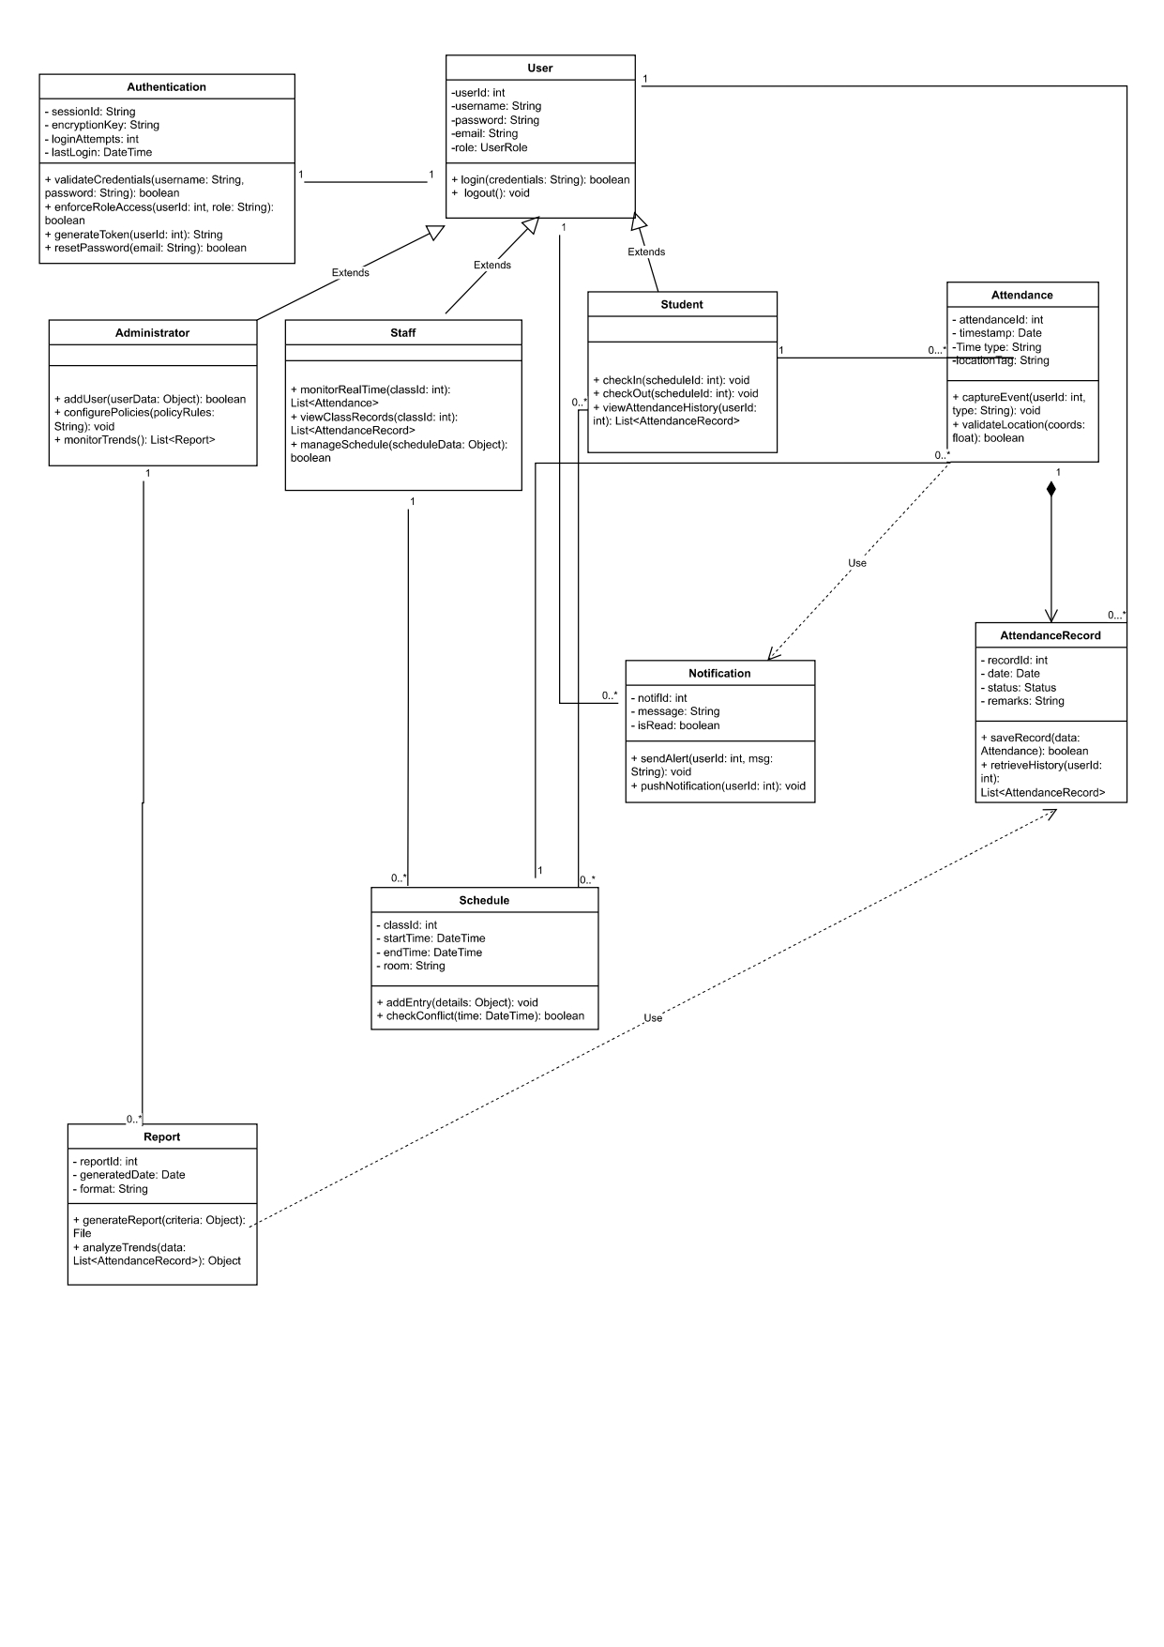

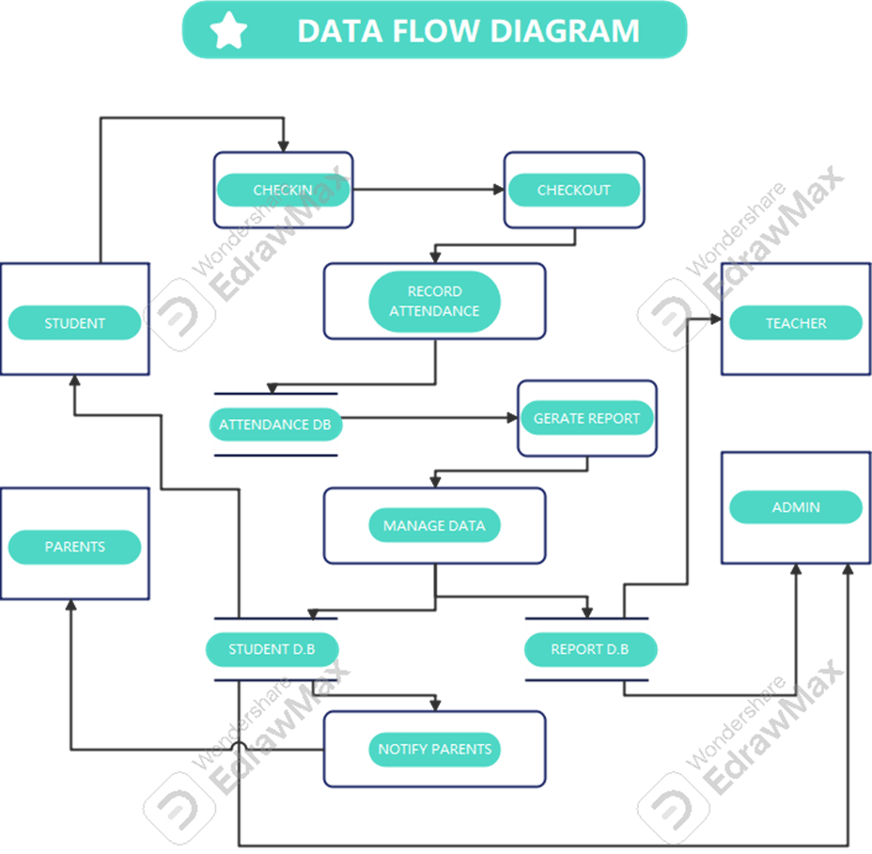

DATA FLOW DIAGRAM

User Classes and Characteristics
The Time and Attendance Management System (TAMS) for Nile University of Nigeria is designed to accommodate various user classes, each with distinct characteristics, needs, and levels of interaction with the system. Understanding these user classes is crucial for tailoring the system's functionality, user interface, and security measures to meet their specific requirements. Below are the identified user classes, along with their pertinent characteristics.

1. Students:
- Frequency of Use: High
- Subset of Functions Used:
  - Check in/out of classes or events
  - View attendance records
  - Receive notifications and alerts
  - Update personal profiles
- Technical Expertise: Moderate; most students are familiar with basic technology and web applications.
- Security or Privilege Levels: Standard user access; can view and sign attendance, but they cannot access other users' information.
- Educational Level: Typically, undergraduate or graduate students.
- Experience: Varies; some may have extensive experience with similar systems, while others may be using such technology for the first time.
Characteristics:
Students are the primary users of the TAMS, and their engagement with the system is critical for its success. They require a user-friendly interface that allows for quick check-ins and easy access to their attendance records. Notifications about attendance status and reminders for classes are essential to keep them informed and engaged.

2. Faculty/Staff:
- Frequency of Use: Moderate to High
- Subset of Functions Used:
  - Check in/out of work or events
  - View attendance records
  - Receive notifications and alerts
  - Record attendance for classes
  - View attendance reports for their courses
  - Manage class schedules
  - Receive notifications about attendance issues
- Technical Expertise: Moderate; faculty and staff are generally comfortable with technology but may require training on specific system functionalities.
- Security or Privilege Levels: Higher access privileges than students; can view and manage attendance data for their classes and students, but can only view their own attendance.
- Educational Level: Typically holds at least a bachelor’s degree, often with advanced degrees.
- Experience: Generally experienced in using administrative systems, but familiarity with TAMS may vary.
Characteristics:
Faculty and staff play a crucial role in the attendance management process. They need to efficiently record attendance and access reports to monitor student engagement. The system should provide them with tools to manage their classes and communicate with students regarding attendance-related matters.

3. Administrators
- Frequency of Use: High
- Subset of Functions Used:
  - Manage user accounts (students and faculty)
  - Configure system settings and parameters
  - Generate comprehensive attendance reports for institutional analysis
  - Monitor overall attendance trends and issues
- Technical Expertise: High; administrators should have a strong understanding of database management and system administration.
- Security or Privilege Levels: Administrative access; can view and manage all user data and system configurations.
- Educational Level: Typically holds a degree in administration, management, or a related field.
- Experience: Experienced in using administrative systems and managing data.
Characteristics:
Administrators are responsible for the overall management of the TAMS. They require advanced functionalities to oversee user accounts, generate reports, and ensure the system operates smoothly. Their role is critical for maintaining data integrity and addressing any issues that arise within the system.

4. IT Support Staff
- Frequency of Use: As needed
- Subset of Functions Used:
  - Troubleshoot technical issues
  - Provide user support and training
  - Maintain system performance and security
  - Technical Expertise: Very high; should have expertise in software development, database management, and system security.
- Security or Privilege Levels: Administrative access; can access all system components for maintenance and troubleshooting.
- Educational Level: Typically holds a degree in information technology, computer science, or a related field.
- Experience: Highly experienced in IT support and system administration.
Characteristics:
IT support staff are essential for ensuring the TAMS operates effectively. They handle technical issues, provide training to users, and maintain system security. Their expertise is crucial for the long-term success of the system.

User Class Importance
Most Important User Classes:
1. Students: As the primary users, their engagement and satisfaction are critical for the system's success.
2. Faculty/Staff: Their ability to efficiently manage students’ attendance directly impacts their engagement and academic performance.
3. Administrators: Responsible for overseeing the system and ensuring it meets institutional needs.

Less Important User Classes:
1. IT Support Staff: While essential for maintenance and troubleshooting, they are not daily users of the system. Their role is more supportive and technical rather than operational.

Operating Environment

The Time and Attendance Management System (TAMS) is designed to operate seamlessly within a university or school environment, incorporating diverse hardware, software, and network configurations to support real-time updates, secure data handling, and efficient user interaction. Below are the key components of the operating environment:

Hardware Platform
- Server Requirements:
- Processor: Minimum 2.5 GHz quadcore (Intel Xeon or equivalent) for high availability and quick response.
- Memory: At least 16 GB RAM to handle large volumes of attendance data.
- Storage: SSD with a minimum of 500 GB for database and application files.
- Network: Gigabit Ethernet for server-side connections to support real-time data transmission and updates.
- Environment: Secure, climate-controlled server rooms to ensure hardware reliability.

- Client-Side Requirements:
- Devices: Desktops or laptops with at least 4 GB RAM and 2 GHz processor.
- Mobile devices (smartphones or tablets) with a minimum of 2 GB RAM and Android/iOS compatibility.
- Biometric devices, such as fingerprint scanners or RFID readers, for attendance tracking with secure user authentication.
- Dedicated attendance devices, where applicable, for efficient classroom and office use.

- Operating Systems
- Server Side:
Compatible with major operating systems, including Windows Server 2019 or later, and Linux distributions such as Ubuntu 20.04 LTS or CentOS 8.

- Client Side:
Windows 10 or later, macOS 10.15 or later for desktops/laptops. Android 8.0 or later, iOS 13.0 or later for mobile devices.

Software Dependencies
- Databases: Robust database management systems such as PostgreSQL 13+, MySQL 8+, or Oracle Database 19c for handling attendance data securely.
- Application Server: Options include Apache Tomcat 9+, Node.js 16+, or Nginx for deployment.
- Frameworks and Libraries: React.js or Angular for the frontend, with Django or Spring Boot for the backend.

Functional Requirements
- RealTime Updates: Instantaneous recording and updating of attendance data accessible by teachers, administrators, and parents.
- Automated Alerts: Notifications for absenteeism, late arrivals, or other anomalies sent to parents and school staff.
- Integration: Seamless integration with other university or school management systems, such as Student Information Portals.
- User Authentication: Secure login methods, including passwords, biometrics, or RFID cards, to ensure data integrity and security.

Nonfunctional Requirements
- Scalability: Designed to handle increasing numbers of students and staff without performance degradation.
- Reliability: High uptime and minimal downtime to ensure continuous operation.
- Security: Strong data encryption, secure access controls, and regular security audits to protect sensitive information.
- Usability: Intuitive user interfaces for ease of use by teachers, administrators, students, and parents.

Network Requirements
- Highspeed internet connection with a minimum of 10 Mbps for seamless real-time updates.
- Support for VPN or secure communication protocols (e.g., HTTPS, TLS 1.3).

Support and Maintenance
- Technical Support: 24/7 technical support to address any issues promptly.
- Regular Updates: Periodic software updates to add new features, improve performance, and enhance security.

By operating within such a robust and flexible environment, the Time and Attendance Management System ensures efficient tracking, real-time insights, and seamless communication between stakeholders, significantly improving the attendance management process.

OTHER SOFTWARE COMPONENTS
1. Collaboration Tools (Integration with Microsoft Teams or Google Workspace):
These tools can enhance communication among staff and students, providing platforms for notifications, announcements, and collaboration on attendance-related matters. Integration with these tools can streamline workflows and improve overall efficiency.

2. Reporting Tools (Microsoft Power BI or Google Data Studio):
These reporting tools can be utilized for data visualization and analysis of attendance metrics. They allow administrators to generate insightful reports, track trends, and make data-driven decisions regarding attendance policies and student engagement.

3. Backup Solutions (Regular Backup Solutions (e.g., Acronis, Veeam)):
Implementing a robust backup strategy is essential for data integrity and recovery. Regular backups ensure that attendance records and user data are protected against data loss due to hardware failures, cyber-attacks, or accidental deletions.

4. Monitoring Tools (Prometheus or Grafana):
These monitoring tools can be used to track system performance, resource utilization, and application health. They provide real-time insights into the system's operation, allowing IT staff to proactively address any issues that may arise.

CO-EXISTING CONSIDERATIONS
1. Integration with Existing Systems:
The Time and Attendance Management System should be designed to integrate seamlessly with existing university systems, such as Student Information Systems (SIS) and Learning Management Systems (LMS). This integration will streamline processes, reduce redundancy, and enhance the overall user experience.

2. Biometric Devices:
Supporting integration with biometric devices, such as fingerprint scanners or facial recognition systems, can enhance the accuracy of attendance tracking. This technology can help prevent proxy attendance and ensure that the system captures accurate data.

3. Network Infrastructure:
Ensuring compatibility with the university's existing network infrastructure, including Wi-Fi access points and firewalls, is crucial for smooth operation. The system should be able to function effectively across various network conditions, providing reliable access to users throughout the campus.

The Time and Attendance Management System (TAMS) is designed to operate seamlessly within a university or school environment, incorporating diverse hardware, software, and network configurations to support real-time updates, secure data handling, and efficient user interaction.

2.5 Design and Implementation Constraints
Limitations and Considerations for the Time and Attendance Management System (TAMS) for Nile University of Nigeria

1. Corporate and Regulatory Policies
- Data Protection Compliance:
The TAMS must comply with the Nigerian Data Protection Regulation (NDPR) and other relevant data privacy laws, such as the General Data Protection Regulation (GDPR) or the Family Educational Rights and Privacy Act (FERPA). This compliance ensures the secure handling of student and staff data, including provisions for data consent, access rights, and data breach notifications.
- University Policies:
Adherence to specific policies regarding time management and attendance tracking is essential for the successful implementation of the TAMS. This may include guidelines on attendance thresholds, reporting requirements, and data retention policies.
- Integration with Institutional Platforms:
The system should seamlessly integrate with existing institutional platforms, including payroll software, security systems (e.g., CCTV), and Learning Management Systems (LMS) or Student Information Systems (SIS). Such integration is crucial for maintaining data consistency and streamlining administrative processes.
2. Hardware Limitations
- Server Performance:
The server infrastructure supporting the TAMS must be capable of handling concurrent access by at least 10,000 users without downtime or performance degradation. This requirement necessitates robust server specifications and effective load balancing strategies to manage peak usage.
- Biometric Device Availability:
Limited availability of high-end biometric devices in specific departments may necessitate fallback options, such as manual attendance entries (hotspot verification for class attendance). This consideration ensures that attendance tracking remains reliable even in the absence of biometric systems.
- Compatibility with Existing Hardware:
The TAMS must be compatible with existing hardware, including biometric scanners, RFID readers, and mobile devices. Ensuring compatibility will facilitate a smoother implementation and reduce additional costs for new hardware.
- Offline Functionality:
The system should allow offline functionality for recording attendance data, which can sync when network access is restored. This feature is particularly important in areas with unreliable internet connectivity.
3. Interfaces and Integrations
- Integration with Existing Systems:
The TAMS must integrate with existing biometric systems and institutional databases, ensuring compatibility with third-party applications, including payroll systems and Student Information Systems. This integration will enhance the overall functionality and user experience.
- APIs for Data Exchange:
APIs should be available to enable data exchange between the Time and Attendance Management System and other applications. This will facilitate interoperability and allow for real-time data updates across systems.
- Exportable Reports:
Reports generated by the TAMS should be exportable in standard formats such as CSV (Comma-Separated Values), PDF (Portable Document Format), and XLSX (Microsoft Excel Spreadsheets). This capability will support data analysis and reporting needs for administrative staff.
4. Technology and Tools
- Open-Source Technologies:
The TAMS should utilize open-source or widely supported technologies to reduce licensing costs. Preferred programming languages include Python for backend development and JavaScript or Typescript for frontend development, as these languages are well-supported and have extensive libraries.
- Database Options:
Robust database options like MySQL, PostgreSQL, or Oracle should be considered for the TAMS, ensuring ACID compliance for data integrity. This compliance is critical for maintaining accurate attendance records and user data.
- Development Tools:
Development tools and environments should support efficient coding, testing, and deployment for the Time and Attendance Management System. Tools like Docker for containerization and CI/CD pipelines for automated testing and deployment can enhance development efficiency.
5. Security Considerations
- Multifactor Authentication:
The TAMS should implement multifactor authentication for administrative users to enhance security. This measure will help prevent unauthorized access to sensitive data.
- Data Encryption:
Strong encryption methods, including TLS 1.3 for data in transit and AES-256 for data at rest, must be implemented in the Time and Attendance Management System to protect sensitive information from unauthorized access and breaches.
- Role-Based Access Control:
Role-based access control must restrict unauthorized access to the TAMS, ensuring that users can only access data relevant to their roles. Regular security audits should be conducted to identify and address vulnerabilities.
6. Programming Standards
- Coding Standards:
Code for the TAMS should adhere to established standards such as PEP 8 for Python and ESLint for JavaScript. Following these standards will improve code readability and maintainability.
- Testing Practices:
Comprehensive unit and integration testing should be conducted for the Time and Attendance Management System using tools like PyTest for Python or JUnit for Java. This practice will help ensure the reliability and functionality of the system.
- Documentation:
Thorough documentation should be provided to facilitate future maintenance and updates by IT staff.
- Performance and Scalability:
- The system should be scalable to handle increasing user numbers and data volume over time.
- It must process attendance data in real-time or near real-time to ensure timely updates and maintain high availability for multiple simultaneous users without performance issues.

- Environmental and Operational Flexibility:
- The system requires secure, climate-controlled server environments to ensure reliable hardware operations.
- Adequate memory and storage should support large volumes of attendance data for institutions with many users.
- Reliable network protocols, such as HTTPS (Hypertext Transfer Protocol Secure), should ensure secure data transmission.

User Documentation
User Documentation Components:
- User Manuals:
Comprehensive documents explaining system features, workflows, and troubleshooting steps for both staff and students. Includes step-by-step guides for tasks like clocking in/out, generating reports, and managing schedules.
- Online Help:
Integrated help menus accessible directly from the user interface. Features searchable FAQs, tooltips, and step-by-step guides for quick assistance.
- Tutorials:
Interactive walkthroughs for first-time users, covering system navigation and core functionalities. Video tutorials demonstrate advanced features like report customization and data export.
- Quick Start Guides:
Basic setup instructions, initial configuration steps, and an overview of key features to help users start quickly.
- Release Notes:
Documents informing users about new features, enhancements, bug fixes, version history, and known issues with each software update.
- Technical Documentation:
Detailed technical information for system administrators and IT staff, including system architecture, installation/configuration instructions, integration details, and maintenance procedures.

User Documentation Delivery Formats:
- PDF Files:
Printable manuals and guides for offline use, following ISO 32000 standards for PDF.
- HTML Help Files:
Web based help documentation accessible through browsers and mobile devices, compliant with Web Content Accessibility Guidelines (WCAG).
- In-app Help:
Embedded contextual help and tooltips directly within the system UI for real-time guidance.
- Video Tutorials:
Hosted on platforms like YouTube or the university’s intranet, offering high-definition quality with closed captions for accessibility.
- Interactive Tutorials:
Step-by-step guides within the software, designed using tools like WalkMe or Intro.js for user engagement and ease of use.
- Web Based Documentation:
Online documentation accessible via a web browser, adhering to web standards (HTML5, CSS3) and optimized for mobile compatibility.

Documentation Standards:
- Documentation adheres to IEEE 1063-2001 Standard for Software User Documentation to ensure consistency and usability.
- Content is localized for English and any additional languages required by the institution.
- Usability and accessibility standards are prioritized to enhance the user experience.

Assumptions and Dependencies
Assumed Factors Affecting Requirements
1. Availability of Third-Party Components:
- Assumption: Our team assumed that third-party components, such as biometric devices, RFID readers, and software libraries, will be readily available and compatible with the TAMS.
- Impact: If these components are not available or do not integrate seamlessly, it could lead to delays in development and increased costs for finding alternatives. Additionally, if the chosen components are discontinued or unsupported, it may necessitate a complete redesign of certain functionalities.

2. User Acceptance and Training:
- Assumption: Our team assumed that users (students and staff) will accept the new system and be willing to undergo training to use it effectively.
- Impact: If users resist the change or do not engage in training, it could lead to poor adoption rates and ineffective use of the system. This could result in inaccurate attendance tracking and reporting, undermining the system's intended benefits.

3. Network Infrastructure:
- Assumption: Our team assumed that the university's existing network infrastructure will support the TAMS, including sufficient bandwidth and reliability for real-time data processing.
- Impact: If the network infrastructure is inadequate, it could lead to performance issues, such as slow response times or system downtime, particularly during peak usage periods. This could frustrate users and lead to a lack of trust in the system.

4. Regulatory Compliance:
- Assumption: Our team assumed that the TAMS will comply with all relevant regulations, such as the Nigerian Data Protection Regulation (NDPR) and any other applicable data privacy laws.
- Impact: If the system does not meet these regulatory requirements, it could lead to legal issues, fines, and damage to the university's reputation. Additionally, non-compliance may require significant rework of the system to address identified gaps.

5. Integration with Existing Systems:
- Assumption: Our team assumed that the TAMS will integrate smoothly with existing university systems, such as Student Information Systems (SIS) and payroll systems.
- Impact: If integration is more complex than anticipated, it could lead to delays and increased development costs. Additionally, if existing systems are outdated or poorly documented, it may complicate the integration process.

5. User Requirements Stability:
- Assumption: Our team assumed that user requirements will remain stable throughout the development process.
- Impact: If user needs change or evolve during development, it could lead to scope creep, requiring additional resources and time to accommodate new requirements. This could also affect project timelines and budgets.

6. Development Environment:

- Assumption: Our team assumed that the development environment (including tools, frameworks, and programming languages) will remain consistent and stable throughout the project lifecycle.
- Impact: If there are changes in the development environment, such as updates to programming languages or frameworks, it could introduce compatibility issues or require retraining of the development team. This could lead to delays and increased costs.

7. Budget and Resource Availability
- Assumption: Our team assumed that the project will have access to the necessary budget and resources (human and technical) throughout the development process.
- Impact: If funding is reduced or resources become unavailable, it could lead to project delays, reduced functionality, or even project cancellation.

Dependencies on External Factors
1. Third-Party Software Components
Dependency: The TAMS may rely on third-party software components, such as libraries for data processing or reporting tools. If these components are not available or become unsupported, it could hinder the development process and require finding alternatives.

2. University IT Support
Dependency: The success of the TAMS is dependent on the university's IT department for support in areas such as network infrastructure, server maintenance, and integration with existing systems. Any delays or failures in these areas could impact the project timeline and functionality.

3. Regulatory Guidance
Dependency: The project relies on legal and compliance teams to provide guidance on regulatory requirements. Any changes in regulations or interpretations could necessitate adjustments to the system.

4. User Feedback
Dependency: The project is dependent on ongoing communication with users and stakeholders to ensure that requirements are accurately captured and managed. Any breakdown in communication could lead to misunderstandings and misaligned expectations.

External Interface Requirements

User Interfaces
User interface description.
Content:
- General characteristics;
  - GUI standards and style guides.
  - Screen Layout constraint
  - Standard buttons and functions, keyboard shortcuts and error messages
- Software component for each user. Interface:
  - Student interface: components, design specifics,
  - Lecturer’s Interface: components, design specifics
  - Admin interface: Components, design specifics
- UI design elements

The interface design for the time and attendance management system will provide users with an. Intuitive, and efficient experience. It incorporates modern usability principles that will enhance user experience, accessibility and efficiency.

General characteristics:
- Graphical User Interface (GUI) Characteristics:

1.1. Consistency:
- Use of same font family and typography for titles, subtitles and body text across different device.
- Have uniform padding, margin and alignment. Providing a visually balanced layout.
- Clear and simple visual elements for easy identification of sections
- Use of universally recognizable icons (e.g., a bell for notifications, a clock for schedules, a question mark for help).

1.2. Layout Constraint:
- Clear separation of navigation, content and action areas in the layout.
- Fixed navigation bar for easy and fast access in the desktop view.
- Maintain a clean, minimalistic layout with intuitive navigation.
- Breadcrumb navigation for hierarchical workflows (e.g., Home > Attendance > Mark Attendance).
- Collapsible sections for extensive data, minimizing scrolling on mobile devices.

1.3. Standard buttons and functions:
- Help button should always be accessible and contextual, linking to a knowledge base or FAQs.
- Logout: Accessible in the user profile dropdown in the navigation bar.
- Descriptive labels for buttons and form fields.

Keyboard shortcuts:
- System wide shortcuts such as CTRL + S for save,
- Esc to close pop-up modals.
- Tab for form navigation.

Error Messages:
- Form validation error message for wrong email/password combination, should include descriptive text such as (example@gmail.com for email).
- Inline error messages, display next to the relevant field in red, with explanatory text (e.g., “This field is required”).
- Connection or loading error messages due to network interruptions.
- Toast notifications for system-level errors or confirmations, with detailed explanations on hover.

- Software component for each user:

2.1. Student interface:
- Dashboard: main page after login to display upcoming classes and attendance record in form of a chart.
- Widget: attendance percentage, and recent notifications displayed as cards.
- Attendance check-in: hotspot verification and Biometric authentication icon.
- History: detailed attendance record, filters with date and subject. Accessible from student profile page.
- Notification tab: Displays upcoming deadlines, class changes, or attendance warnings.

Specifics:
- Tappable icons for mobile compatibility
- Color code attendance status. Green for present, amber for late, and red for absent.
- A quick action button for instant check-in.
- A drop down for subjects and course code.

2.2. Lecturer’s Interface:
- Dashboard: display class overview in tile-based layout showing each class’s name, upcoming schedule, and attendance summary. Have a status indicator for each class (e.g. complete and pending).
- Notification tab: Displays alert for missing attendance records and upcoming classes.
- Attendance check-in: QR code scanner report.
- Mark attendance: Display a class roster with interactive list of registered students name and ID. Toggle buttons or checkboxes for marking attendance manually. “Mark All” and “Reset All” for efficiency. Save button with accessibility during scrolling.
- Report Generation: should have filter options for class, date range and individual student. Options to download attendance record.

Specifics:
- Add notes to attendance records.
- Bulk button for Mark All and Reset All.

2.3. Admin Interface:
- Dashboard: Displays overall attendance trends, statistics, real time alerts for anomalies, and system usage metrics.
- User Management: CRUD (Create, Read, Update, Delete) operations for student/teacher accounts. Table layout, paginated and sorted showing user details including last login.
- Search and filter bar for quick lookups.
- Audit Logs: shows log entries, actions performed, with details like user, timestamp, and action type. Provide filters for date range and action type.

Specifics:
- Export option of audit reports for compliance and record keeping.
- Advanced Search and filter capabilities.

3. User Interface Design Components:
Common Elements:
- Navigation bar: should contain the name and logo of Nile University of Nigeria, primary navigation links and User profile dropdown.
- Search bar: for global search.
- Footer: links to privacy policy, terms of service, and system version.

Forms:
- Should have drop downs for course selection and autocomplete fields for ease of use.
- Inline validations with error and success indicators.

Error and Confirmation Modals:
- Pop-ups for critical actions (e.g., “Are you sure you want to delete this record?”).
- Include a title, detailed message, and distinct action buttons (e.g., Cancel, Confirm).
- Loading state: Spinners or skeleton loaders for asynchronous operations.

Notification System:
- Non-intrusive toast notifications for success and error messages.
- Option to dismiss or view details of the notification.

Responsive Design:
- Grid-based layout adapting seamlessly across device types.
- Touch-friendly elements for mobile devices.

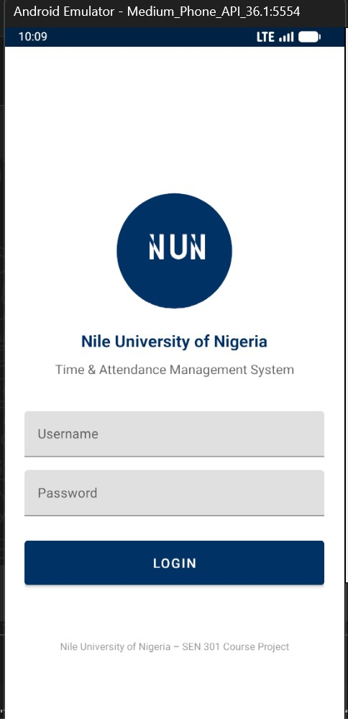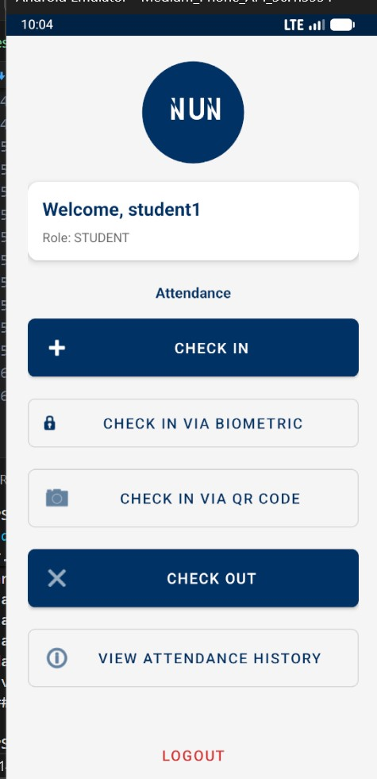

Hardware Interfaces

1. Supported Device Types:
The TAMS may interface with various hardware components, including:
- Biometric Scanners: Devices that capture biometric data (e.g., fingerprint scanners, facial recognition cameras).
- Card Readers: RFID or magnetic stripe card readers for employee identification.
- Computers/Tablets: Devices used by employees and administrators to access the TAMS interface.
- Network Printers: Printers for generating attendance reports, employee badges, etc.
- Mobile Devices: Smartphones or tablets for mobile attendance tracking (e.g., through a mobile app).
- Webcams: For facial recognition or video logging of attendance.

2. Logical Characteristics of Interfaces
The logical characteristics define how the software interacts with the hardware components, including data types and control interactions.
a. Biometric Scanners:
- Data Type: Biometric data (e.g., fingerprint templates, facial images).
- Control Interaction: The software sends commands to the scanner to initiate the capture of biometric data and receives the processed data for verification.
- Nature of Interaction: Real-time data capture and verification.

b. Card Readers:
- Data Type: Employee ID numbers or card data.
- Control Interaction: The software sends a request to read the card, and the reader transmits the card data back to the software for processing.
- Nature of Interaction: Instantaneous data retrieval upon card swipe or tap.

c. Computers/Tablets:
- Data Type: User input (e.g., attendance records, employee information), system logs, and reports.
- Control Interaction: The software provides a user interface for data entry and displays attendance reports.
- Nature of Interaction: Bidirectional data exchange for user commands and system feedback.

d. Network Printers:
- Data Type: Print jobs (e.g., attendance reports, employee badges).
- Control Interaction: The software sends print commands and data to the printer.
- Nature of Interaction: One-way communication from software to printer.

e. Mobile Devices
- Data Type: Attendance logs, notifications, and user inputs.
- Control Interaction: The mobile app communicates with the server to send attendance data and receive updates.
- Nature of Interaction: Bidirectional communication over the internet or local network.

f. Webcams
- Data Type: Video streams for facial recognition.
- Control Interaction: The software controls the webcam to capture images and processes them for attendance verification.
- Nature of Interaction: Real-time video capture and processing.

3. Physical Characteristics of Interfaces
The physical characteristics describe the hardware connections and communication protocols used for each interface.
a. Biometric Scanners
- Connection Type: USB, Serial, or Ethernet.
- Communication Protocols: USB HID (Human Interface Device), TCP/IP for networked devices.
- Data Format: Binary or proprietary formats for biometric data.
b. Card Readers
- Connection Type: USB or Serial.
- Communication Protocols: Wiegand, USB HID.
- Data Format: ASCII or binary format for card data.
c. Computers/Tablets
- Connection Type: Ethernet or Wi-Fi for networked systems.
- Communication Protocols: HTTP/HTTPS for web-based interfaces, Web Socket for real-time communication.
- Data Format: JSON or XML for data exchange.
d. Network Printers
- Connection Type: Ethernet or Wi-Fi.
- Communication Protocols: IPP (Internet Printing Protocol), LPD (Line Printer Daemon).
- Data Format: PCL (Printer Command Language) or PostScript.
e. Mobile Devices
- Connection Type: Wi-Fi or cellular data.
- Communication Protocols: RESTful APIs over HTTP/HTTPS.
- Data Format: JSON for API responses.
f. Webcams
- Connection Type: USB or networked (IP cameras).
- Communication Protocols: UVC (USB Video Class) for USB webcams, RTSP (Real-Time Streaming Protocol) for IP cameras.
- Data Format: Video stream formats (e.g., H.264, MJPEG).

Software Interfaces
To describe the connections between the Time and Attendance Management System (TAMS) and other software components, we focus on the integration points, data flow, required services, and constraints. The system connects to specific software components such as databases, operating systems, tools, libraries, and third-party commercial integrations:

1. Databases:
- PostgreSQL 13+, MySQL 8+, or Oracle Database 19c handle attendance records, user data, schedules, and logs.
- Incoming Data: Attendance data from biometric devices, hotspot verification or manual inputs.
- Outgoing Data: Reports, alerts, and data for integration with payroll systems.
- Data Sharing: Supports ACID compliance for transaction integrity during data read/write operations.

2. Operating Systems:
- Server-Side: Windows Server 2019 or Linux (Ubuntu 20.04 LTS, CentOS 8) host the system backend.
- Client-Side: Windows 10 or later, macOS 10.15 or later, Android 8.0 or later, iOS 13.0 or later support the user interface.

3. Tools and Libraries:
- Backend: Developed using Python (Django) or Java (Spring Boot).
- Frontend: Utilizes React.js or Angular for web applications.
- Libraries for Biometric Integration: Use SDKs like DigitalPersona or SecuGen for device compatibility.

4. Integrated Commercial Components:
- Payroll Systems: SAP, QuickBooks, or similar for syncing attendance and payroll data.
- Security Software: Integration with CCTV systems or RFID-based security.
- Notifications: Third-party SMS/email APIs like Twilio or SendGrid for alerts.

Data Items and Messages

1. Incoming Data:
- Biometric data from fingerprint scanners or RFID readers (used for attendance validation).
- User login credentials and session details for authentication.
- Manual attendance entries and adjustments by administrators.

2. Outgoing Data:
- Attendance reports exported in CSV, PDF, or XLSX formats.
- Alerts/notifications for absenteeism or late arrivals sent to parents or administrators.
- Data streams for integration with payroll or student management systems.

Services Needed and Communication

The system requires:
- Authentication and Authorization services using protocols like OAuth 2.0.
- RealTime Data Sync via WebSocket or REST APIs to ensure seamless updates across devices.
- Data Encryption services for secure communication (TLS 1.3 for transit, AES256 for storage).
- API Gateways for interfacing with third-party systems.

Data Sharing Across Components
- Shared data includes user profiles, attendance logs, schedules, and reports.
- Communication Mechanism: Shared via REST APIs with JSON payloads or direct database integration using secure queries.
- Implementation Constraint: If the system operates in a multitasking environment, global data areas must be thread safe, ensuring synchronization. Use technologies like Redis for shared memory caching to improve efficiency.

Referencing Detailed Protocols
- API specifications for each integration (e.g., biometric SDK, payroll system) will include endpoint definitions, request/response formats, and authentication methods.
- Separate documents should outline these details for developers managing specific integrations.

Communications Interfaces
The Time and Attendance Management System (TAMS) requires robust and secure communication mechanisms to facilitate data exchange between its components and external systems. Below are the detailed requirements associated with the communication functions:

- Email Communication:
- Purpose: To notify users (students, staff, and administrators) about attendance related updates, such as absences, schedule changes, or system alerts.
- Protocols: Simple Mail Transfer Protocol (SMTP) for outgoing emails and IMAP/POP3 for receiving email responses if applicable.
- Formatting:
  - Emails will be formatted in HTML for rich text and better visual presentation.
  - Plain text fallback for systems that do not support HTML emails.
- Security: Emails will use Secure Sockets Layer (SSL) or Transport Layer Security (TLS) to encrypt communication with the mail server.

- Web Browser Access:
- Purpose: To allow users to interact with the system through a web-based user interface (UI).
- Standards:
  - The system will use HTTP/HTTPS protocols, with all user interactions conducted over HTTPS for security.
  - Compatibility with modern web browsers such as Google Chrome, Mozilla Firefox, Safari, and Microsoft Edge.
- Message Formatting: JSON or XML for data exchange between the web client and the server, using RESTful APIs.

- Network Server Communication:
- Protocols:
- Hypertext Transfer Protocol Secure (HTTPS) for secure web interactions.
- WebSocket Protocol for real-time updates where applicable (e.g., live attendance tracking or notifications).
- Security:
  - End-to-end encryption using TLS 1.3.
  - Role Based Access Control (RBAC) to restrict unauthorized communication.

- Electronic Forms:
- Purpose: To collect, display, and process attendance data through the web interface or mobile app.
- Formatting:
  - Form data will be transmitted in JSON format for processing by the server.
  - Validation mechanisms will be implemented on both the client and server sides to ensure data integrity.

- Communication Standards:
- Protocols:
  - File Transfer Protocol Secure (FTPS) for securely uploading or downloading bulk data files.
  - Representational State Transfer (REST) APIs for interoperability between system components.
- Synchronization:
  - Network Time Protocol (NTP) to synchronize timestamps for attendance records across devices.

- Security and Encryption:
- Encryption Standards:
  - Advanced Encryption Standard (AES256) for data at rest.
  - TLS 1.3 for data in transit.
- Authentication:
  - Multifactor Authentication (MFA) for administrative access.
  - OAuth 2.0 for secure API access.
- Data Integrity: Hashing algorithms such as SHA256 to ensure the integrity of data transferred across the network.

- Data Transfer Rates and Bandwidth Requirements:
- Minimum Data Transfer Rate:
- 10 Mbps for server client communication to handle real-time updates.
- Lower bandwidth fallback mechanisms for mobile devices in remote locations.

- Synchronization Mechanisms:
- RealTime Updates:
WebSocket connections for instant updates when attendance is recorded.
- Batch Processing:
Scheduled data synchronization for noncritical updates during off-peak hours.

These requirements ensure that TAMS can deliver reliable, secure, and efficient communication across its various components and with external systems.

System Features

4.1 Attendance Tracking and Management

    - Description and Priority

This feature allows the system to accurately and efficiently track attendance for staff and students using multiple methods, such as biometric devices, hotspot verification, mobile applications, and web portals. It supports real-time logging, synchronization, and reporting to ensure transparency and accountability.

Priority: High
Component Ratings:
Benefit: 9
Penalty: 8
Cost: 7
Risk: 5

4.1.2 Stimulus/Response Sequences

1. Biometric Entry:
Stimulus: A student places their finger on a fingerprint scanner.
Response: The system validates the fingerprint against the user database and logs the attendance.
System Response: Upon successful validation, the system marks the student as "Present" for the class and displays a confirmation message on the scanner.

- Faculty Reviewing Attendance in Real Time
Stimulus: Faculty logs into the system via a web or mobile interface.
System Response: The system displays a dashboard showing the current attendance status for all ongoing classes.

Stimulus: Faculty selects a specific class to view the detailed attendance list.
System Response: The system retrieves and displays the list of students marked as "Present," "Absent," or "Late."

- Real-Time Alerts for Attendance Issues
Stimulus: The system detects a pattern of absences for a particular student.
System Response: Sends an automated alert to the student’s registered email and notifies faculty of the attendance anomaly.

- Mobile App Attendance:
Stimulus: A user logs in through the mobile app and selects the "Clock In" button.
Response: The system verifies credentials, records the time and location, and updates the attendance database.

- Web Portal Entry:
Stimulus: A user logs into the web portal and marks their attendance.
Response: The system timestamps the action, records the user’s IP address, and updates the database.

- Reporting:
Stimulus: An administrator generates an attendance report for a specific date range.
Response: The system queries the database and produces the report in the requested format (e.g., PDF, CSV).

- Notification:
Stimulus: A user forgets to log attendance and requests a notification.
Response: The system sends a notification via email or mobile app, reminding them to log their attendance.

4.1.3 Functional Requirements

REQ1: The system must support attendance logging via biometric devices, hotspot verification, mobile applications, and web portals.
REQ2: The system must validate user credentials (e.g., fingerprints, passwords, or biometrics) before logging attendance.
REQ3: The system must record timestamps, locations (if applicable), and user details for every attendance entry.
REQ4: The system must synchronize attendance data across platforms in real time.
REQ5: The system must allow users to view attendance logs and history through the mobile app and web portal.
REQ6: The system must provide administrators with access to edit or override attendance records.
REQ7: The system must offer notifications for missed or late attendance logging via email, SMS, or in-app alerts.
REQ8: The system must generate attendance reports based on various parameters, including user, date range, and department.
REQ9: The system must allow custom scheduling for recurring attendance tasks, such as exams or holidays.
REQ10: The system must enable geofencing for mobile app attendance, ensuring users are within a predefined radius before logging attendance.
REQ11: The system must log failed attempts for attendance entry (e.g., invalid credentials) and alert administrators for potential security issues.
REQ12: The system must comply with data security standards, including encryption and secure authentication protocols.
REQ13: The system must support offline attendance logging on biometric devices and sync data once connectivity is restored.
REQ14: The system must provide advanced reporting features, including trend analysis and visual dashboards.
REQ15: The system must enable automated penalties for late or missed attendance entries based on predefined rules.

4.2 Leave and Absence Management

4.2.1 Description and Priority

This feature allows staff and students to request, track, and manage leave or absences, providing transparency and improving workflow efficiency.

Priority: Medium
Component Ratings:
Benefit: 8
Penalty: 6
Cost: 5
Risk: 4

4.2.2 Stimulus/Response Sequences

1. Leave Request Submission:
Stimulus: A user submits a leave request via the web portal.
Response: The system validates the request, sends it to the appropriate approver, and updates the leave tracker upon approval.

2. Absence Notification:
Stimulus: A student marks themselves as absent for a specific day via the mobile app.
Response: The system records the absence, notifies relevant administrators, and updates attendance logs.

4.2.3 Functional Requirements
REQ1: The system must allow users to submit leave requests through the mobile app and web portal.
REQ2: The system must enable approvers to review and approve or reject leave requests.
REQ3: The system must automatically update attendance records to reflect approved leaves.
REQ4: The system must send notifications for leave status updates (e.g., approved, rejected).
REQ5: The system must provide a calendar view of scheduled leaves for better planning.

4.3 Integration with External Systems

4.3.1 Description and Priority
This feature enables seamless integration with third-party systems such as payroll, learning management systems (LMS), and student information systems (SIS).
Priority: High
Component Ratings:
Benefit: 9
Penalty: 7
Cost: 6
Risk: 5

4.3.2 Stimulus/Response Sequences

1. Payroll Integration
Stimulus: Attendance data is transferred to a payroll system (e.g., SAP).
Response: The system calculates salary deductions for late or missed attendance as well as bonuses for early arrivals based on predefined rules.

2. LMS Integration
Stimulus: A teacher accesses student attendance data via the LMS.
Response: The system queries the database and provides relevant data for the requested student or class.

4.3.3 Functional Requirements

REQ1: The system must integrate with third-party payroll systems like SAP and QuickBooks to calculate salary adjustments.
REQ2: The system must provide APIs for integration with LMS and SIS platforms.
REQ3: The system must synchronize data across external systems in real time.

4.4 Shift Scheduling and Timetable Management

4.4.1 Description and Priority
Allows administrators to upload and manage work shifts or class timetables, ensuring proper resource allocation.
Priority: High

4.4.2 Stimulus/Response Sequences
1. Shift Creation
Stimulus: An administrator creates a shift schedule for a department.
Response: The system allocates resources and notifies users.

2. Timetable Changes
Stimulus: A class timetable is updated.
Response: The system recalculates attendance requirements and alerts stakeholders.

4.4.3 Functional Requirements
REQ1: The system must allow shift and timetable upload for specific departments or users.
REQ2: The system must notify users of schedule changes in real time.
REQ3: The system must handle overlapping shifts or timetable conflicts.

4.5 Notification and Alerts System

4.5.1 Description and Priority
Provides timely notifications for key events, such as missed attendance, pending leave requests, and system updates.
Priority: Medium

4.5.2 Stimulus/Response Sequences
1. Attendance Reminder
Stimulus: A user is close to missing the attendance logging deadline.
Response: The system sends an SMS and email reminder.

4.5.3 Functional Requirements
REQ1: The system must send reminders for attendance logging, pending tasks, and upcoming shifts.
REQ2: The system must allow customization of notification settings.
REQ3: Notifications must support email, SMS, and in-appr messages.

4.6 Reporting and Analytics

4.6.1 Description and Priority

Automated attendance reporting is designed to provide comprehensive, customizable reports for faculty, administrators, and students. This feature reduces the manual effort required to generate summaries, trends, and compliance metrics. Reports can be scheduled or generated on-demand and are formatted for easy analysis or sharing with stakeholders.

Priority: High
Component Ratings:
Benefit: 9
Penalty: 8
Cost: 6
Risk: 4

4.6.2 Stimulus/Response Sequences
- Generating a Daily Attendance Summary:
Stimulus: Faculty clicks the "Generate Report" button on the dashboard and selects "Daily Summary."
System Response: The system retrieves attendance data for the specified day and compiles it into a tabular format.

Stimulus: Faculty selects "Download" and chooses the preferred format (PDF or Excel).
System Response: The system generates the report in the requested format and prompts the user to download the file.

- Scheduled Monthly Reports for Administrators:
Stimulus: Administrator configures a recurring monthly report summarizing attendance trends for all departments.
System Response: The system schedules the report generation and sends it automatically to the administrator’s email on the first day of each month.

- Customized Reports for Individual Students:
Stimulus: A student requests their attendance record for the semester through their profile interface.
System Response: The system filters attendance data for the student, formats it into a user-friendly chart, and displays it on the screen.

Stimulus: The student selects "Export" to save a copy.
System Response: The system generates the report and provides a downloadable link.

4.6.3 Functional Requirements
REQ1: The system must generate daily, weekly, monthly, and custom reports.
REQ2: Reports must be exportable in PDF, CSV, and Excel formats.
REQ3: The system must support scheduling of recurring reports for delivery via email to specified users.
REQ4: Reports must include visual elements such as graphs and charts for trends, alongside tabular data.
REQ5: The system must allow filtering of reports by parameters such as student ID, department, course, and date range.
REQ6: Real-time data aggregation must ensure that reports include the latest attendance entries without delays.
REQ7: The system must comply with accessibility standards, ensuring reports are usable by individuals with disabilities (e.g., screen reader compatibility).
REQ8: All generated reports must include a timestamp, ensuring traceability and accuracy of the data presented.
REQ9: Administrators should have the ability to set attendance thresholds (e.g., minimum 75% attendance) and generate compliance reports highlighting students who fall below the threshold.
REQ10: Reports must integrate seamlessly with external tools such as Power BI or Google Sheets for advanced analytics.
REQ11: The system must log all report generation activities in an audit trail, ensuring accountability and traceability.

4.7 Performance Monitoring and Evaluation

4.7.1 Description and Priority
Provides tools for tracking employee and student performance based on attendance and punctuality.
Priority: Medium

4.7.2 Functional Requirements
REQ1: The system must calculate attendance scores based on predefined criteria.
REQ2: The system must integrate attendance data with evaluation modules in LMS platforms.

4.8 Geofencing and Location Based Attendance

4.8.1 Description and Priority
Uses geofencing to restrict attendance logging to specific locations.
Priority: Medium

4.8.2 Functional Requirements
REQ1: The system must define geofences for specific locations like classrooms or offices.
REQ2: Attendance logging outside the geofenced area must trigger alerts or be denied.

4.9 Gamification Features

4.9.1 Description and Priority data
Introduces gamification to encourage timely attendance, such as rewards for consistent punctuality.
Priority: Low

4.9.2 Functional Requirements
REQ1: The system must award points for punctual attendance.
REQ2: The system must allow users to redeem points for rewards.

4.10 Accessibility Features

4.10.1 Description and Priority

Ensures the system is usable by individuals with disabilities, following accessibility standards like WCAG.
Priority: Medium

4.10.2 Functional Requirements

REQ1: The system must include screen reader support and keyboard navigation.
REQ2: The system must allow users to adjust font sizes and contrast settings.

4.11 Customization and Branding

4.11.1 Description and Priority
Enables institutions to customize the system’s appearance and workflows according to their brand and policies.
Priority: Low

4.11.2 Functional Requirements
REQ1: The system must allow customization of colors, logos, and themes.
REQ2: The system must allow administrators to define institution specific policies for attendance.

4.12 Biometric Attendance Integration

4.12.1 Description and Priority
Biometric attendance integration enhances the accuracy and security of attendance tracking by utilizing fingerprint scanners, facial recognition, or other biometric devices. This feature eliminates proxy attendance and ensures that attendance records are tied directly to the individual. The system seamlessly integrates with biometric hardware to capture, validate, and store attendance data in real time.

Priority: High
Benefit: 9
Penalty: 9
Cost: 7
Risk: 5

4.12.2 Stimulus/Response Sequences
- Fingerprint Attendance Check-In
Stimulus: A student places their finger on the biometric scanner.
System Response: The device captures the fingerprint and sends the data to the TAMS server for validation.

Stimulus: The system matches the fingerprint against the database.
System Response: If valid, the system marks the student as "Present" and displays a success message on the scanner screen.

- Facial Recognition Attendance Check-In
Stimulus: A faculty member approaches the camera and allows the system to scan their face.
System Response: The system processes the image and matches it with the stored biometric template.
Stimulus: Upon successful validation, the system records the check-in time and updates the attendance log.

- Hardware Failure Handling
Stimulus: A biometric device fails to capture data due to a hardware issue.
System Response: The system displays an error message and prompts the user to try again.
Stimulus: After three failed attempts, the system allows manual attendance entry by authorized personnel.
System Response: Logs the manual entry and flags it for review by administrators.

4.12.3 Functional Requirements
REQ1: The system must support integration with multiple biometric devices, including fingerprint scanners and facial recognition cameras.
REQ2: Biometric data capture and validation must not exceed 3 seconds per transaction.
REQ3: The system must ensure secure transmission of biometric data using encryption protocols (e.g., TLS 1.2 or higher).
REQ4: The system must maintain compliance with data protection regulations (e.g., GDPR, NDPR) for biometric data storage and processing.
REQ5: A fallback mechanism must allow manual attendance recording in case of hardware failure, with appropriate logging for review.
REQ6: The system must perform periodic health checks on biometric devices and notify administrators of any hardware issues.
REQ7: Biometric attendance logs must be integrated with the central database in real time, ensuring consistency across all system modules.
REQ8: The system must support mobile biometric attendance for remote locations using portable scanners or device cameras.
REQ9: Biometric templates must be securely stored and accessible only to authorized administrators.
REQ10: The system must provide a detailed audit trail for all biometric transactions, including device ID, user ID, and timestamp.
REQ11: The system must support multiple languages for biometric prompts to enhance usability in diverse user environments.

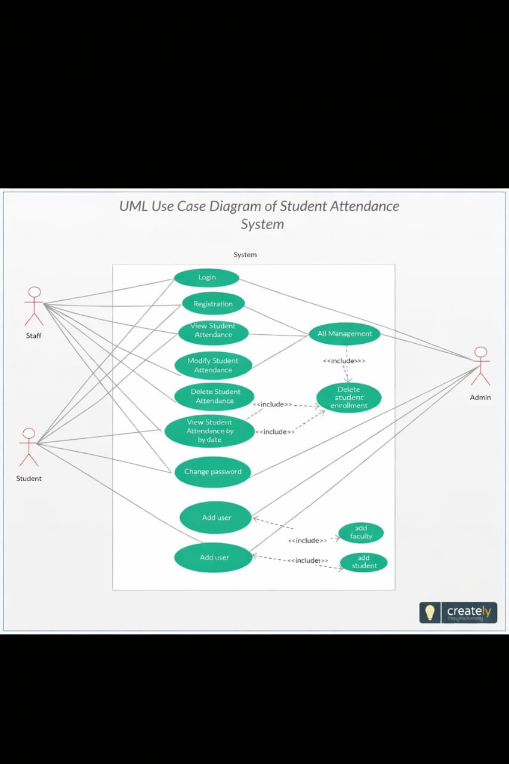
THE USE CASE DIAGRAM

SEQUENCE DIAGRAM BELOW
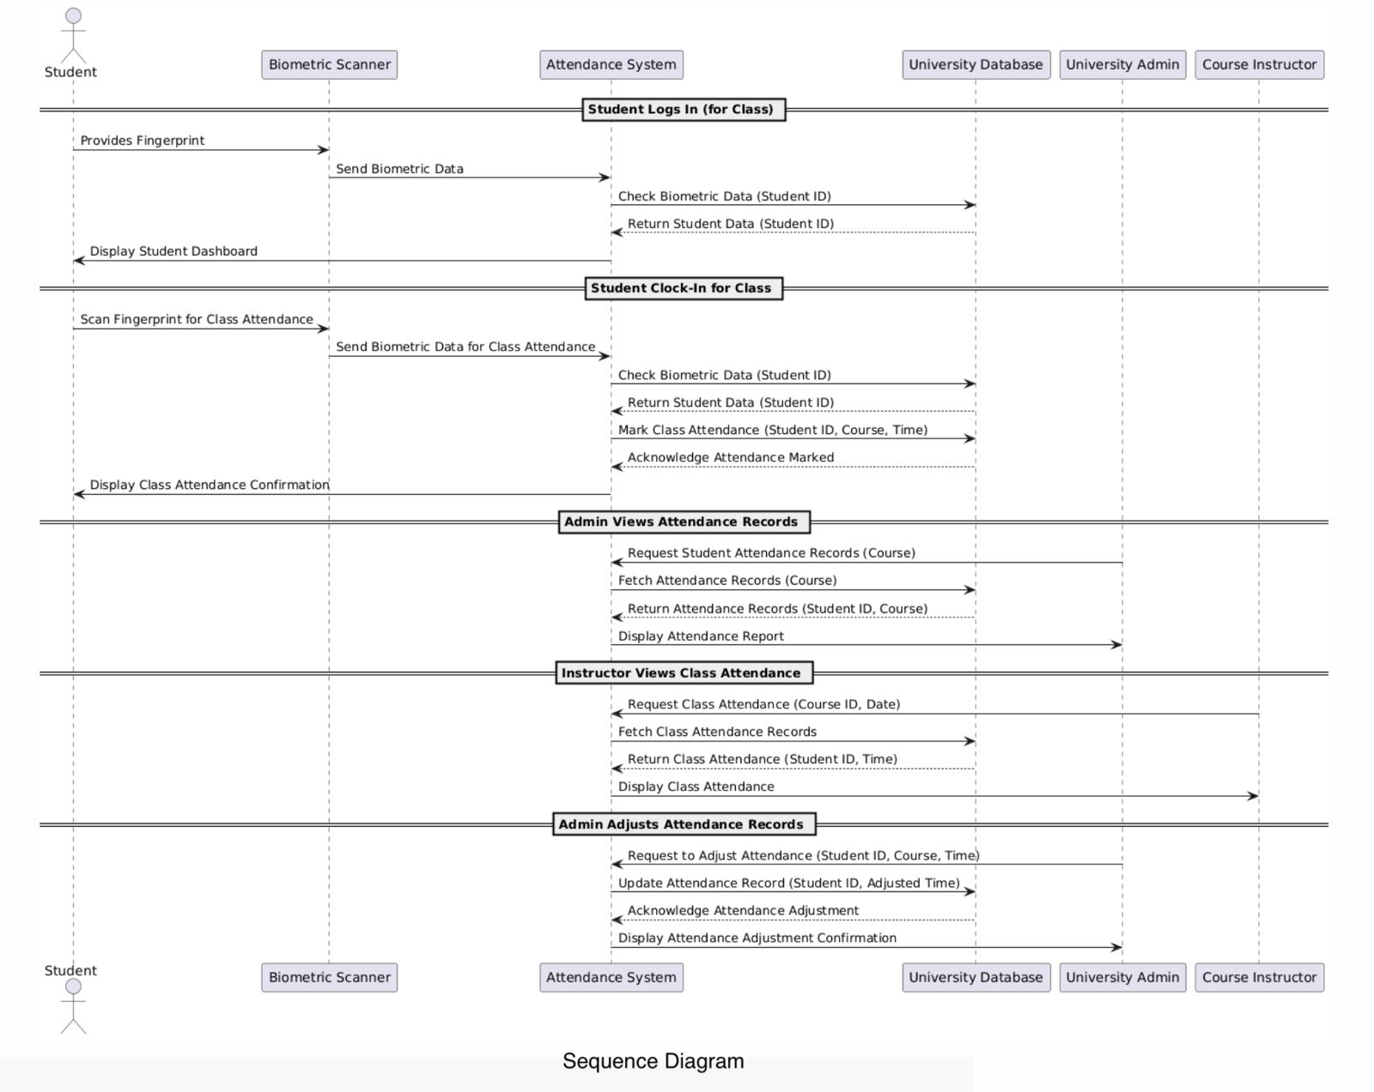

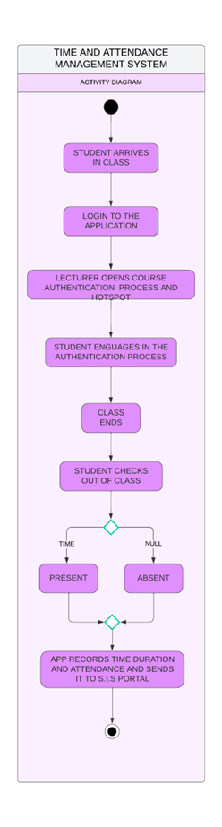ACTIVITY DIAGRAM
ACTIVITY DIAGRAM WHICH SHOWS THE FLOW OF ACTIVITIES WITHIN THE SYSTEM

Other Nonfunctional Requirements

Performance Requirements

- Response time; authentication:
The system must authenticate a user within 3 seconds for 90% of all login attempts under typical load conditions (e.g., up to 100 concurrent users).

Rationale:
- User Experience: Authentication delays beyond 3 seconds will create friction and frustration for users. Quick authentication will ensure users can access their accounts without unnecessary delays.

- Design Considerations:
- Optimized Database Queries: Ensure user credentials (passwords, multi-factor authentication tokens) are efficiently retrieved. Index critical fields like username and email for fast lookups.
- Caching Mechanism: Implement caching for session data and user state to reduce load on the database and speed up repeated login attempts.
- Database Connection Pooling: Use connection pooling to reduce overhead from repeatedly opening and closing database connections.

- Concurrency; Concurrent user capacity in login:
The system must handle up to 10,000 concurrent login attempts without degradation of performance (response time for login must remain below 5 seconds for 90% of requests during peak load).

Rationale:
- Scalability: Systems must support significant concurrent user traffic during events like product launches or high-demand usage periods.
- Design Considerations:
  - Horizontal Scaling: Use load balancers and multiple server instances to distribute user traffic across servers.
  - Auto-Scaling: Implement auto-scaling strategies (especially in cloud environments) that automatically increase resources as concurrent users rise.

- Session Timeouts and Re-authentication:
If the user session remains idle for more than 30 minutes, the system must automatically log the user out and prompt for re-authentication. Session timeout and login prompts must complete within 3 seconds of user inactivity.

Rationale:
- Security & Usability: Session timeouts are a critical security feature to prevent unauthorized access to an account if the user leaves their session unattended. However, delays in logging out or re-authentication will degrade the user experience.
- Design Considerations:
- Session Management: Use session tokens that can expire after a defined period or idle time. Make sure token validation is fast and does not result in unnecessary delays.
- Client-Side Timers: Implement client-side timers to detect inactivity and trigger an alert or re-authentication prompt.

- Availability (Uptime):
The system must maintain 99% uptime over a rolling 12-month period, with no more than 9 hours of downtime annually.
Rationale:
- Reliability: Uptime is crucial for user trust and operational continuity. With 99.9% uptime, the system can tolerate brief outages (e.g., maintenance windows) without significantly affecting users.
- Design Considerations:
  - Redundancy: Design for high availability with redundant systems (e.g., replicated databases, multiple application servers in different availability zones or regions).
  - Monitoring and Alerts: Implement comprehensive monitoring to detect failures early, and ensure that automated alerts notify administrators before outages become critical.
- Scalability:
The system must be able to scale horizontally and handle up to 3x surge in traffic without significant performance degradation or downtime. It should be able to support up to 50% more user traffic in half a year without performance decrease.
Rationale:
- Scalability: The system must be able to accommodate unexpected traffic spikes, such as during marketing campaigns, promotions, or viral events, to ensure that users do not experience slowdowns or downtime.
- Design Considerations:
  - Auto-Scaling: Implement cloud-based auto-scaling mechanisms to dynamically add new instances during high traffic periods and scale down once the load subsides.
  - Load Balancers: Use load balancing to distribute traffic evenly across available servers, preventing any single server from becoming overwhelmed.
- Rate Limiting for Login Attempts:
The system must enforce rate limiting of login attempts such that no user or IP address can attempt more than 5 login attempts per minute. If the rate is exceeded, the system should lock the account for 30 minutes or prompt the user for CAPTCHA verification.
Rationale:
- Security: To prevent brute-force attacks, the system must limit how many times a user or attacker can attempt to guess login credentials in a given period.
- Design Considerations:
  - IP-Based Rate Limiting: Use IP-based rate limiting to restrict the number of requests a client can make in a given time period. This can be implemented using a reverse proxy like Nginx or a web application firewall.
  - Captcha: After a certain number of failed login attempts, introduce a CAPTCHA challenge to distinguish human users from automated bots.
- Data Processing Latency (Real-Time Systems):
For real-time systems or applications that require immediate processing (e.g., attendance management system, live data monitoring), the processing time should be less than 3 second for 95% of data transactions.
Rationale:
- Real-Time Responsiveness: Real-time systems (e.g., attendance system, live chat) require low-latency data processing to ensure that users receive timely updates and can take action accordingly.
- Design Considerations:
  - Low-Latency Data Processing: Employ in-memory databases (e.g., Redis) or high-performance message queues to minimize data processing times. Also, ensure that long-running operations are offloaded to background jobs rather than blocking the user interface.
  - Optimized Algorithms: Use optimized algorithms and data structures (e.g., hash maps) for quick processing and access to user-specific data.
- Error handling and Timeout:
The system must handle timeouts (such as slow network connections or database issues) within 5 seconds, with an appropriate error message displayed to the user. In case of errors such as; invalid credentials, database failure), the system should return an error message in less than 2 seconds and ensure the system is recoverable within 5 minutes if critical failure occurs (e.g., authentication service goes down).
Rationale:
- Resilience: The system needs to be resilient to errors, providing quick feedback to users without crashing or freezing. If there’s a critical failure (e.g., database or authentication service outage), the system should recover quickly and resume normal operations.
- Design Considerations:
  - Graceful Degradation: Implement graceful degradation strategies to ensure that minor errors don't lead to system-wide crashes. For example, if a service is unavailable, notify the user of the issue and provide alternatives or retry options.
  - Failover and Redundancy: Use load balancing and failover mechanisms to ensure that even if one service instance fails, another can take over without impacting user experience. Additionally, use circuit breakers to avoid unnecessary retries when a service is known to be down.

Safety Requirements
When developing a Time and Attendance Management System (TAMS), it is crucial to consider various safety and security requirements to mitigate potential loss, damage, or harm that could arise from its use. Below are the specified requirements, safeguards, actions to be taken or prevented, and relevant external policies or regulations.

1. Data Security and Privacy Requirements:
Requirement: The system must protect sensitive employee data, including personal identification information (PII), attendance records, and biometric data (if applicable).
Safeguards:
- Implement encryption for data at rest and in transit.
- Use secure authentication methods (e.g., multi-factor authentication).
- Regularly update and patch software to protect against vulnerabilities.
Actions to Prevent:
- Prevent unauthorized access to the system through role-based access controls.
- Avoid storing sensitive data in plain text.

2. Compliance with Regulations:
Requirement: The system must comply with relevant data protection regulations, such as the General Data Protection Regulation (GDPR) in Europe, the Health Insurance Portability and Accountability Act (HIPAA) in the U.S. (if applicable), and other local data protection laws.
Safeguards:
- Conduct regular audits to ensure compliance with applicable regulations.
- Implement data retention policies that comply with legal requirements.
Actions to Prevent:
Prevent the collection of unnecessary personal data that does not serve a legitimate business purpose.

3. User Safety and Ergonomics
Requirement: The user interface must be designed to minimize user error and enhance usability, ensuring that employees can easily and accurately record their attendance.
Safeguards:
- Conduct usability testing to identify and rectify potential user interface issues.
- Provide clear instructions and training for users on how to use the system effectively.
Actions to Prevent:
Prevent complex navigation that could lead to user frustration or errors in attendance recording.

4. System Reliability and Availability
Requirement: The system must be reliable and available to prevent loss of attendance data due to system failures.
Safeguards:
- Implement regular backups of attendance data to prevent data loss.
- Use redundancy and failover mechanisms to ensure system availability.
Actions to Prevent:
Prevent single points of failure in the system architecture.

5. Biometric Data Handling (if applicable)
Requirement: If the system uses biometric data (e.g., fingerprint or facial recognition), it must comply with specific regulations regarding the collection and storage of biometric information.
Safeguards:
- Ensure biometric data is stored securely and encrypted.
- Obtain explicit consent from users before collecting biometric data.
Actions to Prevent:
Prevent the sharing of biometric data with third parties without user consent.

6. Safety Certifications
Requirement: The system must meet industry standards and safety certifications relevant to software and data security.

Safeguards:
- Obtain certifications such as ISO/IEC 27001 for information security management.
- Ensure compliance with the Payment Card Industry Data Security Standard (PCI DSS) if payment processing is involved.
Actions to Prevent:
Prevent the deployment of the system without obtaining necessary certifications.
7. Incident Response and Reporting
Requirement: The system must have an incident response plan in place to address data breaches or security incidents.
Safeguards:
- Establish a clear protocol for reporting and responding to security incidents.
- Train staff on recognizing and reporting potential security threats.
Actions to Prevent:
Prevent delays in incident reporting that could exacerbate the impact of a security breach.

Security Requirements

1. Data Security and Privacy:
- All data stored or transmitted by the system must comply with the General Data Protection Regulation (GDPR) for user data protection and the Nigerian Data Protection Regulation (NDPR).
- Sensitive information, including personal details and attendance records, must be encrypted using industry-standard algorithms (e.g., AES-256) during storage and transmission.
- The system must anonymize or pseudonymize personally identifiable information (PII) where feasible to reduce exposure risk.

2. Authentication Requirements:
- User identity must be verified through multi-factor authentication (MFA) for administrators and staff with elevated privileges.
- Students and employees must use strong passwords, adhering to defined password policies, including minimum length, complexity, and expiration intervals.
- Biometric authentication (e.g., fingerprint or facial recognition) may be implemented for additional security during clock-in/clock-out procedures.

3. Access Control:
- Role-based access control (RBAC) must be enforced to restrict data access based on user roles and responsibilities.
- System administrators must have access to manage permissions, but actions must be logged for auditing purposes.

4. Data Protection Policies
- The product must conform to Nile University's IT Governance policies regarding data confidentiality, integrity, and availability.
- Backup and disaster recovery procedures must be implemented, with backups encrypted and tested regularly for integrity.

5. External Regulations and Standards
- Adherence to ISO/IEC 27001 standards for Information Security Management Systems (ISMS).
- Compliance with relevant labor laws regarding attendance tracking and employee data in Nigeria.

6. Certifications
- The product should achieve certification or approval from appropriate security auditors to ensure adherence to security policies and privacy regulations.

7. Logging and Monitoring
- Maintain detailed audit logs of system activity, including logins, data modifications, and administrative actions. Logs must be tamper-proof and stored securely.
- Automated monitoring and alerting systems must be implemented to detect and respond to potential security breaches.

Software Quality Attributes

1. Adaptability:
- The system must allow for updates to business rules and workflows (e.g., changes in appointment booking logic or attendance thresholds) through configuration files without requiring code changes.
- Deployment pipelines must support blue-green or canary deployments to minimize disruption during updates.

2. Availability:
- The system must achieve an uptime of 99.9% annually, translating to a maximum allowable downtime of 8.76 hours per year, excluding scheduled maintenance windows.
- High Availability (HA) architecture must be implemented using load balancers, redundant server instances, and failover mechanisms.

3. Correctness:
- All algorithms used for calculating attendance, generating schedules, and enforcing business rules must undergo formal verification and unit testing to ensure mathematical accuracy.
- A verification mechanism should validate all database operations (e.g., ensuring no duplication of appointments or incorrect attendance entries).

4. Flexibility:
- The system should allow administrators to dynamically enable or disable features (e.g., appointment slots, attendance modules) through a centralized admin panel.
- Feature toggles must be implemented for quick activation or deactivation of specific functionalities during runtime.

5. Interoperability:
- Integration with external systems (e.g., Google Calendar, Outlook, HRIS platforms) must be achieved using RESTful APIs or Webhooks, supporting JSON and XML data formats.
- The system must comply with OpenAPI standards and provide comprehensive API documentation.

6. Maintainability:
- All source code must adhere to industry standard guidelines, such as PSR12 for PHP or PEP 8 for Python.
- The system should achieve a maintainability index of 85 or higher, as measured by tools like SonarQube.
- Logging and monitoring must be implemented using tools like ELK Stack or Grafana for real-time visibility into system operations.

7. Portability:
- The system must be containerized using Docker to ensure consistent deployment across different environments.
- Kubernetes (or an equivalent orchestration tool) must be used to manage deployments and scaling.

8. Reliability:
- The system must handle a load of up to 10,000 concurrent users with no more than a 5% degradation in response time.
- A comprehensive disaster recovery plan must be in place, including automated failover and data replication mechanisms.

9. Reusability:
- Modules such as authentication, notification services, and reporting must be implemented as independent microservices to promote reuse across multiple projects.
- Shared libraries must adhere to semantic versioning and include documentation for integration.

10. Robustness:
- The system must validate all user inputs at both the client and server levels to prevent invalid data entry.
- Error handling mechanisms must be implemented to gracefully handle edge cases, with descriptive error messages logged for debugging.

11. Testability:
- All critical system modules must achieve a minimum of 90% code coverage through automated unit tests.
- Integration tests should validate end-to-end workflows, with results stored in a CI/CD pipeline for traceability.

12. Usability:
- The user interface (UI) must conform to WCAG 2.1 AA standards for accessibility.
- Usability testing must confirm that key actions (e.g., booking an appointment or viewing attendance) require no more than 3 clicks and can be completed within 10 seconds.

13. Scalability:
The system must handle an increasing number of users, including staff, students, visitors, and external entities, without compromising performance or responsiveness.

14. Security:
- Robust security measures must be in place, including encryption of all data and clearance-based access controls.
- Administrators must manage permissions to protect sensitive attendance records from unauthorized access or modification.

Business Rules

- User Roles and Permissions:
- Students: Can perform actions such as viewing attendance, booking appointments, and canceling their bookings.
- Teachers: Can mark attendance, approve or reject appointment requests, and access class level reports.
- Administrators: Have full access to all system functionalities, including data management, role configuration, and reporting.

- Appointment Booking:
- Appointments must be booked at least 24 hours in advance to allow scheduling logistics.
- A user may have a maximum of 3 active (pending or confirmed) appointments at any given time.
- Appointment time slots must be dynamically generated based on staff availability and predefined operating hours.

- Attendance Management:
- Attendance records must be updated by teachers within 48 hours of the class session.
- Any modification beyond this period requires approval from an administrator, with reasons logged for auditing.

- Notification Rules:
- Users must receive real-time notifications for appointment confirmations, cancellations, and attendance updates via email and SMS.
- Notifications should be configurable, allowing users to opt-in or out of specific types.

- Data Retention
- Attendance and appointment data must be retained for a minimum of 5 years to comply with institutional and regulatory policies.
- Archived data should be retrievable within 24 hours upon request.

- Authorized Adjustments:
Only designated personnel (e.g., HR, HODs, or level advisers) are allowed to make adjustments to attendance records. Unauthorized changes must be prohibited.

- Late Arrivals and Early Departures:
These occurrences must be tracked separately for both staff and students, with notifications sent to relevant supervisors or departments to enforce accountability.

- Access Restrictions:
- Students can only view their personal attendance records without modification rights.
- Staff can access department level data but cannot alter records.
- Administrators, particularly in security roles, have full access and control over system data and configurations.

- Report Integrity:
Attendance reports must be secure and tamperproof. Lecturers or staff are not permitted to modify reports to ensure the integrity of attendance data.

- Visitor Attendance:
Records for external visitors, including government officials or other guests, must be logged accurately and stored securely for institutional tracking purposes

- Requirement Traceability Matrix (TRM):

Req. ID | Req. Description | Req. Type | Priority | Test Case ID | Comments | Status
Req 001 | The system shall allow staff and students to register biometric data (e.g., fingerprints). | Functional | High | TC-001 | Ensure compatibility with multiple biometric devices. | Completed
Req 002 | The system shall validate attendance using biometric authentication. | Functional | High | TC-002 | Real-time validation required. | Completed
Req 003 | Attendance records shall be stored securely in the database. | Non-Functional | High | TC-003 | Data encryption must be implemented. | Completed
Req 004 | The system shall generate attendance reports for staff and students. | Functional | Medium | TC-004 |  | Completed
  Reports should be exportable in PDF and Excel.
Req 005 | The system shall provide role-based access for admins, teachers, and students. | Non-Functional | High | TC-005 | Ensure compliance with role-based access control (RBAC). | Completed
Req 006 | Biometric devices shall integrate seamlessly with the system. | Non-Functional | High | TC-006 | Tested with [specific device models]. | Completed
Req 007 | The system shall log all attendance-related activities for auditing. | Non-Functional | Medium | TC-007 | Include timestamps for all logs. | Completed
Req 008 | Users shall receive alerts for missed attendance or errors in logging. | Functional | Low | TC-008 | Email and SMS notifications must be tested. | Completed
Req 009 | The system shall operate across multiple platforms (e.g., desktop and mobile). | Non-Functional | Medium | TC-009 | Ensure responsive design and cross-platform compatibility. | Completed
Req 010 | The system shall support backup and recovery of attendance data. | Non-Functional | High | TC-010 | Backup frequency should meet compliance standards. | Completed

Other Requirements
1. Database Requirements:
- The system must use a relational database (e.g., PostgreSQL or MySQL) for structured data and a NoSQL database (e.g., MongoDB) for unstructured data such as logs.
- All sensitive data, such as user credentials, must be encrypted using AES256 encryption.
- Database queries must be optimized to maintain response times under 500ms for complex operations.

3. Legal Requirements:
The system must comply with GDPR, HIPAA (if applicable), and local data protection laws.
Audit trails must be maintained to log all user actions for at least 5 years.

4. Reuse Objectives:
- Core components, such as authentication and notification services, must be developed as standalone microservices for reuse in future projects.
- Common utilities (e.g., date pickers, validation libraries) should be packaged as shared libraries with clear API documentation.

5. Performance Requirements
- Average response times for all critical user actions must not exceed 2 seconds under normal load conditions.
- Stress tests must ensure the system can scale to handle 10,000 requests per minute during peak usage.

6. Backup and Recovery
- Full database backups must occur daily, with incremental backups every 4 hours.
- Recovery Time Objective (RTO) should not exceed 30 minutes, and Recovery Point Objective (RPO) should not exceed 15 minutes.

- Integration Requirements:
- Seamless integration with biometric devices, the university student portal, payroll systems, and potentially CCTV systems to enhance accountability and utility.
- Compatibility with existing infrastructure to avoid unnecessary replacement costs.

- Hardware and Software Compatibility:
- Transition from outdated card systems to biometric scanners.
- Ensure compatibility with desktops, laptops, and future ready hardware.
- User Documentation:
- Provide clear and detailed user manuals for all user classes (students, staff, and administrators).
- Include online tutorials, FAQs, and QuickStart guides for ease of use.
- Offer technical support documentation for IT teams managing the system.

- Legal Compliance:
Ensure adherence to local data protection laws, institutional policies, and global standards for privacy and security.

- Performance Metrics:
- Success of the system will be evaluated through measurable improvements, such as reduced absenteeism, streamlined payroll processing, and enhanced administrative efficiency.
- Regular audits should ensure the system meets reliability, security, and scalability expectations

Appendix A: Glossary
  - API: Application Programming Interface; a set of protocols for building and interacting with software applications.
  - CI/CD: Continuous Integration and Continuous Deployment; a practice in software development to frequently deliver and test code.
  - HA: High Availability; system design that ensures a high level of operational performance.
  - HIPAA: Health Insurance Portability and Accountability Act; a U.S. regulation for data security and privacy.
  - RPO: Recovery Point Objective; the maximum tolerable amount of data loss measured in time. RTO: Recovery Time Objective; the target time for restoring services after an outage.
  - WCAG: Web Content Accessibility Guidelines; standards for making web content accessible to people with disabilities.
  - System: Refers to the Time and Attendance Management System (TAMS).
  - User: Includes students, teachers, administrators, or any individual interacting with the system. Attendance Record: A log tracking the presence or absence of students or staff.
  - TAMS: Time and Attendance Management System
  - UI: User Interface
  - NUN: Nile University of Nigeria
  - RFID: Radio Frequency Identification
  - SRS: Software Requirements Specification
  - FAQs: Frequently Asked Questions
  - CIA: Confidentiality, Integrity, and Availability
  - TCP/IP: Transmission Control Protocol/Internet Protocol
  - System: Refers to the Time and Attendance Management System (TAMS).
  - User: Includes students, teachers, administrators, or any individual interacting with the system.
  - Attendance Record: A log tracking the presence or absence of students or staff.
  - CSV: Comma-Separated Values
  - PDF: Portable Document Format
  - XLSX: Microsoft Excel Spreadsheets
  - PII: Personal Identification Information
  - GDPR: the General Data Protection Regulation
  - FERPA: the Family Educational Rights and Privacy Act
  - Blue-Green Deployments: In this strategy, you have two identical environments, one live and one in development. You can instantly switch traffic between the two environments, allowing for a seamless transition and zero downtime. If there are issues with the new environment, you can immediately switch back to the live environment.
  - Canary deployment: In this strategy, you roll out a new release to a small group of users first, called canaries. You monitor the performance and feedback of the canaries, and only roll out the new release to the rest of the system if there are no problems. This strategy allows you to identify and fix issues before they affect the majority of users.

Appendix B: Analysis Models
1. Data Flow Diagram (DFD):
A DFD will be provided to illustrate how data moves between system components, including user interfaces, databases, and external systems.

2. Class Diagram:
A UML class diagram will define the relationships between core entities, such as Users, Appointments, Notifications, and Attendance Records.

3. State Transition Diagram:
A state diagram will describe the lifecycle of an appointment, from booking to cancellation or completion.

4. Entity Relationship Diagram (ERD)
The ERD will model the database structure, detailing entities, attributes, and relationships.
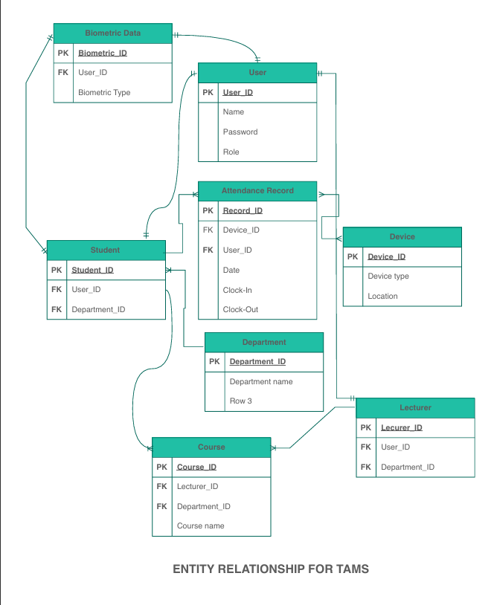

Appendix C: To Be Determined List
- Notification Channels: Determine whether push notifications will be supported in addition to email and SMS.
- Data Retention Policy: Confirm if data retention should exceed 5 years for specific use cases.
- Integration Systems: Finalize the list of external systems for API integration (e.g., third-party calendar systems).
- Accessibility Testing Tools: Select tools for testing compliance with WCAG 2.1 standards.

