Reference

New Project Wizard
What is your application called?
Enter a friendly name that you can refer to this application by.

Where will your updates be hosted?
Path your application will use to find updates:
Enter the network location that that your application can download updates from. This network folder can be an http, ftp, UNC, or file path location. It must be dedicated to this application.
Path you will use to publish updates:
This location will be used to publish updates. You can use a different protocol to publish updates than you use to download. It is common to use http for downloading updates, and use ftp or a file path for publishing updates.

Verifying Paths
You can use the Verify utility to create the update location if it doesn’t already exist, and ensure that the download path and publish path are directed to the same directory.

Program Versioning
Application versioning can be controlled by using the application .Net assembly version, or by setting the version manually.

When using the .Net Assembly Version, the .Net Framework Assembly:Version attribute determines the version of the client application, and is used in determining which updates can be applied. For most .Net applications, this is the best choice for versioning.

When using manual versioning, the Update Controller Version property determines the client version. This method is used for updating situations where updates can be applied without being required to rebuild the main application executable.

Automatically set the new update version
If the .Net assembly version is used for versioning, you can link the new update version number to the assembly version of your main application executable.

Update Process Permissions
Will your updates require permissions elevation?
If the users of your software applications do not hold the permissions necessary to replace your application files during an update, you can elevate the update process permissions using either the User Account Control (UAC) or by using the AppLife Update Windows Service.

If you plan to use the Windows Service, you can register your application on your development computer by using the Register your program for elevation button. Your application must be registered in order to use the service for permissions elevation.

Finish Synchronization
Information about the new AppLife Update project must be included in your application source code. This information can be transferred using the Windows Clipboard.

If your application is not forms based, or you would prefer to create and instantiate the Update Controller in code, you can paste a code snippet in either C#, VB.net, or XAML.

The properties that are synchronized are:
- Application ID
A globally unique identifier (GUID) that uniquely identifies your application. The ID of an update package must match the application ID set in the Update Controller to be applied.
- Public Key Token
An AppLife Update project file (aup) contains an RSA public-private key pair. When an update is built, the resulting update package is signed using the private key. When the Update Controller embedded in your application downloads an update package, it uses the signature and the public key token to verify that the package was built by its corresponding project file. It is important that you back up your project file (aup). If your project file is lost, you will not be able to build updates for your application.
- Update Location
The update location is where the Update Controller will look to find updates for your application.

Project Properties

Update Window Tab
Window Style
Specifies the update window shown as the AppLife Update Engine executes an update.

Update Window Customizations
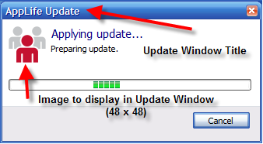
Window title
Action List Current Replaces the default “AppLife Update” text on the update form displayed on the client during the execution of an AppLife Update action list update.

Image
A 48 pixel by 48 pixel image that can be adorned on the update form displayed on the client during the execution of an AppLife Update action list. By default, there is no image present.

Replacement Window
The update engine window can be completely replaced with your own customized update window. This can be accomplished by implementing the ICustomUI interface and importing the assembly that contains a class that implements that interface.

Publishing Tab
Updates can be built and published to one or more update locations. The locations can be configured from this tab.
Each location requires a URL to publish updates to. The location can be given a name and credentials.
Verify the Update Location
The defined update location can be verified using the Verify button. Verification will ensure that the location exists, and prompt to create it if it doesn’t. A test file is then published to the location, verifying the ability to publish.

Security Tab
From the security tab, the public key can be viewed and copied. If UAC elevation is being utilized, the software update launcher can be exported so that it can be code-signed with your organization’s x509 code signing certificate. Once code signed, your organization is identified as the publisher of the update package when the update process is elevated by the UAC.

Localization Tab
Localized resources can be included in built update packages. The update engine user interface has been localized to the listed geographical locales. By selecting one or more of the localized regions, the string resources for those regions will be added to updates as they are built.
Summary Text and Update Window title can also be defined individually for each selected locale.

Custom Actions Tab
The list of referenced custom action assemblies are viewed on this tab. Additional custom action assemblies can be added as well.

Build Tab
Update Version Linking
Define a local file whose assembly version or file version determines the update version as updates are created.

Update Action Paths
Defines the base directory for actions that support relative local file paths. The default base directory is the location of the aup project file.

Pre-Build Script
Defines a batch file that is executed prior to initiating an update build.

Post-Build Script
Defines a batch file that is executed after an update build is completed.

General Tab
Application name
The friendly name of this application.

Application ID
The globally unique identify for this application (GUID). The Application ID of the Update Controller within your application must match this value.

Summary if no updates are available
The text that is displayed to a client user when an update is not found. By default, no summary information is displayed. This text can be localized for each selected language.

The Make Update Window
The Make Update Window allows you to add and configure actions that will be built into your next update. There are three panels within the Make Update Window. The Actions Palette, the Action list, and the Action Editor panel.

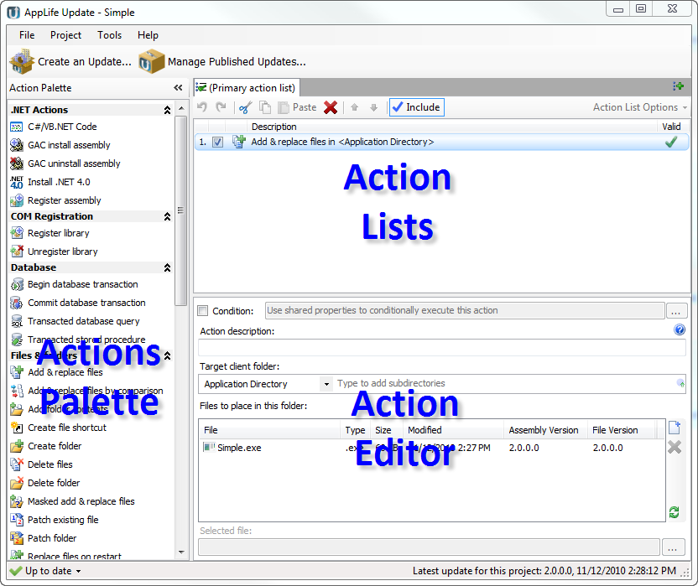

Adding an Action
You can select an action from the Action Palette by clicking on an action or drag and drop onto the Actions list. When you click an action, the action is added to the Action list below the currently selected action in the list.

Manipulating Actions in the list
Actions in the list can be selected individually or in a multi-action selection.
Actions in the list can be dragged and dropped up and down the list. The action list toolbar has Up/Down command buttons. The Up/Down command buttons are enabled when the selected action(s) are contiguous.
Actions can be cut/copied/pasted individually or as a multi-action selection. When actions are pasted, they are added below the currently selected action in the list.
Actions can be deleted individually or as a multi-action selection. You are prompted before an action is deleted.
Actions can be checked for inclusion in the built update or unchecked for exclusion. Actions that are excluded are not included in the build process. They are treated as if they do not exist in the update.

Valid Action Indication
Whether an action in the list is valid or not is visually indicated in the Action list.
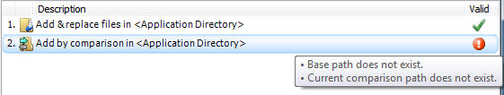
The icon displayed included a tooltip to indicate what validation rule is currently broken. The update cannot be built until all the actions in the list are valid.

Editing Individual Actions
Actions are configured through the Action Editor. When an action is selected in the Action list, its editor is placed in the Action Editor panel for configuration. Custom actions use a property grid for editing their properties. You can implement your own editors for your custom actions.

Action Conditional Expression Dialog
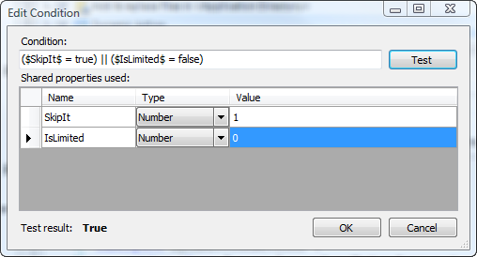

The Action Conditional Dialog provides the ability to test an Update Action conditional expression by defining test values of Shared Properties within the expression.
Any Shared Property utilized in the Conditional Statement is included in the grid, allowing you the ability to set a test value.
The Test button assigns the values specified in the grid to the Shared Properties in the expression, and then evaluates the expression showing the test results in the results label.
See Action Conditionals for more information.

Register Assembly Action Editor
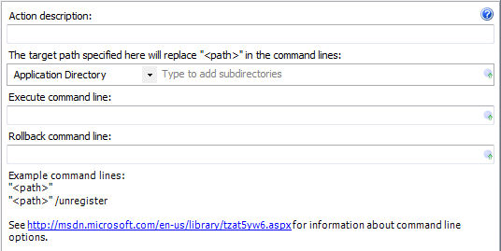
Action description – Descriptive text that can be used to identify this particular action in the Actions list.

Target client folder – The folder on the client that contains the .net dll.

Subdirectories – The directory below the designated client root folder that contains the .net dll that is to be registered.
The target client folder and subdirectory values can be substituted into the Execute and Rollback command lines using the <path> variable.

Execute command line – The Regasm.exe command line to execute during the update execute stage.

Rollback command line – The Regasm.exe command line to execute in the event of a rollback.

Expansion variables can be used to set the target client subdirectory property, Execute, and Rollback command lines.

See the Register Assembly action for more information.

Register Library Action Editor
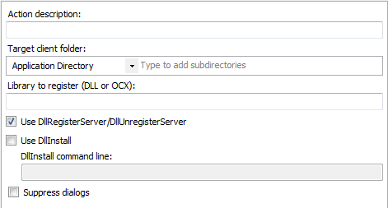

Action description – Descriptive text that can be used to identify this particular action in the Actions list.

Target client folder – The folder on the client that contains the dll or ocx file.

Subdirectories – The directory below the designated client root folder that contains the dll or ocx that is to be registered.

Library to register – The name of the dll or ocx file.

Use DllRegisterServer/DllUnregisterServer, Use DllInstall, DllInstall command line, Supress dialogs – Parameters to the Regsrvr32 call. See msdn for more information.

Expansion variables can be used to set the target client subdirectory property, Library to register name and the DllInstall command line.

See the Register Library action for more information.

Unregister Library Action Editor

Action description – Descriptive text that can be used to identify this particular action in the Actions list.

Target client folder – The folder on the client that contains the dll or ocx file.

Subdirectories – The directory below the designated client root folder that contains the dll or ocx that is to be registered.

Library to register – The name of the dll or ocx file.

Use DllRegisterServer/DllUnregisterServer, Use DllInstall, DllInstall command line, Supress dialogs – Parameters to the Regsrvr32 call. See msdn for more information.

Expansion variables can be used to set the target client subdirectory property, Library to unregister name and the DllInstall command line.

See the Unregister Library action for more information.

Add & Replace Files Action Editor
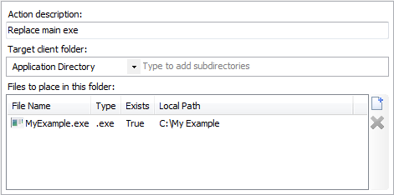

Action description – Descriptive text that can be used to identify this particular action in the Actions list.

Target client folder – The folder on the client to place the files in the file list.

Subdirectories – The directory below the designated client root folder to place the files in the file list.

Files to place in this folder – A collection of files that are to be added or replaced on the client in the defined folder. Files that are added to the list must be present for the action to be valid.

See the Add & Replace files action for more information.

Add Files By Comparison Action Editor
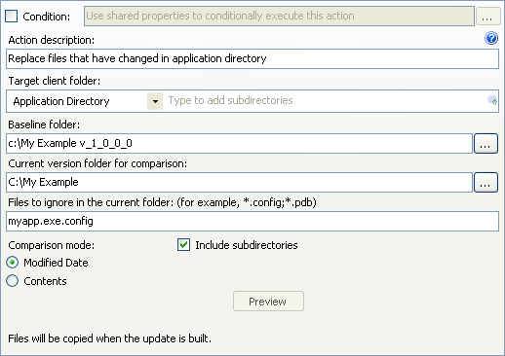
Action description – Descriptive text that can be used to identify this particular action in the Actions list.

Target client folder – The folder on the client to place files that are newer or does not exist in the baseline folder and all previous updates.

Subdirectories – The directory below the designated client root folder to place the files.

Baseline folder – The folder that is compared to the Current version folder to determine files that should be added to the update.

Current version folder – The folder that represents the current version of your software. The client folder will mirror this folder after the update is completed.

Files to ignore in the current folder – Wildcard exclusion filter. This property allows you to exclude files from the update whose name matches your defined wildcard filter. Multiple filters can be applied, delimited by a semicolon. (*.config; *.pdb)

Include subdirectories – Checked to indicate that the analysis should include all subassemblies within the current version folder.

The files that are included in the update is determined during the update build. The output window identifies the action taken for each file in the Current version folder.

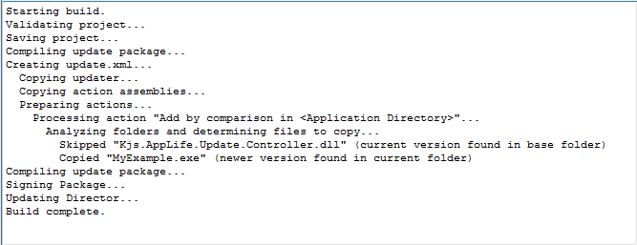

Expansion variables can be used to set the target client subdirectory property.

See Add & Replace Files by Comparison action for more information.

Add Files by Comparison (v4.0 Change)
The algorithm used to identify files to include in an update using the Add & Replace files by Comparison action has been changed in version 4.0. In earlier versions of AppLife Update, an update build folder and data identifying which updates were published in the single update project publish location were maintained by the AppLife Update project file (aup). This information, along with the target version list of the update being built were used to add or remove files from the file list based on a determination that a file must already be on a deployed client targeted by the new update. This analysis allowed for a proper file inclusion list, even when the action baseline folder didn’t match the new update’s lowest target version.

In version 4.0, the project build folder and update location data has been removed from the update project in order to support publishing updates to multiple independent update locations. This change affects the Add & Replace files by Comparison algorithm because this project information was used to determine the files list. Because of this, the action has been simplified to compare files between the designated baseline and current folders, without regard to update version information. For an accurate file list, the designated baseline folder contents needs to represent the lowest target version of the update being built.

Clicking the Update button will upgrade the action to use the replacement action.

Delete Files Action Editor
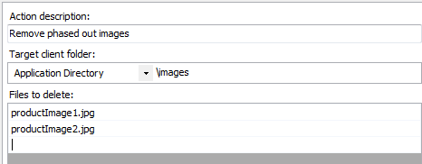

Action description – Descriptive text that can be used to identify this particular action in the Actions list.

Target client folder – The folder on the client to place files that contains the file(s) you are removing.

Subdirectories – The directory below the designated client root folder that contains the files.

Files to delete – The filename of the files that will be deleted. One file per line. The filename must be exact, with no wildcard characters. Case is not considered.

Expansion variables can be used to set the target client subdirectory property.

See Delete Files action for more information.

Masked Add & Replace Files Action Editor
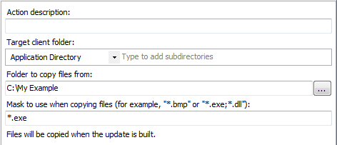

Action description – Descriptive text that can be used to identify this particular action in the Actions list.

Target client folder – The folder on the client to place files that contains the file(s) you are adding/replacing.

Subdirectories – The directory below the designated client root folder that contains the files.

Folder to copy files from – The local folder that contains the files that the mask is applied to.

Mask to use when copying files – The file mask that determines the files that will be included.

The files that match the mask are written to the output window during the build process.

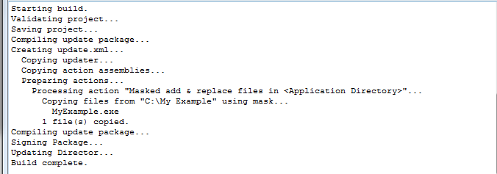

Expansion variables can be used to set the target client subdirectory property.

See the Masked add & replace files action for more information.

Patch Folder Action Editor
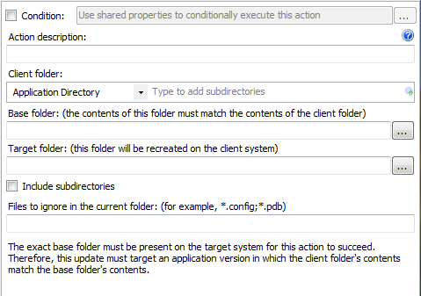

Condition – Use Shared Properties as variables to conditionally execute this action during an update.

Action description – Descriptive text that can be used to identify this particular action in the Actions list.

Client folder – The folder on the deployed client where the files to be patched exists.

Subdirectories – The directory below the designated client root folder that contains the files.

Base folder: The folder on the build machine that includes the baseline file versions. This folder should represent the deployed client folder.

Target folder: The folder on the build machine that includes the target files. As the update is built, files in the target folder are compared with their counterpart in the base folder. If a different version exists in the base folder, a differential patch is created and added to the update. If the file doesn’t exist in the base folder, the whole file is added to the update.

The Patch Folder action utilizes the Microsoft Delta Compression API to create a differential patch file between two versions of an assembly during an update build, and then packages the patch file into the update.
As the update is executed, this differential patch is combined with the base file that exists on a deployed client to construct the target file.
Utilizing the Patch Folder action can significantly reduce the size of the resulting update package. The specific version of the baseline files must be present on the system being updated.
NOTE: The Windows Installer SDK must be present on the system building the update package. Get it here. Patch extraction support is available on all Windows versions later than Windows 2000.
See Patch Folder Action for more details

Patch Existing File Action Editor
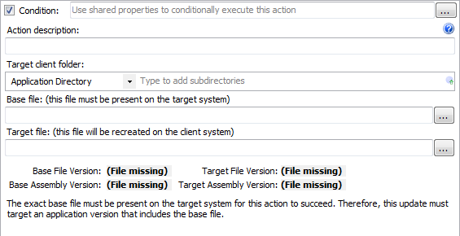
Action description – Descriptive text that can be used to identify this particular action in the Actions list.

Target client folder – The folder on the client to place files that contains the file(s) you are adding/replacing.

Subdirectories – The directory below the designated client root folder that contains the files.

Version Information displays the assembly version and file version of the baseline file and the target file.

The Patch Existing File action utilizes the Microsoft Delta Compression API to create a differential patch file between two versions of an assembly during an update build, and then packages the patch file into the update.
As the update is executed, this differential patch is combined with the base file that exists on a deployed client to construct the target file.
Utilizing the Patch Existing File action can significantly reduce the size of the resulting update package. The specific version of the baseline file must be present on the system being updated.
NOTE: The Windows Installer SDK must be present on the system building the update package. Get it here. Patch extraction support is available on Windows 2000 and later.
See File Patching Action for more details

Replace Files on Restart Action Editor
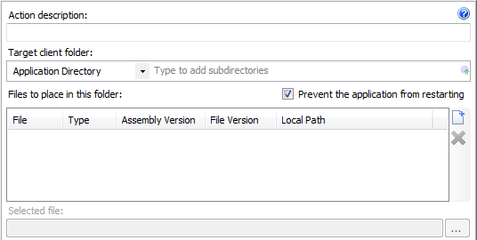
Action description – Descriptive text that can be used to identify this particular action in the Actions list.

Target client folder – The folder on the client to place files that contains the file(s) you are adding/replacing.

Subdirectories – The directory below the designated client root folder that contains the files.
Files to place in this folder – A collection of files that are to be added or replaced on the client in the defined folder. Files that are added to the list must be present for the action to be valid.

Selected file – The file path of the selected file. Paths can be modified. Paths relative to the aup project file location is supported.

Prevent the application from restarting – If the file to be replaced on restart would prevent your application from successfully restarting after the update completes, or your update will request a restart of the operating system, check this box.

See the Replace files on restart action for more details.

Create Folder Action Editor
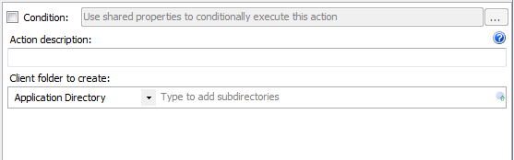
Condition – Use Shared Properties as variables to conditionally execute this action during an update.

Action description – Descriptive text that can be used to identify this particular action in the Actions list.

Target client folder – The folder on the client to create the new folder within.

Subdirectories – The directory below the designated client root folder to create a new folder. This action will create multiple folder levels in one step.

See Create Folder Action for more information.

Delete Folder Action
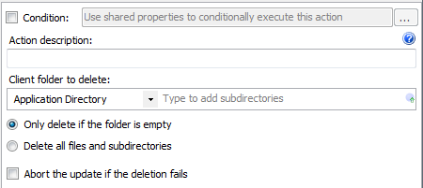

Condition – Use Shared Properties as variables to conditionally execute this action during an update.

Action description – Descriptive text that can be used to identify this particular action in the Actions list.

Target folder to delete – The folder on the client to delete during the update.

Subdirectories – The directory below the designated client root folder to delete.

Only delete if the folder is empty – When selected, the action will not delete any folder contents and will error if the designated folder is not empty.

Delete all files and subdirectories – When selected, the action will delete any content within the designated folder.

Abort the update if the deletion fails – When selected the update will fail and rollback if any deletion fails.

See Delete Folder for more information.

Copy Folder Contents Action Editor
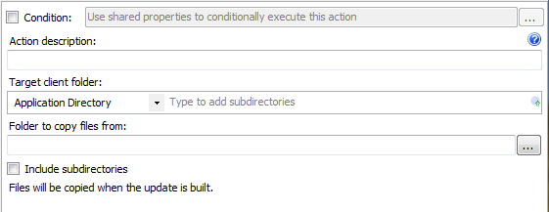

Condition – Use Shared Properties as variables to conditionally execute this action during an update.

Action description – Descriptive text that can be used to identify this particular action in the Actions list.

Target client folder – The folder on the client to copy content into.

Subdirectories – The directory below the designated client root folder to copy content into.

Folder to copy files from – The folder on the build machine from which to add files to the update.

Include subdirectories – When checked, any subdirectories within the folder to copy files from will also be included. Subdirectory folders will be created automatically on the deployed client as the action executes.

See Add Folder Contents Action for more information.

Create File Shortcut Action Editor
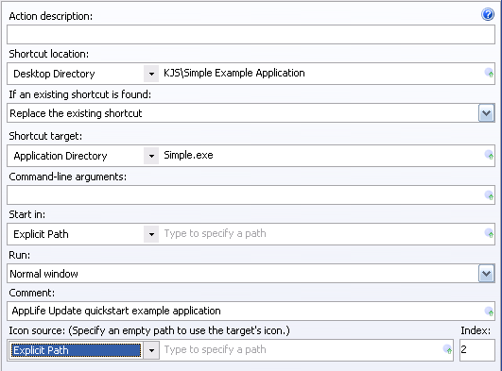
Action description – Descriptive text that can be used to identify this particular action in the Actions list.

Shortcut location – The disk location on the client to place the shortcut. This includes the name of the shortcut. Select the known folder on the client, then provide sub path and shortcut name. If this location does not end with an .lnk extension, it will be appended automatically.

If an existing shortcut is found – Identify what action should be taken if an identically named shortcut already exists in the defined location.
- Replace the existing shortcut (default)
- Skip the action and leave the existing shortcut
- Abort the update

Shortcut target – The disk location of the file that the shortcut is going to operate on. Select the known folder on the client, and then provide any sub path and the file name.

Command-line arguments – Add any arguments that are required to be passed to the shortcut target when this shortcut is executed.

Start in – Specify a path to set the start path property of the shortcut. Select the known folder on the client and specify any sub path information.

Run – Specify the mode that the target should launch in. Choices are:
- Normal window (default)
- Maximized
- Minimized

Comment – Specify the comment property of the shortcut. This value results in a shortcut tooltip.

Icon source – Specifies an assembly that contains an icon that can be displayed with the shortcut. Select the known folder on client, any sub path information, and the name of the assembly. Define the index of the icon within this assembly with the Index property. To use the default icon, set this property to Explicit Path.

Index – The index within the identified Icon source of the icon that is to be used with this shortcut.

See Create File Shortcut for more information.

Install .NET 4.0 Action Editor
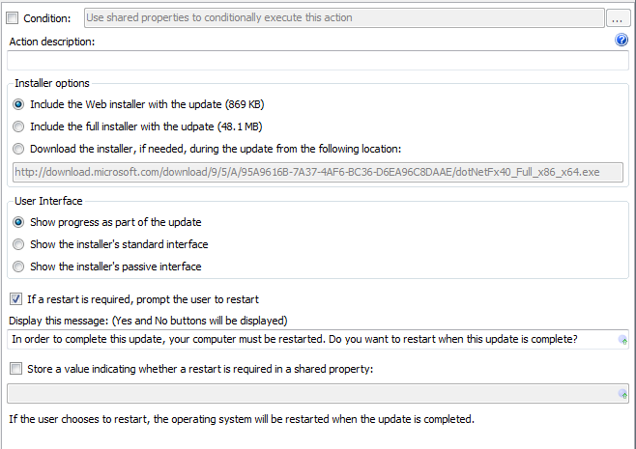

Condition – Use Shared Properties as variables to conditionally execute this action during an update.

Action description – Descriptive text that can be used to identify this particular action in the Actions list.

Installer options – Identify which installer to use. The .Net Framework can be installed using a small bootstrapping installer that downloads necessary framework components from the Microsoft site. Alternatively an installer that includes all framework components can be used.

User interface – Identifies how the AppLife Update process will interact with the user during the framework installation. The framework installer user experience can be shown, or progress can be ticked within the AppLife Update user interface.
Important – If you utilize the AppLife Update Windows Service for permissions elevation, you must use the Show progress as part of the update option. This is because the serviced update process cannot interact with the user outside of the AppLife Update user interface.

If a restart is required, prompt the user to restart – Check this option if the update process should provide the user an option to defer a system restart, if one is necessary. If this option is not checked, and a system restart is necessary, the restart will occur as the update completes.

Restart message – Customize the message displayed to a user if a restart is necessary.

Store a value indicating whether a restart is required as a Shared Property – Identify a Shared Property to indicate a restart is necessary. A Shared Property can be used to conditionally perform follow up actions, such as preventing your host application from restarting.

See Install .NET 4.0 Framework action for more information.

Install GAC Assembly Editor
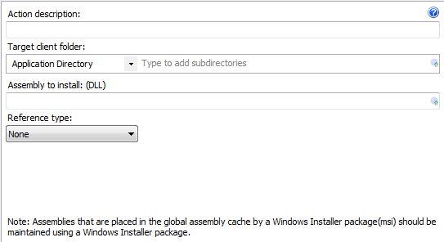
Action description – Descriptive text that can be used to identify this particular action in the Actions list.

Target client folder – The folder on the client to place the assembly for GAC registration.

Subdirectories – The directory below the designated client root folder to place the assembly.

Assembly to Install – The location on the build system where the assembly to be placed in the client GAC resides.

Reference Type – The reference counting scheme to employ in maintaining the assembly in the GAC.

Uninstall GAC Assembly Editor
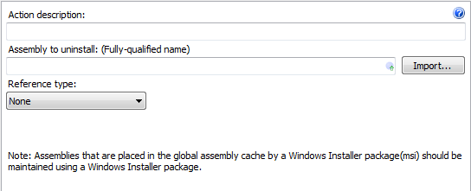
Action description – Descriptive text that can be used to identify this particular action in the Actions list.

Assembly to Install – The location on the build system where the assembly to be placed in the client GAC resides. The fully qualified assembly name is imported.

Reference Type – The reference counting scheme employed in maintaining the assembly in the GAC.

Execute Msi Action Editor
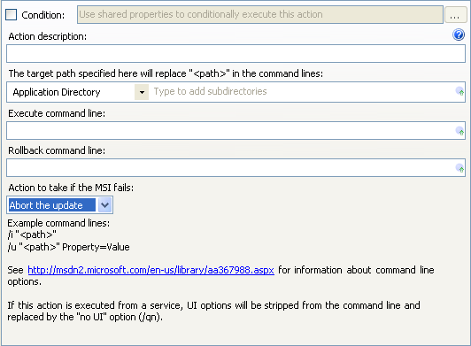
Action description – Descriptive text that can be used to identify this particular action in the Actions list.

Target client folder – The folder on the client that contains the Windows Installer(msi) to execute.

Subdirectories – The directory below the designated client root folder that contains the msi to execute.
The target client folder and subdirectory values can be substituted into the Execute and Rollback command lines using the <path> variable.

Execute command line – The msiexec.exe command line to execute during the update execute stage.

Rollback command line – The msiexec.exe command line to execute in the event of a rollback.

Action to take if the MSI fails – Determines whether to continue the update if this msi fails, or abort.

Expansion variables can be used to set the target client subdirectory property, Execute, and Rollback command lines.

See the Execute Msi action for more information.

Restart Operating System Action Editor
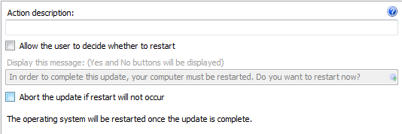
Action description – Descriptive text that can be used to identify this particular action in the Actions list.

Allow the user to decide whether to restart – When checked, this action will prompt the user with the message specified for confirmation of restart.

Display this message – Specify the optional message to display to the user.

Abort the update if restart will not occur – If the user chose not to restart the operating system, this setting determines whether the update will proceed or be aborted.

See the Restart Operating System action for more information.

Run Command Line Action Editor
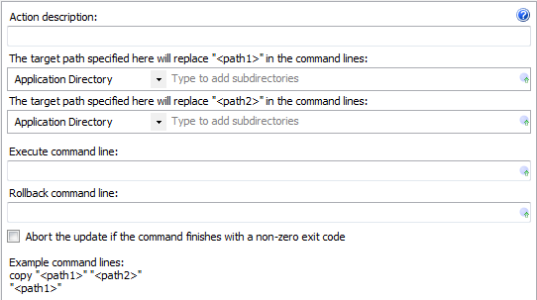

Action description – Descriptive text that can be used to identify this particular action in the Actions list.

<path1> variable – The folder on the client that is assigned to command line variable <path1>.

<path2> variable – The folder on the client that is assigned to command line variable <path2>.

The target client folder and subdirectory values can be substituted into the Execute and Rollback command lines using the <path1> and <path2> variable.

Execute command line – The command line to execute during the update execute stage.

Rollback command line – The command line to execute in the event of a rollback.

Expansion variables can be used to set the target client subdirectory property, Execute, and Rollback command lines.

See the Run Command Line action for more information.

Create Registry Key Action Editor
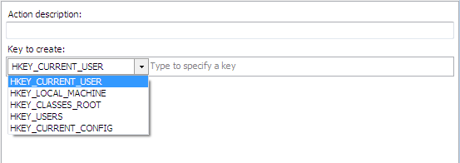

Action description – Descriptive text that can be used to identify this particular action in the Actions list.

Key to create – Defines the registry hive to create the key in. This value, combined with the specific key property locates the new key in the registry.

Type to specify a key – The sub path under the defined hive to create the key. The entire key path is created. The initial \ in the path can be omitted or not.
Ex: \MyKeys\Key1
MyKeys\Key1

Expansion variables can be used to set the key to create sub path.

See Create Registry Key for more information

Delete Registry Key Action Editor
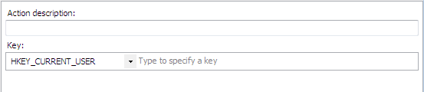

Action description – Descriptive text that can be used to identify this particular action in the Actions list.

Key – Defines the registry hive where the key is located.

Type to specify the key – The sub path under the defined hive where the key is located. The initial \ in the path can be omitted or not.
Ex: \MyKeys\Key1
MyKeys\Key1

Note: This action will not delete a key with sub keys. You must delete each sub key in the branch individually.

Expansion variables can be used to set the key sub path.

See Delete Registry Key for more information.

Delete Registry Values Action Editor
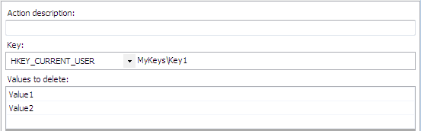

Action description – Descriptive text that can be used to identify this particular action in the Actions list.

Key – Defines the registry hive where the key is located.

Type to specify the key – The sub path under the defined hive where the key is located. The initial \ in the path can be omitted or not.
Ex: \MyKeys\Key1
MyKeys\Key1

Values to delete – A list of individual values within the key to remove. Place one value per line.

Expansion variables can be used to set the key to create sub path, and each value to delete.

See Delete Registry Values for more information.

Set Registry Values Action Editor
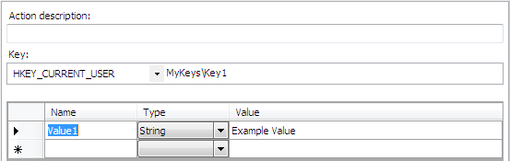

Action description – Descriptive text that can be used to identify this particular action in the Actions list.

Key – Defines the registry hive where the key is located.

Type to specify the key – The sub path under the defined hive where the key is located. The initial \ in the path can be omitted or not.
Ex: \MyKeys\Key1
MyKeys\Key1

Name – The name of the value to be set. The value will be either created or replaced.

Type – Enter the specific type of registry value that should be used.

Value – Enter the value of the registry key value. The value format is dependent on the type specified.
Binary – Binary data in any format. The value is entered in two character hexadecimal sets separated by a space. Each set represents 8 bits.
DWord – 32 bit number, entered in decimal base
Qword – 64 bit number, entered in decimal base.
Multi-String – A sequence of null terminated strings.
Expandable string - A null-terminated string that contains unexpanded references to environment variables.

Expansion variables can be used to set the key sub path, each new registry value name, and each new registry value.

See Set Registry Values for more information.

Read Registry Value Action Editor
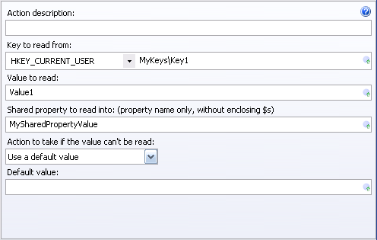

Action description – Descriptive text that can be used to identify this particular action in the Actions list.

Key – Defines the registry hive where the key is located.

Type to specify the key – The sub path under the defined hive where the key is located. The initial \ in the path can be omitted or not.
Ex: \MyKeys\Key1
MyKeys\Key1

Value to read – The value within the registry key to read.

Shared property to read into – Specify the key name of the Shared Property to place the value read. Exclude the enclosing $’s when defining the shared key name.

Action to take if the value can’t be read – You can define a default value if the registry value can’t be read, or you can choose to abort the update.

Expansion variables can be used to set the key sub path, the value to read, the Shared property key name to read into, and the default value if the key value can’t be read.

See Red Registry Value for more information.

Start Service Action Editor
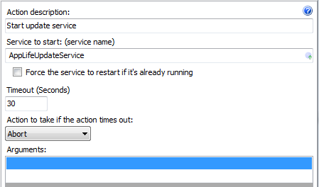

Action description – Descriptive text that can be used to identify this particular action in the Actions list.

Service to start – The name of the service. The name must be defined for this action to be valid.
You can easily locate the service name of any services on your computer by using the Computer Manager Services list. From any service, view the properties and the service name is listed.

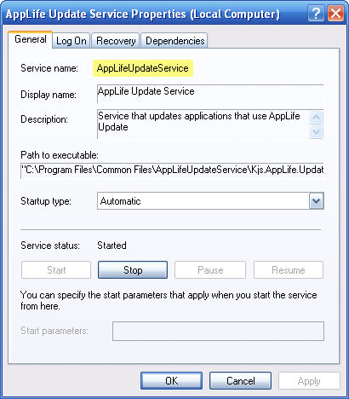

Force the service to restart if already running – When this action is executed, no action is taken if the defined service is already running. If you want to force a restart in this situation, check this box.

Timeout (Seconds) – The time in seconds the action should wait for the service to stop before aborting or continuing.

Action to take if the action times out – When the action times out, the update is either aborted or allowed to continue.

Arguments – List of arguments that are passed to the defined service when the start command is executed. Enter one argument per line.

Expansion variables can be used to set the service name of the service to start and each service argument.

See Start Service for more information.

Stop Service Action Editor
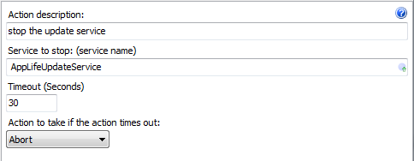

Action description – Descriptive text that can be used to identify this particular action in the Actions list.

Service to stop – The name of the service. The name must be defined for this action to be valid.

Timeout (Seconds) – The time in seconds the action should wait for the service to stop before aborting or continuing.

Action to take if the action times out – When the action times out, the update is either aborted or allowed to continue.

You can easily locate the service name of any services on your computer by using the Computer Manager Services list. From any service, view the properties and the service name is listed.

Expansion variables can be used to set the service name of the service to stop.

See Stop Service for more information.

Replace Public Key Action Editor
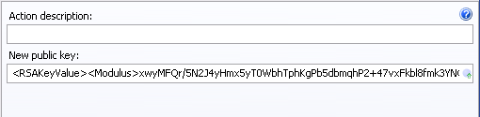
Action description – Descriptive text that can be used to identify this particular action in the Actions list.

New public key – The public key value that will replace the current public key on the client.

See Replace Public Key Action for more information.

Add Xml Attribute Action Editor
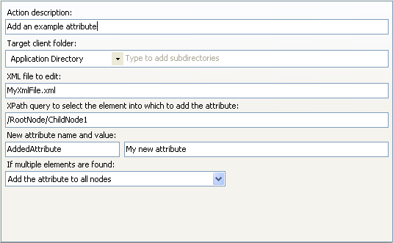

Action description – Descriptive text that can be used to identify this particular action in the Actions list.

Target client folder – The folder on the client where the xml file that is to be edited is located.

Subdirectories – The directory below the designated client root folder to find the xml file that is to be edited.

XML file to edit – The name of the xml file that is to be edited.

XPath query to select the element into which to add the attribute – Use an XPath expression to identify the node within the xml file that you want to add an attribute to.

New attribute name and value – Type the name and value of the new Xml Attribute that you want to add.

If multiple elements are found – Identify the action that you want to occur in the event that multiple xml elements are returned by your XPath expression. You can choose to:
- Add the attribute to all nodes
- Add only to the first node
- Add only to the last node
- Don’t add any attributes
- Abort the update.

Expansion variables can be used to set target client subdirectory, file name of the xml file to edit, Xpath query, attribute name, and attribute value.

See Add Attribute for more information.

Add Xml Element Action Editor
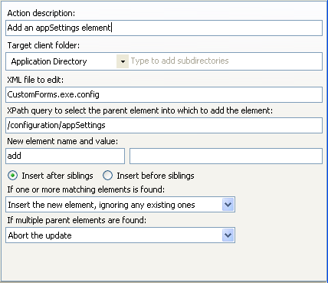

Action description – Descriptive text that can be used to identify this particular action in the Actions list.

Target client folder – The folder on the client where the xml file that is to be edited is located.

Subdirectories – The directory below the designated client root folder to find the xml file that is to be edited.

XML file to edit – The name of the xml file that is to be edited.

XPath query to select the element into which to add the attribute – Use an XPath expression to identify the node within the xml file that you want to add an element to.

New element name and value – Type the name and value of the new Xml Element that you want to add.

If one or more matching elements is found – In the event that one or more elements are found that match the element that is being added, you can choose to:
- Insert the new element, ignoring any existing ones
- Delete any existing elements and then insert the new one
- Do not insert an element
- Abort the update.

If multiple parent elements are found – Identify the action that you want to occur in the event that multiple xml elements are returned by your XPath expression. You can choose to:
- Add the element to all nodes
- Add only to the first node
- Add only to the last node
- Don’t add any elements
- Abort the update.

Expansion variables can be used to set target client subdirectory, file name of the xml file to edit, Xpath query, new element name, and new element value.

See Add Xml Element for more information.

Change Xml Node Action Editor
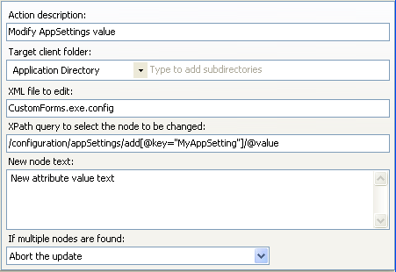

Action description – Descriptive text that can be used to identify this particular action in the Actions list.

Target client folder – The folder on the client where the xml file that is to be edited is located.

Subdirectories – The directory below the designated client root folder to find the xml file that is to be edited.

XML file to edit – The name of the xml file that is to be edited.

XPath query to select the node to be changed – Use an XPath expression to identify the node within the xml file that you want to change.

New node text – Type the new text of the Xml Node.

If multiple nodes are found – Identify the action that you want to occur in the event that multiple xml nodes are returned by your XPath expression. You can choose to:
- Change all nodes
- Change only to the first node
- Change only to the last node
- Don’t change any attributes
- Abort the update.

Expansion variables can be used to set target client subdirectory, file name of the xml file to edit, Xpath query, and new node text.

See Change Xml Node for more information.

Delete Xml Node Action Editor
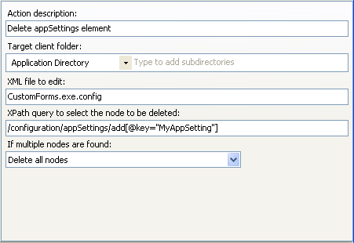

Action description – Descriptive text that can be used to identify this particular action in the Actions list.

Target client folder – The folder on the client where the xml file that is to be edited is located.

Subdirectories – The directory below the designated client root folder to find the xml file that is to be edited.

XML file to edit – The name of the xml file that is to be edited.

XPath query to select the node to be deleted – Use an XPath expression to identify the node within the xml file that you want to delete.

If multiple nodes are found – Identify the action that you want to occur in the event that multiple xml nodes are returned by your XPath expression. You can choose to:
- Delete all nodes
- Delete only to the first node
- Delete only to the last node
- Don’t delete any nodes
- Abort the update.

Expansion variables can be used to set target client subdirectory, file name of the xml file to edit, and Xpath query.

See Delete Xml Node for more information.

Read Xml Node Text Action Editor
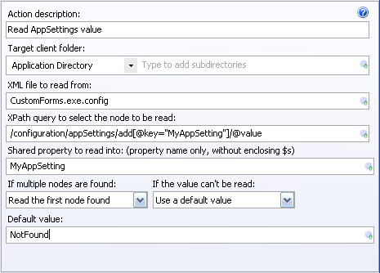

Action description – Descriptive text that can be used to identify this particular action in the Actions list.

Target client folder – The folder on the client where the xml file that is to be edited is located.

Subdirectories – The directory below the designated client root folder to find the xml file that is to be edited.

XML file to read – The name of the xml file that is to be read.

XPath query to select the node to be read – Use an XPath expression to identify the node within the xml file that you want to read.

Shared property to read into – Type the key name of the Shared Property entry that the value should be set to.

If multiple nodes are found – In the event that one or more elements are found that match the element to be read, you can choose to:
- Read the first node found
- Read the last node found
- Use a default value
- Abort the update.

If the value can’t be read – Identify the action that you want to occur in the event that the value can’t be read from the xml document. You can choose to:
- Use a default value
- Abort the update.

Expansion variables can be used to set target client subdirectory, file name of the xml file to read, Xpath query, shared property name, and default value.

See Read Xml Node for more information.

Comment Action Editor
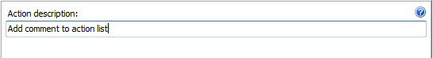
Action description – Descriptive text that can be used to comment the action list actions.

This action perform no work in an update.

Run Action List Editor
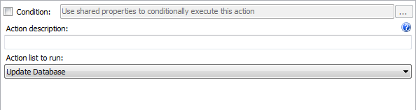
Action description – Descriptive text that can be used to comment the action list actions.

Action list to run – Defines the name of the action list within the current project to run.

See Run Action List action for more information.

Dynamic Code Action
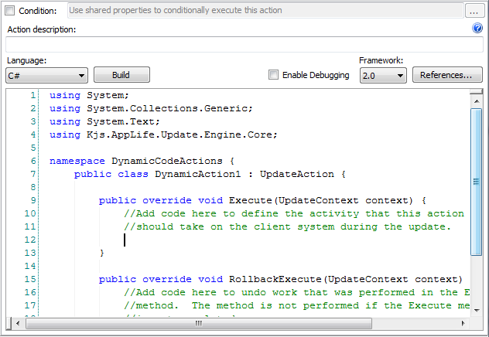
Action Description - Descriptive text that can be used to identify this particular action in the Actions list.
Language: Select C# or Visual Basic.Net (The default language can be set in the application options dialog)
Build – Test builds the source code provided.
Enable Debugging – Builds the resulting dynamic custom actions assembly in debug mode and includes debug symbols in the update. This setting is global for all Dynamic code actions in the project.
Framework- Designates the .Net Framework to target. Note: The build system must have the .Net Framework 3.5 SP1 or higher to designate a target framework.
References – Provides a dialog to reference additional .Net assemblies for use in the dynamic action source code.

The Dynamic Code Action provides the ability to create custom update activity using .Net source code. The defined source code is compiled and packaged into the update as Make Update builds the update.
Through the UpdateContext object, the Shared Properties collection can be manipulated within a Dynamic Code Action.

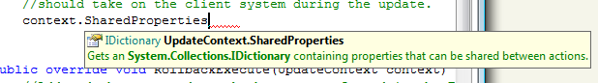

Shared Properties can be used in other actions as well as within Action Conditional expressions.

Progress and textual information can be sent to the Update Engine user interface for user presentation by using the OnProgressChanged method from within an update action method body.
OnProgressChanged(new UpdateProgressChangedEventArgs(10, "Dynamic code action progress comments"));

See the AppLife Update API Documentation content for Kjs.AppLife.Update.Engine.Core UpdateAction class for more detailed technical information. The API documentation can be accessed from the Help menu within Make Update.

Prevent Application Restart Action Editor
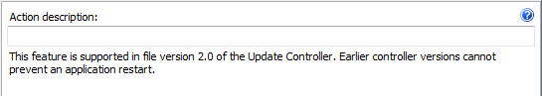
Action Description - Descriptive text that can be used to identify this particular action in the Actions list.

This action will prevent the host application from restarting after the update completes, regardless of the restart behavior specified by the Update Controller configuration.

Begin Transaction Action Editor
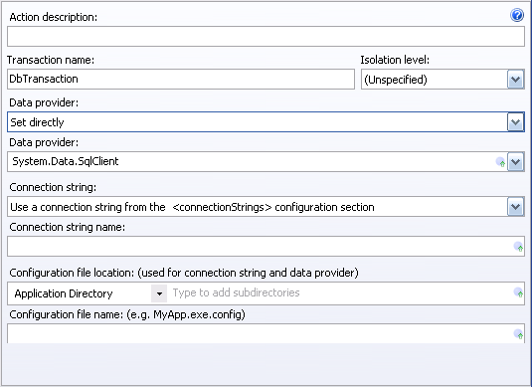

Action Description - Descriptive text that can be used to identify this particular action in the Actions list.

Transaction Name – Name of the transaction that is started by this action. Use this name to configure the other database actions to use the transacted begun by this action.

Isolation Level – Configure the appropriate database isolation level for this transaction. Choices include Chaos, Read Committed, Read Uncommitted, Repeatable Read, Serializable, Snapshot.

Data Provider – You can set the data provider of this transaction directly, read the provider from configuration appSettings, or read from configuration connectionStrings. Any data provider can be set. The data provider must already be installed on the target client systems.

Connection String – You can set the connection string for this transaction directly, read the connection string from configuration appSettings, or read from configuration connectionStrings.

Configuration file location – If either the data provider or the connection string is to be read from a configuration file, you define the location of the config file. Pick the client folder and define the required sub-path.

Configuration file name – The name of the configuration file to use.

Expansion variables can be used to set the Data Provider, Connection String, Configuration file sub path, and Configuration Name.

See Begin Database Transaction for more information

Commit Transaction Action Editor
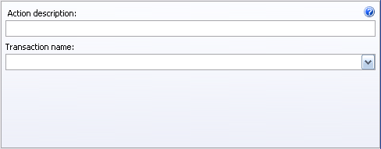
Action Description - Descriptive text that can be used to identify this particular action in the Actions list.

Transaction Name – Name of the transaction that is committed by this action. This name should match the name defined on the corresponding Begin Database Transaction Action.

See Commit Database Transaction for more information.

Transacted Query Action Editor
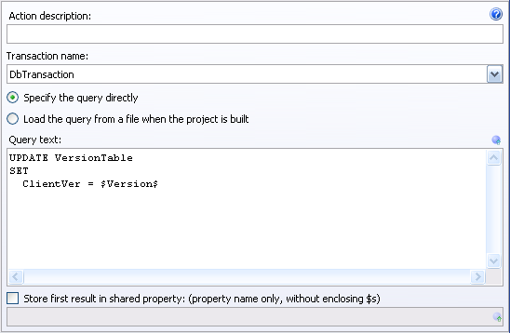

Action Description - Descriptive text that can be used to identify this particular action in the Actions list.

Transaction Name – Name of the transaction that this action should use. This name should match the name defined on the corresponding Begin Database Transaction Action.

Specify the query directly – Allows you to directly enter the query text to be executed on the database.

Load the query from a file when the project is built – Reads the query text from a designated file during the update build process.

Store first result in shared property – Allows you to read information from a database and share the information with other actions through Shared Properties and expansion variables.

Expansion variables can be used to set the Query Text and when defining a shared property name to store the first result in.

Transacted Stored Procedure Action Editor
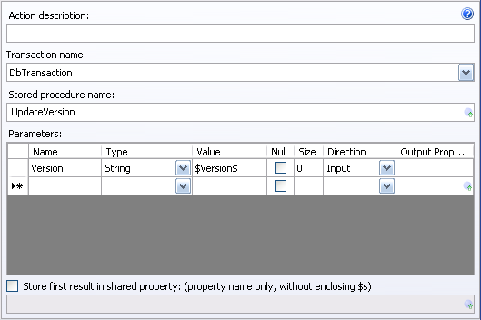

Action Description - Descriptive text that can be used to identify this particular action in the Actions list.

Transaction Name – Name of the transaction that this action should use. This name should match the name defined on the corresponding Begin Database Transaction Action.

Stored Procedure Name – Enter the name of the Stored Procedure that this action should execute.

Parameters Collection
Define the stored procedures parameters by adding rows to the parameters grid.
- Name Column
Enter the name of the parameter
- Type
Select the parameter type
- Value
Enter the value of the parameter
- Null
Check to indicate the parameter is null
- Size
The size of the parameter
- Direction
Define the direction of the parameter
- Output Property
A Shared Property key to copy the parameter value to upon execution completion.

Store first result in shared property – Allows you to read information from a database and share the information with other actions through Shared Properties and expansion variables.

Expansion variables can be used to set the stored procedure name, parameter names, parameter values, and parameter output properties.

See Transacted Stored Procedure for more information.

Backup SQL Server Database Action Editor
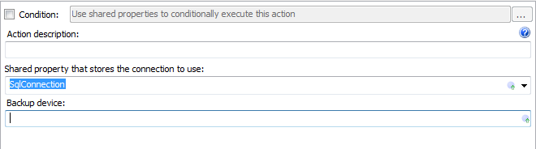
Action Description - Descriptive text that can be used to identify this particular action in the Actions list.

Connection to use – The key name of the SQL Connection to use, as defined in.

See Backup SQL Server Database for more information.

Begin SQL Server Transaction Action Editor
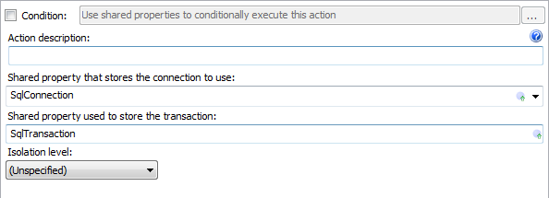

Action Description - Descriptive text that can be used to identify this particular action in the Actions list.

Store the transaction – Defines the Shared Property key value that will hold this transaction.

Isolation level – Choose the SQL Transaction isolation level that this transaction will use.

See Begin SQL Server Transaction Action for more information.

Close SQL Server Connection Action Editor
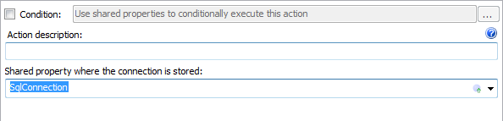
Action Description - Descriptive text that can be used to identify this particular action in the Actions list.

Connection Shared Property Key – The connection to close.

See Close SQL Server Connection Action for more information.

Commit SQL Server Transaction Action Editor
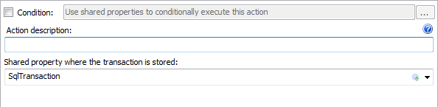
Action Description - Descriptive text that can be used to identify this particular action in the Actions list.

Transaction Shared Property Key – The transaction to commit.

See Commit SQL Server Transaction Action for more information.

Open SQL Server Connection Action Editor
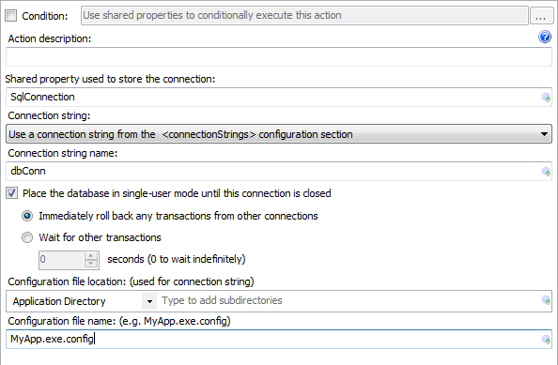
Action Description - Descriptive text that can be used to identify this particular action in the Actions list.

Shared property to store the connection – The key value used to when the new connection is placed into the Update Context Shared Properties collection. This is the key used by other actions in the update to access this connection.

Connection string – Select to define the connection string using a config file Connection Strings collection, a config file appSettings element, or by setting directly.

Connection string name / Connection string – The key value used to look up the connection string, or the string value of the connection string. When setting directly, other shared property values are typically used. Shared properties can be expanded by using the $ notation. (e.g. $MyConnStr$)

Place the database in single-user mode – When checked, the database connection is opened for exclusive access. Any pending database transactions can be cancelled immediately, or the connection will wait for a specified period of time for all ongoing transactions to close.

Configuration file location – Identify the path and name of the config file that holds your connection string information. This information is only necessary when configured to retrieve a connection string from the Connection Strings or appSetttings area of a config file.

See Open SQL Server Connection action for more information.

Run SQL Server Query Action Editor
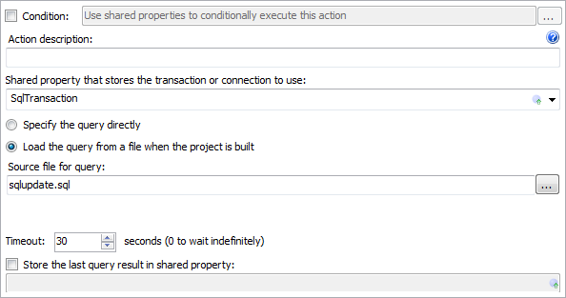
Action Description - Descriptive text that can be used to identify this particular action in the Actions list.

Shared property key – The Shared Property key of either a SQL Connection or SQL Transaction object that will be used to run the SQL query.

Query – The SQL query can be defined directly or by specifying a sql file. If a sql file is used, the file must be present on the build machine, at the time that an update is created. If a direct value is used, the sql text can be entered directly, or specified using a Shared Property. If a shared property is used, the value must contain the SQL text.

Timeout – Specifies the time to wait for the query to complete.

Store the last query result in a shared property – When checked, the output of the last sql statement will be added to the Update Context Shared Properties collection using the key value specified.

See the Run SQL Server Query Action for more information.

Set Shared Property Action Editor
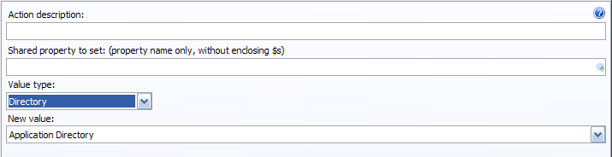

Action Description - Descriptive text that can be used to identify this particular action in the Actions list.

Shared property to set – The key name of the Shared Property that this action will set the value of.

Value type – Defines the type of value to set the shared property to.
- Text – Allows you to type the string value of the shared property in the New Value textbox
- Blank – Sets the value of the defined shared property to an empty string
- Update Version – Sets the value of the shared property to the Update Version value of this update
- Directory – Lets you choose from a list of directory paths to set into the defined shared property. This list includes among others, the Application Directory.
- Processor type – Sets the value to either “32” or “64”, based on the whether the operating system is 32 or 64 bit.

New Value – The value to set the Shared Property to.

Expansion variables can be used to set the Shared Property name and the New value property.

See Set Shared Property for more information.

Missing Action Place Holder
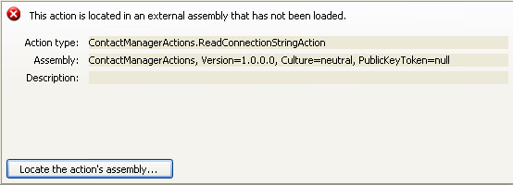

The placeholder maintains the state information of a custom action that is missing. Once the missing assembly is located, the action will be refreshed.

Action type – Displays the name of the missing action type.

Assembly – Displays the Assembly Name of the missing assembly.

To manually locate the missing assembly, click the Locate the action’s assembly… button. You can browse to the location of the assembly.

License Form
The license form allows you to enter your purchased license number. AppLife Update will operate in trial mode for 30 days after installation, after which the build functions will cease to operate until the software is properly licensed.

Your current license number is displayed on this form.

You can purchase a license by clicking on the “Get a license number” button.

To enter or replace a license number, type or paste your license number into the New license number text box and click OK.

See License Management for more information..

Options Form

Preferences
Reset “Don’t show this information again” help dialogs
Clears all help dialogs and displays them again when appropriate.

Clear recent files menu
Clears the list of recent projects from both the start page and the file menu.

Always warn before rebuilding an existing update
Check this box if you always want to be warned before building an update over an existing update. If unchecked, you can re-build the highest version number for 24 hours past its original build time without being warned. are only warned before re-building the highest version 24 hours after its previous build time.

Check for updates at startup
When checked, AppLife Make Update will check for available updates for AppLife Update.

Automatically re-open the last project at startup
When checked, Make Update will store the location of the most recently opened project file and attempt to re-open the project as the Make Update application is launched.

Default language for dynamic actions
The Dynamic Action update action that is located in the Update actions palette provides functionality to use C# or Visual Base.net to create customized updating activity. Set this value to specify the default language for this action.

Proxy
Automatically detect proxy settings – Check this box to configure Make Update to automatically detect proxy settings and use those settings to publish update projects.
Note: Ftp publishing through an http proxy server is not supported. In this scenario, you must use http publishing or bypass your proxy server for ftp.

Proxy address – Manually set the address of your proxy server here. The address is expecting a fully qualified URI identifying the location of your proxy.
Ex: http://kjsproxy.kineticjump.com:8080/

Check the Bypass proxy server for local addresses box to ignore the proxy setting for local addresses.

Check the Use default credentials to send the credentials that you are currently logged in under to the proxy server for authentication when publishing updates.

To set proxy specific credentials to the proxy server, uncheck the Use default credentials box and enter a user name, password and domain into the appropriate text boxes.

Spelling
Enable / disable spell checking by setting the checkbox.
Add words to the custom dictionary by typing into the textbox and clicking on the Add command.
Remove words from the custom dictionary by selecting the word to remove and clicking the Remove command.

