Metadata Searcher Program

User Manual

Contents

Introduction 2

Features 2

System Requirements 2

Software Requirements 2

Starting the Metadata Searcher 2

Using the Metadata Searcher 3

The GUI 3

1. Reset Button 3

2. Sort by Field type 3

3. Ascending or Descending order of search and sort results 4

4. Search by Field type, against one or more values 4

5. Multi-field dynamic filtering of displayed search results 5

6. Tabular display of file metadata 6

# Introduction

The Metadata Searcher program is companion software for our Metadata Harvester program. Together, these two tools provide a user with a view of all files and their metadata in a specified directory of their filesystem.

The Searcher program provides an interactive GUI that enables the searching and sorting of displayed data, and multiple ways to perform those operations.

The Searcher program takes the csv-formatted output of its partner Harvester program as input.

## Features

* Display files and their metadata in a tabular format
* Sort metadata by specified fields
* Search for files by specified metadata fields
* Search for file records against one or more attributes

## System Requirements

* Processor: Intel Pentium 4 1.3GHz / AMD Athlon XP 1600+
* Graphics: AMD Radeon x1270 or NVIDIA GeForce4 MX 420
* Memory: 512 MB RAM
* Storage: 500MB Hard Drive Space

## Software Requirements

* Operating System: Linux
* Python 3.7.3 or higher
  + External Python Libraries Required: PyQt5

# Starting the Metadata Searcher

The Metadata Searcher is invoked via the CLI. An example execution is below:



All that is required to invoke the Searcher program is the name of the searcher script itself, ‘mdsearch.py’, and the path to the CSV file output by the metadata harvester program.

# Using the Metadata Searcher

## The GUI

### Reset Button



At anytime during use the user may press this button to return the display (6) back to its original state at program start-up

### Sort by Field type

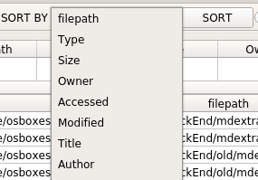

Can sort the displayed data according to a selected metadata field, in ascending or descending order by selecting a field, choosing an order, (ASCENDING or DESCENDING), then hitting the SORT button

### Ascending or Descending order of search and sort results



Displayed file metadata records can be displayed in ascending or descending order. These radio buttons influence the output of the SORT BY (2) and SEARCH BY (4) functions

### Search by Field type, against one or more values



This Search allows for the user to search for file records that hold one or more values in a specified metadata field. The text input field can take one or more arguments, with multiple arguments separated by either the AND or OR operators. Examples with expected results are below:

Upon hitting enter, or clicking the SEARCH button, the searcher will list all file records where the type contains the string, ‘pdf’

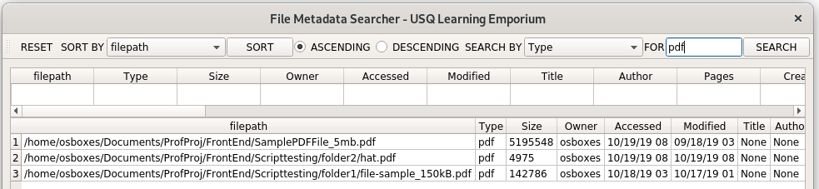

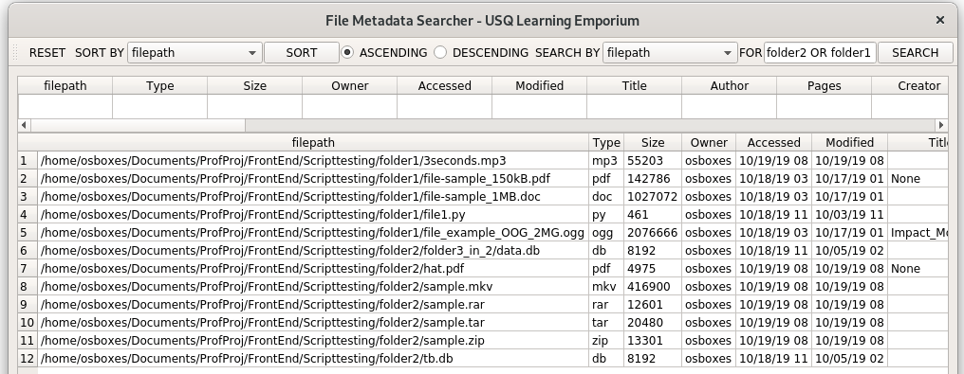

Returns all file records where the filepath contains both folder2 OR folder1, that is, the metadata for all files in either folder1 or folder2. NOTE: will also return files which have folder1 or folder2 in the filename.

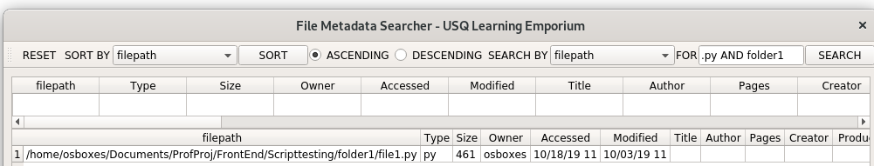

Returns all file records where the filepath contains both ‘.py’ and folder1. In other words, returns all python script files in folder 1. ***To search for empty values, one can do so using the ‘NULL’ keyword***.

Valid input by the user for the search by function must follow these guidelines:

* There must be at least one value supplied
* Where more than one value is supplied, between each value there must either be an AND or an OR operator

If the user attempts to use the search by function with invalid input, an error dialog will appear on the screen like so:

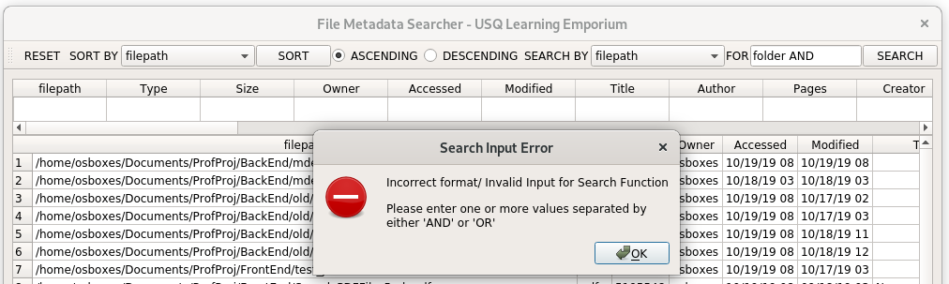

### Multi-field dynamic filtering of displayed search results



Above the main display, there is a single row with columns representing each metadata type encountered in the csv file used by the searcher program. The user can use the cells under each column header to search for records that match multiple field: value pairs at once. On hitting enter or placing another cell into focus, the program will search for records that have fields containing values that match the input provided by the user. See example of usage below:

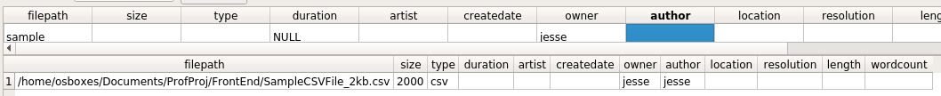

So based of the user input into the cells of the dynamic filter, the program will return all file records that have ‘sample’ within the filepath attribute and an empty duration, with an owner attribute containing ‘jesse’

### Tabular display of file metadata

File records and their metadata attributes are displayed in a tabular layout. It is possible to sort the table by simply clicking on a column header, which will sort the file records by the metadata attribute the header corresponds to, alternating between ascending and descending order each click.

It is also possible to open files by double clinking on the filepath under the filepath header.