**1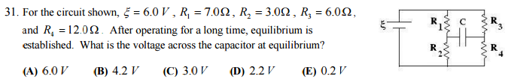2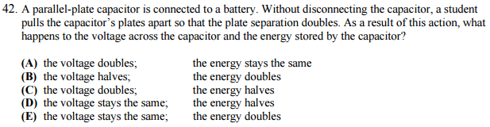3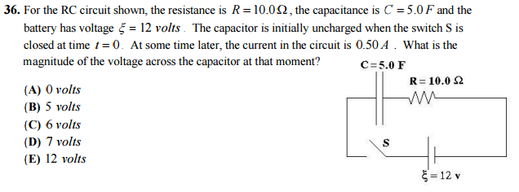4**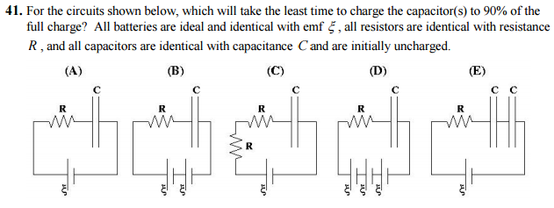

**5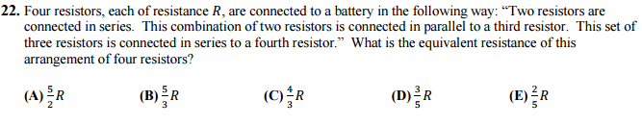6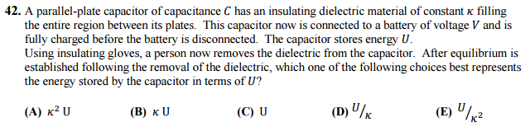7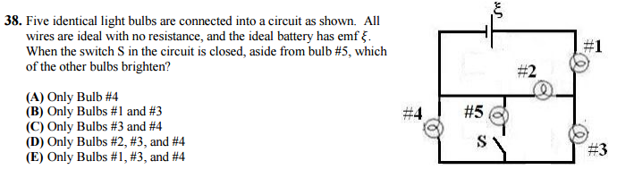8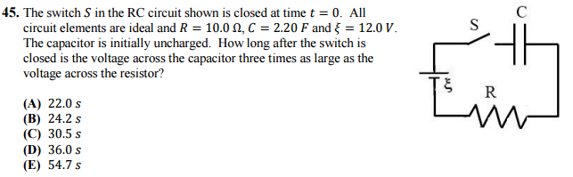9**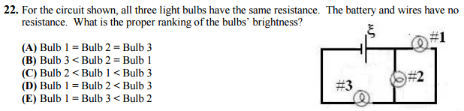

**10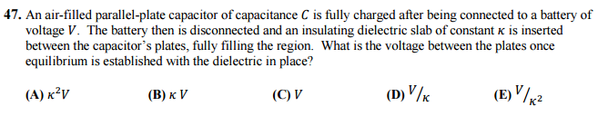11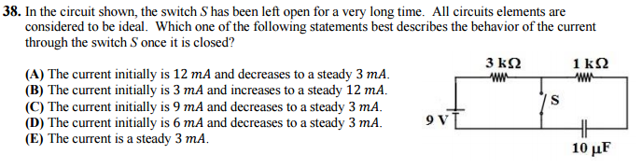12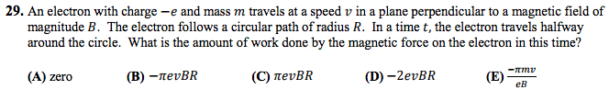13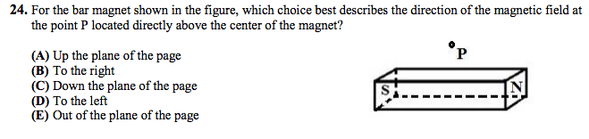14**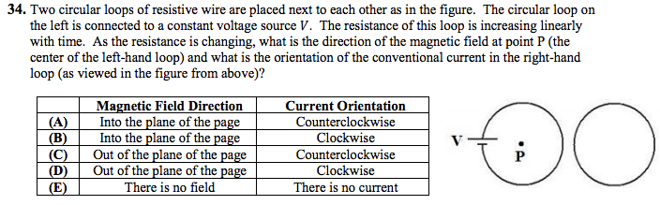

**15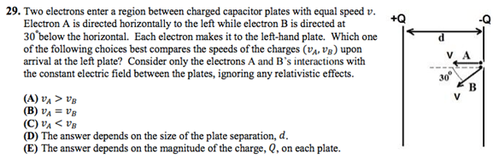16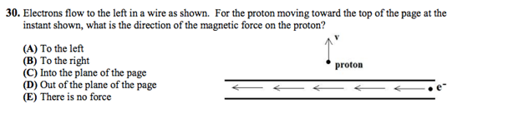17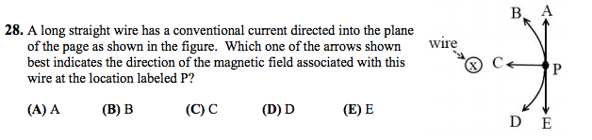18**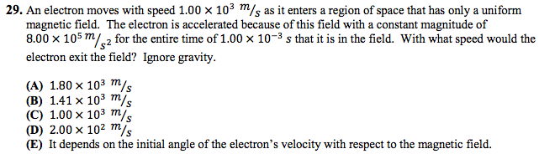

**19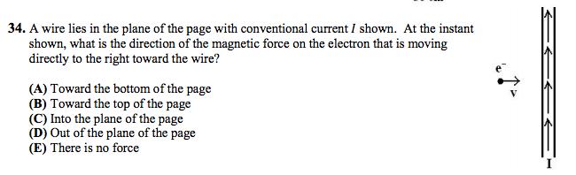20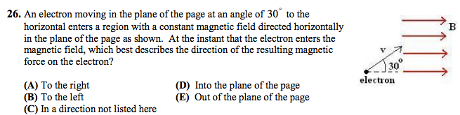21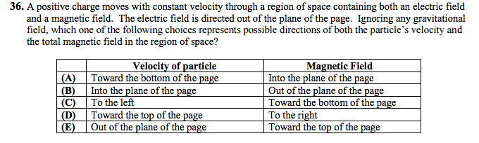22**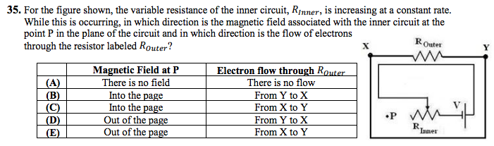

**23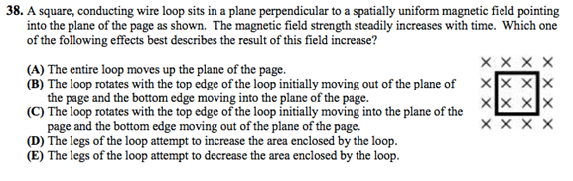24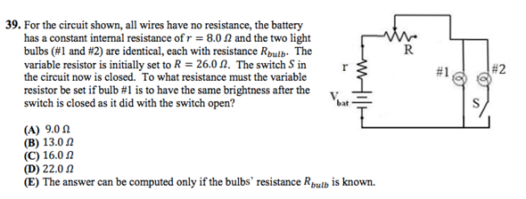25**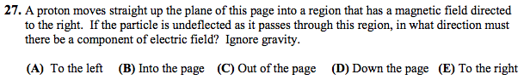

**26**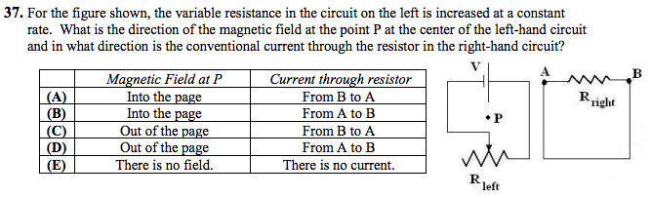

**27**

2007 Q27.

A junior Thomas Edison wants to make a brighter light bulb. He decides to modify the filament. How should the filament of a light bulb be modified in order to make the light bulb produce more light at a given voltage?

(a) Increase the resistivity only.

(b) Increase the diameter only.

(c) Decrease the diameter only.

(d) Decrease the diameter and increase the resistivity.

(e) Increase the length only.

**28**

2007 Q28.

Which statement about a system of point charges that are fixed in space is necessarily true?

(a) If the potential energy of the system is negative, net positive work by an external agent is required to take the charges in the system back to infinity.

(b) If the potential energy of the system is positive, net positive work is required to bring any new charge not part of the system in from infinity to its final resting location.

(c) If the potential energy of the system is zero, no negative charges are in the configuration.

(d) If the potential energy of the system is negative, net positive work by an external agent was required to assemble the system of charges.

(e) If the potential energy of the system is zero, then there is no electric force anywhere in space on any other charged particle not part of the system.

**29**

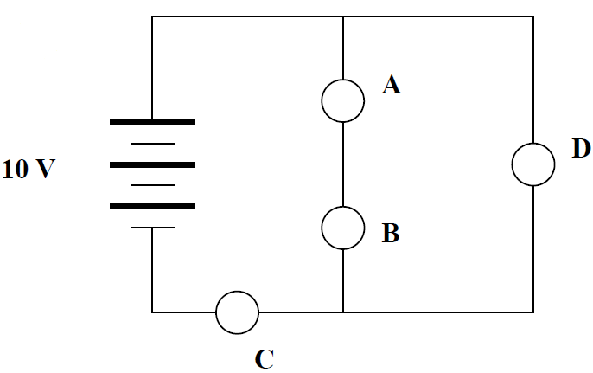2007 Q29.

In the circuit diagram below, all of the bulbs are identical. Which bulb will be the brightest?

(a) A

(b) B

(c) C

(d) D

(e) The bulbs all have the same brightness.

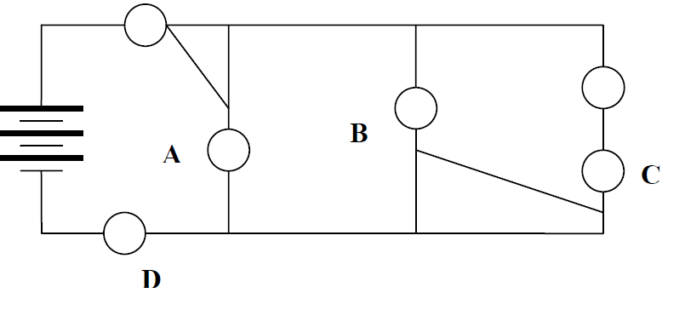**30**

2007 Q30.

In the following circuit diagram, which one of the bulbs will not light?

(a) A

(b) B

(c) C

(d) D

(e) They all light.

**31**

2007 Q33.

For the circuit shown, the ammeter reading is initially *I.* The switch in the circuit then is closed. Consequently:

(a) The ammeter reading decreases.

(b) The potential difference between *E* and *F* increases.

(c) The potential difference between *E* and *F* stays the same.

(d) Bulb #3 lights up more brightly.

(e) The power supplied by the battery decreases.

**32**

2009 Q26.

For the circuit shown, when a shorting wire (no resistance) connects the points labeled A and B, which of the numbered light bulbs become brighter? Assume that all four bulbs are identical and

have resistance *R*.

(A) Bulb 1 only

(B) Bulb 2 only

(C) Bulb 3 only

(D) Bulbs 1 and 3 only

(E) Bulbs 1, 2, and 3

**33**

2010 Q27.

The circuit shown contains a battery (of emf Vbat) with an internal

resistance *r* connected to a rheostat (variable resistor). When the

resistance of the rheostat is increased, which of the following

statements is true?

(A) The terminal voltage (*Va* – *Vb*) increases.

(B) The current through the ammeter in the circuit increases.

(C) The power associated with the internal resistance increases.

(D) The potential difference across the rheostat decreases.

(E) None of the above statements is true.

**34**

2011 Q38.

For the circuit shown, the four light bulbs have identical resistance, all wires have zero resistance, and the battery is assumed to be ideal with emf K. When the switch, S, in the circuit is closed, a wire of zero resistance is added into the circuit. Which of the light bulbs will

be dimmer after the switch is closed?

(A) Only bulb #2

(B) Only bulb #4

(C) Only bulbs #1 and #4

(D) Only bulbs #2, and #4

(E) Only bulbs #1, #2, and #4

**35**

2011 Q46.

A hollow conducting sphere in static equilibrium is isolated in deep space with a net excess charge +Q on it. What is the electric potential (assuming V (r → ∞) = 0) at the position labeled P shown in the interior of the figure?

The sphere has radius R = 3a and the point of interest is at a location r = 2a from the center of the sphere at an angle of 60° with respect to the +x-axis.

(A) 0

(B) kQ / 2a

(C) kQ / 3a

(D) kQ / 4a

(E) √3kQ / 4a

**36**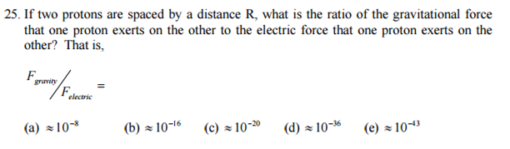

**37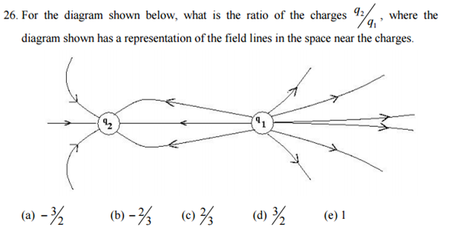38**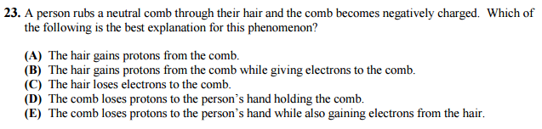

**39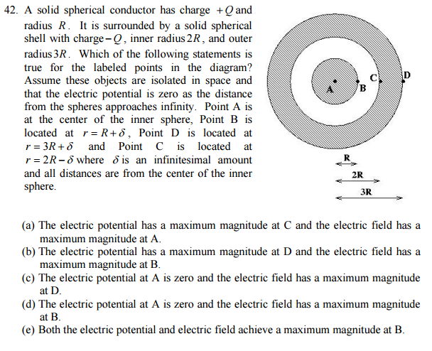Questions 41 - 42 deal with the following diagram.**

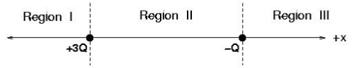

**40**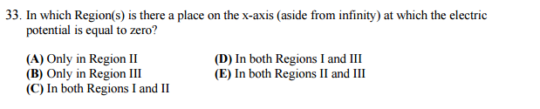

**41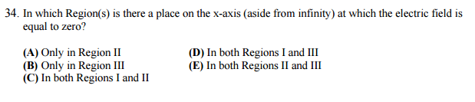42**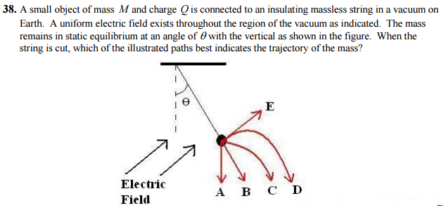

**43**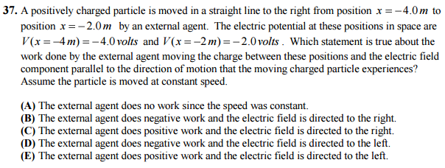

**44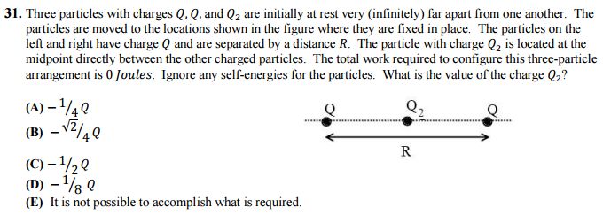45**

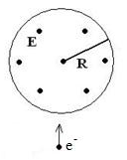2012 - Q50

50. A spatially uniform electric field is constrained within the circular region of radius R as shown. The field is directed out of the plane of the page and its strength is decreasing uniformly with time. Which one of the following choices best represents the direction of the Lorentz force on the electron at the instant shown in the figure when the electron is moving up the plane of the page? Ignore gravity.

(A) No Force

(B) Into the plane of the page

(C) Out of the plane of the page

(D) To the right

(E) To the left

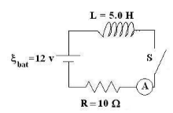**46**

2010 - Q45

45. For the ideal RL circuit shown, the resistance is R = 10.0Ω, the inductance is L = 5.0H and the battery has voltage ξbat = 12 volts. Some time after the switch S in the circuit is closed, the ammeter in the circuit reads 0.40 A . At what rate is energy being stored by the inductor at this instant (in Watts)?

(A) 0.40

(B) 1.0

(C) 2.0

(D) 3.2

(E) 4.8

**47**

2009 - Q44

44. In an ideal LC circuit, what is the time difference between all of the energy in the circuit being stored in the inductor and all of the energy being stored in the capacitor?

(A) No time difference

(B) One-eighth of a period of oscillation

(C) One-quarter of a period of oscillation

(D) One-half of a period of oscillation

(E) After one full period of oscillation has passed

**48**

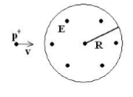2009 - Q47

47. A spatially uniform electric field is constrained within the circular region of radius R as shown. The field is directed out of the plane of the page and its strength is increasing uniformly in time. What is the direction of the force on the proton in the figure if the proton is moving to the right at the instant shown? Ignore gravity.

(A) No Force

(B) Up

(C) Down

(D) Out of the page

(E) Into the page

**49**

2009 - Q41

41. For the circuits shown below, which will take the least time to charge the capacitor(s) to 90% of the full charge? All batteries are ideal and identical with emf ξ , all resistors are identical with resistance R , and all capacitors are identical with capacitance C and are initially uncharged.

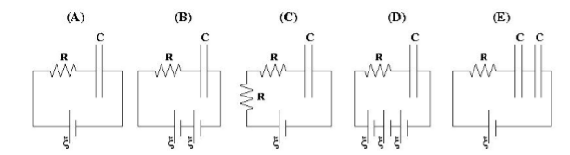

**50**

2008 - Q49

49. A circuit consists of a resistor, capacitor, and inductor connected in series to an AC source. As the source frequency increases, the current in the circuit decreases. Which statement about the circuit is NOT correct as the source frequency increases?

(A) The impedance of the circuit increases.

(B) The circuit is said to become more capacitive than inductive.

(C) The phase angle for the circuit becomes more positive.

(D) The inductive reactance increases.

(E) The total power from the source decreases.

**51**

2008 - Q50

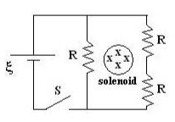50. An infinitely long solenoid passes through the circuit as shown. The magnetic field of the solenoid, directed into the plane of the page, is weakening which produces a constant emf of magnitude ξ for a closed loop around the outside of the solenoid. Once equilibrium is established in this circuit, what is the voltage across the switch S ?

(A) 0

(B) (1/3)ξ

(C) (2/3)ξ

(D) ξ

(E)( 4/3)ξ

**52**

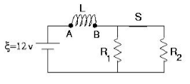2008 - Q41

41. The circuit shown has been operating for a long time. The instant after the switch in the circuit labeled S is opened, what is the voltage across the inductor VL and which labeled point (A or B) of the inductor is at a higher potential? Take R1 = 4.0 Ω, R2 = 8.0Ω, and L = 2.5 H.

(A) VL = 30 V; Points A and B are at equal potentials.

(B) VL = 12 V; Point A is at the higher potential.

(C) VL = 12 V; Point B is at the higher potential.

(D) VL = 6 V; Point A is at the higher potential.

(E) VL = 6 V; Point B is at the higher potential.

**53**

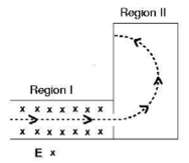2008 - Q36

36. An electron moves in the plane of the page through two regions of space along the dotted-line trajectory shown in the figure. There is a uniform electric field in Region I directed into the plane of the page (as shown). There is no electric field in Region II. What is a necessary direction of the magnetic field in regions I and II? Ignore gravitational forces.

|  |  |  |
| --- | --- | --- |
|  | Region I | Region II |
| (A) | Down the plane of the page | Up the plane of the page |
| (B) | Up the plane of the page | Into the plane of the page |
| (C) | Up the plane of the page | Out of the plane of the page |
| (D) | Down the plane of the page | Out of the plane of the page |
| (E) | Into the plane of the page | Up the plane of the page |

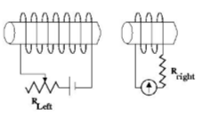**54**

2007 - Q34

34. For the solenoids shown in the diagram (which are assumed to be close to each other), the resistance of the left-hand circuit is slowly increased. In which direction does the galvanometer needle in the right-hand circuit move in response to this change?

(a) The needle deflects to the left.

(b) The needle deflects to the right.

(c) The needle oscillates back and forth.

(d) The needle rotates in counter clockwise circles.

(e) The needle never moves.

**55**

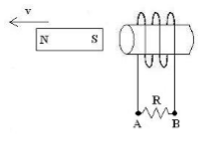2008 - Q29

29. A strong bar magnet is held very close to the opening of a solenoid as shown in the diagram. As the magnet is moved away from the solenoid at constant speed, what is the direction of conventional current through the resistor shown and what is the direction of the force on the magnet because of the induced current?

|  |  |  |
| --- | --- | --- |
|  | Current through resistor | Force on Magnet |
| (A) | From A to B | To the left |
| (B) | From B to A | To the left |
| (C) | From A to B | To the right |
| (D) | From B to A | To the right |
| (E) | No current | To the right |

**56**

2015 - Q29

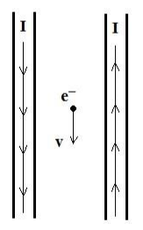29. An electron moves at constant non-zero velocity directly between two long straight wires. The conventional current in each wire has the same magnitude, but the currents are in opposite directions as shown in the figure. Ignoring gravity, which choice best reflects the direction of the magnetic field and the direction of the electric field that exist at the location of the electron? Any electric field in the region originates from an unseen external source.

|  |  |  |
| --- | --- | --- |
|  | Electric Field | Magnetic Field |
| (A) | No field | No field |
| (B) | To the left | Into the plane of the page |
| (C) | To the right | Into the plane of the page |
| (D) | To the left | Out of the plane of the page |
| (E) | To the right | Out of the plane of the page |

**57**

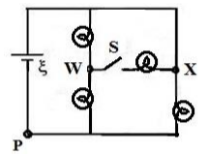2015 - Q39

39. For the circuit shown, the four light bulbs have identical resistance, the battery is ideal and all wires have no resistance. After the switch, S, in the circuit is closed, which one of the following choices correctly describes what happens to the magnitude of the current at the point labeled P and to the magnitude of the potential difference from W to X?

|  |  |  |
| --- | --- | --- |
|  | Current at P | ∆𝑽𝑿𝑾 |
| (A) | No change | Increases |
| (B) | Decreases | Increases |
| (C) | Increases | Increases |
| (D) | Decreases | Decreases |
| (E) | Increases | Decreases |

**58**

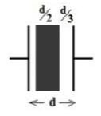2015 - Q45

45. A 6.00 𝜇𝐹 parallel-plate capacitor is disconnected from a 12 volt battery after being fully charged. A person now carefully inserts a dielectric material of constant 𝜅 = 2 so that it fills one-half of the space between the plates as shown. How much work was done by the person while inserting the dielectric?

(A) −81 𝜇𝐽 (B) −108 𝜇𝐽 (C) −144 𝜇𝐽 (D) −216 𝜇𝐽 (E) −288 𝜇𝐽

**59**

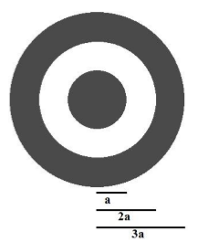2015 - Q48

48. Two concentric charged conducting shells are in free space. The outer shell has inner radius 2𝑎 and outer radius 3𝑎. The inner shell has radius 𝑎. It is known that the electric potential at 𝑟 = 3𝑎 is 𝑉3𝑎 = 𝑘𝑄⁄3𝑎. If the electric potential 𝑉𝑎 at 𝑟 = 𝑎 is 0 volts, what is the charge on the inner spherical shell, 𝑄𝑖𝑛?

(A) 𝑄𝑖𝑛 = −(3⁄2)𝑄

(B) 𝑄𝑖𝑛 = −(2/3)𝑄

(C) 𝑄𝑖𝑛 = −(1/3)𝑄

(D) 𝑄𝑖𝑛 = −2𝑄

(E) 𝑄𝑖𝑛 = −(1/2)𝑄

**60**

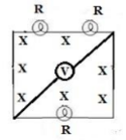2015 - Q50

50. A magnetic field directed into the plane of the page is decreasing in time. A constant emf 𝜉 is produced for the square loop enclosing the field in the figure. The square loop has three identical light bulbs of resistance 𝑅 in it and an ideal voltmeter connected to the corners through the center of the loop. What is the magnitude of the voltmeter’s reading?

(A) 0 𝜉

(B) (1/2) 𝜉

(C) (1/3) 𝜉

(D) (1/6) 𝜉

(E) (2/3) 𝜉