2009 Q 21

1. A 20 0. kg box remains at rest on a horizontal surface while a person pushes directly to the right on the box with a force of 60 N . The coefficient of kinetic friction between the box and the surface is µk = 20.0 . The coefficient of static friction between the box and the surface is µs = 60.0 . What is the magnitude of the force of friction acting on the box during the push?

(A) 200 N

(B) 120 N

(C) 60 N

(D) 40 N

(E) 0 N

2009 Q31

2. A car moves to the right along a one-dimensional track for total time T in two parts.

• Part One: The car maintains constant non-zero speed V for the first ¾ of the total time.

• Part Two: The car accelerates uniformly to rest during the last ¼ of the total time.

What is the ratio of the distance traveled during Part One of the trip to the distance traveled during Part Two of the trip?

(A) 1:6

(B) 3:2

(C) The values of V and T are required to answer the question.

(D) 3:4

(E) 3:8

2010 Q24

3. By computing the area under the acceleration vs. time graph for a fixed time interval of an object’s motion, what quantity has been determined for that object?

(A) The average velocity during the time interval

(B) The velocity at the end of the time interval

(C) The average speed during the time interval

(D) The change in velocity during the time interval

(E) The velocity at the time midway through the time interval

2010 Q25

4. Two point objects are launched straight upward with identical linear momentum. Object 1 has mass M and reaches a maximum height H above the launch point. If object 2 has mass 2M , what is its maximum attained height above the launch point in terms of H ?

(A) H/4

(B) H/2

(C) H

(D) 2H

(E) 4H

2010 Q29

5. A ball initially at rest falls without air resistance from a height h above the ground. If the ball falls the first distance h/2 in a time t, how much time is required to fall the remaining distance of h/2 ?

(A) 0.25t

(B) 0.41t

(C) 0.50t

(D) 0.71t

(E) 1.00t

2011 Q30

6. Two cars travel to the right, each starting from rest, along a straight road. Car A has twice the acceleration of Car B. After traveling a distance d, Car A has speed v. When Car B has traveled the same distance d, what is its speed in terms of v?

(A) ¼ v

(B) ½ v

(C) √3/2 v

(D) √2/2 v

(E) v

2013 Q26

7. An object moving only to the right completes a 20.0 second trip in two states, I and II. The average speed of the entire 20.0 second trip is 10.0m/s. For state I, the object moves with a constant velocity of 6.0m/s for 12.0 seconds. What constant acceleration must the object have during 8.0 seconds of state II?

(A) 2.25 m/s2

(B) 2.50 m/s2

(C) 4.00 m/s2

(D) 6.25 m/s2

(E) 8.50 m/s2

2013 Q33

8. At the top of a high cliff, a small rock is dropped from rest. A ball is launched straight downward with an initial speed of 36.0 m/s at a time 2.10s after the rock was dropped. When the ball has fallen 28.0m further than the initially dropped rock, what is the speed of the ball relative to the rock?

(A) 15.0 m/s

(B) 16.0 m/s

(C) 20.0 m/s

(D) 21.0 m/s

(E) 36.0m/s

2010 Q31

9. An object of mass M starts from rest at the bottom of a fixed incline of height H. A person decides to push the object up the incline in one of two ways with an applied force shown in the diagram. In each of the trials, the object reaches the top of the incline with speed V. How would the work done by the person on the block compare for the first two trials? Assume the same constant non-zero coefficient of kinetic friction between the incline and the object for both trials.

(A) More work would be done in Trial 1

(B) More work would be done in Trial 2

(C) The work would be equal for both trials

(D) It is impossible to determine for which trial there would be more work done without knowing the value of the speed.

(E) It is impossible to determine for which trial there would be more work done without knowing the value of the coefficient of kinetic friction.

2007 Q21

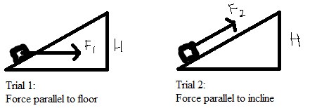10. A box slides to the right across a horizontal floor. A person called Ted exerts a force T to the right on the box. A person called Mario exerts a force M to the left, which is half as large as the force T. Given that there is friction f and the box accelerates to the right, rank the sizes of these three forces exerted on the box.

(A) f < M < T

(B) M < f < T

(C) M < T < f

(D) f = M < T

(E) It cannot be determined.

2007 Q22

11. A mass m is pulled outward until the string of length L to which it is attached makes a 90-degree angle with the vertical. The mass is released from rest and swings through a circular arc. What is the tension in the string when the mass swings through the bottom of the arc?

(A) 0

(B) mg

(C) 2mg

(D) 3mg

(E) It cannot be determined.

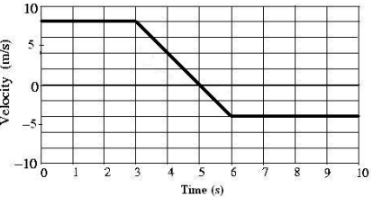Questions 12 - 13 deal with the following graph:

2008 Q23

12. The velocity vs. time graph for the motion of a car on a straight track is shown in the diagram. The thick line represents the velocity. Assume that the car starts at the origin x = 0.

At which time is the car the greatest distance from the origin?

(A) t = 10 s

(B) t = 6 s

(C) t = 5s

(D) t = 3s

(E) t = 0 s

2008 Q24

13. What is the average speed of the car for the 10second interval?

(A) s 1.20m

(B) s 1.40m

(C) s 3.30m

(D) s 5.00m

(E) s 5.40m

2008 Q35

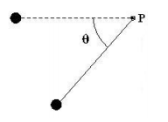14. Astronauts on the Moon perform an experiment with a simple pendulum that is released from the horizontal position at rest. At the moment shown in the diagram with ° ° 0 < θ < 90 , the total acceleration of the mass may be directed in which of the following ways?

(A) straight to the right

(B) straight to the left

(C) straight upward

(D) straight downward

(E) straight along the connecting string toward point P

2008 Q38

15. A 1200kg satellite orbits Planet X in a circular orbit with a constant speed of s 5.00×103 m . The radius of orbit is m7 7.50×10 . What is the magnitude of the gravitational force exerted on the satellite by Planet X?

(A) 400 N

(B) 200 N

(C) 0.080 N

(D) 0.0127 N

(E) More information is required to answer this question

2009 Q24

16. A point mass moves along a horizontal circular path of radius 0.8 m with a constant kinetic energy of 128 J . What is the magnitude of the net force acting on the mass as it moves?

(A) 64 N

(B) 32 N

(C) 16 N

(D) 8N

(E) 0 N

2009 Q31

17. A car moves to the right along a one-dimensional track for total time T in two parts.

• Part One: The car maintains constant non-zero speed V for the first ¾ of the total time.

• Part Two: The car accelerates uniformly to rest during the last ¼ of the total time.

What is the ratio of the distance traveled during Part One of the trip to the distance traveled during Part Two of the trip?

(A) 1:6

(B) 3:2

(C) The values of V and T are required to answer the question.

(D) 3:4

(E) 3:8

2014 Q31

18. A toy crane exerts an upward force and delivers a useful power output of 0.10 𝑊 to raise a block vertically at a constant speed. At what constant speed will this crane raise a 0.20 𝑘𝑔 block?

(A) 0.01 𝑚⁄𝑠

(B) 0.02 𝑚⁄𝑠

(C) 0.05 𝑚⁄s

(D) 0.20 𝑚⁄𝑠

(E) 0.50 𝑚⁄𝑠

2014 Q33

19. An object moves with constant acceleration starting with velocity 𝑣0 = 5.00 𝑚 𝑠 and ending with a velocity of 𝑣 = −1.00 𝑚 𝑠 in a time of 3.00 𝑠. For this motion, what is the average speed associated with the object?

(A) 2.00 𝑚⁄𝑠

(B) 2.17 𝑚⁄𝑠

(C) 2.50 𝑚⁄𝑠

(D) 2.83 𝑚⁄𝑠

(E) 3.00 𝑚⁄𝑠

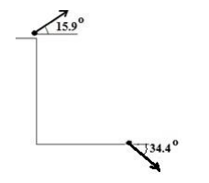2014 Q40

20. A small 1.35 𝑘𝑔 mass is launched from the top of a cliff at an angle of 15.9 ° above the horizontal. When the mass reaches the ground 4.33 𝑠𝑒𝑐𝑜𝑛𝑑𝑠 later, its velocity is directed at 34.4 ° below the horizontal. What is the speed of the mass when it reaches the ground? Ignore air resistance

(A) 60.7 𝑚⁄𝑠

(B) 54.1 𝑚⁄𝑠

(C) 46.4 𝑚⁄𝑠

(D) 43.3 𝑚⁄𝑠

(E) 38.8 𝑚⁄𝑠

2012 Q25

21. Which one of the following choices best represents the average angular speed of the hour hand on a standard clock (in units of rad/s)?

(A) 5.24 x 10-1

(B) 2.62 x 10-1

(C) 1.75 x 10-3

(D) 1.45 x 10-5

(E) 7.27 x 10-5

2012 Q26

22. An object is thrown horizontally with speed 10.0m ⁄s from a height H above the ground. The object reaches the ground with a speed of 20.0m⁄s . Which one of the following choices best represents the time of the object’s flight to the ground? Ignore air resistance.

(A) 1.00s

(B) 1.22s

(C) 1.41s

(D) 1.50s

(E) 1.73s

2011 Q36

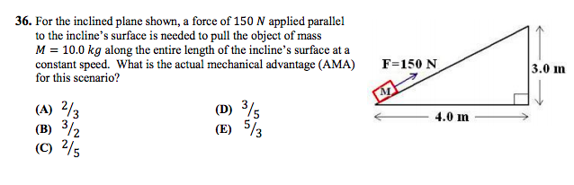

2013 Q28

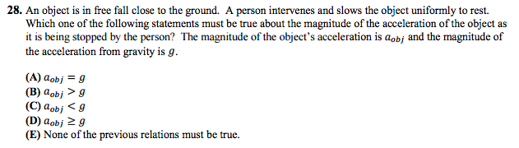

2013 Q32

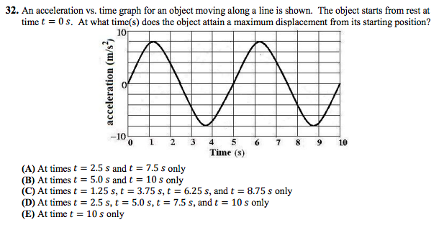

2014 Q23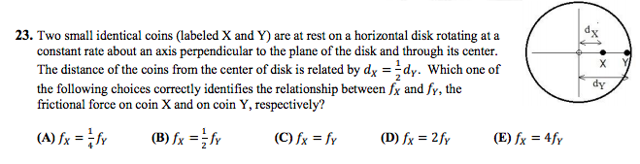

2007 Q23

23. The period of a mass-spring system undergoing simple harmonic oscillation is T. If the amplitude of the mass-spring system’s motion is doubled, the period will be

(A) ¼ T

(B) ½ T

(C) T

(D) 2T

(E) 4T

2007 Q41

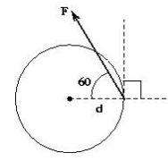24. For the diagram shown, what is the magnitude of the torque from the applied force as measured from the center of the disk?

(A) Fd sin30⁰

(B) Fd tan30⁰

(C) Fd sin90⁰

(D) Fd sin120⁰

(E) Fd cos120⁰

2008 Q37

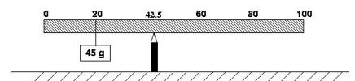25. A uniform meter stick has a 45.0 g mass placed at the 20cm mark as shown in the figure. If a pivot is placed at the 42.5cm mark and the meter stick remains horizontal in static equilibrium, what is the mass of the meter stick?

(A) 18.0 g

(B) 45.0 g

(C) 72.0 g

(D) 120.0 g

(E) 135.0 g

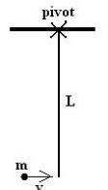2008 Q40

26. A point particle of mass m collides with a thin rod pivoted at one end. The rod has mass M = 2m , length L , and moment of inertia I = $\frac{1}{3}{ML}^{2}$. The particle

moves horizontally with speed V when it hits the bottom of the rod and sticks to it. What is the speed of the particle immediately after collision?

(A) $\frac{1}{3}V$

(B) $\frac{1}{√3}V$

(C) $\frac{3}{5}V$

(D) $\frac{3}{4}V$

(E) $\frac{√3}{2}V$

2008 Q46

27. A traveling wave has the form y(x,t) = 3.0sin(2.5 x − 5.0t) where all quantities given are in MKS units, x is position, and t represents time. What is the period of the wave (in seconds)?

(A) 2.00

(B) 1.26

(C) 1.00

(D) 0.63

(E) 0.20

2008 Q48

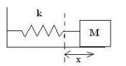28. A block of mass M on a horizontal surface is connected to the end of a massless spring of spring constant k . The block is pulled a distance x from equilibrium and when released from rest, the block moves toward equilibrium. What minimum coefficient of kinetic friction between the surface and the block would prevent the block from returning to equilibrium with non-zero speed?

(A) $\frac{{kx}^{2}}{2Mg}$

(B) $\frac{kx}{Mg}$

(C) $\frac{kx}{2Mg}$

(D) $\frac{Mg}{2kx}$

(E) $\frac{k}{4Mgx}$

2009 Q40

29. A uniform solid cylinder of mass M = 2.00 kg and radius R = 10.0 cm is connected about an axis through the center of the cylinder to a horizontal spring with spring constant 4.00 N/m . The cylinder is pulled back, stretching the spring 1.00 m from equilibrium. When released, the cylinder rolls without slipping. What is the speed of the center of the cylinder when it returns to equilibrium?



(A) 0.577 m/s

(B) 1.00 m/s

(C) 1.15 m/s

(D) 1.22 m/s

(E) 1.41 m/s

2009 Q42

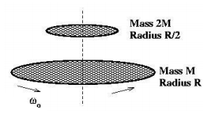30. A uniform, solid disk with mass M and radius R is rotating on a fixed, frictionless platform with constant angular speed ω0 about a fixed axis through its center. A second uniform solid disk of mass 2M and radius R/2 is placed from rest directly on top of the first disk so that the centers of the disks line up. When equilibrium is established, the disks are spinning at the same rate. What is the angular speed of the disks at equilibrium?

(A) $(\frac{1}{4})ω_{0}$

(B) $(\frac{1}{3})ω_{0}$

(C) $(\frac{1}{2})ω_{0}$

(D) $(\frac{2}{3})ω_{0}$

(E) $(\sqrt{\frac{2}{3}})ω_{0}$

2009 Q22

31. A point object is connected to the end of a long string of negligible mass and the system swings as a simple pendulum with period T . What is the period of the pendulum if the string is made to have one-quarter of its original length?

(A) 4T

(B) 2T

(C) T

(D) T/2

(E) T/4

2010 Q35

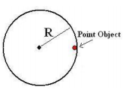32. A point object with mass M = 2.0kg is attached a distance R = 1.75m from the fixed center of a disk as shown in the figure. The disk starts rotating from rest with constant angular acceleration α = 5.00 rad/s2 about an axis perpendicular to the plane of the page through the disk’s center. After how much time T (in seconds) is the tangential component of the point object’s acceleration equal in magnitude to the centripetal component of the point object’s acceleration?

(A) 0.769

(B) 0.592

(C) 0.500

(D) 0.447

(E) 0.350

2010 Q40

33. A uniform, solid cylinder with a mass M and radius R is pulled by a horizontal force F acting through the center as shown. The cylinder rolls to the right without slipping. What is the magnitude of the force of friction between the cylinder and the ground?

(A) $\frac{1}{4}F$

(B) $\frac{1}{3}F$

(C) $\frac{1}{2}F$

(D) $\frac{2}{3}F$

(E) $\frac{3}{4}F$

2010 Q42

34. A comet moves in an elliptical orbit around the sun. As the comet moves from aphelion (the point on the orbit farthest from the sun) to perihelion (the point on the orbit closest to the sun), which of the following results is true? Speed of the comet Angular momentum of the comet/sun system Gravitational potential energy of the comet/sun system

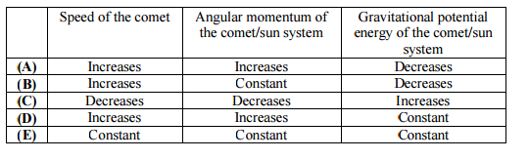

2011 Q37

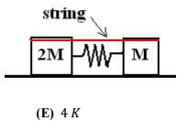35. Two blocks sit on a horizontal frictionless surface connected to an ideal spring. Initially everything is at rest and there is a string compressing the mass-spring system from equilibrium. At some time after the string is cut, the block of mass 2M reaches its maximum kinetic energy J. What maximum kinetic energy does the block of mass M attain in terms of J?

(A) $\frac{1}{2}J$

(B) $\frac{1}{4}J$

(C) J

(D) 2 J

(E) 4 J

2011 Q39

36. An object with mass M moves due East on a frictionless horizontal surface with a speed of L. A second object of mass 1/2M has a speed of 3L. The two objects collide and stick together. If the objects are moving due South after the collision, with what speed are they moving?

(A) $\frac{5}{3}L$

(B) $\frac{1}{3}L$

(C) $\frac{√5}{3}L$

(D) $\frac{4√2}{3}L$

(E) $\frac{√33}{3}L$

2011 Q40

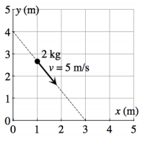37. A 2.0 kg particle travels at a constant speed of 5.0 m⁄s along the line shown in the figure. What is the magnitude of the particle’s angular momentum calculated from the origin?

(A) 10 kg · m2⁄s

(B) 24 kg · m2⁄s

(C) 30 kg · m2⁄s

(D) 32 kg · m2⁄s

(E) 40 kg · m2⁄s

2011 Q47

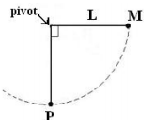38. A simple pendulum of length L has a point mass M released from rest from the horizontal position shown. In the absence of air resistance and friction, the mass swings through the arc of a circle. Let T represent the magnitude of the force from the string on the mass (tension), G represent the magnitude of the gravitational force acting on the mass by the earth, and F represent the magnitude of the net force acting on the mass. Which one of the following choices describes the relationship among these forces when the mass swings at the bottom of the arc (point P)?

(A) G < F < T

(B) F < G = T

(C) F < G < T

(D) T < F < G

(E) G = F < T

2011 Q49

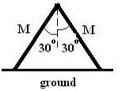39. An inverted “V” in static equilibrium is made from two uniform beams each of mass M = 12 kg. Each beam of the “V” has the same length and makes an angle of 30° with the vertical as shown in the diagram. Which one of the following choices best represents the magnitude of the static friction force acting on the left leg of the “V” from the level ground? The coefficient of static friction between each beam and the ground is

μs = 0.76.

(A) 26.3 N

(B) 34.6 N

(C) 45.6 N

(D) 69.3 N

(E) 91.2 N

2012 Q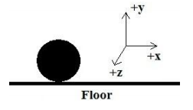33

40. A solid, uniform sphere rolls without slipping on a floor along the +x-axis (to the right). The rotational kinetic energy associated with the sphere about an axis of rotation through its center of mass along the +z-axis (out of the plane of the page) is 20 Joules. What is the translational kinetic energy associated with the sphere?

(A) 8J

(B) 10J

(C) 20J

(D) 40J

(E) 50J

2012 Q34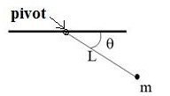

41. A mass m attached to a light string of length L is located at an angle θ below the horizontal as shown in the figure to the right. The mass then is released from rest. Calculated from an axis perpendicular to the plane of the page through the pivot, which one of the following choices represents the magnitude of the torque produced by the gravitational force acting on the mass at this instant?

(A) mgL

(B) mgL sinθ

(C) mgL cosθ

(D) mgL (1 - sinθ)

(E) mgL (1 - cosθ)

2012 Q43

42. Several forces act on a rigid body. If the resultant (net) force on the body is zero, which one of the following statements must be true?

(A) The object is in translational equilibrium and rotational equilibrium.

(B) The object is in translational, but not necessarily rotational, equilibrium.

(C) The object is in rotational, but not necessarily translational, equilibrium.

(D) The object is in static equilibrium.

(E) The object is in neither translational nor rotational equilibrium.

2012 Q48

43.An object of mass M is dropped from a height H above the ground. The object bounces off of a horizontal surface in a collision lasting time T. The object then rises upward to a maximum height H⁄2. What was the magnitude of the average net force acting on the mass during the collision with the surface?

(A) $(2 - √2) \frac{M\sqrt{gH}}{T}$

(B) $(\frac{1}{\sqrt{2}}+ 1) \frac{M\sqrt{gH}}{T}$

(C) $(√3) \frac{M\sqrt{gH}}{T}$

(D) $(2\sqrt{2}- 1) \frac{M\sqrt{gH}}{T}$

(E) $(\sqrt{2}+ 1) \frac{M\sqrt{gH}}{T}$

Questions 44-45 deal with the following diagram:

An ideal uniform solid disk and an ideal uniform ring each have mass M and radius R. Each object begins purely rolling without slipping down a rough inclined plane. The coefficients of friction for the disk and ring with the incline are μdisk > μring.

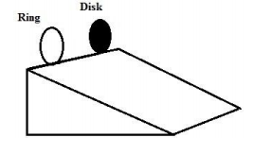

2013 Q39

44. As each object rolls down the incline, which statement is correct about the force of friction from the incline on the objects?

(A) The ring experiences a greater force of friction than the disk.

(B) The disk experiences a greater force of friction than the ring.

(C) The force of friction is equal and non-zero for both objects.

(D) The force of friction is equal to zero for both objects.

(E) Nothing can be concluded about the force of friction without more information

2013 Q40

45. As the objects roll, what is the ratio of the ring’s angular acceleration to the disk’s angular acceleration calculated about an axis perpendicular to the object’s face and through its center of mass?

(A) 1:2

(B) 2:1

(C) μdisk : μring

(D) 4:3

(E) 3:4

2014 Q43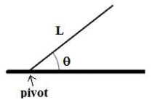

45. A long rod of length 𝐿 is pivoted about its left end. It is released from an angle 𝜃 above the horizontal. What is the magnitude of the angular acceleration of the rod about the pivot when the rod is released?

(A) (6𝑔/𝐿) cos 𝜃

(B) (6𝑔/𝐿) sin 𝜃

(C) (3𝑔/2𝐿) sin 𝜃

(D) (3𝑔/2𝐿) cos 𝜃

(E) (3𝑔/𝐿 ) sin 𝜃

2014 Q39

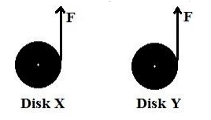46. Two uniform disks, X and Y, have masses 𝑚𝑋 < 𝑚𝑌, equal radii, and equal initial non-zero kinetic energies. Each disk rotates counter clockwise in the plane of the page about a fixed frictionless axis through its center. As shown in the figure, a force 𝐹 is applied tangent to each disk at its right edge for the same amount of time. After the forces are applied, let 𝐿 represent the magnitude of the angular momentum about the center of a disk and 𝐾 represent the kinetic energy of a disk. Which one of the following choices correctly compares these quantities for disk X and disk Y?

(A) 𝐿𝑋 > 𝐿𝑌 ; 𝐾𝑋 < 𝐾𝑌

(B) 𝐿𝑋 > 𝐿𝑌 ; 𝐾𝑋 > 𝐾𝑌

(C) 𝐿𝑋 = 𝐿𝑌 ; 𝐾𝑋 = 𝐾𝑌

(D) 𝐿𝑋 < 𝐿𝑌 ; 𝐾𝑋 < 𝐾𝑌

(E) 𝐿𝑋 < 𝐿𝑌 ; 𝐾𝑋 > 𝐾𝑌

2014 Q45

47. A long thin rod of mass 𝑀 and length 𝐿 is pivoted at one end so that it swings as a pendulum. The rod is set into simple harmonic oscillation and has a period of motion 𝑇. A second thin rod with mass 2𝑀 and length 2𝐿 also is pivoted at one end to swing as a pendulum. When this second rod is set into simple harmonic oscillation, what is its period?

(A) 2 𝑇

(B) √2 𝑇

(C) 𝑇

(D) 1/√2 𝑇

(E) 1/2 T

2014 Q49

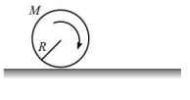48. A solid, uniform disk of mass 𝑀 and radius 𝑅 rotates clockwise about its center with an angular speed 𝜔0. The disk then is placed onto a horizontal surface and begins moving only to the right, slipping as it rolls. The coefficient of friction between the floor and the disk is 𝜇 and the frictional force is considered constant throughout the motion. What is the angular speed of the disk when the disk starts rolling without slipping?

(A) (𝜇/2) 𝜔0

(B) (1/2) 𝜔0

(C) (1/3) 𝜔0

(D) (2𝜇/3) 𝜔0

(E) (3/5) 𝜔0