1. A box slides to the right across a horizontal floor. A person called Ted exerts a force T to the right on the box. A person called Mario exerts a force M to the left, which is half as large as the force T. Given that there is friction f and the box accelerates to the right, rank the sizes of these three forces exerted on the box.

(a) f < M < T (b) M < f < T (c) M < T < f (d) f = M < T (e) It cannot be determined.

2. A mass m is pulled outward until the string of length L to which it is attached makes a 90-degree angle with the vertical. The mass is released from rest and swings through a circular arc. What is the tension in the string when the mass swings through the bottom of the arc?

(a) 0 (b) mg (c) 2mg (d) 3mg

(e) It cannot be determined.

3. The velocity vs. time graph for the motion of a car on a straight track is shown in the diagram. The thick line represents the velocity. Assume that the car starts at the origin x = 0. 23.

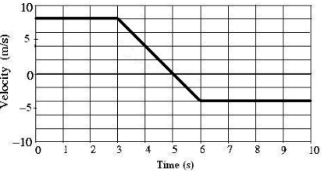

4. At which time is the car the greatest distance from the origin?

(A) t = 10 s (B) t = 6 s (C) t = 5s (D) t = 3s (E) t = 0 s

5. What is the average speed of the car for the 10second interval?

(A) s 1.20m (B) s 1.40m (C) s 3.30m (D) s 5.00m (E) s 5.40m

6. Astronauts on the Moon perform an experiment with a simple pendulum that is released from the horizontal position at rest. At the moment shown in the diagram with ° ° 0 < θ < 90 , the total acceleration of the mass may be directed in which of the following ways?

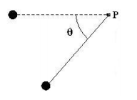

(A) straight to the right (B) straight to the left (C) straight upward (D) straight downward (E) straight along the connecting string toward point P

7. A 1200kg satellite orbits Planet X in a circular orbit with a constant speed of s 5.00×103 m . The radius of orbit is m7 7.50×10 . What is the magnitude of the gravitational force exerted on the satellite by Planet X?

(A) 400 N (B) 200 N (C) 0.080 N (D) 0.0127 N (E) More information is required to answer this question

8. A point mass moves along a horizontal circular path of radius 0.8 m with a constant kinetic energy of 128 J . What is the magnitude of the net force acting on the mass as it moves?

(A) 64 N (B) 32 N (C) 16 N (D) 8N (E) 0 N