3/10/26

P1 - P2 Highest impact tickets
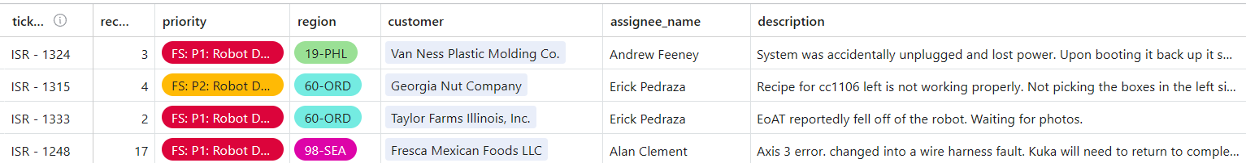P1 - #pd-19_van-ness-plastic-moulding_clifton-nj @Andrew Feeney March 11th
//Pulse Mismatch error following power cycles. @Nathan Brown assisting. Might need an onsite to correct
P2 - #pd-60_georgia_nut_company-niles-il-z @Erick Pedraza March 10th
//Off over the weekend. EP will review March 10th
P1 - #pd-60_taylor-farms_chicago-il_04050-04052 @Erick Pedraza March 10th
//EP onsite today to investigate broken EOAT
P1 - #dply_fresca-mexican-foods_aka_chg_caldwell-id_04786-04862-04863-04864-04865 @Alan Clement March 4th
//Hard down. Normal operation caused the Robot to lose its A3 mastering position.
//New ETA March 12th at best. No confirmed date. Will need Kuka onsite (Still in China)

Hyper Care:
#dply_fresca-mexican-foods_aka_chg_caldwell-id_04786-04862-04863-04864-04865 February 13th -March 13th
#dply_boxed-water_lindon-ut_04778_fsr-84 February 13th -March 13th
#pd-48_haviland-products_grand-rapids-mi_04335 February 3rd - March 3rd

P3 - Needing immediate review/action/parts (Friday review)
P3 - #channel @user March 13th
//Parts on order need ETA
P3 - #channel @user March 9th
//Multiple open request. JM on site Monday to review
P3 - #channel @user March 5th
//JM was onsite with TRF
P3 - #channel @user March 13th
//Needs update from KM
P3 - #channel @user Long term
//MDR on order. long lead time
//Found a used one on eBay. Ordering March 6th .
P3 - #channel @user Long term
//Leak came back after repair from Kuka. @user working with MFG
P3 - #channel @user Long term
//Waiting on belt.
P3 - #channel @user March 6th
//Ongoing work

Confirmed installs -
https://airtable.com/appzLiACOq8tvPZEF/shrfh5E3yoR18H7dT/tblRXewS1BUrOkx1x
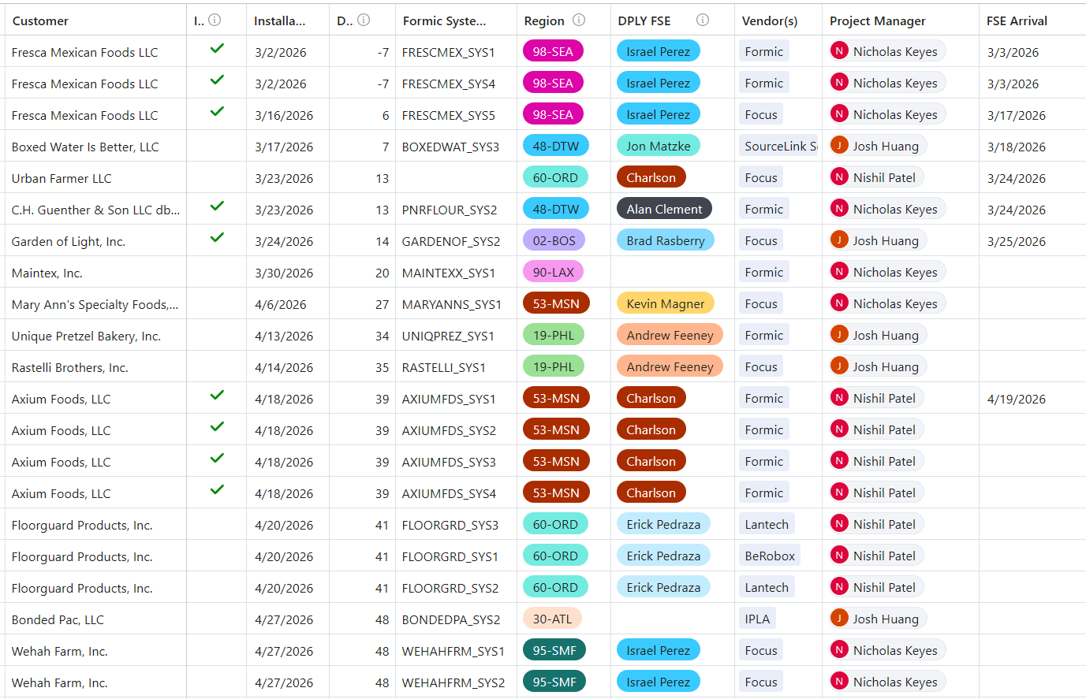#dply_fresca-mexican-foods_aka_chg_caldwell-id_04786-04862-04863-04864-04865
@Andrew Feeney Sys 1 & sys 4
WO#2028
March 6th - March 10th
#channel
@user
WO 2091
March 23rd - March 27th
#channel
@user
WO 1966
March 25th - March 27th

**Delayed
#channel
@user
**moved a month March 2nd unconfirmed
WO#2143
Unknown
#channel
**moved a week March 2nd
@user
WO 1987
March 11th - March 12th
#channel
**Unchecked February 27th
@user
WO 2055
March 25th - March 26th

Parking lot -
Recipe requests
Harvest Deep dive
// #channel @user
Case Erector - Improved reliability
Glue head clogging
Rotary actuators
PM process (was this purchased as a system)
@user set up a customer meeting with #channel @user @user
Detail out SOP for recipe creation process
Customer facing RACI/Responsibility

Usefull links

Ticket Links:
P1-2 priority tickets:
https://airtable.com/appe6WGBd1tZKT4Wn/shrvfitEQTJ5LRBsW/tblKcGSG3xNF1yjid
P3 Tickets:
https://airtable.com/appe6WGBd1tZKT4Wn/shr5ONuMHhAihpWDn/tblKcGSG3xNF1yjid
FE Tickets:
https://airtable.com/appe6WGBd1tZKT4Wn/shraJs03s4FMJtBX4/tblKcGSG3xNF1yjid
FSE Schedule:
https://app.getmaintainx.com/workorders

USAGE & CONNECTIVITY CONCERNS
#channel #channel
https://goformic.slack.com/lists/T019Y3V5LR4/F08NX3SJER0

FS On call Rotation:

FS On call Rotation:
Oncall This week: Andrew Feeney
Oncall next week: Jon Matzke
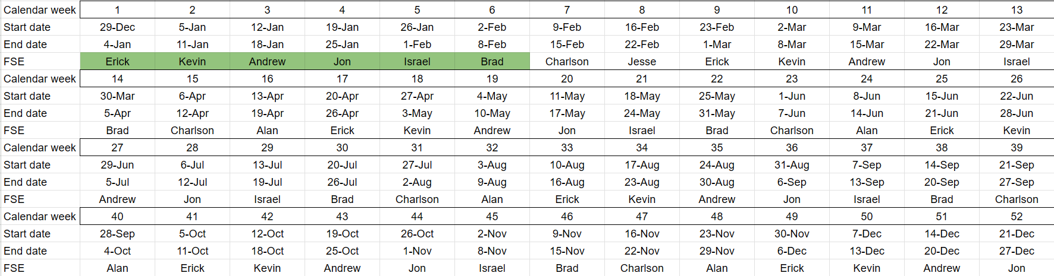

On Call SOP

Coverage Window:
Sunday 12:01 am to Saturday 11:59 pm
Purpose:
Provide steady, reliable support to customers outside normal business hours and ensure issues are documented, escalated, and resolved with clear communication and proper visibility.
1. Primary Responsibilities
• You are the first point of contact during your on call rotation.
• Keep your phone charged and stay reachable at all times.
• Respond to customer outreach quickly and begin gathering information.
• Add all notes as a reply to the inbound ticket.
• Route the ticket to the correct Slack channel so the team has visibility.
• Maintain steady communication with both the customer and the internal team.
2. Missed Call Procedure
If you miss a call:
- Check Slack and the ticketing system to see if someone else answered.
- If a ticket was created, read it and stay aware of the situation.
- If no ticket exists, reach out to the customer within an hour when possible to confirm the issue and start support.

3. Required Information to Collect
Every support request must include:
- Customer channel used to report the issue
- Priority level
- Clear description of the problem
- When the issue started
- What the customer already tried
- Customer contact name
- Customer phone number
- Internal Formic team members who should be notified
- How the escalation was received (support line, email, text, call, or other)
- Correct Formic System ID
Your goal is to create a complete, clean picture so anyone can take over without confusion.

4. Escalation Path
First escalation: HoFS
• HoFS will work the customer directly and attempt to resolve the issue.
• If the issue requires system specific knowledge or on site experience that goes beyond what he can address, he will reach out to the on call FSE.
If HoFS is unavailable:
• The on call FSE becomes the next escalation point and should be ready to step in using the information gathered so far.
You are not expected to fix everything alone. You are expected to gather clear information and provide a clean handoff when needed.
5. Customer Communication Standards
• Confirm with the customer that you received the issue.
• Keep updates simple and direct.
• Set expectations for next steps and timing.
• If additional support is added, explain that this is to get them the fastest resolution possible.
6. End of Week Handoff
Before your on call rotation ends:
• Make sure all active tickets have clean notes.
• Submit a brief summary of any open issues.
• Ensure the next on call engineer can step in without delays.

