# Logical tasks

**Completion conditions:**

* Time for completion: 40 minutes
* Simple hints are allowed, such as the answer to the question "What are pan balance scales?"

1. What is the maximum number of pieces that a pizza can be sliced into with 6 cuts?

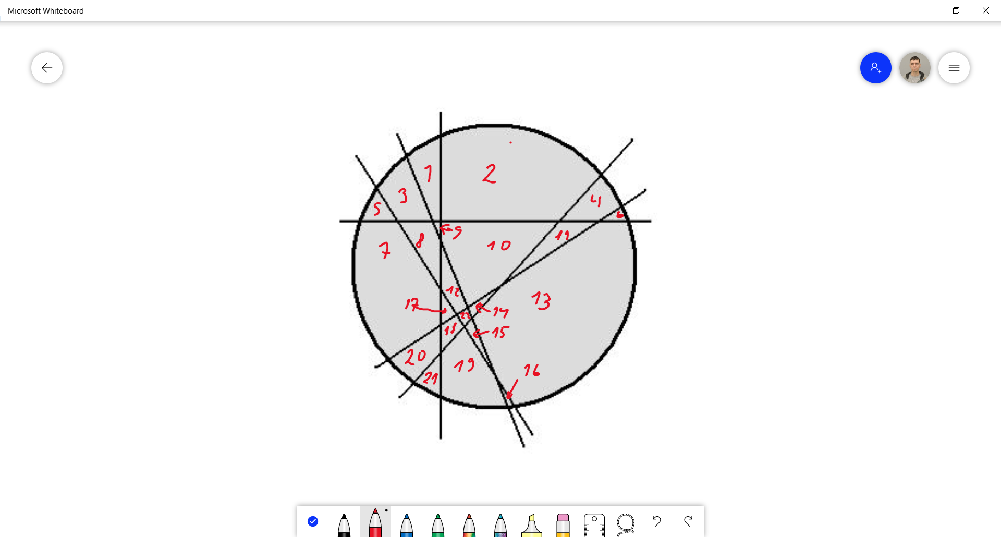

Answers: depending on how you cut it. Normal straight cuts to get equal pieces should give you 12 pieces

However as from the image above 22 pieces.

1. We have two robots, A and B, located on one line, but we don't know which is which. We also don't know the distance between them, only that it's a multiple of 1 meter. We can give commands to the robots to move left or right in multiples of 1 meter and then ask if the robots are located at the same point on the line. What’s the most efficient way to move the robots so that they end up at the same point on the line?



Answer: shortest distance between two points is a straight line.

Getting the average distance should get them to the same point.

From the image above the distance between the two is 4m

Most efficient way if they both move 2m at the same speed. B right and A left.

1. There are pan balance scales and 7 scale weights. What should the masses of those scale weights be so that it is possible to accurately weigh, to the nearest gram, anything from 1 gram to 1 kilogram? The weights can be placed on either scale pan.

Answer: 142.9, 285.7, 428.6, 571.4, 714.3, 857.1, 1000