Phone Comparison Application

**Documentation**

# **Version 1 – Ending 6.26.18**

For this version, we decided to implement all our panels in an easy to understand interface. By clicking on the tabs on the side, one can switch between the different menu panels. The panels are Home, Phone Comparison, and Knowledge Center. With these panels working correctly, our first version of the project will be complete.

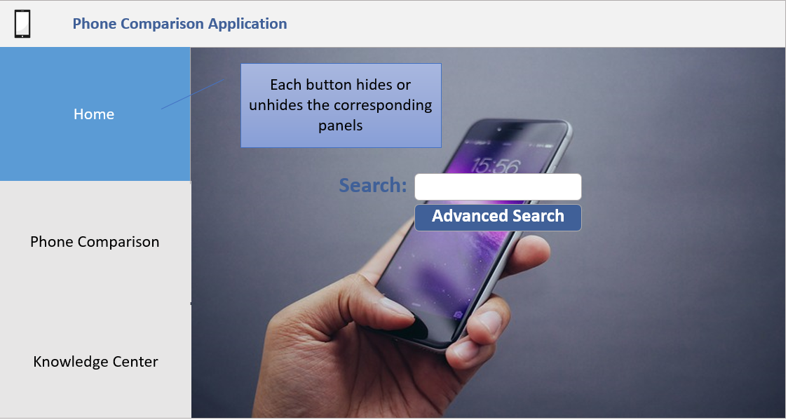

# **Test Scenarios**

Test Scenario 1: Check that pnlHome displays when btnHome is clicked   
Test Scenario 2: Check that btnHome is blue when pnlHome is displayed   
Test Scenario 3: Check that pnlPhone displays when btnPhone is clicked   
Test Scenario 4: Check that btnPhone is blue when pnlPhone is displayed

# **Variable and Control Identifiers**

Home Panel

frmHome - Form for the whole project.

pnlHome – Panel for the home screen.

btnHome – Button to navigate to pnlHome.

btnPhone – Button to navigate to pnlPhone.

btnKnowledge – Button to navigate to Knowledge Comparison panel.

lblSearchPrompt – Label for search bar.

cmboxSearchFilter – Drop down box for the search bar. Selects either brand or phone model.

btnSearch – Button to search for phones brands or phone models.

grpHmBox – This is the container around the three buttons on the left hand side of the home page.

txtSearchBar –Text box for the user to enter a phone brand or phone model to search.

Phone Comparison Panel

pnlPhnComp – Panel for the phone comparison screen.

lblPhnComp – Main header on pnlPhone

Knowledge Center Panel

pnlKnowledge – Panel for the knowledge screen.

lblKnowledge – Main header on pnlKnowledge.

# **Version 2 – Ending 7.17.18**

In version 2, we created the Phone Comparison screen based on the wire frame design. Clicking on the Phone Comparison tab on the side brings up the screen. In this screen, the user can select a phone to compare. Each phone’s information is stored in a text file and is read into the screen once the user selects the phone name from the combo boxes. Another requirement that was self-imposed was the use of the tooltips over the [?] boxes. There is helpful information displayed when the user’s mouse hovers over it long enough. With the phone comparison screen complete, our requirements for the second version are completed.

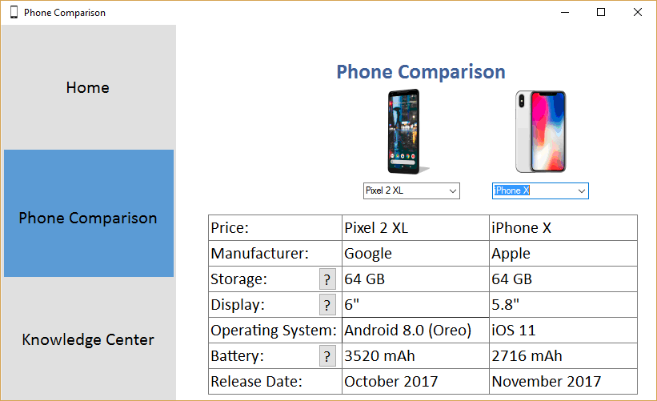

# **Test Scenarios**

Test Scenario 1: Check that each combo box is displaying the correct phone with its information present in the table below.   
Test Scenario 2: Check that the text file is being read from correctly by looking at the data in the table.

# **Classes**

Phone: The purpose of this class is to create properties of the phone.

# **Variable and Control Identifiers**

Phone Comparison Panel

PicPhone1, picPhone2 – two pictures to show both phones

CmboxPhone1DropDown, cmboxPhone2DropDown – list of phone options for the user to select

TxtPhone1Manufacturer, txtPhone2Manufacturer – lists manufacturer information for both phones

TxtPhone1Price, txtPhone2Price – lists phone prices for both phones

TxtPhone1Storage, txtPhone2Storage –lists phone storage size options for both phones

TxtPhone1Display, txtPhone2Display – lists display size for both phones

TxtPhone1OS, txtPhone2OS – lists both phone operating systems

TxtPhone1Battery, txtPhone2Battery – lists battery size for both phones

TxtPhone1ReleaseDate, txtPhone2ReleaseDate – lists release date for both phones

# **Version 3 – Ending 7.31.18**

In version 3, we created the Knowledge center screen based on the wire frame design. Clicking on the Knowledge Center tab on the side brings up the screen. In this screen, the user can select one phone look at more closely. The phone’s information is stored in the same text file that the phone comparison tab uses, but with the addition of more attributes. For example, there is battery life, special features, and many other snippets of information to help educate the consumer. We are also changing the way that the [?] boxes work by replacing the tool tips with a message box instead, this is easier for readability. We added another feature where from the phone comparison screen, you can click on the picture of the phone and it will take you directly to the knowledge center with that phone you clicked on. We did not include inheritance or class hierarchies because we did not think any of the classes had any “is-a” relationships with each other.

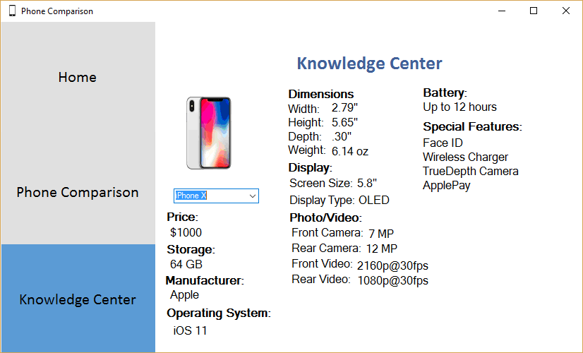

# **UML Diagram**

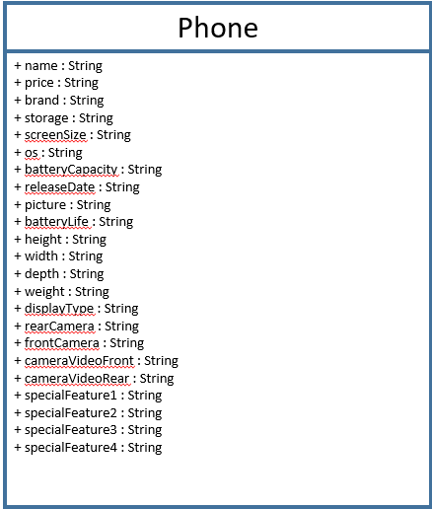

# **Test Scenarios**

Test Scenario 1: Check that the phone comparison phone image takes you to the correct knowledge center phone.

Validation: This works; all six possible phone images on the phone comparison page (three on the left column and three on right column) take you to the corresponding knowledge center page about that phone.

Test Scenario 2: Check that the picture in the knowledge center appears.

Validation: This works; pictures for all three possible phone options in the knowledge center appear.

Test Scenario 3: Check that all the labels are generating information based on the selected phone.

Validation: This is true; all labels generate information for the corresponding phone that is selected. They change when the selected phone in the drop-down menu changes, as intended.

Test Scenario 4: Check that the drop down generates all the phones correctly.

Validation: This works; the drop-down menu in the knowledge center displays all three possible phones.

# **Variable and Control Identifiers**

picPhone3 – Picture for the phone in the knowledge center.

cmboxPhone3DropDown – Drop down used in the Knowledge Center to select a phone.

lblPrice - Price label that is used in the Knowledge Center.

txtPhone3Price – The price of the phone in the Knowledge Center.

lblPhoneStorage – Storage label that is used in the Knowledge Center.

txtPhone3Storage – The storage capacity of the phone that is used in the knowledge center.

lblManufacturer – Manufacturer label that is used in the knowledge center.

txtPhone3Manufacturer – The manufacturer of the phone that is used in the knowledge center.

lblOS - OS label that is used in the knowledge center.

txtPhone3OS – The OS of the phone that is used in the knowledge center.

lblSizeWeight – The group label for the dimensions and weight of the phone in the knowledge center.

txtPhone3WidthLabel – The label of the width for the phone in the knowledge center.

txtPhone3Width – The width for the phone in the knowledge center.

txtPhone3HeightLabel - The label of the height for the phone in the knowledge center.

txtPhone3Height - The height for the phone in the knowledge center.

txtPhone3DepthLabel - The label of the depth for the phone in the knowledge center.

txtPhone3Depth - The depth for the phone in the knowledge center.

txtPhone3WeightLabel - The label of the weight for the phone in the knowledge center.

txtPhone3Weight - The weight for the phone in the knowledge center.

lblDisplay - The group label for the screen size and display type of the phone in the knowledge center.

txtPhone3ScreenSizeLabel - The label of the screen size for the phone in the knowledge center.

txtPhone3ScreenSize - The screen size for the phone in the knowledge center.

txtPhone3DisplayTypeLabel - The label of the display type for the phone in the knowledge center.

txtPhone3DisplayType - The display type for the phone in the knowledge center.

lblPhotoVideo- The group label for the camera and video of the phone in the knowledge center.

txtPhone3CameraFrontLabel- The label of the front camera for the phone in the knowledge center.

txtPhone3FrontCamera - The front camera specification for the phone in the knowledge center.

txtPhone3CameraRearLabel - The label of the rear camera for the phone in the knowledge center.

txtPhone3RearCamera - The rear camera specification for the phone in the knowledge center.

txtPhone3CameraVideoFrontLabel - The label of the front video for the phone in the knowledge center.

txtPhone3CameraFrontVideo - The front video specification for the phone in the knowledge center.

txtPhone3CameraVideoRearLabel - The label of the rear video for the phone in the knowledge center.

txtPhone3CameraVideoRear - The rear video specification for the phone in the knowledge center.

lblBattery - The label of the battery information for the phone in the knowledge center.

txtPhone3BatteryLife - The battery life for the phone in the knowledge center.

lblSpecialFeatures - The group label for the special features of the phone in the knowledge center.

txtPhone3SpecialFeature1 - The first special feature for the phone in the knowledge center.

txtPhone3SpecialFeature2 - The second special feature for the phone in the knowledge center.

txtPhone3SpecialFeature3 - The third special feature for the phone in the knowledge center.

txtPhone3SpecialFeature4 - The fourth special feature for the phone in the knowledge center.

# **Final Version – Ending 8.7.18**

For the final version, we implemented a database as an additional feature into the phone comparison application. Before this, the program would parse a text file for the different components of each cell phone. We created a database from scratch for the phones because we could not find one on the internet that worked with our project. On the backend, we added all the rows to a list of phone objects. Then, the front end would display all the information in the phone comparison and knowledge center panes. This allowed our project to be more dynamic, because it is much easier to add a phone to a database than to add one to a text file.

We also made many changes to the GUI to make it more appealing for users and easier to navigate. We added a title to the project: “Phone Comparison Application” and changed many colors throughout the project. We fixed an error that allowed users to change the text in the phone comparison pages by making the textboxes read only. We added a description to the home page to give the user more information about how to user our project. We also put examples beneath the search bar of phones that could be searched (examples: iphone, pixel, etc.). Lastly, we slightly rearranged the knowledge center. We believe that making all these small changes will significantly increase the user-friendliness of our application.

New test scenario: Verify that all the data from the database are being presented correctly in the application.

Validation: This is correct; information for all the phones is correctly displayed in the phone comparison and knowledge center panes.