**System Requirements Specification**

**for**

Spacecraft-Control-Center-Training and Testing Environment (STaTE)

**Version 1.6 approved**

**Prepared by Jesse Slager, Juliana Altamira, Kyle Garber, Jeff Cevallos, AnnaMaria Summer, Carly Bosma**

**2022-23 Senior Design Group**

**Created 03/01/2023**

**Table of Contents**

**1. Introduction** **1**

**1.1 Purpose** **1**

**1.2 Document Conventions** **1**

**1.3 Intended Audience and Reading Suggestions** **1**

**1.4 Product Scope** **2**

**1.5 References** **2**

**2. Overall Description** **3**

**2.1 Product Perspective** **3**

**2.2 Product Functions** **3**

**2.3 User Classes and Characteristics** **4**

**2.4 Operating Environment** **5**

**2.5 Design and Implementation Constraints** **5**

**2.6 User Documentation** **5**

**2.7 Assumptions and Dependencies** **6**

**3. External Interface Requirements** **6**

**3.1 User Interfaces** **6**

**3.2 Hardware Interfaces** **8**

**3.3 Software Interfaces** **8**

**3.4 Communications Interfaces** **8**

**4. System Features** **9**

**4.1 SWA - STaTE Web Application** **9**

**4.2 FO - Flight Operator** **Platform 11**

**4.3 TC - Test Conductor** **Platform 15**

**4.4 Control Console 15**

**4.5 SimObject 17**

**4.6 SimCraft** **Subsystems 18**

**5. Other Nonfunctional Requirements** **21**

**5.1 Performance Requirements** **21**

**5.2 Safety Requirements** **22**

**5.3 Security Requirements** **22**

**5.4 Software Quality Attributes** **23**

**5.5 Business Rules** **23**

**6. Other Requirements** **24**

**6.1 - Database Requirements** **28**

**Revision History**

| **Name** | **Date** | **Reason For Changes** | **Version** |
| --- | --- | --- | --- |
| Jesse Slager | 3/1 | Beginning of document  Initialized sections 1-6 | 1.0 |
| Kyle Garber | 3/2 | Revision of sections 3.2, 3.3, 3.4, and 4.1 | 1.1 |
| Carly Bosma | 3/2 | Revision of sections 3.1, 4.1, 4.2, and 4.3 | 1.2 |
| Jeremy Mog | 3/2 | Revision of sections 4.2, 4.4, 4.5, 4.6 | 1.3 |
| AnnaMaria Summer | 3/2 | Revision of sections 3.4, 4.1, 4.2, 4.5, 4.6 | 1.4 |
| Juliana Altamira | 3/2 | Revision of sections 3.1, 4.2, 4.4, 4.6 | 1.5 |
| Jeff Cevallos | 3/2 | Revision of sections 4.5 and 4.6 | 1.6 |
| Jeremy Mog | 4/27 | Update for sprint 6 | 1.7 |

# **Introduction**

The STaTE product is a web application serving to facilitate real-time management of simulated spacecraft.

## **Purpose**

The purpose of this product is to create a simulated training and testing environment that trains students to become effective members of a spacecraft-control-center spaceflight management team. This document contains the requirements that apply to the STaTE system.

## **Document Conventions**

Priorities for higher-level requirements are assumed to be inherited by detailed requirements.

DC1 - For important notes throughout the document, usually pertaining to incomplete sections, a bolded-underlined note will be present to explain why the section is currently unfinished.

DC2 - Bold larger writing refers to section titles. New Section: 17.

## **Intended Audience and Reading Suggestions**

The intended audience of this document are software developers either developing or testing the STaTE product. Other readers include the product owner, customer, users, testers, and stakeholders of the STaTE product. The following sections of this document serve to create a framework for the development team to reference. Section 1.2 defines the product scope, which is necessary to understand before reviewing system design and functionality requirements. Section 2 focuses on elaborating on the project’s design, functionality, and constraints. Section 3 describes the external interfaces of the project: user, hardware, software, and communication. Due to the web-based nature of the project, there are not many considerations regarding hardware interfaces. Section 4 focuses on functional requirements for each component of the system: SWA, Flight Operator Console, Test Conductor Console, and SimCraft Subsystems. Section 5 focuses on the nonfunctional requirements of the system: performance, safety, security, software quality attributes, and organizational rules. The performance requirements consist of a list of assumptions. Safety and business rules do not have much consideration for the scope of this project. Section 6 contains database requirements. The document concludes with Appendix A: Glossary. Suggestions for how the document should be read based on reader types:

Documentation Writers: Documentation writers refer to those producing documentation for the development team. The development team should refer to and revise this document throughout the development process. Each developer is responsible for reading the document and following established principles.

Product Owner: The Product Owner is the member of the team responsible for maximizing team value to the customer. The Product Owner should refer to this document to help the development team prioritize the product backlog and ensure system design and requirements meet the needs of the customer. Some focus should be given to sections 2.2, 2.4, 2.7, 3.2, and all of sections 4 and 5. Appendix A: The glossary contains definitions of specialized terms utilized throughout the document.

Customer: The customer of this product should review this document with the product owner, focusing on sections that explain the product and product functionality. These are primarily sections 1 and 2. Appendix A: The glossary contains definitions of specialized terms utilized throughout the document.

System Testers: A System Tester is anyone testing the functionality of the product against its requirements. Depending on the system being tested, a System Tester should refer to both the section defining the system’s design and its requirements. A System Tester can review the document against their testing to ensure product design and functionality is as defined in the document.

Capstone Course Related Readers: Capstone Course Related Readers should read the document in its entirety and provide feedback to the document writers in order to enhance the quality of the document.

## **Product Scope**

This product shall be a platform for creating and maintaining continuously running spacecraft simulations. These simulations are designed to enable Flight Operators to solve complex issues that may arise during the course of spaceflight or from Test Conductor manipulation. The training environment shall also demonstrate the importance of responsibility delegation to Flight Operators and train their leadership abilities.

## **References**

References for Spacecraft-Control-Center Consoles:

* *How the Mission is Controlled: Inside NASA and Boeing Joint Operations.* (Gary Jordan, Dec. 20, 2019*)*
  + <https://www.nasa.gov/feature/how-the-mission-is-controlled-inside-nasa-and-boeing-joint-operations>
* *Major Tom: Mission Ops for the 21st century.* (Marshall Culpepper, Aug. 4, 2017)
  + <https://medium.com/kubos-tech/major-tom-mission-ops-for-the-21st-century-329905913911>
* *Xplore’s Major Tom® software delivers satellite operations testing for NOAA with Microsoft Azure Orbital.* (PRWeb, Jun. 3, 2022)
  + <https://www.prweb.com/releases/xplores_major_tom_software_delivers_satellite_operations_testing_for_noaa_with_microsoft_azure_orbital/prweb18732185.htm>
* *Major Tom* (Xplore, N.D.)
  + <https://www.xplore.com/services/operations-as-a-service/major-tom.html>

# **Overall Description**

## **Product Perspective**

This product is a simulation environment for spacecraft-control-center spaceflight management team member training and testing.

This product is designed and developed for educational purposes. This product is designed to be easily integrated into a learning environment.

## **Product Functions**

2.2.1 SWA management system hosts both Flight Operator and Test Conductor users.

2.2.2 SWA management system facilitates the creation of SimCraft with Test Conductor-defined subsystems.

2.2.3 SimCraft continuously updates attributes to simulate spaceflight as defined by Test Conductor during creation.

2.2.4 Test Conductor console facilitates the assignment of Flight Operators to manage simulated spacecraft.

2.2.5 Flight Operator console facilitates control of SimCraft attributes via widgets defined by the SimCraft’s subsystems.

2.2.6 Test Conductor console maintains a log of Flight Operator performance for each SimCraft accessible by the Test Conductor.

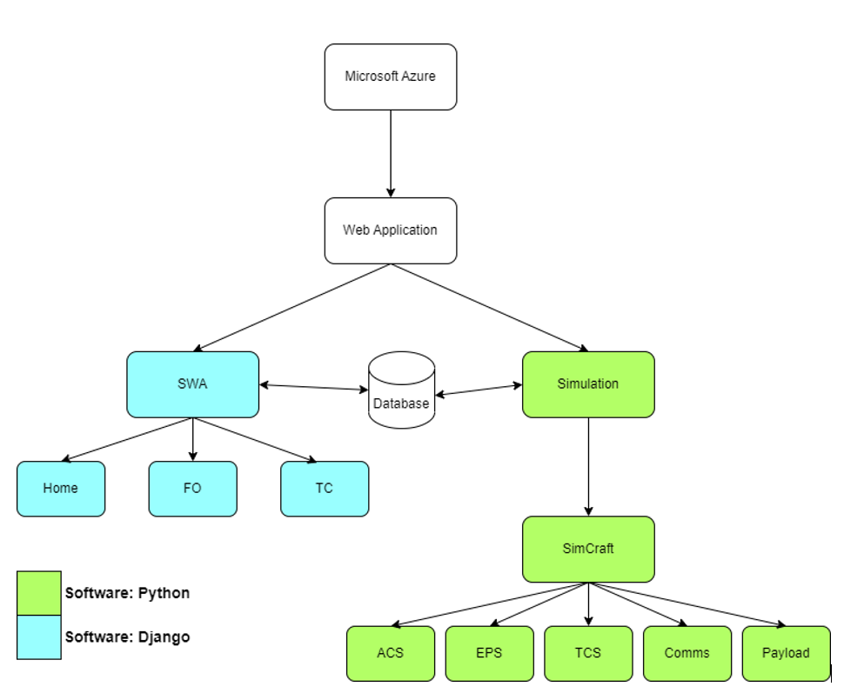

Figure 1: Top-level Data Flow Diagram.

Figure 1 shows the main function of the web application is to handle the SWA and simulations. The SWA and Simulations communicate with the database to perform their intended jobs which are represented by the sub-boxes underneath them.

## **User Classes and Characteristics**

For this product, a team of five Flight Operators are expected to manage a SimCraft. These flight operators are expected to be a part of a class that will typically consist of around 15-20 students and about 4-5 simulations per class are expected to be running simultaneously.

A team consists of a flight director, a test conductor, and some flight operators.

Test Conductor:

* A user who can create a SimCraft, assign Flight Operators, and define the mission payload.
  + Typically fulfilled by the professor instructing the class.
  + Each SimCraft only has one Test Conductor.
  + A Test Conductor can be a Test Conductor for multiple SimCraft.
  + A Test Conductor will most likely never be a student for its intended use case, but the option to open this role to a student user should be considered for alternative deployments of the STaTE product.

Flight Operator:

* A user who can manage SimCraft that they are assigned to via SimCraft’s defined subsystem.
  + Typically fulfilled by students in a flight operations class.
  + Each SimCraft has 5 subsystems, each assigned to individual Flight Operators.
  + Flight Operators can be assigned to multiple SimCraft.

## **Operating Environment**

The product is designed to be a simulation tool that users can remotely access via a website. The website is handled by Django which is a high-level Python web framework.

For this product to operate, the following are considered:

* A server that can be remotely accessed
* The most common web browsers
  + Google Chrome
  + Apple’s Safari Browser
  + Microsoft Edge

§ Other browsers may be considered, but within those four web browsers, roughly 93% of all internet users are contained within those browsers.

§ Anyone not using those browsers is most likely to be using an outdated web browser.

## **Design and Implementation Constraints**

The team chose to use Microsoft Azure as a cloud-based web hosting platform. Although the application can be hosted locally on a computer, it is not recommended as it may not have the capacity to run 24/7, however using Microsoft Azure through a student license has posed some design/implementation constraints. These constraints include:

* The Inability to pull & edit GitHub repository files from VS codes Azure extension without IT admin permissions
* RAM capacity limited to 1.5GB

## **User Documentation**

Documentation for users will include:

* Start-Up Guide
  + A guide for Test Conductors covering:
    - How to set up a mission
    - How to set up a SimCraft
    - How to add students to a SimCraft
    - How to review SimCraft activities
* Flight Operator Guide
  + A guide for Flight Operators covering:
    - The goals for the intended mission; mission requirements script
    - How to manage a SimCraft
* Azure Web Deployment Guide
  + A guide to help system admin or Test Conductor move the STaTE to the Azure web hosting service

UD-STANDARD-1: The documentation will be provided online through the web application excluding the mission requirements script.

UD-STANDARD-2: The documentation can be downloaded, sent, or given in physical form to users.

UD-STANDARD-3: The intended audience of the documentation is the teachers conducting spacecraft control center training and the students in training.

## **Assumptions and Dependencies**

The primary assumption for this program is that the student is knowledgeable of the function of the options they are presented with when adjusting the simulated spacecraft.

# **External Interface Requirements**

## **User Interfaces**

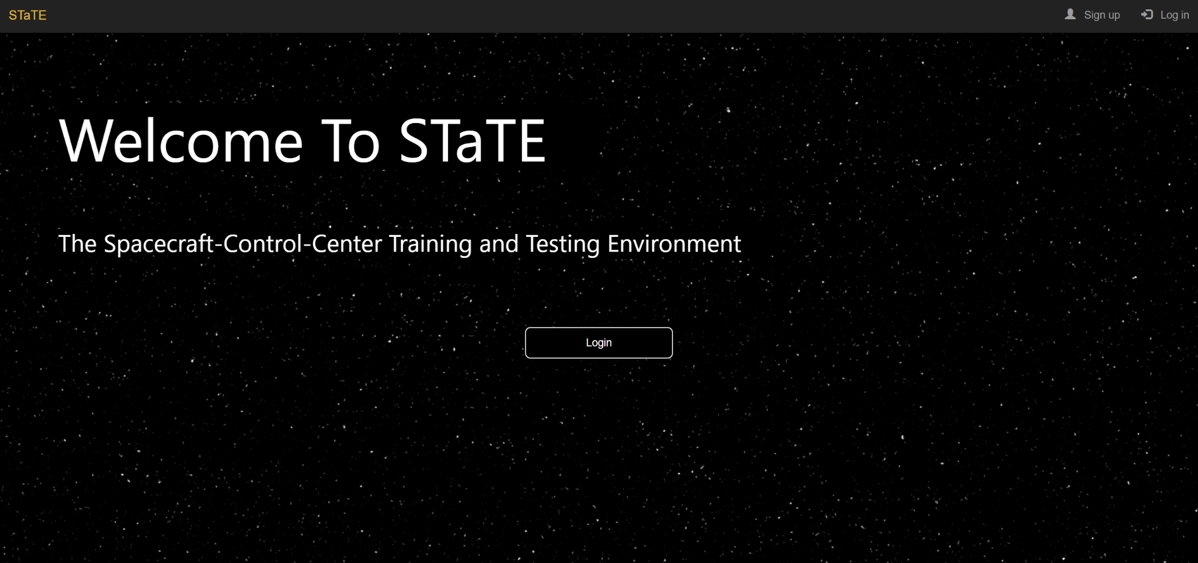

Figure 2: SWA Homescreen

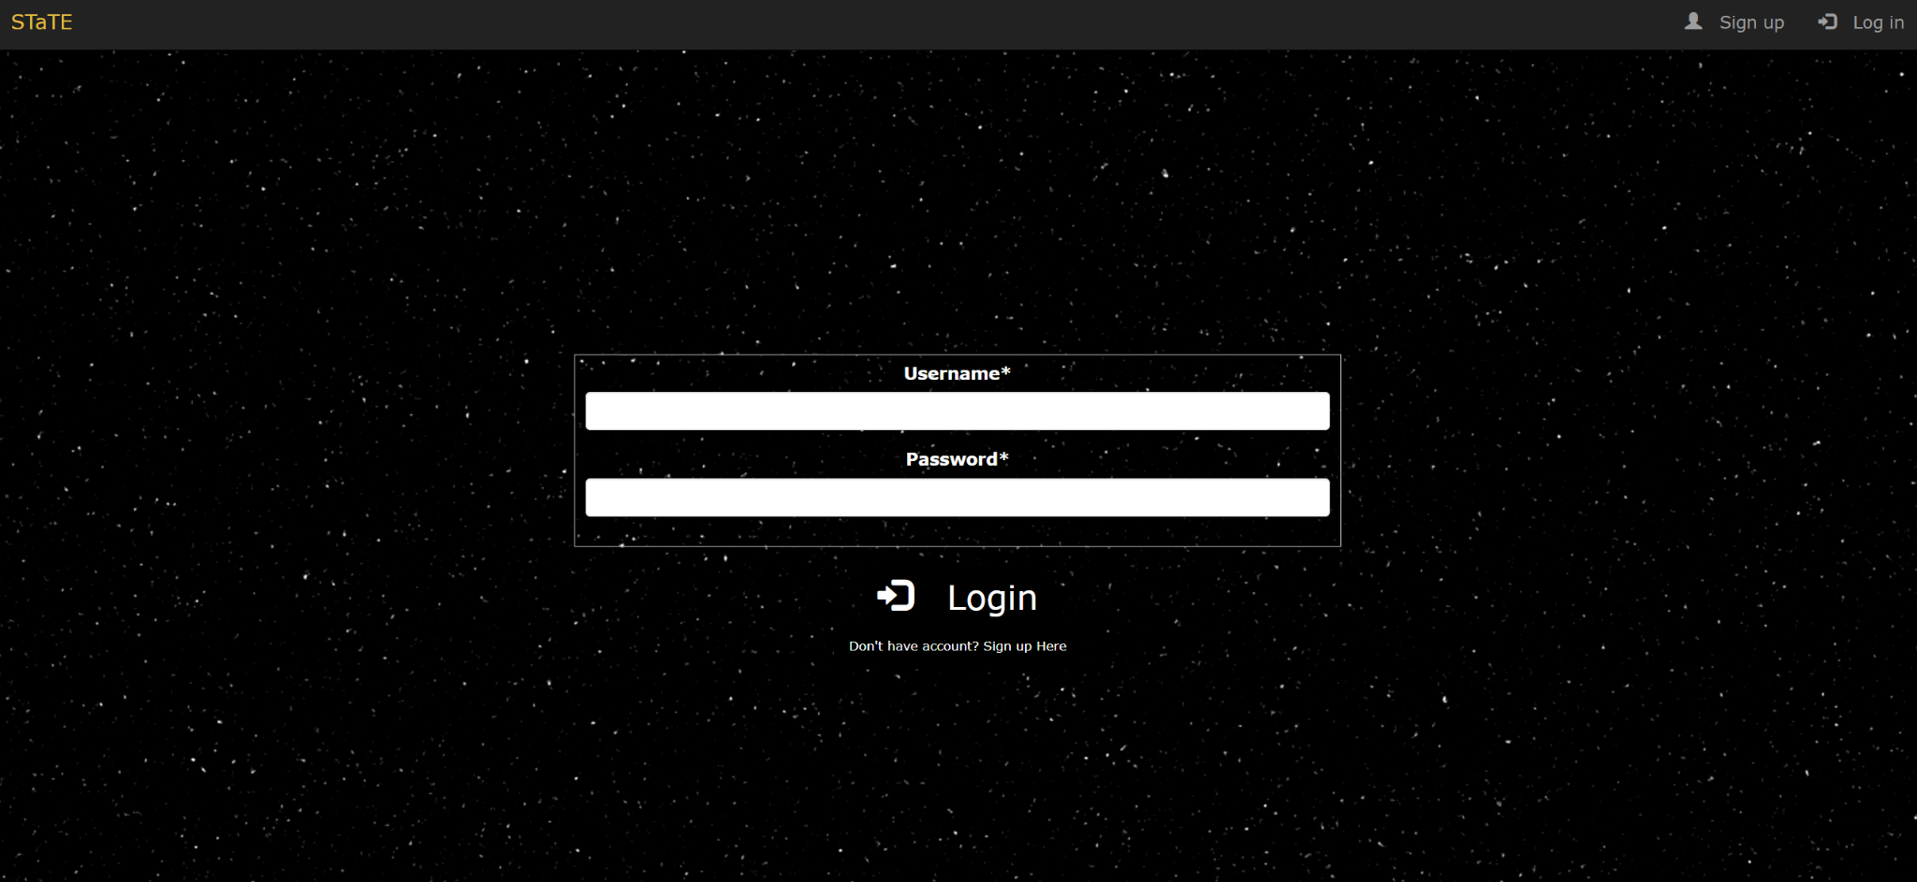

Figure 3: FO and TC Login Page

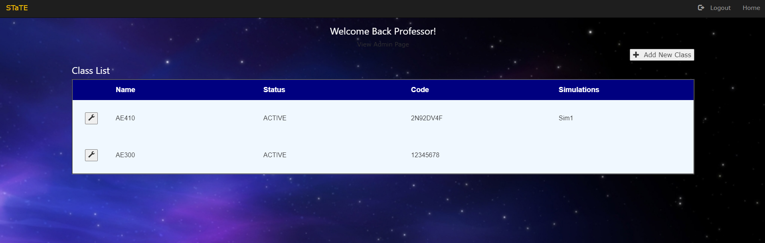

Figure 4: TC Homepage

There are two distinct user interfaces projected for this project: the Flight Operator user interface and the Test Conductor user interface.

The Flight Operator user interface includes a login screen, where the user will be directed to log in to or create their Flight Operator account. These inputs will be interpreted as text box entries or button clicks. The output of a successful Flight Operator login leads to a page change in the simulation(s).

The Test Conductor user interface shares the same login screen as the Flight Operator interface. Though, there is a link that will bring up a login page that is solely for the Test Conductor. Upon successful login, there is a page change that will lead to a dashboard of accessible information to the Test Conductor.

## **Hardware Interfaces**

The primary hardware component expected for the user to use with the system is an internet-connected device that has the capability of inputting commands through the touchscreen display or by keyboard and is capable of running one of the following compatible web browsers:

* Google Chrome
* Microsoft Edge
* Safari
* Chromium-based web browsers

Devices that the users will utilize include devices such as desktops, laptops, mobile devices, and tablets.

## **Software Interfaces**

The Django web application and simulation will connect to a local SQLite database. The web application needs the database to get and verify login data, and the web application saves new users to the database. Once logged in the web application uses the database to create and save simulation data. The simulation needs the database to pull simulation data and set up the simulation based on the TC specifications. The simulation saves simulation results back to the database. The database is required for a simulation to end because there is no communication between the web application and simulation, so the database has a flag that when the simulation reads it as off, the simulation ends.

## **Communications Interfaces**

Software Communication: Being a webpage, the web browsers (also stated above) that this website will be compatible with are:

* Google Chrome
* Safari
* Microsoft Edge
* Chromium-based web browsers

Note: Firefox and possibly some other unlisted browsers have proved to have unwanted defects and they should be avoided.

HTTPS will be the communication standard that the webpage will use. There will be a login system for the web page, so encryption of a password may be needed, however, information like the student’s school email address may serve as enough credentials for the project.

Internal communications architecture includes interactions between the simulation and the database and communications between Django and SWA.

Hardware Communication: All hardware client components will communicate to the host server through browser interaction.

# **System Features**

## SWA - STaTE Web Application

4.1.1 Description and Priority

Priority: High

SWA is a hosted web application that serves as the platform for the project’s sub-applications and features. Top-level site traffic is routed through the STaTE Web Application. SWA also maintains a Home Page, Contact Page, and About Page.

4.1.2 Stimulus/Response Sequences

§ User enters {host domain} into a web browser. SWA responds by displaying the site's Login Page in the browser window.

§ User selects the “Login” button on the Home Page. SWA responds by displaying Flight Operator Login Page defined by Flight Operator User Interface feature in the browser window.

§ Flight Operator selects the “Create an Account” button on the Home Page. SWA responds by displaying Flight Operator Login Page defined by Flight Operator User Interface feature in the browser window.

§ User selects the “Home” button. SWA responds by displaying Home Page in the browser window.

4.1.3 Functional Requirements

SWA-FR-Section-I: Maintained URLs

SWA-FR-1: SWA shall maintain a hosted web application at {host domain}.

SWA-FR-3: SWA shall maintain a Flight Operator Django app at {host domain}/fo/home.

SWA-FR-4: SWA shall maintain a Test Conductor Django app at {host domain}/tc/home.

SWA-FR-Section-II: Home Page Definition

SWA-FR-9: The home page shall display a “Login” button.

SWA-FR-10: The “Login” button displayed on Home Page shall navigate the user’s browser to {host domain}/login when selected.

## FOP - Flight Operator Platform

4.2.1 Functional Requirements

Priority: High

Each student in a group is a Flight Operator (FO). The Flight Operator Platform gives an FO the ability to interact with a control console to change the simulated spacecraft state of their assigned subsystem.

4.2.2 Stimulus/Response Sequence

§ The Flight Operator can edit subsystem data while on the Flight Operator Platform. The Flight Operator Platform responds by passing the Control Console the changes.

§ The Flight Operator Platform passes changes made to a subsystem by the Flight Operator. The Control Console responds by changing the subsystem data to the parameters provided by the Flight Operator Platform.

4.2.3 Functional Requirements

FOP-FR-1: The FOP shall enact a visual change of a subsystem when a student changes a value in an input terminal.

FOP-FR-2: The FOP shall accurately pass user inputs to the control console via commands.

FOP-FR-3: The FOP shall display all subsystems on the SimCraft to which the Flight Operator is assigned.

FOP-FR-4: The FOP shall contain a button on a navigation bar to access the Attitude and Control Subsystem (ACS) webpage at {host domain}/FO/[SimCraft]/ACS.

FOP-FR-5: The FOP shall contain a button on a navigation bar to access the Electrical Power Subsystem (EPS) webpage at {host domain}/FO/[SimCraft]/EPS.

FOP-FR-6: The FOP shall contain a button on a navigation bar to access the Thermal Control Subsystem (TCS) webpage at {host domain}/FO/[SimCraft]/TCS.

FOP-FR-7: The FOP shall contain a button on a navigation bar to access the Communications Subsystem (Comms) webpage at {host domain}/FO/[SimCraft]/Comms.

FOP-FR-8: The FOP shall contain a button on a navigation bar to access the Payload Subsystem webpage at {host domain}/FO/[SimCraft]/Payload.

FOP-FR-9: The FOP shall display SimCraft behavior.

## TCP - Test Conductor Platform

4.3.1 Description and Priority

Priority: High

TC is one of the apps routed to by the SWA. This app serves as the login, verification, and interface for a TC user, assuming login credentials are passed. The TC application maintains a Login Page (AKA TC Page), TC Home Page, TC Class Manage Page, New Mission Page, New Simulation Page, and Simulation Management Page.

* TC Page: The login page for TC users.
* TCHome Page: The home screen for a TC user after login.
* TC Class Manage page: The page a TC would use to create, edit, start, delete, view, and report on all missions and simulations for that class.
* New Mission page: The page a TC would use to create a new mission.
* New Simulation page: The page a TC would use to create a new simulation, select the mission for that simulation, and assign initial conditions and subsystems to students.
* Simulation Interaction Page: The page a TC would use to view an active simulation in a Flight Director view.

4.3.2 Stimulus/Response Sequences

§ User enters {host domain} into a web browser. SWA responds by displaying the site's Home Page in the browser window.

§ User enters {host domain}/Home into a web browser. SWA responds by displaying the site's Home Page in the browser window.

§ User enters {host domain}/login into a web browser. SWA responds by displaying the Login Page in the browser window.

§ User enters login credentials into the respective text boxes. The user selects the “Login” button on TC Login Page. The Test Conductor App (TCA) responds by validating entered data with data in the database. TCA passes or fails the data. The user is routed to {host domain}/TC/home if it passes.

§ Test Conductor selects the “Add New Class”. TCA responds by displaying a popup window in the browser window for the TC to enter a New Class name.

§ Test Conductor selects a specific Class’s name in the table on the TC homepage. TCA responds by displaying the Class Page in the browser window.

§ Test Conductor selects the “New Mission” button on the Class Manage page. The TCA responds by displaying the New Mission page in the browser window.

§ Test Conductor enters the parameters for a new mission and clicks the “Submit” button on the New Mission page. The TCA responds by displaying the Class page in the browser window with the missions table updated.

§ Test Conductor selects the “New Simulation” button on the Class Manage page. The TCA responds by displaying the New Simulations page in the browser window.

§ Test Conductor enters the parameters for a new simulation and clicks the “Submit” button on the New Simulation page. The TCA responds by displaying the Class page and in the browser window with the simulations table updated.

§ Test Conductor selects the [Simulation Name] link in the simulation management table. The TCA responds by showing the Flight Director UI Dashboard.

4.3.3 Functional Requirements

TCP-FR-Section-I: Maintained URLs

TCP-FR-1: TCP shall maintain a hosted web application at {host domain}.

TCP-FR-2: TCP shall maintain a TC Home Page at {host domain}/TC/Home.

TCP-FR-3: TCP shall maintain a Class Management Page at {host domain}/TC/Home/[ClassName].

TCP-FR-4: TCP shall maintain a Simulation Management Page at {host domain}/TC/Home/[ClassName]/[SimName].

TCP-FR-5: TCP shall maintain a New Mission page at {host domain}/TC/Home/[ClassName]/newMission.

TCP-FR-6: TCP shall maintain a New Simulation page at {host domain}/TC/Home/[ClassName]/newSim.

TCP-FR-Section-II: URL Navigation

TCP-FR-8: SWA shall navigate to {host domain}/TC when a user clicks a button to log in as TC.

TCP-FR-9: TCP shall navigate to {host domain}/TC/Home when a user enters the correct login credentials.

TCP-FR-10: TCP shall navigate to {host domain}/TC/home/[ClassName] when a class is selected on the TC homepage.

TCP-FR-11: TCP shall navigate to {host domain}/TC/Home/[ClassName]/newSim when the new simulation button is pressed on the TC Class Management page.

TCP-FR-12: TCP shall navigate to {host domain}/TC/Home/[ClassName] when the new simulation submission button is pressed on the New Simulations Page.

TCP-FR-13: TCP shall navigate to {host domain}/TC/Home/[ClassName]/newMission when the new mission button is pressed on the TC homepage.

TCP-FR-14: TCP shall navigate to {host domain}/TC/Home/[ClassName] when the new mission submission button is pressed on the New Missions page.

TCP-FR-15: TCP shall navigate to {host domain}/TC/Home from any TC Page “Home” button.

TCP-FR-Section-III: TC Login Page Definition

TCP-FR-16: Login Page shall display 2 text boxes: 1 for username, 1 for password.

TCP-FR-17: The login Page shall display a “Login” button.

TCP-FR-Section-IV: TC Home Page Definition

TCP-FR-18: TC Home Page shall display a “Add New Class” button.

TCP-FR-19: The “Add New Class” button displayed on TC Home Page shall open a popup window to define a class name and status.

TCP-FR-20: TC Home Page shall display a table with all active and inactive classes.

TCP-FR-21: The “Settings” button displayed next to every class on TC Home Page shall open a popup window to change the class name, status, and code.

TCP-FR-Section-V: Class Management Page Definition

TCP-FR-22: TC Class Management Page shall display a “New Sim” button.

TCP-FR-23: TC Class Management Page shall display a “New Mission” button.

TCP-FR-24: The “Home” button displayed on the Class Management Page shall navigate the TC user’s browser to {host domain}/TC/Home when selected.

TCP-FR-Section-VI: Simulation Interaction Page Definition

TCP-FR-27: The Simulation Interaction Page shall display information about the active simulations.

TCP-FR-28: The Simulation Interaction Page shall show what the simulation Fight Director sees.

## Control Console

4.4.1 Description and Priority

Priority: High

The simulated control consoles each provide monitoring, command, and control capabilities of a specific system aboard the SimCraft. The console simulations approximate how a real-world control team performs space flight operations procedures. Each console interfaces with the appropriate simulated systems in SimCraft to allow for monitoring and control of those systems.

4.4.2 Stimulus/Response Sequence

§ The Flight Operator Platform passes the Control Console the user inputted changes. The Control Console responds by passing the changes to SimCraft.

§ SimCraft passes the Control Console updated subsystem data. The Control Console responds by updating the interface for the user to see.

§ SimCraft passes the Control Console what data to flag. The Control Console updates the interface with the correct flag.

4.4.3 Functional Requirements

Note: Each section is one iteration of a Control Console.

Control Console-FR-Section I: The ACS console

Control Console-FR-1: The Control Console shall present the indicators given by SimCraft.

Control Console-FR-2: The Control Console shall allow commands for the control moment gyroscope (CMG) roll, pitch, and yaw angle ranges.

Control Console-FR-3: The Control Console shall allow commands for the telemetry transfer.

Control Console-FR-4: The Control Console shall allow commands to verify the signal status.

Control Console-FR-Section II: The EPS console

Control Console-FR-5: The Control Console shall provide monitoring capabilities for the Electrical Power Subsystem.

Control Console-FR-6: The Control Console shall allow commands for the solar panel electrical charge and dissipation.

Control Console-FR-7: The Control Console shall allow commands for the telemetry transfer.

Control Console-FR-Section III: The TCS console

Control Console-FR-8: The Control Console shall provide monitoring capabilities for the Thermal Control Subsystem.

Control Console-FR-9: The Control Console shall allow commands for cooling of the Comm’s transceiver, antenna, and amplifier attributes.

Control Console-FR-10: The Control Console shall allow commands for cooling of the ACS’s CMGs and sensor attributes.

Control Console-FR-11: The Control Console shall allow commands for cooling of the payloads camera attribute.

Control Console-FR-14: The Control Console shall allow commands for cooling the EPS solar panel and battery temperature attributes.

Control Console-FR-15: The Control Console shall allow commands for the telemetry transfer.

Control Console-FR-Section IV: The Communications Console

Control Console-FR-16: The Control Console shall provide monitoring capabilities for the Communications Control Subsystem.

Control Console-FR-17: The Control Console shall receive telemetry data from the ACS, EPS, TCS, and payload subsystems.

Control Console-FR-18: The Control console shall allow commands to upload data acquired to complete the mission.

Control Console-FR-Section V: The Payload Console

Control Console-FR-19: The Control Console shall provide monitoring capabilities for the payloads.

Control Console-FR-20: The Control Console shall allow for monitoring and updating the gimbal of the imager.

Control Console-FR-21: The Control Console shall allow for monitoring and updating the slew of the imager.

Control Console-FR-22: The Control Console shall allow a command to capture a photo.

## SimObject

4.5.1 Description and Priority

Priority: High

Simulation environment for a spacecraft. Will be the class that actually runs all threads using initial conditions given to it by the Test Conductor using it to update Simcraft objects created and managed by the SimObject.

4.5.2 Stimulus/Response Sequences

§ The Test Conductor interacts with SimObject attributes. The SimObject responds by altering an initial condition of a soon-to-be-deployed SimCraft.

§ The student will interact with the simulation through the web page as a Test Conductor or Flight Director/Operator.

4.5.3 Functional Requirements

SimObject-FR-Section-I: Attitude and Control Subsystem Console

SimObject-FR-1: The SimObject Attitude and Control console shall control the SimCraft in a Low Earth Orbit (LEO).

SimObject-FR-2: The SimObject Attitude and Control console shall control sensors related to the Attitude and Control Subsystem, with nominal and off-nominal values.

SimObject-FR-Section-II: Electrical Power Subsystem Console

SimObject-FR-3: The SimObject Electrical Power console shall provide power to SimCraft via power stored in the system’s batteries.

SimObject-FR-4: The SimObject Electrical Power console shall distribute power as needed to the payload.

SimObject-FR-5: The SimObject Electrical Power console shall have the ability to distribute power to the payload as needed, with excess power stored in the system’s batteries.

SimObject-FR-6: The SimObject Electrical Power console shall have the ability to distribute power in the batteries to the SimCraft when the object is within Earth’s shadow.

SimObject-FR-7: The SimObject Electrical Power console shall monitor solar panel power production, related to the angle of incidence with the sun, where the angle of incidence is defined as the angle between a line normal to the surface of the solar panel and the line pointing to the SimCraft to the sun.

SimObject-FR-8: The SimObject Electrical Power console shall have the ability to control the angle of incidence of the SimCraft only to one degree of rotational freedom.

SimObject-FR-9: The SimObject Electrical Power console shall monitor the ACS, presumed to maintain an incidence angle of +/- 5 Degrees when operating normally, allowing for maximal energy capture during the daylight portion of the SimCraft orbit.

SimObject-FR-Section-III: Thermal Control Subsystem Console

SimObject-FR-10: The SimObject Thermal Control console shall control SimCraft's internal temperature.

SimObject-FR-11: The SimObject Thermal Control console shall control thermal exposure in a new attitude position.

SimObject-FR-Section-IV: Communications Subsystem Console

SimObject-FR-12: The SimObject Communications console shall control SimCraft's communication between the Ku-Band satellite antenna and a group station antenna.

SimObject-FR-13: The SimObject Thermal Control console shall control transmission frequencies and gain values to process and transmit images.

SimObject-FR-Section-V: Payload Subsystem Console

SimObject-FR-14: The SimObject Payload console shall control SimCraft's ability to capture the imagery of a target during a flyover period based on GPS coordinates.

## SimCraft

4.6.1 Description and Priority

Priority: High

Classes and Methods hold all information relating to the spacecraft/satellite. Will be created and managed by SimObject.

4.6.2 Stimulus/Response Sequences

§ SimObject creates SimCraft based on mission type and initial conditions.

§ SimCraft returns information when requested by the SimObject via the use of AJAX.

4.6.3 Functional Requirements

SimCraft-FR-Section-I: Attitude and Control Subsystem

SimCraft-FR-1: The Attitude and Control Subsystem shall monitor the spacecraft's angle of incidence toward the sun and Earth using GPS coordinates.

SimCraft-FR-2: The Attitude and Control Subsystem shall monitor the spacecraft's degrees of freedom as roll, pitch, and yaw degree values.

SimCraft-FR-3: The Attitude and Control Subsystem shall monitor the spacecraft’s CMG roll, pitch, and yaw values to determine the spacecraft’s angular acceleration.

Simcraft-FR-Section-II: Electrical Power Subsystem

SimCraft-FR-4: The Electrical Power Subsystem shall monitor the spacecraft orbit and solar arrays alignment showing energy gathering efficiency.

SimCraft-FR-5: The Electrical Power Subsystem shall monitor the spacecraft’s electrical status and command full power to the satellite in preparation for the payload power needed to capture an image.

SimCraft-FR-6: The Electrical Power Subsystem shall monitor the spacecraft’s signal status and stability between the Ku-Band satellite antenna and a ground station.

Simcraft-FR-Section-III: Thermal Control Subsystem

SimCraft-FR-7: The Thermal Control Subsystem shall monitor the spacecraft’s internal temperature to prevent overheating or over-cooling in a new attitude position.

SimCraft-FR-Section-IV: Communication Subsystem

SimCraft-FR-8: The Communication Control Subsystem shall monitor the spacecraft’s wireless connection with ground stations.

SimCraft-FR-9: The Communication Subsystem shall monitor the spacecraft’s signal status and stability between the Ku-Band satellite antenna and a ground station.

SimCraft-FR-Section-V: Payload Subsystem

SimCraft-FR-10: The Payload Control Subsystem shall monitor the spacecraft’s geological position above the earth given by GPS coordinates.

# **Other Nonfunctional Requirements**

## **Performance Requirements**

The performance of the system will be based on key assumptions that are based on the requirements of the customer. To reiterate, this product is to be used as a student learning tool for a high-level class that is taught primarily in person. With this in mind, we can expect a relatively low number of local users.

The assumptions of the users going forward will be the following:

* The maximum number of users is expected to be 50 individual users, where each user is connecting from a different device.
* The location of the user is going to be in the same region as the location of the hosting of this product.
* Because of the two campuses of ERAU, and due to the uncertainty if this product will be used in the Prescott Campus, this product will take into consideration the possible student body connecting from Prescott in conjunction with the students connecting from Daytona Beach.

Efficiency

PR-1: The program shall not exceed a response time of 10 ms from connections made in the United States unless the current number of users exceeds the maximum number of users.

PR-2: The program shall not exceed a response time of 20 ms from the connections made in the United States unless the current number of users exceeds double the maximum number of users.

PR-3: The program shall be capable of running 15 simulated missions in tandem while connected with the maximum number of users.

PR-4: Local spacecraft data written regarding a simulated spacecraft shall not exceed 2 GB in size per simulated mission.

Reliability

PR-5: The program shall update data transmitted to the connected user no less than every 5 seconds.

PR-6: The program shall save all flight conductor and flight operator inputs entered through the terminal.

Survivability

PR-7: In the event that the program suffers an error that ceases runtime, the program shall not lose any local data regarding conductor inputs.

## **Safety Requirements**

No safety requirements as there is no physical component to the application.

## **Security Requirements**

For security requirements, the only people who shall access this webpage are the intended users and the developers.

Intended users are defined as the teachers, teacher assistants, and students of ERAU.

Teachers and teacher assistants shall be the only ones in the intended user group that shall be allowed to read and alter the simulation, as well as any saved data. Teachers and teacher assistants shall also be able to access Flight Operator, Flight Conductor, and Test Conductor controls.

Students can access the webpage, but only with Flight Operator accounts.

The team will be aware that improper awareness of the safety/security risks could possibly lead to consequences not only for the project but also for the university.

Possible harm that can come from using the simulation/webpage will come from any unintended vulnerabilities that may arise when using a server. Currently, as it stands, only developers have access to the simulation code and webpage code, but without proper care, an ERAU IT vulnerability may be present.

The team will be aware that improper awareness of the safety/security risks could possibly lead to consequences not only for the project but also for the university.

## **Software Quality Attributes**

**5.4.1 - Usability**

SQA-1: The program shall be when given a physical script provided by a TC.

SQA-2: After login, both user interfaces shall have a locatable navigation pane on each page.

SQA-3: After login, both user interfaces shall have a “Logout” button on each page.

SQA-4: On the login page, the username vs password text box must be clearly marked.

SQA-5: On the login page, there must be a marked and “Login” button.

SQA-6: The program shall allow for teachers to set up a mission in 7 clicks.

SQA-7: The program shall allow for teachers to deploy a SimCraft after creating a mission in 10 clicks.

**5.4.2 - Interoperability**

SQA-8: The program shall be cross-platform compatible with all major browsers as of writing this document (April 2023).

**5.4.3 - Reusability**

SQA-9: The program shall be reusable, so that it may act as a teaching tool long after the project’s development.

**5.4.4 - Maintainability**

SQA-10: The program shall be reliable so that the department using this program will not have to (a) go through the code, or (b) employ further senior design groups to attempt to fix the program once developed to the scope of the remainder of the semester.

## **Business Rules**

* Only professors/instructors should have the role of Test Conductor unless stated otherwise
* Flight Director and Flight Operators are assigned by Test Conductor

# **Other Requirements**

## 6.1 - Database Requirements

DR-1: The database shall store users, simulations, and missions.

DR-2: The database shall be able to send and receive data sets from the program.

**Appendix A: Glossary**

DR - Database Requirement.

FOP - Flight Operator Platform.

FR – Functional requirement. Describes an atomic piece of system functionality that is testable.

HTTPS - Hypertext Transfer Protocol Secure

SimCraft - Simulated spacecraft. Within the STaTE system, these are created by a test conductor and managed by a flight operator.

STaTE – Spacecraft-Control-Center Training and Training Environment.

SWA – STaTE Web Application.

TCP - Test Conductor Platform.

URL – Uniform Resource Locator.