1. In the MQTT protocol, the QoS has three different flags which 0 stands for at most send once, 1 stands for at least send once and 2 stands for send once only. All three of QoS level has initial handshake which are

- Sent the connect command from client,

- Server sent the acknowledgement back to client,

- The client sent the subscribe request,

- Subscribe acknowledgement send from Server.

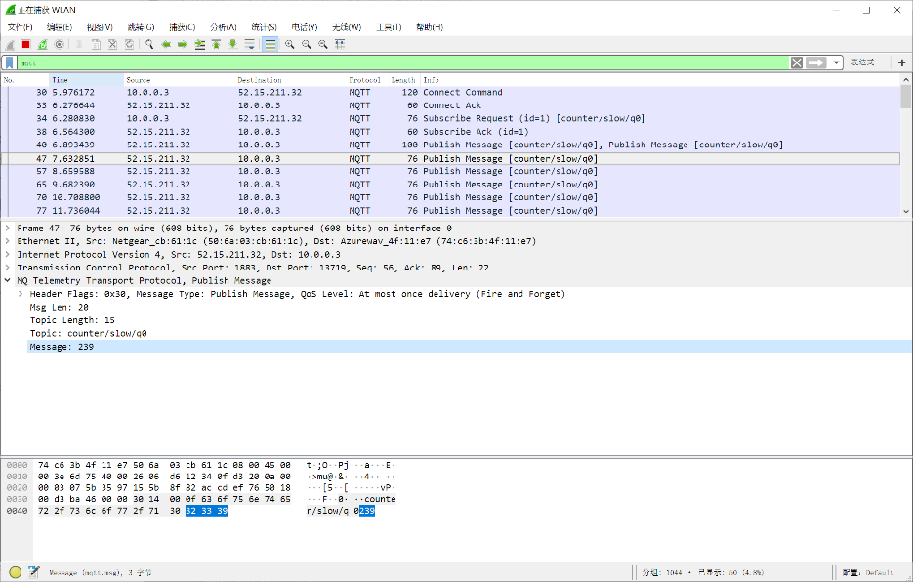However, each QoS level has different message handshakes. When the QoS level is 0 each message at most send once. There is no extra handshake, the server will send the message only. Thus, the server will not get any acknowledgement from clients. In this case, some message could be lost if the connection between the sever and clients is not stable. Nowadays, this level could be used for the environment sensor data transportation, lost some packages is not critical in this case because the newer data will be sent very soon.

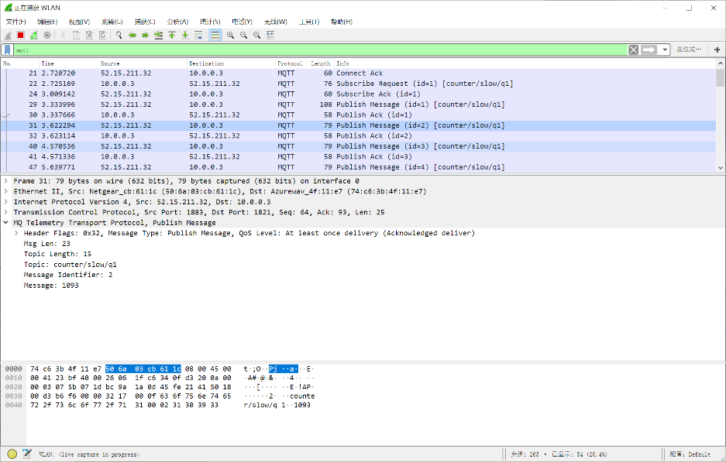When the QoS level is 1, each message will be sent at least once. In this case, the client will send an extra acknowledgement back to sever to ensure the client has received that message successfully. If the server did not receive that acknowledgement on time, the server will send that message again. However, if the client communication jammed to cause the receiving acknowledgement not sent out on time the server will send same message as well. Thus, that may cause duplicate packages. This level could be used for

When the QoS level is 2, which send one package exactly once. In this case, there are 4 steps between the server and the client for each package. Firstly, the server will send the message to clients. Secondly, the client will send the receiving acknowledgement to server. Thirdly, after the server receive that acknowledgement, server will send to client again about that publish is released. Finally, the client will send back to server about the publish is complete. Compare with level 0 and 1, this level is the most complicate QoS level. It requires 4 communications for each message. Due to that, this level also cost the more time than level 0 and 1. However, level 2 is the most reliable QoS level. It will guarantee the message arrived successfully and without duplicate in most time. Due to the reliability, the level 2 could use for paying system. Usually, the duplicate and lost message might cause incorrect amount to pay. But the level 2 will not generate the lost and duplicate message in the most of time.

However, in the situation which the sever sending a lot of message fast. The CPU usage and memory are not infinity big on both client machine and server. Furthermore, the QoS level 2 cost a lot of time for sending each message. Thus, in that situation the server or client will drop some message due to there not fast enough to handle all message in that speed or insufficient memory. That dropping packages will show as lost packages in the sequence of MQTT 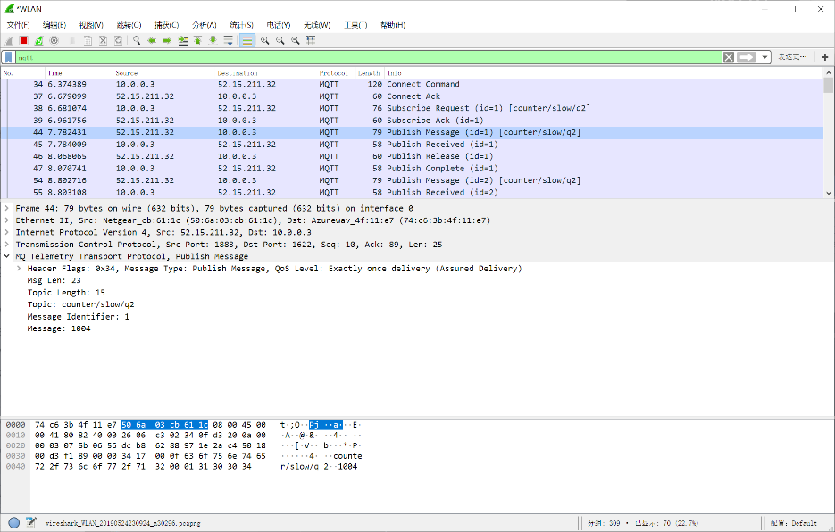message.

2.

3.

4.