Appliance Warehouse – Service Department

Hi Carlie,
I hope this email finds you well! I wanted to update you on the progress regarding the object model and use case diagram for the new Service Information System (SIM) for Appliance Warehouse's Service Department. I have successfully identified the key entities—technicians, customers, appointment setters, and the Parts Department—and outlined their interactions in the use case diagram.
Additionally, I have created the object model, detailing the attributes and methods associated with each entity, as well as the overall data model. Following your request, I have also included three instance examples for each entity based on the data library and the organizational chart below.

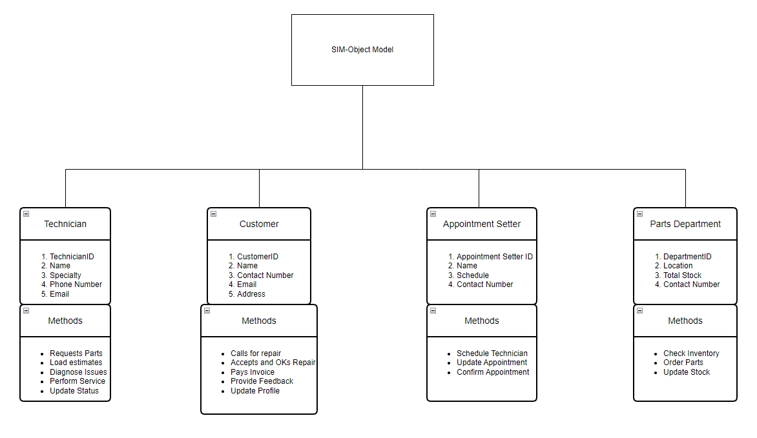
Object-Model for the new SIM system.

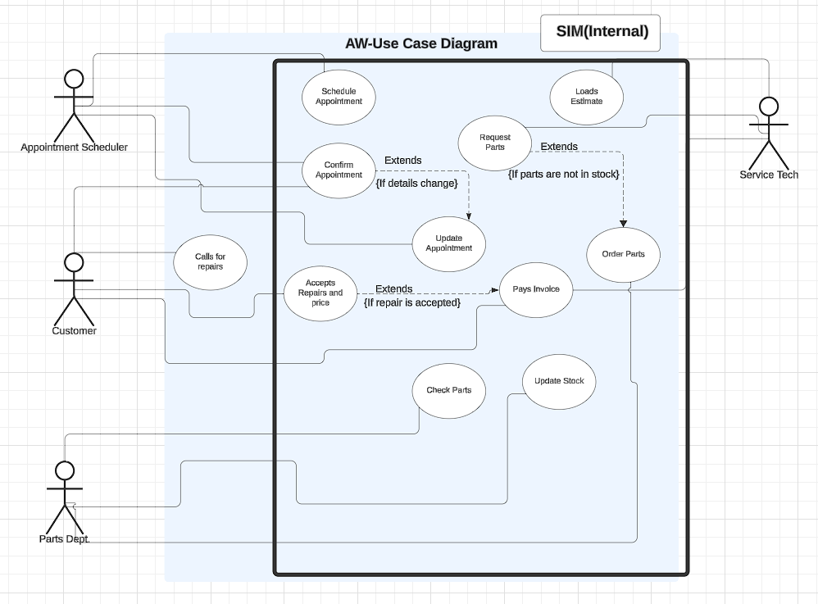
Use Case Diagram

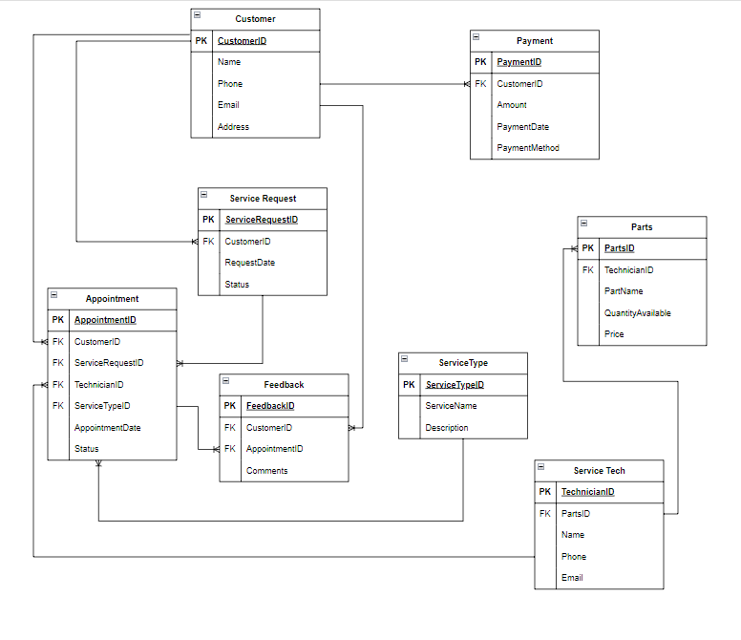
Data Model

Create 3 instance examples for each of the entities.
- I suggest that you use the data library and previously developed organizational chart to find examples.
