Appliance Warehouse Appointment Management System: ERD and Database Design

Hi Carlie,
I hope you're doing well!
I received your message about the database admin being available next week. I'll focus on the ERD and database design this week, using the entities from the DFD and Use Case Diagram. I'll ensure to prioritize 1:1 and 1
relationships, and use M
relationships sparingly. Once the ERD is done, I'll move on to designing the tables in 3NF.
Below is the ERD. After this, I'll create the database tables.
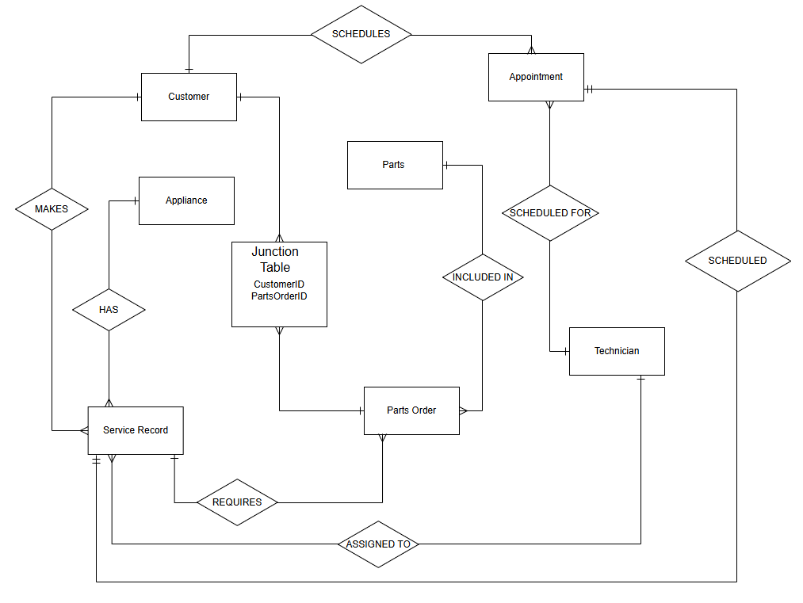
Let me know if you need anything from me.
Hi Carlie,
I hope you’re doing well.
As per your request, I have attached the database tables with the primary keys (PK), foreign keys (FK), and all necessary fields in 3NF, as required. I’ve also ensured that the appropriate fields are highlighted for clarity, including the primary keys.
Please let me know if you need any additional adjustments or if there’s anything further, you’d like me to do. I’m happy to clarify any details if needed.
Thank you for your time, and I look forward to hearing your thoughts.
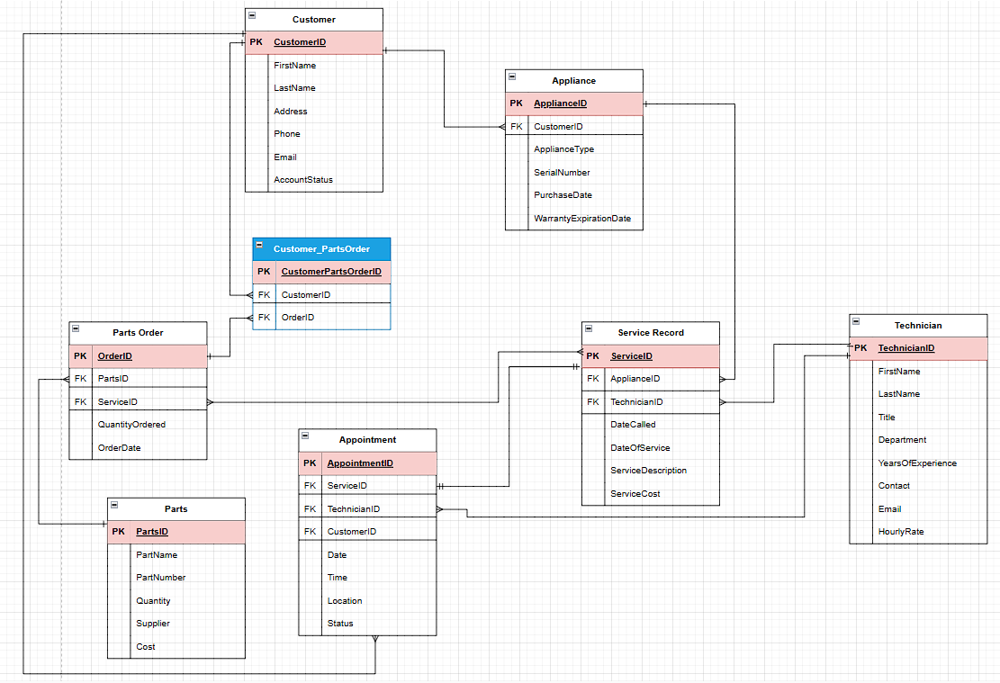

Hi Carlie,
I wanted to let you know that I've added three sets of "dummy" data to each of the tables, as requested. This will allow us to better assess the field sizes and data types. I’ve also referenced some of the sample data from the data library to help populate the records.
Feel free to let me know if you need any additional changes or if you have any questions about the data.
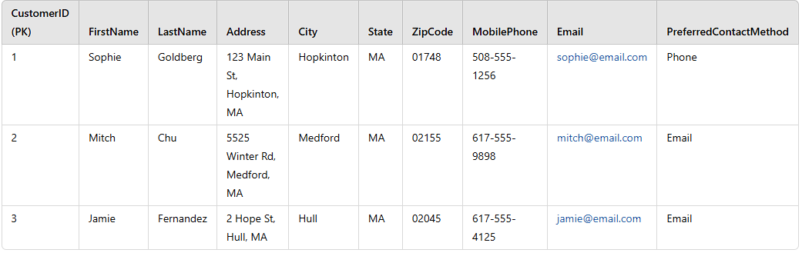
Wishing you a great weekend!
