Bellabeat Case Study: Fitbit Smart Device Data Analysis

Jessica Nalli

Date: 07-09-2025

**Objective:**

To analyze user activity and sleep data to uncover patterns in engagement and wellness. The goal is to identify trends in daily usage, peak activity hours, and sleep quality, and to provide recommendations that can improve user habits and overall app engagement.

* The dataset used in this analysis comes from the FitBit Fitness Tracker Data available on Kaggle (CC0: Public Domain). It contains daily activity and health data collected from 30 eligible FitBit users who consented to share their information.
* The dataset spans March–May 2016 and includes three tables: Daily Activity, Hourly Activity, and Minute Activity. These were cleaned and merged to analyze consumer smart device usage trends, which can inform Bellabeat’s product and marketing strategy.

**Tools Used:**  
  
• Excel (exploration)  
• SQL (data cleaning)  
• Tableau (visualization)

**Visualizations and Insights:**

Chart 1: Comparison of average daily steps

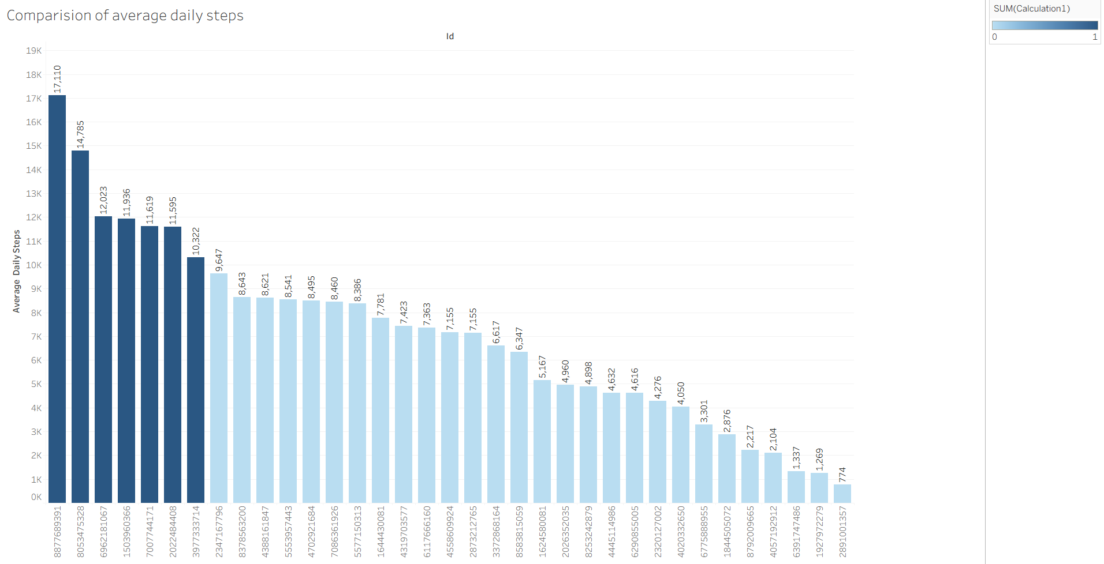

Calculates average daily steps for each user. It helps to identify general activity level of each person. Useful as baseline metric.

Chart 2: Step Goal

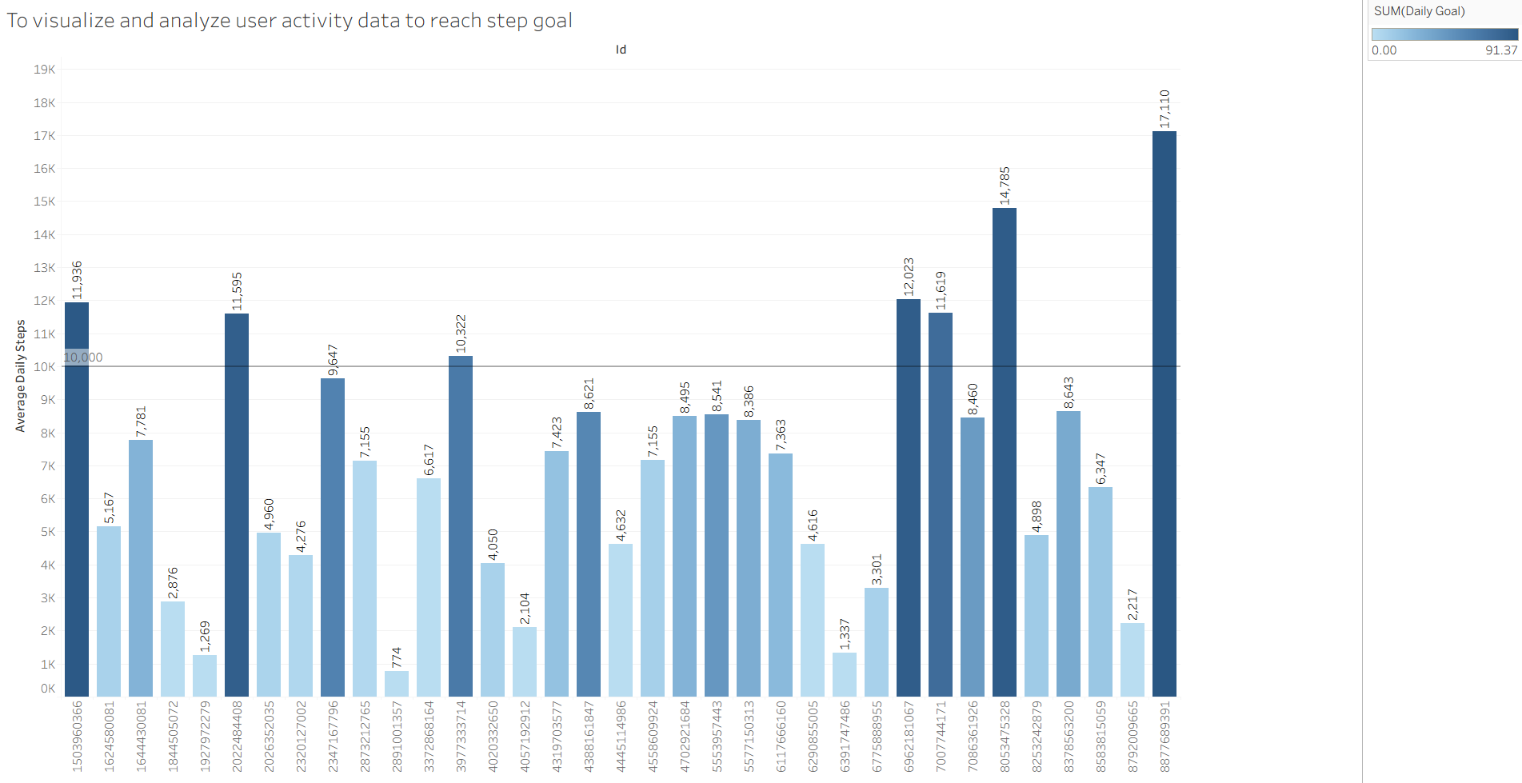

it is in bar chart that visualizes the average daily steps for various users. The bars are sorted and coloured to make them easy to read. A reference line has been added at 10k step mark. I have created a calculated field that show various goal. Like if it reaches above 10k the they reached goal. if not then, do not meet.

Chart 3: Correlation between steps, calories and distance burned

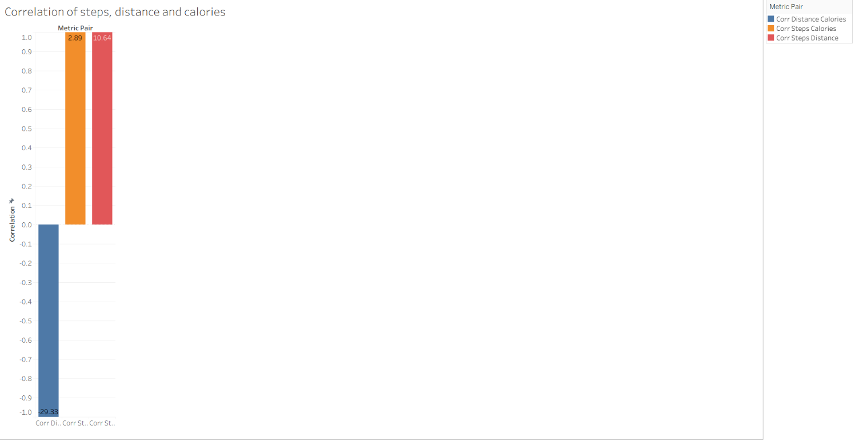

Used bar chart to effectively display the correlation coefficients for each metric pair. A correlation value between -1 and 1 indicates the strength and direction of the relationship.

Chart 4: Active vs Sedentary Time

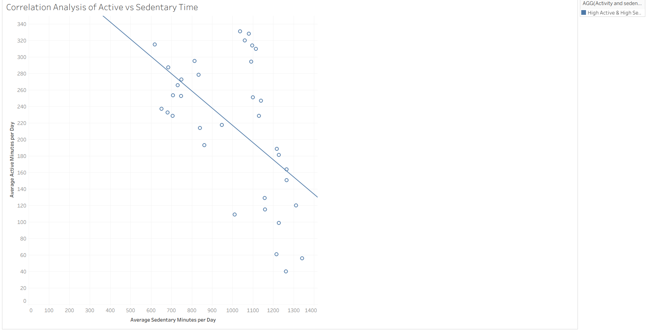

This scatterplot shows the relationship between average sedentary minutes per day(x-axis) and average active minutes per day(y-axis). Each dot represents a user. The trend line added indicates the overall direction of the relationship.

WHO suggests adults should get 150-300 min/week of moderate intensity of 70-150 min/week activity. this suggests for higher intensity activity rather than just light movement.

Chart 5: Sleep and Sedentary Thresholds

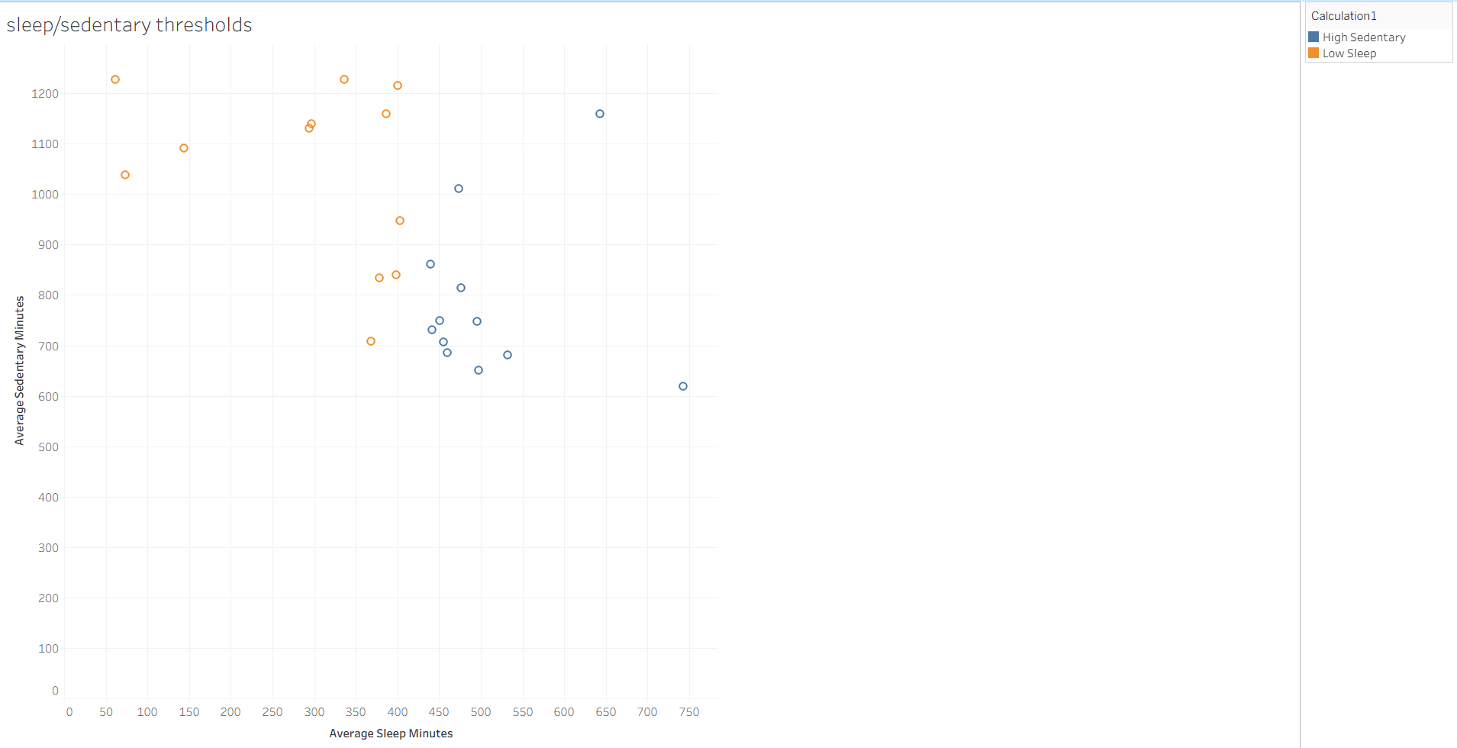

This scatterplot compares average sleep duration with sedentary time. The threshold based coloring highlights two groups of users. The chart suggests that higher sedentary time often coincides with moderate sleep ranges, though the relationship is not strongly linear. This visualization helps identify behavior clusters among users.

According to health guidelines from WHO, adults should sleep up to 7-9 hrs daily.

less than 7 hours is sleep deprived which may lead to fatigue, stress, reduced focus, and long-term health issues.

between 7-9 hrs is good sleep. it is considered as the most balanced and restorative.

more than 8-9 hrs are long sleeper could be ok for recovery, but consistently oversleeping may signal low activity or health issues.

and for sedentary min 720 min = 12hrs of being sedentary means only sitting and inactive. health studies show that sitting more than 8 hrs is linked to higher risks of obesity, diabetes, and heart disease.

more than 12hrs is considered very high-risk And less than 8hrs sedentary is healthier (low risk)

Chart 6: Sleep Patterns

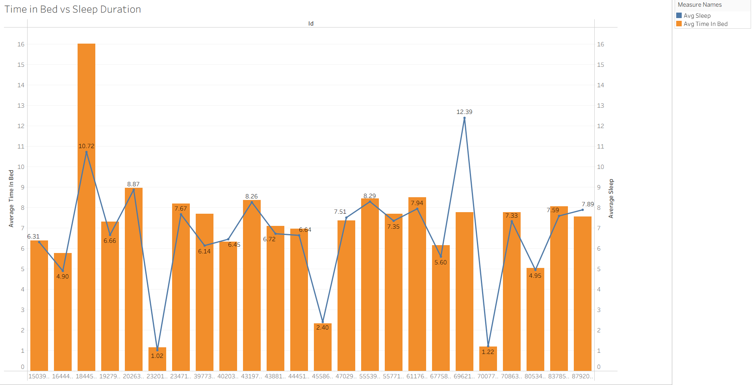

This dual-axis chart compares average time in bed(line) with average sleep duration(bar) for each user. It shows whether more time in bed leads to more actual sleep or not. We can clearly see the difference that some users have big gap, meaning inefficient sleep, while others have small gaps meaning they use their time in bed more efficiently.

Chart 7: Weekend vs Weekday Activity

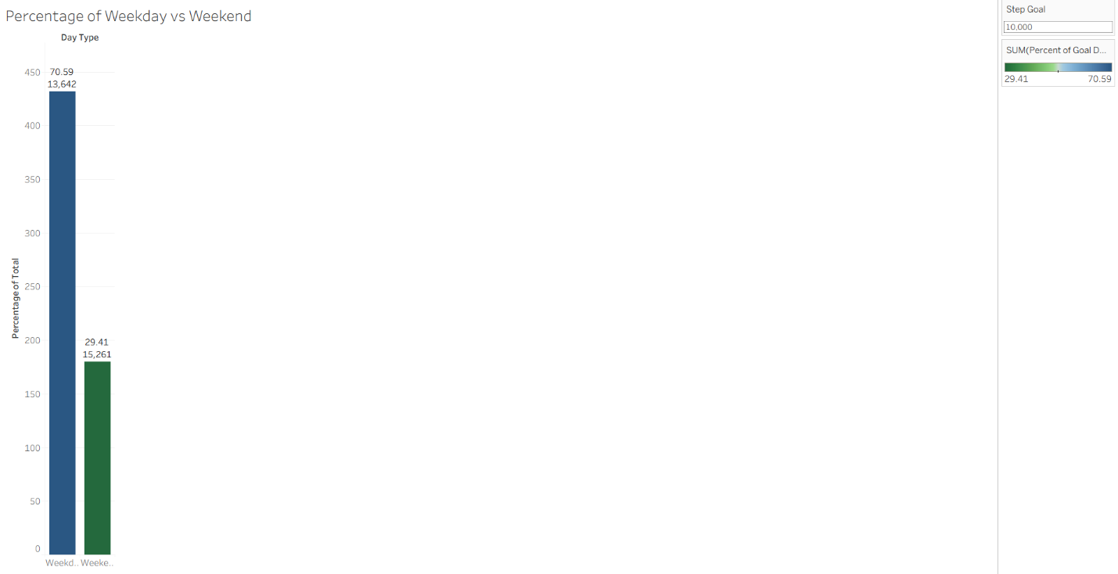

this groups steps by day of week. it shows the people who reached the goal whether they are active in weekends or weekdays. And are they completing the goal in the week not only daily . it helps to identify behavioural patterns.

Chart 8: Peak activity per user

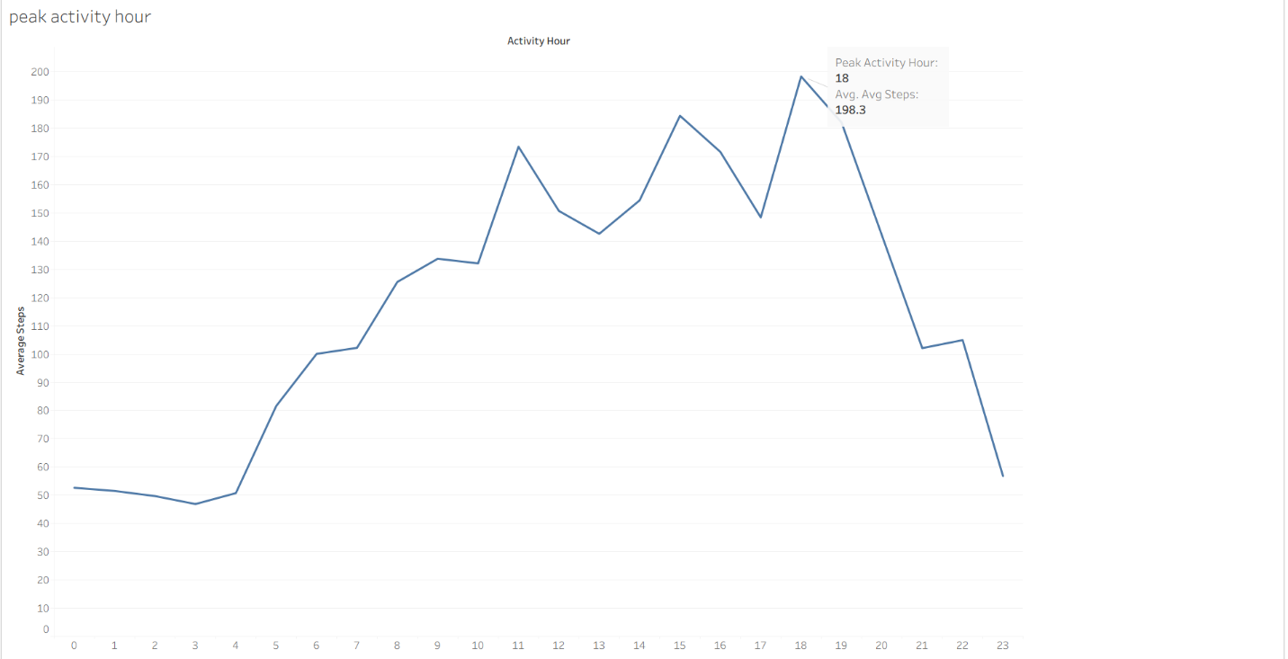

Peak activity hours are the times of day when engagement, traffic or workload is at highest.

The peak hour is at 18 with average of 198.3 steps.

Chart 9: Calories burned per day

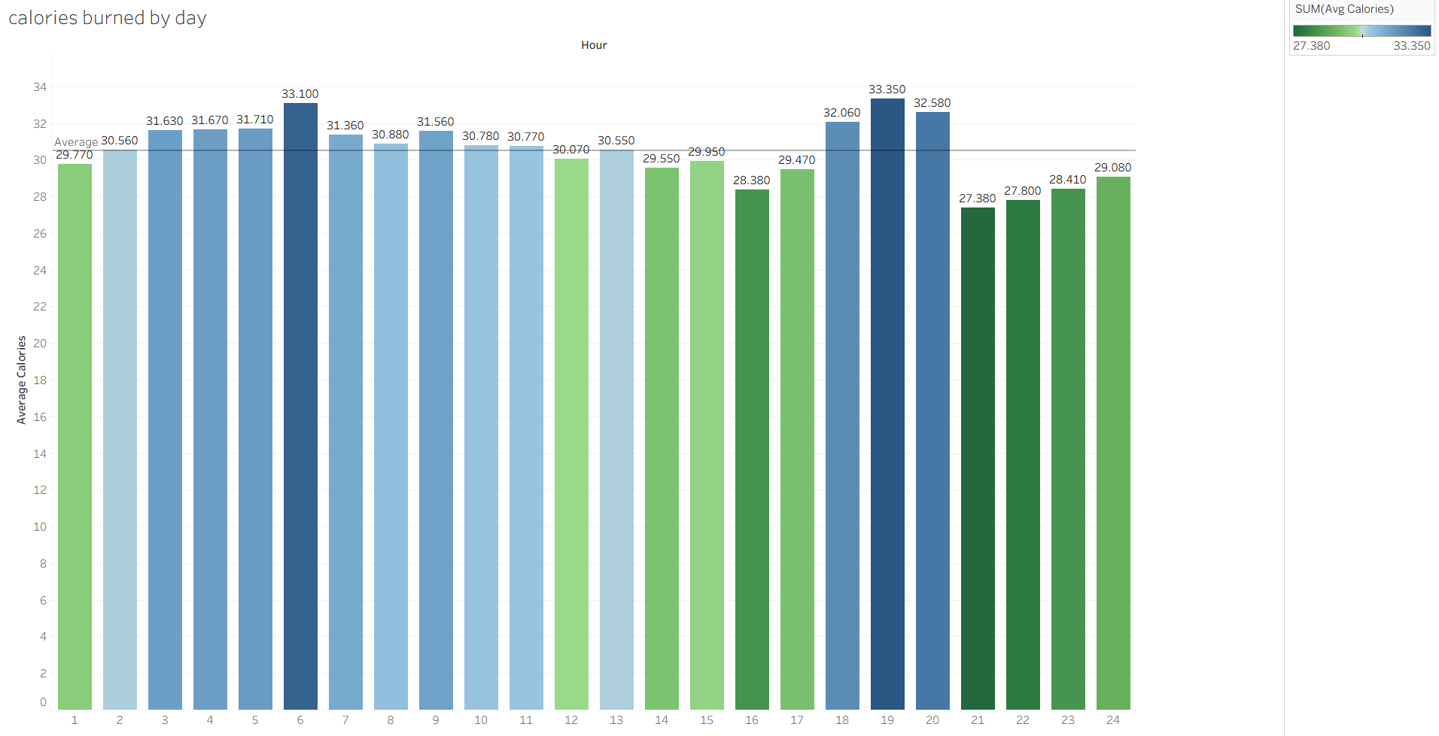

Calories burned per day is the total amount of energy your body uses in 24 hours. This includes the energy needed to keep your body alive and functioning.

Chart 10: METs per week

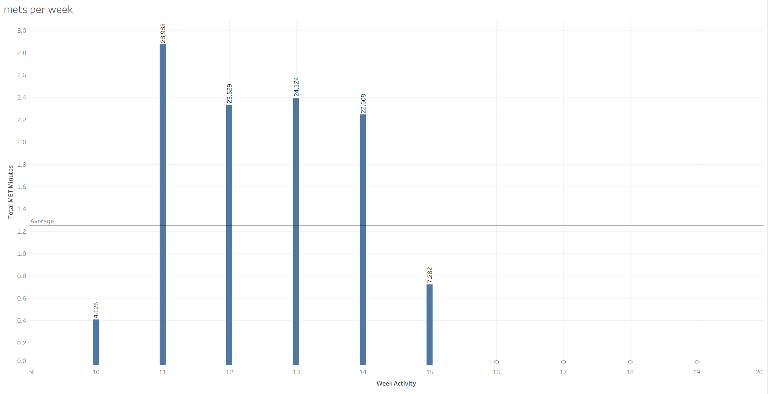

METs per week measure the total energy spent on physical activity over seven days. They are calculated by multiplying the MET value of an activity by the time spent and summing across the week. Health guidelines recommend aiming for 500-1000 MET-minutes per week for good health.

MET - metabolic equivalent of task is a ratio of energy expanded during an activity to the energy expanded art rest.

1met = the energy you use wheile sitting quietly. which is 3.5ml of oxygen per kg of body weight per min.

Chart 11: Weekly Activity minutes by intensity zone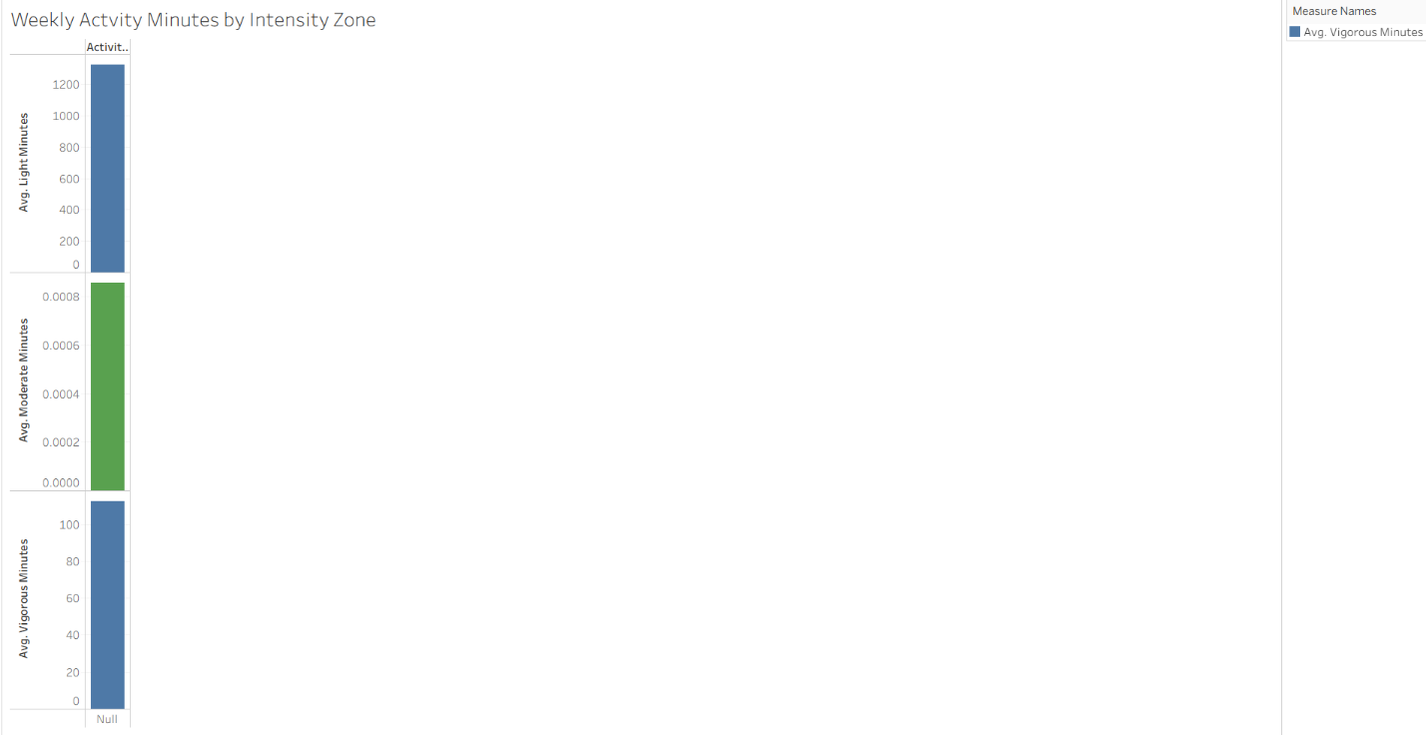

Weekly activity minutes by intensity zone show how much time a person spends in light, moderate and vigorous activity levels. These zones are based on effort or heart rate, and tracking them helps access whether activity meets health guidelines.

**Recommendations:**

* Encourage regular usage through reminders, notifications or scheduled challenges that motivates daily activity.
* Add short walks or stretching breaks in the morning and midafternoon to reduce long sedentary periods.
* If possible, maintain some level of activity earlier in the day to build a steadier rhythm rather than concentrating more steps in the evening.
* Avoid late night screening time, irregular work hours. And aim for a consistent sleep routine.
* Promote sleep quality, not just time in bed.
* To improve overall sleep health, interventions should focus on enhancing sleep quality, reducing disturbances, and promoting consistent sleep habits across months, especially during periods with lower averages.
* Focus on boosting activity on low steps days throughout targeted challenges, reminders or community engagement while building on Saturday’s momentum to maximize overall weekly step counts.

**Conclusion:**  
  
The analysis shows that user engagement and wellness can be strengthened by focusing on consistent activity, improved sleep quality, and targeted app features**.** Implementing these recommendations will not only help users build healthier habits but also enhance long-term engagement with the Bellabeat app.

These insights provide actionable strategies for Bellabeat to promote healthier lifestyles and strengthen its competitive position in the wellness technology market.