**INSTALLATION AND CONFIGURATION OF CENTOS-7**

This file will take you through installation and configuration of CentOS-7. Note that any Unix flavor you prefer would work will produce almost the same output. Now, we will be looking into the set up of our work environment.

My system runs on windows 10 OS. I had to install a VMware to run Linux.

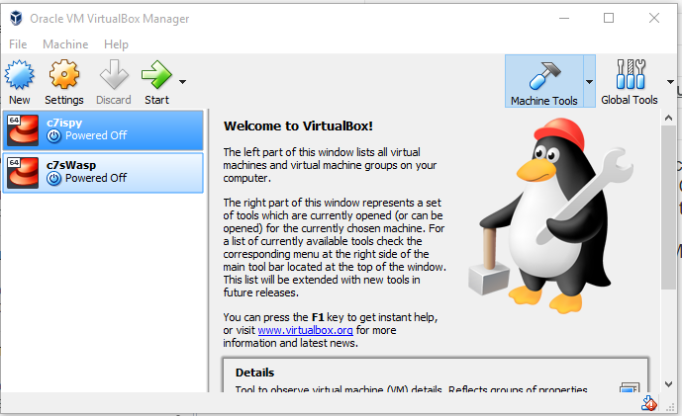

There are two type of network you can configure the server of your VM:

a. Dynamic server which receives its ip address from the router,

b. Static server with ip address given by you.

I will be setting up a dynamic server for the VM.

1. Verify Network by running the command prompt on your system and typing "ipconfig"

http://127.0.0.1:54549/attach/o1555266055x0004

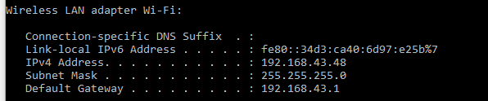

 Now, let us install and configure CentOS-7

2. Click on the "New" icon

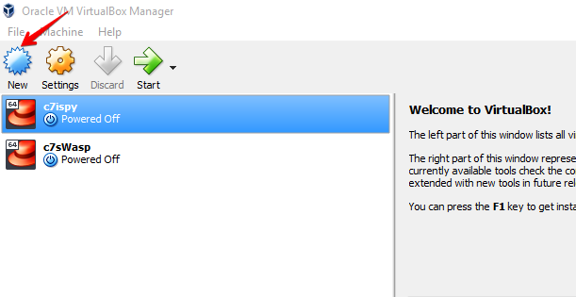

3. Insert name of server (any name), type = Linux and version = red hat (64-bit)

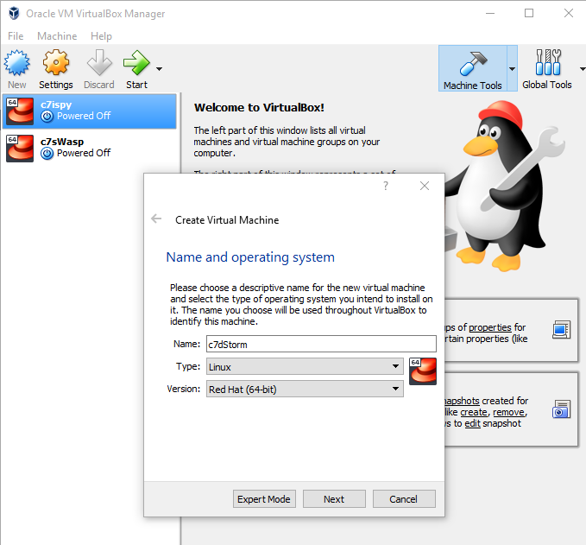

4. Click next for "Memory size" 1024MB (This is dependent of how much space you can allocate for the VM)

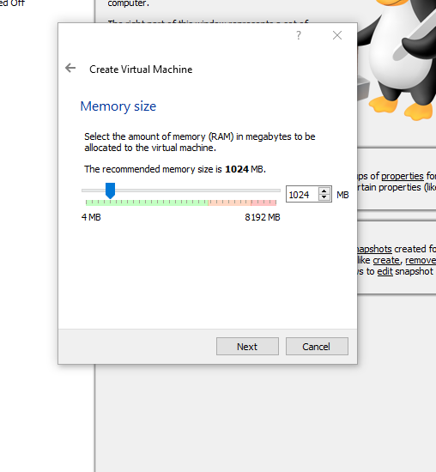

5. Click Next to "Create Virtual Machine (VM)" then click "Create"

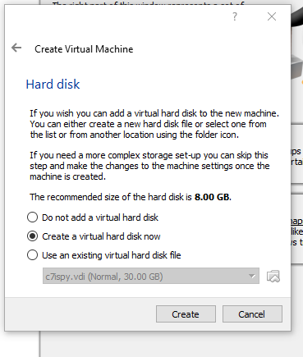

6. Click next to create VDI "Virtual Hard Disk"

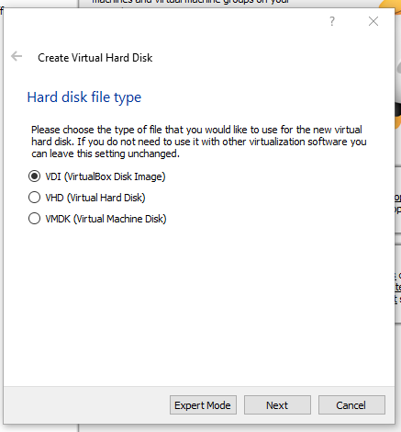

7. Click "Next" to choose "Dynamically allocated" hard disk

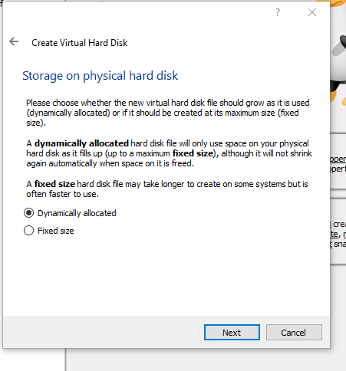

8. Click "Next" to select the size of the virtual hard disk. Double click on 8.00GB and insert 30.00GB (dependent on the size you want to allocate). Click "Create" to complete the creation of hard disk

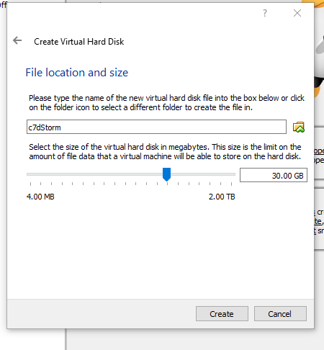

9. Now, we click on "Details" to navigate to the network setting

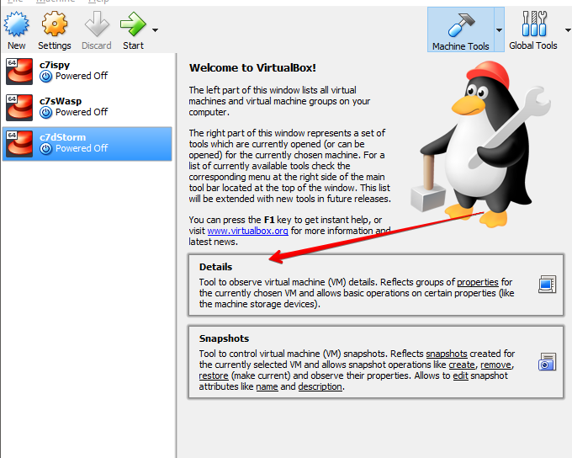

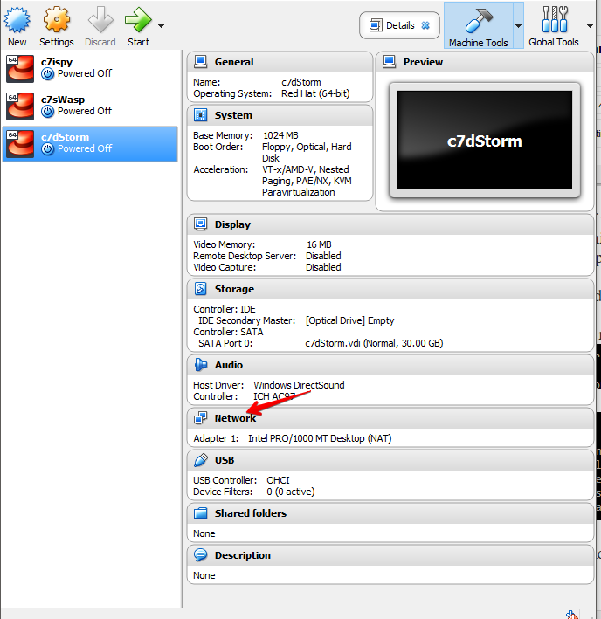

10. Step 1: click on network. Step 2: change "NAT" to "Bridged Adapter"

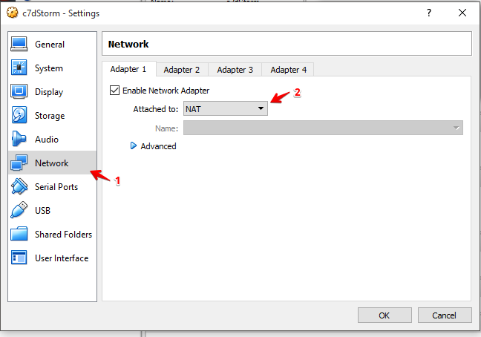

11. Select "Bridged Adapter" and click "OK"

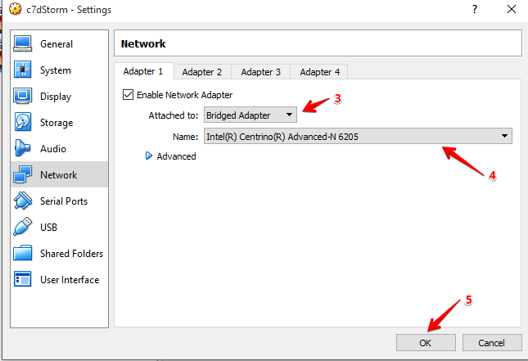  
  
12.  Now we can start by clicking on the Green arrow

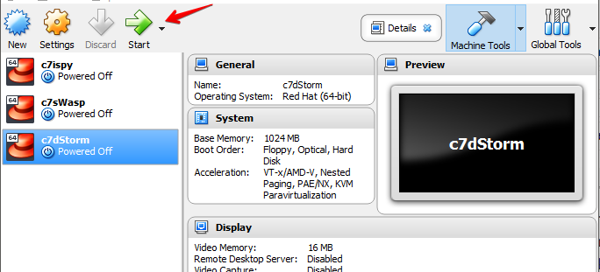

13. To select "Start-up disk", click on the yellow folder icon and locate "CentOS-7-X86-64-dvd-1810' and then click "Open"

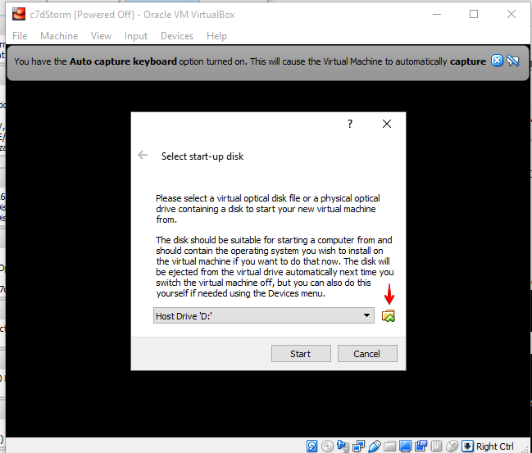

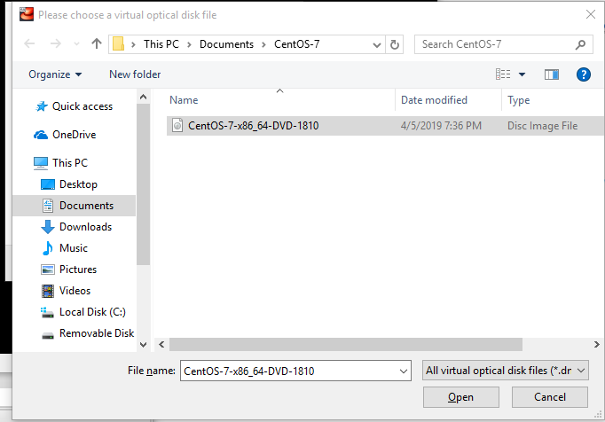

14. Click "Start"

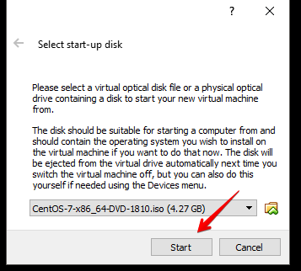

15. Use top arrow on your keyboard to select "Install CentOS Linus 7"

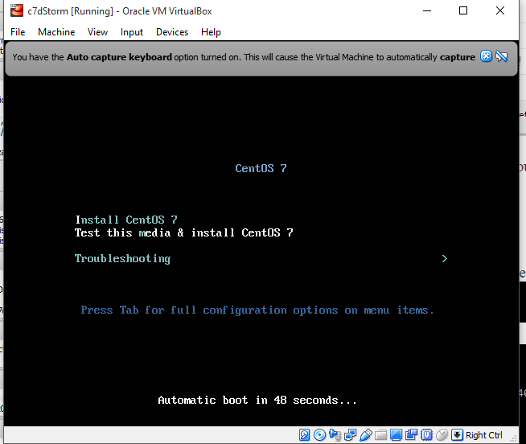

    And hit "Enter" on your keyboard. Once your cursor is captured, use the "Right CNRL" key to release your mouse

16. Choose "English (United States)"

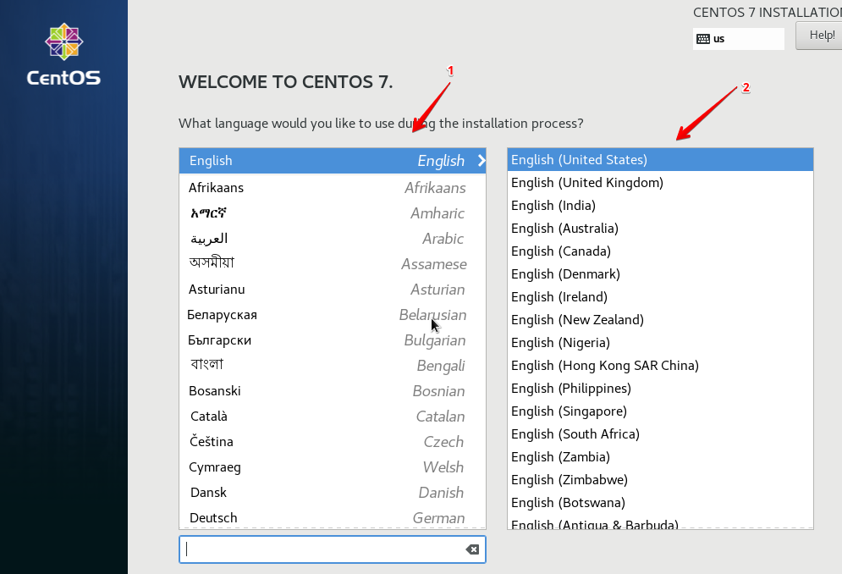

   And click "Continue"

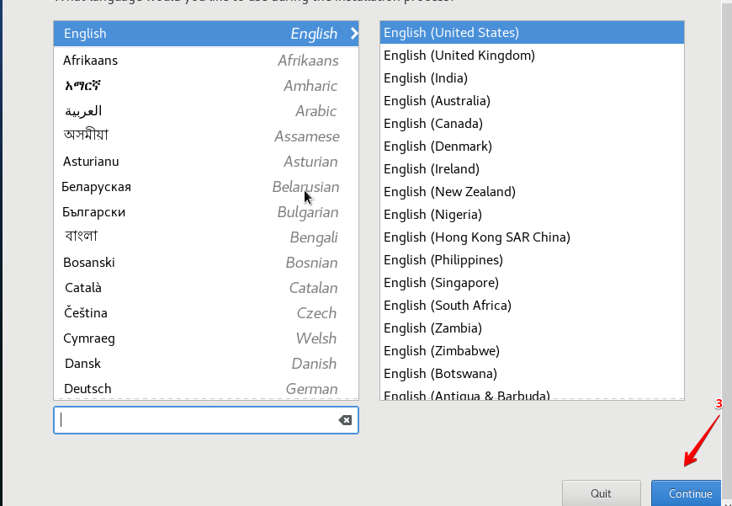

17. These are the areas you should edit: "Software Selection", "Installation Destination", "Network and Hostname".

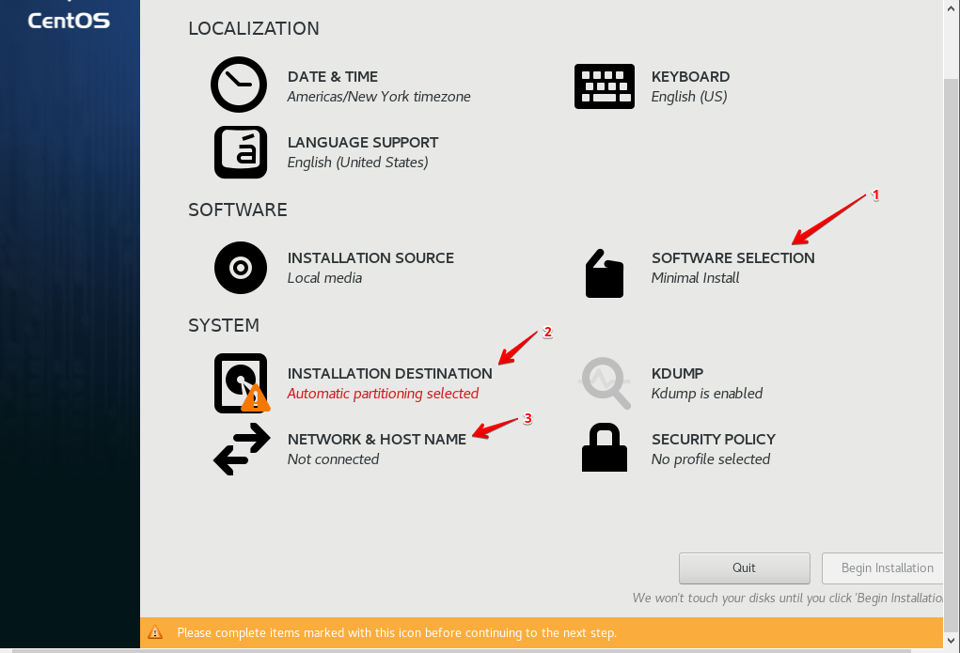

18. Click on "Software Selection" and select "Server with GUI" then click "Done"

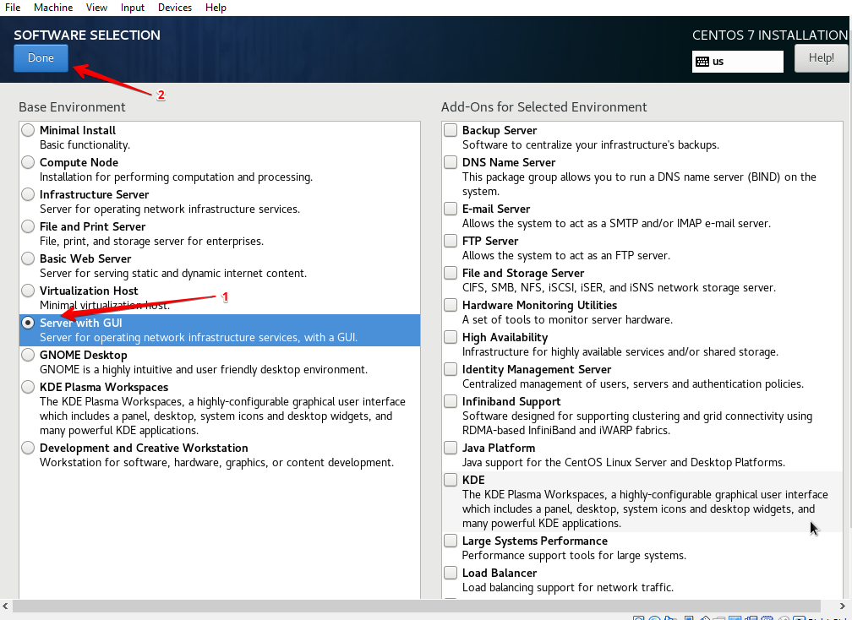

19. Click on "Installation Destination" and select "Automatically configure partitioning" then click "Done"

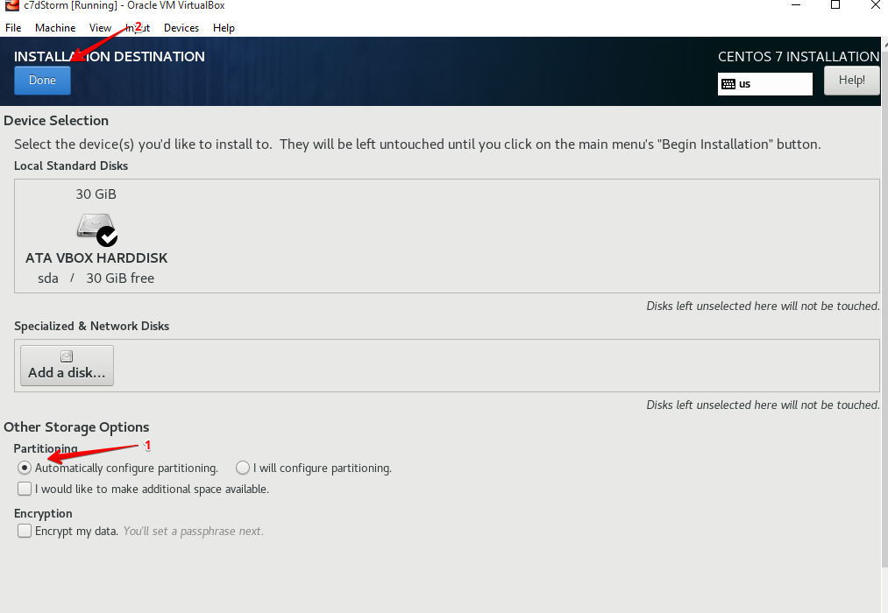

20. Click on "Network Configuration". Edit the highlighted "step 1" to the name of your VM. Since we are setting a dynamic server, we turn the "Ethernet (enp0s3)" on.

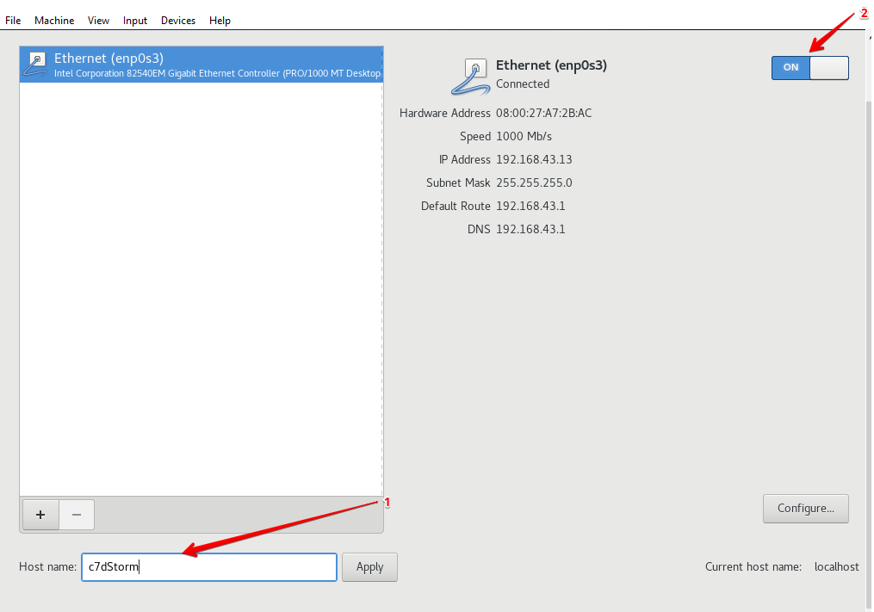  
 And click on "Done"

21. Now, click on "Begin Installation"

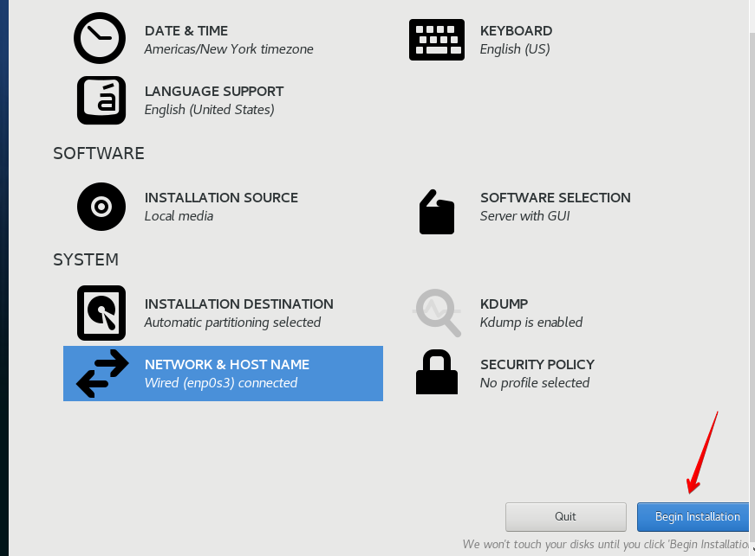

22. Next, we set the "Root Password" and "User Creation"

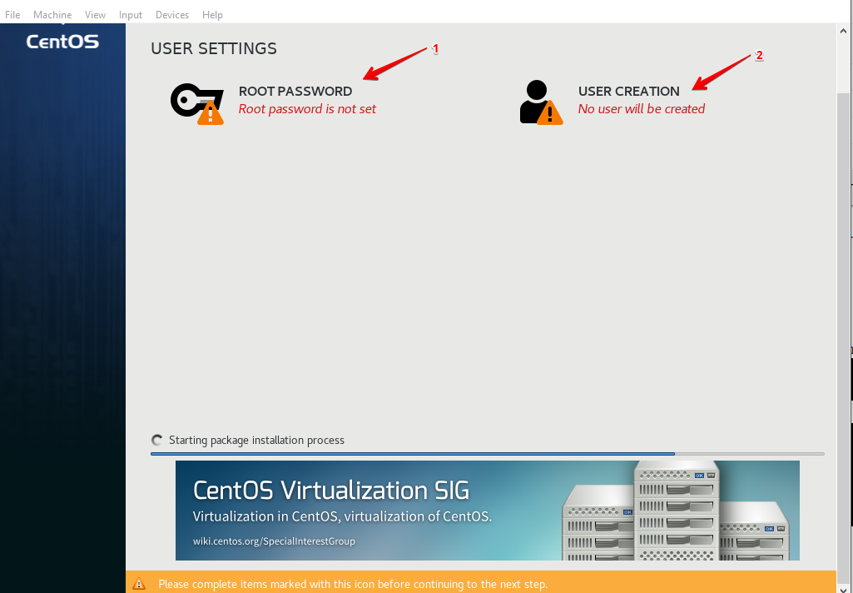

23. Set "Root Password" to any password that you can remember. I will be using "centos1" as my root password. Click "Done" when you finish

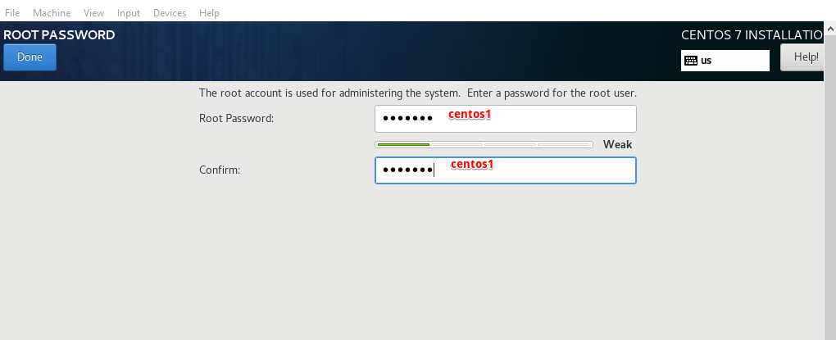

24.  Select "Create User" and edit the name and password you want. Also select "Make this user administrator". Click "Done" when you finish

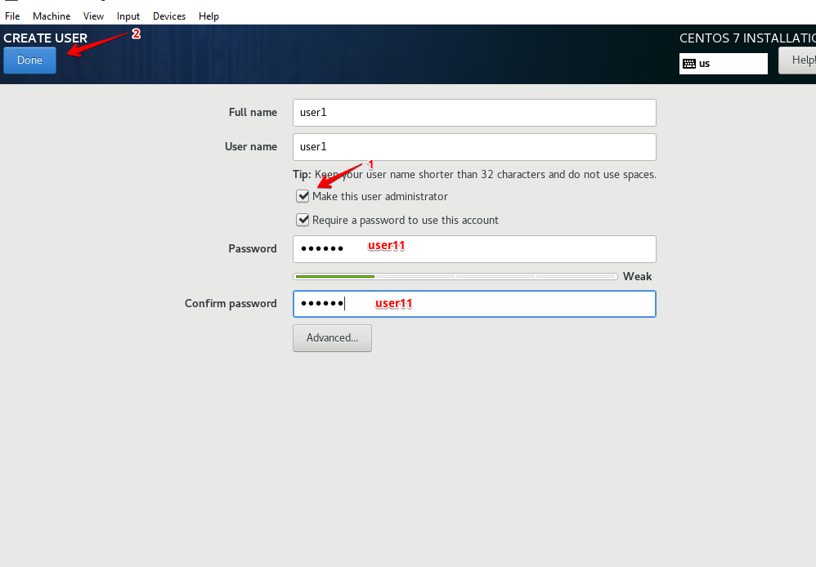

25. Click on "Reboot"  
            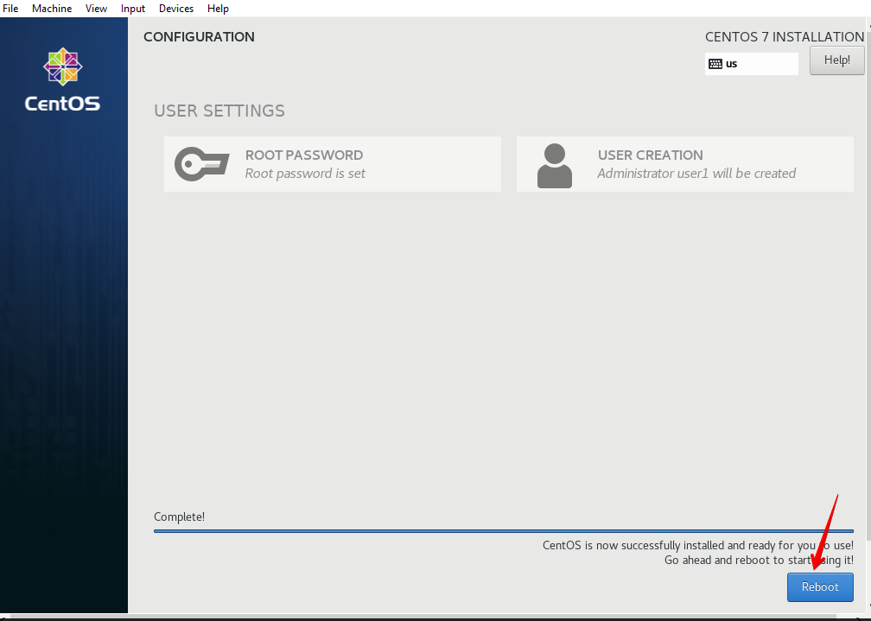

26. Click "License Information" and select "I accept the license agreement”

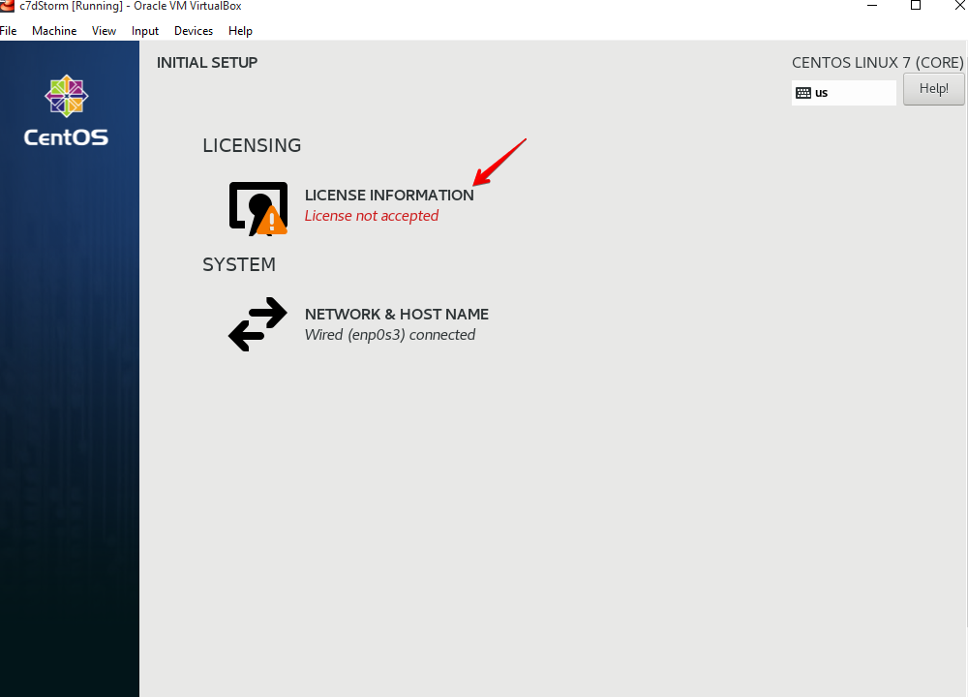

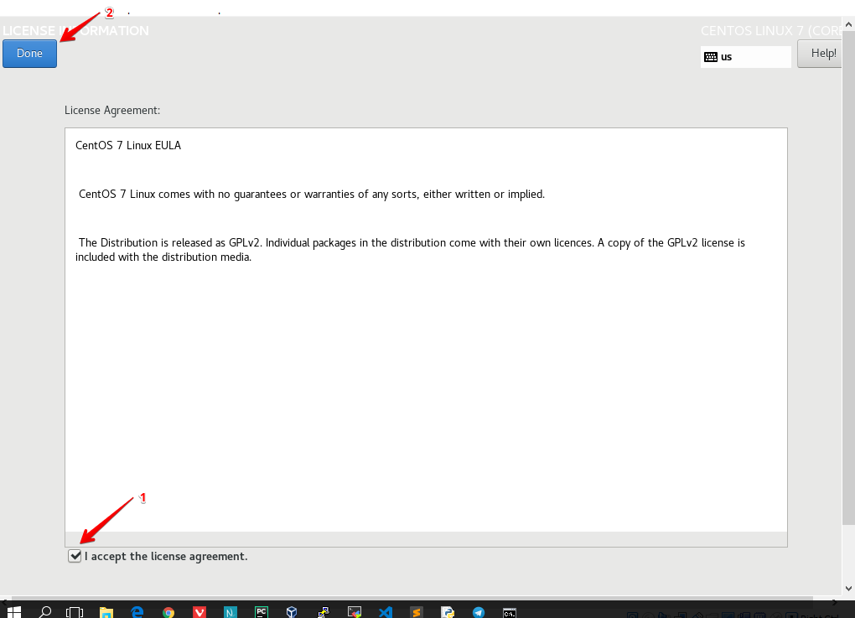  
  
 Click on "Done". It would take some minutes for the server to install

27. Now, click on "Finish Configuration"

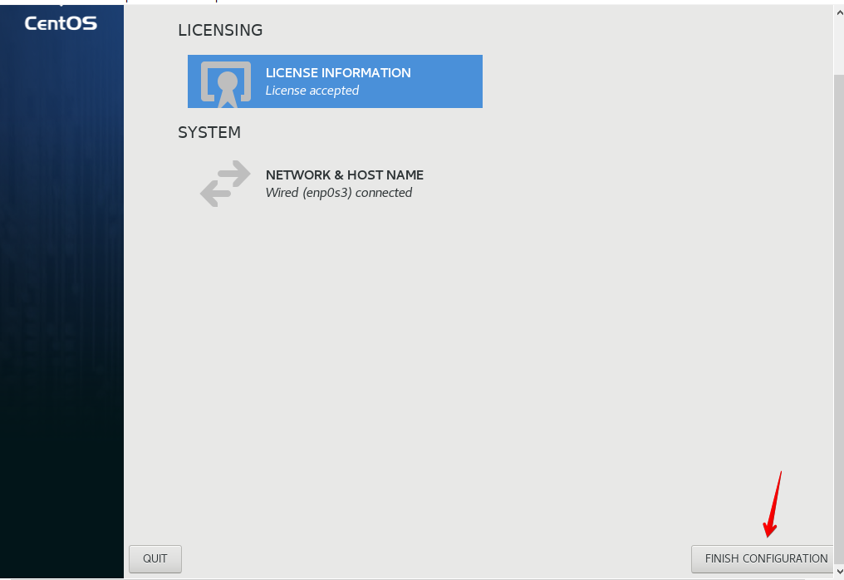

28. Now, you have finished the installation. This is the locked screen. Click on "user1"

            .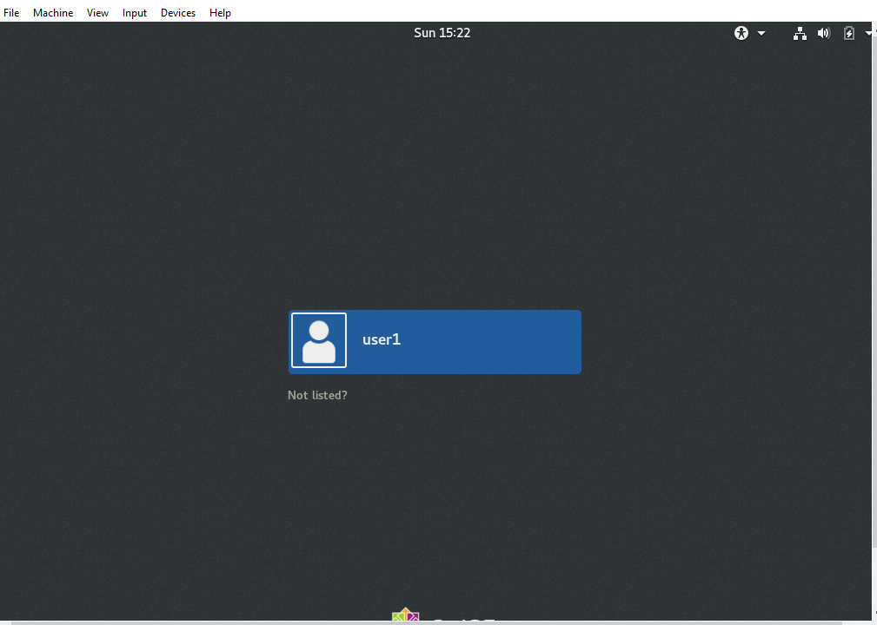

29. For the first time, you will have to set up the VM

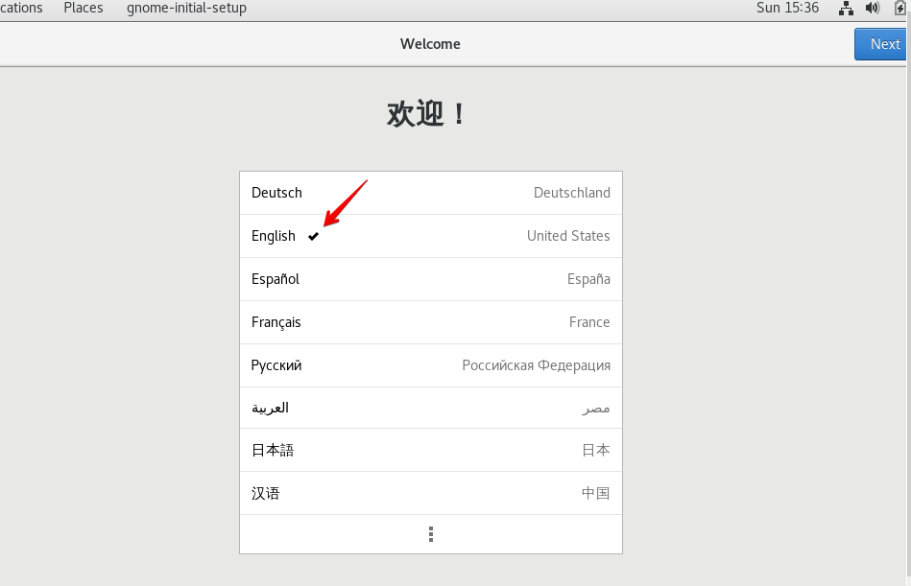

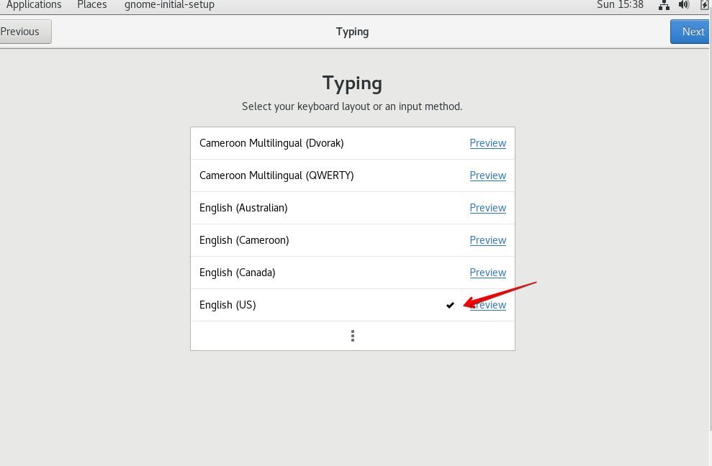

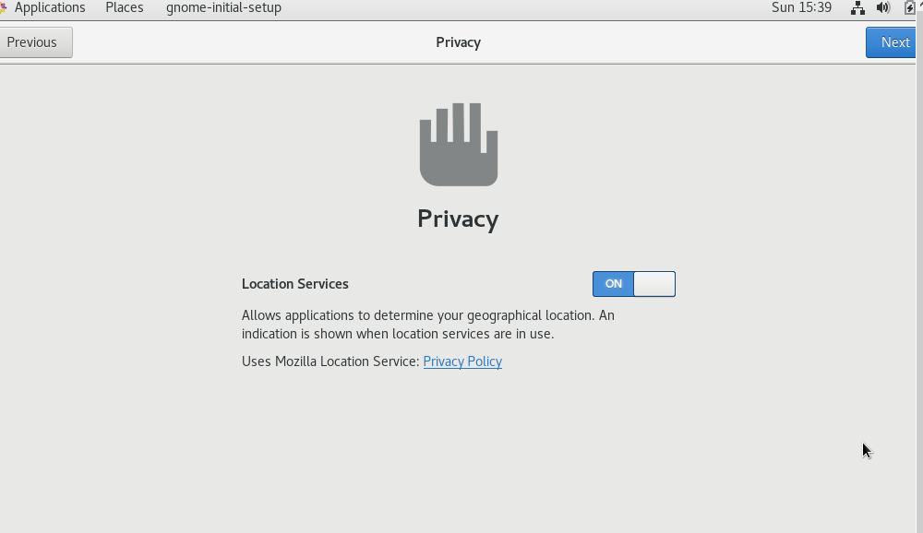

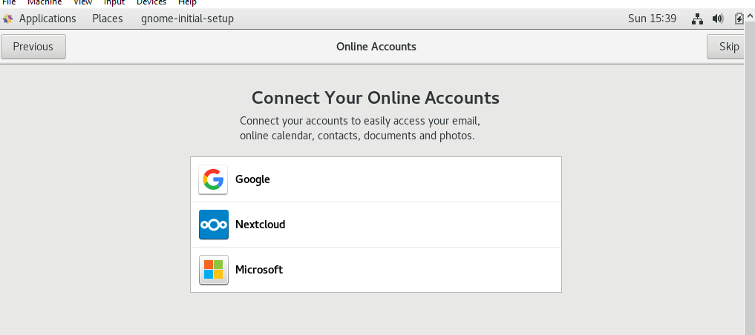

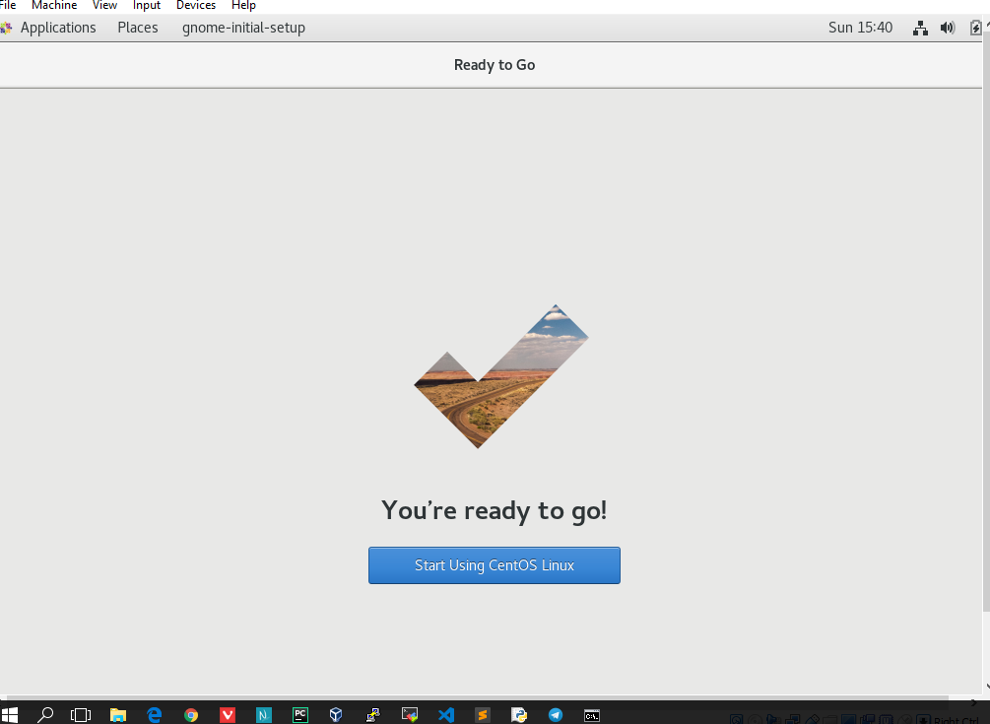

 Now, you can now make use of the VM.

30. Navigate to the "Terminal"

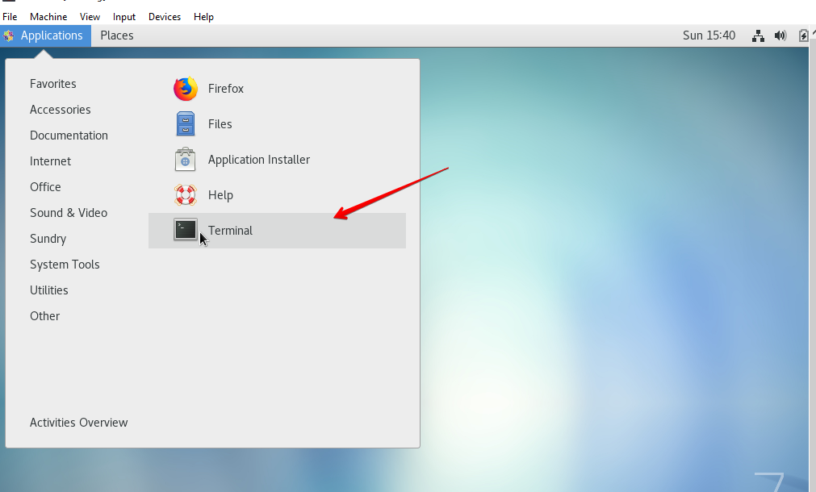

31. Run the command "ip a" to check the network of the server

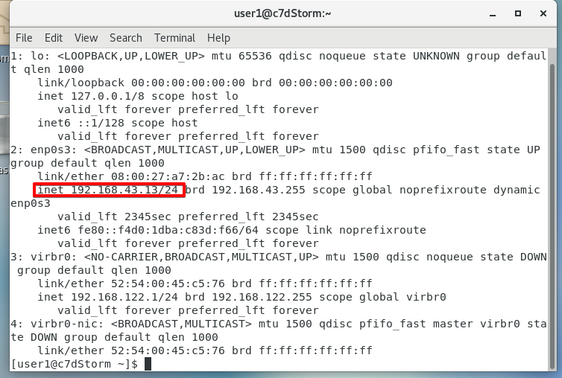

WELDONE, YOU JUST FINISHED THE SET UP OF A DYNAMIC SERVER!