**ArcGIS Insights**

This assignment had us try the desktop version of ArcGIS Insights to conduct an analysis on the [Drug Enforcement Administration's (DEA) pain pill database](https://www.washingtonpost.com/graphics/2019/investigations/dea-pain-pill-database/) released by the Washington Post. The DEA database tracks the shipment of all pain pills sold in the United States by manufacturers and distributors to pharmacies in every town and city. Mingo County, WV was the county selected due to its high rates of prescription compated to the number of residents in the surrounding area. Below is a screenshot of Mingo County by the distribution map of sellers to pharmacies compared to the number of pharmacies with the highest number of shipments. The amount of pills shipped to the Countyis alarming given the small number of distributors and population.

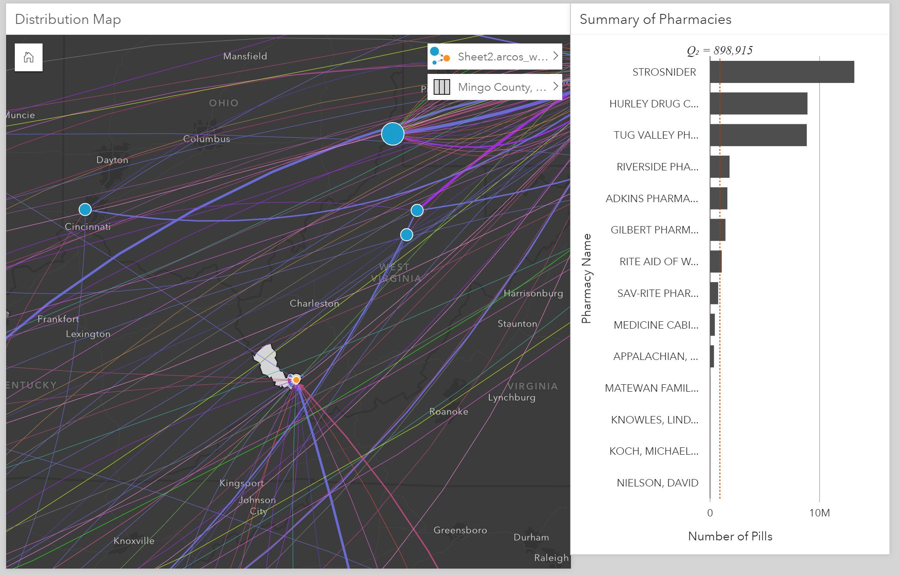

**Kepler**

A handy open source tool for geospatial datasets is [Kepler](http://kepler.gl/), and using data downloaded from [412 Food Rescue](https://412foodrescue.org/), a nonprofit organization based in Pittsburgh, PA, I looked at the concentration of food donors between November 14, 2016 and January 4, 2017 using the custom map style I created with Mapbox. Oakland, the Strip District, and East Liberty were neighborhoods that had a high number of donor points and many of the arcs led to Hazelwood and Wilkinsburg. This tool is helpful to determine, over time, the neighborhoods with active participants in the organizations, both as donors and recipients, which can inform the 412 Food Rescue team on where to target their marketing and outreach.

