Homework 3 - HR Data Intelligence Executive Recommendation
Jessica Taylor, Daira Beckum, Yasmine Lopez, Bailea Branni, Thierry Njalenga, Kristina Nastally

| HR Team | Denver-LoHi Applicant Data
Main Finding
We analyzed 148 applicants across five positions to see where HR could improve hiring. Overall, 18 applicants received offers and 7 accepted, for a 38.9% offer acceptance rate. The biggest concern was Sales Associate: 11 offers were made but only 2 were accepted (18.2%). The company offered $17.50 per hour compared with a $19.75 Denver market rate, and 5 applicants who declined an offer said pay was below expectations. Applicants also averaged about 19.8 days since their last HR contact, and 94 of 148 had gone more than two weeks without contact. This suggests both pay and slow follow-up may be hurting hiring.
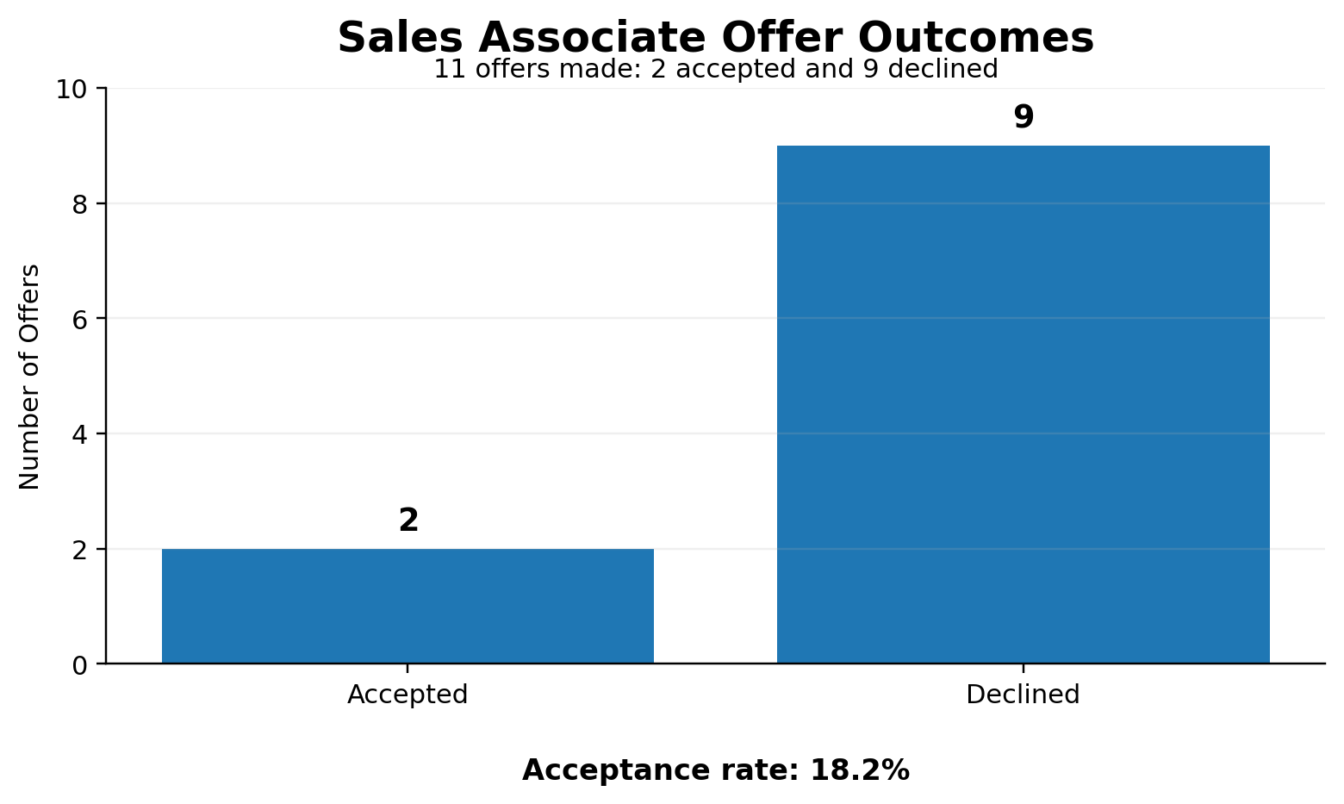 | 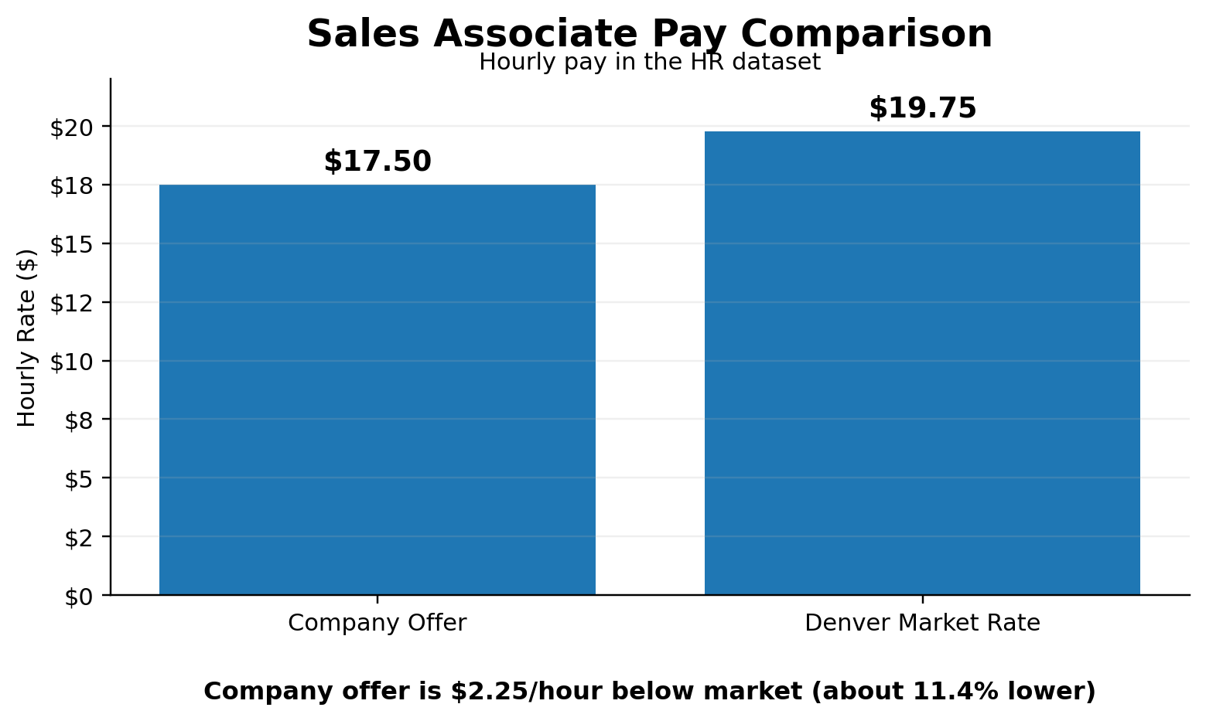
Options
1. Increase Sales Associate Pay - Move starting pay closer to $19.75/hour. This may improve offer acceptance, but labor costs would increase.
2. Use AI for Applicant Follow-Up - Flag candidates who have waited too long for a response so HR can follow up faster. HR employees would still review the alerts and make final decisions.
3. Keep the Current Process - Avoids new costs, but the company may continue losing candidates because of lower pay and long waiting periods.
Recommendation
We recommend Option 2 along with a review of Sales Associate pay. AI can help HR identify applicants who have gone too long without contact and remind the team when follow-up is needed. HR management should also review whether the $17.50 rate should move closer to the Denver market rate. This addresses both problems shown in the data while keeping people responsible for hiring and pay decisions.
Tools, Method & Verification
We analyzed the GT_HR_Denver_Applicants spreadsheet using ChatGPT data-analysis tools and checked applicant records, stages, offer results, pay, decline reasons, and days since last contact. We checked all 148 Applicant IDs and found no duplicates or conflicting offer records. Blank offer/interview fields were treated as not applicable when an applicant had not reached that stage. We spot-checked the 18 total offers, 7 accepted offers, and Sales Associate results against the spreadsheet.
Supporting Google Sheet: https://docs.google.com/spreadsheets/d/1jmjYaa0uViTIOCOolIC34lDw0AXioKrB81-TnBCfDXE/edit?usp=sharing
Decision Rights / Human in the Loop: AI can flag applicants and show patterns, but an HR employee or manager should decide who to contact, who moves forward, and whether pay rates change. AI should support the decision, not make the final decision.

