# DAD 220 Project One: Create a Database

## Step One: Create a Database

1. Navigate to your online integrated development environment (IDE). List and record the SQL commands that you used to complete this step here:

**First navigate to the online integrated development environment, then connect to SQL by using the command *mysql;* After that, I connected to the database I created in module one, which contains the database schema I will be using in this project. I connected to the database created in module one with the command *use duft;***

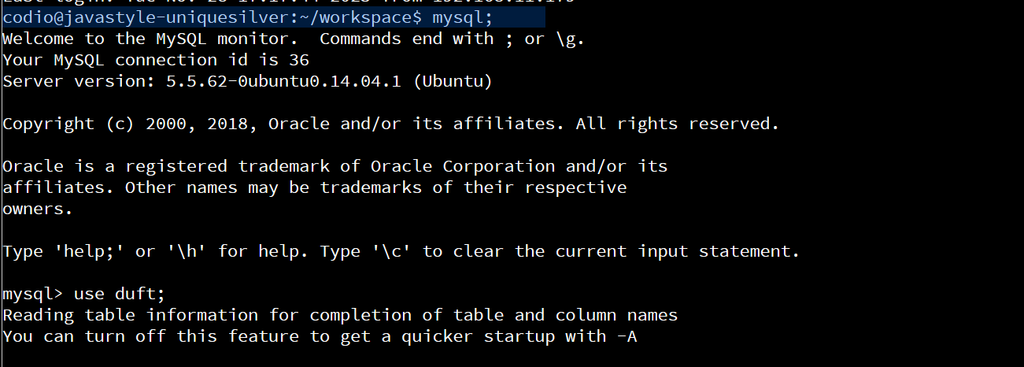

1. Create a database schema called QuantigrationUpdates. List out the database name. Provide the SQL commands you ran against MySQL to successfully complete this in your answer:

**Created database with the command : create database  QuantigrationRMA;**

**Connected to database with command : use  QuantigrationRMA;**

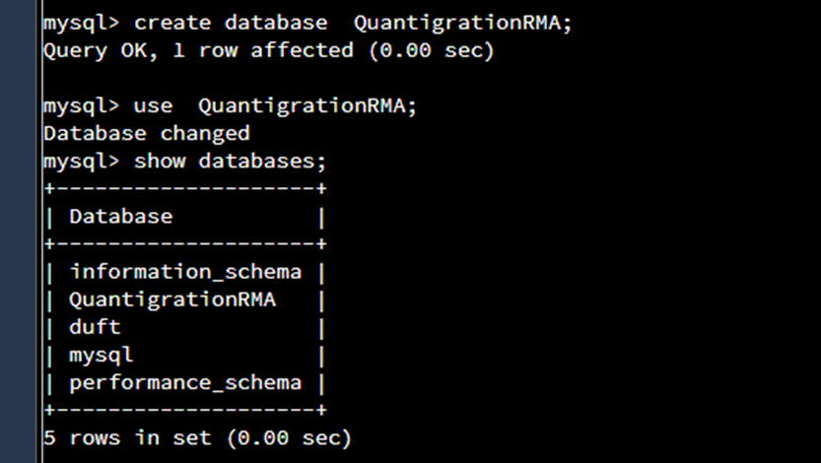

1. Using the entity relationship diagram (ERD) as a reference, create the following tables with the appropriate attributes and keys:
   1. A table named **Customers** in the QuantigrationUpdates database, as defined on the project ERD. Provide the SQL commands you ran against MySQL to complete this successfully in your answer:

**I created a table called customers with a primary key of CustomerID, this table stores customer information. I created the table with the following command:**

***create table Customers(***

***CustomerID INT,***

***FirstName VARCHAR(25),***

***LastName VARCHAR(25),***

***Street VARCHAR(50),***

***City VARCHAR(50),***

***State VARCHAR(25),***

***ZipCode INT,***

***Telephone VARCHAR(15),***

***PRIMARY KEY (CustomerID)***

***);***

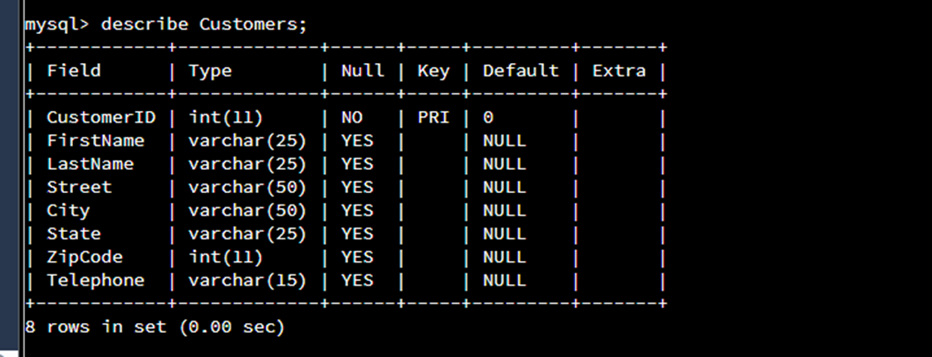

* 1. A table named **Orders** in the QuantigrationUpdates database, as defined on the project ERD. Provide the SQL commands you ran against MySQL to complete this successfully in your answer:

**I created a table named Orders with a primary key of OrderID and a foreign key of CustomerID. This table stores order information. I created the table using the following command:**

***create table Orders(***

***OrderID int,***

***CustomerID INT,***

***SKU VARCHAR(20),***

***Description VARCHAR(50),***

***PRIMARY KEY (OrderID),***

***FOREIGN KEY (CustomerID) REFERENCES Customers(CustomerID)***

***);***

* 1. A table named **RMA** in the QuantigrationUpdates database, as defined on the project ERD. Provide the SQL commands you ran against MySQL to complete this successfully in your answer:

**I created a table named RMA with a primary key of RMA ID and a foreign key of Order ID. This table stores RMA information. I created the table using the following command:**

***CREATE table RMA (***

***RMAID int,***

***OrderID int,***

***Step VARCHAR(50),***

***Status VARCHAR(15),***

***Reason VARCHAR(15),***

***PRIMARY KEY (RMAID)***

***);***

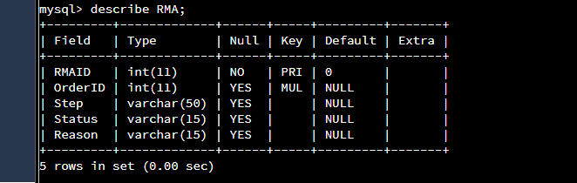

## Step Two: Load and Query the Data

1. **Import the data from each file into tables.** 
   * Use the QuantigrationUpdates database, the three tables you created, and the three CSV files preloaded into Codio.
   * Use the import utility of your database program to load the data from each file into the table of the same name. You will perform this step three times, once for each table.

**I used the import utility of my database to load the data from each file into the appropriate table. I imported the data for each table using the following commands :**

***SET FOREIGN_KEY_CHECKS = 0; //bypass foreign key validation as there was an error in relation to the foreign keys set in the Orders and RMA tables***

**//Load data into the customers table**

***LOAD DATA INFILE '/home/codio/workspace/customers.csv'***

***INTO TABLE Customers***

***FIELDS TERMINATED BY ','***

***ENCLOSED BY '"'***

***LINES TERMINATED BY '\n'***

***IGNORE 1 ROWS;***

**//Load data into the RMA table**

***LOAD DATA INFILE '/home/codio/workspace/rma.csv'***

***INTO TABLE RMA***

***FIELDS TERMINATED BY ','***

***ENCLOSED BY '"'***

***LINES TERMINATED BY '\n'***

***IGNORE 1 ROWS;***

**//Load data into the Orders table**

***LOAD DATA INFILE '/home/codio/workspace/orders.csv'***

***INTO TABLE Orders***

***FIELDS TERMINATED BY ','***

***ENCLOSED BY '"'***

***LINES TERMINATED BY '\n'***

***IGNORE 1 ROWS;***

***SET FOREIGN_KEY_CHECKS = 1; //revalidate foreign key check***

1. **Write basic queries against imported tables to organize and analyze targeted data.** For each query, replace the bracketed text with a screenshot of the query and its output. You should also include a 1- to 3-sentence description of the output.
   * Write an SQL query that returns the **count** of orders for customers located only in the city of Framingham, Massachusetts.
     1. How many records were returned?

**There were 505 orders from Framingham Massachusetts. I found this information using the following command:**

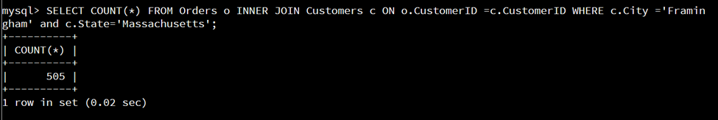***SELECT COUNT(*) FROM Orders o INNER JOIN Customers c ON o.CustomerID =c.CustomerID WHERE c.City=’Farmingham’ and c.State=’Massachusetts’***

* + Write an SQL query to **select all** of the Customers located in the state of Massachusetts.
    1. Use a WHERE clause to limit the number of records in the Customers table to only those who are located in Massachusetts.
    2. Record an answer to the following question: How many records were returned?

**There were 982 records returned.***

* + Write a SQL query to insert four new records into the Orders and Customers tables using the following data:

**Customers Table**

| **CustomerID** | **FirstName** | **LastName** | **StreetAddress** | **City** | **State** | **ZipCode** | **Telephone** |
| --- | --- | --- | --- | --- | --- | --- | --- |
| 100004 | Luke | Skywalker | 15 Maiden Lane | New York | NY | 10222 | 212-555-1234 |
| 100005 | Winston | Smith | 123 Sycamore Street | Greensboro | NC | 27401 | 919-555-6623 |
| 100006 | MaryAnne | Jenkins | 1 Coconut Way | Jupiter | FL | 33458 | 321-555-8907 |
| 100007 | Janet | Williams | 55 Redondo Beach Blvd | Torrence | CA | 90501 | 310-555-5678 |

**I added the four new customer records using the following command:**

***insert into Customers***

***Values (100004, 'Luke', 'Skywalker', '17 Maiden Lane', 'New York', 'NY', 10222, '212-555-1234'),***

***(100005, 'Winston', 'Smith', '128 Sycamore Street', 'Greensboro', 'NC', 27401, '919-555-6623'),***

***(100006, 'MaryAnne', 'Jenkins', '2 Coconut Way', 'Jupiter', 'FL', 33458, '321-555-8907'),***

***(100007, 'Janet', 'Williams', '58 Redondo Beach Blvd', 'Torrence', 'CA', 90501, '310-555-5678');***

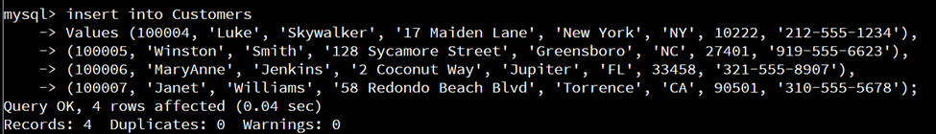

**Orders Table**

| **OrderID** | **CustomerID** | **SKU** | **Description** |
| --- | --- | --- | --- |
| 1204305 | 100004 | ADV-24-10C | Advanced Switch 10GigE Copper 24 port |
| 1204306 | 100005 | ADV-48-10F | Advanced Switch 10 GigE Copper/Fiber 44 port copper 4 port fiber |
| 1204307 | 100006 | ENT-24-10F | Enterprise Switch 10GigE SFP+ 24 Port |
| 1204308 | 100007 | ENT-48-10F | Enterprise Switch 10GigE SFP+ 48 port |

**I added the four new records into the orders table using the following command :**

***insert into Orders***

***Values (1204305, 100004, 'ADV-24-10C', 'Advanced Switch 10GigE Copper 24 port'),***

***(1204306, 100005, 'ADV-48-10F', 'Advanced Switch 10 GigE Copper/Fiber 44 port copper 4 port fiber'),***

***(1204307, 100006, 'ENT-24-10F', 'Enterprise Switch 10GigE SFP+ 24 Port'),***

***(1204308, 100007, 'ENT-48-10F', 'Enterprise Switch 10GigE SFP+ 48 port');***

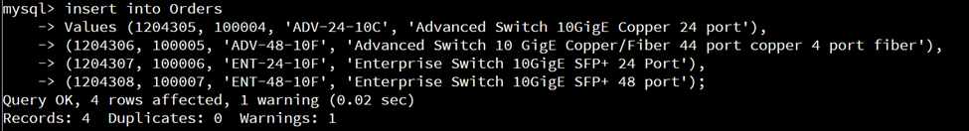

**See Validation of the new customer and order records here :**

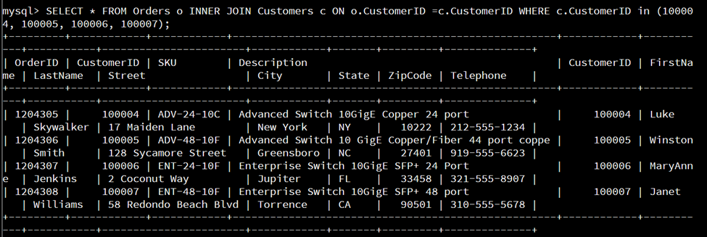

* + In the Customers table, perform a query to count all records where the city is Woonsocket, Rhode Island.
    1. How many records are in the Customers table where the field “city” equals “Woonsocket”?

**There are 7 records where the city equals Woonsocket. I was able to find this information using the following command :**

***SELECT COUNT(*) from Customers WHERE City=’Woonsocket’;***

* + In the RMA database, update a customer’s records.
    1. Write an SQL statement to select the current fields of **status** and **step** for the record in the **RMA** table with an **orderid** value of “5175.”
       1. What are the current status and step?

**The current status of the order with OrderID 5175, is pending and the current step is awaiting customer documentation. I was able to determine this information using the following command:**

***SELECT Status, Step from RMA WHERE OrderID=5175;***

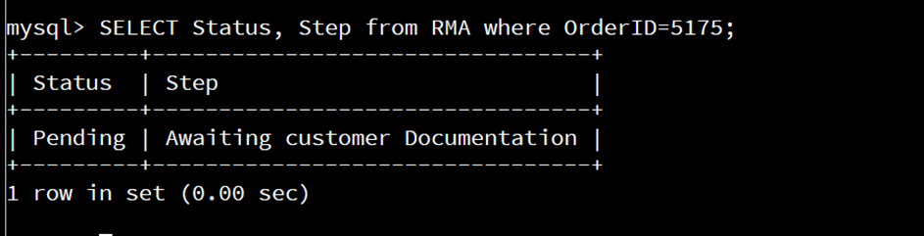

* + 1. Write an SQL statement to update the **status** and **step** for the **OrderID**, 5175 to **status** = “Complete” and **step** = “Credit Customer Account.”
       1. What are the updated **status** and **step** values for this record?

**I updated the status and step for the order with OrderID 515 so that the status is now ‘Complete’ and the step is now ‘Credit Customer Account’. I was able to update the record using the following command:**

***UPDATE RMA SET Status = 'Complete', Step = 'Credit Customer Account' WHERE OrderID = 5175;***

* + Delete RMA records.
    1. Write an SQL statement to delete all records with a reason of “Rejected.”
       1. How many records were deleted?

**I deleted the rejected RMAS using the following command:**

***DELETE FROM RMA WHERE Reason LIKE '%Rejected%';***

**There were 595 records deleted.**

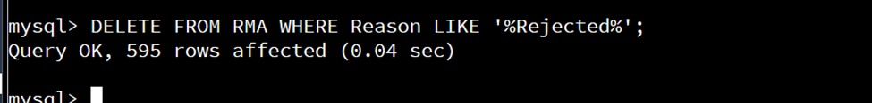

1. **Update your existing tables** from “Customer” to “Collaborator” using SQL based on this change in requirements. Provide the SQL commands you ran against MySQL to complete this successfully in your answer:
   1. Rename all instances of “Customer” to “Collaborator.”

**I renamed all instances of Customer to Collaborator by creating a Collaborator view which allows the user to search the database based on the new requirements. I was able to complete this task using the following command:**

***CREATE VIEW Collaborator AS***

***SELECT***

***CustomerID AS CollaboratorID,***

***FirstName,***

***LastName,***

***Street,***

***City,***

***State,***

***ZipCode,***

***Telephone***

***FROM Customers;***

***Describe Collaborator ;***

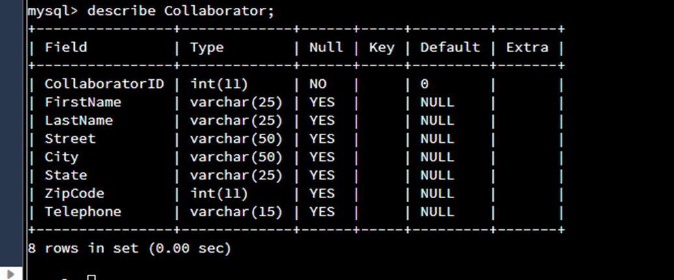

1. **Create an output file of the required query results.** Write an SQL statement to list the contents of the **Orders** table and send the output to a file that has a .csv extension.

**I created an output .csv file that list the contents of the Orders table. I was able to complete this task using the following command:**

***SELECT * FROM Orders into outfile'/home/codio/workspace/Mod_4_Major_Activity.csv' FIELDS TERMINATED BY',';***

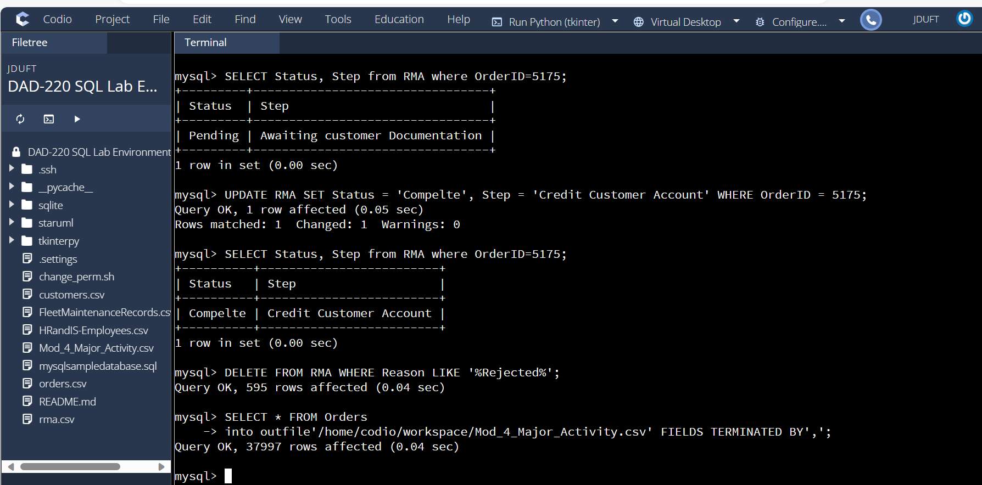



**Notice how the file appears under the lab environment now.**