**Goldstein Price function**

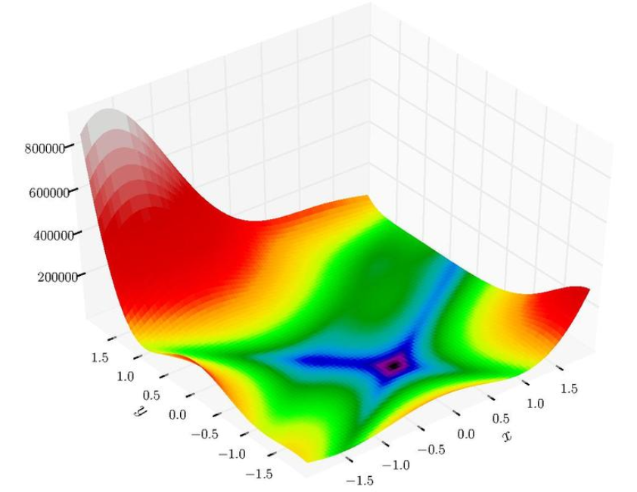

**Formula:**

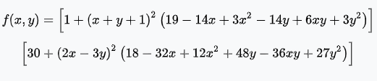

**Mínimo global**



**Dominio**



**Resultados**

|  |  |  |  |  |
| --- | --- | --- | --- | --- |
| S | Clim | Cmax | Calidad | tiempo |
| 20 | 4 | 50 | 0,9980 | 0,813 |
| 20 | 4 | 100 | 0,9936 | 1.579 |
| 20 | 4 | 150 | 0,9972 | 2,36 |
| 20 | 4 | 200 | 0,9984 | 3.135 |
| 20 | 4 | 250 | 0,9974 | 3.919 |
| 20 | 4 | 300 | 0,9980 | 4.699 |
| 20 | 8 | 50 | 0,9976 | 0,79 |
| 20 | 8 | 100 | 0,9833 | 1.574 |
| 20 | 8 | 150 | 0,9942 | 2.359 |
| 20 | 8 | 200 | 0,9888 | 3.137 |
| 20 | 8 | 250 | 0,9980 | 3.907 |
| 20 | 8 | 300 | 0,9989 | 4.704 |
| 20 | 12 | 50 | 0,9977 | 0,783 |
| 20 | 12 | 100 | 0,9939 | 1.579 |
| 20 | 12 | 150 | 0,9998 | 2.363 |
| 20 | 12 | 200 | 0,9994 | 3.136 |
| 20 | 12 | 250 | 1,0000 | 3.912 |
| 20 | 12 | 300 | 0,9998 | 4.696 |
| 40 | 4 | 50 | 0,9968 | 0,789 |
| 40 | 4 | 100 | 0,9946 | 1.569 |
| 40 | 4 | 150 | 0,9954 | 2.354 |
| 40 | 4 | 200 | 0,9963 | 3.128 |
| 40 | 4 | 250 | 0,9844 | 3.921 |
| 40 | 4 | 300 | 0,9998 | 4.711 |
| 40 | 8 | 50 | 0,9978 | 0,796 |
| 40 | 8 | 100 | 0,9996 | 1.642 |
| 40 | 8 | 150 | 0,9997 | 2.372 |
| 40 | 8 | 200 | 0,9997 | 3.159 |
| 40 | 8 | 250 | 0,9996 | 3.941 |
| 40 | 8 | 300 | 1,0000 | 4.704 |
| 40 | 12 | 50 | 0,9994 | 0,797 |
| 40 | 12 | 100 | 0,9956 | 1.587 |
| 40 | 12 | 150 | 0,9995 | 2.378 |
| 40 | 12 | 200 | 1,0000 | 3.141 |
| 40 | 12 | 250 | 1,0000 | 3.923 |
| 40 | 12 | 300 | 0,9996 | 4.704 |
| 60 | 4 | 50 | 0,9993 | 0,797 |
| 60 | 4 | 100 | 0,9798 | 1.578 |
| 60 | 4 | 150 | 0,9946 | 2.386 |
| 60 | 4 | 200 | 0,9980 | 3,14 |
| 60 | 4 | 250 | 0,9851 | 3.922 |
| 60 | 4 | 300 | 0,9928 | 4.691 |
| 60 | 8 | 50 | 0,9793 | 0,791 |
| 60 | 8 | 100 | 0,9939 | 1,57 |
| 60 | 8 | 150 | 0,9989 | 2.358 |
| 60 | 8 | 200 | 0,9984 | 3.191 |
| 60 | 8 | 250 | 0,9979 | 4.026 |
| 60 | 8 | 300 | 0,9999 | 4.761 |
| 60 | 12 | 50 | 0,9999 | 0,802 |
| 60 | 12 | 100 | 0,9995 | 1.568 |
| 60 | 12 | 150 | 1,0000 | 2,41 |
| 60 | 12 | 200 | 0,9997 | 3,14 |
| 60 | 12 | 250 | 0,9993 | 3.928 |
| 60 | 12 | 300 | 0,9999 | 4.706 |
| 80 | 4 | 50 | 0,9920 | 0,788 |
| 80 | 4 | 100 | 0,9990 | 1.601 |
| 80 | 4 | 150 | 0,9969 | 2.393 |
| 80 | 4 | 200 | 0,9949 | 3.192 |
| 80 | 4 | 250 | 0,9973 | 3.922 |
| 80 | 4 | 300 | 0,9979 | 4,71 |
| 80 | 8 | 50 | 0,9981 | 0,786 |
| 80 | 8 | 100 | 0,9992 | 1.596 |
| 80 | 8 | 150 | 0,9983 | 2,37 |
| 80 | 8 | 200 | 0,9997 | 3.155 |
| 80 | 8 | 250 | 0,9984 | 3.929 |
| 80 | 8 | 300 | 0,9998 | 4,71 |
| 80 | 12 | 50 | 0,9964 | 0,799 |
| 80 | 12 | 100 | 0,9999 | 1.578 |
| 80 | 12 | 150 | 0,9994 | 2,36 |
| 80 | 12 | 200 | 1,0000 | 3.128 |
| 80 | 12 | 250 | 1,0000 | 3.933 |
| 80 | 12 | 300 | 1,0000 | 4.717 |
| 100 | 4 | 50 | 0,9856 | 0,806 |
| 100 | 4 | 100 | 0,9969 | 1.569 |
| 100 | 4 | 150 | 1,0000 | 2.368 |
| 100 | 4 | 200 | 0,9972 | 3.144 |
| 100 | 4 | 250 | 0,9983 | 3.937 |
| 100 | 4 | 300 | 0,9998 | 4.697 |
| 100 | 8 | 50 | 0,9979 | 0,801 |
| 100 | 8 | 100 | 0,9998 | 1.576 |
| 100 | 8 | 150 | 0,9994 | 2.358 |
| 100 | 8 | 200 | 0,9990 | 3,14 |
| 100 | 8 | 250 | 0,9987 | 3.931 |
| 100 | 8 | 300 | 1,0000 | 4.726 |
| 100 | 12 | 50 | 0,9979 | 0,804 |
| 100 | 12 | 100 | 0,9998 | 1.568 |
| 100 | 12 | 150 | 0,9998 | 2.362 |
| 100 | 12 | 200 | 0,9999 | 3.138 |
| 100 | 12 | 250 | 1,0000 | 3.961 |
| 100 | 12 | 300 | 1,0000 | 4.708 |

**Sphere function**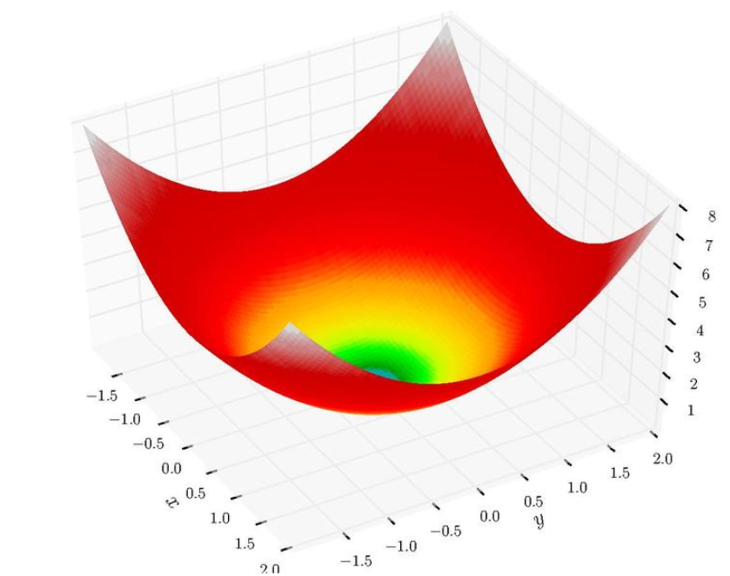

**Formula:**

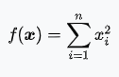

**Mínimo global**



**Dominio**



**Resultados**

|  |  |  |  |  |
| --- | --- | --- | --- | --- |
| S | Clim | Cmax | Calidad | tiempo |
| 20 | 4 | 50 | 1,0000 | 0,819 |
| 20 | 4 | 100 | 1,0000 | 1.574 |
| 20 | 4 | 150 | 1,0000 | 2.357 |
| 20 | 4 | 200 | 1,0000 | 3.164 |
| 20 | 4 | 250 | 1,0000 | 3.942 |
| 20 | 4 | 300 | 1,0000 | 4.718 |
| 20 | 8 | 50 | 1,0000 | 0,808 |
| 20 | 8 | 100 | 1,0000 | 1.607 |
| 20 | 8 | 150 | 1,0000 | 2.374 |
| 20 | 8 | 200 | 1,0000 | 3 |
| 20 | 8 | 250 | 1,0000 | 3.965 |
| 20 | 8 | 300 | 1,0000 | 4.702 |
| 20 | 12 | 50 | 1,0000 | 0,8 |
| 20 | 12 | 100 | 1,0000 | 1.576 |
| 20 | 12 | 150 | 1,0000 | 2.353 |
| 20 | 12 | 200 | 1,0000 | 3.138 |
| 20 | 12 | 250 | 1,0000 | 3.919 |
| 20 | 12 | 300 | 1,0000 | 5 |
| 40 | 4 | 50 | 1,0000 | 0,796 |
| 40 | 4 | 100 | 1,0000 | 1.578 |
| 40 | 4 | 150 | 1,0000 | 2 |
| 40 | 4 | 200 | 1,0000 | 3.148 |
| 40 | 4 | 250 | 1,0000 | 4 |
| 40 | 4 | 300 | 1,0000 | 4.719 |
| 40 | 8 | 50 | 1,0000 | 0,797 |
| 40 | 8 | 100 | 1,0000 | 1.603 |
| 40 | 8 | 150 | 1,0000 | 2.374 |
| 40 | 8 | 200 | 1,0000 | 3.136 |
| 40 | 8 | 250 | 1,0000 | 3.922 |
| 40 | 8 | 300 | 1,0000 | 5 |
| 40 | 12 | 50 | 1,0000 | 0,79 |
| 40 | 12 | 100 | 1,0000 | 1.583 |
| 40 | 12 | 150 | 1,0000 | 2.356 |
| 40 | 12 | 200 | 1,0000 | 3.138 |
| 40 | 12 | 250 | 1,0000 | 3.918 |
| 40 | 12 | 300 | 1,0000 | 5 |
| 60 | 4 | 50 | 1,0000 | 0,794 |
| 60 | 4 | 100 | 1,0000 | 1.605 |
| 60 | 4 | 150 | 1,0000 | 2 |
| 60 | 4 | 200 | 1,0000 | 3.155 |
| 60 | 4 | 250 | 1,0000 | 3.944 |
| 60 | 4 | 300 | 1,0000 | 4.734 |
| 60 | 8 | 50 | 1,0000 | 0,825 |
| 60 | 8 | 100 | 1,0000 | 1.579 |
| 60 | 8 | 150 | 1,0000 | 2 |
| 60 | 8 | 200 | 1,0000 | 3.151 |
| 60 | 8 | 250 | 1,0000 | 3.931 |
| 60 | 8 | 300 | 1,0000 | 4.709 |
| 60 | 12 | 50 | 1,0000 | 0,813 |
| 60 | 12 | 100 | 1,0000 | 1.575 |
| 60 | 12 | 150 | 1,0000 | 2.387 |
| 60 | 12 | 200 | 1,0000 | 3.155 |
| 60 | 12 | 250 | 1,0000 | 3.932 |
| 60 | 12 | 300 | 1,0000 | 4.688 |
| 80 | 4 | 50 | 1,0000 | 0,803 |
| 80 | 4 | 100 | 1,0000 | 2 |
| 80 | 4 | 150 | 1,0000 | 2.397 |
| 80 | 4 | 200 | 1,0000 | 3.168 |
| 80 | 4 | 250 | 1,0000 | 3.941 |
| 80 | 4 | 300 | 1,0000 | 4.719 |
| 80 | 8 | 50 | 1,0000 | 0,795 |
| 80 | 8 | 100 | 1,0000 | 1.579 |
| 80 | 8 | 150 | 1,0000 | 2.373 |
| 80 | 8 | 200 | 1,0000 | 3 |
| 80 | 8 | 250 | 1,0000 | 3.987 |
| 80 | 8 | 300 | 1,0000 | 4.747 |
| 80 | 12 | 50 | 1,0000 | 0,788 |
| 80 | 12 | 100 | 1,0000 | 1.584 |
| 80 | 12 | 150 | 1,0000 | 2379 |
| 80 | 12 | 200 | 1,0000 | 3.157 |
| 80 | 12 | 250 | 1,0000 | 3.915 |
| 80 | 12 | 300 | 1,0000 | 4.742 |
| 100 | 4 | 50 | 1,0000 | 0,815 |
| 100 | 4 | 100 | 1,0000 | 1.578 |
| 100 | 4 | 150 | 1,0000 | 2 |
| 100 | 4 | 200 | 1,0000 | 3.152 |
| 100 | 4 | 250 | 1,0000 | 3.931 |
| 100 | 4 | 300 | 1,0000 | 4.721 |
| 100 | 8 | 50 | 1,0000 | 0,797 |
| 100 | 8 | 100 | 1,0000 | 1.579 |
| 100 | 8 | 150 | 1,0000 | 2.367 |
| 100 | 8 | 200 | 1,0000 | 3.141 |
| 100 | 8 | 250 | 1,0000 | 3.922 |
| 100 | 8 | 300 | 1,0000 | 4.719 |
| 100 | 12 | 50 | 1,0000 | 0,812 |
| 100 | 12 | 100 | 1,0000 | 2 |
| 100 | 12 | 150 | 1,0000 | 2.359 |
| 100 | 12 | 200 | 1,0000 | 3.165 |
| 100 | 12 | 250 | 1,0000 | 3.924 |
| 100 | 12 | 300 | 1,0000 | 4.737 |

**Eggholder function**

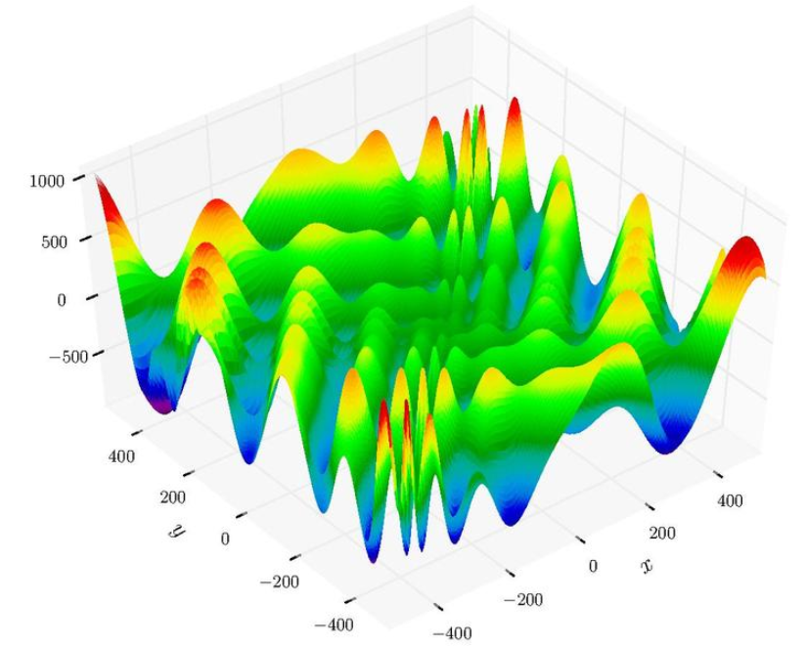

**Formula:**



**Mínimo global**



**Dominio**



**Resultados**

|  |  |  |  |  |
| --- | --- | --- | --- | --- |
| S | Clim | Cmax | Calidad | tiempo |
| 20 | 4 | 50 | 0,9966 | 0,807 |
| 20 | 4 | 100 | 0,9703 | 1.581 |
| 20 | 4 | 150 | 0,9929 | 2,36 |
| 20 | 4 | 200 | 0,9874 | 3.156 |
| 20 | 4 | 250 | 0,9924 | 3.923 |
| 20 | 4 | 300 | 1,0000 | 4.719 |
| 20 | 8 | 50 | 1,0000 | 0,797 |
| 20 | 8 | 100 | 0,9990 | 1.578 |
| 20 | 8 | 150 | 0,9677 | 2.376 |
| 20 | 8 | 200 | 1,0000 | 3.149 |
| 20 | 8 | 250 | 0,9886 | 3.973 |
| 20 | 8 | 300 | 1,0000 | 5 |
| 20 | 12 | 50 | 0,9823 | 0,797 |
| 20 | 12 | 100 | 1,0000 | 1.578 |
| 20 | 12 | 150 | 0,9999 | 2.361 |
| 20 | 12 | 200 | 0,9999 | 3.158 |
| 20 | 12 | 250 | 1,0000 | 3.943 |
| 20 | 12 | 300 | 0,9946 | 4.719 |
| 40 | 4 | 50 | 0,9976 | 0,812 |
| 40 | 4 | 100 | 0,9921 | 1.578 |
| 40 | 4 | 150 | 0,9968 | 2.353 |
| 40 | 4 | 200 | 0,9969 | 3.146 |
| 40 | 4 | 250 | 0,9998 | 3.933 |
| 40 | 4 | 300 | 0,9998 | 4.704 |
| 40 | 8 | 50 | 0,9999 | 0,813 |
| 40 | 8 | 100 | 0,9995 | 1.586 |
| 40 | 8 | 150 | 1,0000 | 2.363 |
| 40 | 8 | 200 | 1,0000 | 3.189 |
| 40 | 8 | 250 | 0,9972 | 3.938 |
| 40 | 8 | 300 | 0,9997 | 4.706 |
| 40 | 12 | 50 | 0,9792 | 0,797 |
| 40 | 12 | 100 | 0,9944 | 1.579 |
| 40 | 12 | 150 | 0,9997 | 2.385 |
| 40 | 12 | 200 | 0,9998 | 3.145 |
| 40 | 12 | 250 | 1,0000 | 3.926 |
| 40 | 12 | 300 | 1,0000 | 4.704 |
| 60 | 4 | 50 | 0,9929 | 0,797 |
| 60 | 4 | 100 | 0,9838 | 1.578 |
| 60 | 4 | 150 | 0,9978 | 2.362 |
| 60 | 4 | 200 | 0,9999 | 3.144 |
| 60 | 4 | 250 | 0,9999 | 3.951 |
| 60 | 4 | 300 | 0,9995 | 4.694 |
| 60 | 8 | 50 | 0,9908 | 0,814 |
| 60 | 8 | 100 | 0,9980 | 1.579 |
| 60 | 8 | 150 | 0,9999 | 2.375 |
| 60 | 8 | 200 | 1,0000 | 3.139 |
| 60 | 8 | 250 | 0,9991 | 3.918 |
| 60 | 8 | 300 | 0,9999 | 4.719 |
| 60 | 12 | 50 | 0,9991 | 0,797 |
| 60 | 12 | 100 | 1,0000 | 1.578 |
| 60 | 12 | 150 | 0,9989 | 2.375 |
| 60 | 12 | 200 | 0,9996 | 3.159 |
| 60 | 12 | 250 | 0,9993 | 3.938 |
| 60 | 12 | 300 | 0,9987 | 5 |
| 80 | 4 | 50 | 0,9506 | 0,813 |
| 80 | 4 | 100 | 0,9992 | 1.594 |
| 80 | 4 | 150 | 0,9938 | 2.375 |
| 80 | 4 | 200 | 1,0000 | 3.139 |
| 80 | 4 | 250 | 1,0000 | 3.935 |
| 80 | 4 | 300 | 1,0000 | 4.717 |
| 80 | 8 | 50 | 0,9994 | 0,813 |
| 80 | 8 | 100 | 0,9995 | 1.578 |
| 80 | 8 | 150 | 0,9994 | 2.352 |
| 80 | 8 | 200 | 0,9997 | 3.145 |
| 80 | 8 | 250 | 1,0000 | 3.927 |
| 80 | 8 | 300 | 0,9999 | 4.735 |
| 80 | 12 | 50 | 0,9972 | 0,813 |
| 80 | 12 | 100 | 1,0000 | 1.578 |
| 80 | 12 | 150 | 0,9984 | 2.375 |
| 80 | 12 | 200 | 0,9998 | 3.184 |
| 80 | 12 | 250 | 1,0000 | 3.921 |
| 80 | 12 | 300 | 1,0000 | 4.716 |
| 100 | 4 | 50 | 0,9967 | 0,813 |
| 100 | 4 | 100 | 0,9995 | 1.579 |
| 100 | 4 | 150 | 1,0000 | 2.392 |
| 100 | 4 | 200 | 0,9996 | 3.147 |
| 100 | 4 | 250 | 1,0000 | 4 |
| 100 | 4 | 300 | 0,9993 | 4.703 |
| 100 | 8 | 50 | 1,0000 | 0,797 |
| 100 | 8 | 100 | 1,0000 | 1.593 |
| 100 | 8 | 150 | 1,0000 | 2.375 |
| 100 | 8 | 200 | 0,9998 | 3.213 |
| 100 | 8 | 250 | 1,0000 | 4.003 |
| 100 | 8 | 300 | 1,0000 | 4.729 |
| 100 | 12 | 50 | 0,9955 | 0,812 |
| 100 | 12 | 100 | 0,9999 | 1.634 |
| 100 | 12 | 150 | 0,9893 | 2.398 |
| 100 | 12 | 200 | 0,9999 | 3.194 |
| 100 | 12 | 250 | 1,0000 | 3.919 |
| 100 | 12 | 300 | 1,0000 | 4.719 |

**Damavandi function**

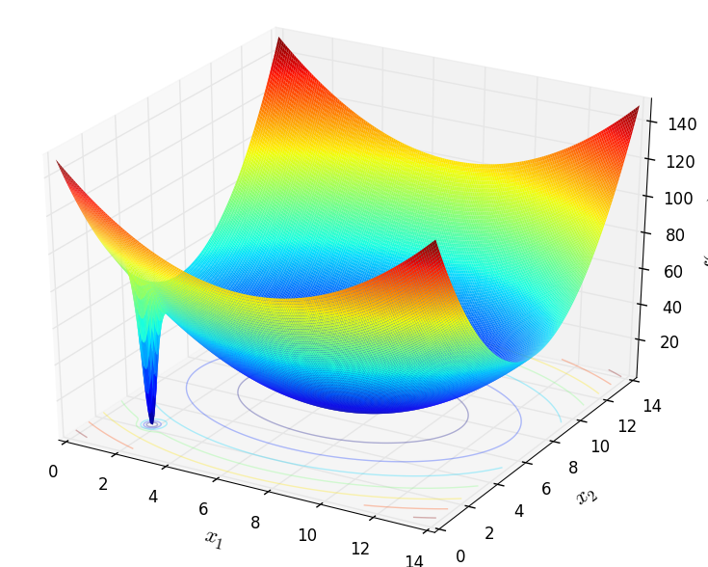

**Formula:**

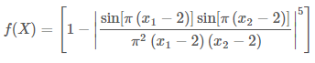



**Mínimo global**

**Dominio**

**Resultados**

|  |  |  |  |  |
| --- | --- | --- | --- | --- |
| S | Clim | Cmax | Calidad | tiempo |
| 20 | 4 | 50 | 0,4042 | 0,828 |
| 20 | 4 | 100 | 0,4043 | 1.579 |
| 20 | 4 | 150 | 0,4043 | 2.352 |
| 20 | 4 | 200 | 0,4043 | 3.145 |
| 20 | 4 | 250 | 0,4043 | 3.939 |
| 20 | 4 | 300 | 0,4043 | 4.737 |
| 20 | 8 | 50 | 0,4043 | 0,798 |
| 20 | 8 | 100 | 0,4043 | 1.579 |
| 20 | 8 | 150 | 0,4043 | 2 |
| 20 | 8 | 200 | 0,6207 | 3.141 |
| 20 | 8 | 250 | 0,4043 | 3.961 |
| 20 | 8 | 300 | 0,4043 | 4.729 |
| 20 | 12 | 50 | 0,4043 | 0,811 |
| 20 | 12 | 100 | 0,4043 | 1.579 |
| 20 | 12 | 150 | 0,4043 | 2.358 |
| 20 | 12 | 200 | 0,4043 | 3.138 |
| 20 | 12 | 250 | 0,4043 | 3.938 |
| 20 | 12 | 300 | 0,4043 | 4.726 |
| 40 | 4 | 50 | 0,4043 | 0,797 |
| 40 | 4 | 100 | 0,4043 | 1.579 |
| 40 | 4 | 150 | 0,4888 | 2 |
| 40 | 4 | 200 | 0,4043 | 3.143 |
| 40 | 4 | 250 | 0,4043 | 3.942 |
| 40 | 4 | 300 | 0,4043 | 4.704 |
| 40 | 8 | 50 | 0,4043 | 0,822 |
| 40 | 8 | 100 | 0,4043 | 1.598 |
| 40 | 8 | 150 | 0,4043 | 2.379 |
| 40 | 8 | 200 | 0,4043 | 3.151 |
| 40 | 8 | 250 | 0,4043 | 4 |
| 40 | 8 | 300 | 0,4043 | 4.749 |
| 40 | 12 | 50 | 0,4043 | 0,812 |
| 40 | 12 | 100 | 0,4043 | 1.569 |
| 40 | 12 | 150 | 0,4043 | 2.383 |
| 40 | 12 | 200 | 0,4043 | 3.165 |
| 40 | 12 | 250 | 0,4043 | 3.924 |
| 40 | 12 | 300 | 0,4043 | 4.719 |
| 60 | 4 | 50 | 0,4043 | 0,788 |
| 60 | 4 | 100 | 0,4043 | 1.582 |
| 60 | 4 | 150 | 0,4043 | 2.366 |
| 60 | 4 | 200 | 0,4043 | 3.184 |
| 60 | 4 | 250 | 0,4043 | 3.942 |
| 60 | 4 | 300 | 0,5275 | 4.733 |
| 60 | 8 | 50 | 0,4043 | 0,82 |
| 60 | 8 | 100 | 0,4043 | 1583 |
| 60 | 8 | 150 | 0,4043 | 2.353 |
| 60 | 8 | 200 | 0,4043 | 3 |
| 60 | 8 | 250 | 0,4043 | 4 |
| 60 | 8 | 300 | 0,4043 | 4.738 |
| 60 | 12 | 50 | 0,4043 | 0,816 |
| 60 | 12 | 100 | 0,4043 | 1.583 |
| 60 | 12 | 150 | 0,5063 | 2369 |
| 60 | 12 | 200 | 0,4043 | 3183 |
| 60 | 12 | 250 | 0,4043 | 4 |
| 60 | 12 | 300 | 0,4043 | 4.716 |
| 80 | 4 | 50 | 0,4043 | 0,796 |
| 80 | 4 | 100 | 0,4043 | 1.617 |
| 80 | 4 | 150 | 0,4043 | 2.368 |
| 80 | 4 | 200 | 0,4043 | 3.182 |
| 80 | 4 | 250 | 0,4043 | 3.952 |
| 80 | 4 | 300 | 0,4043 | 4.719 |
| 80 | 8 | 50 | 0,4043 | 0,798 |
| 80 | 8 | 100 | 0,4043 | 1.585 |
| 80 | 8 | 150 | 0,4043 | 2,4 |
| 80 | 8 | 200 | 0,4043 | 3.152 |
| 80 | 8 | 250 | 0,4043 | 3.993 |
| 80 | 8 | 300 | 0,4043 | 4.739 |
| 80 | 12 | 50 | 0,4043 | 0.831 |
| 80 | 12 | 100 | 0,4043 | 1.584 |
| 80 | 12 | 150 | 0,4043 | 2368 |
| 80 | 12 | 200 | 0,4043 | 3.136 |
| 80 | 12 | 250 | 0,4043 | 3.931 |
| 80 | 12 | 300 | 0,4043 | 4.694 |
| 100 | 4 | 50 | 0,4043 | 0,798 |
| 100 | 4 | 100 | 0,5797 | 1.585 |
| 100 | 4 | 150 | 0,8444 | 2.385 |
| 100 | 4 | 200 | 1,1532 | 3.152 |
| 100 | 4 | 250 | 0,6984 | 3.966 |
| 100 | 4 | 300 | 0,7453 | 4.768 |
| 100 | 8 | 50 | 0,4043 | 0.8 |
| 100 | 8 | 100 | 0,4043 | 1.584 |
| 100 | 8 | 150 | 0,4043 | 2.367 |
| 100 | 8 | 200 | 0,7088 | 3.199 |
| 100 | 8 | 250 | 0,4043 | 3.953 |
| 100 | 8 | 300 | 0,4043 | 4.704 |
| 100 | 12 | 50 | 0,4043 | 0,8 |
| 100 | 12 | 100 | 0,4043 | 1.598 |
| 100 | 12 | 150 | 0,4043 | 2.383 |
| 100 | 12 | 200 | 1,0000 | 3 |
| 100 | 12 | 250 | 0,4043 | 3.966 |
| 100 | 12 | 300 | 0,4043 | 4.751 |