**Part 1**

-- create a view named "initialCustomers" that shows the first name, last name, and email address of customers that have an id of less than 100.

-- once that is complete, select and view your newly created view

CREATE VIEW InitialCustomers AS

SELECT first_name, last_name, email

FROM sakila.customer

WHERE customer_id < 100;

SELECT * FROM InitialCustomers;

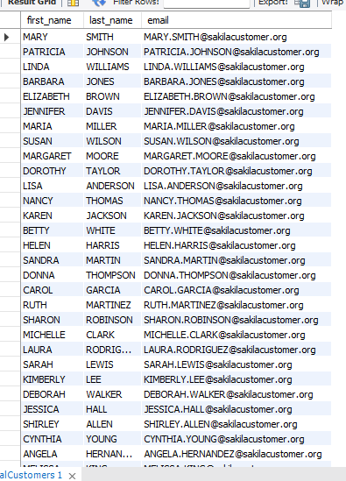

**Part 2**

-- Create a table named "ProductList". Include the following columns: ProductId, ProductName, Price, DateAdded, EmployeeSupportId,

-- Include the following requirements:

-- Every product should have an automatically generated id number that should be unique for each product.

-- Give each column a data type that would apply

-- Give the DateAdded column a default value for the current local time.

-- All columns CANNOT be null.

CREATE TABLE ProductList(

ProductId INTEGER PRIMARY KEY AUTO_INCREMENT,

ProductName varchar(85) NOT NULL,

Price INTEGER NOT NULL,

DateAdded datetime DEFAULT current_timestamp,

EmployeeSupportID varchar(25) NOT NULL

);

- Next, insert one product into the table following the given guidelines when the table was created.

-- When inserting the data, don't include the ProductId or the DateAdded.

insert INTO ProductList(ProductName, Price, EmployeeSupportID)

values ("Soy_Candle", 5.99, "T25863");

-- Finally, run a query to see the single product in your table.

SELECT * FROM ProductList;

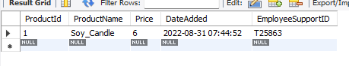

After creating and adding to the table, I see I should have entered behind price “numeric” instead of “integer” so it would have included the exact price instead of rounding up.