

Assessment Cover Page
Student Full Name
Jessica de Oliveira
Student Number
sba26102
Module Title
Strategic Thinking
Assessment Title
Predicting Full Room Occupancy
Lecturer/Supervisor
Taufique Ahmed
Assessment Due Date
25/10/2026

Cover Page- AI Declaration

Use of AI Tools
I acknowledge the use of [ChatGPT/Claude] for the purpose of [Brainstorming, narrowing the focus, understanding the titles and descriptions, enhancing grammar and spelling, investigating possible data sources, and structuring the capstone]
Declaration
By submitting this assessment, I confirm that I have read the CCT policy on academic misconduct and understand the implications of submitting work that is not my own or does not appropriately reference material taken from a third party or other source.
I declare it to be my own work and that all material from third parties has been appropriately referenced.
I further confirm that this work has not previously been submitted for assessment by myself or someone else in CCT College Dublin or any other higher education institution.

Table of Contents

Cover Page- AI Declaration 1
Introduction 3
Problem Definition 4
Aim and Objectives 4
Scope 4
Methodology 5
Data Sources 7
Expected Deliverables 7
Ethical and Legal Considerations 9
References 10
Appendix 12
Appendix A- Commits GitHub 12
Appendix B- AI Declaration using the AI Fluency Framework 13
Appendix C- Ethical Machine Learning Research Student Researcher Capstone Project Ethics Form 15

Introduction

This project aims to predict whether a small accommodation/hotel with six rooms, located above a pub named The Merry Cobbler in Dublin 4, will reach full occupancy during the summer season by using historical data.
The Merry Cobbler is a pub and accommodation/hotel located in a prime location on Irish Town Road in Dublin 4. It has convenient access to public transport, the city centre, and Dublin's main attractions. It is also within walking distance of the 3Arena, Aviva Stadium, and Sandymount Beach are all accessible by foot. The owner bought the bar in 2016, but the accommodation only opens in 2025.
For this project, we will use and analyse historical booking data from the accommodation's first year of operation to identify patterns associated with full occupancy. These patterns will help determine the factors that contribute to all six rooms being booked at a particular time during the summer season and may help the business identify and optimise opportunities to increase occupancy and revenue.
The project is relevant to the business because the accommodation is relatively new and operates in a competitive hospitality environment. The information collected and analysed will help the business identify opportunities and improve the management and operation of the accommodation.

Problem Definition
The business operates in a highly competitive environment, as it is relatively new to the market, has limited amenities to offer, and has limited previous experience in the accommodation sector. The accommodation is located above a pub, which can be noisy on certain nights and may potentially affect the guest experience. In addition, it is located in an area with several competing accommodation options that may offer more amenities at a similar or higher price. These factors may affect its competitiveness and customers’ booking decisions, particularly when compared with alternative accommodation in the same area.
After collecting, organising, analysing, and interpreting historical data (Data Analytics), such as past occupancy and reservation patterns, predictive modelling will be used to forecast future outcomes. This may include predicting cancellations and no-shows, as well as demand forecasting, such as estimating the probability of achieving full occupancy, which is the main aim of this project.

Aim and Objectives
The primary goal of this project is to analyse historical booking and occupancy data and develop a predictive model to estimate the probability of the small hotel reaching full occupancy during the summer season. It is a fundamental and essential task for the hotel management to estimate the occupancy rate as it greatly influences the hotel revenue.
Therefore, this project also aims to contribute to operational efficiency, to support marketing planning, to improve pricing strategies, to support making strategic choices and to gain a competitive advantage. The main objectives that must be met to be able to achieve this are as follows:
• Collect, organize, analyse and interpret historical data to identify relationships and trends that influence occupancy trends.
• Build a predictive classification model to predict the probability of the hotel reaching full occupancy on the pre-processed data set and provide business insights and recommendations that could help in improving customer satisfaction.
• Analyse customer behaviour, competitor offers and retention strategies to know about factors that may influence customers’ booking decisions and occupancy levels.

Scope
The project will focus on developing a model to predict whether a small accommodation establishment, consisting of six rooms, will reach full occupancy during the summer season using historical data.
The project will primarily use historical data from the accommodation establishment. However, if the available data from pulse website is not sufficient, additional data from the accommodation market will be used to complement the analysis.
Included
- Data collection: collect, arrange, and clean hotel data from the past and present, including reservations, occupancy, availability, room rates, booking dates, and more.
- Modelling: Choose a machine learning model for a classification problem, such as Random Forest Classifier. Although many models may be compared. In this phase where our algorithms learn to make solid predictions based on the given engineered features. In hospitality, classification models can predict whether a customer will book a room, the chance of repeat visits, or whether a guest will leave a positive or negative review.
- Evaluation of the model: Use suitable evaluation measures, such as a confusion matrix, precision, recall, f1 score, to assess the model and choose the one that has the best predictive results.
- Present the results (predictions): Communicate the model's results and provide information that can help decision-making and improve business results.
- Model Monitoring and Updating: Depending on the model's performance and the availability, review and update it as needed.
Not included
The following data will not be analysed:
- Names, phone numbers, and email addresses that are specific to the owner or visitors. Sensitive personal data.
- Information unrelated to the accommodation analysis or the objectives of the project.

Methodology
This section gives a brief overview of how the project will be carried out. It outlines the data analytics methods, predictive modelling techniques, and tools that are planned to be used, all of which are illustrated in the architectural diagram developed for this project.

DEFINE THE PROBLEM
Predicting Full Room Occupancy in a Small Pub Accommodation During the Summer Season


DATA PREPARATION FOR ML (Split data in train 80% and test 20%)
DATA PROCESSING

DATA SOURCES
Booking.com/Pulse Data/Airbnb data/Calendar and Public data sources

FEATURE SELECTION AND
TARGET DEFINITION
(features: month/day week/weekend. Target variable: Full occupancy or non-occupancy
DATA COLLECTION
(CSV files/Pandas)
EXPLORATORY DATA ANALYSIS
(Identify patterns and relationships/ Identify trends/Descriptive statistics

TEST THE DATA
(evaluate performance on unseen observations)
)
(xcvvvvvvv
TRAINING THE DATA
(Model training will be used)

DATA LOADING AND CLEANING
(Missing values/ Duplicates and errors)

DATA PROCESSING
(Encoding, Scaling and treating data when necessary)


MACHINE LEARNING
DATA PROCESSING

ALGORITHM SELECTION (May be Random Forest Classifier as it can model non-linear relationships and interactions between features)
MODEL TRAININGS
(use the training dataset)
DATA PREPARATION
MODELLING
PREDICTIONON TEST SET
MODEL PERFOMANCE
EVALUATION
(Precision, Recall, Accuracy)

EVALUATION
FORECAST AND RESULTS
EVALUATION


PREDICTIONS AND RESULTS
Test Full Occupancy/ performance metrics/ Interpret Results and Business recommendations.

Data Sources
For this project, the dataset will consist of historical reservation and occupancy data from The Merry Cobbler's Booking.com Pulse account, which is used by the owners to manage the accommodation. The data may include:
- Reservations
- Occupancy
- Availability
- Room prices
- Booking dates
- Guest confirmations
- Property performance
The hotel has only six rooms and has only been open for a short time, therefore the historical booking data that is currently available might not be enough to create and accurately assess the prediction model. As a result, other data sources might be needed to boost the number of observations and bolster the analysis. Publicly accessible datasets from websites like Inside Airbnb and pertinent travel and lodging datasets are examples of potential sources. Before these external datasets are integrated into the project, their applicability, quality, and usefulness will be evaluated.
The data will be analysed to identify patterns in historical bookings and occupancy and to develop a predictive model to determine whether the accommodation is likely to reach full occupancy on a given date.
The owner consented to the use of the data under the General Data Protection Regulation (GDPR). The owner was assured that the data would be used solely for academic purposes and that the security, integrity and confidentiality of the data would be maintained throughout the project. Proper permission can be presented when it becomes necessary.

Expected Deliverables
By the end of Semester 2, a data analysis and predictive modelling solution is expected to be developed to predict whether the small accommodation will reach full occupancy on a given date. This will help the hotel owner protect revenue by supporting pricing decisions, optimise resource management through staff planning, maintain service quality by reducing waiting times, and also improve marketing strategy.
To enhance data visualisation, a dashboard will be developed to facilitate data interpretation and enable the quick identification of trends, anomalies, and opportunities. The final predictive model will show how machine learning and data analytics can help a small company with occupancy planning and informed decision-making.

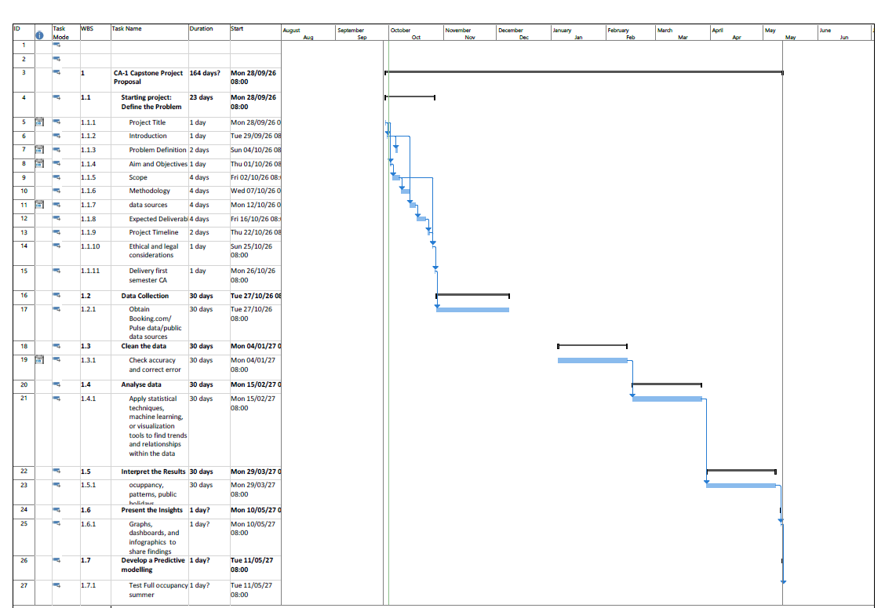
Project Timeline
The project timeline for both semesters is shown in the Gantt chart below. The specified dates could change as the project progresses. Predictive modelling, evaluation, data collection, and preparation will be the main tasks of this capstone project.
Figure 1- Gantt chart Timetable

Ethical and Legal Considerations
The project will follow the principles of the General Data Protection Regulation (GDPR), particularly regarding the legitimate purpose of data processing. The data will be used only for the purpose of the Strategic Thinking CAs. Only the data necessary to make this project possible will be collected and processed. Personal data such as guests' names, dates of birth, email addresses, phone numbers, and other identifying information will not be necessary for this project. However, all data collected from the company will be handled securely, ensuring its security, integrity, and confidentiality.

Permission to access and use the business data has been obtained from the owner/manager and will be uploaded when requested.

References
Finn, T. and Smalley, I. (2024) What is predictive analytics? Available at: https://www.ibm.com/think/topics/predictive-analytics (Accessed: 28 september 2026).
Booking.com (no date) The Merry Cobbler, Dublin: guest reviews. Available at: https://www.booking.com/hotel/ie/the-merry-cobbler.html (Accessed: 1 October 2026).
‘7 Steps of Data Analysis for Predictive Analytics & Business Insights’. Available at: https://thevistaacademy.com/data-analysis-process-steps/(Accessed: 1 October 2026).
Ahmed, Taufique(2026) Identifying a business problem. Data Analytics for Business. CCT College Dublin. Available at: https://moodle.cct.ie/my (Accessed: 1 October 2026).
Carneiro T, Picoto WN, Pinto I(2023) Big Data Analytics and Firm Performance in the Hotel Sector. Tourism and Hospitality. Available at: https://doi.org/10.3390/tourhosp4020015 (Accessed: 5 October 2026).
Ahmed, Taufique(2026) Strategic Business & Professional Development. CCT College Dublin. Available at: https://moodle.cct.ie/my (Accessed: 5 October 2026).
Carter, Alex(Oct 1, 2024) Predictive Analytics in Project Management: Guide. Available at https://daily.dev/blog/predictive-analytics-in-project-management-guide/(Accessed: 5 October 2026).
Hassan, Muhammad (Updated on: June 28, 2026) Predictive Analytics – Methods, Models, Examples, and Uses. Available at https://researchmethod.net/predictive-analytics/(Accessed: 8 October 2026).
London School of Business and Research (No date) Predictive Analytics and Forecasting in Hospitality. Available at https://www.lsbronline.com/wp-content/uploads/2025/01/Predictive-Analytics-and-Forecasting-in-Hospitality.pdf (Accessed: 8 October 2026).
‘Predictive Analytics in Hospitality: Use Cases, AI and Hotel Optimization’ (Last Updated on February 16, 2026). Available at https://www.latentview.com/blog/predictive-analytics-in-hospitality/ (Accessed: 12 October 2026).
‘Take-off Edu Group’ (no date). Available at https://takeoffprojects.com/project-details/theoretical-evaluation-of-machine-learning-approaches-for-hotel-recommendation--17167 (Accessed: 13 October 2026).
Rekiek, Siham , Jebari, Hakim , Reklaoui, Kamal (October 2024) Prediction of Booking Trends and Customer Demand in the Tourism and Hospitality Sector Using AI-Based Models. Available at https://www.researchgate.net/publication/385384852_Prediction_of_Booking_Trends_and_Customer_Demand_in_the_Tourism_and_Hospitality_Sector_Using_AI-Based_Models(Accessed: 13 October 2026).
Scikit-learn (no date) Getting Started. Available at: https://scikit-learn.org/stable/getting_started.html (Accessed: 17 October 2026).
Mudryi,Volodymyr (Updated 18 January 2025) Preparing Data for ML Development in 6 Steps. Available at https://intelliarts.com/blog/data-preparation-in-machine-learning/ (Accessed: 17 October 2026).
OpenAI (2026). ChatGPT (Version GPT-6). Artificial intelligence model. (Accessed: 28 september 2026-5 October 2026-13 October 2026). See appendix for prompt used.
OpenAI (2026). ChatGPT (Version GPT-6). Artificial intelligence model. (Accessed: 28 september 2026-5 October 2026-13 October 2026). See appendix for prompt used.
Anthropic (2026) Claude Sonnet 5.5 [Large language model]. Available at: https://claude.ai (Accessed: 24 October 2026).
Farag, Youssef (Jan 23, 2025) The Machine Learning Process - The Path to Your Hotel Pricing AI. Available at https://hotellistat.com/en/blog/the-path-to-your-hotel-pricing-ai. (Accessed: 24 October 2026)

Appendix

Appendix A- Commits GitHub

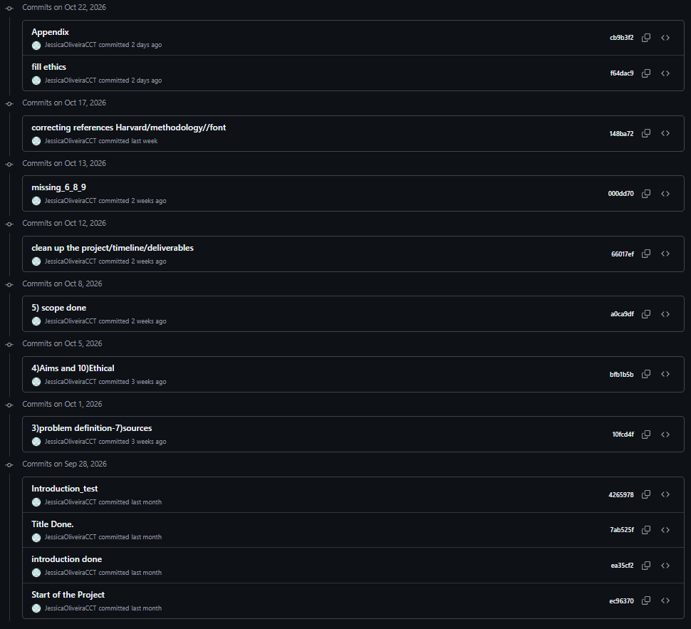
AI competence | Reflective prompts (to students) | Lecturer expectations | Student response
Delegation  Deciding whether & when to use AI | Identify the specific tasks in this assessment where you chose to use AI and explain your reasoning. Where did AI add value? Where did you decide not to use it, and why? | For this assessment, Generative AI may be used only as a supporting tool for brainstorming and refining ideas, fine-tuning research questions, finding relevant information, drafting an outline, checking grammar, clarity and writing style, and other uses explicitly approved by the lecturer.  These uses support planning, research and communication. GenAI must not replace the student's own technical implementation, analysis, modelling, evaluation or interpretation, as these directly assess the learning outcomes. You may not copy and paste GenAI output in your submission. All GenAI use must be declared in the GenAI Tools Declaration (Appendix A). Failure to do so is considered to be academic misconduct. | I decided to use AI for brainstorming, narrowing the focus, enhancing grammar and spelling, investigating possible data sources, and structuring the capstone. As the capstone was my first project, I felt a bit lost, so using AI helped me see where I should focus and what I should look for.  I did not use it to answer the requested titles, as I found a lot of information in other sources, which can be seen in my references. The title I chose ended up having a lot of material available from different sources.
Description  How you prompted the AI | Include the exact prompts you used in your appendix (recorded on the AI Tools declaration). Reflect on how you communicated your goals to the AI — did you need to iterate or refine your prompts to get useful output? | Students must provide evidence of prompting for all permitted GenAI use. The exact prompts used, together with relevant links, screenshots or evidence of prompt refinement where applicable, must be provided in Appendix B. Failure to do so is considered to be academic misconduct. | See prints bellow. But mostly:  -Check if what I wrote is good for this title in the capstone; - Enhancing grammar and spelling and improve the structure without changing the original meaning or ideas; -What this title and description can mean for my capstone; - How to access the dataset from Booking.com; - Enhancing grammar and spelling;
Discernment  Evaluating what the AI produced | In your reflection (~100 words), critically evaluate the AI output: what did you accept, modify, or reject — and why? Assess accuracy, relevance, and quality. You are responsible for verifying all AI-generated content before submitting. | A reflection is required for this assessment. In approximately 100 words, students must critically evaluate the accuracy, relevance and quality of any GenAI-assisted outputs, explaining what they accepted, modified or rejected and why. Failure to do so is considered to be academic misconduct. | Most of the time I found the replies useful. I did not need to copy or take anything from there, as I said, because I found many data sources available in different places. But it was useful for brainstorming and narrowing the focus, and as many of the titles were new to me and I would not have known what to search for if it had not been for the AI. With AI help I could clear understand the titles and what was being requested and search for right references.
Diligence  Responsibility for your AI use | Declare all AI tools used and cite them here. Briefly outline (~100 words) how you considered data protection, copyright, and ethical responsibilities when choosing what to input into any AI system. Unauthorised use is subject to CCT disciplinary procedures. | Students must declare all GenAI tools used and cite them appropriately. In approximately 100 words, students must explain how they considered data protection, copyright and ethical responsibilities when using GenAI. Unauthorised GenAI use is subject to CCT disciplinary procedures. Failure to do so is considered to be academic misconduct. | ChatGPT and Claude were used for this capstone for the purposes already explained in the delegation section. Regarding data protection, no personal or business information was used. I did not need to copy and paste, as I found many data sources, and if I had needed to, I would have used an in-text citation. I confirm that this is my own work, based on the searches and reading I did, and that the capstone is entirely my own.

Appendix B- AI Declaration using the AI Fluency Framework

For use in assessment briefs and student submissions. Lecturers complete the Lecturer Expectations column per assessment; students complete the Student Response column.
Adapted from the AI Fluency Framework (Dakan, Feller, Anthropic, 2025)
PROMPTS
Enhancing grammar and spelling.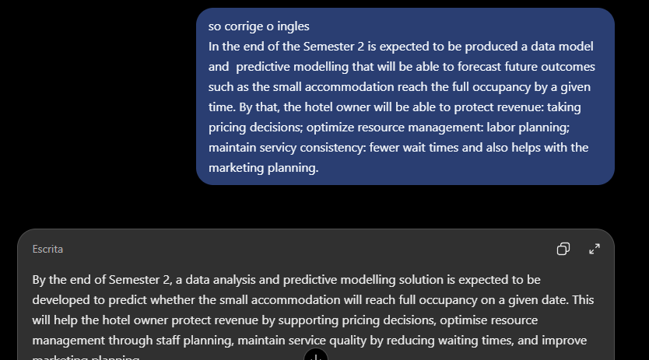 | Investigating possible data sources  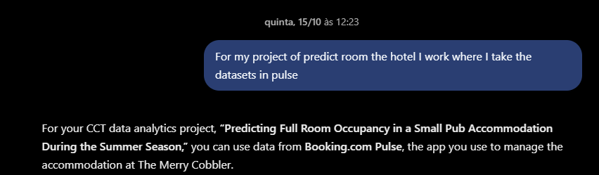
Brainstorm: Checking if the title and proposal was good for the capstone.  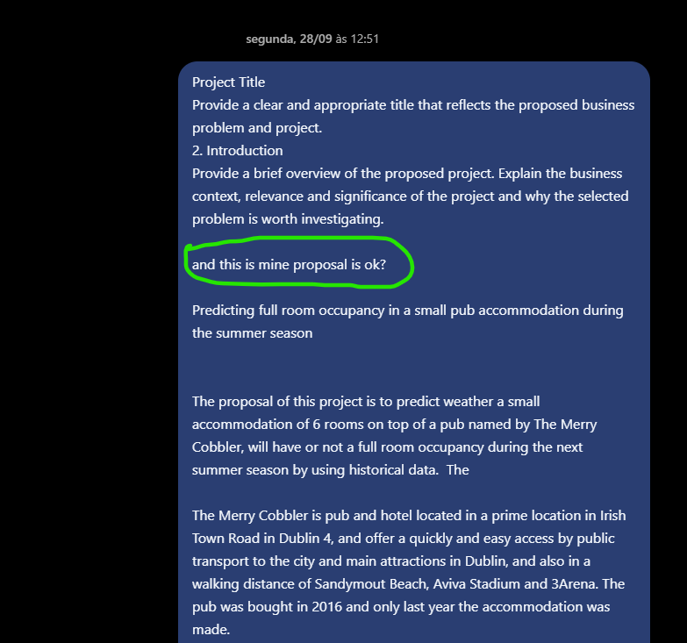 | Enhancing grammar and spelling and improve the structure without changing the original meaning or ideas.  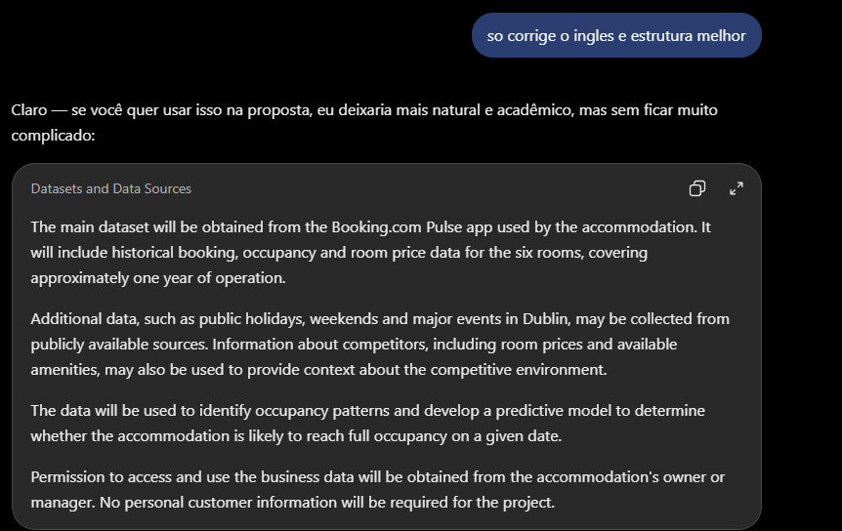
Correct the English and improve the structure without changing the original meaning or ideas.  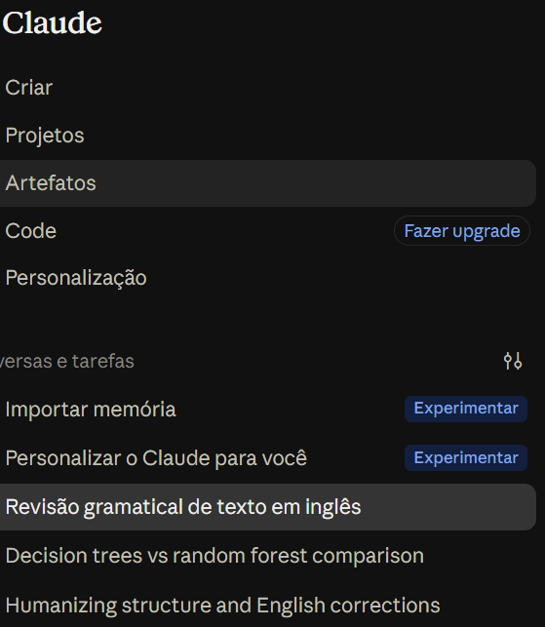 | Correct the English and improve the structure without changing the original meaning or ideas.  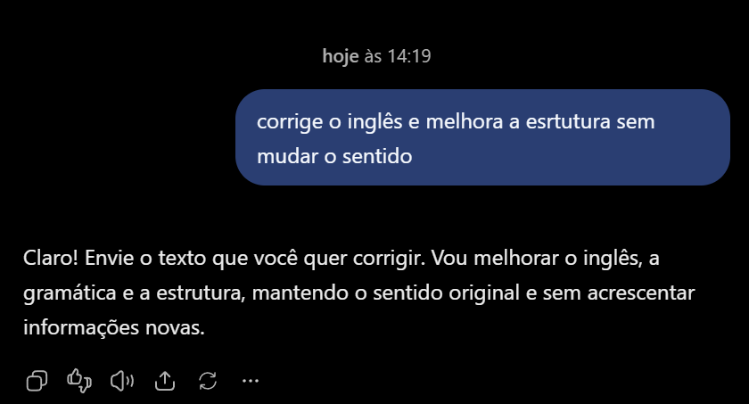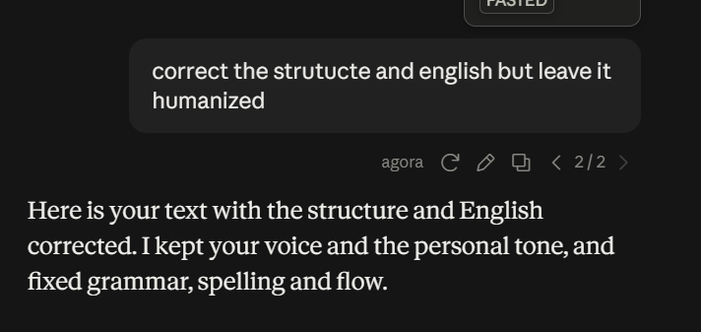

Appendix C- Ethical Machine Learning Research Student Researcher Capstone Project Ethics Form
As a student researcher in the capstone project, you are vital in ensuring the project is conducted ethically and without bias. Before you embark on the capstone project, please carefully read and understand the following information.
By conducting the capstone project, you will be actively engaged in the following research activities:
- Data analysis and preprocessing.
- Training and evaluating machine learning models.
- Drawing conclusions on the machine learning models and the dataset, nothing else.
The capstone project will comprehensively examine machine learning models without introducing biases or negatively affecting vulnerable populations in society. The focus is on improving the fairness and accuracy of the results obtained from the machine learning models. The focus is on the models themselves and the dataset without delving into social work, bias or anthropology. Use deductive reasoning on the model outcomes.
Yes | No | As a student researcher, your responsibilities include:
 |  | Adhering to ethical guidelines provided for data handling and analysis.
 |  | Data is anonymised, and personal identifiers will be removed to protect the privacy of individuals.
 |  | Ensure that the research does not introduce bias and avoids adverse effects on the vulnerable in society and minors.
 |  | Focus on evaluating and improving machine learning model accuracy and results.

I have read and understood the information provided in this ethics form, and I agree as a student researcher to abide by the ethics outlined in this form in the capstone project. I understand that my role will focus on machine learning models and dataset analysis and will not involve social work, health and care, vulnerable social groups or anthropology (no personal interviews of human subjects).
If you have any questions or concerns or require clarification on the capstone project's ethics, please contact James Garza at jgarza@cct.ie.


Student Name (printed): Jessica Rodrigues de Oliveira
Student Number: SBA26102
Student Signature: __________________________
Date: 25/10/2026

