Jessica Page

Homework 4

Problem 1]

1. To obtain numerical results similar to the analytic answer

y = -sin(πcos(x))

it was necessary to set the tolerable error to 0.5, and the step size h equal to 0.01 using RK45 and allowing the first iteration of yi+1 and zi+1 calculations to be calculated with h. Proper data fitting was not implemented, but the comparison shows the code was working properly. (fig. 1)

1. Comparing RK4 and RK5 methods individually added assurance that the process was working correctly as they are indistinguishable. (fig. 2)
2. Using a variable step size required to meet a lower tolerance of 5 x 10-3, the step size varied as a function of x as shown below in figure 3.
3. The minimum step size hmin was found to be 1.7 x 10-6. Using constant hmin as the step size for comparison, using the variable step size method was found to be 39ms in real time and 47ms in user time faster than a constant step size. The output is shown below.

|  |  |
| --- | --- |
| Constant hmin | variable h |
| real 0m0.776s | real 0m0.737s |
| user 0m0.702s | user 0m0.655s |
| sys 0m0.062s | sys 0m0.077s |

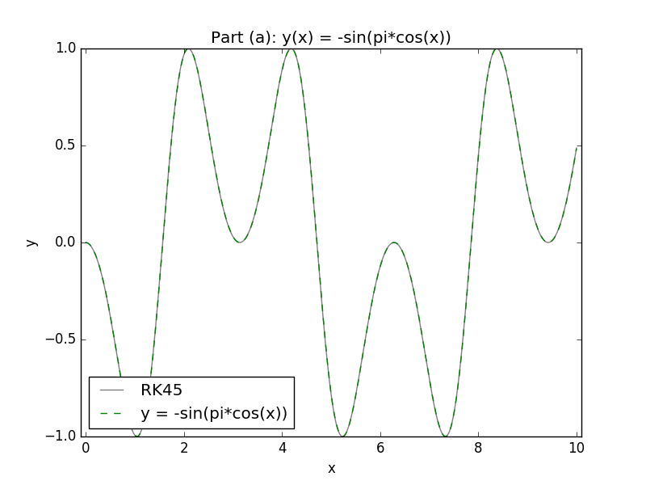

Figure

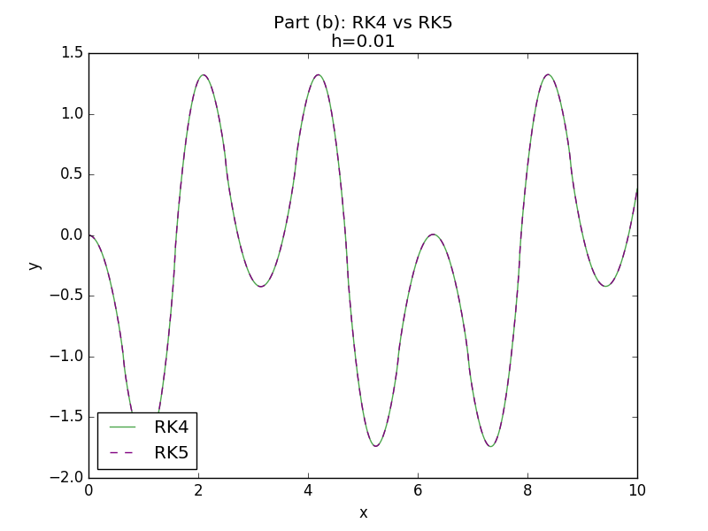

Figure

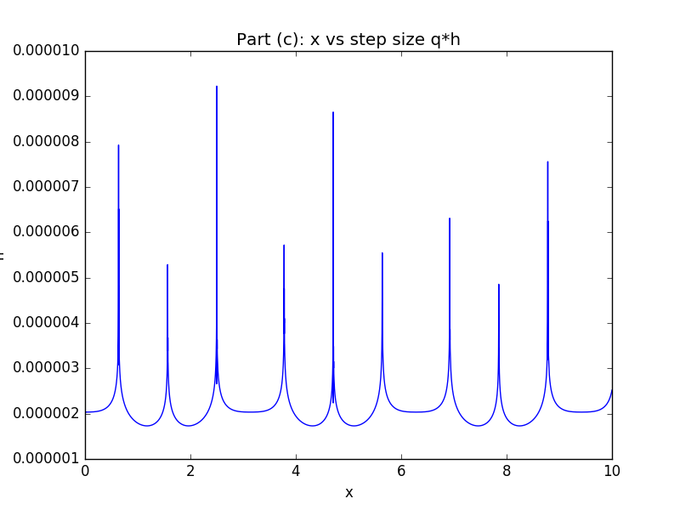

Figure

Problem 2]

1. Using the RK45 method to solve for y(t) yielded an exponential decay in height with time with a ymax ~ 5. Tolerance was set to 0.001 and dt was set to 0.1. (fig. 4)
2. The results were not the accurate physical trend. The computational results are due to a variable q which can increase rapidly. The function was not analyzed well in the time for y < yhigh so it appears to automatically begin decreasing. The small amount of difference between yi+1 and zi+1 leads to a high q since they were identical during times when y is negative due to setting Qout = 0 and the differences in RK4 and RK5 are mostly contained in the upper k values.
3. Increasing the tolerance to 0.5 and setting q < 2 yielded a more accurate solution. (fig. 5)
4. The reasoning behind a fixed time step is the same argument made in (b). If q can vary unchecked its possible to increase rapidly making it possible to skip over important points in the domain. (fig. 6)

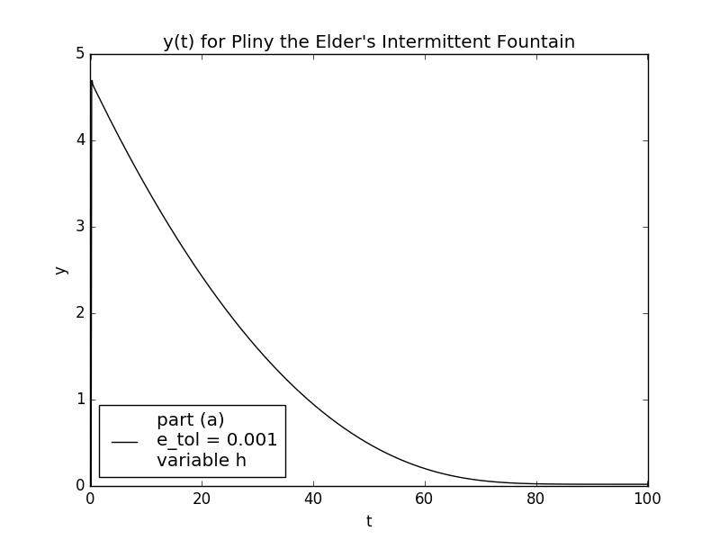

Figure

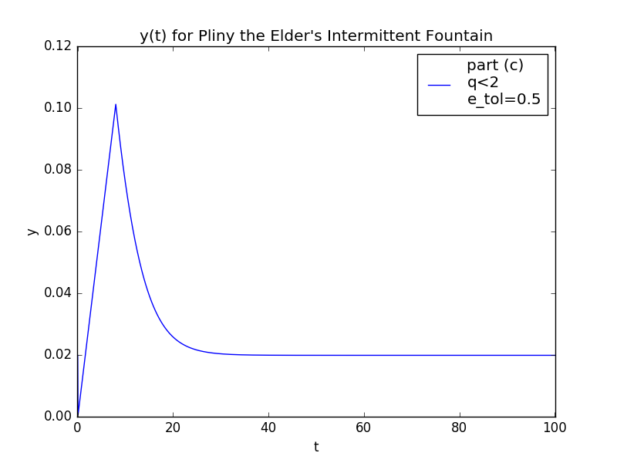

Figure

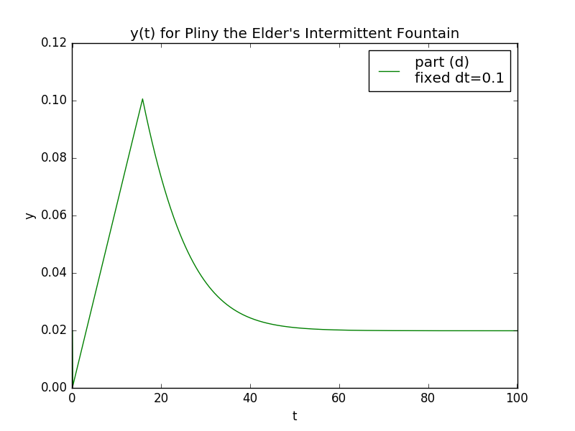

Figure 6