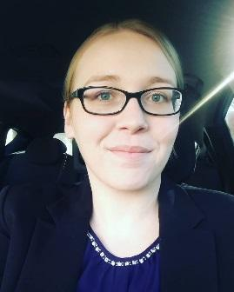

**Jessica Phillips**

**Software Developer**

Lincoln, NE

Jessicaphillips.jp@gmail.com

|  |  |
| --- | --- |
| Qualifications Summary | * Bachelor in Software Development + 2 years of software development experience * Over 2 years’ experience in Object Oriented Programming and Java Development * Over 2 years’ experience with technical writing and marketing for startup company * Over 2 years’ experience with web development including HTML5, CSS3, Bootstrap, PHP, and SQL(sqlite3) * Ability to work autonomously, great verbal and written communication skills, and ability to communicate technical information to technical and non-technical audiences. |
| Skills | **Development & Software**  Java, HTML, JavaScript, CSS, SQL, PHP, Perl  NetBeans, GitLab, Eclipse, MS Office, Windows Vista/7/8.1/10, Adobe Photoshop, Gimp, Visual Basic, Adobe Acrobat, GitHub, HTML Help  **Technical Writing**  Newsletters, User Guides, White Papers, Technical Guides and Website updates |
| Work History | **gc image, llc – Lincoln, NE** 2016 – Present  **Remote Developer**  Varying positions, including: Developer, Tester and Technical Writer and Web Designer for GC Image chromatography software. Develop GUI solutions, workflow issues, Unit testing, and manual testing using Java. Track and monitor bugs and changes to software.  Notate all changes and keep an accurate history using GitLab. Write technical documents including the user guides, and newsletters.  Update the website and add release updates to the forum. Web development for website using HTML, CSS, PHP and SQL and Javascript. Design and develop new web pages for updated information, or brand new projects.  **army national guard– Omaha, NE** 2008 – 2014  **Military Police/Intelligence Analyst**  Over 6 years in positions of increasing responsibility within the U.S. Army National Guard. Operations and management of personnel, conducted seminars and briefing sessions. Worked closely with senior-level management to coordinate workflow. |
| Education | Bellevue University – Bellevue, NE 2017  **Bachelor of Science in Software Development**  Ashford university – Clinton, IA 2014  **Associate of Arts in Business** |