Which of the following statements are true of security in Aurora? (Select THREE.)

- Aurora requires both authentication and permission for users to access tables. (Correct)
- IAM policies can be used to assign permission to users. (Correct)
- Security groups are used to control access to the database instance. (Correct)
- Data is encrypted at rest using 256-bit RC6 algorithms.
- Amazon Cognito is used to control who can access the database instance.
Users must be authorized and must have permission to access tables in Aurora. IAM policies can be used to assign permissions to users. Security groups are used to control access to your database.

Data is not encrypted using 256-bit RC6 algorithms in Aurora. Instead, 256-bit AES algorithms are used. Amazon Cognito is not a service that controls who can access the database instance in Amazon RDS.

Which of the following statements are true of Aurora databases? (Select THREE.)
- Aurora can have up to 15 read replicas. (Correct)
- Aurora is managed by Amazon RDS. (Correct)
- Aurora Serverless manages database instances for you. (Correct)
- Aurora requires primary keys to create uniqueness.
- Aurora charges for data transferred in from and out to the internet.
Aurora Serverless manages database instances for you. Aurora can have up to 15 read replicas. Aurora is managed by Amazon RDS.

Aurora does not require you to create unique tables. You are never charged for data transfers into your database regardless of their source. You are charged for data transfers out to the internet and to other AWS Regions.

Which of the following are instance classes or features supported by Aurora? (Select TWO.)
- Memory-optimized (Correct)
- Burstable performance (Correct)
- Fixed performance
- Accelerated computing
- Cluster networking
Aurora supports general purpose and memory-optimized instance classes. It also supports the burstable performance instance feature.

Fixed performance is not a supported instance type. Accelerated networking is an Amazon EC2 instance class, and cluster networking is an Amazon EC2 instance feature. Aurora does not support either of these.

You can pay for Aurora using which of the following pricing methods? (Select THREE.)
- On-Demand (Correct)
- Reserved (Correct)
- Serverless (Correct)
- Spot
- Provisioned
Aurora supports On-Demand, Reserved, and Serverless pricing methods.

Spot and Provisioned are instance pricing methods available with other AWS services but not with Aurora.

Which of the following database engines is Aurora compatible with? (Select TWO.)
- MySQL (Correct)
- PostgreSQL (Correct)
- Oracle
- SQL Server
- Spark SQL
Aurora is compatible with PostgreSQL and MySQL.

Aurora is not compatible with Oracle, SQL Server, or Spark SQL. However, you can use the AWS Database Migration Service (AWS DMS) and AWS Schema Conversion Tool to convert and migrate content within these databases to Aurora.

What does a centralized solid state drive (SSD) virtualized storage layer in Amazon Aurora replicas do? (Select THREE.)
- Eliminates the need to copy data to the read replicas
- Enables configuration of specific read replicas to also write to the distributed storage
- Provides a single point to write to the storage from the primary source
- Makes horizontal scaling of Amazon Aurora replicas extremely fast
- Automatically creates read replicas
- Provides multiple points to write to the storage from a primary source

What are suitable applications for logical replication in PostgreSQL? (Select TWO.)
- Replicating changes from PostgreSQL instances running on premises
- Upgrading between PostgreSQL versions
- Reducing CPU overhead for replications
- Replicating DDL
- Replicating changes running offsite

Which tasks does Amazon Relational Database Service (Amazon RDS) automate to help database administrators (DBAs)?

- Queries and query construction
- Time-consuming administration tasks
- Schema design
- All administration tasks

What is the purpose of the Write Ahead Log (WAL) files in Amazon Aurora?
- Record boxcars.
- Write I/O traffic in Aurora.
- Read traffic in Aurora.
- Batch data nodes.

WAL files are PostgreSQL transaction logs used to write I/O traffic in Aurora. Before writing data changes to permanent storage, these changes are first recorded in WAL files. These log records are organized through LSNs to identify the transaction records for future reference.

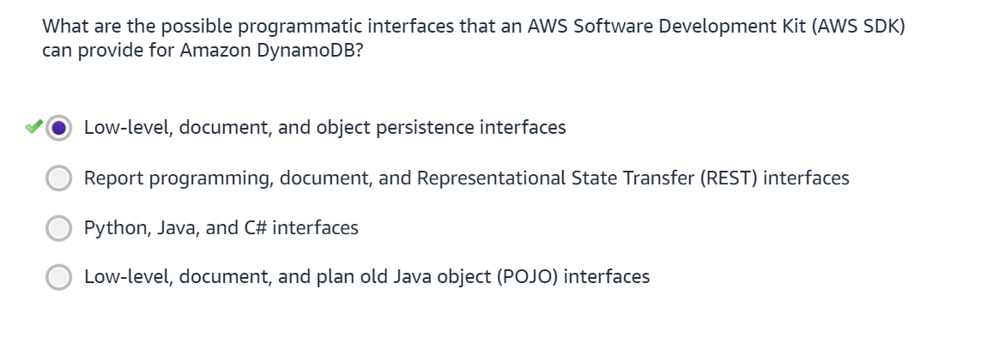
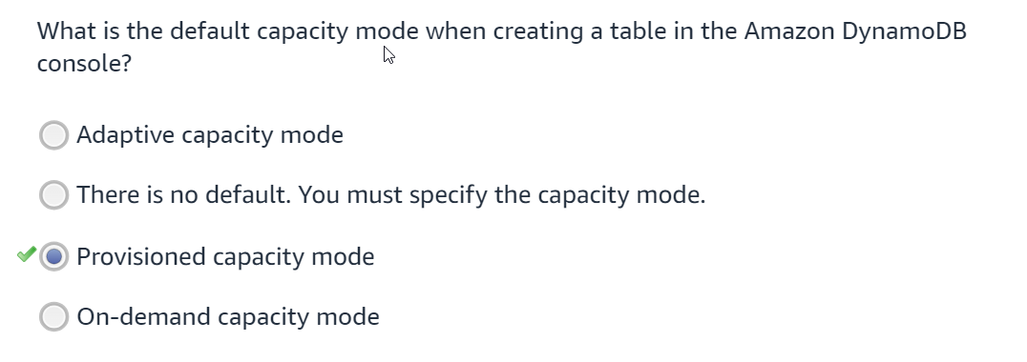

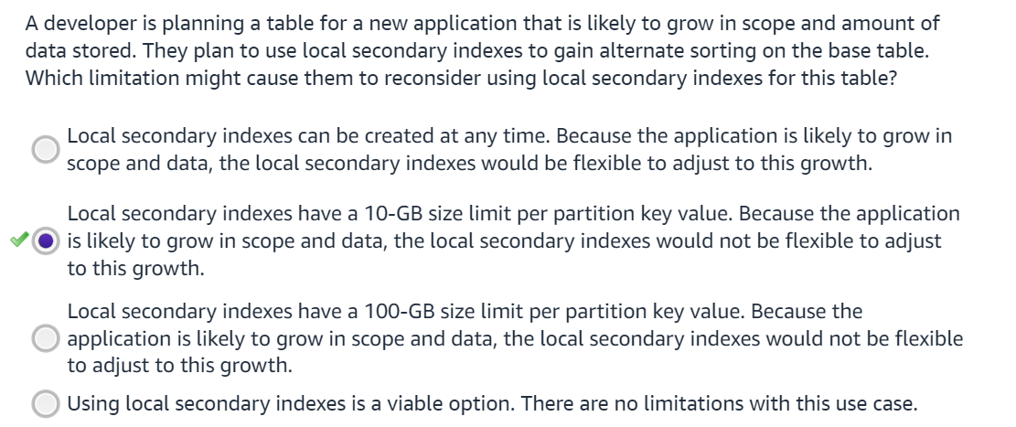

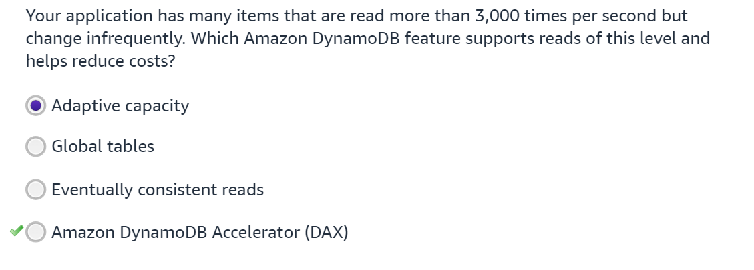
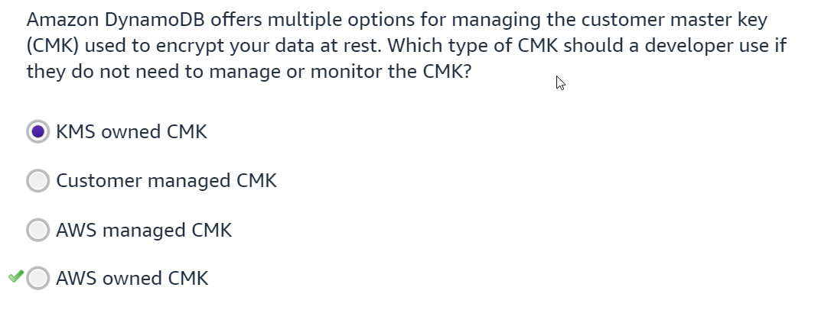

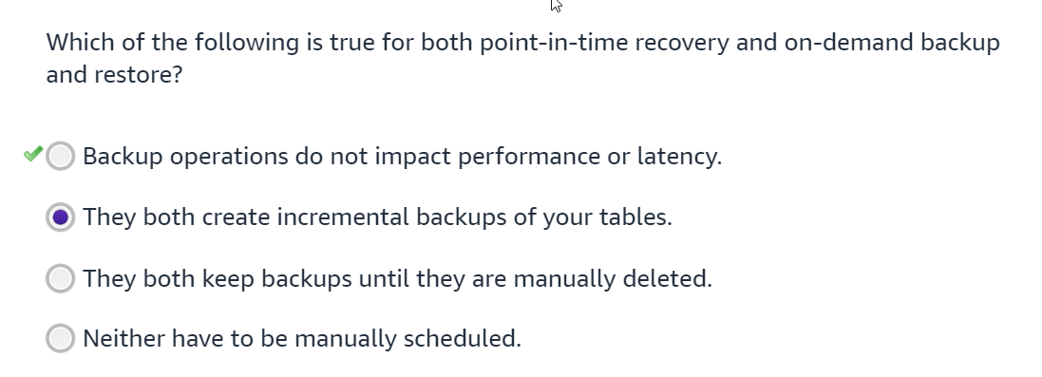
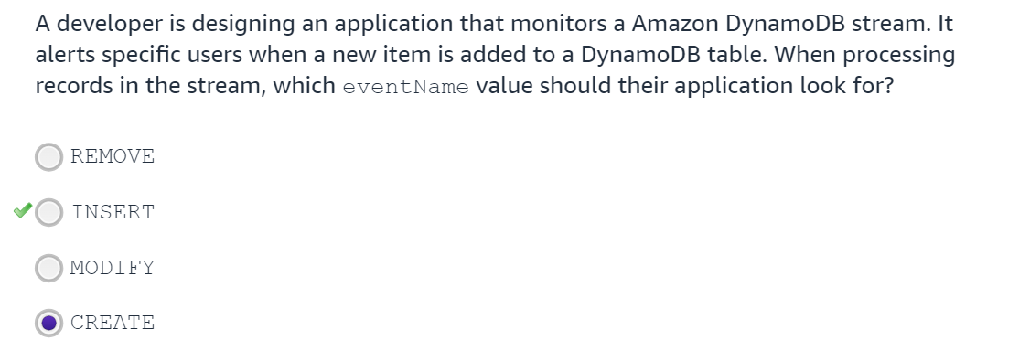

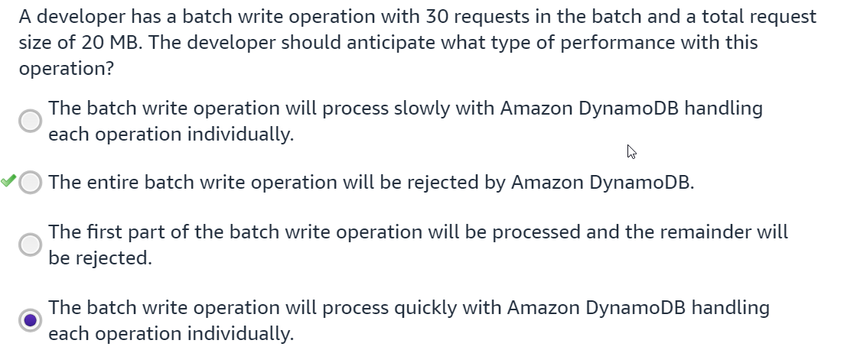

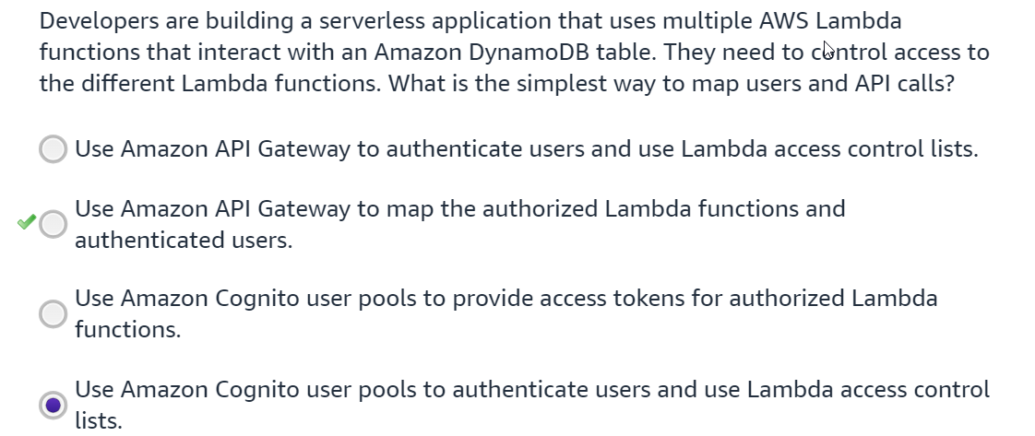

Which of the following workload characteristics might be a good fit for DynamoDB? (Select THREE)
- The data is “hot” – serving real-time, transactional, operational, interactive uses.
- The data is historical, infrequently accessed for complex ad-hoc analytical queries that can be requested as a job and delivered minutes or hours later as a report.

- The data is a collection of very large binary objects which are written only once but often read by direct reference.

- The data must be stored in a highly available, durable, and highly scalable manner

- The session states for your application need to be stored off of your instances

One basic factor for success with DynamoDB is: (Select ONE.)
- Selecting optimal node size and availability zones for your table.
- Default to creation of strongly consistent tables to avoid corruption.

- Choosing a high cardinality sort key and localizing the index.

- Remembering to regularly adjust the shard algorithm for each item type.

- Choosing a high cardinality partition key for even item and request distribution.

Which statements about consistency are true?
- DynamoDB Accelerator (DAX) passes strongly consistent reads through but does not cache them.
- Strongly consistent reads can be made via a VPC Endpoint.

- Local and Global Secondary Indexes both support eventually consistent reads.

- You can make two eventually consistent reads (each up to 4KB) for one RCU.

- All successful writes are redundantly stored and durable – there is no eventual or strong consistency choice to be made for writes.

- All of the above

- None of the above

Time-To-Live (TTL) can be used to have DynamoDB delete expired items from a table without being charged for WCU consumption. When you set an attribute for use by TTL, what is the value you should set for that attribute to result in expiry?
- The number of seconds since last update for the item to remain in the table.
- The epoch timestamp (with unit seconds) after which the item can be removed.

- The number of days since last update for the item to remain in the table.

- A string pattern which needs to match the TTL expression for expiry.

- A Boolean specifying true or false for expiration.

Optimistic concurrency control in DynamoDB provides a form of locking. Which is the correct description of the mechanism?
- Read, transform, conditionally write, retry as required.
- Strongly consistent write with lock option set true.

- Enable streams, check the stream to confirm no other updates are in progress, DeleteItem, PutItem.

- PutItem/UpdateItem, then strongly consistent GetItem to confirm that your change has not been overwritten.

- Conditional Write, retry, transform, read, retry.

How does Amazon DocumentDB allocate the memory between host operations and cache on the instance?
- One-quarter of the memory is reserved for host operations, and three-quarters of the memory is available for the cache.
- No memory is needed for the host operations, and all of the instance memory is available for cache.
- One-third of the memory is reserved for host operations, and two-thirds of the memory is available for the cache.
- Memory allocation between host operations and cache on the instance varies according to the workload.
Be sure to choose an instance type with enough RAM to fit your working set in memory. The working set represents the total body of data that the application uses in the course of normal operations.
Which statement is TRUE regarding buffer cache and index buffer cache?
- Different instances in the cluster always have the same BufferCacheHitRatio values.
- The amount of memory allocated to buffer cache is configurable through parameter values.
- IndexBufferCacheHitRatio is the measure of index requests that are served from the buffer cache.
- It is recommended to keep BufferCacheHitRatio as low as possible.
You can measure the percentage of data and indexes served from an instance's memory cache with IndexBufferCacheHitRatio.
Which statement best describes freeable memory?
- RAM that is used by the working set, host operations, and database engine
- RAM that is used by database engine and host operations only
- RAM that is used only by the working set
- RAM, plus the virtual memory on the instance
Memory consumption can be consistently high (low freeable memory values) on the instances, depending on the workload that is running. Monitor the consumption over a period of time to understand the baseline levels.
Which pattern provides more optimal performance when calculating a dataset that changes infrequently?
- Subset pattern
- Precompute pattern
- Schema versioning pattern
- Sewing pattern
The precompute pattern is ideal when dealing with infrequent calculations that can be stored in the document and referenced by the application, such as review ratings. This provides faster retrieval and avoids calculation delays in the application.
Similar to referencing, the subset pattern is ideal when dealing with large datasets that will continue to grow.
Schema versioning is ideal for database schema changes that make it possible for the application to process both different schema versions while documents are being updated.

Which statements are true about Amazon DocumentDB encryption at rest?
(Select TWO.)

- After the cluster is created, you can change the encryption at rest option.
- Clusters that you create using the AWS Command Line Interface (AWS CLI) have encryption at rest deactivated by default.
- Clusters that you create using the console have encryption at rest deactivated by default.
- Instances, automated backups, and snapshots are encrypted with different AWS Key Management System (AWS KMS) keys.
- All instances, automated backups, snapshots, and indexes in an Amazon DocumentDB cluster are encrypted with the same Amazon Key Management System (Amazon KMS) key.
Clusters that you create using the AWS CLI have encryption at rest deactivated by default. All instances, automated backups, snapshots, and indexes in an Amazon DocumentDB cluster are encrypted with the same Amazon KMS key.

Which is a key difference between graph databases and relational databases?
- Graph databases use metadata to derive relationships at runtime.
- Performance in graph databases is directly related to the number of objects that need to be evaluated.
- Graph databases use SQL for queries.
- Graph databases enforce a strict schema for vertices and edges.
Relational databases use metadata to derive relationships at runtime, whereas graph databases store relationships directly as data.
The correct answer is that performance in graph databases is directly related to the number of objects that need to be evaluated, whereas in relational databases, performance is related to sets of data multiplied against each other.

Which framework should be considered to query data from your model if required to know the path in addition to the destination?
- Labeled property graph (LPG) framework
- Resource description framework (RDF)
- Object-relational mapping (ORM) framework
- Key-value store framework
If your workload requires not only knowing the answer, but also the path that got to the answer, consider using the LPG model. The LPG framework has the native capabilities to return the path of the traversal between the starting vertices and the ending vertices using Gremlin or openCypher.
SPARQL, the query language for RDF, does not have these native capabilities. Although it is possible to write a query that will give you some form of this, it can be very complex, long, and inefficient.
Which statements are correct about Amazon Neptune? (Select THREE.)
- Neptune supports auto scaling read replicas.
- Neptune supports multi-writer configuration.
- Neptune supports labeled property graph (LPG) and resource description framework (RDF) .
- Neptune DB cluster can be accessed outside VPC.
- Neptune supports caching.
- Neptune doesn’t allow to export the data out.
Correct. Neptune auto scaling can be used to automatically adjust the number of Neptune replicas in a DB cluster to meet your connectivity and workload requirements. Neptune supports LPG and RDF, as well as caching.

What are the recommended ways to access Amazon Neptune DB clusters? (Select THREE.)
- Using applications deployed externally with a virtual private network (VPN)
- Using applications deployed on Amazon EC2 or AWS Lambda in the same VPC
- From inside AWS, using applications deployed on Amazon EC2 or AWS Lambda in a different VPC and using VPC peering
- Using applications deployed on containers externally
- From inside AWS, using applications deployed on containers in the same VPC
Using a public endpointUsing an externally deployed application is not a secure way to access Neptune. Neptune doesn’t support public endpoints.

Which of the following statements describes Amazon QLDB? (Select TWO.)
- It is a purpose-built ledger database that provides cryptographically verifiable history.
- It is a blockchain or distributed ledger technology.
- It is a fully managed ledger database.

- It provides transparent but mutable transaction logs.

Amazon QLDB is a fully managed ledger database that provides a transparent, immutable, and cryptographically verifiable transaction log ‎owned by a central trusted authority.
Amazon QLDB is not a blockchain or distributed ledger technology.
Which of the following views does Amazon QLDB provide? (Select THREE.)
- Committed
- History
- Customer
- User

There are three views in Amazon QLDB:
- User view: Shows the latest non-deleted revision of your application-defined data only. This is the default view in QLDB.
- Committed view: Shows the latest non-deleted revision of both your application-defined data and the system-generated metadata. This is the full system-defined table that corresponds directly to your user table.
- History view: Shows the revisions from the system-defined view of your table. This view includes both your data and the associated metadata in the same schema as the committed view.
Which monitoring tools are available for monitoring Amazon MemoryDB for Redis? (Select THREE.)
- Amazon CloudWatch
- Amazon Cognito
- AWS CloudTrail
- Amazon Simple Queue Service (Amazon SQS)
- Redis INFO Command
- Amazon CloudFormation

What are some of the engine-level metrics available to monitor Amazon MemoryDB for Redis? (Select THREE.)
- FreeableMemory
- CurrConnections
- EngineCPUUtilization
- CPUUtilization
- DatabaseMemoryUsagePercentage
- NetworkBytesOut
CurrConnections, EngineCPUUtilization, and DatabaseMemoryUsagePercentage are correct engine-level metrics. CPUUtilization and NetworkBytesOut are host-level metrics.

Which AWS purpose built database service would you choose to implement a fully managed, Redis compatible, durable primary database solution?
- Amazon Keyspaces
- Amazon ElastiCache
- Amazon MemoryDB
- Amazon DocumentDB
A database has a table which stores metadata of images as json documents. How do you categorize this data?
- Unstructured
- Hybrid
- Semi-structured
- Structured
Semi-structured data is often stored as json documents.
What are the components of the AWS Well-Architected Framework? (Select THREE.)
- A software framework
- A series of questions
- Design principles
- Six pillars
- The framework conversion tool
- A checklist
"A fast, cloud-centered, fully managed, and secure data warehousing service that houses analytical data for use in complex queries, business intelligence reporting, and machine learning."
Which AWS database solution does this describe?
- Amazon RDS
- Amazon Athena
- Amazon DynamoDB
- Amazon Redshift

Which of the following are pillars in the AWS Well-Architected Framework? (Select THREE)
- Automation
- Cost optimization
- Performance efficiency
- Execution
- Scalability
- Reliability
Operational excellence,Security,Reliability,Performance efficiency,Cost optimization,Sustainability

Which AWS migration solution is recommended to use first for heterogeneous migrations, where you migrate between different database engines?
- AWS Schema Conversion Tool (AWS SCT)
- AWS Migration Tool
- Amazon Elastic Compute Cloud (Amazon EC2)
- AWS Database Migration Service (AWS DMS)
Correct! The AWS Schema Conversion Tool (AWS SCT) can help with identifying "issues" with migrating over two different types of schemas. This will be covered in more detail in the Database Migration lesson later on in the course.

What type of database solution might you want to use if you want a transparent, immutable, and cryptographically verifiable transaction log? Select the BEST answer.
- A time-series database
- A key-value database
- A wide-column database
- A ledger database
Which of the following database engines can Amazon Relational Database Service (Amazon RDS) run? (Select THREE.)
- Spark SQL
- Amazon Aurora
- PostgreSQL
- Oracle
- IBM DB2
- Apache Cassandra
Which pillar of the AWS Well-Architected Framework features the "stop guessing capacity" design principle?
- Sustainability
- Security
- Reliability
- Cost optimization
How can I ensure that my database is cost effective? (Select TWO.)
- Use auto scaling.
- Using a server-based approach.
- Use Multi-AZ deployment.
- Use read replicas.
- Use cross-Region deployment.
Auto-scaling and read replicas are great ways to cost optimize your database.
What is one difference between a read replica and a Multi-AZ deployed database?
- Multi-AZ is synchronous while read replicas are asynchronous.
- There is no difference between the two.
- Read replicas are not scalable, while Multi-AZ are.
- Multi-AZ is not available for AWS database services.
What is the data type of mp3 audio files that are stored in an Amazon Simple Storage Service (Amazon S3) bucket?
- Semi-structured data
- Unstructured data
- Structured data
- Structured, semi-structured, and unstructured data.
Correct! Files stored as objects is an example of unstructured data.

