February 2023

Commit b616559de52b8b9af08c95be4c2384b90b05ba11

Audited by © cyberscope

## Table of Contents

**Table of Contents** **1**

**Review** **2**

**Audit Updates** **2**

**Source Files** **2**

**Analysis** **3**

**Diagnostics** **4**

**CO - Code Optimization** **5**

**Description** **5**

**Recommendation** **5**

**L20 - Succeeded Transfer Check** **6**

**Description** **6**

**Recommendation** **6**

**Functions Analysis** **7**

**Inheritance Graph** **8**

**Flow Graph** **9**

**Summary** **10**

**Disclaimer** **11**

**About Cyberscope** **12**

## Review

| **Repository** | https://github.com/ammagtech/OGB-ICO-SmartContract |
| --- | --- |
| **Commit** | b616559de52b8b9af08c95be4c2384b90b05ba11 |

### Audit Updates

| **Initial Audit** | 10 Feb 2023  <https://github.com/cyberscope-io/audits/tree/main/OpenGames/v1/audit.pdf> |
| --- | --- |
| **Corrected Phase 2** | 13 Feb 2023 |

### Source Files

| **Filename** | SHA256 |
| --- | --- |
| **OGBToken.sol** | 2ef98349146c1e896cdae3ae7e5e694fb62ed3def9d834a9ee9e5310dc0bc324 |

## Analysis

|  | ⬤ | Critical | ⬤ | Medium | ⬤ | Minor / Informative | ⬤ | Pass |
| --- | --- | --- | --- | --- | --- | --- | --- | --- |

| **Severity** | **Code** | **Description** | **Status** |
| --- | --- | --- | --- |
| ⬤ | ST | Stops Transactions | Passed |
| ⬤ | OCTD | Transfers Contract's Tokens | Passed |
| ⬤ | OTUT | Transfers User's Tokens | Passed |
| ⬤ | ELFM | Exceeds Fees Limit | Passed |
| ⬤ | ULTW | Transfers Liquidity to Team Wallet | Passed |
| ⬤ | MT | Mints Tokens | Passed |
| ⬤ | BT | Burns Tokens | Passed |
| ⬤ | BC | Blacklists Addresses | Passed |

## Diagnostics

|  |  |  | ⬤ | Critical | ⬤ | Medium | ⬤ | Minor / Informative |
| --- | --- | --- | --- | --- | --- | --- | --- | --- |

| **Severity** | **Code** | **Description** | **Status** |
| --- | --- | --- | --- |
| ⬤ | CO | Code Optimization | Unresolved |
| ⬤ | L20 | Succeeded Transfer Check | Unresolved |

### 

### CO - Code Optimization

| **Criticality** | Minor / Informative |
| --- | --- |
| **Location** | OGBToken.sol#L30,35 |
| **Status** | Unresolved |

#### Description

There are code segments that could be optimized. A segment may be optimized so that it becomes a smaller size, consumes less memory, executes more rapidly, or performs fewer operations. The contract extends the ERC20 contract, so the transfer() and approve() functions are already implemented. That means there is not reason to use IERC20 interface to get access to these function.

| IERC20(address(this)).approve(_devContract, _devAmount);  ...  IERC20(address(this)).transfer(  msg.sender,  IERC20(address(this)).balanceOf(address(this))  ); |
| --- |

#### Recommendation

The team is advised to take into consideration these segments and rewrite them so the runtime will be more performant. That way it will improve the efficiency and performance of the source code and reduce the cost of executing it.

### 

### L20 - Succeeded Transfer Check

| **Criticality** | Minor / Informative |
| --- | --- |
| **Location** | OGBToken.sol#L35 |
| **Status** | Unresolved |

#### Description

According to the ERC20 specification, the transfer methods should be checked if the result is successful. Otherwise, the contract may wrongly assume that the transfer has been established.

| IERC20(address(this)).transfer(  msg.sender,  IERC20(address(this)).balanceOf(address(this))  ) |
| --- |

#### Recommendation

The contract should check if the result of the transfer methods is successful. The team is advised to check the SafeERC20 library from the [Openzeppelin library](https://github.com/OpenZeppelin/openzeppelin-contracts/blob/master/contracts/token/ERC20/utils/SafeERC20.sol).

## Functions Analysis

| **Contract** | **Type** | **Bases** |  |  |
| --- | --- | --- | --- | --- |
|  | **Function Name** | **Visibility** | **Mutability** | **Modifiers** |
|  |  |  |  |  |
| **IDevSupply** | Interface |  |  |  |
|  | deposit | External️ | ✓ | -️ |
|  |  |  |  |  |
| **OGBToken** | Implementation | ERC20, ERC20Burnable, Ownable |  |  |
|  |  | Public️ | ✓ | ERC20 |
|  | distribute | Public️ | ✓ | -️ |
|  | burn | Public️ | ✓ | -️ |

## Inheritance Graph

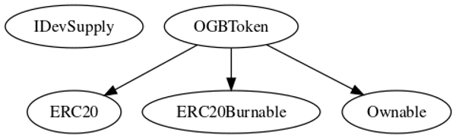

## 

## Flow Graph

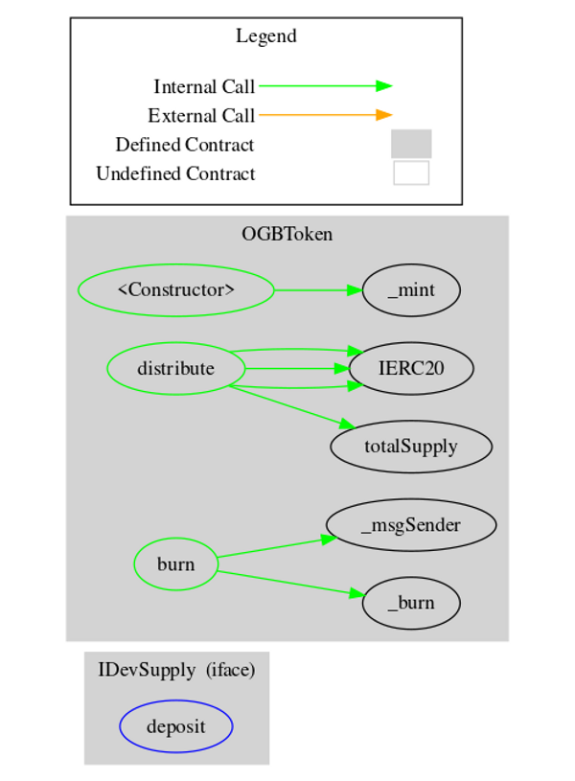

## Summary

OpenGames is an interesting project that has a friendly and growing community. The Smart Contract analysis reported no compiler errors or critical issues. The contract Owner can access some admin functions that can not be used in a malicious way to disturb the users’ transactions.

## Disclaimer

The information provided in this report does not constitute investment, financial or trading advice and you should not treat any of the document's content as such. This report may not be transmitted, disclosed, referred to or relied upon by any person for any purposes nor may copies be delivered to any other person other than the Company without Cyberscope’s prior written consent. This report is not nor should be considered an “endorsement” or “disapproval” of any particular project or team. This report is not nor should be regarded as an indication of the economics or value of any “product” or “asset” created by any team or project that contracts Cyberscope to perform a security assessment. This document does not provide any warranty or guarantee regarding the absolute bug-free nature of the technology analyzed, nor do they provide any indication of the technologies proprietors' business, business model or legal compliance. This report should not be used in any way to make decisions around investment or involvement with any particular project. This report represents an extensive assessment process intending to help our customers increase the quality of their code while reducing the high level of risk presented by cryptographic tokens and blockchain technology.

Blockchain technology and cryptographic assets present a high level of ongoing risk Cyberscope’s position is that each company and individual are responsible for their own due diligence and continuous security Cyberscope’s goal is to help reduce the attack vectors and the high level of variance associated with utilizing new and consistently changing technologies and in no way claims any guarantee of security or functionality of the technology we agree to analyze. The assessment services provided by Cyberscope are subject to dependencies and are under continuing development. You agree that your access and/or use including but not limited to any services reports and materials will be at your sole risk on an as-is where-is and as-available basis Cryptographic tokens are emergent technologies and carry with them high levels of technical risk and uncertainty. The assessment reports could include false positives false negatives and other unpredictable results. The services may access and depend upon multiple layers of third parties.

## About Cyberscope

Cyberscope is a blockchain cybersecurity company that was founded with the vision to make web3.0 a safer place for investors and developers. Since its launch, it has worked with thousands of projects and is estimated to have secured tens of millions of investors’ funds.

Cyberscope is one of the leading smart contract audit firms in the crypto space and has built a high-profile network of clients and partners.



The Cyberscope team

<https://www.cyberscope.io>